《ASP.NET程序设计》实验报告
专业 计算机 班级_ 142 实验日期_2017_年_ 4 月_ 20_日
学号 2014211436 姓名 蔡梦璋 实验地点 2-809
- 实验名称
SportsStore
- 实验环境
Pc机
- 实验主要步骤
- 先建立数据库，把数据存进去；
1 | Kayak | A boat for one person | Watersports | 275.00
2 | Lifejacket | Protective and fashionable | Watersports | 48.95
3 | Soccer Ball | FIFA-approved size and weight | Soccer | 19.50
4 | Corner Flags | Give your playing field a professional touch | Soccer | 34.95
5 | Stadium | Flat-packed, 35,000-seat stadium | Soccer | 79500.00
6 | Thinking Cap | Improve your brain efficiency by 75% | Chess | 16.00
7 | Unsteady Chair | Secretly give your opponent a disadvantage | Chess | 29.95
8 | Human Chess Board | A fun game for the family | Chess | 75.00
9 | Bling-Bling King | Gold-plated, diamond-studded King | Chess | 1200.00
NULL | NULL | NULL | NULL | NULL

- 利用mvc做出页面的主体部分
using System;
using System.Collections.Generic;
using System.Linq;
using System.Text;
using System.Threading.Tasks;

namespace SportsStore.Domain.Entities
{
public class Product
{
public int ProductID { get; set; }
public string Name { get; set; }
public string Description { get; set; }
public decimal Price { get; set; }
public string Category { get; set; }
}
}
using System;
using System.Collections.Generic;
using System.Linq;
using System.Web;
using System.Web.Mvc;
using SportsStore.Domain.Abstract;
using SportsStore.Domain.Entities;
using SportsStore.WebUI.Models;
namespace SportsStore.WebUI.Controllers
{
public class ProductController : Controller
{
private IProductRepository repository;
public int PageSize = 4;
public ProductController(IProductRepository productRepository)
{
this.repository = productRepository;
}
public ViewResult List(string category, int page = 1)
{

ProductsListViewModel viewModel = new ProductsListViewModel
{
Products = repository.Products
.Where(p => category == null || p.Category == category)
.OrderBy(p => p.ProductID)
.Skip((page - 1) * PageSize)
.Take(PageSize),
PagingInfo = new PagingInfo
{
CurrentPage = page,
ItemsPerPage = PageSize,
TotalItems = repository.Products.Count()
},
CurrentCategory = category
};
return View(viewModel);
}
}
}

using System.Collections.Generic;
using SportsStore.Domain.Entities;
namespace SportsStore.WebUI.Models
{
public class ProductsListViewModel
{
public IEnumerable<Product> Products { get; set; }
public PagingInfo PagingInfo { get; set; }
public string CurrentCategory { get; set; }
}
}
- 分类建立购物车
using System;
using System.Collections.Generic;
using System.Linq;
using System.Web;
using System.Web.Mvc;
using SportsStore.Domain.Abstract;
using SportsStore.Domain.Entities;
using SportsStore.WebUI.Models;
namespace SportsStore.WebUI.Controllers
{
public class CartController : Controller
{
private IProductRepository repository;
public CartController(IProductRepository repo)
{
repository = repo;
}
public ViewResult Index(string returnUrl)
{
return View(new CartIndexViewModel
{
Cart = GetCart(),
ReturnUrl = returnUrl
});
}
public RedirectToRouteResult AddToCart(int productId, string returnUrl)
{
Product product = repository.Products.FirstOrDefault(p => p.ProductID == productId);
if(product!=null)
{
GetCart().AddItem(product, 1);
}
return RedirectToAction("Index", new { returnUrl });
}
public RedirectToRouteResult RemoveFromeCart(int productId, string returnUrl)
{
Product product = repository.Products.FirstOrDefault(p => p.ProductID==productId);
if (product != null)
{
GetCart().AddItem(product, 1);
}

return RedirectToAction("Index", new { returnUrl });
}
private Cart GetCart()
{
Cart cart = (Cart)Session["Cart"];
if (cart == null)
{
cart = new Cart();
Session["Cart"] = cart;
}
return cart;
}
}
}

4.建立结算系统和邮件反馈
using System.Collections.Generic;
using System.Linq;
using System.Web.Mvc;
using SportsStore.Domain.Abstract;
using SportsStore.WebUI.Models;

namespace SportsStore.WebUI.Controllers
{

public class NavController : Controller
{
private IProductRepository repository;

public NavController(IProductRepository repo)
{
repository = repo;

}
public PartialViewResult Menu()
{

IEnumerable<string> categories = repository.Products
.Select(x => x.Category)
.Distinct()
.OrderBy(x => x);

return PartialView(categories);
}
}
}
using System;
using System.Collections.Generic;
using System.Web.Mvc;
using System.Linq;
using Microsoft.VisualStudio.TestTools.UnitTesting;
using Moq;
using SportsStore.Domain.Abstract;
using SportsStore.Domain.Entities;
using SportsStore.WebUI.Controllers;
using SportsStore.WebUI.Models;
using SportsStore.WebUI.HtmlHelpers;
namespace SportsStore.UnitTests
{
[TestClass]
public class UnitTest1
{
[TestMethod]
public void Can_Paginate()
{
// Arrange
Mock<IProductRepository> mock = new Mock<IProductRepository>();
mock.Setup(m => m.Products).Returns(new Product[] {
new Product {ProductID = 1, Name = "P1"},
new Product {ProductID = 2, Name = "P2"},
new Product {ProductID = 3, Name = "P3"},
new Product {ProductID = 4, Name = "P4"},
new Product {ProductID = 5, Name = "P5"}
});
ProductController controller = new ProductController(mock.Object);
controller.PageSize = 3;
// Act
ProductsListViewModel result = (ProductsListViewModel)controller.List(null, 2).Model;
// Assert
Product[] prodArray = result.Products.ToArray();
Assert.IsTrue(prodArray.Length == 2);
Assert.AreEqual(prodArray[0].Name, "P4");
Assert.AreEqual(prodArray[1].Name, "P5");
}
[TestMethod]
public void Can_Send_Pagination_View_Model()
{
// Arrange
Mock<IProductRepository> mock = new Mock<IProductRepository>();
mock.Setup(m => m.Products).Returns(new Product[] {new Product {ProductID = 1, Name = "P1"},
new Product {ProductID = 2, Name = "P2"},
new Product {ProductID = 3, Name = "P3"},
new Product {ProductID = 4, Name = "P4"},
new Product {ProductID = 5, Name = "P5"}
});
// Arrange
ProductController controller = new ProductController(mock.Object);
controller.PageSize = 3;
// Act
ProductsListViewModel result = (ProductsListViewModel)controller.List(null, 2).Model;
// Assert
PagingInfo pageInfo = result.PagingInfo;
Assert.AreEqual(pageInfo.CurrentPage, 2);
Assert.AreEqual(pageInfo.ItemsPerPage, 3);
Assert.AreEqual(pageInfo.TotalItems, 5);
Assert.AreEqual(pageInfo.TotalPages, 2);
}
[TestMethod]
public void Can_Generate_Page_Links()
{
// Arrange - define an HTML helper - we need to do this
// in order to apply the extension method
HtmlHelper myHelper = null;
// Arrange - create PagingInfo data
PagingInfo pagingInfo = new PagingInfo
{
CurrentPage = 2,
TotalItems = 28,
ItemsPerPage = 10
};
// Arrange - set up the delegate using a lambda expression
Func<int, string> pageUrlDelegate = i => "Page" + i;
// Act
MvcHtmlString result = myHelper.PageLinks(pagingInfo, pageUrlDelegate);
// Assert
Assert.AreEqual(@"<a class=""btn btn-default"" href=""Page1"">1</a>"+ @"<a class=""btn btn-default btn-primary selected"" href=""Page2"">2</a>"+ @"<a class=""btn btn-default"" href=""Page3"">3</a>",result.ToString());
}
[TestMethod]
public void Can_Filter_Products()
{
// Arrange
// - create the mock repository
Mock<IProductRepository> mock = new Mock<IProductRepository>();
mock.Setup(m => m.Products).Returns(new Product[] {
new Product {ProductID = 1, Name = "P1", Category = "Cat1"},
new Product {ProductID = 2, Name = "P2", Category = "Cat2"},
new Product {ProductID = 3, Name = "P3", Category = "Cat1"},
new Product {ProductID = 4, Name = "P4", Category = "Cat2"},
new Product {ProductID = 5, Name = "P5", Category = "Cat3"}
});

// Arrange - create a controller and make the page size 3 items
ProductController controller = new ProductController(mock.Object);
controller.PageSize = 3;
// Action
Product[] result = ((ProductsListViewModel)controller.List("Cat2", 1).Model)
.Products.ToArray();
// Assert
Assert.AreEqual(result.Length, 2);
Assert.IsTrue(result[0].Name == "P2" && result[0].Category == "Cat2");
Assert.IsTrue(result[1].Name == "P4" && result[1].Category == "Cat2");
}
[TestMethod]
public void Can_Create_Categories()
{
// Arrange
// - create the mock repository
Mock<IProductRepository> mock = new Mock<IProductRepository>();
mock.Setup(m => m.Products).Returns(new Product[] {
new Product {ProductID = 1, Name = "P1", Category = "Apples"},
new Product {ProductID = 2, Name = "P2", Category = "Apples"},
new Product {ProductID = 3, Name = "P3", Category = "Plums"},
new Product {ProductID = 4, Name = "P4", Category = "Oranges"},
});
// Arrange - create the controller
NavController target = new NavController(mock.Object);
// Act = get the set of categories
string[] results = ((IEnumerable<string>)target.Menu().Model).ToArray();
// Assert
Assert.AreEqual(results.Length, 3);
Assert.AreEqual(results[0], "Apples");
Assert.AreEqual(results[1], "Oranges");
Assert.AreEqual(results[2], "Plums");
}
}
}
- 主要结果截图（注意图片居中，调整大小）
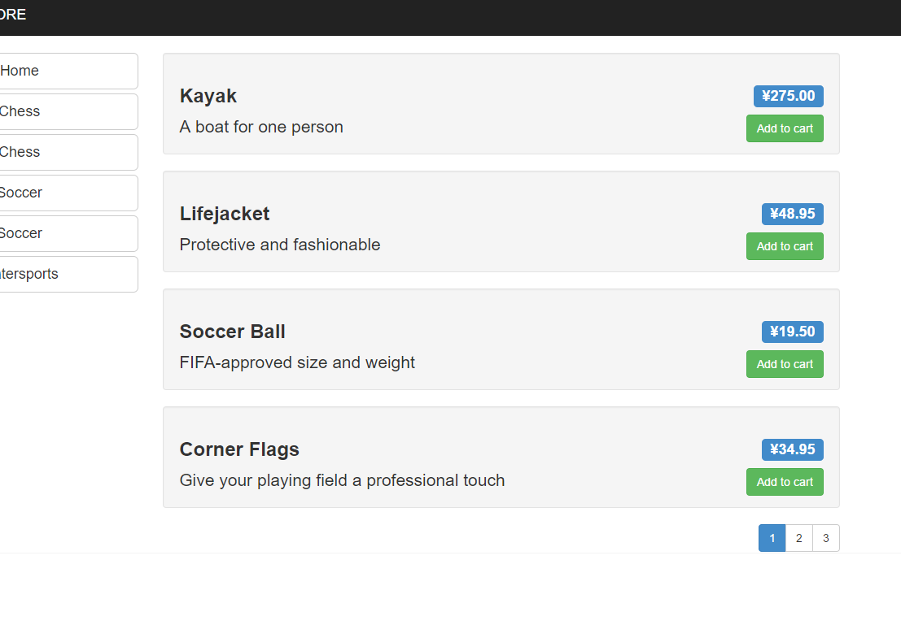
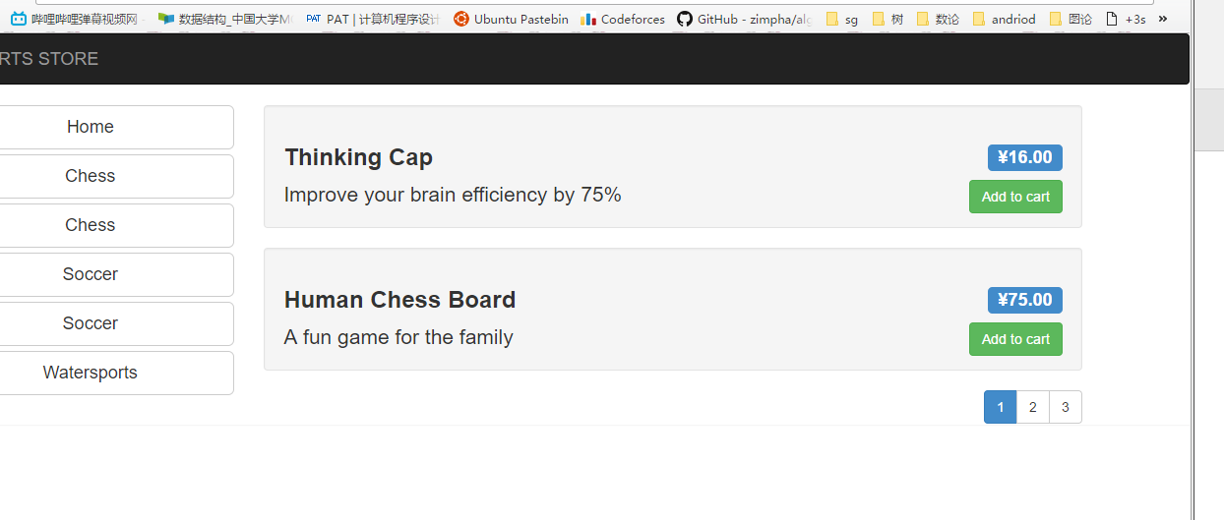
- 实验总结（实验学习到的内容、遇到的问题、学习感想和建议等）
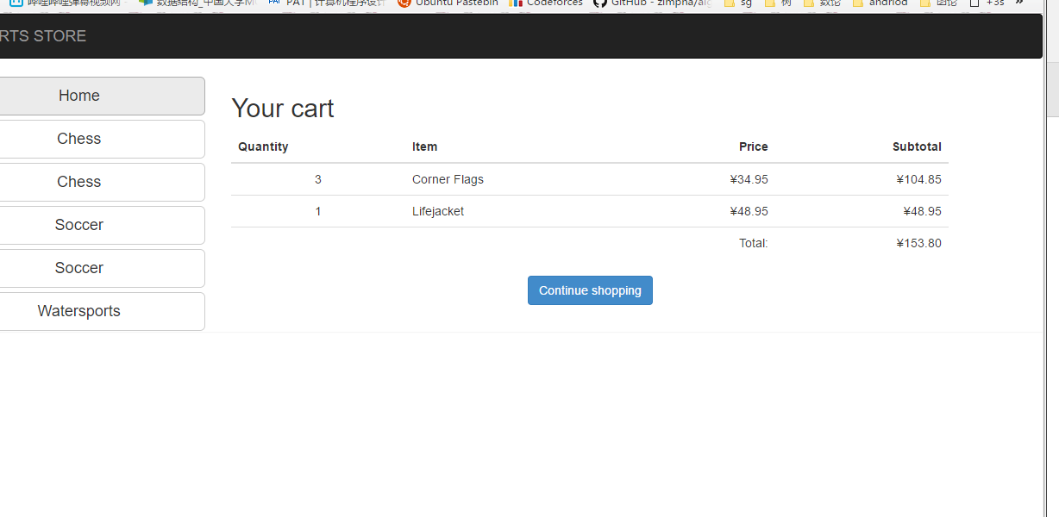

学习感想
这次作业量比较大，做的过程中也遇到了很多麻烦绝大多数书上都能找到答案但有些错误就想了很久也没弄明白还是对mvc有点陌生把，需要更多地去写一写

注：学生做每个实验都必须写实验报告。实验报告可以是纸质的，也可以是电子形式的。后面的表3“实验报告”仅作为参考。任课教师可根据实验的特殊情况自行设计实验报告。实验报告（如是电子形式的必须刻成光盘）在学期结束时交给教务科存档。
实验指导教师签名______________ _______年____ 月____ 日

