《ASP.NET程序设计》实验报告
专业 计算机 班级_ 142 实验日期_2017_年_ 3 月_1 _日
学号 2014211436 姓名 蔡梦璋 实验地点 2-809
- 实验名称
MVC入门
- 实验环境
809装有vs2015的pc
- 实验主要步骤
1. 新建、保存打开工程
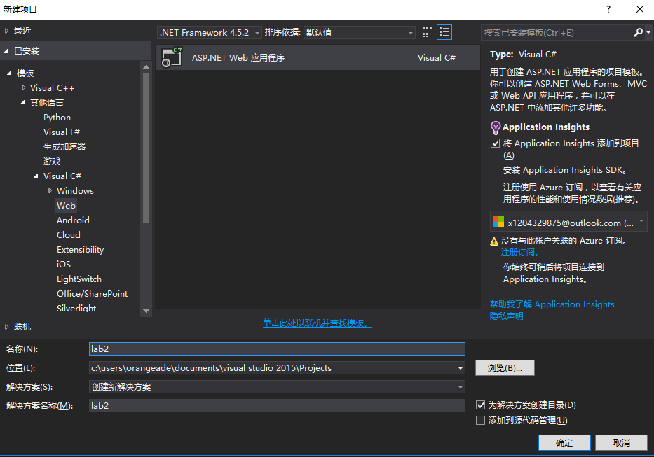
2.. 新建和修改模型（Modelusing System;
using System.Collections.Generic;
using System.ComponentModel.DataAnnotations;
using System.Linq;
using System.Web;

namespace Lab1.Models
{
public class GuestResponse
{
[Required(ErrorMessage ="Please enter your name")]
public string Name { get; set; }
[Required(ErrorMessage ="Please emter your email")]
[RegularExpression(".+\\@.+\\..+",ErrorMessage ="please enter an valid email address")]
public string Email { get; set; }
[Required(ErrorMessage ="Please enter your phone number")]
public string Phone { get; set; }
[Required(ErrorMessage ="Please specify whether you'll attend")]
public bool? willAttend { get; set; }
}
}
3. 新建和修改控制器（Controller
using Lab1.Models;
using System;
using System.Collections.Generic;
using System.Linq;
using System.Web;
using System.Web.Mvc;

namespace Lab1.Controllers
{
public class HomeController : Controller
{
// GET: Home
public ViewResult Index()
{
int hour = DateTime.Now.Hour;
ViewBag.Greeting = hour <= 12 ? "Good Morning!" : "Good Afternoon!";
return View();
}
public ViewResult RsvpForm()
{
return View();
}

[HttpPost]
public ViewResult RsvpForm(GuestResponse guestResponse)
{
if (ModelState.IsValid) return View("Thanks", guestResponse);
else
return View();
}
}
}
4. 新建和修改视图（View

@{
Layout = null;
}

<!DOCTYPE html>

<html>
<head>
<meta name="viewport" content="width=device-width" />
<title>index</title>
<link href="~/Content/bootstrap.min.css"rel="stylesheet"/>
<link href="~/Content/bootstrap-theme.css"rel="stylesheet"/>
<style>
.btn a {
color: white;
text-decoration: none;
}

body {
background-color: #f1f1f1;
}
</style>
</head>
<body>
<div class="text-center">
<h1>
@ViewBag.Greeting World(from the view)
</h1>
<div class="btn btn-success">
@Html.ActionLink("RSVP Now", "RSVPForm")
</div>
</div>
</body>
</html>

@model Lab1.Models.GuestResponse
@{
Layout = null;
}

<!DOCTYPE html>

<html>
<head>
<meta name="viewport" content="width=device-width" />
<title>RsvpForm</title>
<link href="~/Content/bootstrap.min.css" rel="stylesheet" />
<link href="~/Content/bootstrap-theme.css" rel="stylesheet" />
</head>
<body>
<div class="panel panel-success text-center">
<div class="panel-heading text-center">
<h4>RSVP</h4>
</div>
<div>
@using (Html.BeginForm())
{
@Html.ValidationSummary()
<div><label>Your name:</label>@Html.TextBoxFor(x => x.Name)</div>
<div><label>Your email:</label>@Html.TextBoxFor(x => x.Email)</div>
<div><label>Your phone:</label>@Html.TextBoxFor(x => x.Phone)</div>

<div><label>Will you attend?</label>@Html.DropDownListFor(x => x.willAttend,
new[] {
new SelectListItem() { Text="No,I can't come",Value=bool.FalseString},
new SelectListItem() { Text="Yes,I'll be there",Value=bool.TrueString}},"Choose an option")
</div>
<input type="submit"value="提交" class="btn btn-success"/>
}
</div>
</div>
</body>
</html>

@{
Layout = null;
}

<!DOCTYPE html>

<html>
<head>
<meta name="viewport" content="width=device-width" />
<title>Thanks</title>
<link href="~/Content/bootstrap.min.css" rel="stylesheet" />
<link href="~/Content/bootstrap-theme.css" rel="stylesheet" />
</head>
<body>
<div class="text-center">
<h1>Thanks,@Model.Name!</h1>
</div>
<div class="text-center">
@if(Model.willAttend==true)
{
@:It' great that you're coming.
}
else
{
@:Sorry to hear that you can't make it.
}
@{
try
{
WebMail.SmtpServer = "smtp-mail.outlook.com";
WebMail.SmtpPort = 587;
WebMail.EnableSsl = true;
WebMail.UserName = "x1204329875@outlook.com";
WebMail.Password = "wectivocu?!0";
WebMail.From = "x1204329875@outlook.com";
WebMail.Send("1204329875@qq.com", "RSVP Notification", "Notification coming!");

}
catch (Exception)
{
@:<b>Sorry-we can not send the email to you !</b>
}
}
</div>
</body>
</html>

5. 表单项的模型绑定
namespace Lab1.Controllers
{
public class HomeController : Controller
{
// GET: Home
public ViewResult Index()
{
int hour = DateTime.Now.Hour;
ViewBag.Greeting = hour <= 12 ? "Good Morning!" : "Good Afternoon!";
return View();
}
public ViewResult RsvpForm()
{
return View();
}

[HttpPost]
public ViewResult RsvpForm(GuestResponse guestResponse)
{
if (ModelState.IsValid) return View("Thanks", guestResponse);
else
return View();
}
}
}
7. Bootstrap引入使用
PM> Install-Package -version 3.0.0 bootstrap
8. 邮件发信通知
@{
try
{
WebMail.SmtpServer = "smtp-mail.outlook.com";
WebMail.SmtpPort = 587;
WebMail.EnableSsl = true;
WebMail.UserName = "x1204329875@outlook.com";
WebMail.Password = "wectivocu?!0";
WebMail.From = "x1204329875@outlook.com";
WebMail.Send("1204329875@qq.com", "RSVP Notification", "Notification coming!");

}
catch (Exception)
{
@:<b>Sorry-we can not send the email to you !</b>
}
}

- 主要结果截图（注意图片居中，调整大小）
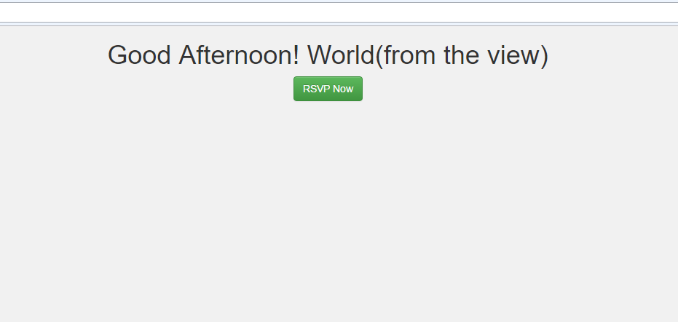
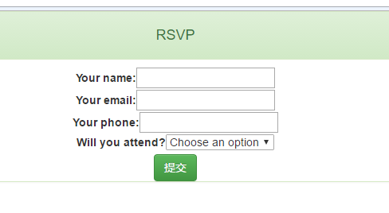
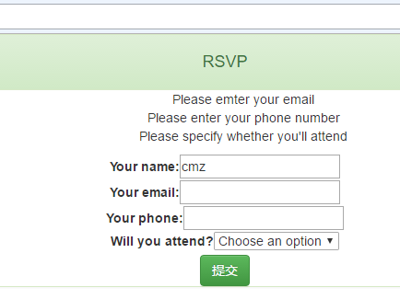
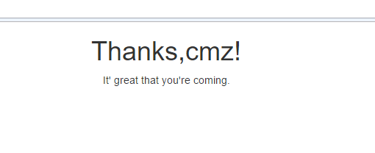
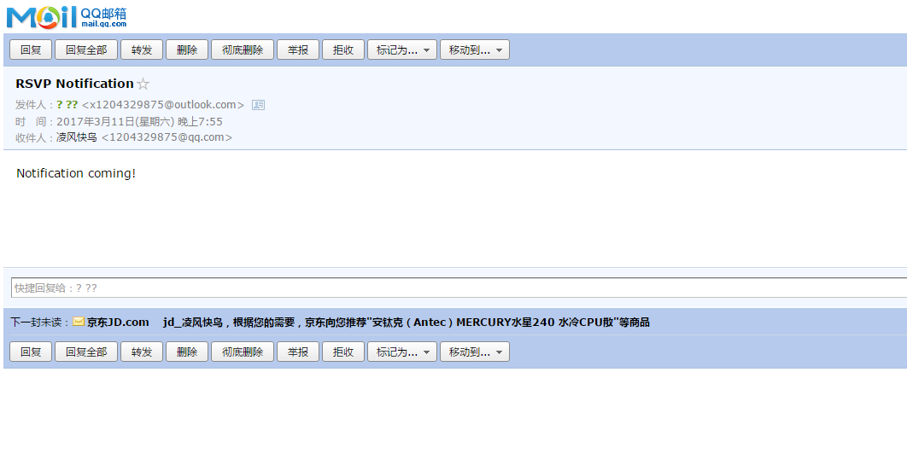
- 实验总结（实验学习到的内容、遇到的问题、学习感想和建议等）
学习内容:
学习到了mvc是一个怎么样的样式，能够跟着pdf慢慢的做下来，了解到怎样用stmp发送邮件，了解学习了一下bootstrap的使用。
问题：
一开始发送邮件出了点问题 后来查了一下端口号就行了
学习感想
感觉mvc架构很方便呀，整合型挺高的。

注：学生做每个实验都必须写实验报告。实验报告可以是纸质的，也可以是电子形式的。后面的表3“实验报告”仅作为参考。任课教师可根据实验的特殊情况自行设计实验报告。实验报告（如是电子形式的必须刻成光盘）在学期结束时交给教务科存档。
实验指导教师签名______________ _______年____ 月____ 日

