实验4主成分检验

蔡梦璋 2014211436

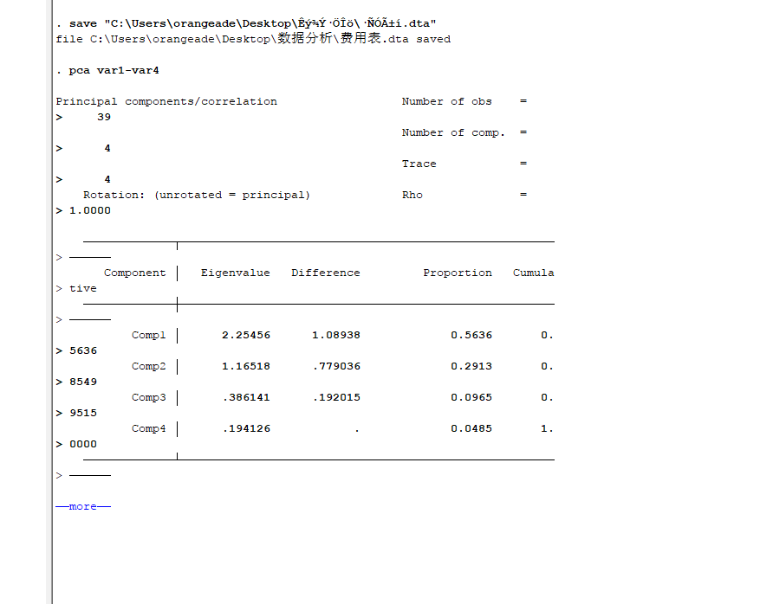

/*KMO检验，越高越好*/

estat kmo

Kaiser-Meyer-Olkin measure of sampling adequacy

-----------------------

Variable | kmo

-------------+---------

var1 | 0.3489

var2 | 0.5491

var3 | 0.5775

var4 | 0.7139

-------------+---------

Overall | 0.5594

-----------------------

/*SMC检验，值越高越好*/

. . estat smc

Squared multiple correlations of variables with all other variables

-----------------------

Variable | smc

-------------+---------

var1 | 0.3601

var2 | 0.6558

var3 | 0.6459

var4 | 0.4288

-----------------------

碎石图检验

. screeplot

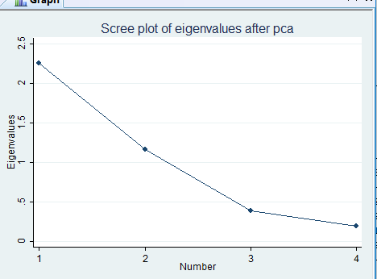

/*预测变量得分、拟合值和残差以及残差的平方和*/

. screeplot

. predict score fit residual q

(score assumed)

Scoring coefficients

sum of squares(column-loading) = 1

------------------------------------------------------

Variable | Comp1 Comp2 Comp3 Comp4

-------------+----------------------------------------

var1 | 0.2370 0.8242 0.3992 0.3244

var2 | 0.5885 0.2667 -0.3479 -0.6793

var3 | 0.5930 -0.2182 -0.4271 0.6468

var4 | 0.4958 -0.4494 0.7329 -0.1223

------------------------------------------------------

. . predict f1 f2 f3

(score assumed)

(1 components skipped)

Scoring coefficients

sum of squares(column-loading) = 1

------------------------------------------------------

Variable | Comp1 Comp2 Comp3 Comp4

-------------+----------------------------------------

var1 | 0.2370 0.8242 0.3992 0.3244

var2 | 0.5885 0.2667 -0.3479 -0.6793

var3 | 0.5930 -0.2182 -0.4271 0.6468

var4 | 0.4958 -0.4494 0.7329 -0.1223

------------------------------------------------------

. predict q1 q2 q3

(score assumed)

(1 components skipped)

Scoring coefficients

sum of squares(column-loading) = 1

------------------------------------------------------

Variable | Comp1 Comp2 Comp3 Comp4

-------------+----------------------------------------

var1 | 0.2370 0.8242 0.3992 0.3244

var2 | 0.5885 0.2667 -0.3479 -0.6793

var3 | 0.5930 -0.2182 -0.4271 0.6468

var4 | 0.4958 -0.4494 0.7329 -0.1223

------------------------------------------------------

. 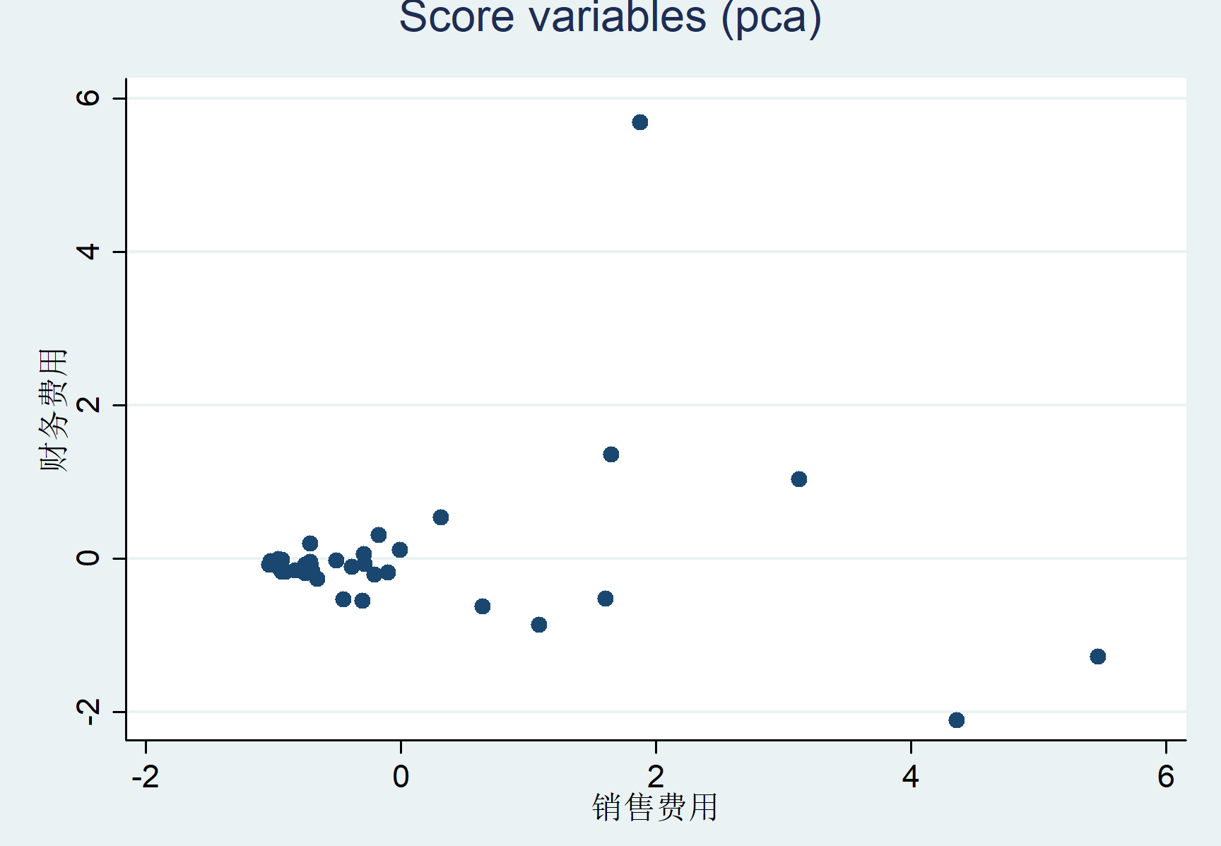

**scatter f2 f3,xtitle("销售费用") ytitle("财务费用")**

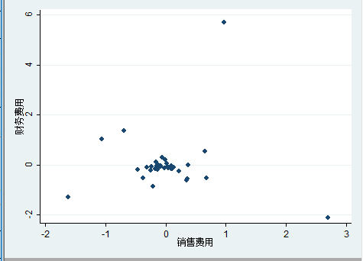

. rotate

Principal components/correlation Number of obs = 39

Number of comp. = 4

Trace = 4

Rotation: orthogonal varimax (Kaiser off) Rho = 1.0000

--------------------------------------------------------------------------

Component | Variance Difference Proportion Cumulative

-------------+------------------------------------------------------------

Comp1 | 1.00001 5.79297e-06 0.2500 0.2500

Comp2 | 1.00001 9.93968e-06 0.2500 0.5000

Comp3 | .999997 .0000141777 0.2500 0.7500

Comp4 | .999983 . 0.2500 1.0000

--------------------------------------------------------------------------

Rotated components

--------------------------------------------------------------------

Variable | Comp1 Comp2 Comp3 Comp4 | Unexplained

-------------+----------------------------------------+-------------

var1 | 0.0000 -0.0000 1.0000 -0.0000 | 0

var2 | 1.0000 0.0000 -0.0000 -0.0000 | 0

var3 | 0.0000 0.0000 0.0000 1.0000 | 0

var4 | -0.0000 1.0000 0.0000 -0.0000 | 0

--------------------------------------------------------------------

Component rotation matrix

------------------------------------------------------

| Comp1 Comp2 Comp3 Comp4

-------------+----------------------------------------

Comp1 | 0.5885 0.4959 0.2370 0.5930

Comp2 | 0.2667 -0.4494 0.8242 -0.2182

Comp3 | -0.3479 0.7329 0.3992 -0.4271

Comp4 | -0.6793 -0.1223 0.3244 0.6468

------------------------------------------------------

.