**In-class programming No.3**

Two-dimension sort

A school needs to publish scores of an exam for Grade 1. It has 10 classes, and 15 students in each class. You need to sort the name of the classes in increasing order first (A to Z), and sort the scores for each class in decreasing order (500 to 1).

**Requirements:**

Generate the name of the 10 classes randomly from A to Z.

Generate an array of 15 random integers ranged from 1 to 500 for each class.

Sort the name first, then sort the scores for each class.

The initial unsorted data can be printed as followed:

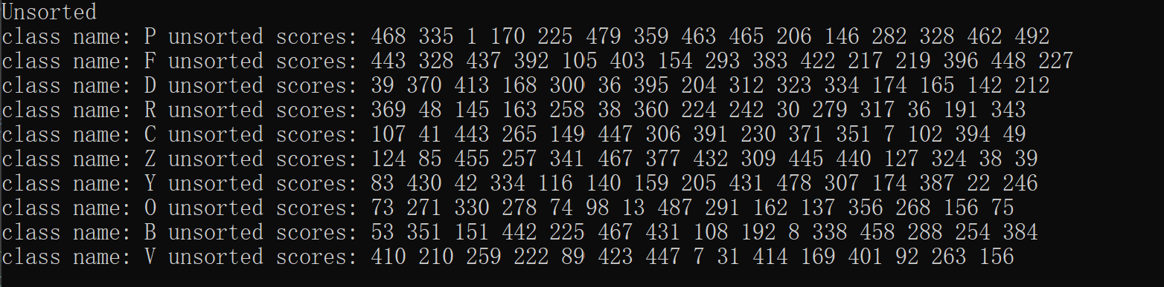

You also need to print sorted results after this.

You can finish the code using the sample code, or do it by yourself.

You can use any of the sorting methods.

Send the code and result to the TA’s email after class.