General Description:
The OrangeCrab is an electronics development board. It is FPGA based, featuring an ECP5 from Lattice. The board follows the slim feather board specification from Adafruit.
The FPGA is compatible with the opensource toolchain and is perfect for experimenting with RISC-V and other soft-core SoCs.

Key features:
- Small Compact size
- Direct USB connection to the FPGA
- Onboard DDR3 Memory
- Preloaded USB bootloader
- Original Orange Colour

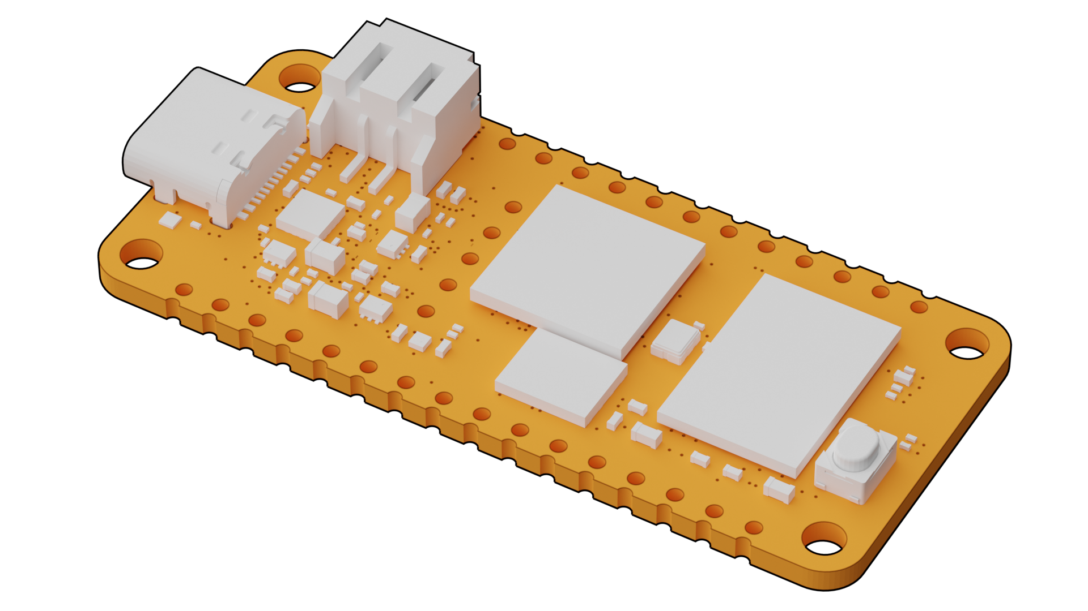
Specifications:
- Lattice ECP5 FPGA csfBGA285 package
- DDR3L Memory
- USB-C connection
- FPGA based Full-speed (12Mbit) USB
- 128Mbit QSPI FLASH Memory
- MicroSD socket
- Power supply
  - High effeciency DCDC for main supplies
  - Battery charger (100mA), with charge indicator LED
  - LiPo battery connector (PH type)
- 48MHz onboard oscillator
- User I/O
  - 1x Button
  - 1x RGB LED
  - 20x I/O on 0.1" headers
  - 6x Analog Compatible
- Dimensions: 22.86mm x 50.8mm (0.9" x 2.0")

Product Variants:

Part Number | Configuration | FPGA | Memory
OrangeCrab-r0d2-25 | 25F / 128 MiB | LFE5U-25F-8MG285C | MT41K64M16TW
OrangeCrab-r0d2-85 | 85F / 512 MiB | LFE5U-85F-8MG285C | MT41K256M16TW

