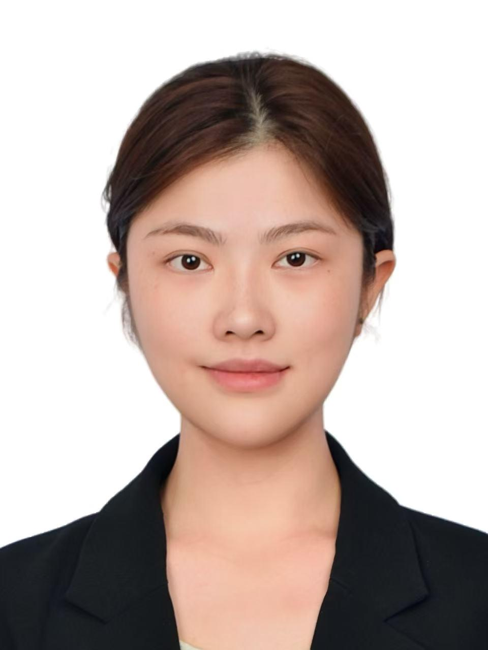
Yujing (Jean) Zhang
Chapel Hill, NC | +86 18513193708 | yujingzh@unc.edu | WeChat: Mayist_415
EDUCATION

2024.08-2026.08 University of North Carolina at Chapel Hill
Master of Arts in Educational Innovation, Technology, and Entrepreneurship (MEITE), with a concentration in Adaptive Learning Analytics.
2023.06-2023.08 University of California, Berkeley
Summer Exchange Program focusing on Cultural Psychology and Data Analysis.
2020.09-2024.06 Beijing Normal University
Bachelor of Arts in Chinese Language and Literature with a cumulative GPA of 3.8/4.0.
TIKTOK LIVE EXPERIENCE

2025.08-2026.02 TikTok US | Independent Creator & Part-time Streamer
Profile Link：https://www.tiktok.com/@jeannnmay
Directed end to end operations for a personal TikTok Live channel, engineering a cross cultural visual brand that maximized user engagement and commercial monetization. Executed high frequency interactive campaigns aligned with major cultural events, broadcasting five days per week at three hours per session to utilize platform analytics and optimize audience retention. Achieved explosive channel growth within six weeks, advancing platform ranking from D5 to B1 and scaling the community to over 4,500 followers, including an engaged base of 100 core fans and 11 super fans. Secured the top ranking on the US B4 Daily Leaderboard with a daily revenue peak of 147k coins and a record 15 consecutive competitive wins, while consistently maintaining an average concurrent viewership exceeding 1k users and generating 70k to 120k likes per session.
PROFESSIONAL EXPERIENCE 2025.08-2026.05 People Powered | Remote Instructional Design and EdTech Intern

Administered the TalentLMS environment for the Climate Democracy Accelerator, ensuring seamless delivery for international cohorts by structuring complex course sessions and integrating global case studies. Engineered a scalable onboarding asset using Canva and ElevenLabs AI narration, solving technical synchronization challenges between mobile and desktop interfaces to reduce user friction. Optimized the offboarding workflow for the Inclusive Democracy Accelerator by analyzing learner data and automating certificate issuance, ensuring 100 percent tracking accuracy for program requirements. Iterated on course content based on post program survey data, directly enhancing curriculum relevance and accessibility for diverse global learners.
2024.08-2025.11 The University of North Carolina at Chapel Hill Graduate Research Assistant
Designing Transparent Generative AI Systems, investigating user interaction with LLMs in collaborative educational settings. Designed and prototyped interface transparency features, such as Model Cards and Evaluation Metrics, to help students critically evaluate AI outputs and reduce over reliance on automated suggestions. Facilitated semi structured focus groups with 22 graduate students across distinct disciplines to validate design prototypes and gather qualitative user feedback. Conducted rigorous thematic analysis on user interaction transcripts, identifying critical factors such as social transparency and instructor demonstration that drive the adoption of AI tools in classrooms.
2024.08-2025.5 The University of North Carolina at Chapel Hill AI Product Designer and Project Lead
AIgnite (ToB)：Directed the conceptualization and UX design of AIgnite, a business to business AI driven employee onboarding system. Utilized Figma to engineer core functionalities, including an AI learning assistant and business simulation dialogues, facilitating personalized progress tracking for corporate training. Prototype link：AIgnite
CoSkill (ToC)：Concurrently developed CoSkill, a consumer facing AI matching platform rooted in project based learning methodologies. Deployed matching algorithms to precisely connect learners with complementary skills, effectively transforming isolated study environments into dynamic social collaboration experiences. Prototype link：CoSkill
2023.02-2023.6 Tomorrow Advancing Life | Beijing, China Product Intern
Collaborated with cross functional product teams to design and launch digital and physical K through 12 language learning products, ensuring alignment with curriculum standards. Developed high quality supplementary teaching assets, including interactive slide decks and handouts, which were deployed in live classrooms to enhance student engagement and instructional delivery

2022.06-2022.8 Xuetang Online Technology | Beijing, China New Media Operation Intern
Analyzed course usage metrics and user feedback to identify and correct content errors in exercise questions, directly optimizing the online learning experience for thousands of users. Spearheaded data driven social media campaigns that achieved record breaking engagement, with key promotional content ranking as most viewed weekly on the platform.
2021.09-2022.09 Student Union, College of Chinese Language and Literature | Beijing, China
Director of Publicity Department
Directed the end to end execution of the Master of Literature cultural program, managing concept generation, visual design, and campus wide distribution strategies. Led a design team in producing over 10 promotional assets for major university events, resulting in a 2x year over year increase in product sales and student participation.
RELEVANT SKILLS

- EdTech and Instructional Design: Talent LMS, Canvas, MOOC Platform Operations, Curriculum Development, User Research, Blended Learning.
- Generative AI and Tools: ElevenLabs, ChatGPT, Claude, Gemini, PlayHT, AI Assisted Content Creation.
- Multimedia and Design: Adobe Photoshop, Final Cut Pro, Canva, Figma.
- Research and Analysis: Qualitative Research, Focus Group Facilitation, User Experience Research.
- Languages: English(with a TOEFL score of 105), Chinese

