Development Plan for OCR Web
Document design - current phase
Target stack: DDD, ASP.NET Core Web API, MediatR, FastEndpoints, CQRS, file-based DB, ASP.NET Core BFF, Angular, Playwright
Objective: define the initial project-creation and project-opening workflow for a web-based OCR system before implementation starts.

1. Scope ณ ตอนนี้
- ออกแบบ flow เริ่มต้นสำหรับสร้าง project ใหม่จากไฟล์ PDF
- ออกแบบ flow เปิด project เดิมจากรายชื่อ folder บน server
- วางขอบเขตสถาปัตยกรรมแบบ DDD + CQRS + BFF สำหรับรอบแรก
- ยังไม่ลงรายละเอียด OCR pipeline ภายใน เช่น page extraction, job queue, text recognition, indexing

2. User Journeys

2.1 New Project
- ผู้ใช้กด Create New Project
- ผู้ใช้เลือกไฟล์ PDF จากเครื่อง
- ระบบตรวจสอบชื่อไฟล์และชนิดไฟล์
- Backend สร้าง folder ตามชื่อไฟล์ภายใต้ storage root
- ระบบ copy ไฟล์ PDF ไปเก็บใน project folder
- ระบบบันทึก metadata ลง file-based DB
- ระบบ redirect ไปหน้า project detail หรือ workspace

2.2 Open Existing Project
- ผู้ใช้กด Open Existing Project
- BFF เรียก backend เพื่อดึงรายชื่อ project folders
- UI แสดงรายการ project ตามชื่อ folder หรือ display name
- ผู้ใช้เลือก project ที่ต้องการ
- ระบบโหลด metadata, source PDF path และสถานะล่าสุดของ project

3. Working Diagram
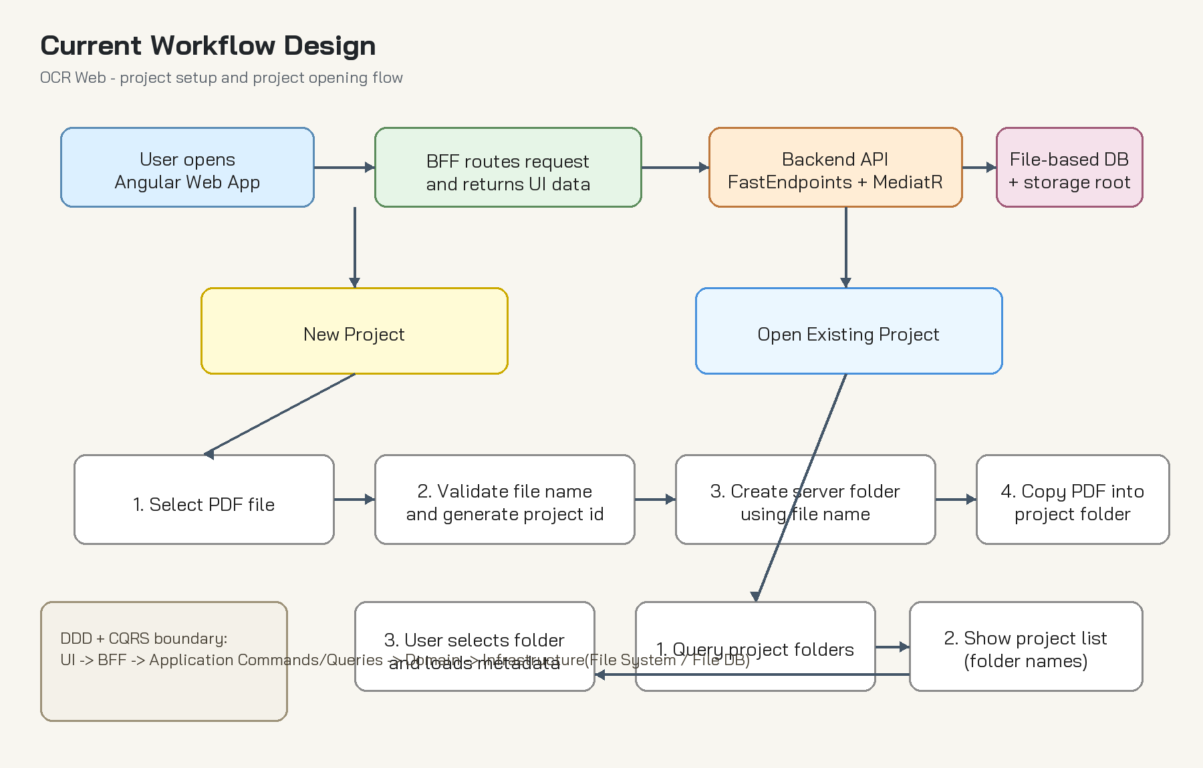
Figure 1. Current workflow for new project and open existing project

4. Architecture Direction
Area | Decision | Notes
Frontend | Angular | Responsible for upload UI, project list, workspace, and invoking BFF endpoints.
Web Entry | ASP.NET Core BFF | Single facade for Angular, authentication boundary, anti-corruption layer to backend APIs.
Backend API | ASP.NET Core + FastEndpoints | Expose command/query endpoints, delegate to MediatR handlers.
Application | CQRS + MediatR | Separate commands and queries clearly for project creation and project lookup.
Domain | DDD modules | Encapsulate project lifecycle, naming rules, document registration, and state transitions.
Infrastructure | File system + file-based DB | Persist metadata and store PDF files in project folders.
Testing | Playwright | Cover major user journeys from Angular UI to BFF behavior.

5. Suggested Bounded Contexts
- Project Management Context: create/open/archive project, naming policy, metadata lifecycle
- Document Intake Context: validate PDF, register source file, assign storage path
- OCR Processing Context (future): page processing, OCR jobs, recognition output, retry policy
- Search/Review Context (future): review text, annotations, export results

6. Initial Folder Strategy
- Storage root example: /data/projects/
- Project folder name starts from sanitized PDF file name
- If duplicate name exists, append stable suffix such as timestamp or short id
- Each project folder should keep source PDF, metadata file, and future OCR output folders together
Example structure:
projects/
invoice-2026-001/
source.pdf
project.json
ocr/
output/

7. CQRS Design Draft
- Command: CreateProjectFromPdfCommand
- Command Handler: validate input, sanitize name, create folder, copy PDF, persist metadata, return project id
- Query: GetProjectListQuery
- Query: GetProjectDetailQuery
- Read model can be optimized independently from write model even when using file-based storage

8. API / BFF Flow Draft
- Angular uploads PDF to BFF endpoint
- BFF forwards request to backend command endpoint or orchestrates multipart transfer
- Backend returns project id, display name, created timestamp, and storage status
- For existing projects, BFF calls query endpoint and shapes DTO for UI needs

9. File-based DB Recommendation
- Keep metadata in JSON per project for simplicity during early phase
- Add a lightweight index file for fast project listing if folder count grows
- Treat file system operations as part of infrastructure service behind domain/application interfaces
- Define explicit recovery rules if file copy succeeds but metadata write fails, or vice versa

10. Testing Strategy
- Domain tests: project naming, duplicate handling, state rules
- Application tests: command/query handlers and infrastructure adapters
- API tests: FastEndpoints request/response contract
- Playwright E2E: create new project, open existing project, invalid file upload, duplicate project name scenario

11. Risks and Early Decisions
- Using folder name directly from file name requires strong sanitization and duplicate handling
- File-based DB is simple but needs clear concurrency and locking strategy
- Large PDF uploads may need streaming and size limits at BFF/backend layers
- Project list performance may degrade if folder scanning is the only listing mechanism

12. Recommended Next Design Steps
- Freeze project metadata schema (project.json)
- Define naming and collision policy for project folders
- Draw backend module boundaries and interfaces in more detail
- Draft endpoint contracts for create/list/detail project use cases
- Then move to OCR processing workflow and background job design

Appendix A. Proposed Metadata Schema
{
"projectId": "proj_20260711_001",
"displayName": "invoice-2026-001",
"folderName": "invoice-2026-001",
"sourceFileName": "invoice-2026-001.pdf",
"sourcePdfPath": "projects/invoice-2026-001/source.pdf",
"status": "Created",
"createdAtUtc": "2026-07-11T08:30:00Z",
"updatedAtUtc": "2026-07-11T08:30:00Z"
}

