Development Plan for OCR Web
Document design - current phase
Target stack: DDD, ASP.NET Core Web API (.NET 10), MediatR, FastEndpoints, CQRS, file-based DB, ASP.NET Core BFF (.NET 10), Angular 22 + Angular Material, xUnit, Moq, Playwright, Docker Image CI/CD
Objective: define the initial project-creation and project-opening workflow for a web-based OCR system before implementation starts.

1. Scope ณ ตอนนี้
- ออกแบบ flow เริ่มต้นสำหรับสร้าง project ใหม่จากไฟล์ PDF
- ออกแบบ flow เปิด project เดิมจากรายชื่อ folder บน server
- วางขอบเขตสถาปัตยกรรมแบบ DDD + CQRS + BFF สำหรับรอบแรก
- ยังไม่ลงรายละเอียด OCR pipeline ภายใน เช่น page extraction, job queue, text recognition, indexing

2. Working Diagram
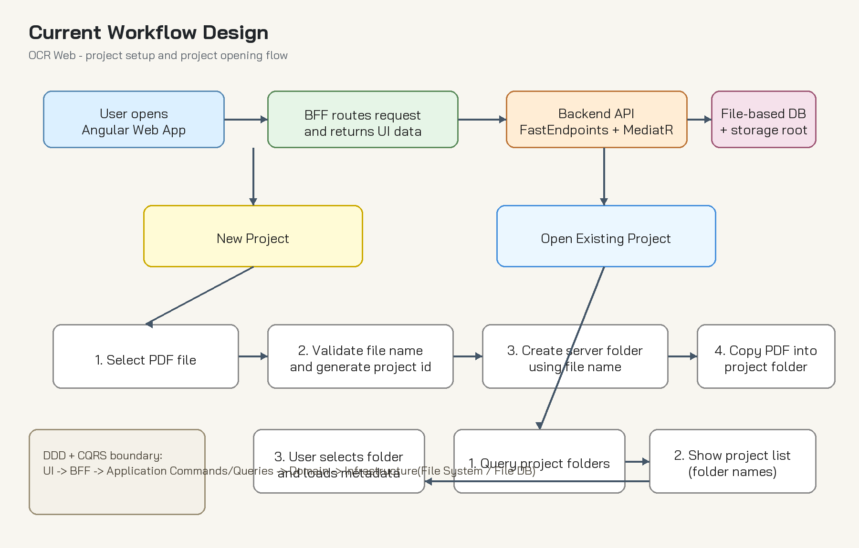
Figure 1. Current workflow for new project and open existing project

3. Architecture Direction
Area | Decision | Notes
Frontend | Angular 22 + Angular Material | Responsible for upload UI, Angular Material-based project list and workspace screens, and invoking BFF endpoints.
Web Entry | ASP.NET Core BFF (.NET 10) | Single facade for Angular, authentication boundary, anti-corruption layer to backend APIs.
Backend API | ASP.NET Core (.NET 10) + FastEndpoints | Expose command/query endpoints, delegate to MediatR handlers.
Application | CQRS + MediatR | Separate commands and queries clearly for project creation and project lookup.
Domain | DDD modules | Encapsulate project lifecycle, naming rules, document registration, and state transitions.
Infrastructure | File system + file-based DB | Persist metadata and store PDF files in project folders.
Testing | xUnit + Moq + Playwright | Use xUnit and Moq for backend unit tests, and Playwright for end-to-end user journeys.

4. Suggested Bounded Contexts
- Project Management Context: create/open/archive project, naming policy, metadata lifecycle
- Document Intake Context: validate PDF, register source file, assign storage path
- OCR Processing Context (future): page processing, OCR jobs, recognition output, retry policy
- Search/Review Context (future): review text, annotations, export results

5. Initial Folder Strategy
- Storage root example: /data/projects/
- Project folder name starts from sanitized PDF file name
- If duplicate name exists, append stable suffix such as timestamp or short id
- Each project folder should keep source PDF, metadata file, and future OCR output folders together
Example structure:
projects/
invoice-2026-001/
source.pdf
project.json
ocr/
output/

6. CQRS Design Draft
- Command: CreateProjectFromPdfCommand
- Command Handler: validate input, sanitize name, create folder, copy PDF, persist metadata, return project id
- Query: GetProjectListQuery
- Query: GetProjectDetailQuery
- Read model can be optimized independently from write model even when using file-based storage

7. API / BFF Flow Draft
- Angular uploads PDF to BFF endpoint
- BFF forwards request to backend command endpoint or orchestrates multipart transfer
- Backend returns project id, display name, created timestamp, and storage status
- For existing projects, BFF calls query endpoint and shapes DTO for UI needs

8. File-based DB Recommendation
- Keep metadata in JSON per project for simplicity during early phase
- Add a lightweight index file for fast project listing if folder count grows
- Treat file system operations as part of infrastructure service behind domain/application interfaces
- Define explicit recovery rules if file copy succeeds but metadata write fails, or vice versa

9. Testing Strategy
- Domain tests: xUnit for project naming, duplicate handling, and state rules
- Application tests: xUnit + Moq for command/query handlers and infrastructure adapters
- API tests: integration tests for FastEndpoints request/response contract
- Playwright E2E: create new project, open existing project, invalid file upload, duplicate project name scenario

10. Risks and Early Decisions
- Using folder name directly from file name requires strong sanitization and duplicate handling
- File-based DB is simple but needs clear concurrency and locking strategy
- Large PDF uploads may need streaming and size limits at BFF/backend layers
- Project list performance may degrade if folder scanning is the only listing mechanism

11. Recommended Next Design Steps
- Freeze project metadata schema (project.json)
- Define naming and collision policy for project folders
- Draw backend module boundaries and interfaces in more detail
- Draft endpoint contracts for create/list/detail project use cases
- Define Docker image build, test, and release flow for CI/CD
- Then move to OCR processing workflow and background job design

12. Project Structure
Recommended repository layout:
- OCRWeb.Shared - shared DDD library for reusable domain primitives, shared abstractions, and common cross-module concepts.
- src/Backend/OCRWeb.Shared - shared DDD library for reusable domain primitives, shared abstractions, and common cross-module concepts.
- src/Backend/OCRWeb.ProjectManagement - DDD module for creating new projects and opening existing projects.
- src/Backend/OCRWeb.DocumentProcessing - processing module for PDF handling, CropPDF, and Split PDF workflows.
- src/Backend/OCRWeb.Contract - shared API contracts, DTOs, and transport models.
- src/Backend/OCRWeb.API - main ASP.NET Core Web API (.NET 10) that orchestrates ProjectManagement and DocumentProcessing modules.
- src/Backend/OCRWeb.Bff - ASP.NET Core BFF (.NET 10) for frontend orchestration.
- src/Frontend/OCRWeb.Frontend - Angular 22 application.
- src/Frontend/OCRWeb.Frontend.Shared - Angular 22 shared component library for frontend-only reusable UI such as Text, Label, Button, and CropPdf.
Testing layout:
- tests/unit - xUnit + Moq unit tests grouped by project when applicable.
- tests/integration - integration tests for API, BFF, and other cross-boundary behavior.
- tests/component - frontend component tests and other project-level component verification where applicable.
- tests/integration/OCRWeb.Frontend.PlaywrightTests - end-to-end browser tests for key user journeys.
Structure guidance:
- Keep test projects outside src for clearer separation between production code and verification code.
- Use OCRWeb.Frontend.Shared only for frontend UI reuse, and keep BFF to Web API communication as normal service calls.
- Do not turn OCRWeb.Shared into a catch-all library; keep only shared concepts that are truly reused across modules, and keep project-specific rules inside ProjectManagement or DocumentProcessing.

13. AI Delivery and Commit Policy
- AI or automation-assisted changes must follow normal engineering discipline and create clear, reviewable commits.
- Before every commit, verify the impacted code can compile and build successfully.
- Check whether Unit Test, Integration Test, and Component Test suites exist and can be executed for the changed scope.
- If the relevant Unit Test, Integration Test, or Component Test can be run, they must be executed before commit.
- When tests cannot be run, the reason should be recorded in the change summary or commit context.
- Whenever a framework, SDK, package, runtime, or image version is updated, the change must be recorded in ChangeLogs.txt every time.
- Commits should stay focused, describe the intent clearly, avoid mixing unrelated changes, and follow the Conventional Commits specification.
- Recommended pre-commit order: restore dependencies, compile, run targeted tests, build artifacts, then commit.
- Recommended Conventional Commit prefixes: feat:, fix:, refactor:, test:, docs:, chore:, build:, and ci:.

14. Domain Modules
- OCRWeb.Shared - shared DDD concepts, base abstractions, value objects, and reusable cross-module contracts.
- OCRWeb.ProjectManagement - responsible for create project, open existing project, project metadata, and project storage coordination.
- OCRWeb.DocumentProcessing - responsible for PDF validation, PDF copy, CropPDF, Split PDF, and future OCR-related document preparation workflows.

15. Implementation Plan
Tracking rule: when a task is completed, mark it as [x] and record the completion date.

15.1 Frontend Shared Components
- [ ] ButtonComponent - Done Date: ____-__-__
- [ ] LabelComponent - Done Date: ____-__-__
- [ ] TextboxComponent - Done Date: ____-__-__
- [ ] PopupMessageInfoComponent - Done Date: ____-__-__
- [ ] PopupMessageQuestionComponent - Done Date: ____-__-__
- [ ] PopupErrorMessageComponent - Done Date: ____-__-__
- [ ] FormComponent - Done Date: ____-__-__
- [ ] WindowComponent - Done Date: ____-__-__
- [ ] ModalWindowComponent - Done Date: ____-__-__

15.2 Backend and Workflow Foundations
- [ ] Create OCRWeb.Shared project - Done Date: ____-__-__
- [ ] Create OCRWeb.ProjectManagement project - Done Date: ____-__-__
- [ ] Create OCRWeb.DocumentProcessing project - Done Date: ____-__-__
- [ ] Create OCRWeb.Contract project - Done Date: ____-__-__
- [ ] Implement New Project use case - Done Date: ____-__-__
- [ ] Implement Open Existing Project use case - Done Date: ____-__-__

16. Use Cases
Implementation note: each use case should identify the implementation stack, external dependency or third-party package, and current delivery status so the team can build feature-by-feature.

Case 1. New Project
Status: [ ] Not Started [ ] In Progress [ ] Done
Technology Stack / 3rd Party: Angular 22 + Angular Material, ASP.NET Core BFF (.NET 10), ASP.NET Core Web API (.NET 10), FastEndpoints, MediatR, file-based DB, file storage service.
Implementation Scope: project creation from PDF upload, folder provisioning, source PDF copy, metadata creation, and redirect to project workspace.
- ผู้ใช้กด Create New Project
- ผู้ใช้เลือกไฟล์ PDF จากเครื่อง
- ระบบตรวจสอบชื่อไฟล์และชนิดไฟล์
- Backend สร้าง folder ตามชื่อไฟล์ภายใต้ storage root
- ระบบ copy ไฟล์ PDF ไปเก็บใน project folder
- ระบบบันทึก metadata ลง file-based DB
- ระบบ redirect ไปหน้า project detail หรือ workspace

Case 2. Open Existing Project
Status: [ ] Not Started [ ] In Progress [ ] Done
Technology Stack / 3rd Party: Angular 22 + Angular Material, ASP.NET Core BFF (.NET 10), ASP.NET Core Web API (.NET 10), FastEndpoints, MediatR, file-based DB, folder indexing or directory scanning service.
Implementation Scope: project listing, folder selection, metadata lookup, and loading the selected project into the workspace.
- ผู้ใช้กด Open Existing Project
- BFF เรียก backend เพื่อดึงรายชื่อ project folders
- UI แสดงรายการ project ตามชื่อ folder หรือ display name
- ผู้ใช้เลือก project ที่ต้องการ
- ระบบโหลด metadata, source PDF path และสถานะล่าสุดของ project

Appendix A. Proposed Metadata Schema
{
"projectId": "proj_20260711_001",
"displayName": "invoice-2026-001",
"folderName": "invoice-2026-001",
"sourceFileName": "invoice-2026-001.pdf",
"sourcePdfPath": "projects/invoice-2026-001/source.pdf",
"status": "Created",
"createdAtUtc": "2026-07-11T08:30:00Z",
"updatedAtUtc": "2026-07-11T08:30:00Z"
}

