Problems Proposed for 2025-26 Pal4Pal
Steven, Derek, Andy
August 2025
Steven
Q1 Geometry [4 points]
Consider semicircle with diameter AB, C is a point, D is the midpoint of arc BC. AD meets BC at E. If CE = 3, and BD = 2√5, find AB. 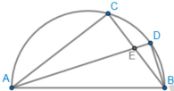
Q2 Geometry [4 points]
Consider right △ABC with ∠C = 90◦, AB = 10, and AC = 8. CP = CQ = 2. BQ and AP meet at R. CR meet AB at S. QP meet AB extension at T. Find TS.
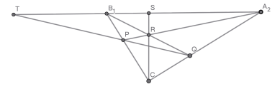
Derek
Q1 Combinatorics [4 points]
Ryan has three six-sided dice, one fair, one that rolls threes ⁶₇of the time, 1
and each of the other five sides equally with probability ¹₃₅ of the time, and one that rolls threes ²₇of the time, and each of the other five sides equally with probability ¹₇of the time. He selects one of the dice at random. The probability he rolls a three given the first two rolls are threes is ^{p}_{q}. What is the remainder when p + q is divided by 1000?
Q2 Number Theory [4 points]
For each integer n, 1 < n < 500, there exists a number that is divisible by all positive integers less than or equal to n except m and m + 1. Find the sum of all possible m.
Andy
Q1 Number Theory [4 points]
Let a and b be positive integers satisfying
lcm(a, b) − gcd(a, b) = 23
Find the sum of all possible values of a + b
Q2 Number Theory [4 points]
Let n be a positive integer. Find all sum of all possible values of gcd(5n + 11, n + 7)
2

