|  |  |  |
| --- | --- | --- |
| **Tools Project Design Document** | |  | | --- | | *11/19/2020*  Yohan Ma 1930014. | |

|  |  |  |  |
| --- | --- | --- | --- |
| **Project Concept** | | | |
| **1** **Intro** |  | You create or edit a   |  | | --- | | *Character stat sheet* | | in this   |  |  | | --- | --- | | *character editor* | tool | |
|  | where   |  | | --- | | *user* | | can   |  | | --- | | *modify existing character file with ease* | |

|  |  |  |  |  |  |  |
| --- | --- | --- | --- | --- | --- | --- |
| **2** **Who is it for?** |  | The tool is created for   |  |  | | --- | --- | | *Designers or QA Testers* | to | | create/edit   |  | | --- | | *character’s stat* | |
|  | and the goal of the tool is to   |  | | --- | | *Make many character template for testing different unit, building an army with different type of units.* | | |

|  |  |  |  |  |  |
| --- | --- | --- | --- | --- | --- |
| **3** **What game engine is it used for?** |  | The output can be used in   |  | | --- | | *Mount and Blade warband* | | and is used for   |  | | --- | | *Loading a character with custom stats* | |
|  | [*optional*] There will also be   |  | | --- | | *description of anything else that we may want to consider when using it in the game engine.* | | |

|  |  |  |  |  |  |
| --- | --- | --- | --- | --- | --- |
| **4** **File format**  **Technical Stack** |  | The tool export the data as,   |  | | --- | | *Text* | | and will be consumed with   |  | | --- | | *Character class* | |
|  | There will also be   |  | | --- | | *A library for character class in Mount and Blade* | | |

|  |  |  |  |  |  |  |  |
| --- | --- | --- | --- | --- | --- | --- | --- |
| **5** **User**  **Interface** |  | The tool has   |  | | --- | | *buttons and textboxes* | | that will   |  | | --- | | *Increase and decrease* | | to modify   |  | | --- | | *A character’s stats* | |
|  | When we export in the tool   |  |  | | --- | --- | | *Text* | will be generated | | | and we can use it for   |  | | --- | | *Importing back to the game* | |

|  |  |  |  |  |
| --- | --- | --- | --- | --- |
| **6** **Other Features** |  | |  | | --- | | *Give to the players as develop kit for making their custom units to build an army.* | |  | |

|  |  |  |  |  |
| --- | --- | --- | --- | --- |
| **7** **How much will you charge for it?** |  | |  | | --- | | *Free* | | *Are there other tools that exist that do what your tool is doing? Unity? Unreal? TexturePacker* | |

# **Project Timeline**

|  |  |  |
| --- | --- | --- |
| **Milestone** | **Description** | **Due** |
| **#1** | |  | | --- | | * *A Mount and Blade type character class library with serialize/deserialize functions.* | | |  | | --- | | *mm/dd* | |
| **#2** | |  | | --- | | * *A WPF project with save and load buttons and the ability to edit the characters.* | | |  | | --- | | *mm/dd* | |
| **#3** | |  | | --- | | *Build and test the app.* | | |  | | --- | | *mm/dd* | |
| **#4** | |  | | --- | | * *Functional feature(s) by milestone #4* | | |  | | --- | | *mm/dd* | |
| **#5** | |  | | --- | | * *Functional feature(s) by milestone #5* | | |  | | --- | | *mm/dd* | |
| **Backlog** | |  | | --- | | * *Feature on backlog - not a part of the minimum viable product* * *Feature on backlog - not a part of the minimum viable product* * *Feature on backlog - not a part of the minimum viable product* | | |  | | --- | | *mm/dd* | |

# **Project Sketch**

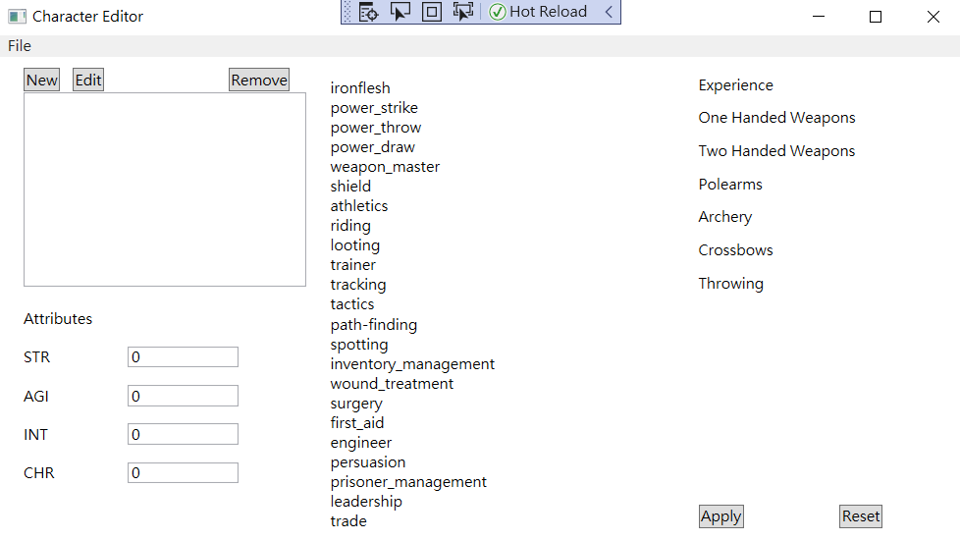

# **How to use / Instructions**

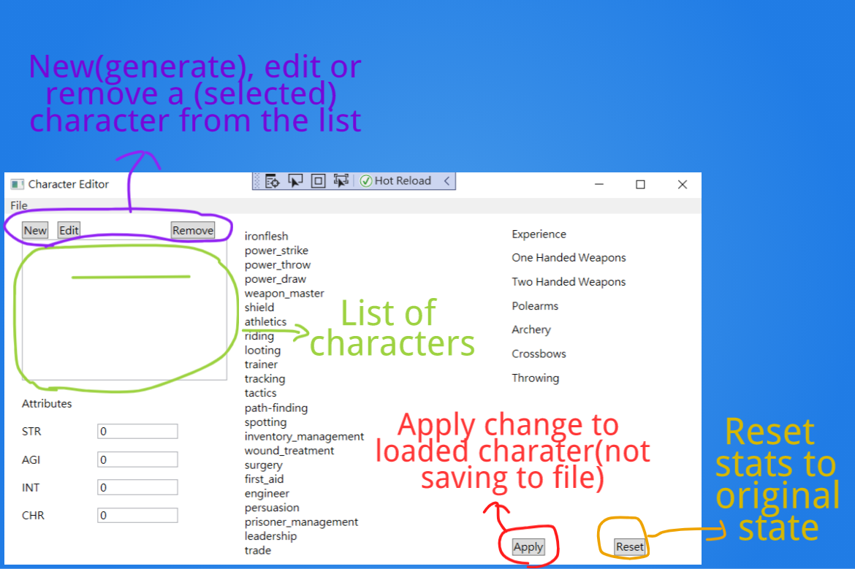

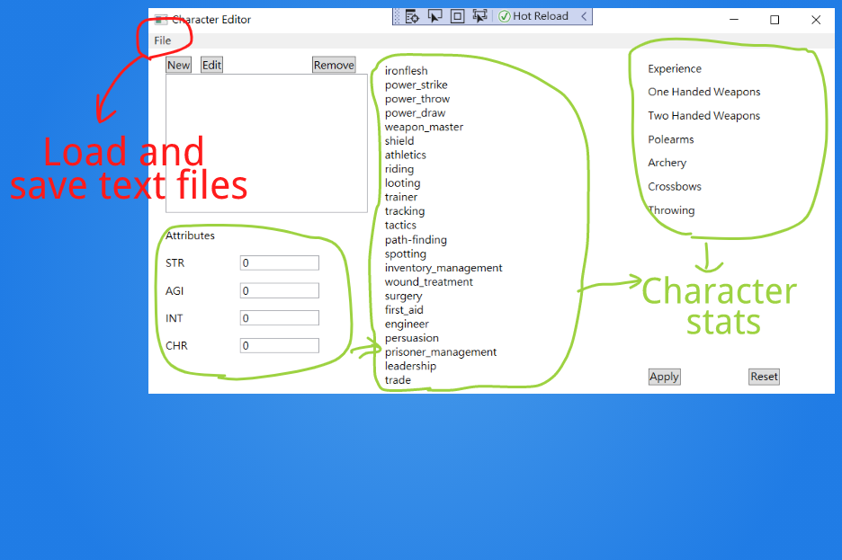

# 

Use the tool to edit the text format then import to the game.