Color Picker Challenge
Your task is to create a very basic color picker, from scratch, with no (related) dependencies, in whatever web framework you're most comfortable with.

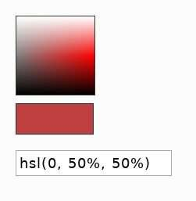
Example look
- Don't sweat the margins/typography, this is just a very quick, one possible rendering of the component.
- User should be able to pick any single color with the red hue.
- On pick, color must be shown in the hsl format as seen here:

Functionality
- A 101px * 101px "rainbow" colors box, which shows all of red's variations (Hue=0, changing this is out of scope) - Saturation goes from left to right, Lightness from bottom to top.
- Clicking any point in that box should update the preview swatch with the picked color
- The input box should also be updated accordingly
That's it. Do your best to provide all three before the deadline, and only if you're 100% positive you've covered them, start thinking of bonuses and extras.

Guidelines
As this exercise should be short , so you'd probably want to skip dev-env/cli stuff and work with codepen/codesandbox/whatever works quick for you.
Feel free to work with UI frameworks and generic utils. Please DO NOT bring or even look at any existing color related libraries or components, the idea is to come up with a solution on your own. Exception - If you feel you need to convert between color formats, do bring a readymade solution for that.

Clock starts ticking now. Good luck!

