Category Tree
Your goal is to create a category tree, with infinite depth. Something like this:
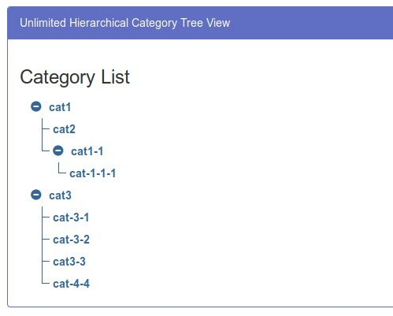
Your solution should include next features:
- Ability to add new subcategories for each category.
- Rename category.
- Delete category (if it has children - delete them as well).
- Expand/Collapse parent category (children categories should collapse too).
- Save (and Load) this tree in Firebase

As a bonus you can do any set of optional tasks, you’re free to add anything you can imagine. Some examples:
- Testing
- Typings
- Styling
- Build & Deploy configurations
- Create Multiple trees

You can use any technology, but don’t use any libraries that are implementing trees for you. Create a project from scratch.

