UI Exercise

The UI enables users to work with remote mobile devices kept at the labs. The devices are shared between users and so there’s a requirement to allow users to reserve a device for a later time as well as allow them to open a device if it is not being used at the moment.

The PM has defined the following screens to be implemented:

Devices:

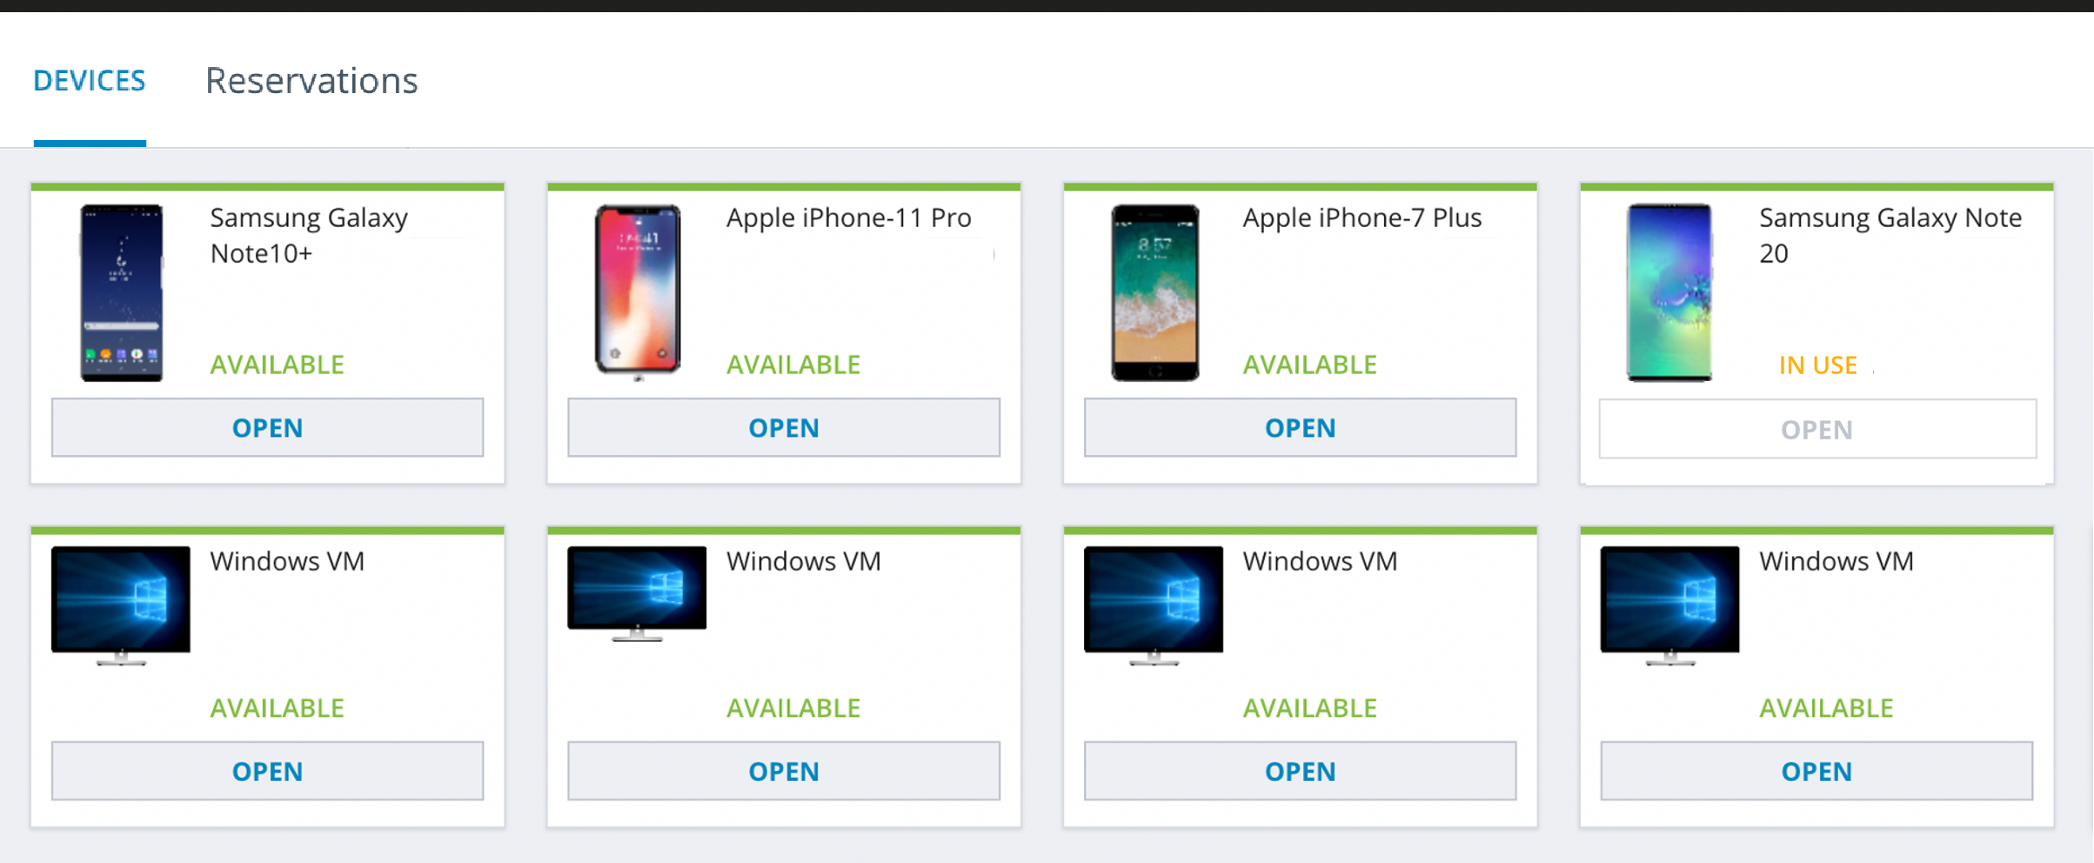

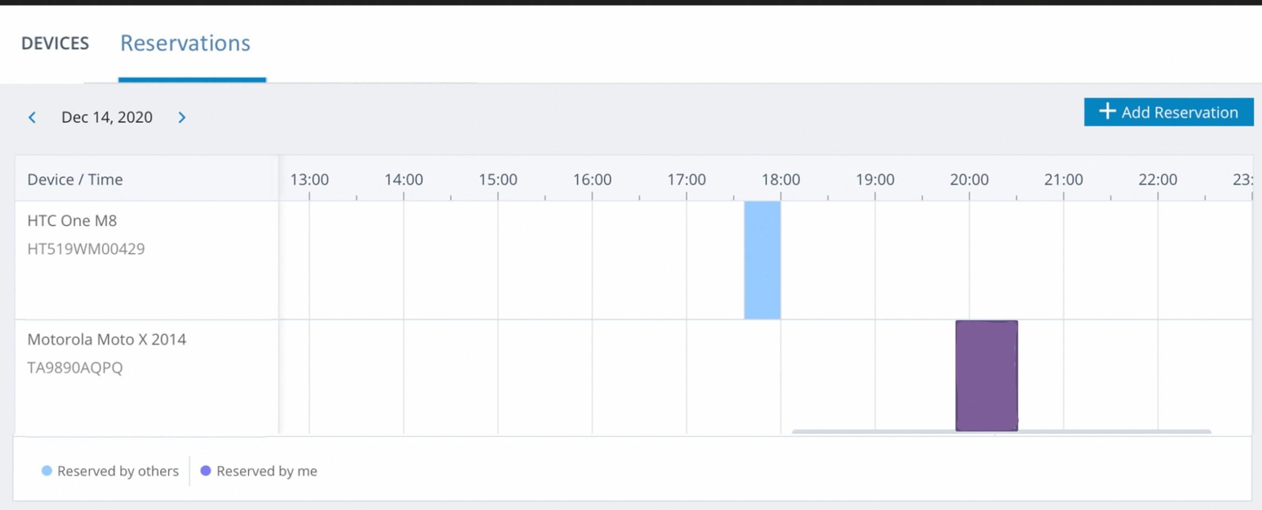Here the user can see the list of devices and the current availability of each. Reservations:

When a user logs in he sees the Reservations for the current date – his and those of other users. If there are no reservations the grid is empty. Changing the arrows on the top left changes the date and fetches the relevant reservations.

When clicking on “Add Reservations” first the following screen/dialog should appear allowing the user to select the desired device from all the devices:

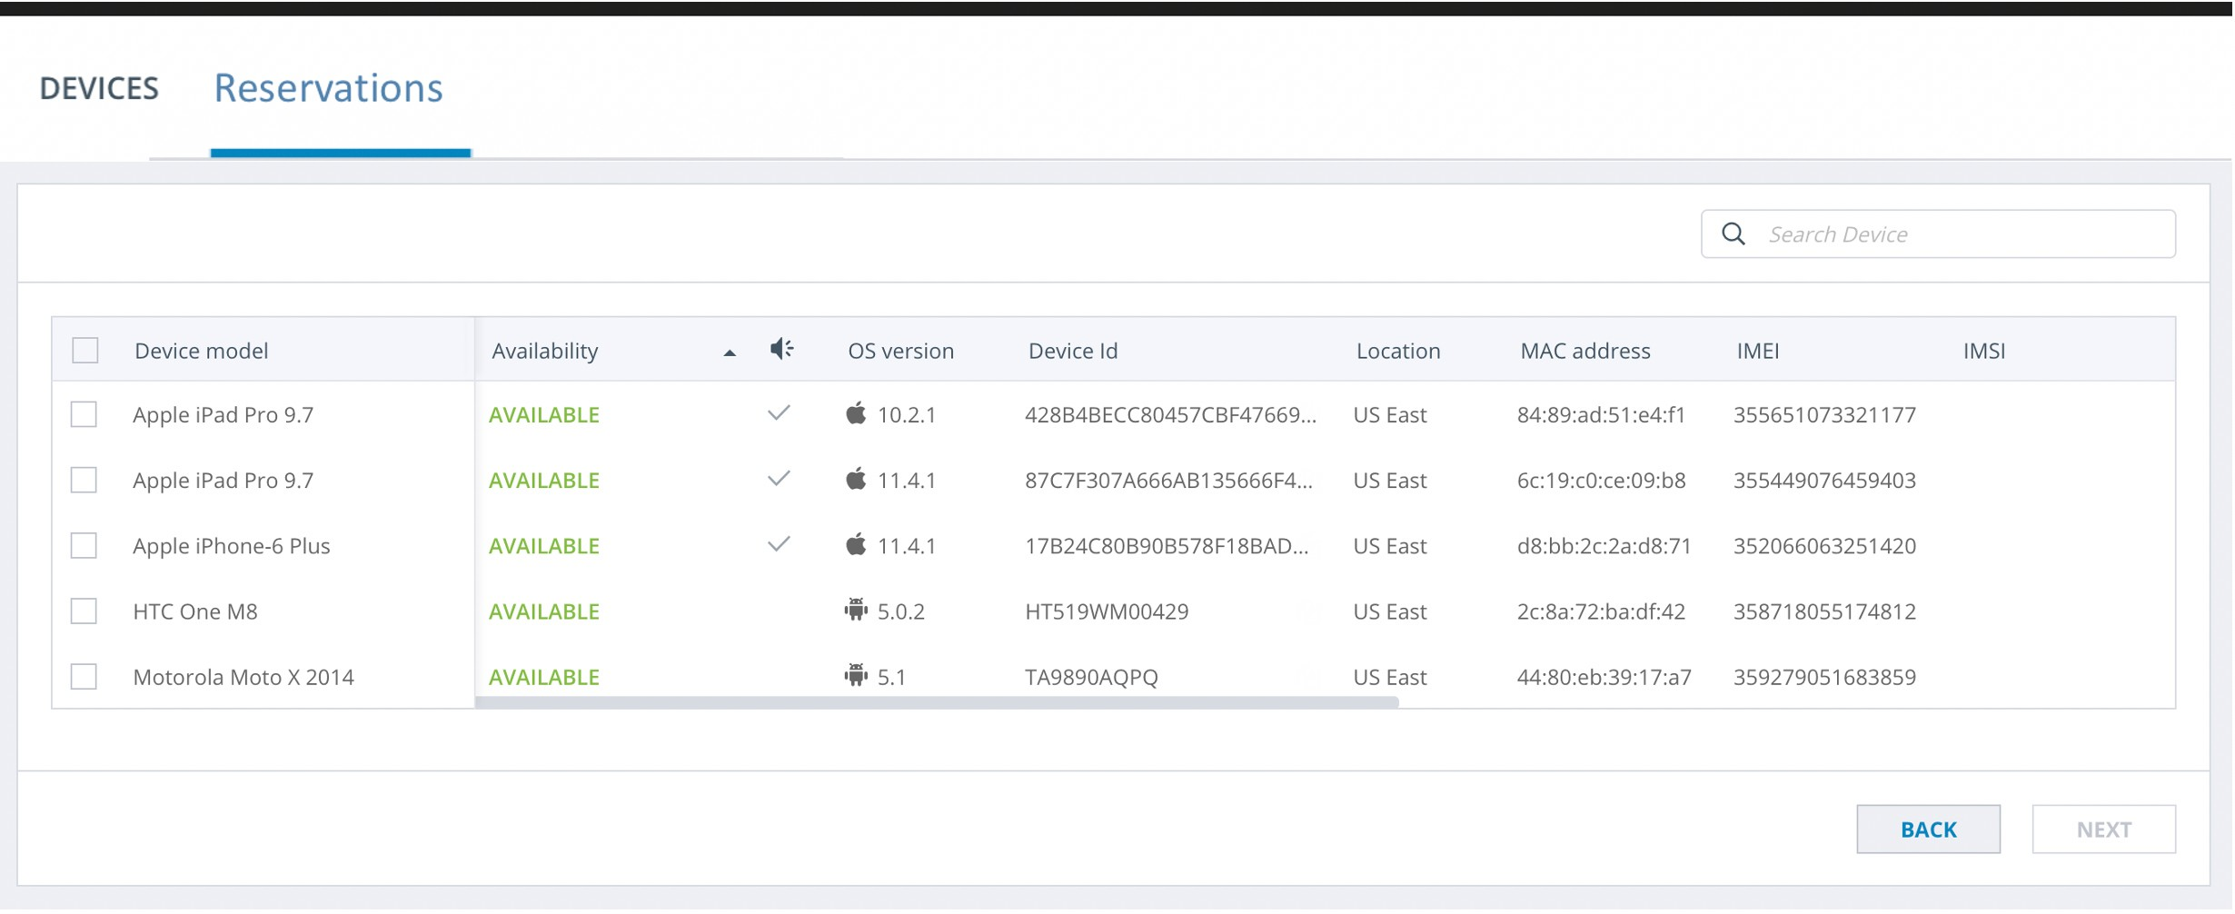

Clicking “Next” goes to the following where the user can select the desired time and duration of the reservation:

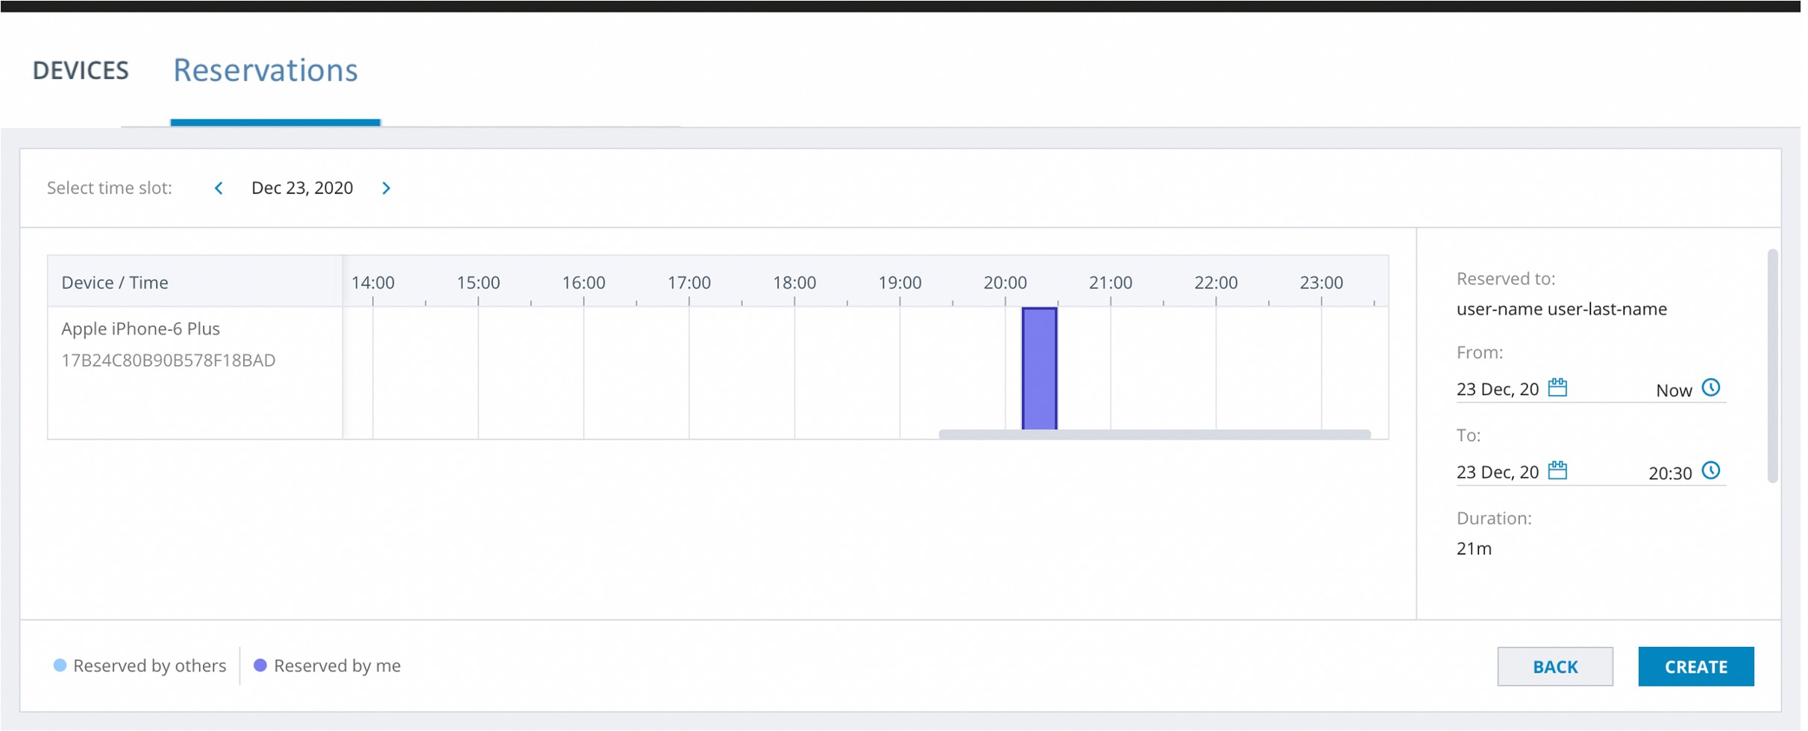

Clicking “Create” here closes the screen/dialog and returns to the reservation view showing the newly created reservation.

Questions (you may answer in any order you wish):

* What API would you require from the server?
* What state does the app has to maintain?

How would you implement it?

* What components will you need to implement the second image?

How would you implement the Reservations part?

* What will you test in the app?

How would you test it?