Category Tree

Your goal is to create a category tree, with infinite depth. Something like this:

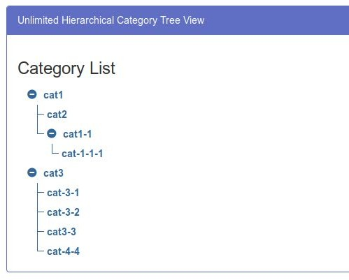

Your solution should include next features:

* Ability to add new subcategories for each category.
* Rename category.
* Delete category (if it has children - delete them as well).
* Expand/Collapse parent category (children categories should collapse too).
* Save (and Load) this tree in [Firebase](https://firebase.google.com/)

As a bonus you can do any set of optional tasks, you’re free to add anything you can imagine. Some examples:

* Testing
* Typings
* Styling
* Build & Deploy configurations
* Create Multiple trees

You can use any technology, but don’t use any libraries that are implementing trees for you. Create a project from scratch.