Московский государственный технический
университет им. Н.Э. Баумана

Факультет Информатика и системы управления
Кафедра ИУ5 «Системы обработки информации и управления»

Дисциплина «Парадигмы и конструкции языков программирования»

Отчет по лр1

Выполнил: |  | Проверил:
студент группы ИУ5-31Б: |  | преподаватель каф.ИУ5
Есакова О. А. |  | Гапанюк Ю. Е.
Подпись и дата: |  | Подпись и дата:

Москва, 2025 г.
Организация файлов:
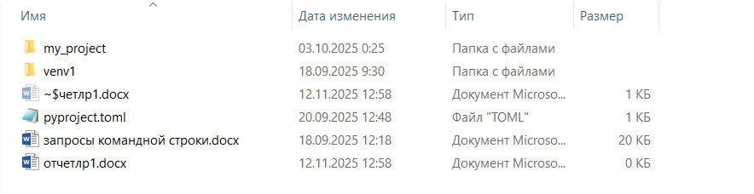
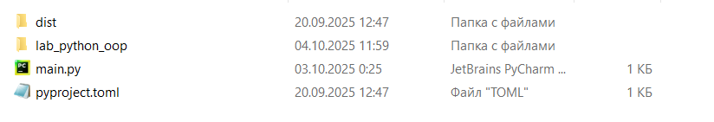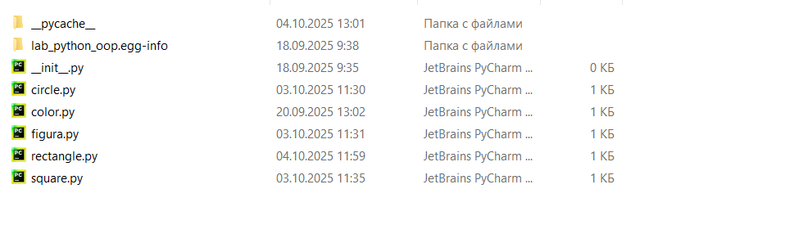
Файл main.py
from lab_python_oop.rectangle import Rectangle
from lab_python_oop.circle import Circle
from lab_python_oop.square import Square
import numpy as np
def main():
N = 5
rect = Rectangle(width=N, height=2, color='синий')
circle = Circle(radius=N, color='зеленый')
square = Square(side=N, color='красный')
print(rect)
print(circle)
print(square)
if __name__ == "__main__":
main()
array = np.array([1, 2, 3, 4, 5])
print("массив с использованием метода внешнего пакета, установленного с использованием pip:", array)

Файл _unit_.py
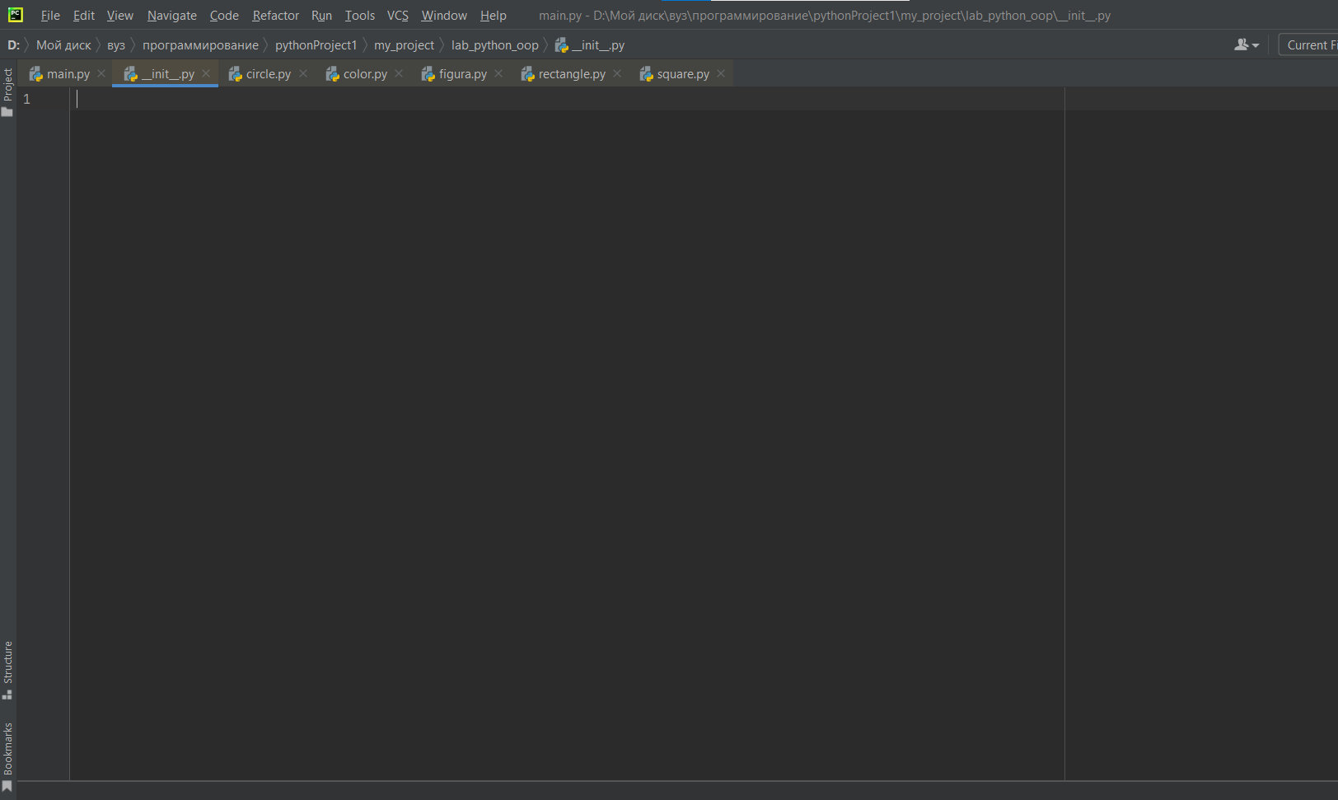
Файл circle.py
import math
from lab_python_oop.figura import GeometricFigure
from lab_python_oop.color import ColorFigure
class Circle(GeometricFigure):
def __init__(self, radius, color):
self.radius = radius
self.color_obj = ColorFigure(color)
@classmethod
def get_name(cls):
return "Круг"
def area(self):
return math.pi * self.radius ** 2
# def __str__(self):
# return (f"{self.get_name()}: радиус={self.radius}, цвет={self.color_obj.color}, "
# f"площадь={self.area():.2f}")
def __str__(self):
return "{}: радиус={}, цвет={}, площадь={:.2f}".format(
self.get_name(),
self.radius,
self.color_obj.color,
self.area()
)

Файл color.py
class ColorFigure:
def __init__(self, color): #свойство для описания цвета геометрической фигуры
self._color = color
@property
def color(self):
return self._color

Файл figura.py
from abc import ABC, abstractmethod
class GeometricFigure(ABC):
@abstractmethod
def area(self):
pass
@classmethod
@abstractmethod
def get_name(cls):
pass
# def __str__(self):
# return f"{self.get_name()}: площадь={self.area():.2f}"
def __str__(self):
return "{}: площадь={:.2f}".format(self.get_name(), self.area())

Файл rectangle.py
from lab_python_oop.figura import GeometricFigure
from lab_python_oop.color import ColorFigure
class Rectangle(GeometricFigure):
def __init__(self, width, height, color):
self.width = width
self.height = height
self.color_obj = ColorFigure(color)
@classmethod
def get_name(cls):
return "Прямоугольник"
def area(self):
return self.width * self.height
# def __str__(self):
# return (f"{self.get_name()}: ширина={self.width}, высота={self.height}, "
# f"цвет={self.color_obj.color}, площадь={self.area():.2f}")
def __str__(self):
return "{}: ширина={}, высота={}, цвет={}, площадь={:.2f}".format(
self.get_name(),
self.width,
self.height,
self.color_obj.color,
self.area()
)

Файл square.py
from lab_python_oop.figura import GeometricFigure
from lab_python_oop.color import ColorFigure
class Rectangle(GeometricFigure):
def __init__(self, width, height, color):
self.width = width
self.height = height
self.color_obj = ColorFigure(color)
@classmethod
def get_name(cls):
return "Прямоугольник"
def area(self):
return self.width * self.height
# def __str__(self):
# return (f"{self.get_name()}: ширина={self.width}, высота={self.height}, "
# f"цвет={self.color_obj.color}, площадь={self.area():.2f}")
def __str__(self):
return "{}: ширина={}, высота={}, цвет={}, площадь={:.2f}".format(
self.get_name(),
self.width,
self.height,
self.color_obj.color,
self.area()
)

Файл pyproject.toml
[build-system]
requires = ["setuptools", "wheel"]
build-backend = "setuptools.build_meta"

[project]
name = "lab_python_oop"
version = "0.1.0"
description = "Пакет с геометрическими фигурами и цветами"
authors = [{ name = "Ваше Имя", email = "email@example.com" }]
dependencies = []

[tool.setuptools.packages.find]
where = ["lab_python_oop"]

Запросы командной строки:
Microsoft Windows [Version 10.0.19045.6093]
(c) Корпорация Майкрософт (Microsoft Corporation). Все права защищены.

C:\Users\User>D:

D:\>D:\Мой диск\вуз\программирование
"D:\Мой" не является внутренней или внешней
командой, исполняемой программой или пакетным файлом.

D:\>cd D:\Мой диск\вуз\программирование

D:\Мой диск\вуз\программирование>cd pythonProject1

D:\Мой диск\вуз\программирование\pythonProject1>python -m venv .\venv1

D:\Мой диск\вуз\программирование\pythonProject1>dir .\venv1
Том в устройстве D имеет метку Data
Серийный номер тома: FE93-6443

Содержимое папки D:\Мой диск\вуз\программирование\pythonProject1\venv1

18.09.2025 09:30 <DIR> .
18.09.2025 09:30 <DIR> ..
18.09.2025 09:30 71 .gitignore
18.09.2025 09:30 <DIR> Include
18.09.2025 09:30 <DIR> Lib
18.09.2025 09:30 361 pyvenv.cfg
18.09.2025 09:30 <DIR> Scripts
2 файлов 432 байт
5 папок 221 670 715 392 байт свободно

D:\Мой диск\вуз\программирование\pythonProject1>cd venv1\scripts

D:\Мой диск\вуз\программирование\pythonProject1\venv1\Scripts>activate.bat

(venv1) D:\Мой диск\вуз\программирование\pythonProject1\venv1\Scripts>pip --help

Usage:
pip <command> [options]

Commands:
install Install packages.
lock Generate a lock file.
download Download packages.
uninstall Uninstall packages.
freeze Output installed packages in requirements format.
inspect Inspect the python environment.
list List installed packages.
show Show information about installed packages.
check Verify installed packages have compatible dependencies.
config Manage local and global configuration.
search Search PyPI for packages.
cache Inspect and manage pip's wheel cache.
index Inspect information available from package indexes.
wheel Build wheels from your requirements.
hash Compute hashes of package archives.
completion A helper command used for command completion.
debug Show information useful for debugging.
help Show help for commands.

General Options:
-h, --help Show help.
--debug Let unhandled exceptions propagate outside the main subroutine, instead
of logging them to stderr.
--isolated Run pip in an isolated mode, ignoring environment variables and user
configuration.
--require-virtualenv Allow pip to only run in a virtual environment; exit with an error
otherwise.
--python <python> Run pip with the specified Python interpreter.
-v, --verbose Give more output. Option is additive, and can be used up to 3 times.
-V, --version Show version and exit.
-q, --quiet Give less output. Option is additive, and can be used up to 3 times
(corresponding to WARNING, ERROR, and CRITICAL logging levels).
--log <path> Path to a verbose appending log.
--no-input Disable prompting for input.
--keyring-provider <keyring_provider>
Enable the credential lookup via the keyring library if user input is
allowed. Specify which mechanism to use [auto, disabled, import,
subprocess]. (default: auto)
--proxy <proxy> Specify a proxy in the form scheme://[user:passwd@]proxy.server:port.
--retries <retries> Maximum attempts to establish a new HTTP connection. (default: 5)
--timeout <sec> Set the socket timeout (default 15 seconds).
--exists-action <action> Default action when a path already exists: (s)witch, (i)gnore, (w)ipe,
(b)ackup, (a)bort.
--trusted-host <hostname> Mark this host or host:port pair as trusted, even though it does not
have valid or any HTTPS.
--cert <path> Path to PEM-encoded CA certificate bundle. If provided, overrides the
default. See 'SSL Certificate Verification' in pip documentation for
more information.
--client-cert <path> Path to SSL client certificate, a single file containing the private key
and the certificate in PEM format.
--cache-dir <dir> Store the cache data in <dir>.
--no-cache-dir Disable the cache.
--disable-pip-version-check
Don't periodically check PyPI to determine whether a new version of pip
is available for download. Implied with --no-index.
--no-color Suppress colored output.
--use-feature <feature> Enable new functionality, that may be backward incompatible.
--use-deprecated <feature> Enable deprecated functionality, that will be removed in the future.
--resume-retries <resume_retries>
Maximum attempts to resume or restart an incomplete download. (default:
5)

(venv1) D:\Мой диск\вуз\программирование\pythonProject1\venv1\Scripts>pip list
Package Version
------- -------
pip 25.2

(venv1) D:\Мой диск\вуз\программирование\pythonProject1\venv1\Scripts>python.exe -m pip install --upgrade pip
Requirement already satisfied: pip in d:\мой диск\вуз\программирование\pythonproject1\venv1\lib\site-packages (25.2)

(venv1) D:\Мой диск\вуз\программирование\pythonProject1\venv1\Scripts>D:

(venv1) D:\Мой диск\вуз\программирование\pythonProject1\venv1\Scripts>cd D:
D:\Мой диск\вуз\программирование\pythonProject1\venv1\Scripts

(venv1) D:\Мой диск\вуз\программирование\pythonProject1\venv1\Scripts>cd D:\Мой диск\вуз\программирование

(venv1) D:\Мой диск\вуз\программирование>cd pythonProject1

(venv1) D:\Мой диск\вуз\программирование\pythonProject1>pip install numpy
Collecting numpy
Using cached numpy-2.3.3-cp313-cp313-win_amd64.whl.metadata (60 kB)
Using cached numpy-2.3.3-cp313-cp313-win_amd64.whl (12.8 MB)
Installing collected packages: numpy
Successfully installed numpy-2.3.3

(venv1) D:\Мой диск\вуз\программирование\pythonProject1>notepad pyproject.toml

(venv1) D:\Мой диск\вуз\программирование\pythonProject1>pip install --upgrade pip setuptools wheel build
Requirement already satisfied: pip in d:\мой диск\вуз\программирование\pythonproject1\venv1\lib\site-packages (25.2)
Collecting setuptools
Using cached setuptools-80.9.0-py3-none-any.whl.metadata (6.6 kB)
Collecting wheel
Using cached wheel-0.45.1-py3-none-any.whl.metadata (2.3 kB)
Collecting build
Using cached build-1.3.0-py3-none-any.whl.metadata (5.6 kB)
Collecting packaging>=19.1 (from build)
Using cached packaging-25.0-py3-none-any.whl.metadata (3.3 kB)
Collecting pyproject_hooks (from build)
Using cached pyproject_hooks-1.2.0-py3-none-any.whl.metadata (1.3 kB)
Collecting colorama (from build)
Using cached colorama-0.4.6-py2.py3-none-any.whl.metadata (17 kB)
Using cached setuptools-80.9.0-py3-none-any.whl (1.2 MB)
Using cached wheel-0.45.1-py3-none-any.whl (72 kB)
Using cached build-1.3.0-py3-none-any.whl (23 kB)
Using cached packaging-25.0-py3-none-any.whl (66 kB)
Using cached colorama-0.4.6-py2.py3-none-any.whl (25 kB)
Using cached pyproject_hooks-1.2.0-py3-none-any.whl (10 kB)
Installing collected packages: wheel, setuptools, pyproject_hooks, packaging, colorama, build
Successfully installed build-1.3.0 colorama-0.4.6 packaging-25.0 pyproject_hooks-1.2.0 setuptools-80.9.0 wheel-0.45.1

(venv1) D:\Мой диск\вуз\программирование\pythonProject1>python -m build
* Creating isolated environment: venv+pip...
* Installing packages in isolated environment:
- setuptools
- wheel
* Getting build dependencies for sdist...
running egg_info
error: error in 'egg_base' option: 'my_package' does not exist or is not a directory

ERROR Backend subprocess exited when trying to invoke get_requires_for_build_sdist

(venv1) D:\Мой диск\вуз\программирование\pythonProject1>mkdir my_project

(venv1) D:\Мой диск\вуз\программирование\pythonProject1>cd my_project

(venv1) D:\Мой диск\вуз\программирование\pythonProject1\my_project>mkdir my_package

(venv1) D:\Мой диск\вуз\программирование\pythonProject1\my_project>type nul > my_package\__init__.py

(venv1) D:\Мой диск\вуз\программирование\pythonProject1\my_project>type nul > my_package\circle.py

(venv1) D:\Мой диск\вуз\программирование\pythonProject1\my_project>type nul > my_package\color.py

(venv1) D:\Мой диск\вуз\программирование\pythonProject1\my_project>type nul > my_package\figura.py

(venv1) D:\Мой диск\вуз\программирование\pythonProject1\my_project>type nul > my_package\geometry.py

(venv1) D:\Мой диск\вуз\программирование\pythonProject1\my_project>type nul > my_package\rectangle.py

(venv1) D:\Мой диск\вуз\программирование\pythonProject1\my_project>type nul > my_package\square.py

(venv1) D:\Мой диск\вуз\программирование\pythonProject1\my_project>type nul > main.py

(venv1) D:\Мой диск\вуз\программирование\pythonProject1\my_project>pip install --upgrade build
Requirement already satisfied: build in d:\мой диск\вуз\программирование\pythonproject1\venv1\lib\site-packages (1.3.0)
Requirement already satisfied: packaging>=19.1 in d:\мой диск\вуз\программирование\pythonproject1\venv1\lib\site-packages (from build) (25.0)
Requirement already satisfied: pyproject_hooks in d:\мой диск\вуз\программирование\pythonproject1\venv1\lib\site-packages (from build) (1.2.0)
Requirement already satisfied: colorama in d:\мой диск\вуз\программирование\pythonproject1\venv1\lib\site-packages (from build) (0.4.6)

(venv1) D:\Мой диск\вуз\программирование\pythonProject1\my_project>python -m build
* Creating isolated environment: venv+pip...
* Installing packages in isolated environment:
- setuptools
- wheel
* Getting build dependencies for sdist...
running egg_info
creating my_package\my_package.egg-info
writing my_package\my_package.egg-info\PKG-INFO
writing dependency_links to my_package\my_package.egg-info\dependency_links.txt
writing top-level names to my_package\my_package.egg-info\top_level.txt
writing manifest file 'my_package\my_package.egg-info\SOURCES.txt'
reading manifest file 'my_package\my_package.egg-info\SOURCES.txt'
writing manifest file 'my_package\my_package.egg-info\SOURCES.txt'
* Building sdist...
running sdist
running egg_info
writing my_package\my_package.egg-info\PKG-INFO
writing dependency_links to my_package\my_package.egg-info\dependency_links.txt
writing top-level names to my_package\my_package.egg-info\top_level.txt
reading manifest file 'my_package\my_package.egg-info\SOURCES.txt'
writing manifest file 'my_package\my_package.egg-info\SOURCES.txt'
warning: sdist: standard file not found: should have one of README, README.rst, README.txt, README.md

running check
creating my_package-0.1.0
creating my_package-0.1.0\my_package\my_package.egg-info
copying files to my_package-0.1.0...
copying pyproject.toml -> my_package-0.1.0
copying my_package\my_package.egg-info\PKG-INFO -> my_package-0.1.0\my_package\my_package.egg-info
copying my_package\my_package.egg-info\SOURCES.txt -> my_package-0.1.0\my_package\my_package.egg-info
copying my_package\my_package.egg-info\dependency_links.txt -> my_package-0.1.0\my_package\my_package.egg-info
copying my_package\my_package.egg-info\top_level.txt -> my_package-0.1.0\my_package\my_package.egg-info
copying my_package\my_package.egg-info\SOURCES.txt -> my_package-0.1.0\my_package\my_package.egg-info
Writing my_package-0.1.0\setup.cfg
Creating tar archive
removing 'my_package-0.1.0' (and everything under it)
* Building wheel from sdist
* Creating isolated environment: venv+pip...
* Installing packages in isolated environment:
- setuptools
- wheel
* Getting build dependencies for wheel...
running egg_info
writing my_package\my_package.egg-info\PKG-INFO
writing dependency_links to my_package\my_package.egg-info\dependency_links.txt
writing top-level names to my_package\my_package.egg-info\top_level.txt
reading manifest file 'my_package\my_package.egg-info\SOURCES.txt'
writing manifest file 'my_package\my_package.egg-info\SOURCES.txt'
* Building wheel...
running bdist_wheel
running build
installing to build\bdist.win-amd64\wheel
running install
running install_egg_info
running egg_info
writing my_package\my_package.egg-info\PKG-INFO
writing dependency_links to my_package\my_package.egg-info\dependency_links.txt
writing top-level names to my_package\my_package.egg-info\top_level.txt
reading manifest file 'my_package\my_package.egg-info\SOURCES.txt'
writing manifest file 'my_package\my_package.egg-info\SOURCES.txt'
Copying my_package\my_package.egg-info to build\bdist.win-amd64\wheel\.\my_package-0.1.0-py3.13.egg-info
running install_scripts
creating build\bdist.win-amd64\wheel\my_package-0.1.0.dist-info\WHEEL
creating 'D:\Мой диск\вуз\программирование\pythonProject1\my_project\dist\.tmp-vlrpev5y\my_package-0.1.0-py3-none-any.whl' and adding 'build\bdist.win-amd64\wheel' to it
adding 'my_package-0.1.0.dist-info/METADATA'
adding 'my_package-0.1.0.dist-info/WHEEL'
adding 'my_package-0.1.0.dist-info/top_level.txt'
adding 'my_package-0.1.0.dist-info/RECORD'
removing build\bdist.win-amd64\wheel
Successfully built my_package-0.1.0.tar.gz and my_package-0.1.0-py3-none-any.whl

(venv1) D:\Мой диск\вуз\программирование\pythonProject1\my_project>pip install dist/my_package-0.1.0-py3-none-any.whl
Processing d:\мой диск\вуз\программирование\pythonproject1\my_project\dist\my_package-0.1.0-py3-none-any.whl
Installing collected packages: my-package
Successfully installed my-package-0.1.0

(venv1) D:\Мой диск\вуз\программирование\pythonProject1\my_project>python -m build
* Creating isolated environment: venv+pip...
* Installing packages in isolated environment:
- setuptools
- wheel
* Getting build dependencies for sdist...
running egg_info
writing my_package\my_package.egg-info\PKG-INFO
writing dependency_links to my_package\my_package.egg-info\dependency_links.txt
writing top-level names to my_package\my_package.egg-info\top_level.txt
reading manifest file 'my_package\my_package.egg-info\SOURCES.txt'
writing manifest file 'my_package\my_package.egg-info\SOURCES.txt'
* Building sdist...
running sdist
running egg_info
writing my_package\my_package.egg-info\PKG-INFO
writing dependency_links to my_package\my_package.egg-info\dependency_links.txt
writing top-level names to my_package\my_package.egg-info\top_level.txt
reading manifest file 'my_package\my_package.egg-info\SOURCES.txt'
writing manifest file 'my_package\my_package.egg-info\SOURCES.txt'
warning: sdist: standard file not found: should have one of README, README.rst, README.txt, README.md

running check
creating my_package-0.1.0
creating my_package-0.1.0\my_package\my_package.egg-info
copying files to my_package-0.1.0...
copying pyproject.toml -> my_package-0.1.0
copying my_package\my_package.egg-info\PKG-INFO -> my_package-0.1.0\my_package\my_package.egg-info
copying my_package\my_package.egg-info\SOURCES.txt -> my_package-0.1.0\my_package\my_package.egg-info
copying my_package\my_package.egg-info\dependency_links.txt -> my_package-0.1.0\my_package\my_package.egg-info
copying my_package\my_package.egg-info\top_level.txt -> my_package-0.1.0\my_package\my_package.egg-info
copying my_package\my_package.egg-info\SOURCES.txt -> my_package-0.1.0\my_package\my_package.egg-info
Writing my_package-0.1.0\setup.cfg
Creating tar archive
removing 'my_package-0.1.0' (and everything under it)
* Building wheel from sdist
* Creating isolated environment: venv+pip...
* Installing packages in isolated environment:
- setuptools
- wheel
* Getting build dependencies for wheel...
running egg_info
writing my_package\my_package.egg-info\PKG-INFO
writing dependency_links to my_package\my_package.egg-info\dependency_links.txt
writing top-level names to my_package\my_package.egg-info\top_level.txt
reading manifest file 'my_package\my_package.egg-info\SOURCES.txt'
writing manifest file 'my_package\my_package.egg-info\SOURCES.txt'
* Building wheel...
running bdist_wheel
running build
installing to build\bdist.win-amd64\wheel
running install
running install_egg_info
running egg_info
writing my_package\my_package.egg-info\PKG-INFO
writing dependency_links to my_package\my_package.egg-info\dependency_links.txt
writing top-level names to my_package\my_package.egg-info\top_level.txt
reading manifest file 'my_package\my_package.egg-info\SOURCES.txt'
writing manifest file 'my_package\my_package.egg-info\SOURCES.txt'
Copying my_package\my_package.egg-info to build\bdist.win-amd64\wheel\.\my_package-0.1.0-py3.13.egg-info
running install_scripts
creating build\bdist.win-amd64\wheel\my_package-0.1.0.dist-info\WHEEL
creating 'D:\Мой диск\вуз\программирование\pythonProject1\my_project\dist\.tmp-dcysirfn\my_package-0.1.0-py3-none-any.whl' and adding 'build\bdist.win-amd64\wheel' to it
adding 'my_package-0.1.0.dist-info/METADATA'
adding 'my_package-0.1.0.dist-info/WHEEL'
adding 'my_package-0.1.0.dist-info/top_level.txt'
adding 'my_package-0.1.0.dist-info/RECORD'
removing build\bdist.win-amd64\wheel
Successfully built my_package-0.1.0.tar.gz and my_package-0.1.0-py3-none-any.whl

(venv1) D:\Мой диск\вуз\программирование\pythonProject1\my_project>dir my_package
Том в устройстве D имеет метку Data
Серийный номер тома: FE93-6443

Содержимое папки D:\Мой диск\вуз\программирование\pythonProject1\my_project\my_package

18.09.2025 09:44 <DIR> .
18.09.2025 09:44 <DIR> ..
18.09.2025 09:43 638 circle.py
18.09.2025 09:43 142 color.py
18.09.2025 09:43 421 figura.py
18.09.2025 09:43 1 683 geometry.py
18.09.2025 09:38 <DIR> my_package.egg-info
18.09.2025 09:44 781 rectangle.py
18.09.2025 09:44 933 square.py
18.09.2025 09:35 0 __init__.py
18.09.2025 09:44 <DIR> __pycache__
7 файлов 4 598 байт
4 папок 221 599 113 216 байт свободно

(venv1) D:\Мой диск\вуз\программирование\pythonProject1\my_project>

