Solar Team 2023 – automatic transfer switch for solar system

As a part of this project’s tasks, Solar team had to come up with a solution for switching between solar energy and public power. A good solution would be helpful for us (meaning we don’t have to switch manually) and for the battery to not let it run out, and therefore to extend battery life.

After research, we found automatic transfer switch (ATS) that was purchased on this website: <https://www.solariss.sk/Automaticky-prepinac-medzi-solarnym-syst-d11.htm?tab=description#anch1>

The transfer switch is MOES Dual Power Controller for off grid Solar and Wind systems for both 110V and 220V input voltage and with the ability to distinguish input voltage itself. Transfer time is less than 16 milliseconds. This ATS is commonly used in RV (recreational vehicle) community and therefore seemed like a good solution for our relatively small system. The scheme of ATS itself, connections and how it works is displayed on pictures below:

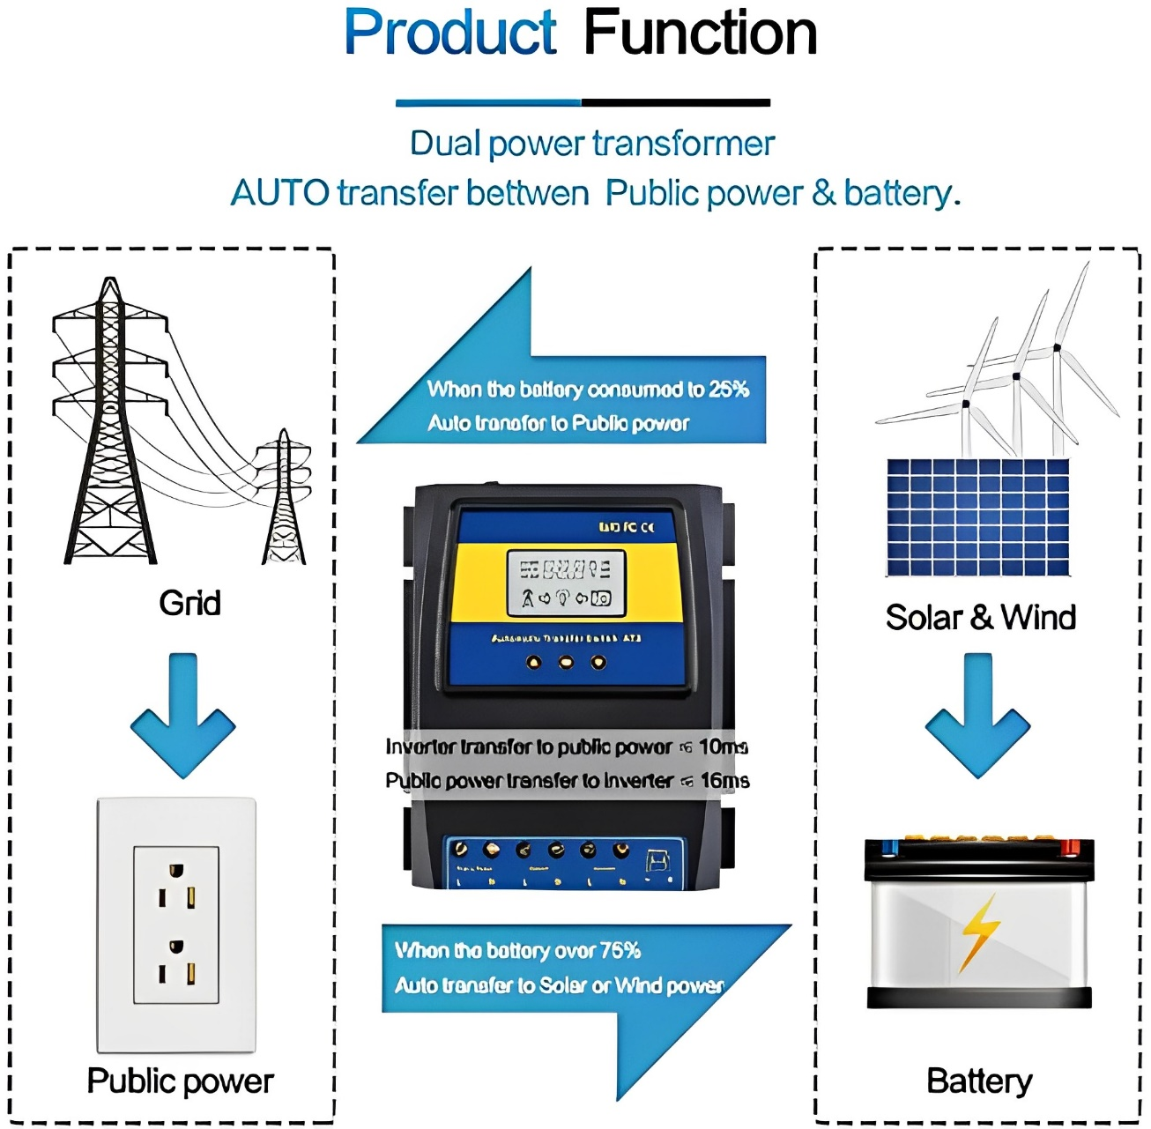

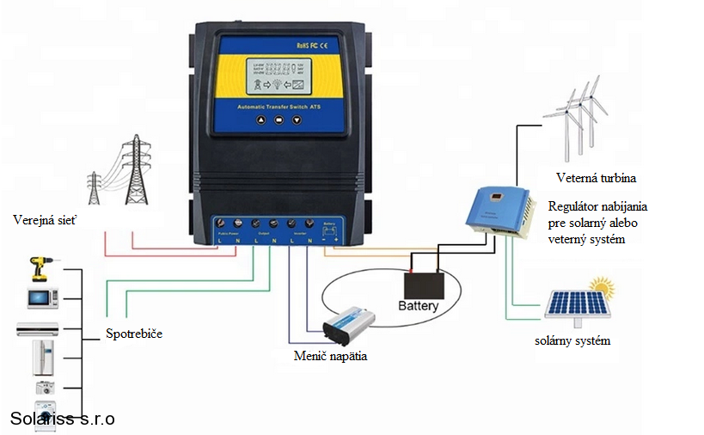

As we can see, ATS has three buttons. If we hold the middle button, we can access setting of values when should the ATS switch from one power to another. Our battery, zero percent charged, has 11.34V and fully charged 13.16V. That means the whole span of 100% battery is 1.82V, meaning one percent is 0.0182V. 25% in this case then equals 0.455V and that is 11.795V for our battery at 25%. As the ATS allows us to set values with only one decimal point, we set the point for transferring from solar power to public power at 11.8V (slightly more than 25%). For setting these values we use other two buttons on the ATS, one meaning +0.1V and another -0.1V. The value for transferring from public power to solar power was calculated similarly. One percent of the battery is 0.0182V, therefore 75% means 1.365V, which is 12.705V for our battery. And so, this value was set as 12.7V (slightly less than 75%).

Right now, it works as follows: We have our battery at 50% capacity (app. 12.2V) and we use solar power. But it is night and so the battery isn’t being charged. Once it reaches 11.8V (slightly more than 25% of battery’s capacity), the ATS switches to public power. Then in the morning, the battery starts to charge. While it charges, we use public power. Once the battery reaches 12.7V (slightly less than 75%), the ATS switches back to solar power and uses this energy.

These transfer values are set to extend the battery’s life. To not let it be fully charged for a long time, but more importantly to not let it run out. These values can be changed as described in this document. However, we don’t recommend setting the low value any lower, to not burden the battery.