Obrázok, na ktorom je diagram, schematický

Automaticky generovaný popis**EASYEDA - VESNA**

* The UART interface consists of two pins: the Rx and Tx pin. The Rx pin is used to receive data. The Tx pin is used to transmit data. When two devices are connected using a UART, the Rx pin of one device is connected to the Tx pin of the second device.
* 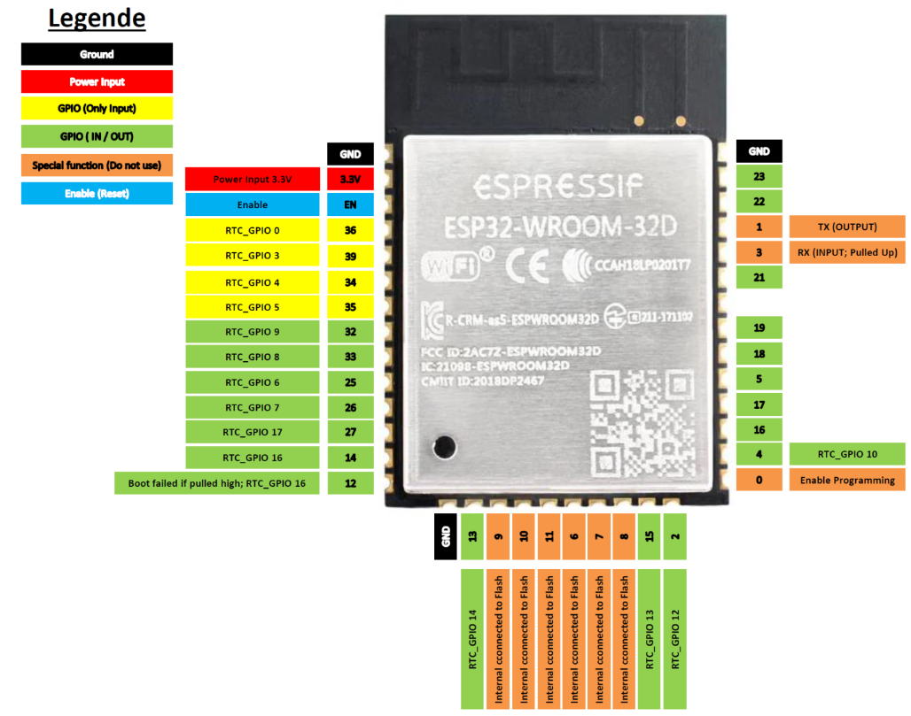
* Connect the USB to UART Converter to RX, TX and ground. RX and TX should be crossed. This mean RX from the USB to UART Converter should connect to TX from the ESP 32 and TX from the USB to UART Converter should connect to RX from the ESP 32.
* **Do not connect anything to GPIO 6, 7, 8, 9, 10 and 11. They are connected to the internal flash. The ESP 32 cannot communicate with the flash if something is connected.**
* **GPIO 12 should not be pulled high at boot. Otherwise the ESP 32 cannot start correctly.**
* **GPIO 0 should be pulled low for programming. This GPIO is internally pulled high.**
* **GPIO 1 and 3 are used for programming and debugging.**
* Obrázok, na ktorom je tabuľka

  Automaticky generovaný popis Obrázok, na ktorom je tabuľka

  Automaticky generovaný popis
* **Q = CU** P: U1=U2, Q = Q1+Q2 S: Q1 = Q2, U = U1+U2
* Obrázok, na ktorom je text

  Automaticky generovaný popisThe **S8050** is a low voltage, high current NPN transistor that can be used as Class B push-pull amplifiers. S8050 is a bipolar junction transistor where electrons are major carriers, and holes are minor carriers. With a high DC gain of 300, S8050 finds its major application as an amplifier for boosting low signals, such as audio amplifiers. Before we analyze the S8050 datasheet, let’s discuss some basic principles behind its usage.
* Amplifiers are used to power up the low power signal to a high power signal. One of the common applications is audio amplifiers such as loudspeakers and headphones
* Amplifier – an electronic device for increasing the amplitude of electrical signals, used chiefly in sound reproduction
* **DTR and RTS**
* ***DTR means Data Terminal Ready and indicates that the connected device is ready to receive data.***
* ***RTS means Request To Send and indicates to the connected device that it wants to send data.***
* Basically DTR is used to indicate the presence of some equipment, and RTS is one half of hardware flow control (along with CTS) to start and stop communication.
* DTS and RTS are used on esp8266 boards with USB (Wemos, NodeMcu) to reset the board and to set io 0 low for bootloader mode. You can see it in source code of esptool.py. Sometimes you want a reset without going to bootloader mode.
* RTS = either CH_PD/EN or nRESET (both active low = chip in reset
* DTR = GPIO0 (active low = boot to flasher)
* Obrázok, na ktorom je diagram, schematický

  Automaticky generovaný popis
* The **AMS1117** offers thermal shut down and current limit functions, to assure the stability of the chip and power system. It uses a trimming technique to guarantee output voltage accuracy within ±2%. The AMS1117 is a fixed 3.3V surface mount voltage regulator that can deliver up to 800mA output current.
* 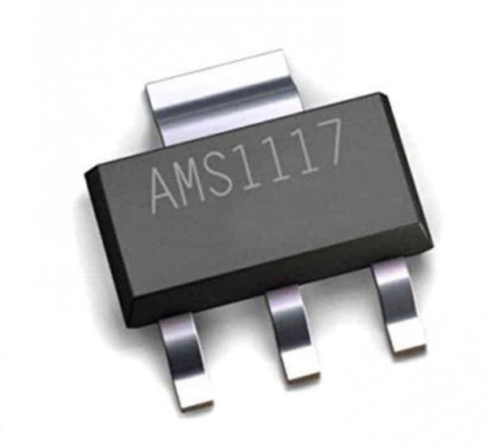 Obrázok, na ktorom je diagram, schematický

  Automaticky generovaný popis
* **TSR DC/DC Converters**
* **Obrázok, na ktorom je text, športový zápas

  Automaticky generovaný popis**
* TRACO Power TSR Series are non-isolated step down DC/DC Converters. **These POL (point of load)** switching regulators have a very high efficiency and are suitable for replacing linear converters. The TSR-1 series has a high efficiency of up to 96% which allows full load operation up to +60ºC without the need for heat sink or forced cooling. Other features which distinguish TSR-1 over linear regulators include better output accuracy (±2%) and lower standby current of 2mA.
* Proximity to power. It’s one of the best ways to improve voltage accuracy, efficiency, and the dynamic response of a power rail. A point-of-load converter is a power supply DC-to-DC converter placed as close to the load as possible to achieve proximity to power. Applications that benefit from POL converters include high performance CPUs, SoCs, and FPGAs—all of which require ever increasing power levels. In automotive applications, for example, the number of sensors used for an advanced driver assistance system (ADAS)—such as those in radar, LIDAR, and vision systems—is steadily multiplying, resulting in the need for faster data processing (more power) to detect and track surrounding objects with minimal latency.
* Many of these digital systems operate at high current and low voltages, increasing the need to minimize the distance from power supply to load. One obvious problem with high currents is trace-induced voltage drops from converter to load. Figure 1 and Figure 2 show how minimizing the resistance of the leads between supply and load minimizes the output voltage drop of the converter’s output—in this case, a controller IC and MOSFETs powering a CPU.
* <https://www.analog.com/en/analog-dialogue/raqs/raq-issue-191.html>
* MC-101C
* L5.55×W7.40×H2.4 MICRO-USB CONNECTORS)
* Obrázok, na ktorom je diagram

  Automaticky generovaný popis Obrázok, na ktorom je diagram

  Automaticky generovaný popis
* This USB input section has proper ESD protection to save the device from ESD surges.
* Obrázok, na ktorom je diagram

  Automaticky generovaný popis
* **KF301-5.0-2P_INPUT_VOLTAGE_12V**
* <https://www.robotics.org.za/KF301-2P>
* 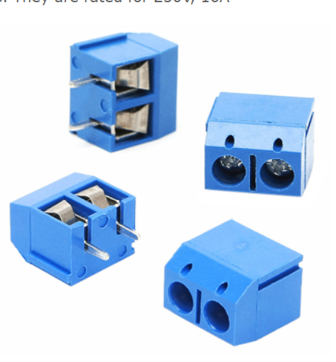
* is a type of electrical connector, frequently used to connect wires to the PCB. The connector has a screw in each pin to fasten the wire securely. It has tin-plated brass for pin header and has nickel-plated brass contacts
* The **CP2102-GM** is a highly integrated USB to UART Bridge Controller providing a simple solution for updating RS-232 designs to USB using a minimum of components and PCB space.
* Obrázok, na ktorom je text, elektronika, okruh

  Automaticky generovaný popis
* The CP2102/9 is a highly-integrated USB-to-UART Bridge Controller providing a simple solution for updating RS232 designs to USB using a minimum of components and PCB space. The CP2102/9 includes a USB 2.0 fullspeed function controller, USB transceiver, oscillator, EEPROM or EPROM, and asynchronous serial data bus (UART) with full modem control signals in a compact 5 x 5 mm QFN-28 package. No other external USB components are required.
* **USB to UART convertor** 
  + **UART stands for universal asynchronous receiver / transmitter and defines a protocol, or set of rules, for exchanging serial data between two devices.**
* Obrázok, na ktorom je diagram, schematický

  Automaticky generovaný popis
* <https://www.farnell.com/datasheets/2674213.pdf>
* 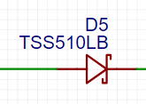
* using external power supply with the micro USB connected to our notebook, we could destroy everything connected, this prevents it from happening.
* 
* Transmit and receive data
* Obrázok, na ktorom je diagram

  Automaticky generovaný popis
* ensures good functioning of ESP32 with CP2102-GM
* Obrázok, na ktorom je text, šódži, zelená, dláždený/obkladaný

  Automaticky generovaný popis
* USB positive and negative
* 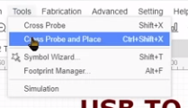
* how to use exact unit in PCB >> press the unit you want to transfer from sketch to PCB and follow these steps
* <https://www.youtube.com/watch?v=S_p0YV-JlfU&t=11s> >>>> 3h video about it all
* Additional PCB design
  + Obrázok, na ktorom je text

    Automaticky generovaný popis
  + <https://jlcpcb.com/capabilities/pcb-capabilities>
  + If placed incorrectly, the EasyEDA will let you know as an error
  + 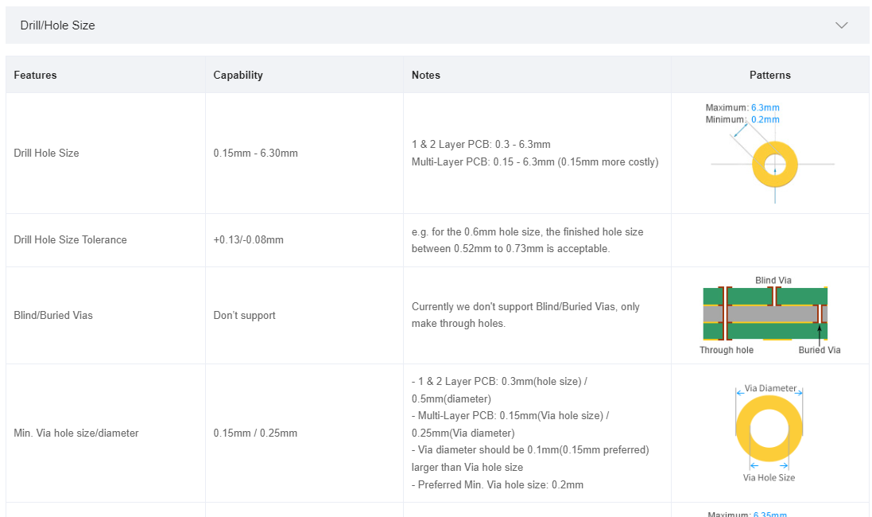
  + Find min via hole size (0.2 and 0.45 – if bigger, it is better)
  + Obrázok, na ktorom je stôl

    Automaticky generovaný popis
  + For 4-6 layers (we added 2 [inner 1 plane for +3V3 and another inner 2 plane for GND])
  + Right click on the  >>> both diameter as shown below >>> this  is inserted via 
  + 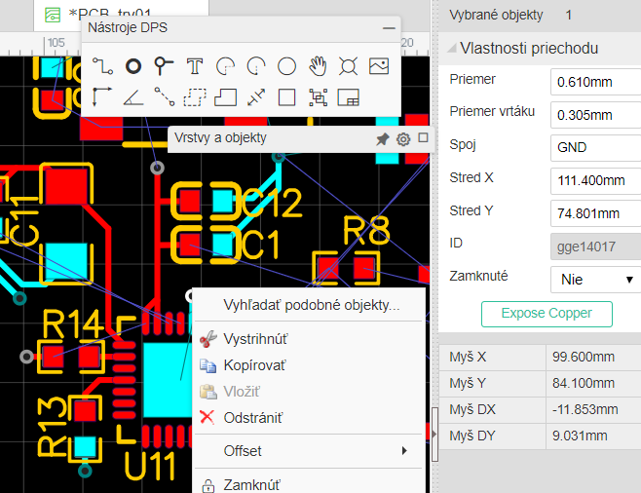
  + 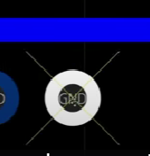 this means, it is too close
  + 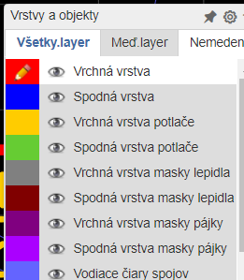
  + Visible colours of lines or layers are those, where the eye is present
  + Obrázok, na ktorom je text, snímka obrazovky, softvér, displej

    Automaticky generovaný popis
  + We needed different rules for USB and those were applied only to USB_DN a USB_DP
  + 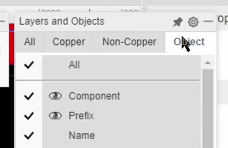 delete prefix eye to not to show the names (R1… U1… etc)
  + For both GND and 3V3 vias we used these values 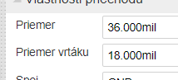

GOOD TO KNOW TO AVOID MISTAKES MAKING:

* After converting a schematic to a PCB by doing **Convert to PCB...** the connections between the pads of various Footprints in the newly created PCB are shown as thin blue lines. These lines are called Ratlines. Ratlines do not represent PCB tracks. They show which pins are connected together. Therefore, they show the **electrical connectivity** of each net, not the **physical routing** of that net. Ratlines are also dynamic and snap between the nearest pins on the same net as footprints are moved around, which can be quite confusing the first few times you see it. It is up to you to place your footprints where they need to be and then use the **Track** tool (in the **PCB Tools** pallette) to route the board. As you connect nodes together by copper tracks along a net, the ratlines will move around and successively disappear. When all nodes on a net are connected by copper track, the last ratline for that net will disappear.
  + For more information please see <https://easyeda.com/forum/topic/How_does_the_Connect_Pad_to_Pad_tool_work_-JgQO0Ay7H>