Program 1: pthread Pi Approximation
Thomas Hughes
CSC-4760, Fall 2015
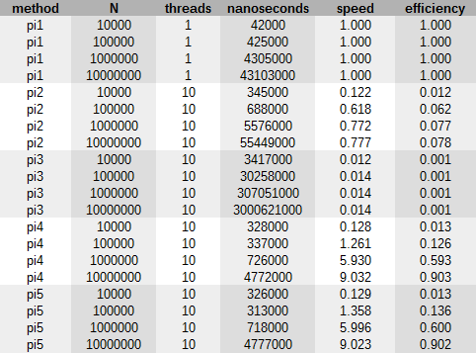

- pi1: serial
- pi2: global sum, no locking
- pi3: global sum, busy-waiting
- pi4: private sum, busy-waiting
- pi5: private sum, mutex
The results indicate that busy-wait private sum and mutex private sum methods are the fastest methods for N > 10000. I found the assignment fairly easy to complete, the only slip-up I had was that not turning off an optimization flag messed up busy-waiting at first. Almost all of the implementation is in the book, aside from timing which I used chrono for.

