GeoCatalog
Project Overview

20/08/2007

GeoCatalog is a plugin for OrbisGIS. It allows the user to manage projects containing the files and databases needed for that project.

Index
1.Functionalities 1
1.1.Folder managment 2
1.2.Datasources managment 2
1.3.SLD managment 2
1.4.SQL managment 2
1.5.User friendly 2
1.6.Integration 3
2.Screenshots 3
3.Recommended Improvements 3

Functionalities
- Manage folders (create, delete, move, rename)
- Manage data sources of any type (Database, FlatFiles, Vector or Raster) and drop them in another plugin (GeoView2D, GeoView3D...)
- Manage SLD files and create links with data sources
- Manage SQL queries and drop them in GeoViewSQLEditor
- User friendly
- Integration with other plugins
- Launch/show GeoView2D or 3D

Folder managment
The user should be able to add, delete, rename, move folders simply.
There is a popup menu to add or delete a folder. To move a folder, use drag and drop. To rename it, clic on it and type the new name.

Datasources managment
The user should be able to add, delete, move datasources simply. Datasources are the objects containing the datas. They are :
-Flat files : shp, cir, tif, asc, csv, dbf
-Databases : H2, PostGrey, HSQL, MySQL, ODBC
There is a popup menu to add or delete a DataSource. To move a DataSource, use drag and drop.

SLD managment
SLD files are used to apply a style on a vector file. The user should be able to add and delete SLD files using a popup menu. He should be able to create links between a datasource and a SLD file so the linked datasource will remain styled.

SQL managment
The user should be able to create SQL queries and store them with an alias. He should be able to modify a query and more especially to drop it in the plugin « SQLConsole » in order to execute it.

User friendly
The catalog must be intuitive and have a nice appearance.
-Intuitive
Wide use of drag and drop
Right clic with simple popup menu
Database connection reminder to avoid re-typing login informations
No redundant menus

-Nice
Nice icons in the catalog and the menus

Integration
The catalog is made for OrbisGIS and fully integrates in it.
It automatically listen for creation/deletion of new Datasources by any other plugin and update itself. It supports dragging elements and dropping them in another plugin. The user can, for example, drag a DataSource from the catalog and drop it in GeoView2D or 3D. It is the targeted plugin that handle the drop event, not the catalog.

Screenshots

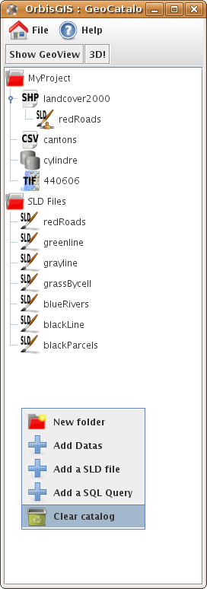

Recommended Improvements

-Sorting elements in the Catalog
-...

