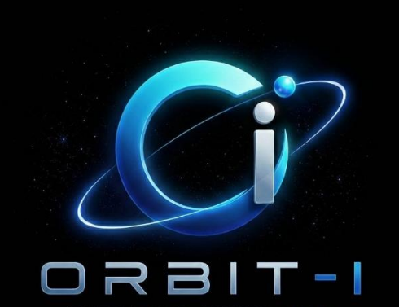 | ORBIT-I  Building Ideas, Creating Impacts

OFFER LETTER
Software Engineer
Hybrid - Karachi, Pakistan
Date: August 07, 2026
DEAR PREM KUMAR,
We are pleased to offer you the position of Software Engineer in the software engineering department at ORBIT-I, based in Hybrid - Karachi, Pakistan. After carefully reviewing your experience and qualifications, we are confident that you will be a valuable addition to our team.
Your monthly salary will be PKR 100,000, and your employment will begin on August 21, 2026, subject to a probation period of 3 months.
We are truly excited about the opportunity to have you join our team and contribute your skills and creativity to our continued growth. Should you have any questions, please feel free to reach out at any time. We look forward to welcoming you and building a successful journey together.

Regards,

HR Department
HR Department, ORBIT-I

