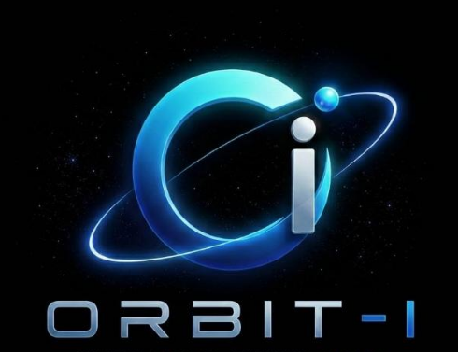 | ORBIT-I  Building Ideas, Creating Impacts

OFFER LETTER
{{ position_title }}
{{ location }}
Date: {{ offer_date }}
DEAR {{ candidate_name | upper }},
We are pleased to offer you the position of {{ position_title }} in the {{ domain }} department at {{ company_name }}, based in {{ location }}. After carefully reviewing your experience and qualifications, we are confident that you will be a valuable addition to our team.
Your monthly salary will be PKR {{ salary }}, and your employment will begin on {{ start_date }}, subject to a probation period of {{ probation_period }}.
We are truly excited about the opportunity to have you join our team and contribute your skills and creativity to our continued growth. Should you have any questions, please feel free to reach out at any time. We look forward to welcoming you and building a successful journey together.

Regards,

{{ hr_signatory }}
HR Department, {{ company_name }}

