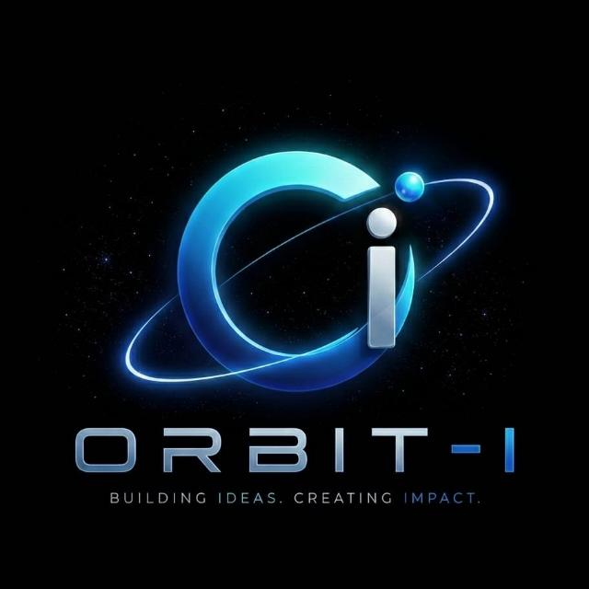 | ORBIT-I  CV Intelligence & Offer Automation Platform  Karachi, Sindh, Pakistan · orbiti2026@gmail.com

Date: {{offer_date}} | Ref: ORBIT-I/OL/2026

Dear {{candidate_name}},
We are pleased to extend this formal offer of employment for the position of {{position_title}} within the {{domain}} department at ORBIT-I. We believe your skills and experience make you an excellent fit for our team.
Employment Details
Position Title | {{position_title}}
Department / Domain | {{domain}}
Monthly Salary | {{salary}}
Date of Joining | {{start_date}}
Work Location | {{location}}
Probation Period | {{probation_period}}
Reporting To | HR Department

This offer is subject to the successful completion of your probation period of {{probation_period}}, during which your performance will be evaluated against the key objectives of your role.
Please confirm your acceptance of this offer by signing and returning a copy of this letter within three (3) working days of receipt. Failure to do so may result in the offer being withdrawn.
We look forward to welcoming you to the team and are excited about the contributions you will bring to ORBIT-I.
Sincerely,  _______________________  {{hr_signatory}}  ORBIT-I  Karachi, Sindh, Pakistan | Accepted by:  _______________________  {{candidate_name}}  Date: _______________

ORBIT-I · Karachi, Sindh, Pakistan · orbiti2026@gmail.com · This document is confidential and intended solely for the named recipient.

