ORBITER

Space Shuttle Atlantis Operations Manual

Copyright (c) 2000-2006 Martin Schweiger 08 November 2026

Orbiter home: orbit.medphys.ucl.ac.uk/ or www.orbitersim.com



Contents
1 Introduction 2
2 Notes on operation 3
2.1 Shortcut keys 3
2.2 Launch 3
2.3 Docking 3
2.4 Payload bay operations 3
2.5 RMS manipulation and grappling 5
3 Virtual cockpit 7
3.1 Navigating the VC 7
3.2 Operating the MFDs 7
4 Configuration 9
5 Implementation notes 10
5.1 Mesh-derived parameters 10
5.2 SRB thrust characteristics 11
5.3 Orbiter aerodynamic characteristics 12
6 Credits 14

Introduction
Space Shuttle Atlantis represents the only “real” spacecraft in the basic Orbiter distribution (but there are many more available as addons). Its flight characteristics are less forgiving than fictional models like the Delta-glider, and just reaching orbit is a challenge.

The Atlantis orbiter features a working payload bay with remote manipulator system (“Canadarm”), so you can simulate the deployment or even recapture of satellites, or the shipment of resupplies to the International Space Station.

The model now also features a virtual cockpit, with working MFD instruments and head-up display.

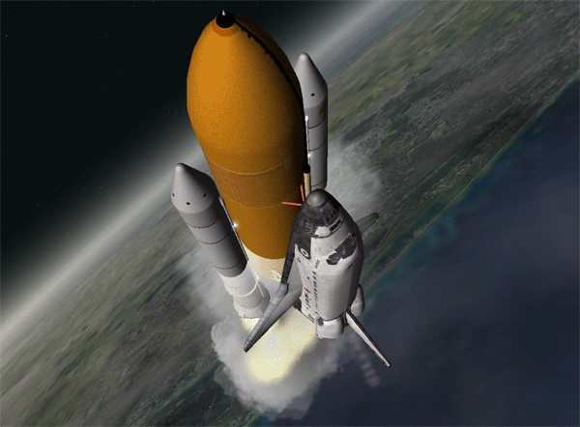

Notes on operation
This section contains some details on launch, docking and payload operations of the default Atlantis model distributed with Orbiter. To test the procedures described here in practice, launch Orbiter and try any of the scenarios in the Space Shuttle Atlantis folder.

Shortcut keys
The following Atlantis-specific keyboard shortcuts are supported:

☺ | Jettison: separate SRBs or main tank
😐 | Operate cargo bay doors. (shortcut – for the full procedure see Section 2.4)
 | Operate landing gear (activated only after tank separation)
▪ | Operate split-rudder speed brake.
▪ | Deploy/retract Ku-band antenna. (shortcut – for the full procedure see Section 2.4)
▪+Space | Open payload bay and RMS control dialogs.

Launch
The default Atlantis does not implement an autopilot or launch computer, so you need to adjust the ascent to orbit manually. (You can download 3rd party addons which provide more realistic launch and flight operation modes). Here is a quick checklist you can follow to get Atlantis into orbit:

- Fire main engines at 100%.
- SRBs are ignited automatically when main engines reach 95%. SRBs are not controlled manually. Once ignited, they cannot be shut off.
- During launch, attitude is controlled via SRB thrust vectoring. Roll shuttle for required heading, and decrease pitch during ascent for required orbit insertion.
- SRBs separate automatically at T+2:06min. In an emergency, SRBs can be jettisoned manually with ☺.
- Ascent continues with Orbiter main engines. Throttle down as required for 3g max acceleration.
- Tank separates at T+8:58min (alt 110km) when empty, or manually with ☺.
- After tank separation, orbiter switches to OMS (orbital maneuvering system) using internal tanks, for final orbit insertion. Attitude thrusters (RCS – reaction control system) are activated.

 | Unlike the futuristic spacecraft designs, Atlantis provides only a small margin of error for achieving orbit. Try some of the other ships before attempting to launch the Shuttle. Limited fuel must be selected, otherwise Atlantis is too heavy to reach orbit!

Docking
- The orbiter carries a docking attachment in the cargo bay.
- Open cargo bay doors before docking.
- Docking direction is in orbiter’s +y direction (up). The Docking MFD must be interpreted accordingly.

Payload bay operations
The payload bay operations in the default Atlantis model consist of

- opening and closing the payload bay doors
- deploying and retracting the forward radiator panels
- deploying and retracting the Ku-band antenna
- operating the RMS arm for deploying and stowing payload

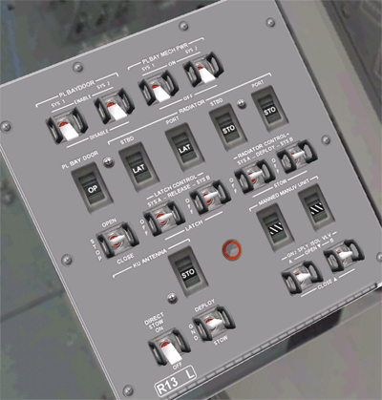
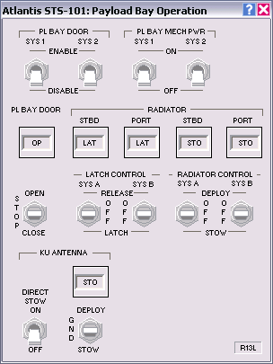
The bay door, radiator and Ku-band antenna operation closely follows the real shuttle procedures, using panel R13L. This panel is accessible from the payload operator position of the VC (via ▪). Alternatively, a dialog representation of the panel is available by pressing ▪-Space, and selecting Payload door operation. The dialog is also available in external views.

Bay Door Operation
Bay door opening sequence:
- Set the PL BAY DOOR switch to STOP.
- Set the PL BAY DOOR SYS 1 and SYS 2 switches to ENABLE.
- Set the PL BAY DOOR switch to OPEN.
- Wait until the OP/CL status of the talkback indicator shows OP.
- Set the PL BAY DOOR switch to STOP.
- Set PL BAY DOOR SYS 1 and SYS 2 switches to DISABLE.

Bay door closing sequence:
- Make sure that the radiators, Ku-band antenna and RMS arm are stowed.
- Set the PL BAY DOOR switch to STOP.
- Set the PL BAY DOOR SYS 1 and SYS 2 switches to ENABLE.
- Set the PL BAY DOOR switch to CLOSE.
- Wait until the OP/CL status of the talkback indicator shows CL.
- Set the PL BAY DOOR switch to STOP.
- Set PL BAY DOOR SYS 1 and SYS 2 switches to DISABLE.

Ref: Operations Manual Sec. 2.17.

Radiator Operation
The Space Shuttle has four radiators to dissipate heat from the coolant loops - two on the inside of each of the payload bay doors. The forward radiator panels on each side can be deployed when the doors are open; the aft panels are fixed. The bay doors and radiators are operated by using the switches on panel R13L. Note that the software interface for operating the doors is not currently simulated.

Radiator deployment sequence:
- The payload bay doors must be fully open.
- Set the PL BAY MECH PWR SYS 1 and SYS 2 switches to ON.
- Set the LATCH CONTROL SYS A and SYS B switches to REL (release).
- After 30 seconds, set both latch control switches back to OFF.
- Set the RADIATOR CONTROL SYS A and SYS B switches to DEPLOY.
- After 50 seconds, set both radiator control switches back to OFF.
- Set both PL BAY MECH PWR switches back to OFF.

Radiator stowing sequence:
- Set the PL BAY MECH PWR SYS 1 and SYS 2switches to ON.
- Set the RADIATOR CONTROL SYS A and SYS B switches to STOW.
- After 50 seconds, set both radiator control switches back to OFF.
- Set the LATCH CONTROL SYS A and SYS B switches to LATCH.
- After 30 seconds, set both latch control switches back to OFF.
- Set both PL BAY MECH PWR switches back to OFF.

Ref: Operations Manual Sec. 2.9.

Ku-Band Antenna Operation
The Ku-band antenna is carried on the starboard sill longeron inside the Orbiter's cargo bay and can be deployed once the payload bay doors are opened. The antenna is used for communication with ground stations. Alternatively, it can also be used as a radar system for tracking objects in space. The controls for deployment and stowage of the Ku-band system are located on panel R13L. Jettisoning the assembly, and the actual functionality of the Ku-band system are not currently implemented in this version.

Ku-band deployment sequence:
- The payload bay doors must be fully open.
- Set theKU ANTENNA switch to DEPLOY.
- The deployment procedure takes approximately 23 seconds.
- When the talkback indicator shows "DPL", set the KU ANTENNA switch back to GND.

Ku-band stowing sequence:
- Set the KU ANTENNA switch to STOW.
- The stowing procedure takes approximately 23 seconds.
- When the talkback indicator shows "STO", set the KU ANTENNA switch back to GND.
- If the assembly does not respond to the normal stowing operation, set the KU ANTENNA DIRECT STOW switch to ON. This bypasses the normal stow control sequences and causes the assembly to be driven inside the payload bay.

Ref: Operations Manual Sec. 2.4.

RMS manipulation and grappling
- The shuttle carries a mechanical manipulator arm in the cargo bay which can be used for releasing and recapturing satellites, MMU control, etc.
- The arm can be used in orbit once the cargo doors have been fully opened.
- To bring up the RMS control dialog, press ▪+Space.
- The arm has three joints: the shoulder joint can be rotated in yaw and pitch, the elbow joint can be rotated in pitch, and the wrist joint can be rotated in pitch, yaw and roll.
- To grapple a satellite currently stowed in the cargo bay, move the RMS tip onto a grappling point, and press “Grapple”. If grappling was successful, the button label switches to “Release”.
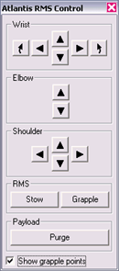
- To make it easier to identify the grappling points of satellites, you can tick the “Show grapple points” box. This marks all grappling points with flashing arrows.
- To release the satellite, press “Release”.
- You can also grapple freely drifting satellites if you move the RMS tip onto a grappling point.
- To return a satellite back to Earth, it must be stowed in the cargo bay. Use the RMS arm to bring the satellite into its correct position in the payload bay. When the Payload “Arrest” button becomes active, the satellite can be fixed in the bay by pressing the button. It is automatically released from the RMS tip.
- The RMS arm can be stowed in its transport position by pressing the RMS “Stow” button. This is only possible as long as no object is attached to the arm.
- Payload can be released directly from the bay by pressing the “Purge” button.
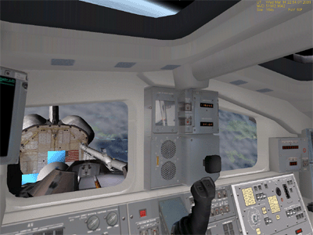
View into the payload bay from the payload operator position.

Virtual cockpit
You can switch between the generic glass-cockpit view and the virtual cockpit (VC) with . The virtual cockpit puts you directly on the Atlantis flight deck, surrounded by display screens and instrument panels. Currently, a subset of the instruments is active, including 10 working MFDs, and panel R13L in the rear of the flight deck, controlling the payload door operations.
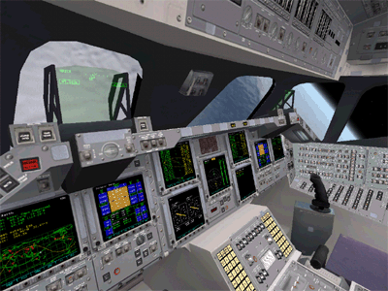
The virtual cockpit from the commander’s seat.

Navigating the VC
There are three camera positions available: commander, pilot, and payload operator. By default, you are placed in the commander seat, but you can move to a different position by pressing ▪ and an arrow key. ▪ and ▪ jump between the commander and pilot seats, while ▪ switches to and from the payload operator position.

Looking around
You can rotate the view at each of the three positions in different ways:
- by pressing  and a cursor key
- by pressing the right mouse button and dragging the mouse
- by using the direction controller on the joystick, if available

Leaning forward and sideways
You can also move the head position by pressing ▪ in combination with a cursor key. Leaning forward (▪) in the commander and pilot seat will get you closer to the HUD. Leaning sideways (▪ and ▪) will provide better access to the MFD instruments on the central panel, or give a better view out of the windows.
In the payload operator position, ▪ provides a view out of the right payload bay window, ▪ gets you close to one of the top windows, and ▪ brings the payload door operation panel (R13L) into view.
In all positions, ▪ returns to the default head position.

Operating the MFDs
The VC provides 10 multifunctional displays which can be operated independently:

- 2 commander MFDs (CDR1 and CDR2), accessible from the commander position
- 2 pilot MFDs (PLT1 and PLT2), accessible from the pilot position
- 5 MFDs on the central console, accessible from commander and pilot positions
- 1 MFD on the right rear panel, accessible from the payload operator position

Due to the layout of the Shuttle MFD control switches, the operation differs slightly from the generic Orbiter MFD mode. All 10 MFDs work identically. The controls consist of a power button on the left, a brightness dial on the right, and 6 function buttons along the bottom edge.

- Clicking the power button turns the MFD on and off.
- Clicking the left and right half of the brightness button decreases and increases the display brightness, respectively.
- The left 5 function buttons provide mode-specific functions. The corresponding labels displayed at the bottom of the display change accordingly.
- The right function button (PG) has a double function: clicking briefly pages through the function buttons, if the current mode supports more than 5 functions. Holding down the button for longer than one second brings up the mode selection page, with 5 entries per page. You can use the function buttons to select one of the modes.
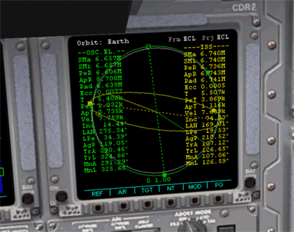
power
brightness
page/mode button
function buttons
MFD display

Configuration
The Space Shuttle model provided with Orbiter contains very detailed meshes and textures of the exterior and flightdeck interior, to provide the best possible visual appearance. On some older computers this may lead to loss of performance and slow response. To address this problem, Orbiter can be configured to use a less detailed visual model:

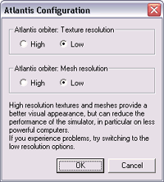
On the Extra tab of the Orbiter launchpad, double-click Vessel configuration, then Atlantis Configuration.
Set the Texture and Mesh resolution settings to “low”. This will put less load on the graphics system of your computer, at the cost of some visual detail.

Implementation notes
This section contains details of the implementation of the Space Shuttle (Atlantis) vessel class implementation in ORBITER. The module code is available in the samples\Atlantis subdirectory of the SDK. The pysical parameters discussed here are the values used by ORBITER, as I collected them from public sources, and may deviate from the actual Space Shuttle characteristica. It is my goal to model the shuttle performance as close to life as possible, so if you have corrections to parameters or procedures, please get in contact.

Mesh-derived parameters
The following parameters were derived directly by analysing the meshes:

Orbiter
Length: 39.16 m
Wingspan: 24.54 m
Height: 14.29 m
Volume: 1133 m³
Cross-sections: 234.8 m² (projection on yz-plane: side-on)
389.1 m² (projection on xz-plane: top-down)
68.2 m² (projection on xy-plane: head-on)
PMIª: 78.2/82.1/10.7 m²

Tank^{b}
Length: 47.83 m
Diameter: 9.68 m
Volume: 2829 m³
Cross-sections: 412.1 m² (projection on yz-plane: side-on)
411.8 m² (projection on xz-plane: top-down)
72.7 m² (projection on xy-plane: head-on)
PMIª: 145.6/145.6/10.5 m²

SRB
Length: 45.7 m
Diameter: 3.8 m (tube) 5.9 m (max)
Volume: 452 m³
Cross-sections: 162.1 m² (projection on yz-plane: side-on)
162.1 m² (projection on xz-plane: top-down)
26.6 m² (projection on xy-plane: head-on)
PMIª: 154.3/154.3/1.83 m²

Orbiter+Tank assembly
Length: 57.55 m
Height: 24.44 m
Volume: 3962 m³
Cross-sections: 646.2 m² (projection on yz-plane: side-on)
597.5 m² (projection on xz-plane: top-down)
140.0 m² (projection on xy-plane: head-on)
PMIª: 173.3/161.0/24.0 m²

Orbiter+Tank+SRBs (launch assembly)
Length: 57.91 m
Height: 24.44 m
Volume: 4868 m³
Cross-sections: 687.4 m² (projection on yz-plane: side-on)
849.5 m² (projection on xz-plane: top-down)
189.4 m² (projection on xy-plane: head-on)
PMIª: 179.1/176.8/29.3 m²
ª: principal moments of intertia tensor, mass-normalised, assuming homogeneous density distribution
^{b}: including Orbiter mount brackets

SRB thrust characteristics
The following parameters are used for the solid rocket boosters (per unit):

Thrust at liftoff: 1.17918⋅10⁷ N
SRB separation: 126 s after liftoff
Weight empty: 87543 kg
Weight propellant: 502126 kg

The following (largely fictional) piecewise linear functions for thrust rate and propellant level as a function of burn time are assumed (liftoff time t=0)

Time [s] | -4 | -1 | 103 | 115 | 126 (sep.) | 135
Thrust [%] | 0 | 100 | 100 | 85 | 5 | 0
Propellant [%] | 100 | 98.768 | 13.365 | 4.250 | 0.185 | 0
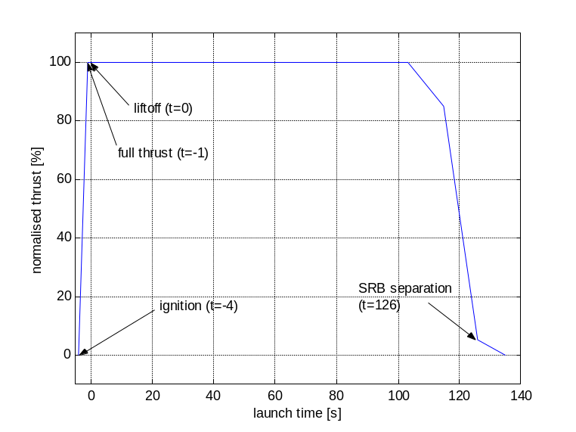
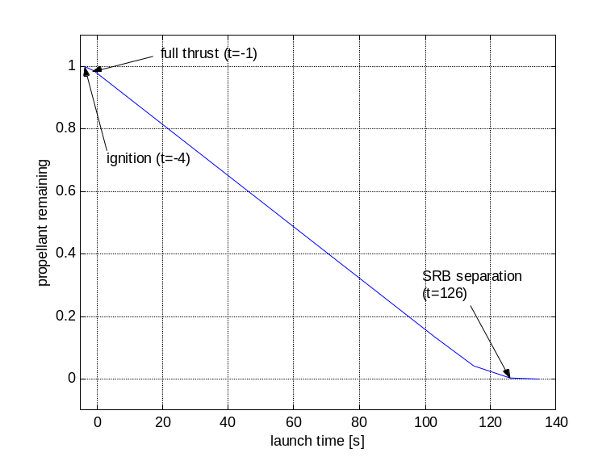

From this table, the value derived for the fuel-specific impulse (ISP), i.e. the amount of thrust obtained from burning 1kg of propellant per second, is
ISP = 2859.74 m/s (at liftoff)

The actual maximum thrust also depends on the ambient atmospheric pressure. We assume that the freespace thrust is 1.25 times the thrust at (Earth) liftoff, with an exponential pressure relationship of the following form:

F = F∞ exp (-p β) with β = -1/p₀ log (F₀/F∞)

where p₀ is the pressure at liftoff altitude, p is the current pressure, and F₀ and F∞ are the liftoff and freespace thrust ratings, respectively.
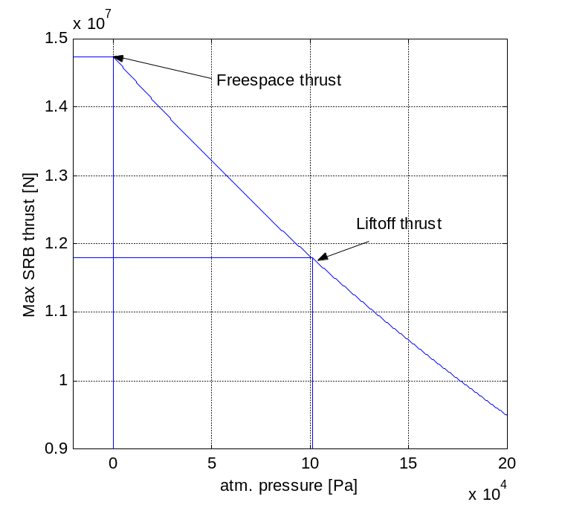

Problems:
- The thrust curve during the burnout stage is not based on any data. In particular the amount of thrust produced at separation (t=126) is not known.
- According to sources, the SRB’s reduce thrust by 1/3 after 50 s to keep acceleration within limits. This is not currently modelled.
- The pressure-thrust relationship is assumed, not backed by any data.

Orbiter aerodynamic characteristics
The Atlantis orbiter uses the following subsonic lift and moment coefficients:

Vertical lift component – wings and body
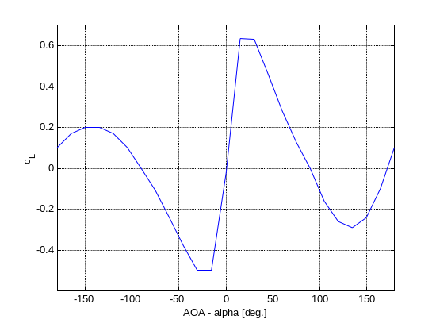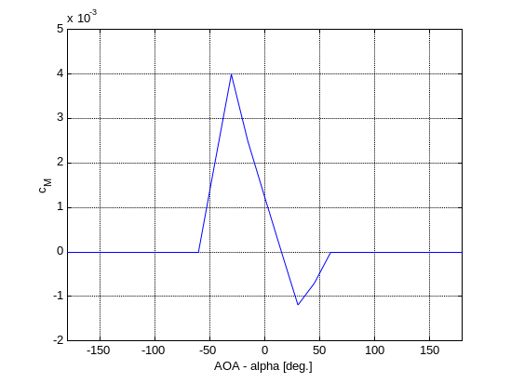

The lift profile utilises a documented lift slope of 0.0437/deg. Everything else is rather ad-hoc. In particular the moment coefficient profile needs more thought. Other parameters:

Zero-lift drag | c_{D,0} = 0.06
Chord length | c = 20 m
Reference area | S = 270 m2
Wing aspect ratio | A = 2.266
Oswald efficiency factor |  = 0.6

This produces the following drag polar:
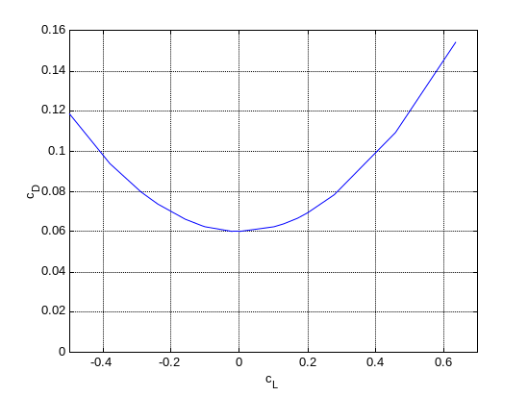
Horizontal lift component – vertical stabiliser and body
Lift coefficient and drag polar for the horizontal lift component (produced by the orbiter body and vertical stabiliser) are given by:
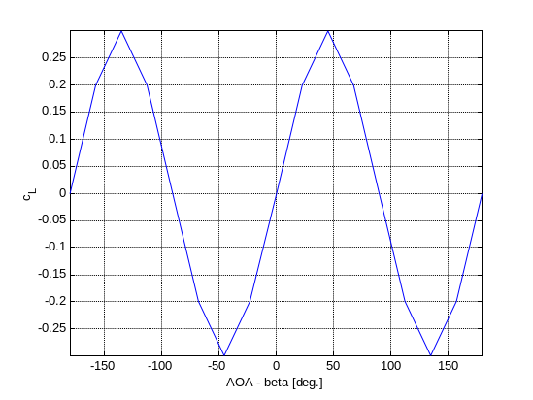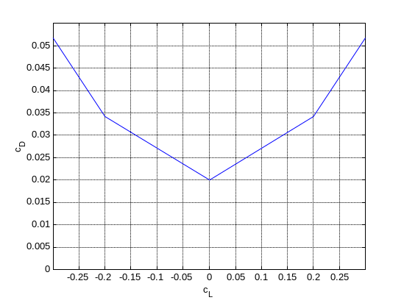
The horizontal lift profile is symmetric (symmetric airfoil). Other parameters:
Moment coefficient | c_{M} = 0
Zero-lift drag | cD,0 = 0.02
Chord length | c = 20 m
Reference area | S = 50 m2
Wing aspect ratio | A = 1.5
Oswald efficiency factor |  = 0.6

Speed brake
The split-rudder speed brake is activated with ▪. Deployment time is 4.93 seconds. At full extent, the brake will generate a subsonic drag force of 5.0m² q∞ (q∞: freestream dynamic pressure) in Orbiter. It will also generate a pitch-up moment.

Credits
The Atlantis orbiter 3-D model and virtual cockpit for the latest version of Orbiter has been kindly contributed by Michael Grosberg.
Don Gallagher’s extensive work on the cockpit interior, including high resolution instrument panels, switches and buttons, was essential to realise the working virtual cockpit implementation.
Damir Gulesich has provided the models for the external tank (ET) and solid rocket boosters (SRB).
Robert Conley’s code provided the basis for the RMS operation, and he also contributed the MMU extensions.
Douglas Beachy contributed to the virtual cockpit code.
And not least I would like to thank the beta team for their valuable feedback during the development of the model and code.

