Delta-glider Operations Manual

Copyright (c) 2005-2010 Martin Schweiger 07 November 2026
Orbiter home: orbit.medphys.ucl.ac.uk/ or www.orbitersim.com

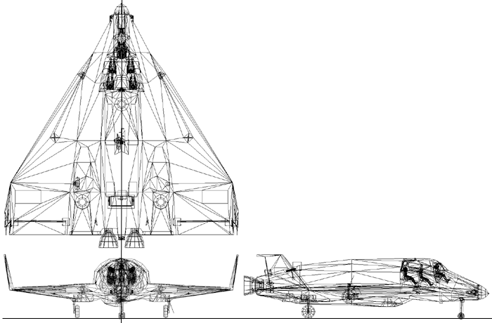
DG/DG-S Mk.4

Contents
1 Introduction 2
2 Cockpit camera modes 2
2.1 Instrument panels 2
2.2 Virtual cockpit 3
3 Controls and instruments 4
4 Keyboard controls 5
5 Control dialog 5
6 Autopilot functions 6
6.1 Atmospheric autopilot 6
7 Technical specifications 7

Introduction
The Delta-glider (DG) is the ideal ship for the novice pilot to get spaceborne. Its futuristic design concept, high thrust and extremely low fuel consumption make it easy to achieve orbit, and it can even be used for interplanetary travel. The winged design provides aircraft-like handling in the lower atmosphere, while the vertically mounted hover-thrusters allow vertical takeoffs and landings independent of atmospheric conditions and runways.
Two versions are available: The standard DG is equipped with main, retro and hover engines. The scramjet version (DG-S) has in addition two airbreathing scramjet engines fitted, which can be used for supersonic atmospheric flight. The scramjets have an operational airspeed range of Mach 3-8.
The glider comes with operating landing gear, nose cone docking port, airlock door, deployable radiator and animated aerodynamic control surfaces. It now supports particle exhaust effects.

Cockpit camera modes
Apart from the generic “glass cockpit” camera mode which supports a head-up display (HUD), up to two multi-functional displays (MFD) and some of the most essential control and display components, the DG also supports a set of 2-D instrument panels, and a virtual 3-D cockpit (VC), all of which can be operated with the mouse. You can switch between the different cockpit modes by pressing .

Instrument panels
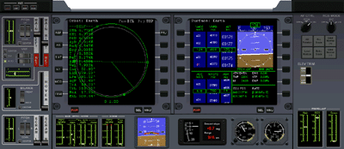
The glider supports three 2-D instrument panels which can be selected with ▪ and ▪.
HUD mode selector
main throttle, gimbal control
hover throt-tle, balance control
scram throt-tle, gimbal control
left MFD
right MFD
AF/RCS selectors
navmodes
main/RCS fuel status
pitch trim control
AOA indicator
slip indicator
slope/range indicator
artificial horizon
scram engine status
main engine status
scram fuel status
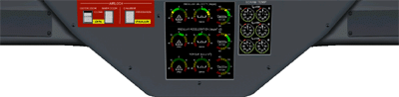
left/right scramjet temperature: diffusor, combustion, exhaust
Nosecone/airlock operation
Torque angular acceleration/angular velocity indicators

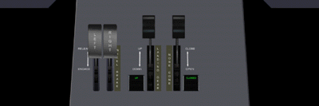
left/right wheel brake
landing gear control/status
nose cone control/status

Virtual cockpit
The delta-glider provides a 3-D virtual cockpit (VC) mode in addition to the 2-D panel mode. The VC puts you in the pilot’s seat, with the head-up display in front of you, and all controls and displays within easy reach. You can operate switches and levers with the mouse. Look around you by pressing the right mouse button and dragging the mouse, by using , or with the coolie hat on your joystick. You can also lean left, right and forward with ▪, to get a better view of your surroundings.
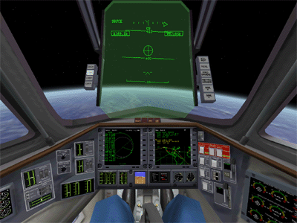
HUD
navmode panel
HUD mode panel
left MFD
hover f/b balance
indicator lights
right MFD
HUD colour/
brightness
airfoil control
scramjet gimbal
RCS control
main gimbal
airlock control
scramjet temperature
fuel level
nosecone
angular vel./mom.
fuel status
horizon
slope
AOA/slip
controls
gear
trim

Moving between VC positions
The default virtual cockpit position places you in the pilot’s seat, behind the pane of the head-up display and with access to all instruments and flight controls. You can however also switch your position to any of the 4 passenger seats in the cabin, for example to experience the replay of a recorded flight from a passenger’s perspective.
To switch to a different VC position, use Ctrl-arrow key combinations. The picture illustrates the different jump paths.
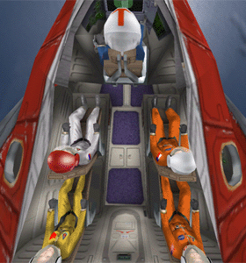
▪
▪
▪
▪
▪
▪
▪
▪
▪
▪
▪

Controls and instruments

RCS and aerodynamic control selection
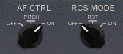
The AF CTRL selector is used to activate control of aerodynamic surfaces via manual user input. Manipulating the control surfaces is only effective within an atmosphere at sufficiently high dynamic pressures. The settings are: OFF (control surfaces disconnected), ON (control surfaces enabled), and PITCH (only pitch control enabled).
The RCS MODE selector sets the Reaction Control System mode which is used to control attitude in free space. During atmospheric flight, when aerodynamic control surfaces are active, the RCS is usually disabled. The selector can be set to OFF (RCS disabled), ROT (RCS in rotational mode), and LIN (RCS in linear mode).
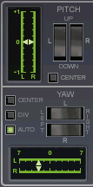
Both selectors can be set with the left and right mouse buttons. Shortcuts for RCS are _{Numpad} (ROT/LIN) and ▪_{Numpad} (ON/OFF). Shortcut for AF control is _{Numpad} (ON/OFF).

Main engine gimbal control
Both main engines can be gimballed independently in pitch and yaw. Gimbal range is ±1.0° in pitch, and ±7.7° in yaw. The yaw range allows to compensate for torque generated by a single engine at main thrust.
The main engine pitch and yaw gimbal controls are arranged left of the main throttle. The gimbal setting is controlled by flip switches for the left and right engine. The gimbals can be operated for both engines individually, or simultaneously by clicking between the switches.
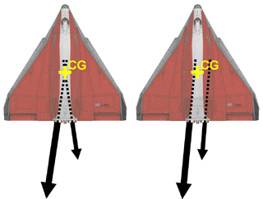
Both the pitch and jaw gimbals can be returned to neutral position by pressing the appropriate “CENTER” button. In addition, the yaw gimbal control supports divergent (“DIV”) and automatic (“AUTO”) settings: With “DIV”, both engines are set to divergent thrust at their extreme limit, so that both thrust vectors are aligned with the glider’s centre of gravity; with “AUTO”, both engines are set to parallel thrust, and the gimbal angle is adjusted so that the total thrust vector is aligned with the centre of gravity, even if the two engines produce different thrust. The automatic mode remains active until another mode is selected.
Yaw gimbal DIV and AUTO modes
The current setting of pitch and yaw gimbals is shown by indicators next to the controls.
The scramjet version (DG-S) has additional gimbal controls for the scramjet engines. The scramjets can only be gimballed in a single axis (pitch). The controls are identical to the main pitch controls.

Keyboard controls
In addition to the generic Orbiter vessel control keys, the DG supports the following vessel-specific key controls:
 | Operate landing gear
😐 | Operate nose cone docking mechanism
 | Open/close outer airlock door
▪ | Deploy/retract airbrakes
 | Deploy/retract radiators
▪  +Space | Open animation control dialog box

Control dialog
You can open a dialog box with shortcuts with some common control actions for the DG by pressing ▪–Space. This is particularly useful for external camera views, when the control elements on the instrument panels are not accessible.
- Landing gear: extend/retract the undercarriage.
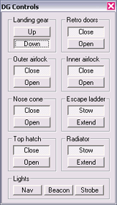
- Retro doors: Open/close protective doors covering the retro engines on the leading edge of the wings. The retros are only functional when the doors are fully open. Close the doors during atmospheric flight.
- Outer airlock: Open/close the outer airlock door.
- Inner airlock: Open/close the inner airlock door.
- Nose cone: Open/close the four segments of the nose cone to expose the docking mechanism. Open before docking approach or for EVA operations, close during atmospheric flight.
- Escape ladder: Extend/retract a ladder for access to the airlock entry when landed. The escape ladder is only operational if the nose cone is open, and will retract automatically when the cone is closed.
- Top hatch: Open/close the escape hatch at the top of the passenger cabin.
- Radiator: Extend/stow the radiator located in the rear of the glider’s fuselage. Extend only during orbital phase of the flight.
- Lights: Turn the glider’s strobe and navigation beacons on and off.

Autopilot functions
Autopilot functions for the DG are provided via the LuaOrbiter Script Interface. For details on using scripts, see LuaScripting.pdf. You can enter commands and scripts either from the ScriptMFD mode, or from the Lua console window.

Atmospheric autopilot
Atmospheric autopilot (AAP) functions provide altitude and airspeed control. They require the presence of sufficient atmospheric pressure to function. The atmospheric autopilot works similarly to the autopilot in a conventional aircraft.
The AAP is defined in Script/dg/atmap.lua. This script is loaded automatically into the glider's Script MFD environment. When using the console window, the script must be loaded manually with the following command:
run('dg/aap')
If you try to run this script for a different vessel type, a warning is displayed. The autopilot parameters are tailored towards the glider's aerodynamic behaviour.
The altitude autopilot is enabled with
aap.alt(tgtalt)
where tgtalt is the target altitude [m]. The target altitude of a running autopilot can be modified by either calling the aap.alt function with a different target altitude argument, or by overwriting the aap.tgtalt parameter:
aap.tgtalt = newalt
where newalt is the new target altitude [m]. The autopilot can be disabled by omitting the altitude argument:
aap.alt()
The airspeed autopilot uses a similar mechanism. It can be activated, modified and disabled with the following syntax:
aap.spd(tgtspeed)
aap.tgtspd = newspeed
aap.spd()
The altitude and airspeed autopilots can be activated simultaneously
The altitude autopilot acts on the elevator position only. The airspeed autopilot acts on the main throttle setting only. Certain combinations of target settings may not result in a stable condition. For example, a low speed and high altitude setting cannot be sustained simultaneously. In this case, the AP will maintain the target airspeed and move the elevators to full up position, but will sink to an altitude below the target altitude, until sufficient lift is generated to compensate for gravity.
The bank function sets the DG to a defined bank angle:
aap.bank(tgtbank)
aap.tgtbnk = newbank
aap.bank()
where the bank angle is given in degrees. Positive angles indicate a left bank, negative angles a right bank.
The heading autopilot turns the DG to a specified heading:
aap.hdg(tgtheading)
aap.tgthdg = newheading
aap.hdg()
where the heading argument is given in degrees in the range 0 ≤ heading < 360. The heading autopilot internally launches the bank function in a sub-process to achieve the specified heading. Bank and heading autopilots should not be activated simultaneously by the user.

Technical specifications
Empty mass | 11.0·10³ kg (DG) | 13.0·10³ kg (DG-S)
Main fuel mass | 12.9·10³ kg | (10.4·10³ kg + 2.5·10³)
RCS fuel mass | 0.6·10³ kg
Max takeoff mass | 24.9·10³ kg (DG) | 26.9·10³ kg (DG-S)
Length | 17.76 m
Wingspan | 17.86 m
Thrust | 2 x 1.6·10⁵ N | (main engines)
 | 2 x 3.4·10⁴ N | (wing-mounted retro thrusters)
 | 3 x 1.1·10⁵ N | (hover thrusters)
Isp | 4·10⁴ m/s | (fuel-specific impulse in vacuum)
Inertia (PMI) | 15.5 / 22.1 / 7.7 m²
Stall C_{L} | 1.0
Stall AOA | 20°

