Delta-glider Operations Manual

Copyright (c) 2005-2016 Martin Schweiger 29 September 2019
Orbiter home: orbit.medphys.ucl.ac.uk/

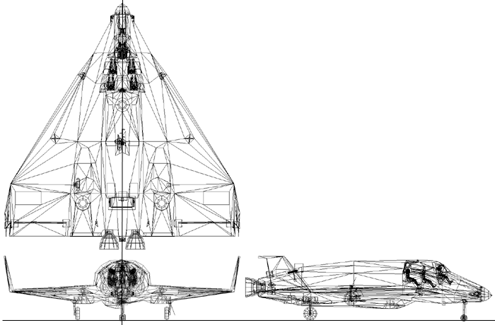
DG/DG-S Mk.4

Contents
1 Introduction 2
2 Cockpit camera modes 2
2.1 Instrument panels 2
2.2 Virtual cockpit 3
3 Controls and instruments 5
3.1 RCS and aerodynamic control selection 5
3.2 Main engine gimbal control 5
3.3 Hover attitude control 6
3.4 Hover hold altitude/vertical speed control 7
4 Keyboard controls 7
5 Control dialog 8
6 Autopilot functions 8
6.1 Atmospheric autopilot 8
7 Technical specifications 10

Introduction
The Delta-glider (DG) is a futuristic “space plane” design concept, ideal for both novice and experienced pilots. Its high thrust and extremely low fuel consumption provides single-stage to orbit (SSTO) capability that makes it easy to achieve orbit. Its large delta-V budget can be used for extensive orbit changes or interplanetary travel. The winged design provides aircraft-like handling in the lower atmosphere, while the vertically mounted hover-thrusters allow vertical takeoffs and landings independent of atmospheric conditions and runways.
Two versions are available: The standard DG is equipped with main, retro and hover engines. The scramjet version (DG-S) has in addition two airbreathing scramjet engines fitted, which can be used for supersonic atmospheric flight. The scramjets have an operational airspeed range of Mach 3-8.
The glider comes with operating landing gear, nose cone docking port, airlock, deployable radiator and animated aerodynamic control surfaces.

Cockpit camera modes
Apart from the generic “glass cockpit” camera mode which supports a head-up display (HUD), up to two multi-functional displays (MFD) and some of the most essential control and display components, the DG also supports a set of 2-D instrument panels, and a virtual 3-D cockpit (VC), all of which can be operated with the mouse. You can switch between the different cockpit modes by pressing .

Instrument panels
The glider supports a 2-D panel mode consisiting of a main and overhead instrument panel which can be selected with ▪ and ▪. The panels can be scrolled up and down with  and . Active panel elements, such as buttons, switches and dials can be operated with the left mouse button. Pressing the right mouse button and dragging the mouse pans the camera. The camera can be rotated back to the forward direction with the  key.
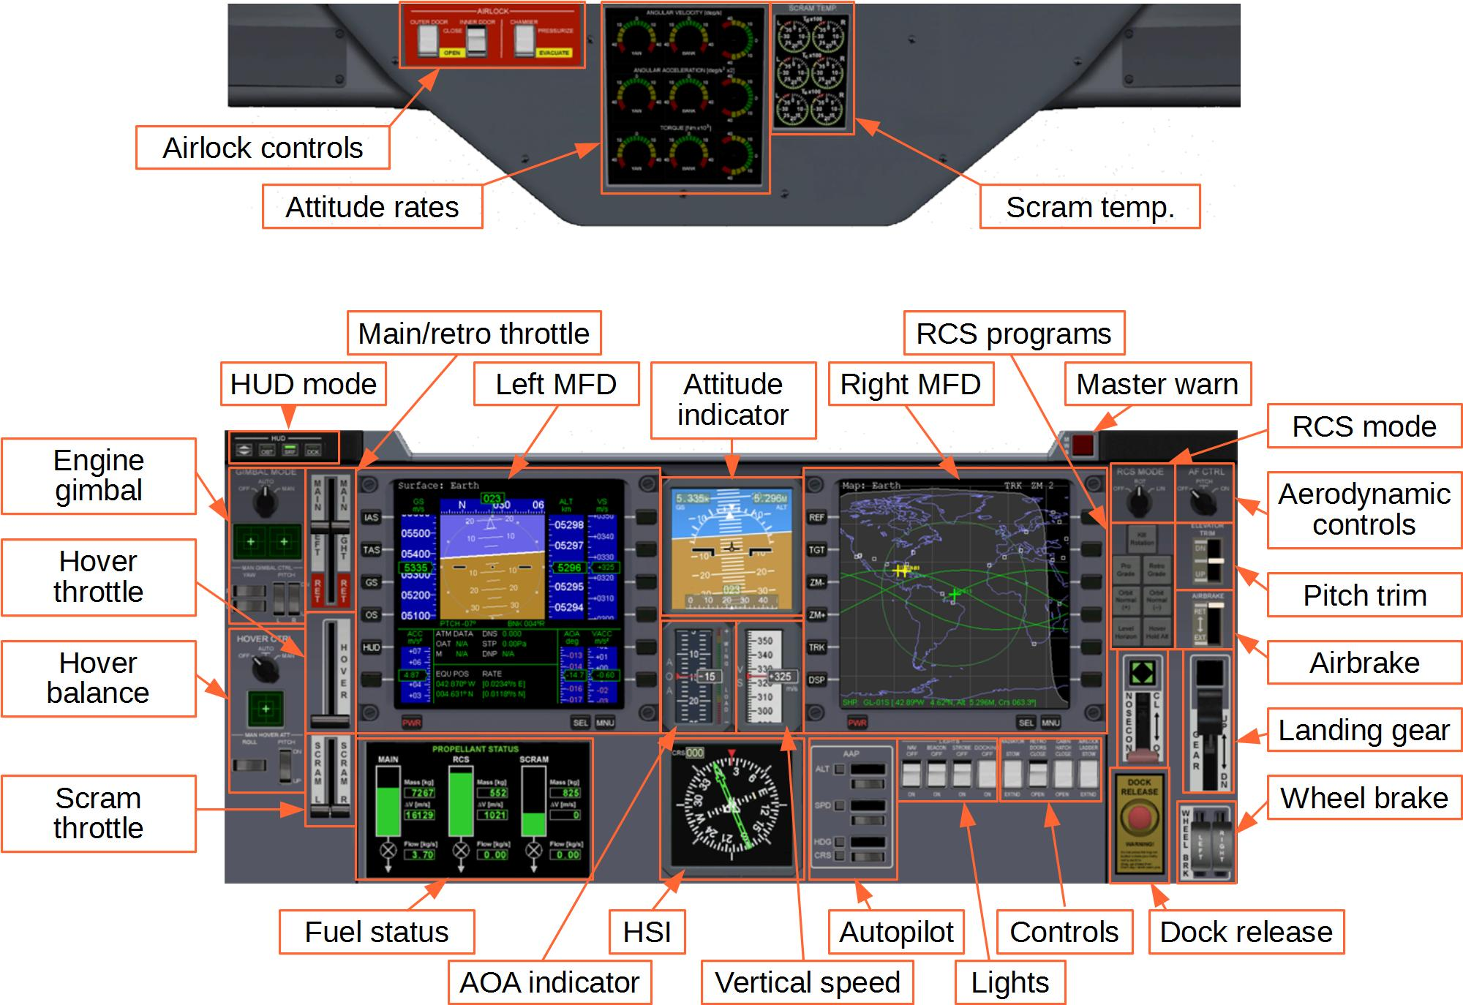Figure 1: Delta-glider 2D overhead and main panels

Virtual cockpit
The delta-glider provides a 3-D virtual cockpit (VC) mode in addition to the 2-D panel mode. The VC puts you in the pilot’s seat, with the head-up display in front of you, and all controls and displays within easy reach. You can operate switches and levers with the mouse. Look around you by pressing the right mouse button and dragging the mouse, by using , or with the coolie hat on your joystick. You can also lean left, right and forward with ▪, to get a better view of your surroundings.
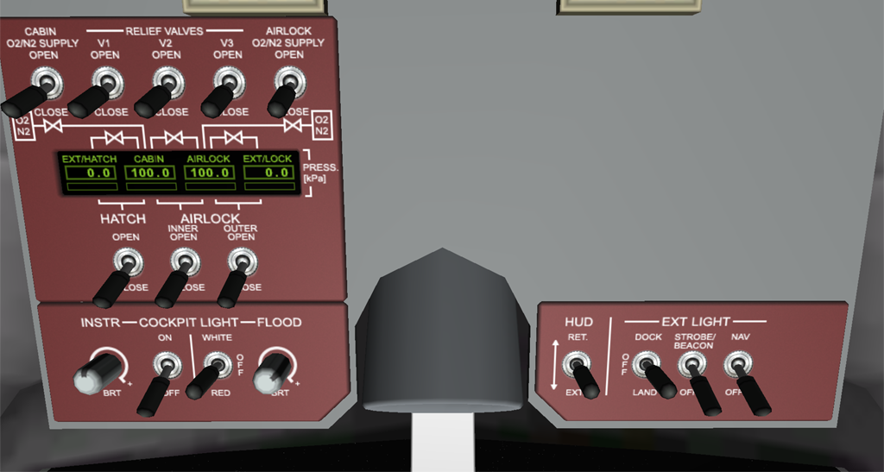Pressure valve controls
Pressure indicators
HUD projector

Hatch and airlock operation
HUD retract/extend
Landing/
docking, navigation lights
Cockpit lights

Delta-glider virtual cockpit: overhead panel
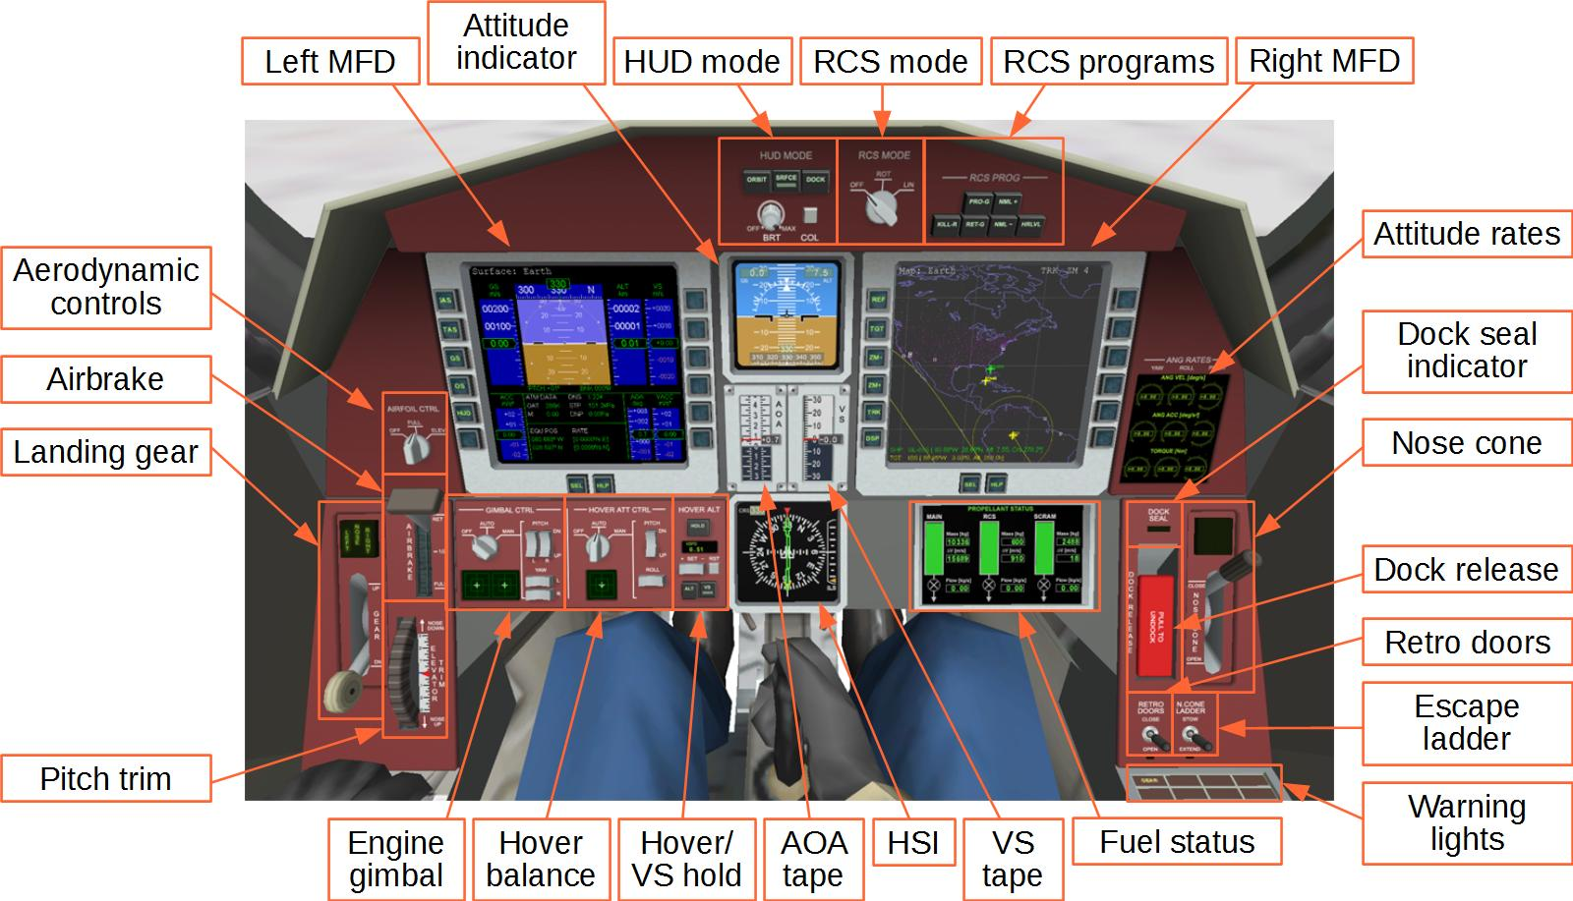
Delta-glider virtual cockpit: main instrument panel

Moving between VC positions
The default virtual cockpit position places you in the pilot’s seat, behind the pane of the head-up display and with access to all instruments and flight controls. You can however also switch your position to any of the 4 passenger seats in the cabin, for example to experience the replay of a recorded flight from a passenger’s perspective.
To switch to a different VC position, use Ctrl-arrow key combinations. The picture illustrates the different jump paths.
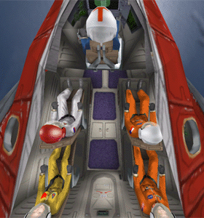
▪
▪
▪
▪
▪
▪
▪
▪
▪
▪
▪

Controls and instruments

RCS and aerodynamic control selection
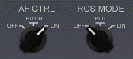
The AF CTRL selector is used to activate control of aerodynamic surfaces via manual user input. Manipulating the control surfaces is only effective within an atmosphere at sufficiently high dynamic pressures. The settings are: OFF (control surfaces disconnected), ON (control surfaces enabled), and PITCH (only pitch control enabled).
The RCS MODE selector sets the Reaction Control System mode which is used to control attitude in free space. During atmospheric flight, when aerodynamic control surfaces are active, the RCS is usually disabled. The selector can be set to OFF (RCS disabled), ROT (RCS in rotational mode), and LIN (RCS in linear mode).
Both selectors can be set with the left and right mouse buttons. Shortcuts for RCS are _{Numpad} (ROT/LIN) and ▪_{Numpad} (ON/OFF). Shortcut for AF control is _{Numpad} (ON/OFF).

Main engine gimbal control
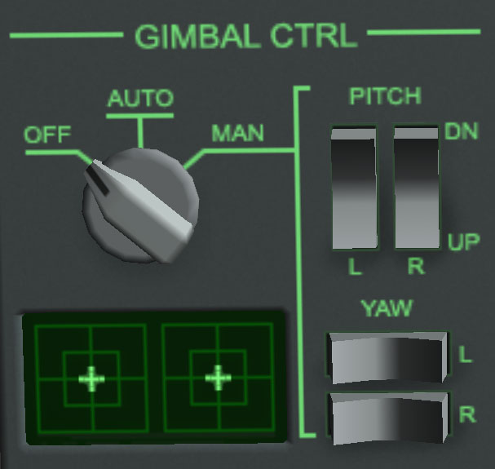
Both main engines can be gimballed independently in pitch and yaw. Gimbal range is ±5.0° in pitch, and ±7.4° in yaw. The yaw range allows to compensate for torque generated by a single engine at main thrust.
The main engine pitch and yaw gimbal controls are located on the lower left main panel. The mode selector dial has three settings: OFF – engines are centered; AUTO – gimbal settings are commanded from pilot control input, yaw gimbal compensated for engine differential thrust; MAN – gimbal settings are adjusted manually.
The display below the selector dial shows the commanded and current pitch and yaw gimbal positions for both engines. The outer box indicates maximum gimbal deflection, the inner box half that value.
In AUTO mode, the gimbal settings follow the pilot's pitch, yaw and roll commands from joystick or keyboard controls. They provide automatic thrust vectoring for enhanced angular acceleration. Thrust vectoring can be used in conjunction with aerodynamic control surfaces or RCS attitude control, or on its own.
Note that the roll moment provided by thrust vectoring is relatively small, since the main engines are mounted close to the vessel centerline.
In addition to thrust-vector assisted attitude control, the AUTO gimbal mode also provides compensation for thrust differences between the two main engines by adjusting the yaw gimbal setting. The gimbal positions are set such that the main engines do not generate an angular momentum as a result of thrust differentials. However, a lateral (left-right) linear momentum will be induced by a non-neutral yaw gimbal setting, resulting in a nonzero slip angle.
In MAN mode, the gimbal settings for pitch and yaw can be set manually with the rocker switches right of the selector dial. Clicking between a switch pair activates both switches, while clicking at the edge of a switch activates it individually.

Hover attitude control
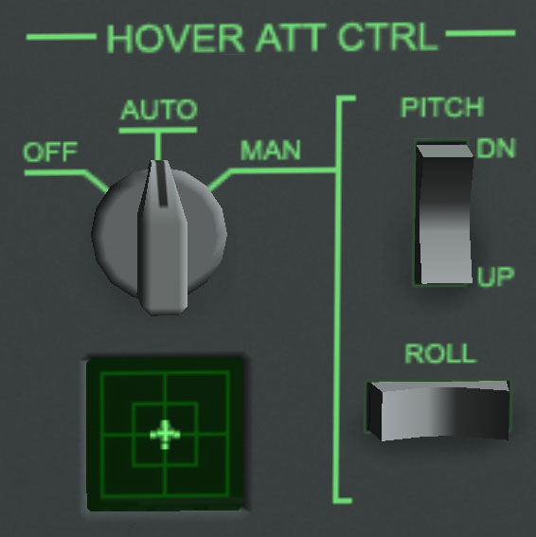
The hover attitude mode allows to modulate the relative thrust of the three hover engines to change the vessel attitude during hover operation. The hover attitude panel is located at the lower left front panel in the virtual cockpit.
The selector dial has three positions: OFF – attitude control disabled, all thrusters engage at the same levels; AUTO – automatic attitude balancing mode; MAN – manual pitch and roll modulation.
In AUTO mode, the target attitude is commanded by the manual input controls (keyboard or joystick). With controls in neutral position, the differential hover thrust is set to keep the vessel level with the local horizon. Engaging pitch and roll controls commands a target pitch or roll attitude, maintained by differential hover thrust. This change in attitude creates a horizontal component of the thrust from the hover engines, resulting in a horizontal acceleration. Centering the stick again zeros the horizontal acceleration, maintaining the current horizontal velocity (in the absence of an atmosphere). This mode is useful adjusting the vessel position over a target touchdown point during VTOL operations.
The automatic hover attitude mode should usually be used in conjuction with the hover hold altitude/vertical speed mode, since the vertical component of the hover thrust is affected by the vessel attitude, resulting in a change of vertical speed. The hover hold altitude/vertical speed mode automatically adjusts for this.
Note that the automatic hover attitude mode is only operational for vessel pitch and bank angles < 30°. At higher attitudes, the automatic mode disengages.
The hover attitude control system modulates the differential thrust of the hover engines so that the total thrust from the engines is unaffected. This means that hover attitude control is disabled if the hover engines are operating close to full or zero thrust, because this leaves insufficient reserve for the differential modulation.
In general, RCS rotational attitude control should be disengaged before activating hover attitude control to avoid conflicts between the two attitude control loops.
In MAN mode, the commanded pitch and roll angles are set with the two rocker switches to the right of the selector dial.
The display below the dial shows the current and commanded hover pitch and bank attitudes. The inner and outer box shown in the display indicate an attitude angle of 5° and 10°, respectively.

Hover hold altitude/vertical speed control
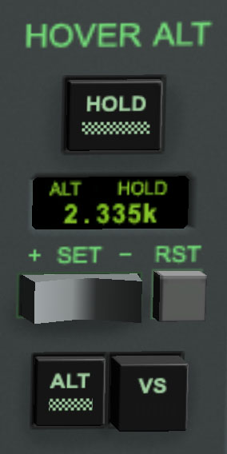
The hover hold altitude/vspeed panel allows to automatically adjust the thrust of the hover engines for maintaining a specified altitude or vertical speed. The panel is located at the centre of the lower front panel in the virtual cockpit.
Select the altitude or vertical speed mode with the ALT/VS buttons at the bottom of the panel. The display shows the current target setting of the selected parameter in m above mean radius (ALT) or m/s (VSPD). The value can be adjusted with the SET +/- rocker switch. In ALT mode, the RST button sets the target altitude to the current vessel altitude. In VSPD mode, the RST button sets the target vertical velocity to 0.
Press the HOLD button to activate the selected hover mode. Pressing the button again disengages the hover program. The vessel will maintain the hover thrust setting at that point.
When switching directly from active ALT mode to active VS mode, the target vertical speed is set to the current vertical speed. Likewise, switching from active VS to active ALT mode set the target to the current altitude.
The hold altitude/vertical speed mode requires the vessel to be moderately level with the local horizon. It should therefore be used in combination with the automatic hover balance mode. At significant pitch or bank angles the available hover thrust may not be sufficient to maintain the commanded value.
The hover hold altitude/vertical speed mode is most useful in proximity of the surface of a planetary body without atmosphere, where vertial takeoff and landing is required. The vertical speed mode can be used for controlled launches and touchdowns.

Keyboard controls
In addition to the generic Orbiter vessel control keys, the DG supports the following vessel-specific key controls:

 | Operate landing gear
😐 | Operate nose cone docking mechanism
 | Open/close outer airlock door
▪ | Open/close inner airlock door
U | Open/close top hatch
 | Deploy airbrakes by one step
▪ | Retract airbrakes by one step
 | Deploy/retract radiators
h | Cycle HUD modes
▪H | Deploy/retract HUD screen
▪+Space | Open animation control dialog box

Control dialog
You can open a dialog box with shortcuts with some common control actions for the DG by pressing ▪+Space. This is particularly useful for external camera views, when the control elements on the instrument panels are not accessible.
- Landing gear: extend/retract the undercarriage.
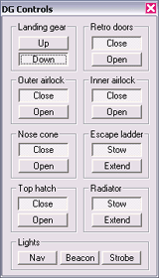
- Retro doors: Open/close protective doors covering the retro engines on the leading edge of the wings. The retros are only functional when the doors are fully open. Close the doors during atmospheric flight.
- Outer airlock: Open/close the outer airlock door.
- Inner airlock: Open/close the inner airlock door.
- Nose cone: Open/close the four segments of the nose cone to expose the docking mechanism. Open before docking approach or for EVA operations, close during atmospheric flight.
- Escape ladder: Extend/retract a ladder for access to the airlock entry when landed. The escape ladder is only operational if the nose cone is open, and will retract automatically when the cone is closed.
- Top hatch: Open/close the escape hatch at the top of the passenger cabin.
- Radiator: Extend/stow the radiator located in the rear of the glider’s fuselage. Extend only during orbital phase of the flight.
- Lights: Turn the glider’s strobe and navigation beacons on and off.

Autopilot functions
Autopilot functions for the DG are provided via the LuaOrbiter Script Interface. For details on using scripts, see LuaScripting.pdf. You can enter commands and scripts either from the ScriptMFD mode, or from the Lua console window.

Atmospheric autopilot
Atmospheric autopilot (AAP) functions provide altitude and airspeed control. They require the presence of sufficient atmospheric pressure to function. The atmospheric autopilot works similarly to the autopilot in a conventional aircraft.
The AAP is defined in Script/dg/atmap.lua. This script is loaded automatically into the glider's Script MFD environment. When using the console window, the script must be loaded manually with the following command:
run('dg/aap')
If you try to run this script for a different vessel type, a warning is displayed. The autopilot parameters are tailored towards the glider's aerodynamic behaviour.
The altitude autopilot is enabled with
aap.alt(tgtalt)
where tgtalt is the target altitude [m]. The target altitude of a running autopilot can be modified by either calling the aap.alt function with a different target altitude argument, or by overwriting the aap.tgtalt parameter:
aap.tgtalt = newalt
where newalt is the new target altitude [m]. The autopilot can be disabled by omitting the altitude argument:
aap.alt()
The airspeed autopilot uses a similar mechanism. It can be activated, modified and disabled with the following syntax:
aap.spd(tgtspeed)
aap.tgtspd = newspeed
aap.spd()
The altitude and airspeed autopilots can be activated simultaneously
The altitude autopilot acts on the elevator position only. The airspeed autopilot acts on the main throttle setting only. Certain combinations of target settings may not result in a stable condition. For example, a low speed and high altitude setting cannot be sustained simultaneously. In this case, the AP will maintain the target airspeed and move the elevators to full up position, but will sink to an altitude below the target altitude, until sufficient lift is generated to compensate for gravity.
The bank function sets the DG to a defined bank angle:
aap.bank(tgtbank)
aap.tgtbnk = newbank
aap.bank()
where the bank angle is given in degrees. Positive angles indicate a left bank, negative angles a right bank.
The heading autopilot turns the DG to a specified heading:
aap.hdg(tgtheading)
aap.tgthdg = newheading
aap.hdg()
where the heading argument is given in degrees in the range 0 ≤ heading < 360. The heading autopilot internally launches the bank function in a sub-process to achieve the specified heading. Bank and heading autopilots should not be activated simultaneously by the user.

Technical specifications
Empty mass | 11.0·10³ kg (DG) | 13.0·10³ kg (DG-S)
Main fuel mass | 12.9·10³ kg | (10.4·10³ kg + 2.5·10³)
RCS fuel mass | 0.6·10³ kg
Max takeoff mass | 24.9·10³ kg (DG) | 26.9·10³ kg (DG-S)
Length | 17.76 m
Wingspan | 17.86 m
Thrust | 2 x 1.6·10⁵ N | (main engines)
 | 2 x 3.4·10⁴ N | (wing-mounted retro thrusters)
 | 3 x 1.1·10⁵ N | (hover thrusters)
Isp | 4·10⁴ m/s | (fuel-specific impulse in vacuum)
Inertia (PMI) | 15.5 / 22.1 / 7.7 m²
Stall C_{L} | 1.0
Stall AOA | 20°

