ORBITER Antelope Valley Scenery Pack

Copyright (c) 2000-2016 Martin Schweiger Monday, November 21, 2016
Orbiter home: orbit.medphys.ucl.ac.uk/

Contents
1 Introduction 2
2 Installation 2
3 Contents 2
3.1 Coverage 3
3.2 Scenarios 3
4 Included airports 3
4.1 Edwards AFB 3
4.2 Palmdale USAF Plant 42 4
4.3 Mojave Spaceport 5
5 Airport diagrams 7

Introduction
The Antelope Valley scenery pack is an addon scenery package for Orbiter Space Flight Simulator 2016. It contains high-resolution surface textures for a section of Antelope Valley in southern California, including some airports with spaceflight-related significance.
Texture processing from public domain aerial imagery by Martin Schweiger. Base structures by Ricardo Nunes (Edwards, from Orbiter stock bases upgrade with permission) and Martin Schweiger (Mojave and Palmdale).

Installation
The Antelope Valley scenery can be installed in a basic Orbiter installation and does not require prior installation of the global Earth high resolution texture pack (available at http://orbit.medphys.ucl.ac.uk/mirrors/orbiter_radio/tex_mirror.html). However, if you choose to merge the scenery pack into the texture tree archive (see Step 3 below), then subsequent installation of the global high-resolution textures will require re-installation of all merged texture pack addons.
Step 1: Unzip the antelope_scn.zip file in your main Orbiter installation directory. (Recommended: use 7-zip utility with “extract here” option.) Allow the unzip utility to overwrite files when prompted.
Note: Some unzip utilities will extract the contents of the zip file into a directory “antelope_scn”. If that happens, you will have to manually move the contents of that directory into the Orbiter main directory.
Step 2: Launch Orbiter, open the Extra tab on the Launchpad dialog, open Visualisation parameters | Planet rendering options, and make sure that Tile sources is set to Try cache first, then archive. This will make sure that Orbiter finds the high resolution texture content.
Note: If running an external graphics clients, the equivalent option on the client-specific configuration page should be selected.
Step 3 (optional): If the texture pack works ok, you can merge the new textures into your Earth tile database. You can either use the Utils\texpack.exe utility to unpack your existing database and then repack it together with the addon tiles. This method is not recommended (can be very slow and generates a large number of files). Or you can use the 3rd-party Orbiter texture tree tools (OT3) utility (see http://orbiter-forum.com/showthread.php?t=37452).

Contents
The Antelope Valley scenery pack contains
- Surface texture tiles (resolution levels 17-19) which replace some of the tiles in the global Earth highres package and add some additional ones
- Elevation tiles (up to resolution level 15) based on National Elevation dataset (NED) data replacing the SRTM-30 data of the global Earth highres package with less noisy elevation data in the southern CA area.
- Elevation mod tiles for flattening airports and runways
- Modified/added surface base definition files for Edwards AFB, Palmdale USAF Plant 42 and Mojave spaceport.
- Some Orbiter scenarios for showcasing the new scenery.

Coverage
The high-resolution texture contained in this package covers the area between 117.421875° W to 118.4765625° W and 34.453125° N to 35.15625° N in Antelope Valley, Kern County, southern California.
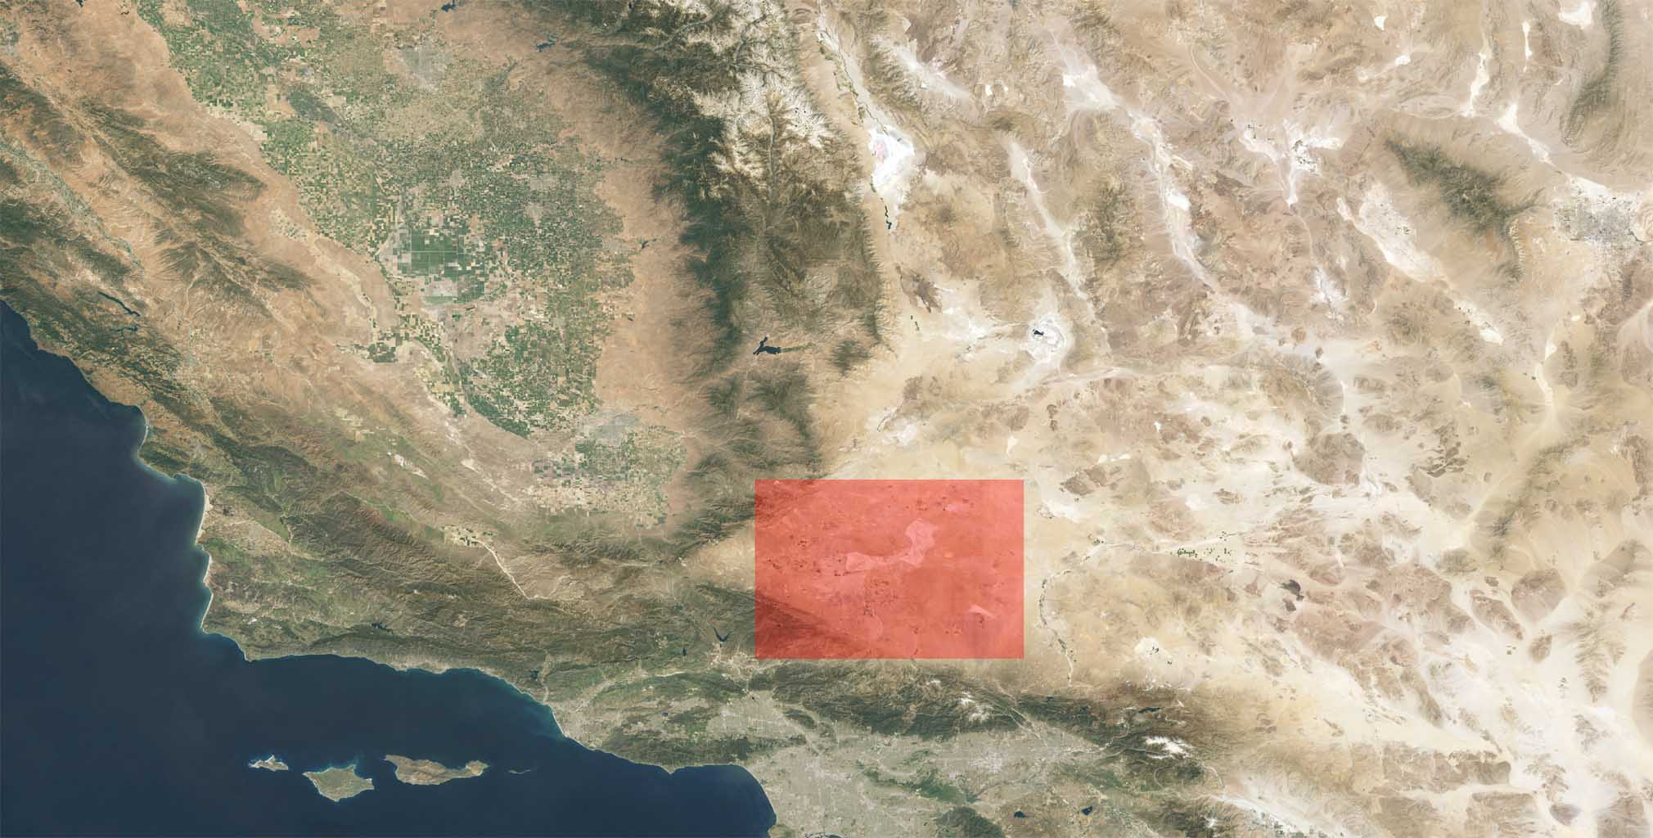

Scenarios
After launching Orbiter, some introductory scenarios showcasing the new scenery and airports in the addon package can be found under the Antelope Valley scenery folder. This also includes the playback scenario Mojave to Edwards. After trying out these scenarios, the Scenarios\Antelope Valley scenery folder can safely be deleted, because all its scenarios are also available from other locations (Launch sites and spaceports, Playback).

Included airports

Edwards AFB
Edwards was used for Space Shuttle orbiter testing during the development phase of the Space Shuttle program, conducting test flights with the prototype Space Shuttle Enterprise. During the operational phase of the Shuttle program, Edwards served as the primary landing site until 1991, and as backup thereafter.
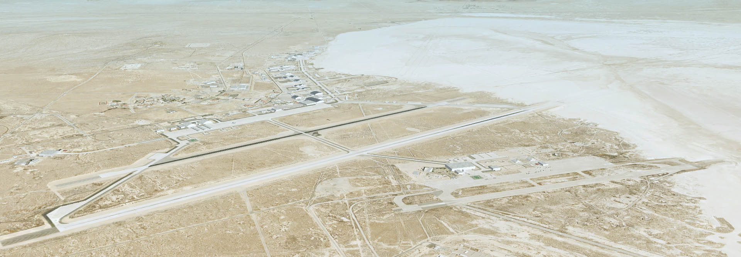
Location: 34.90556°N 117.88361°W
Elevation: 702 m

Runways:
There are three paved runways and a number of marked runways on the Rogers lakebed.
04R/22L | 4,579m x 91m (+2,922m on lakebed)
04L/22R | 3,658m x 61m
06/24 | 2,438m x 15m (+3,100m x 64m on lakebed)

17/35 | 11,917m x 274m
05L/23R | 6,759m x 91m
05R/23L | 4,572m x 91m
06/24 | 2,149m x 91m
07/25 | 7,041m x 91m
09/27 | 3,045m x 91m
12/30 | 2,815m x 183m (2 adjacent runways L, R)
15/33 | 8,988m x 91m
18/36 | 7,037m x 274m (three adjacent runways L, C, R)

ILS support:
22L | LOC/GS: 110.10 MHz

Palmdale USAF Plant 42
Plant 42 is the site of the Rockwell Palmdale assembly facility where the individual systems of the Space Shuttle were assembled and tested.
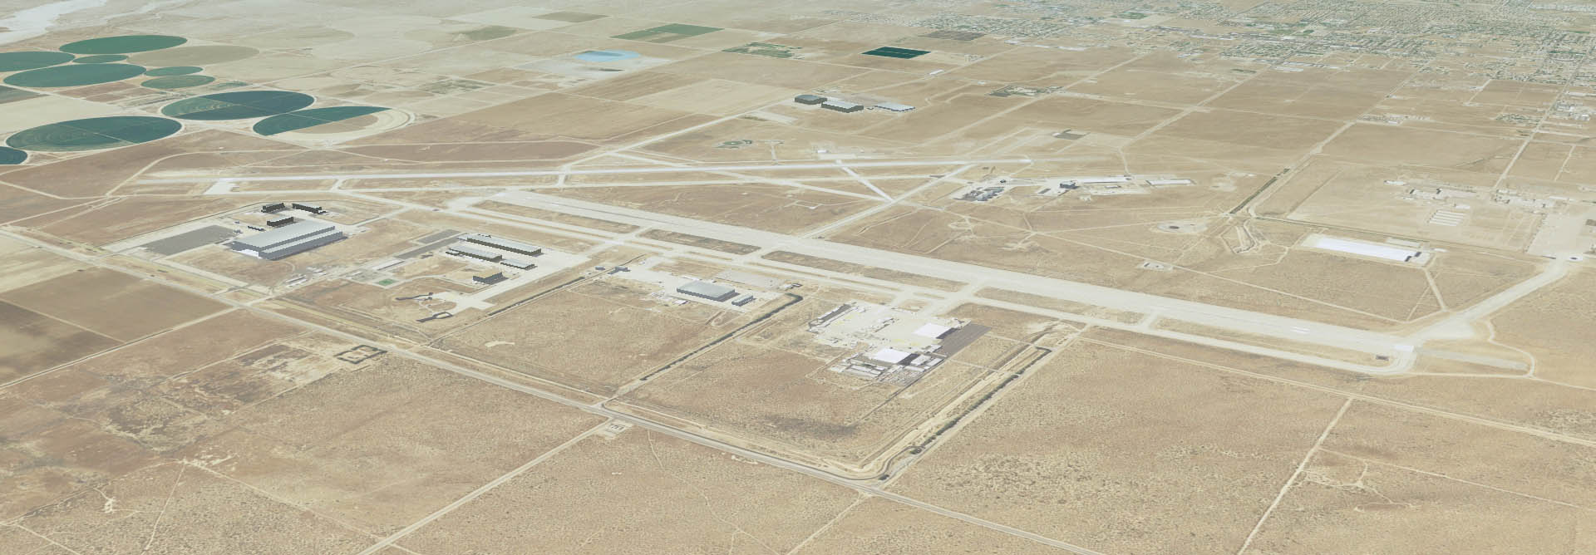
Location: 34.62944°N 118.08444°W
Elevation: 775.1 m

Runways:
4/22 | 3,658m x 46m
7/25 | 3,658m x 61m
072/252 | 1,829m x 23m

Mojave Spaceport
The Mojave Air and Space Port is a test centre for civilian aerospace research. It has been chosen as a test site for several teams in the Ansari X Prize, including Scaled Composites (SpaceShipOne). Other companies represented at Mojave Spaceport are Virgin Galactic, XCOR Aerospace and Masten Space Systems.
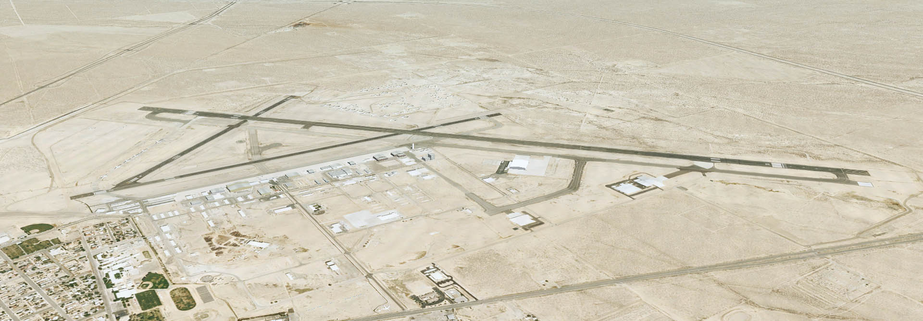
Location: ﻿35.05944°N 118.15167°W
Elevation: 851 m

Runways:
12/30 | 3,811m
08/26 | 2,149m
04/22 | 1.446m

Airport diagrams
Source: www.faa.gov
