Shuttle-A Operations Manual

Copyright (c) 2005-2010 Martin Schweiger 07 November 2026
Orbiter home: orbit.medphys.ucl.ac.uk/ or www.orbitersim.com

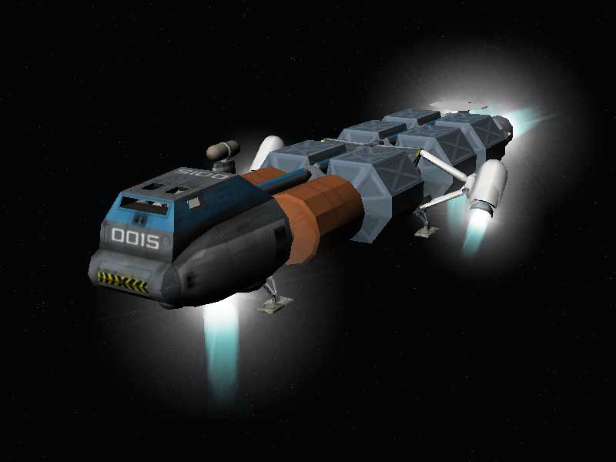

Contents
1 Introduction 2
2 Instrument panels 2
2.1 Main panel 2
2.2 Attitude director indicator 3
2.3 Overhead panel 3
3 Vessel-specific keyboard functions 4
4 Technical specifications 4
4.4 Engine specifications 4
4.5 Propellant resources 4
4.6 Docking port 5
4.7 Physical parameters 5
5 Credits 5

Introduction
The Shuttle-A is a cargo vessel designed for a low gravity/low pressure operational environment. Its primary area of deployment is for transport duty between LEO (low Earth Orbit), the Moon, Mars, and potentially moons in the outer solar system. In its current configuration it is also capable of achieving orbit from Earth’s surface, but this requires a precise ascent profile.
The engine layout consists of a set of two main engines, two hover engines, and two engines in central side pods which can be rotated for hover or retro duty. There are two different propellant systems for main and RCS engines.
The Shuttle-A contains a docking port and airlock below the habitat module which is protected by a hatch during atmospheric flight.

Instrument panels
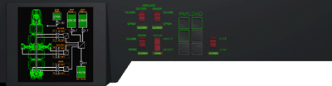
payload control
Fuel tank/pump status indicator
airlock/lock cover control

main engines
hover engines
thrust indicators
aux engines
aux pod tilt controls

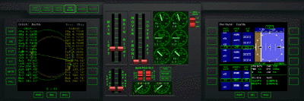
Navmode selectors/
indicators
left MFD
RCS mode selector
right MFD

Main panel
The main panel provides access to the manual engine controls on the middle console, and two multifunctional displays (MFD) on the left and right.
Main, hover and auxiliary thrusters can be operated individually, by engaging the throttle controls separately, or in pairs, by clicking and dragging between throttle sliders.
The thrust levels for the 6 principal engines are shown via the gauges on the middle console.
The RCS operation mode (linear, rotational, disengaged) can be selected by the switch on the top right of the middle console.
Navmode selectors/indicators are located above the left MFD.

Auxiliary engine controls
The controls at the bottom of the middle console operate the auxiliary engines located in two side pods in the central section of the vessel. They can be used for providing a mixture of forward, retro and/or hover thrust.
The throttle sliders control the amount of thrust generated by the auxiliary pods. The two flip switches can be used to rotate the pods, to modify the thrust direction. Shortcut buttons for forward, hover and retro directions are also available. The indicators below the switches show the preset and actual directions of the pods.

Attitude reference and ADI
The attitude director indicator (ADI) provides feedback to the pilot about the spacecraft orientation with respect to a given frame of reference. It consists of a ball that can rotate and is always aligned with the reference frame, and a direction index representing the orientation of the spacecraft (given by its pitch, yaw and roll angles) relative to the frame.
The parameters of the attitude reference, as well as the operation mode of the ADI, can be controlled by the panel below the ADI.

Attitude frame
The frame selection dial sets the reference frame represented by the ADI. In practicce, the most useful reference frame will depend on the current task or journey segment.
- Ecliptic (ECL). Reference frame is the ecliptic and equinox of epoch J2000. Direction (P=0, Y=0) points to the vernal equinox. Direction (P=+90) points to the ecliptic north pole. This is an inertial frame most useful for interplanetary trips.
- Equator (EQU). Reference frame is the equator of the body currently being orbited. Direction (P=0, Y=0) points to the ascending node of the ecliptic w.r.t. the planet’s equator. Direction (P=+90) points in the positive direction of the planet’s rotation axis. This is a (nearly) inertial frame (subject to the planet’s axis precession), and most useful for orbital operations.
- Orbital velocity / orbital momentum vector (OV/OM). This is a rotating frame. The axis (P=0, Y=0) is aligned with the vessel’s current orbital velocity vector relative to the orbit reference body. The (P=+90) axis is aligned with the orbital momentum vector (i.e. perpendicular to the orbital plane). This reference frame is equivalent to that used by the Orbit HUD mode, but rotated by 90 degrees in roll.
- Local horizon / local north (LH/LN). This is a rotating frame. The axis (P=0, Y=0) is aligned with the local heading=0 direction in the local horizon plane. Axis (P=+90) is aligned with the normal of the local horizon plane. This reference frame is equivalent to that used by the Surface HUD mode.
- Link to NAV radio source (NAV 1/2). The reference frame can be selected implicitly by feeding data from one of the NAV radio receivers to the ADI. The orientation of the frame depends on the NAV signal type.
NAV signal | Reference frame
None | None (ADI deactivated)
IDS | Aligned with docking port orientation:  (P=0, Y=0): port approach direction (DIR)  (P=+90): longitudianl port alignment (ROT)

A user-defined offset can be added to any of the predefined reference frames. To do this, set the selector toggle in the “Offset” group to “Frm”, and then use the “R” (roll), “P” (pitch) and “Y” (yaw) switches to set the offset to any of the three Euler angles. The “Reset” button resets the offsets to zero.

Target
The ADI contains two error needles designating the direction of a target on top of the ADI ball. The needles form a cross-hair marking a particular point on the ADI ball (within the limit of about +/- 40 degrees in pitch and yaw from the current vessel orientation). The type of target can be selected with the “Target” dial on the control panel.
- None (no target). The error needles are deactivated and return to the centered position. Target indicator on the ADI instrument shows “OFF”.
- Fixed (fixed location relative to reference frame). In this mode, the error needles mark a fixed point on the ADI ball. By default, this is the point (P=0, Y=0), but any pitch/yaw point can be selected by specifying target offsets (see below).
- N. Brg (NAV transmitter bearing). If the reference frame is set to NAV 1 or NAV 2, and the specified NAV receiver is currently tuned to a transmitter in range, then the error needles point to the bearing of the transmitter in the current frame. Otherwise the error needles are deactivated.
- N. Vel (NAV transmitter velocity). If the reference frame is set to NAV 1 or NAV 2, and the specified NAV receiver is currently tuned to a transmitter in range, then the error needles point to the velocity of the transmitter relative to the spacecraft. Otherwise the error needles are deactivated.
Note that in all modes, the error needles mark the direction 180 degrees away from the target as well as the direction towards the target. To distinguish between directions towards and away from the designated target, the ADI ball shows “TO” and “FROM” in the target indicator box, respectively. For example, if the target is set to N. Brg, the needles are centered, and the target indicator shows “FROM”, then the target is located exactly behind the spacecraft.
Similar to the reference frame, an offset can be added to the target direction. To do this, set the selector toggle in the Offset group to “TGT”, and then use the “P” (pitch) and “Y” (yaw) switches to define an offset. Note that the “R” (roll) switch is not used for target offsets. The “Reset” button resets the target offsets to zero.

Attitude rates
The rates of change in pitch, yaw and roll are indicated by indicators at the left, bottom and top edge of the instrument respectively. The indicator ranges are -10 to +10 deg./s for all three angles, with tick marks spaced at 2 deg./s. The rates refer to the local vessel frame. (The option to display the rates in the reference frame will be provided later).

ADI layout
The ADI ball is available in two layouts:
Layout | Pitch range | Yaw range | Poles
0 | -90 ... +90 | 0 ... 360 | at pitch = -90 and +90
1 | 0 ... 360 | -90 ... +90 | at yaw = -90 and +90
The layout can be selected on a per vessel/per scenario basis by adding an ADI_LAYOUT item with value 0 or 1 to the Shuttle’s scenario entry. If this item is not present, the value from ADI_DEFAULT_LAYOUT in the ShuttleA configuration file (Config\Vessels\ShuttleA.cfg) is used. If this entry is also not present, layout 0 is used. The layout can be switched interactively from a console with the command
v:set_adilayout(layout)
where v is assumed to be a valid Shuttle-A instance and layout is 0 or 1.
Note that the two layouts do not report the same attitude angles. The definition of the Euler angles differs between the two layouts. Let R be the rotation matrix that maps the current vessel attitude from reference to global frame. Then the Euler angles for the two ADI layouts are given as follows:

Overhead panel
Located on the left of the overhead panel is the propellant status indicator. It contains readouts for current tank fill status, and mass flow rates for the main fuel pumps.
The panel also contains switches and indicators to operate the docking hatch, airlocks and landing gear.
(Note: The inner airlock is not yet operational in this release)
This panel also contains controls to operate the release control of the six cargo pods of the Shuttle-A.

Vessel-specific keyboard functions
In addition to the generic keyboard functions, Shuttle-A class vessels respond to the following keyboard commands:
😐 | Operate docking hatch mechanism
 | Open/close outer airlock door
 | Operate landing gear.

Technical specifications

Engine specifications
Main engines (2)
Thrust rating: 193.52 kN per engine
Isp: 3⋅10⁴ m/s

Hover engines (2)
Thrust rating: 135.45 kN per engine
Isp: 3⋅10⁴ m/s

Auxiliary retro/hover engines (2)
Thrust rating: 60.0 kN per engine
Isp: 3⋅10⁴ m/s
Engines are located in pods which can be rotated for retro/hover thrust.

Reaction Control System
Thrusters located in crew module, main engine module and side pods.
Linear modes: 5 kN thrust for each translation axis
Rotational modes, torque:
Pitch: 75 kNm
Bank: 30 kNm
Yaw: 75 kNm
Isp: 3⋅10⁴ m/s

Propellant resources
Two external tanks in the forward cargo holds (capacity: 6.4⋅10³ kg each) and one internal tanks in the aft module (capacity: 3.2⋅10³ kg) provide fuel for the main, hover and auxiliary engines.
A separate tank in the central module (capacity: 700 kg) provides fuel for the Reaction Control System.

Docking port
The docking port is located in the front module. During flight it is covered by two panels, which can be folded back to expose the docking mechanism.

Docking port reference position:
0, 0, 18.32 (aligned with longitudinal vessel axis)

Docking approach direction:
0, 0, 1 (forward)

Physical parameters
Empty mass: 22⋅10³ kg
Length: 35.0 m
Height: 6.98 m
Width: 15.4 m
Cross sections: 132.2 m², 237.9 m², 42.4 m²
Principal moments of inertia (PMI), mass-normalised:
86.6 m², 89.8 m², 5.5 m²
Atmospheric resistance coefficients (c_{W}):
0.2 (longitudinal), 1.5 (vertical), 1.5 (transversal)
Rotation drag coefficients:
0.7 (yaw), 0.7 (pitch), 0.3 (bank)

Credits
Special thanks to Roger “Frying Tiger” Long for his excellent model of the Shuttle-A, and to Radu Poenaru for the virtual cockpit implementation and code extensions, including cargo management and landing gear.

