ORBITER Scenario Editor

Copyright (c) 2006-2022 Martin Schweiger Tuesday 26 July 2022
Orbiter home: orbit.medphys.ucl.ac.uk
Contents
1 Introduction 2
2 Using the editor 3
2.1 Creating a new vessel 3
2.2 Configuring a vessel 3
2.3 Orbital elements 4
2.4 State vectors 6
2.5 Orientation 7
2.6 Angular velocity 8
2.7 Surface location 8
2.8 Propellant levels 10
2.9 Docking management 10
2.10 Deleting a vessel 11
2.11 Changing the simulation date and time 11
2.12 Saving a scenario 13
3 Developer section 14
3.1 Vessel configuration files 14
3.2 Adding vessel-specific editor pages 14

Introduction
Orbiter’s Scenario Editor can be used to create, configure and delete vessels during a running simulation session.
Vessel states can be edited by applying orbital elements, state vectors, surface location, fuel states, docking connections or vessel-specific parameters. The resulting configuration can be saved as a scenario and used to launch a simulation session later.
The editor is provided as a plug-in module that comes with the default Orbiter installation. To make it available in Orbiter, make sure that the ScnEditor module is loaded from the Modules tab of the Orbiter Launchpad dialog (see Chapter Modules tab in the Orbiter User Manual for details on activating plug-ins).
During the simulation, the scenario editor can be opened from the list in the Custom Functions dialog (▪). This brings up the editor’s main page, containing a list of all vessels in the current simulation session. Each entry displays the vessel name, class and reference celestial body. When a vessel is selected from the list, the camera automatically jumps to that vessel if the Track box is ticked.
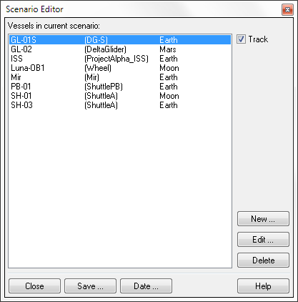
From the main page, the user has the option to
Track selected vessel
Create new vessel
Edit selected vessel
Delete selected vessel
Close editor
Save scenario
Set date & time
Open help
Vessel list
- create a new vessel,
- edit the vessel selected in the list,
- delete the selected vessel,
- change the simulation date, or
- save the scenario to a file.

Using the editor

Creating a new vessel
After clicking the New button on the main page, the editor displays the vessel creation page. It shows a list of all spacecraft types recognised by Orbiter in the Vessel type box.. Note that some vessel types may be located in subfolders. To see what a particular vessel class looks like, click on the entry in the list, and a picture is shown next to it. (Not all vessel types may support this feature).
Select a type from the list, and enter a unique vessel name in the Vessel name box above. If you enter a name that is already in use, or forget to select a vessel type, the editor will not allow you to proceed.
If you want the simulator to display the new vessel as soon as it is created, tick the Set camera box. In addition, ticking the Set input focus box makes the new vessel the focus vessel, receiving user input via keyboard, mouse and joystick. Note that some vessel types may not accept input focus.
Click the Create button to generate the new vessel. All new vessels are placed in a default location (in a low Earth orbit).
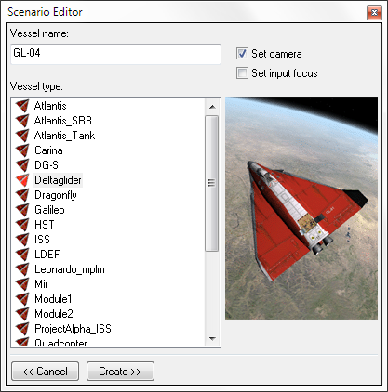
The editor now switches to Configuration mode. From here, the position, orientation and other state parameters of the new vessel can be set.
Attach camera to new vessel
Vessel thumbnail
Return to main page
Create new vessel
Vessel name
Set input focus to new vessel
Vessel class list

Configuring a vessel
After clicking the Edit button on the main page, or after creating a new vessel, the scenario editor displays the vessel configuration page for the selected vessel. From here, various aspects of the vessel state can be adjusted, such as its position, velocity and orientation. It can also be refuelled or docked to another vessel. Some vessel types may also allow control of class-specific parameters from here.
Note: Although not strictly necessary, it is sometimes useful to pause the simulation (▪p) before editing a vessel. Otherwise the continuously changing state values may make a precise configuration tricky.
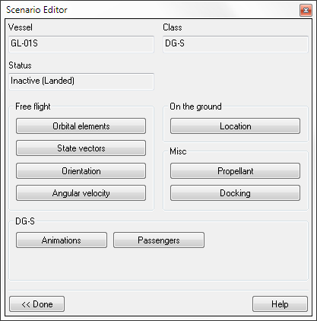
Vessel class
Set ground location
Set propellant levels
Set docking connections
Vessel name
Vessel status
Set orbital elements
Set position and velocity
Set vessel orientation
Set angular velocity
Set vessel-specific options
Return to main page
Open help

Orbital elements
This page can be used to place a vessel in orbit around a celestial body.
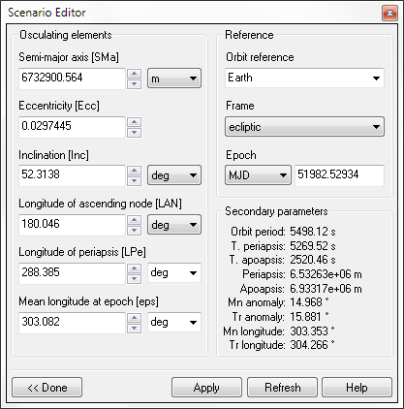
First select the reference body (planet, moon or sun) around which the vessel is to orbit in the Orbit reference box in the right column.
Reference body
Reference frame
Reference time
Additional orbi-tal parameters
Elements of the osculating orbit
Open help
Return to configuration page
Apply elements
Refresh elements
Next, in the Frame box below, select the coordinate frame in which the elements are expressed. The choices are ecliptic and ref. equator. The ecliptic frame is defined by the plane of Earth’s orbit and the direction of the vernal equinox (at epoch J2000.0). This frame is useful for example to place the vessel into an orbit for an interplanetary transfer. The equatorial frame is defined by the equatorial plane of the reference body. It is useful if you want to place the vessel into a specific orbit with respect to the planet surface, e.g. geostationary or polar.
Finally, set the reference epoch for the elements. This is the date to which the mean longitude parameter of the orbital elements refers (see below). When setting this to current, the longitude value refers to the current simulation time. Otherwise, the value refers to the longitude at the specified MJD (Modified Julian Date). The latter option is more useful when editing a scenario without pausing, because a vessel’s mean longitude is continuously changing along its orbit.
Now everything is ready to set the elements in the left column. The six elements completely describe a Keplerian (2-body) orbit of an object in the form of a conic section, either periodic (elliptic) or non-periodic (hyperbolic). Under the influence of gravitational perturbations the elements change over time. In this case, the specified values define the current osculating orbit, i. e. the hypothetical unperturbed orbit that would produce the vessel’s state vectors (position and velocity) at the current time.
Below is a short description of the 6 orbital elements. See also Chapter Orbital mechanics primer in the Orbiter User Manual (orbiter.pdf).

Semi-major axis [SMa]
For elliptical orbits, this is the largest semi-diameter of the orbital trajectory. For hyperbolic orbits, SMa is negative and its absolute value represents the distance between the origin (the point where the asymptotes of the hyperbola intersect) and the orbit periapsis.

Eccentricity [Ecc]
The eccentricity e defines the shape of the orbit.
e = 0: circular orbit
0 < e < 1: elliptic orbit
e = 1: parabolic orbit
e > 1: hyperbolic orbit

Inclination [Inc]
Inclination i is the angle between the orbital plane and the reference plane. For example, in the equatorial frame, i = 0° puts the vessel into an orbit above the planet’s equator, while i = 90° defines a polar orbit.

Longitude of ascending node [LAN]
This is the angular distance between the reference direction (e.g. to the vernal point) and the direction to the ascending node (the point at which the orbital trajectory passes through the reference plane from below).

Longitude of periapsis [LPe]
The sum of LAN and the argument of periapsis (the angle between the direction to the ascending node and the direction to periapsis).

Mean longitude at epoch [eps]
This parameter defines the vessel’s position along the orbital trajectory. The mean longitude is the sum of LAN and the mean anomaly (the angle between periapsis and the vessel position for a hypothetical circular orbit with the same orbital period as the true orbit). The value entered here refers to the specified epoch. For epoch = current, the value represents the vessel’s current (continuously varying) mean longitude. Otherwise, it is the longitude at the specified date (fixed for a given orbit).

State vectors
Instead of defining the vessel’s orbital trajectory by setting its osculating elements as described in the previous section, it is also possible to fix the vessel’s state vectors (position and velocity) at the current simulation time. Both methods are equivalent, but each may be better suited to specific situations.
First, select the desired celestial body (sun, planet or moon) in the Orbit reference box. All position and velocity parameters are interpreted relative to the centre of this body.
Next, select the reference coordinate frame in which the state vectors are expressed. The Frame box provides three options:
- ecliptic: The ecliptic frame uses the Earth’s mean orbital plane (epoch J2000.0) as reference plane (xz), and the direction of the vernal point as reference direction (+x). The ecliptic north pole defines the +y direction.
- ref. equator (fixed): The frame is defined by the equatorial plane of the reference body (xz), with +y pointing to the north pole. The frame is non-rotating, i.e. fixed with respect to the celestial sphere.
- ref. equator (rotating): This equatorial frame rotates with the celestial body (around the y-axis). The +x direction points to the prime meridian (longitude 0°).
Finally, select the coordinates to use. The choice is between cartesian coordinates (x, y, z) and (dx/dt, dy/dt, dz/dt) and spherical polar coordinates (r, φ, θ) and (dr/dt, dφ/dt, dθ/dt). Generally, polar coordinates will be more intuitive to use.
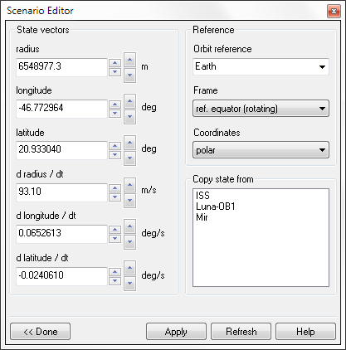
Everything is now set to edit the vessel position and velocity values. As the vessel’s state vectors are continuously changing during the simulation, it is probably best to pause the simulation at this point. Then press Refresh to update the data to the current vessel state. Now enter the new state vector data, and press Apply to pass them to the simulation. Use the spin controls next to the input boxes for direct updates.
Reference body
Reference frame
Coordinate system
Vessel list for copying state vectors
Position data (polar or cartesian)
Open help
Return to configuration page
Apply state
Refresh state
Velocity data (polar or cartesian)

Copy state
To place the vessel next to another spacecraft in the simulation, simply copy that vessel’s state vectors over into the scenario editor by clicking one of the entries in the Copy state from list (Only active vessels are shown in the list). Then click Apply to apply the copied state to your vessel. Unless the simulation was paused, the other vessel may have already moved away in the meantime. To copy and apply the state in a running simulation directly, you can double-click on the vessel in the list.
After copying your vessel to the other spacecraft’s position, you can edit the state vector entries to fine-tune the relative position and velocity of the two vessels.

Usage tips
Editing the state vectors is probably most useful when the vessel is close to a planetary surface, for example during atmospheric flight. At orbital altitudes, it is easier to control the vessel state via its orbital elements. Defining a stable orbit via position and velocity data is much more difficult.
When editing a vessel close to the surface, the rotating equatorial frame is a good choice. In combination with polar coordinates, the position values translate directly to planetary longitude, latitude and radius data, and the velocity data are equivalent to ground speed in longitudinal, latitudinal and radial direction.
By editing its state vectors, the vessel is set to active flight mode. Make sure the parameters you enter define a position above the surface. To place a vessel on the ground, use the Surface location page instead.

Orientation
Adjust the spacecraft orientation on this page. This applies only to active vessels (in flight), not for landed vessels (whose heading can be adjusted on the Location page).
Either explicitly set the Euler angles of the spacecraft axes with respect to the ecliptic frame of reference, or rotate the spacecraft around its pitch, yaw and bank axes.
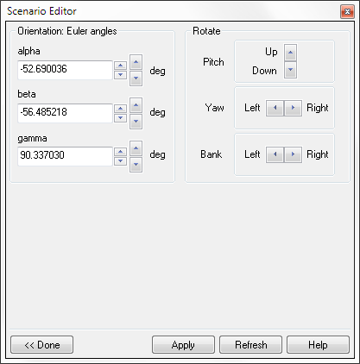
The Euler angles α, β, γ define the rotation matrix R which transforms from the vessel local frame to the global ecliptic frame as follows:
Pitch rotation
Yaw rotation
Bank rotation
Euler angles (ecliptic frame)
Open help
Return to configuration page
Apply rotation
Refresh data

More intuitively, the vessel can be rotated around its local axes by pressing the pitch, yaw and bank buttons. The pitch buttons rotate the vessel around its x-axis, the yaw buttons around the y-axis, and the bank buttons around the z-axis.
If the vessel is part of a composite structure (e.g. a spacecraft docked to a space station), the whole structure will be rotated.

Angular velocity
The controls on this page can be used to set the vessel’s angular velocity around its three principal axes: x-axis (pitch rate), y-axis (yaw rate) and z-axis (bank rate). To terminate the vessel spin altogether, press the Kill button.
Note that the angular velocity components can oscillate between the three axes, depending on the vessel’s inertia tensor. This means that pressing the Refresh button repeatedly may change the angular velocity values in the three axes, even if no additional torque is applied. Likewise, pressing the Apply button repeatedly with the same angular velocity values can lead to abrupt changes in vessel spin.
The angular velocity settings have no effect for vessels on the ground.
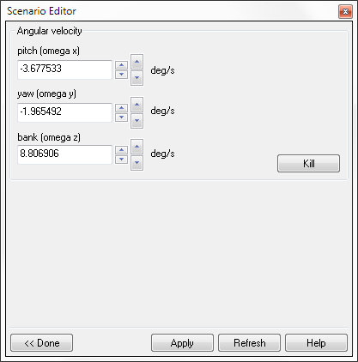
Kill rotation
Pitch velocity
Open help
Return to configuration page
Apply rates
Refresh data
Yaw velocity
Bank velocity

Surface location
Applying the options from this page places the vessel on the surface of a planet or moon.
First select the body on which to place the vessel in the Celestial body box. If applicable, select a spaceport in the Surface base box, and a Landing pad for the vessel. Alternatively, the equatorial coordinates of the landing site can be input directly in the Longitude and Latitude boxes. Use the Heading box to adjust the orientation of the vessel on the ground.
You can use the spin buttons next to the Longitude, Latitude and Heading boxes to adjust the values (small spinners scroll by small amounts, large spinners scroll by large amounts). If numerical values are entered directly, press Apply to register the new values.

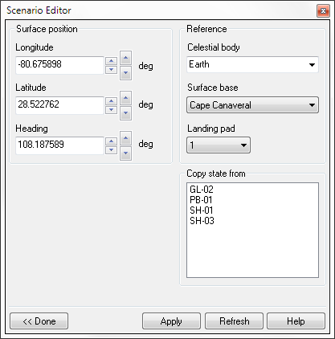
Composite structures
Reference body
Surface base
Landing pad
Vessel list for copying state vectors
Surface location
Open help
Return to configuration page
Apply state
Refresh data
Surface heading
Currently, placing a composite structure of docked vessels on the surface using the scenario editor is not well supported and can lead to positioning artefacts (parts of the structure submerged below the surface or incorrect orientation). To fix a ground-positioning problem, you can try the following workaround:
- pause the simulation
- go to the State vector tab, switch to rotating equatorial frame and polar coordinates
- use the radius spinner to lift the composite structure off the ground
- if necessary, switch to the Orientation tab and correct the structure’s orientation relative to the ground
- un-pause the simulation to let the structure drop back to the surface and allow it to settle on its own accord (make sure to start close to the surface, otherwise it will bounce and may fall over before coming to rest).

Copy state
Similar to the State vector page, the Surface location page provides a list of vessels from which the surface parameters can be copied over. All vessels in the list are currently landed on a planetary surface. By clicking on an entry in the list, that vessel’s surface parameters are copied into the scenario editor page. You can then click Apply to move your spacecraft to the specified vessel’s location. Alternatively, double-clicking applies the copied parameters immediately.
Once the state has been copied, use the surface position parameters to separate the vessels and fine-tune the position and heading.

Propellant levels
On this page the amount of propellant in each of the vessel’s fuel tanks can be adjusted.
Select a tank in the Tank no. box. Then use the slider to set the propellant fill level in that tank. Alternatively, enter a fill level (0–1) or the fuel mass in one of the text boxes below and press Apply.
To empty or fill all fuel tanks simultaneously, use the Empty all and Fill all buttons.
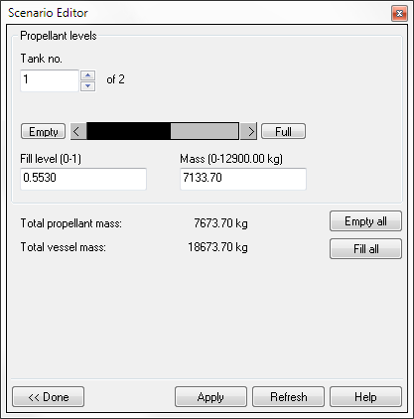
Fill level slider
Fuel mass
Empty all tanks
Fill all tanks
Tank selector
Open help
Return to configuration page
Apply levels
Refresh data
Fill level
Mass indicators

Docking management
If the vessel is equipped with docking ports, this page can be used to set up docking connections to other vessels, or to disengage existing connections.
First, select the docking port to operate on. The available docking ports can be cycled with the Dock no. control in the top left. Many spacecraft have only a single docking port, but some – in particular space stations – may have several.
Next, an IDS (Instrument Docking System) transmitter can be enabled or disabled for that dock, using the controls in the top right of the page. IDS transmitters allow other vessels to use their Docking MFD and HUD modes for instrument-assisted docking approaches. When IDS is enabled, the transmitter frequency can be adjusted between 108.00–139.95 MHz in 0.05 MHz steps. Make sure that every docking port of the vessel uses a different IDS frequency to avoid interference.
Finally, the docking connections at the port can be configured. If a vessel is already docked, its name is displayed. Clicking the Undock button breaks the docking connection.
If the dock is not engaged, a vessel can be picked from the list provided. Clicking the Dock button connects the vessel at the selected dock. If the target vessel has more than one docking port, the connecting port on the target vessel must also be specified.
Before executing the docking operation, it is also possible to select how the two vessels are moved to make the connection. The Bring target to my current position option will keep the vessel you are configuring at its current position, and drag the target vessel to the docking port of your vessel. The Move me to current target position option works in the reverse way: the target vessel maintains its position, and your vessel is dragged to the target vessel’s docking port.
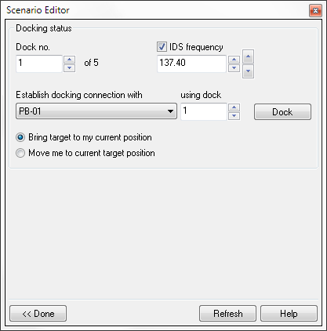
Docking vessels while landed on a planetary surface can sometimes lead to stability problems, in particular if the resulting configuration buries one of the vessels below the surface. See Chapter 2.7 for a workaround.
Activate IDS
IDS frequency
Make connection
Target dock
Docking port selector
Open help
Return to configuration page
Refresh data
Target vessel
Transition mode

Deleting a vessel
Clicking the Delete button in the editor’s main page deletes the selected vessel. Input focus and camera automatically switch to a different vessel if necessary.
You are not allowed to delete all vessels from the simulation: Orbiter requires at least one vessel that accepts control input in a running simulation. Deleting the last vessel leads to undefined behaviour. (Note that some vessels may have been designed not to receive input focus).
If the deleted vessel was part of a docked composite structure, the remaining parts of the superstructure will persist in the simulation. If the structure was landed on a planetary surface, the resulting remnant may become instable (try deleting an SRB from a Space Shuttle launch stack!).

Changing the simulation date and time
The Date button on the editor main page opens the date selection page. It allows to change the date of a running simulation, and specify how vessels are propagated from the current to the new date.
The simulation date is displayed in different formats:
- Date and time: A conventional time specification by day [DD], month [MM], year [YYYY], hour [h], minute [m] and second [s].
- Julian Date (JD): The interval of time in days and fractions of a day since 1 January 4713 BC, Greenwich noon.
- Modified Julian Date (MJD): The Julian date minus 2 4000 000.5.
- Julian Century (JC2000): The interval of time in centuries and fractions of a century since 1 January 2000, Greenwich midnight.
- Epoch: Year and fraction of a year.
If any of the date fields are modified, all other date formats are adjusted automatically. Clicking the Refresh button updates the dialog fields with the current simulation time. Clicking the Apply button sets a new simulation time, and clicking the Now button sets the simulation time to the current computer system time. By using the spin controls in the Date and Time section, the simulation time is updated directly.
All dates are referenced to Barycentric Dynamical Time (TDB), a common time scale for describing orbital events. TDB is similar to Universal Time (UT), with an offset of currently 66.184 seconds.
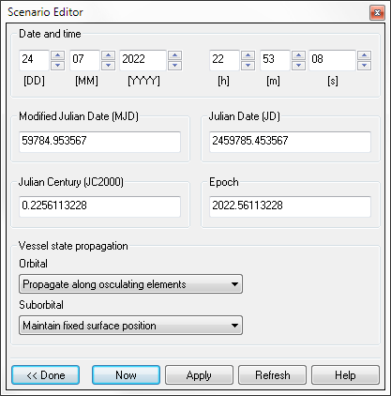
Before changing the simulation time, the vessel propagation mode from current to new date should be set. Different propagation modes can be selected for orbiting vessels (with orbits that don’t intersect the central body) and for suborbital vessels (with trajectories that intersect the surface). The following options are available for orbital vessels:
Date: hour/min/sec
Julian Date (JD)
Epoch
Date: day/month/year
Open help
Return to configuration page
Apply date
Refresh date
Modified Julian Date (MJD)
Julian Century (JC2000)
Vessel state propagation (orbital/suborbital)
Set system time
- Maintain fixed state vectors: Keep the vessel’s relative position and velocity with respect to the central body fixed in a non-rotating frame. This means that the planet is rotating underneath, while the vessel keeps its location and altitude.
- Maintain fixed surface position: Keep the vessel’s position, velocity and altitude fixed relative to the planet surface. This means that the vessel is rotating together with the planet, and stays fixed above the same point on the surface.
- Propagate along osculating elements: Move the vessel along its current orbital trajectory, assuming that no forces other than the central body’s gravitational force are acting on the vessel.
For suborbital vessels, in addition to the above one further option is available:
- Destroy vessels: Destroy any suborbital vessels (i.e. assume that the vessels impacted on the ground during time propagation.
Time can be adjusted backward as well as forward, but remember that moving back in time will not necessarily restore the simulation to a previous state, because the vessel propagation does not take into account events such as engine burns.

Saving a scenario
Once you are happy with the scenario you have created, you can save it to a file which can be run at a later time or shared with other Orbiter users.
To save the current simulation state, click the Save button on the main editor page. This opens the Save scenario page. Enter a file name and a short scenario description. Optionally, the name can include a directory path. All paths are relative to Orbiter’s root scenario folder (.\Scenarios). The specified directory must already exist.
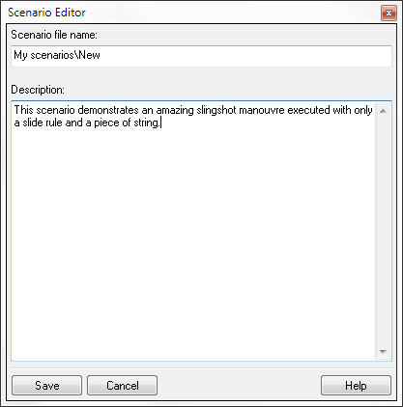
The text entered in the description box will be displayed in Orbiter’s launchpad dialog when a user selects the scenario from the list. It should briefly explain what the scenario is about.
Scenario path and name
Open help
Save scenario
Scenario description
Cancel without saving
Finally, click Save to save the scenario to file, or Cancel to return without saving.

Developer section
This section contains information for vessel addon developers who want to prepare their vessel plugins to work with the scenario editor.

Vessel configuration files
The scenario editor can create instances of any add-on vessels the user has installed in their Orbiter directory. The only requirement is that the add-on vessel configuration file (.cfg) is placed in the Config\Vessels directory. Whenever the editor displays the Vessel creation page, it scans this directory and lists all vessel types for which configurations have been found.
Vessel configuration files can also be placed in subfolders below the Config\Vessels directory, for example Config\Vessels\MyAddon\MyVessel.cfg. The vessel creation page will show these subfolders in the list, and the user can descend into them. The path relative to the Config\Vessels folder is then part of the vessel class name, and is included in the vessel class specification in all scenario files referring to these vessel types.
Scenario example:
[. . .]
BEGIN_SHIPS
MyShip-01:MyAddon\MyVessel
[. . .]
END
[. . .]
END_SHIPS
When editing scenario files by hand, remember to include the config file path. Otherwise Orbiter will not find the configuration files and terminate with an error message.
If you don’t want a vessel type to appear in the vessel creation list, add the entry
EditorCreate = FALSE
to its config file. The scenario editor skips config files with this entry when populating the vessel type list.
Note: In older Orbiter versions, vessel configuration files were placed directly in the Config directory. Placing vessel configuration files in Config is still valid, but the editor will not recognise these vessel types in the creation page. Therefore, placing a vessel config file in the Config folder has the same effect as the “EditorCreate = FALSE” config tag.

Adding vessel-specific editor pages
Vessel add-on developers can include editor pages in their vessel projects to allow users to configure vessel-specific options from within the scenario editor. These may include animation settings, payload management, launch stack configuration, etc.
To configure editor pages for your vessel class, you need to compile a DLL which contains the dialog page templates and the code that responds to user input. If your vessel is already controlled by a DLL, you can add the editor elements to that. Alternatively, you can put the editor elements into a separate DLL. This is particularly useful if your vessel is managed by a script-driven wrapper DLL such as spacecraft.dll or ScriptVessel.dll.
To tell Orbiter where to find the editor extensions, the vessel configuration file (.cfg) must contain the line
EditorModule = <editor-module>
where <editor-module> is the name of the DLL containing the editor elements. If you are using the vessel DLL for this, the EditorModule value is identical to the Module value. If the configuration file does not contain an EditorModule entry, the editor still allows to configure the vessel’s generic parameters, but won’t provide any vessel-specific options.
The editor extension DLL must contain a secInit callback function (sec = scenario editor callback) with the following format:
DLLCLBK void secInit (HWND hEditor, OBJHANDLE hVessel)
where hEditor is the editor window handle, and hVessel is the vessel instance handle.
Vessel-specific options in the scenario editor are accessed by creating additional buttons in the Vessel configuration page (see Chapter 2.2). Up to 6 custom buttons can be added. You can create a button in the body of the secInit function in two ways:

Creating an embedded editor page
To create a button that opens a custom page inside the editor dialog box, add code of the following form in the body of secInit:
EditorPageSpec eps = {“Animations”, hDLL, IDD_EDITOR_PG, EdPgProc};
SendMessage(hEditor, WM_SCNEDITOR, SE_ADDPAGEBUTTON, (LPARAM)&eps);
EditorPageSpec is a structure that contains the parameters for the custom editor function. It has the format
typedef struct {
char btnlabel[32];
HINSTANCE hDLL;
WORD ResId;
DLGPROC TabProc;
} EditorPageSpec;
where
btnlabel label displayed on the new button in the configuration page
hDLL module instance handle
ResId resource identifier for the embedded dialog page
TabProc dialog page window procedure
ResId is the identifier for a dialog resource defined in the DLL. Its size and layout should conform to the standard dialog pages of the scenario editor. The simplest way to create a conforming dialog page is by copying one of the standard pages from the scenario editor resource file (.\Src\Plugin\ScnEditor\ScnEditor.rc), and then modifying the page in a resource editor.
TabProc must be implemented in the DLL as a standard Windows dialog message procedure, i.e. with the interface
BOOL CALLBACK TabProc(HWND hWnd, UINT uMsg, WPARAM wParam,
LPARAM lParam)
This function receives all user input to the custom page like an ordinary dialog message procedure. The module can use the messages sent to the message procedure to set or display vessel parameters. To obtain a handle to the vessel inside the message procedure, use
OBJHANDLE hVessel = (OBJHANDLE)lParam;
when processing the WM_INITDIALOG message, and
OBJHANDLE hVessel;
SendMessage(hDlg, WM_SCNEDITOR, SE_GETVESSEL, (LPARAM)&hVessel);
when processing any other messages.

Creating a callback function
Instead of creating an embedded dialog page, you can simply request the editor to notify your module whenever a custom button is pressed. This gives more freedom over the custom functionality you are adding. For example, you can open a separate dialog box, or perform some other action.
To create a button that calls a notification function in your module, add the following code in the body of secInit:
EditorFuncSpec efs = {“Playload”, EditorFunc};
SendMessage(hEditor, WM_SCNEDITOR, SE_ADDFUNCBUTTON, (LPARAM)&efs);
EditorFuncSpec is a structure that contains the parameters for the custom button. It has the format
typedef struct {
char btnlabel[32];
CustomButtonFunc func;
} EditorFuncSpec;
where
btnlabel label displayed on the new button in the configuration page
func callback function in the module to be called after the button in pressed
The CustomButtonFunc must be defined in the module with the following format:
void EditorFunc(OBJHANDLE hVessel)
It receives the vessel handle as an input parameter.
An example for the implementation of vessel-specific editor pages can be found in the DeltaGlider vessel module that comes with the Orbiter source code (.\Src\Vessel\DeltaGlider).

