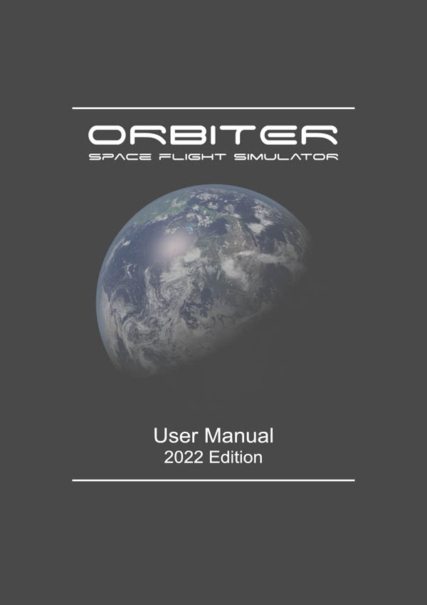
ORBITER User Manual

Copyright (c) 2000-2022 Martin Schweiger Monday 13 June 2022
Orbiter home: orbit.medphys.ucl.ac.uk
Contents
1 Introduction 4
1.1 About Orbiter 5
1.2 About this manual 5
1.3 Orbiter on the web 6
1.4 Finding more help 6
1.5 Getting started 6
2 What is new in Orbiter 2016? 8
3 Installation 10
3.1 Hardware requirements 10
3.2 Download 10
3.3 Installation 10
3.4 Uninstall 11
4 Before you start: The Launchpad 12
4.1 Scenarios tab 12
4.2 Parameters tab 13
4.3 Visual effects tab 15
4.4 Modules tab 17
4.5 Video tab 18
4.6 Joystick tab 19
4.7 Extra tab 19
4.8 About Orbiter tab 20
5 Quickstart 21
6 The main menu 27
6.1 Vessel selection 28
6.2 Camera control 28
6.3 Time acceleration 31
6.4 Object info 31
6.5 Map 33
6.6 Visual helpers 34
6.7 Inline help 37
6.8 Custom functions 37
7 User interface 39
7.1 Keyboard interface 39
7.2 Joystick interface 43
7.3 Mouse interface 43
7.4 Physical measures, units and magnitudes 44
8 Included spacecraft types 46
8.1 Delta-glider 46
8.2 Shuttle-A 47
8.3 Shuttle PB (PTV) 48
8.4 Dragonfly 49
8.5 Space Shuttle Atlantis 50
8.6 International Space Station (ISS) 52
8.7 Space Station Mir 53
8.8 Lunar Wheel Station 54
8.9 Hubble Space Telescope 55
8.10 LDEF Satellite 55
9 Cockpit views 57
9.1 Glass cockpit 57
9.2 2-D panel view 59
9.3 3D virtual cockpit 60
9.4 HUD modes 61
10 Multi-functional display modes 65
10.1 NAV receiver/transmitter setup 66
10.2 Surface 68
10.3 Map 70
10.4 VOR/VTOL 73
10.5 Horizontal Situation Indicator 74
10.6 Orbit 76
10.7 Align Orbital Plane 80
10.8 Synchronise orbit 83
10.9 Docking 85
10.10 RCS Attitude 88
10.11 Transfer 91
11 Spacecraft controls 95
11.1 Main, retro and hover engines 95
11.2 Attitude thrusters 96
12 Basic flight manoeuvres 98
12.1 Surface flight 98
12.2 Launching into orbit 98
12.3 Changing the orbit 99
12.4 Rotating the orbital plane 101
12.5 Synchronising orbits 103
12.6 Docking 104
12.7 Lunar and interplanetary transfers 106
12.8 Landing (runway approach) 107
13 Fight recorder 109
13.1 Trajectory and event data 110
13.2 Playback event editor 111
14 Script interface 113
15 Extra functionality 115
15.1 Scenario editor 115
15.2 External MFDs 115
15.3 Performance meter 116
15.4 Remote vessel control 116
15.5 Flight data monitor 116
15.6 Lua Console 117
16 Flight checklists and challenges 118
16.1 Checklist mission 1: Delta-glider to ISS 118
16.2 Checklist mission 2: ISS to Mir transfer 121
16.3 Checklist mission 3: De-orbit from Mir 122
16.4 Challenge missions 123
17 The solar system neighbourhood 125
17.1 Solar system bodies 125
17.2 Orbital mechanics primer 130
17.3 Selected constants and parameters 134
18 Demo mode 137
19 Command line interface 138
20 Glossary 139
21 License notice 142

Introduction

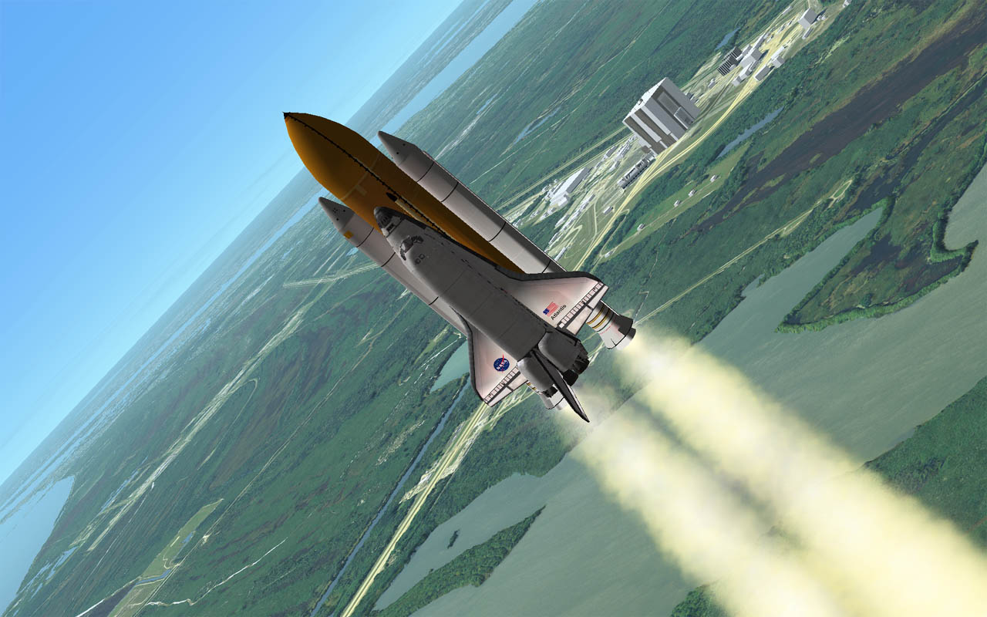
Welcome to Orbiter 2016!
Orbiter 2016 is the latest instalment of the Orbiter Spaceflight Simulator series. The most notable improvement from the 2010 Edition is the added support for surface elevation of planetary bodies, higher resolution surface and cloud textures, and improved surface collision modelling.
High-resolution planetary textures packs are available for Earth, the Moon and Mars. In fact, there is now so much texture and elevation data available that you may need to free a bit of space on your hard disk to install it all – but I hope you’ll agree that the result is worth the extra space.
In addition, several of the spacecraft included in the standard distribution have had their cockpits updated and flight models improved. The simulation engine has been extensively reworked for improved stability.
If the built-in graphics engine is not sufficient, Orbiter’s interface for external graphics support has been extended. Try the excellent D3D9 Client by Jarmo Nikkanen for advanced visual features and improved frame rates.
As usual, the new version adds numerous bug fixes and feature enhancements. Give it a try!

Martin Schweiger

About Orbiter
They say a little knowledge is a dangerous thing, but it’s not one half so bad as a lot of ignorance.
Terry Pratchett – Equal Rites
Orbiter is a spaceflight simulator based on Newtonian mechanics. Its playground is our solar system with many of its major bodies – the sun, planets and moons. You take control of a spacecraft – either historic, hypothetical, or purely science fiction. Orbiter is unlike most commercial computer games with a space theme – there are no predefined missions to complete (except the ones you set yourself), no aliens to destroy and no goods to trade. Instead, you will get a pretty good idea about what is involved in real space flight – how to plan an ascent into orbit, how to rendezvous with a space station, or how to fly to another planet. It is more difficult, but also more of a challenge. Some people get hooked, others get bored. Finding out for yourself is easy – simply give it a try. Orbiter is free, so you don’t need to invest more than a bit of your spare time.
Orbiter is a community project. The Orbiter core is just the skeleton that defines the rules of the simulated world (the physical model). A basic solar system and some spacecraft (real and fictional) are included, but you can get a lot more with add-on modules developed by other enthusiasts in the Orbiter community. There are add-ons for nearly every spacecraft that ever flew (and quite a few that never got beyond the drawing board), for many more celestial bodies in the solar system (or entirely new fictional systems), for enhanced instruments, and much more. The Orbiter web site contains links to many Orbiter add-on repositories.

About this manual
This document is the main help file that comes with the basic distribution of Orbiter. It is a User’s Guide to the Orbiter software – which is to say that it gives an introduction into how most things work, but doesn’t tell you much why they behave as they do. By following the instructions, you will find out how to operate the engines of your spacecraft, how to use the instruments, and how to perform the most common missions.
But a big part of the appeal of Orbiter is finding out about the why – why do spacecraft in orbit behave as they do, what is involved in a gravity-assist flyby, why do rockets have multiple stages, why can it be tricky to line up for docking with a space station, what do the numbers in the instrument displays actually mean … ?
This is where physics comes into the picture. If you want to conquer the final frontier, you will at some stage need to understand a few of the fundamental physical concepts that form the basis of astrodynamics and space flight. Luckily most of it is not very difficult – if you learn a bit about forces and gravity (“Newtonian mechanics”) and how they relate to the motion of planets and spacecraft in orbit (“Kepler’s laws”), you will have covered a good deal of it. Of course, there are always opportunities to dig deeper into the details, so your next steps might be finding out about the effects of orbit perturbations, attitude control, trajectory optimisation, mission planning, instrument design – to name just a few.
Don’t get frustrated if you don’t succeed immediately – it’s only rocket science. Read the documentation and try some of the numerous Orbiter tutorials available on the internet, and you will soon be orbiting like a pro.
Eventually you might start to develop your own add-on modules to enhance Orbiter’s functionality, write tutorials and help files for newcomers – or even take active part in the Orbiter core development by identifying and discussing flaws or omissions in the Orbiter physics model (and there are still many!)

Orbiter on the web
The Orbiter home page can be found at orbit.medphys.ucl.ac.uk. It is your portal to Orbiter news, downloads, forum, add-on sites, and related pages.
The main Orbiter forum, www.orbiter-forum.com, is a friendly meeting place for an active community of new and seasoned users and developers. It is a good place to find answers to any problems you may encounter, or just to hang out with fellow Orbinauts. Suggestions, bug reports (and of course praise) are always welcome. Links to other forum sites can be found on the Orbiter web site.
Next door to the forum, at www.orbithangar.com, is the primary Orbiter add-on repository, where you can find a huge number of user-created spacecraft, instruments, textures and more. And once you have started to write your own plug-ins, you can upload them here to share with others.
The Orbiter wiki, at www.orbiterwiki.org, is a community-maintained site which contains useful information for users and developers.
For general information about Orbiter, have a look at the Wikipedia entry, en.wikipedia.org/wiki/Orbiter_(sim).
A site dedicated to Orbiter graphics development is the Orbiter Visualisation Project at sourceforge.net/projects/orbitervis.

Finding more help
The help files that come with the main Orbiter package are located in the Doc subfolder below your main Orbiter directory. Many add-ons will place their own help files in the same directory after installation. The Doc/Technotes folder contains some documents with technical details and background information for interested readers. They are not required for using Orbiter.
Many people have written documentation and tutorials covering particular aspects of Orbiter. Links can be found on the Related sites page of the Orbiter home page.
A very good introduction to using and understanding Orbiter for beginners (and a handy refresher for old-timers) is Bruce Irving’s online book Go Play In Space, which can be found via a link from the Manual page on the Orbiter web site.
The scientific and technical background of space flight is covered in many textbooks and online sites. A good introduction is JPL’s Basics of Space Flight, or R. Braeunig’s Rocket & Space Technology. Among the many online resources for the general and physics relevant for space flight, you might find the Scienceworld site useful.

Getting started
If you are a first-time user, it is probably a good idea to have a look at this manual to get you off the ground quickly. Ideally, use it together with the simulator. If you don’t want to print it, run Orbiter in window mode (see Section 4.5) and have the manual open next to it.
For installation help, see Section 3. The first time you run Orbiter, you will have to configure the video options (Sec. 4.5). Then you are good to go – see Sec. 4.1 on how to select a scenario and launch the simulation.
To get a feel for Orbiter, you can run some of the pre-recorded flights and tutorials. These are the scenarios you find under the Tutorials and Playback folders. They don’t require any user input, so you can lean back and enjoy the view.
Once you are ready to take control, have a look at the Quickstart chapter (Sec. 5). It contains step-by-step instructions for take-off, flight and landing in the futuristic Delta-glider.
Some more complex missions, including a flight from Kennedy Space Center to the International Space Station, can be found in the Flight checklists folder (Sec. 16).
For an overview of basic spacecraft controls, see Sec. 11. A detailed list of common keyboard commands can be found in Sec. 7.
And once you have made your first steps into orbit, you might want to consult the rest of the manual to learn about some of the more advanced details of Orbiter.

What is new in Orbiter 2016?

Terrain elevation support
Orbiter now supports terrain elevation for planetary bodies. Planets are no longer perfect spheres – mountain ranges and canyons are now modelled properly. The default Orbiter installation comes with elevation data for Earth, the Moon, Mars and some minor bodies. Expect other bodies to be supported in add-ons soon.

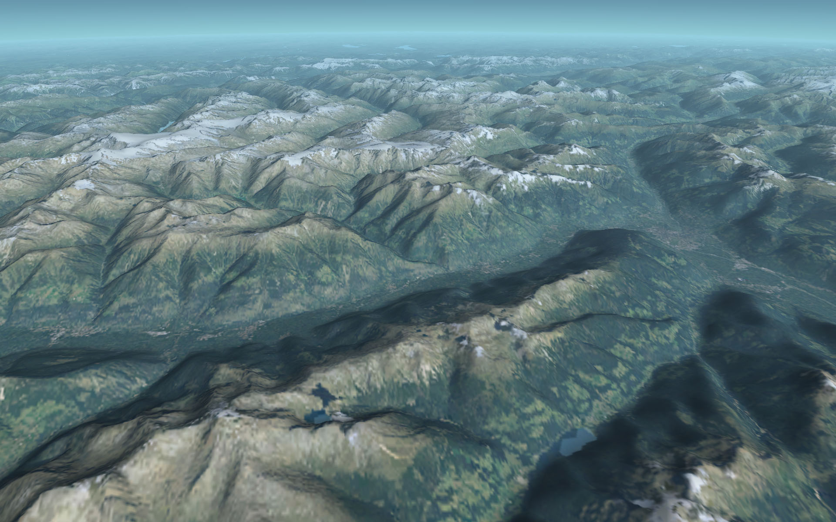
High resolution surface texture support
The Alps in Orbiter 2016: Terrain support with SRTM-90 DEM data.
In addition to the new elevation support, Orbiter now also provides a new texture format that can display planetary surfaces and cloud layers at much higher resolution than before (~1 pixel/m for Earth). Global Earth textures have been generated from raw Landsat-7 scenes with extensive processing for colour correction, seam and cloud removal and coastline fitting. For Florida and the Kennedy Space Center, even higher resolution textures have been generated from aerial image sources. Moon, Mars and several other planetary bodies also support the new texture format in the default installation.
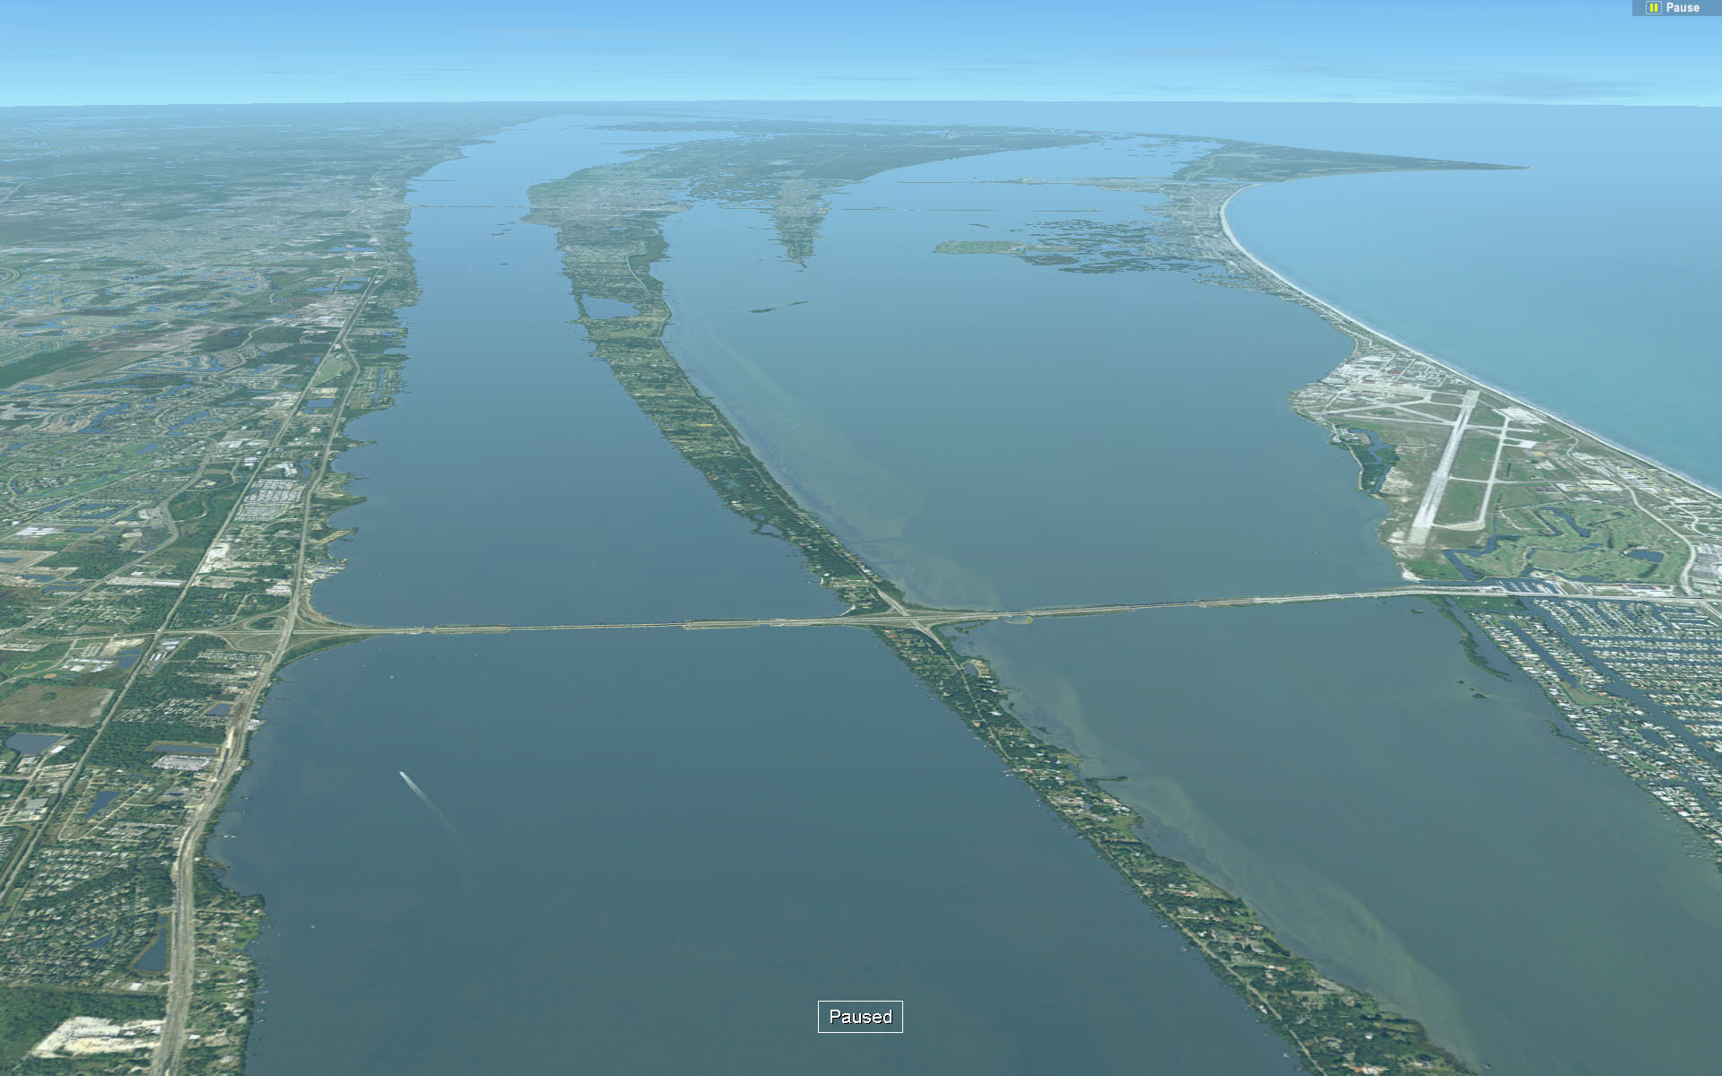
The texture packages are now too large to be included with the basic Orbiter installation. The default Orbiter package contains low-resolution versions for all bodies. You can download and install the high-resolution versions from the Orbiter texture repository.
High-resolution textures: View towards Kennedy Space Center from the south. Patrick AFB is visible on the right.

Improved terrain impact model
Vessel impact on planetary surfaces is now modelled more realistically, using a dynamic compression model. Vessels can now define a convex hull of impact points to provide surface interaction parameters at all attitudes. Impact hulls for docked vessels are now automatically merged, allowing docked assemblies on the ground.

New cockpit models for default vessels
The Delta-glider and Shuttle-A vessels included in the Orbiter basic installation now come with improved virtual cockpits and 2D instrument panels. The Delta-glider has a few interesting new features like the automatic engine gimbal mode, hover attitude control, and a pressure control module in the overhead panel.

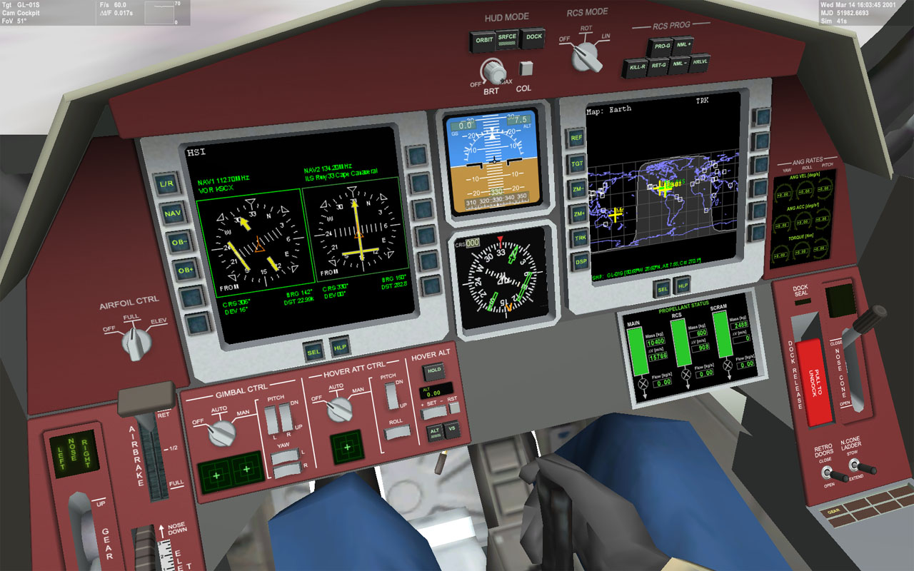
Improved physics
Delta-glider virtual cockpit view.
Orbiter 2016 contains a re-worked physics engine with improved accuracy. Orbiter now automatically subsamples frame updates when required. Subsampling is particularly important during impact events, where large forces are active over very short time intervals.

And much more …
A lot of additional features and bug fixes have gone into the new version to improve overall stability and user experience. And of course, development is going on, with additional fixes to be distributed in patch releases whenever necessary.

Installation
This section lists the computer hardware requirements for running Orbiter, and contains download and installation instructions.

Hardware requirements
Orbiter should run on most Windows PCs with 4 GB of memory or more, running a recent Windows version. A high-performance graphics card is recommended for improved performance.
The basic installation requires approximately 2 GB of hard disk space. Installing high-resolution texture packs can significantly increase space requirements. A complete installation of all currently available texture packs may require close to 100 GB of space.
Orbiter supports an optional joystick.
The TrackIR head tracker is supported via a plug-in module included in the basic installation.

Download
The Orbiter distribution can be obtained from one of several Orbiter mirror sites on the internet. You can find links to these mirrors at the Download page of the Orbiter site, http://orbit.medphys.ucl.ac.uk. The downloads are provided as torrents for fast and reliable transfer. If you can’t handle torrent downloads, alternative http download links are also provided.

Installation
- The Orbiter installation package comes in two flavours: an MSI (Microsoft installation) package, and a ZIP package.
- The MSI package allows to install Orbiter like a standard Windows software package. It guides the user through the installation process with a wizard dialog, and provides a desktop icon and uninstall option. This method is recommended for general users.
- The ZIP package requires manual extraction of the contents into a new folder. This method allows multiple Orbiter installations on a single computer and is non-intrusive (it doesn’t modify the registry and doesn’t install anything outside the Orbiter directory). However, the user is responsible for providing the runtime environment, including required system libraries. This method is recommended for advanced users. For the ZIP installation,
  - Create a new folder for the Orbiter installation, e.g. C:\Orbiter2016 or %HOMEPATH%\Orbiter2016. Note that creating an Orbiter folder in Program files or Program files (x86) is not recommended, because Windows puts some restrictions on these locations.
  - If a previous version of Orbiter is already installed on your computer, you should not install the new version into the same folder, because this could lead to file conflicts. You may want to keep your old installation until you have made sure that the latest version works without problems. Multiple Orbiter installations can exist on the same computer.
  - Unzip the Orbiter ZIP installation package into the new folder, using either the default Windows unzip function, or an external tool like 7-zip or WinZip. Important: Take care to preserve the directory structure of the package (for example, in WinZip this requires to activate the “Use Folder Names” option).
  - After unzipping the package, make sure your Orbiter folder contains the executable (orbiter.exe) and, among other files, the Config, Meshes, Scenarios and Textures subfolders.
- Run orbiter.exe. This will bring up the Orbiter “Launchpad” dialog, where you can select video options and simulation parameters.
- You are now ready to start Orbiter. Select a scenario from the Launchpad dialog and click the Launch Orbiter button!

If Orbiter does not show any scenarios in the Scenario tab, or if planets appear plain white without any textures when running the simulation, the most likely reason is that the installation packages were not properly unpacked. Make sure your Orbiter folder contains the subfolders as described above. If necessary, you may have to repeat the installation process.

Uninstall
If you installed Orbiter via the MSI package, simply use the standard Windows method for uninstalling a software package. Note that this will only remove the files of the original installation package. Texture packs and add-ons installed later may need to be deleted manually from the Orbiter folder.
If you installed the ZIP package, simply remove the Orbiter folders with all contents and subdirectories. This will completely remove Orbiter from your hard drive.

Before you start: The Launchpad
Starting orbiter.exe brings up the Orbiter Launchpad dialog box. The launchpad is your gateway to Orbiter. From here, you can
- select and launch a simulation scenario
- set simulation, video and joystick parameters
- load available plug-in modules to extend the basic Orbiter functionality
- open the online help system
- launch the Orbiter simulation window, or
- exit to the desktop.
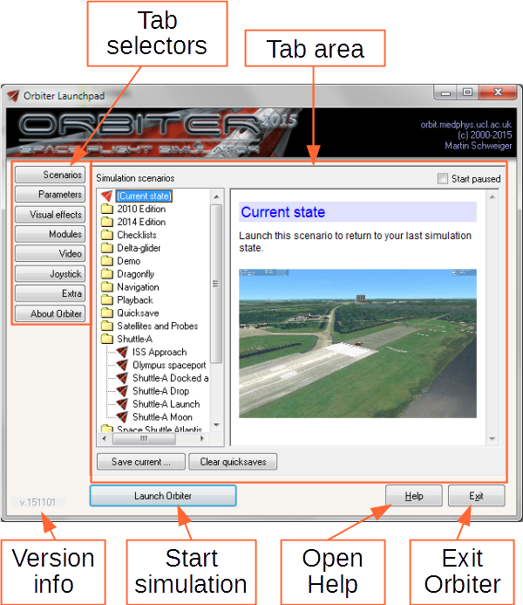
Clicking on one of the tab selector buttons along the left edge of the dialog box opens the corresponding configuration page.
Orbiter Launchpad dialog: Start a simulation scenario, edit parameters and video options, activate modules.
Important: Before running Orbiter for the first time, make sure that all simulation parameters (in particular the video options) are set correctly.
When you are ready, select a scenario and press the “Launch Orbiter” button to jump into the simulation.

Scenarios tab
The Scenarios tab allows you to manage and browse the available simulation startup scenarios. A “scenario” defines the initial setup of a simulation session (the date, spacecraft positions, velocities and other parameters).
The scenario list contains all stored scenarios (including any you created yourself) in a hierarchical folder structure. Double-click on a folder to open its contents. Double-click on a scenario (marked by the red “Delta-glider” icon) to launch it.
Selecting a scenario or folder brings up a description on the right of the dialog box. This can include mission objectives, screenshots and background information.
There are a few special scenarios and folders:
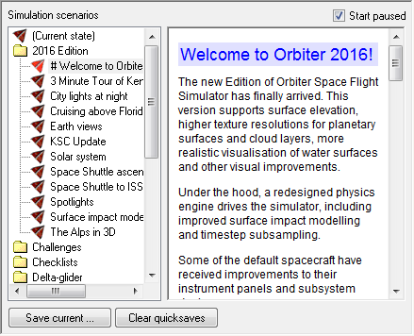
- The (Current state) scenario is automatically generated whenever you exit the simulator. Use this to continue from the latest exit state.
- The Tutorials folder contains pre-recorded flights with on-screen annotations that explain different aspects and stages of spaceflight missions.
- The Playback folder contains the flights you have recorded with Orbiter’s built-in flight recorder. Launching one of these will start a replay.
- The Quicksave folder contains in-game saved scenarios generated by pressing ▪. Multiple quicksaves are possible. Orbiter saves the quicksave states under the original scenario name, followed by a quicksave counter. The counter is reset each time the simulation is launched, so make sure you copy any scenarios you want to keep!
- The Demo folder can be filled with scenarios that are automatically run in kiosk/demo mode (see Section 18). This allows to put together a set of simulation runs that can be displayed in unsupervised environments.

To start the simulation paused:
Tick the Start paused box to pause the simulation on start. You can resume by pressing ▪p.

To save your own scenarios:
After exiting a simulation session, click the Save current button to save the current simulation state in a new scenario file. For setting up custom simulation scenarios, see also the Scenario Editor Manual.

To clear quicksaved scenarios:
Click the Clear quicksaves button to delete all scenarios stored in the Quicksave folder.

Parameters tab
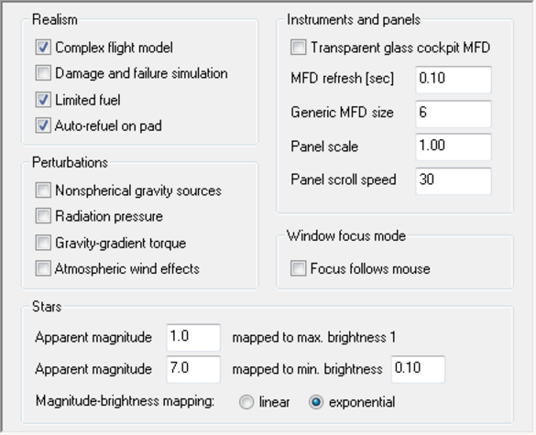
The Parameters tab contains various options to customise the simulation behaviour, including realism and difficulty settings, background star rendering, instrument display settings and the focus behaviour for dialog boxes.

Realism
- Complex flight model: Select the realism level of the flight model for the spacecraft. Tick this box to enable the most realistic flight parameters available for all vessel types. Disabling this option may activate simplified flight parameters which make spacecraft easier to control for newcomers. Not all vessel types may support this option.
- Damage and failure simulation: Spacecraft can sustain damage and system failure, for example if operational limits are exceeded. Not all vessel types may support this option.
- Limited fuel: Untick this box to ignore fuel consumption of your spacecraft.
Some of the more “realistic” spacecraft, such as the Space Shuttle, may not work properly if “Limited fuel” is not selected, because they rely on the reduction of mass during lift-off as a consequence of fuel consumption.
- Nonspherical gravity sources: This option activates a more complex gravity force calculation which can take into account perturbations in the gravitational potential due to non spherical celestial body shapes, thus allowing more accurate orbit predictions. Note that this option can make orbital calculations more difficult, and may reduce the reliability of instruments that don’t take this effect into account. For a planet to make use of the perturbation code, its configuration file must supply shape parameters via the JCoeff entry. For background and technical implementation details please refer to the Orbiter Technical Note Nonspherical gravitational field perturbations.
- Gravity-gradient torque: If this option is enabled, vessels can experience an angular moment in the presence of a gravitational field gradient. This will be noticeable in particular in low orbits and can lead to attitude oscillations around the equilibrium or attitude-locked orbits. For background and technical implementation details please refer to the Orbiter Technical Note Distributed vessel mass.

Window focus mode
- Focus follows mouse: If this option is ticked, the input focus is automatically switched to the window under the mouse pointer. If unticked, the focus is switched in normal Windows style by clicking the window.

Stars
The parameters in this group adjust the number and brightness of background stars displayed on the celestial sphere. Orbiter uses the Hipparcos star catalogue with more than 10⁵ entries.
The apparent magnitude is a logarithmic scale describing the brightness of a star as seen from Earth. The brightest star (except for the sun), Sirius, has an apparent magnitude of m_{v} = −1.5. The faintest stars visible without instruments are approximately of magnitude m_{v} = 6.
Using a higher magnitude value for the max. brightness setting will render stars brighter. Using a higher magnitude for the min. brightness setting will increase the number of faint stars rendered. Increasing the min. brightness level will make faint stars look brighter.
Using a logarithmic mapping will increase the contrast between bright and faint stars to a more realistic level, but will make faint stars hard to see.

Instruments
- Transparent MFD: Make the multifunctional displays in glass cockpit mode (see Sec. 9.1) transparent. This provides a better view of the 3-D environment, but makes it more difficult to read the instruments.
- MFD refresh: Time (in seconds) between MFD updates. Shorter intervals provide smoother updates, but may degrade performance. Some built-in MFD modes, such as the Surface and HSI modes, override the user-defined update frequency.
- Panel scale: Sizing factor for instrument panels. Scale 1 provides optimal visual quality, but other values may be used to adapt the panel size at low or high screen resolutions.
- Panel scroll speed: Determines how fast the panel can be scrolled across the screen [pixels/second]. Negative values invert the panel scroll directions.

Visual effects tab
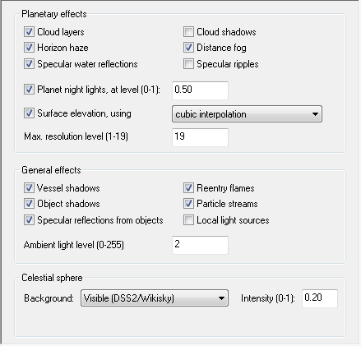
The Visual effects tab provides options for tuning the rendering parameters and graphic detail. These options will improve the visual appearance and realism of the simulator, but most of them can have an adverse effect on simulation performance (frame rates) when enabled, and may increase video and main memory demands, so they should be used with care, in particular on less powerful computers. As a first step in troubleshooting Orbiter problems it is often a good idea to turn off all visual effects.
Note that some advanced rendering options can also be found in the Extra tab, under Visualisation parameters. This includes mipmap and anisotropic filtering options as well as texture and elevation resolution bias settings.

Planetary effects
- Cloud layers: Add a cloud layer above the surface for planets which support it.
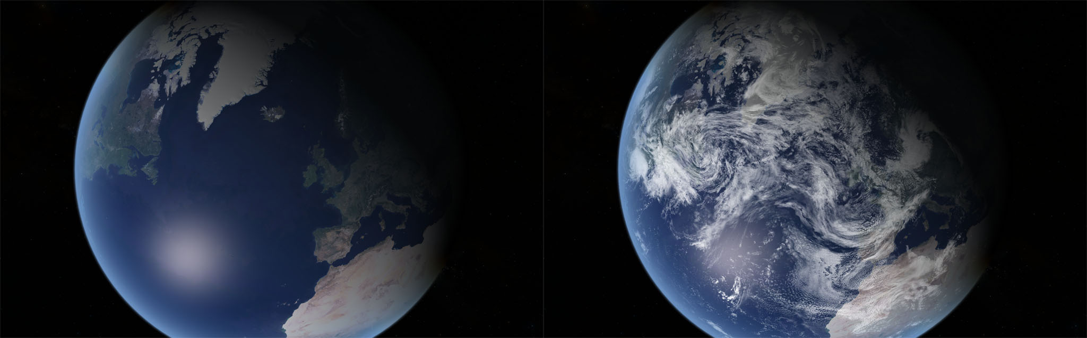
- Cloud shadows: Render cloud shadows cast on the planet surface. Only planets whose config files contain a CloudShadowDepth entry < 1 will actually render cloud shadows.
Cloud layers disabled (left) and enabled (right).
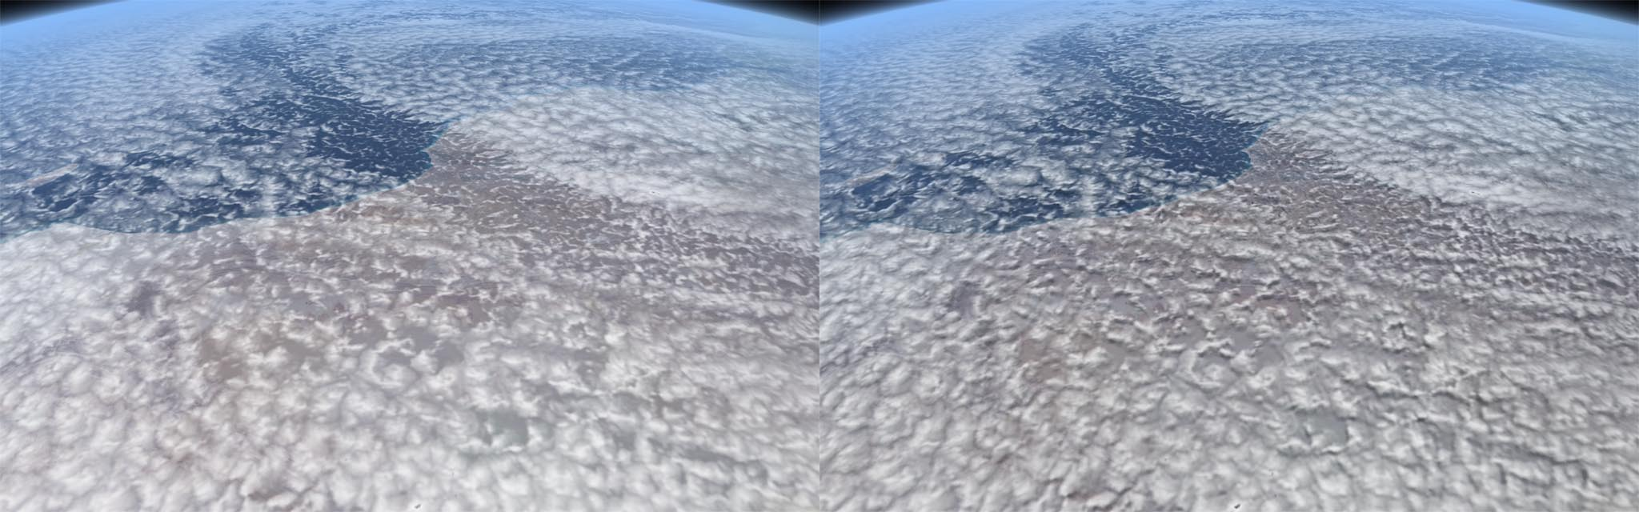
- Horizon haze: Render an intensity-graded (“glowing”) horizon layer for planets with atmospheres.
Cloud shadows disabled (left) and enabled (right).
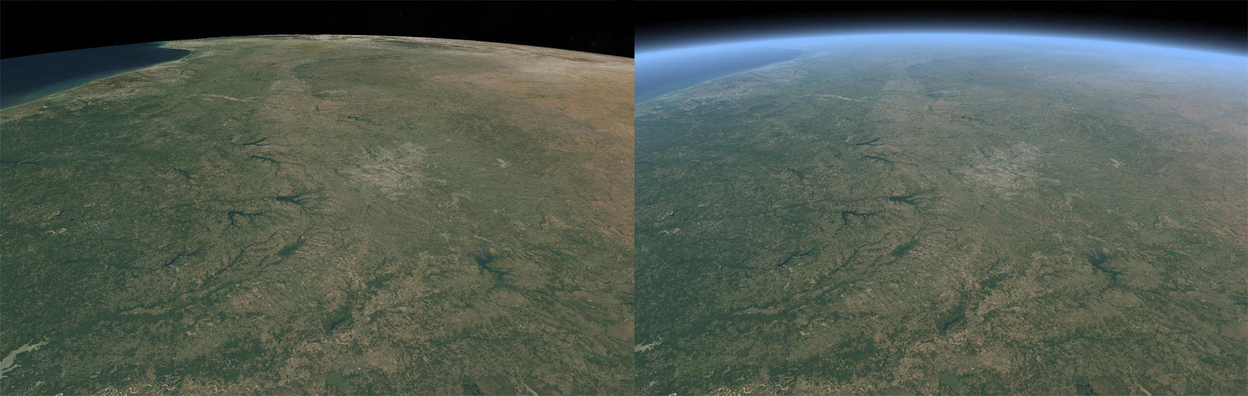
- Distance fog: Apply atmospheric mist and fog effects to distant objects when viewed through planetary atmospheres.
Horizon haze disabled (left) and enabled (right).
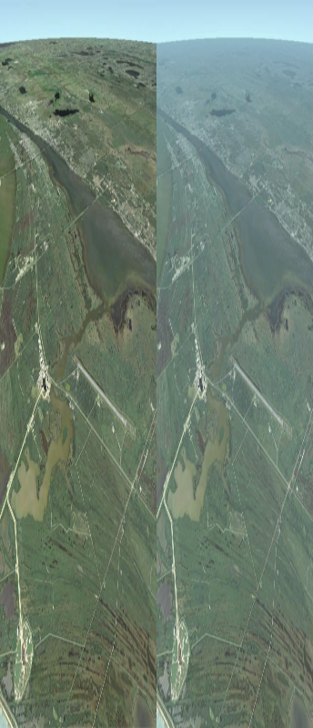
- Specular water reflections: Render water surfaces on planets with specular reflection effects.
Distance fog disabled (left) and enabled (right).
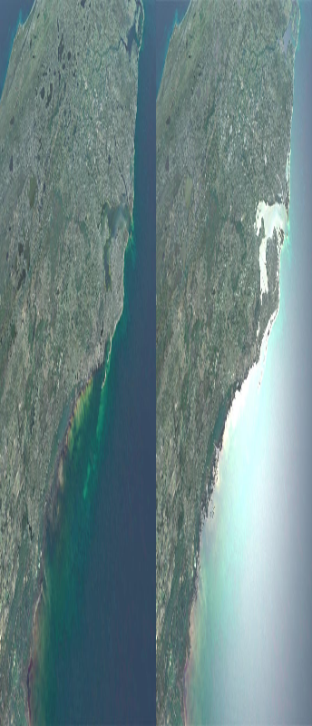
- Specular ripples: Generate “ripple” effect in specular reflections from oceans for improved appearance of water surfaces.
Specular water reflections disabled (left) and enabled (right).
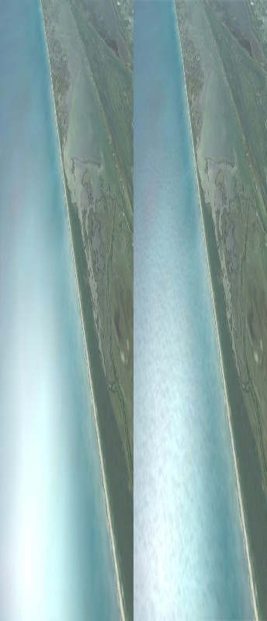
- Planet night lights: Render city lights during night-time where available.
Specular ripples disabled (left) and enabled (right).
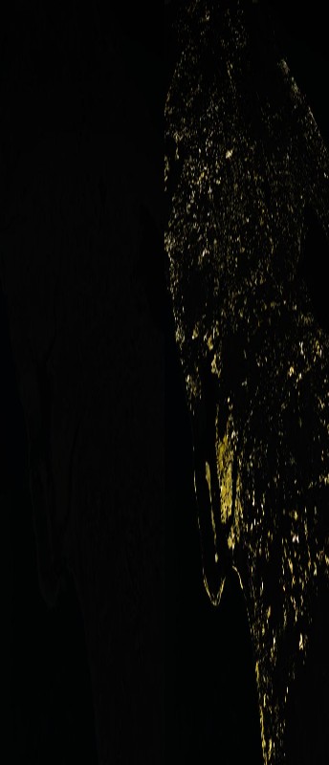
- Night light level: Defines the brightness of night city lights. Valid range is 0 to 1 (ignored if planet night lights are disabled).
Planet night lights disabled (left) and enabled (right).
- Surface elevation: Enable or disable modelling of ground elevation on planetary surfaces. When enabled, select between linear and cubic (smoother) interpolation of elevation data.
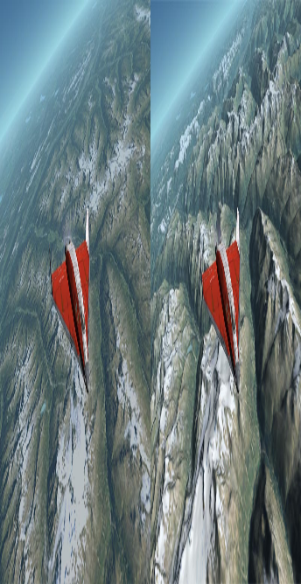
- Max. resolution level: The maximum resolution at which planetary surfaces can be rendered. Supported values are 1 to 19. Higher values provide better visual appearance of planets that support high texture resolutions, but also significantly increase the demand on computing resources (graphics processor and memory). Note that the actual resolution level supported by any planetary body may be lower than this value, depending on the texture set available. Higher resolution textures for many bodies may be downloaded from the Orbiter website or add-on repositories. The highest resolution levels are usually only supported in selected areas on the surface (e.g. around spaceports).
Planet surface elevation disabled (left) and enabled (right).

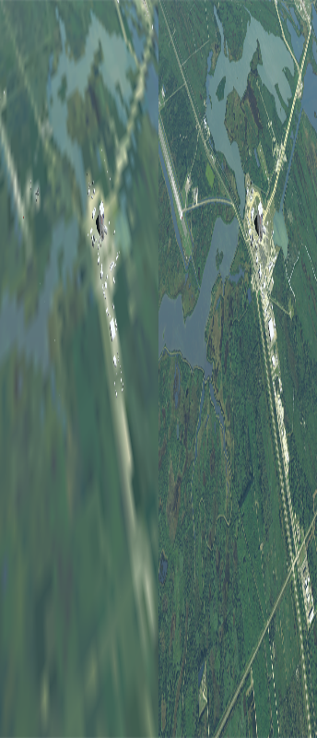
General effects
Kennedy Space Center at resolution level 12 (left) and 19 (right)
- Vessel shadows: Enable shadows cast by spacecraft on planet surfaces.
- Object shadows: Enable dynamic shadows of ground-based objects such as buildings.
- Specular reflection from objects: Render reflective surfaces like solar panels, window panes and metallic surfaces. May degrade performance.
- Reentry flames: Render a glowing plasma hull during reentry.
- Particle streams: Render ionised exhaust gases and vapour trails with particle effects.
- Local light sources: Enable localised light sources, e.g. from engines, landing lights, floodlights etc. This option can have a significant influence on frame rates.
- Ambient light level: Defines the brightness of the unlit side of planets and moons. Ambient level 0 is the most realistic, but makes it difficult to spot objects in the dark. Level 255 is uniform lighting (no darkness).

Celestial sphere
- Background: Select a bitmap to cover the celestial sphere background. Various options are available in the default distribution, including sky surveys from various mapping projects at different wavelength ranges. More maps may be available as add-ons.
- Intensity: The brightness of the background image (range: 0–1). For a realistic setting, try the Visible map with a very low intensity setting (e.g. 0.05).

Modules tab
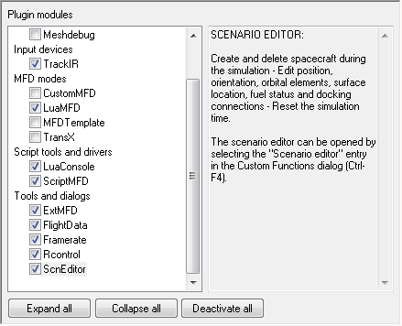
The Modules tab allows the activation and deactivation of plug-in modules for Orbiter which can extend the functionality of the core simulator. Plug-ins can contain additional instruments, dialogs, interfaces to external programs etc. Make sure you only activate modules you actually want to use, because modules can take up some processing time even if they run in the background, and thus affect Orbiter’s performance.
To activate a module, click the tick box next to its entry in the list. By clicking on the entry itself, many modules provide a short description about their function and user interface in the right panel. Entries are grouped in categories. You can expand or collapse categories by double-clicking the category header. The buttons at the bottom of the tab allow expanding or collapsing the entire list, and quick deactivation of all modules.
The modules provided with the standard Orbiter distribution are demos from the SDK package, and are available in full source code. A wide variety of additional modules by 3rd party add-on developers can be downloaded from Orbiter repositories on the internet.
Some of the standard modules distributed with Orbiter are:
ScnEditor: A versatile scenario editor that allows adding, editing and deleting spacecraft in a running simulation. See Section 15.1 for more details.
ExtMFD: This module allows to open additional multifunctional displays in external dialog boxes. Useful if you need more information than a vessel’s built-in MFD displays provide, or if you want to track flight data in external camera views.
CustomMFD: This module provides an additional Ascent MFD mode for the multifunctional displays, which can be selected via ◻+◻p. The sources for this module are a good starting point for developers who want to create their own MFD modes.
Rcontrol: Remote control of ship engines. This allows to manipulate vessels even if they don’t have input focus. If this module is active, the remote control window can be selected from the Custom Functions list (▪).
FlightData: Real-time atmospheric flight data telemetry. If this module is active, the flight data window can be selected from the Custom Functions list (▪).
Framerate: A graphical simulation frame rate (FPS) display. If this module is active, the frame rate window can be selected from the Custom Functions list (▪).
LuaConsole: Provides a console window for interactive processing of script commands. Can be opened via the Custom Functions list.
LuaMFD: Adds a new MFD mode for script input via a console MFD.

Video tab
The Video tab provides options to select the rendering device, switch between full-screen and windowed mode, and set the resolution, window size and colour depth.
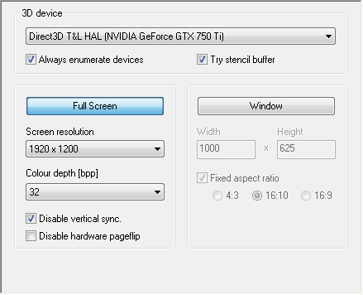
3D Device: Lists the available hardware and software devices for 3-D rendering. Select a hardware device with transform and lighting capabilities when possible, such as Direct3D T&L HAL or similar. (On some systems, the hardware devices might be listed with the name of your graphics card). Software devices such as RGB Emulation will provide poor performance or not run at all. Note that some older hardware devices do not support window mode.
Always enumerate devices: Tick this box if Orbiter does not display 3D devices or screen modes correctly. This option enforces a hardware scan whenever Orbiter is launched and skips the device data stored in device.dat. Make sure you tick this box after upgrading your graphics hardware or DirectX/video drivers to make Orbiter aware of the changes.
Try stencil buffer: Enables stencil buffering, if the video mode supports it. Stencil buffers can improve various visual effects (for example, provide support for alpha-blended shadows), but may have a slight impact on frame rates. If the selected video mode doesn’t support stencil buffers, this option is ignored.
Full screen: Select this option to run Orbiter in full-screen mode. You can choose the screen resolution and colour depth from the list provided. Only modes supported by the selected device are listed here. Higher resolution and colour depth will improve the visual appearance at the cost of reduced performance. Note that selecting a low colour depth can lead to visual artefacts (insufficient depth resolution).
In addition, you can select the Disable vertical sync option. This allows Orbiter to update a frame without waiting for a synchronisation signal from the monitor. This can improve frame rates, but may lead to visual artefacts (tearing).
On some systems the hardware frame buffer switching may cause the screen occasionally to flash white. Use Disable hardware pageflip to solve this problem. Disabling hardware pageflip also disables vertical sync.
Window: Select this option to run Orbiter in a window. You can specify the size of the render window here. Selecting one of the available fixed aspect ratio options (4:3 normal, 16:10 widescreen or 16:9 widescreen) automatically adjusts the window width or height to maintain the aspect ratio. Large window sizes can reduce simulation performance. Note that some older graphics drivers may not allow 3-D applications to run in window mode.

Joystick tab
The Joystick tab allows selection and configuration of your joystick device, if present.
Joystick device: Lists all attached joysticks.
Main engine control: Define the joystick axis which controls the main thrusters. Try different options if the throttle control on your joystick doesn’t work in Orbiter.
Ignore throttle setting on launch: If ticked, the joystick throttle will be ignored at the launch of a scenario until the user manipulates it. Otherwise, the throttle setting is used immediately.
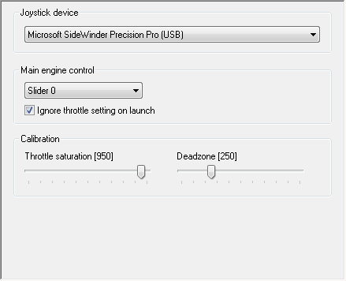
Deadzone: Use this to define how soon the joystick will respond when moved out of its centre position. Smaller values make it respond sooner. Increase if attitude thrusters do not cut out completely in neutral position.
Throttle saturation: Defines the tolerance zone at the minimum and maximum range of the throttle control at which the joystick reports zero and maximum throttle, respectively. Reduce if main engines do not cut out completely at minimum throttle setting. (Applies only to joysticks with throttle control).
If further calibration is required you should use the appropriate tools in the Windows Control Panel.

Extra tab
The Extra tab contains a list of more advanced and specialised settings and configuration parameters, including details about Orbiter’s dynamic state propagation, vessel configuration and debugging options. Add-on plug-ins may add their own configuration entries to the list when activated.
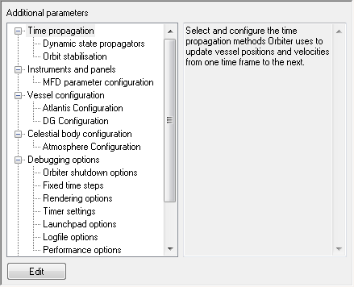
It is generally safe for new users to leave all settings in this list at their default values. Advanced users can fine-tune the behaviour of the simulator here.
Click on an item to see a short description of its purpose to the right of the list. Double-clicking, or pressing the Edit button opens the associated configuration dialog. Among the default configuration options available are:
Time propagation: defines the parameters for dynamic update of linear (position and velocity) and angular vessel states (orientation and angular velocity). Users can select the integration methods as a function of step interval. The Orbit stabilisation entry allows to configure the conditions under which Orbiter switches from dynamic to orbit perturbation updates. For technical details on the dynamic propagation schemes available in Orbiter, refer to the Orbiter Technical Note Dynamic state vector propagation.
Vessel configuration: Different spacecraft types may provide options for defining visual and physical behaviour under this section.
Celestial body configuration: Parameters to define particular characteristics of planetary bodies. Currently this section contains configuration options for the atmospheric models of some planets.
Debugging options: Miscellaneous settings, including the way Orbiter shuts down a simulation session and the option to enforce fixed time steps, which can be useful for debugging or trajectory generation.
Visual parameters: This section contains advanced rendering and texture load options for planetary bodies.

About Orbiter tab
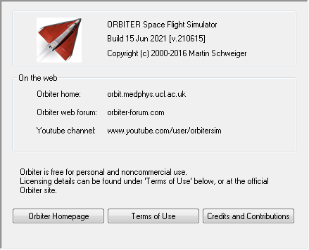
The About Orbiter tab contains version and build information, as well as links to the Terms of Use, credits and the Orbiter home page and forum.

Quickstart
This section demonstrates how to take off and land with one of Orbiter’s default spacecraft, the Delta-glider. If you are using Orbiter for the first time, this will help to familiarise yourself with some basic concepts of spacecraft and camera control. You should also read the rest of this manual, in particular Chapter 7 on keyboard and joystick interface, Chapter 10 on instrumentation, Chapter 11 on spacecraft control and Chapter 12 on basic flight manoeuvres.
Make sure you have configured Orbiter before launching your first simulation, in particular the video and joystick parameters (see Chapter 4). Once you have started the Quickstart scenario, you can get the following scenario instructions also on-screen by opening the Help window with .

Starting:
- Select the Checklists\Quickstart scenario (see Chapter 4.1 on scenario selection), and press the Launch Orbiter button to launch the scenario. Once the mission has been loaded (this can take a few moments) you will see in front of you runway 33 of the SLF (Shuttle Landing Facility) at the Kennedy Space Center, Cape Canaveral, Florida.
- You are in control of a Delta-glider, a powerful futuristic spacecraft, aligned with the runway centreline and ready for take-off.
- You can always exit the simulation by pressing ▪ or , or by clicking Exit on the main menu (). Orbiter saves the current simulation status in the (Current status) scenario, so you can continue your flight later by selecting this scenario.

Camera modes:
You are in an external camera mode, looking towards your ship.
- You can rotate the camera around your ship by pressing and holding down the ▪ key and pressing a cursor key () on the cursor keypad of your keyboard. Alternatively you can press the right button on your mouse and drag the mouse to rotate the camera. Or, if you have a joystick with a direction controller (“coolie hat”) you can use that as well.
- To jump into the cockpit of your glider, press . ( always toggles between cockpit and external view of the spacecraft you are controlling).
- In the cockpit, you can look around by rotating the camera with , or with the right mouse button or the joystick coolie hat.
- To look straight ahead, press the  button.
- To learn more about camera modes have a look at Chapter 6.2.

Cockpit modes:
- At the moment, you are in “virtual cockpit” mode – that is, you are inside a three-dimensional representation of the glider cockpit, with the glass pane of the head-up display (HUD) in front of you, and the instruments and controls arranged around you. If you look back, you can even get a glimpse of your passengers in the cabin behind you!
- You can switch to a different cockpit mode by pressing . Pressing  once will open the generic glass cockpit mode with only the HUD and two on-screen multifunctional displays. Pressing  again will open a 2-D panel mode.
- The 2-D control panel can be scrolled by pressing a cursor key () on the cursor keypad. To scroll the panel out of the way, press . You should now be able to see the runway stretching in front of you. Scrolling the panel is useful if you want to see more of your surroundings. Also, if the panel is larger than your simulation window, you can scroll different parts of the panel into view.
- If the native resolution of the panel is larger than your simulation window, you can use the mouse wheel to zoom the panel view in and out (this feature may not be supported by all spacecraft types).
- Some spacecraft have more than a single panel which can be accessed by pressing ▪ in combination with a cursor key. If you press ▪, you will see the glider’s overhead panel with some additional controls. Pressing ▪ switches back to the main panel.
- Not all spacecraft types support 2-D panels or 3-D virtual cockpits, but the generic glass cockpit mode is always available.
- You can find more information on cockpit modes in Chapter 9.

MFD instruments:
The most important and versatile instruments are the two multifunctional displays (MFDs) in the centre of the instrument panel. Each MFD consists of a square LCD screen and buttons along the left, right and bottom edges.
- MFDs can be set to different modes: With the mouse, left-click the SEL button at the bottom edge of one of the MFDs. (Alternatively, you can press ◻. MFD keyboard interfaces always use ◻ key combinations, where the left ◻ key controls the left MFD, and the right ◻ key controls the right MFD). You will see a list of available modes.
- Click on one of the buttons along the left or right edge to select the corresponding mode. If you click the top-left button, the MFD switches to Orbit mode.
- If you want to select a mode via keyboard, press ◻+◻[letter], where [letter] is the keyboard character listed in grey next to the MFD mode in the selection page.
- Most modes have additional settings and parameters that can be controlled with the buttons as well. The button labels change to indicate the various mode functions. For example, the Orbit mode has a button labelled TGT. This can be used to display the orbit of a target object. Click this button – you will see a dialog box to select a target object. Press , type iss in the text box, and press  again. This will show the orbital parameters of the International Space Station in the MFD display.
- To see a short description of the available mode functions, click the MNU button at the bottom of the MFD (alternatively, use ◻).
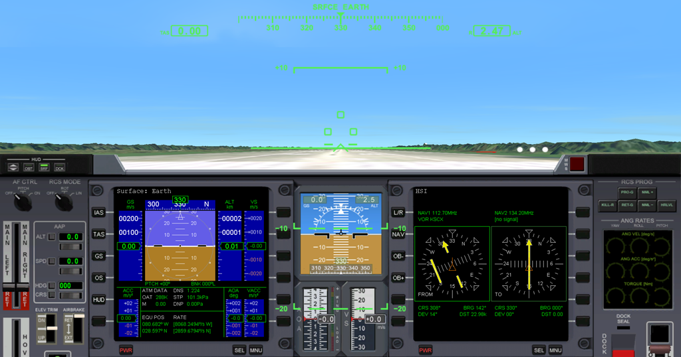
- A description of standard MFD modes can be found in Chapter 10. Orbiter can also be extended with add-on MFD modes, so you may see additional modes in the list.
- For now, switch the left MFD to Surface mode, and the right MFD to HSI mode.

Take-off:
Your glider is capable of runway take-offs and landings on Earth (and on any other planet, if the atmospheric density is sufficient to provide aerodynamic lift).
- For take-off, engage main engines at full thrust. You can do this by pushing the Main engine sliders at the left of the panel to the top using the mouse. Make sure you push both sliders simultaneously by clicking between them. If you engage only one of your engines, you will quickly veer off the runway into the ditch! (Although you can take-off with just one main engine, using thrust vectoring and a lot of rudder – a challenge for another day.)
- Your spacecraft will start to roll. You can check the speed (in m/s) on the airspeed indicator of the Surface MFD (the tape left of the artificial horizon), or on the HUD – the value in the green box at the top left of the screen.
- When the airspeed reaches 150 m/s, pull back on the joystick to rotate, or press and hold Num.
- Once clear of the runway, press  to raise the landing gear.

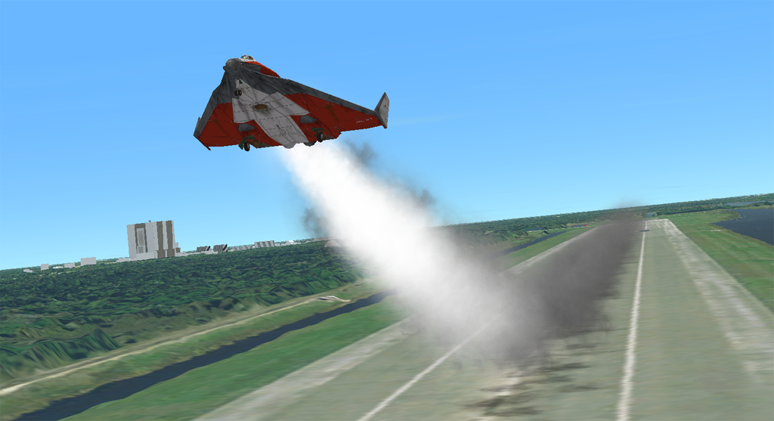
Atmospheric flight:
In the lower atmosphere, the glider behaves very much like an aircraft. Try the joystick controls for pitch, yaw and roll to get a feeling for the handling at different altitudes. Without a joystick, you can use the numerical keypad (/8Num for pitch, 1/3Num for yaw, and 4/6Num for roll). The glider has powerful rocket engines, but their performance depends on atmospheric pressure (at very low altitudes, it will not even go supersonic).
This is a good time to try different camera modes. Open the Camera dialog (▪) and check the effect of different track modes and field of view (FOV) settings.

Landing:
- Go around and approach runway 33 of the SLF from the south. Line up with the runway. Your HSI instrument helps maintain the correct approach path and slope. One of its two displays should already be tuned to the runway ILS system. The HSI contains a course pointer, deviation and glideslope indicator. It works like a standard aircraft instrument, so you may already be familiar with its use. If not, check Chapter 10.5 for details.
- As you approach the runway, you will see PAPI and VASI landing aids in front of and beside the runway (see Chapter 12.8). The PAPI is of limited use here, because it is adjusted to the Space Shuttle’s steep descent slope of 20°.
- Throttle back and engage airbrakes (b to engage by ½ step, ▪b to retract by ½ step) to reduce speed. Lower the landing gear (g) at speed < 300 m/s.
- After touchdown, engage left and right wheel brakes (, and . simultaneously) once below 150 m/s until you come to a full stop.

Space flight:
So far we have treated the glider much like a conventional aircraft. Now it is time to aim a bit higher …
- Take off as before. Turn east (use the compass ribbon at the top edge of the HUD, or the one in the Surface MFD display) and pitch up to 50°.
- As you gain altitude, you will notice that your craft starts behaving differently, due to the reduction in atmospheric pressure. One of the effects is a loss of lift, which causes the flight path indicator (the ⊕ HUD marker) slowly to drift down. Another effect is the loss of response from your aerodynamic control surfaces.
- At about 40 km altitude your glider will start to drop its nose even while you are pulling back on the stick. That isn’t a problem for now – we have already left the denser parts of the atmosphere, and need to pick up horizontal speed to enter orbit anyway, so the levelling of the trajectory is a typical ascent profile for spacecraft – but before the flight path drops too low and you start to lose altitude, it is time to activate the RCS (Reaction Control System) by clicking on the right of the RCS Mode dial (on the right side of the instrument panel) or by pressing ▪Num. You are now controlling your craft with attitude thrusters. The controls for pitch, yaw and roll remain the same, but the handling will feel different – without atmospheric friction, your craft will continue rotating until an opposite force is applied. If you lose control, the 5Num key is your friend. It will automatically engage RCS thrusters until any rotation is cancelled out (the killrot autopilot mode).
- Side note: You can fly most of your ascent trajectory with the Delta-glider without activating RCS along the way. In fact, at this point you could probably just take your hands off the controls and leave the glider to its own devices, relying on the equilibrium between speed and atmospheric density to take you on a “natural” ascent profile. Try it later! You will need RCS later on to set up the final, orbit circularisation burn.
- Pitch down to about 20° to shift emphasis from gaining altitude to gaining tangential velocity. Your flight path indicator (which tells you the direction your vessel is actually going) should stay above 0°.
- Now is a good time to activate the Orbit mode in one of your MFDs. This shows the shape of your current orbit (the green ellipse) in relation to the planet surface (they grey circle), together with a list of orbital parameters along the left side of the display. You should switch the display to current orbital plane projection mode, by clicking the PRJ button until Prj SHP is shown in the top right corner of the display. Also select altitude readouts by clicking the DST button so that the PeR and ApR entries in the data column change to PeA and ApA (periapsis altitude and apoapsis altitude above ground), respectively.
- At the moment, your orbit will be a rather eccentric ellipse, which for the most part is below the Earth’s surface. This means that you are still on a suborbital trajectory rather than in a stable orbit. As you keep gaining tangential velocity, the orbit curve will start to expand. Once the green curve is completely above the planet surface (and sufficiently high above the atmosphere) you will have entered orbit.
- You probably won’t achieve this with a single continuous engine burn. Turn off the engines as soon as the highest point of your orbit (ApA, apoapsis altitude readout) is around 200 km (ApA 200k), even if the projected path is still suborbital. Apart from ApA the most important pieces of information from the Orbit display are periapsis altitude (PeA), eccentricity (Ecc) and orbital velocity (Vel). For this mission, the aim is to enter a stable circular orbit at about 200 km altitude. This requires both ApA and PeA to be at 200k, Ecc close to 0, and a velocity of approximately 7800 m/s.
- You are now nearly in orbit. All that remains to do is raise the periapsis (the lowest point of the orbit). This is done best when you reach apoapsis, which should be in half an orbit (or around 45 minutes) from your current position. Time to switch into an external camera mode and enjoy the view!
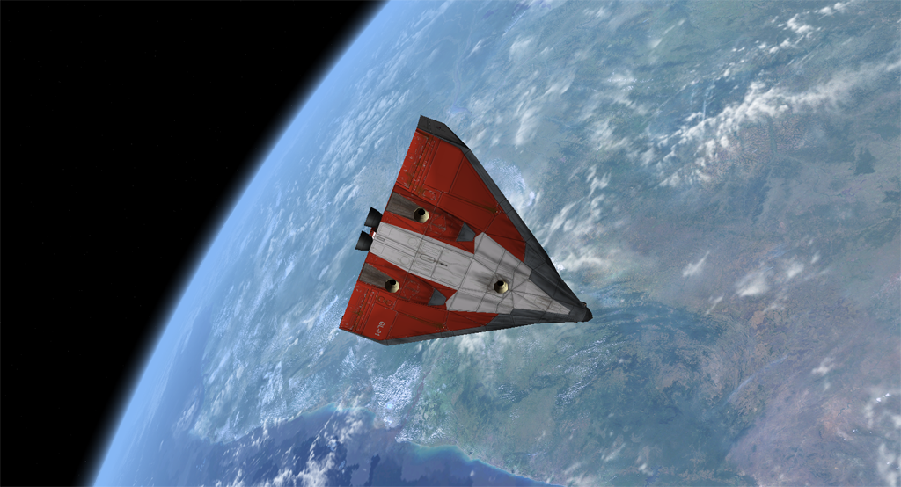
- It is also a good idea to switch the HUD from surface mode to orbit mode now. Do this by clicking the OBT button in the top left corner of the instrument panel, or by clicking the HUD button on the Orbit MFD. The keyboard shortcut for cycling through HUD modes is . In Orbit mode, the HUD flight path ladder is aligned with the orbital plane instead of the horizon plane, and there is a ribbon showing your orbital azimuth angle. It also shows indicators for prograde (the direction of your orbital velocity vector) and retrograde (the opposite direction).
- When you reach apoapsis, turn your craft prograde. You can see how close you are to apoapsis by checking the ApT (time to apoapsis) value in the Orbit MFD. If it takes too long, press  to engage time acceleration, and  to switch back. To turn prograde, you can operate the RCS manually until the prograde HUD marker (⊕) is centered in view, but it is easier to leave it to the automatic attitude control, by simply pressing the Prograde (PRO-G) button in the top right of the instrument panel. The keyboard shortcut is .
- Now fire your main engines again for final orbit insertion. The two parameters to watch are orbit eccentricity (Ecc) and periapsis altitude (PeA). The eccentricity value should get smaller, indicating that the orbit becomes more circular, while the periapsis altitude approaches the apoapsis altitude. Once the eccentricity value reaches a minimum, turn the main engines off. You can also deactivate the prograde altitude by clicking the PRO-G button again.
- Congratulations! You made it into orbit!

Deorbiting:
Should you ever want to come back to Earth, you need to de-orbit. This means to drop the periapsis point to an altitude where the orbit intersects the dense part of the atmosphere, so that your vessel is slowed down by atmospheric friction.
- Deorbit burns are performed retrograde. Click the Retrograde button (RET-G), wait until the vessel attitude has stabilised, and engage main engines.
- Keep burning until the periapsis point is well below the Earth’s surface (PeA < 0), then cut the engines. Strictly speaking, the de-orbit burn must be timed precisely, because too shallow a reentry angle will cause you to skid off the atmosphere, while too steep an angle will turn you into a shooting star. For now we are not concerned with the finer details …
- Turn prograde again and wait for your altitude to drop. As you enter the lower atmosphere, friction will cause your velocity to decrease rapidly. Reentries are usually performed with a high angle of attack (AOA) to increase friction – about 40° for the Space Shuttle.
- Once your aerodynamic control surfaces become responsive again you can turn off the RCS system. Your glider has now turned back into an aircraft. (Make sure the airfoil controls are activated if you switched them off in orbit – the AF Ctrl dial must be ON.)
- You have probably ended up a long way from your launch point at the KSC. Re-entering towards a specified landing point requires some practice in timing the de-orbit burn and the reentry flight path. We’ll leave that for a later mission. For now, simply look for a dry patch to land your glider.
- This completes your first orbital excursion!
You are now ready to try more advanced missions. Try the DG to ISS flight described in Chapter 16.1 for an orbital rendezvous and docking task. First you might want to learn a bit more about orbital manoeuvres and docking procedures in Chapter 12.

The main menu
The main menu is displayed at the top centre of the simulation window. It provides access to various functions and control dialogs. To the left and right of the menu bar, additional information panels may be shown.
If the menu bar is not visible, you may need to move the mouse pointer towards the top edge of the simulation window to scroll it down. Alternatively, pressing  will show or hide the menu bar.
The behaviour of the menu and info panels can be defined via the menu configuration dialog, which can be accessed by right-clicking on the menu bar.
Menu bar and info panels

Menu options:
- ship: Open the Vessel selection dialog which allows to switch input focus to a different spacecraft in the simulation (see Chapter 6.1). Keyboard shortcut: .
- camera: Open the Camera dialog which allows to configure the observer camera, including camera target selection, positioning, field of view and track mode (see Chapter 6.2). Keyboard shortcut: ▪.
- speed: Open the Simulation speed dialog, which provides access to time acceleration settings, and allows pausing/resuming the simulation (see Chapter 6.3). Keyboard shortcut: ▪.
- pause: pause/resume the simulation. Keyboard shortcut: ▪p.
- info: Open the Object info dialog which displays live information for all simulation objects (see Chapter 6.4). Keyboard shortcut: ▪i.
- function: Open the Custom function dialog which lists all accessible functions provided by active external modules, if available (see Chapter 6.8). Keyboard shortcut: ▪.
- display: Open the Visual helpers dialog which allows to configure additional display elements such as constellation lines, celestial coordinate grids and planetary surface markers (see Chapter 6.6). Keyboard shortcut: ▪.
- map: Open the Map window for a planetary body, including day/night terminator lines, orbital planes or ground tracks and planetary surface markers (see Chapter 6.5). Keyboard shortcut: ▪M.
- record: Open the Record/playback dialog which allows to record a simulation session, or configure the playback parameters during a replay (see Chapter 13). Keyboard shortcut: ▪.
- help: Open the inline Help dialog window (see Chapter 6.7). Keyboard shortcut: .
- save: Saves the current simulation state to the Quicksave scenario folder. Keyboard shortcut: ▪s.
- exit: Quit the simulation session and return to the Launchpad dialog. Keyboard shortcuts: ▪q or .

Additional info panels:
- The panel in the top left corner of the simulation window contains the name of the camera target (Tgt), the camera mode (Cam) and the field of view angle (FoV).
- The panel in the top right corner contains the date in Ephemeris Time (ET) and in Modified Julian Day (MJD) format, the simulation elapsed time (Sim) in seconds, as well as indicators for pause, time acceleration and record/playback if applicable.
- Note that Orbiter provides a date conversion utility (date.exe) in the Utils subdirectory. The Scenario Editor (see Chapter 15.1) allows to manipulate the date of a running simulation.
- Optionally, two more info panels can be displayed by user selection from the menu configuration dialog, including a frame rate display, a render statistics display showing the graphics engine load, or a viewport info display.

Vessel selection
The Vessel selection dialog can be used to switch to a different spacecraft in the simulation session, if available. It is opened with the ship button from the main menu (keyboard shortcut ).
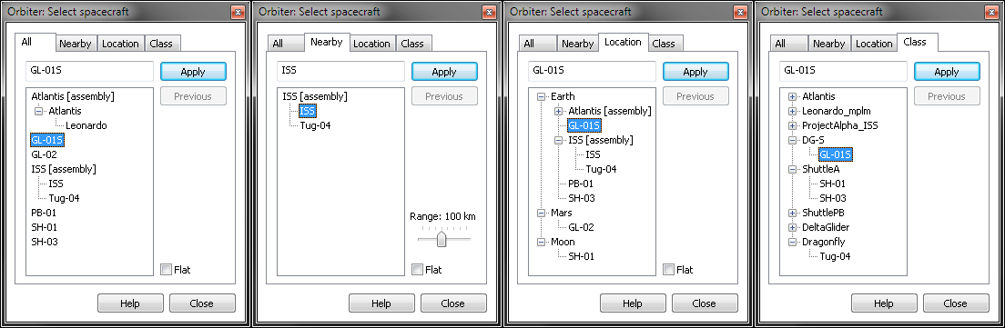
You can pick a vessel from the list and click Apply to jump into a new spacecraft. Clicking Previous puts you back into the original ship. (▪ is a shortcut to switch between the two most recent vessels.)
The tab pages (All, Nearby, Location, Class) present the vessel list sorted according to different criteria:
- All: shows all vessels in the current simulation session.
- Nearby: shows only vessels in the vicinity of the current focus vessel. The search radius can be adjusted with the slider on the right.
- Location: Groups the vessels according to the closest celestial body.
- Class: Groups the vessels according to type (vessel class).
Vessel assemblies (spacecraft that consist of multiple docked components) are normally represented as groups, listing the component vessels as sub-entries of the assembly. The Flat option shows the vessels in a flat list instead, regardless of their connections.
Note that only vessels which accept user input focus appear in the list. Vessels and components which don’t support individual manual control, such as the Space Shuttle’s booster rockets (SRBs) or external tank which are managed from the Shuttle orbiter, are omitted.

Camera control
The Camera dialog offers various ways to select viewpoints, camera targets or movement modes. It can be accessed via the camera button on the main menu (keyboard shortcut ▪).

Control tab:
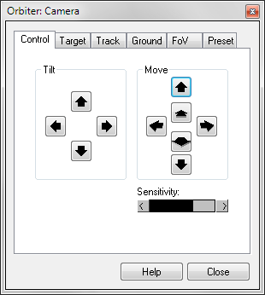
This tab contains controls for moving and tilting the viewer camera. The available options depend on the current camera mode.
In internal (cockpit) views, the camera can be rotated to allow the pilot to look around (keyboard shortcuts Cur, or alternatively right-click and drag the mouse). The view direction can be re-centered with the Forward button (shortcut Cur).
In external views the camera can be rotated around the target (keyboard shortcuts ▪Cur or right-click and drag the mouse). It can also be moved towards or away from the target (shortcuts Cur or mouse wheel).
In ground-based views, the camera can be tilted (shortcuts Cur), panned (shortcuts ▪Cur) or raised and lowered (shortcuts Cur) unless locked onto a target, in which case it can only be rotated around the target (shortcuts ▪Cur), moved towards or away from the target (shortcuts ▪Cur). Raising and lowering the camera is also possible in target-locked mode.
The Sensitivity slider can be used to adjust the speed of movement.

Target tab:
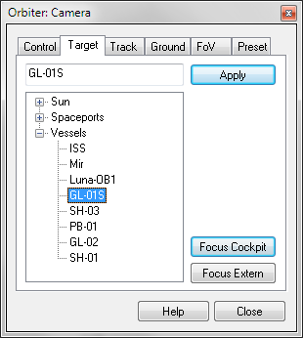
This tab provides a list of potential camera targets (vessels, celestial bodies, spaceports). Click on an object in the list and Apply to set a new camera target. Note that setting a new vessel target does not automatically switch the input focus. To do that, use the Vessel selection dialog (see Chapter 6.1). You can switch the camera back to the vessel you are controlling by pressing the Focus cockpit or Focus extern buttons (shortcut ).
Note that after selecting a new camera target, you may need to adjust the distance (Num).

Track tab:
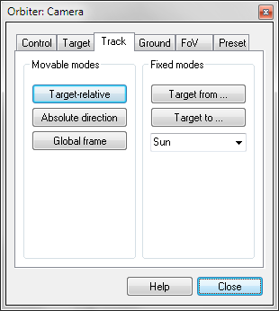
Allows to select different camera track modes which determine how the camera moves around and follows the target.
- Target-relative: camera maintains its position and orientation relative to the target. Camera movement is aligned with the vessel axes.
- Absolute direction: Movement is still aligned with the vessel axes, but the camera keeps looking in a fixed direction even if the target is rotating.
- Global frame: The camera still follows the target, but maintains a fixed orientation in a global frame of reference.
- Target from: This mode places the camera so that the observer looks at the target from the direction of a specified reference object. For example, Target from Sun always places the Sun behind the observer, so always shows the lit side of the target. Unlike the first three track modes, this mode fixes the camera position and doesn’t allow rotation around the target.
- Target to: Similar to Target from, but this mode places the reference object behind the target. So for example, Target to Sun makes the camera look into the Sun, and shows the unlit side of the target.
A keyboard shortcut for cycling between the first three track modes is .

Ground tab:
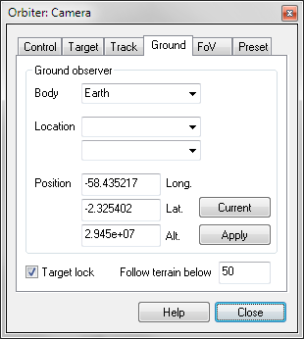
This page allows setting the camera into a surface-relative position and orientation. Unlike the track modes, the camera doesn’t follow the target, but stays fixed relative to the planet surface. It can be set up either in free mode, or in target lock mode, where it keeps looking in the direction of the target. Use the Target lock check box to choose between the two modes.
You can either manually set the surface location (latitude/longitude) and altitude on a reference planet and press Apply, or just press Current to put the camera into ground mode at its current location relative to the reference planet.
Note: when the camera is in free ground mode, it is no longer linked to a target object, so picking targets in the Target tab will not have an effect in this mode, but the new target will be used when switching back to a target-tracking mode.

FoV tab:
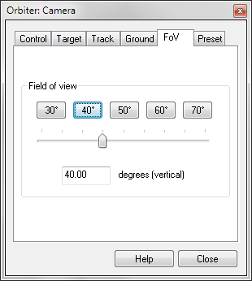
This page allows adjustment of the camera field of view (FoV), i.e. the camera zoom setting. The FoV can be set in discrete steps by clicking the buttons (30°–70°) or continuously by moving the slider, in the range 10°–90°. The FoV is measured between the top and bottom edges of the view window.
Keyboard shortcuts: /x for continuous FoV adjustment, or ▪z/▪x for discrete adjustments in steps of 10°.
Note that separate FoV settings are used for internal (cockpit) and external views, and adjusting one will not affect the other. Jumping between internal and external views will switch the FoV values to their respective settings.

Preset tab:
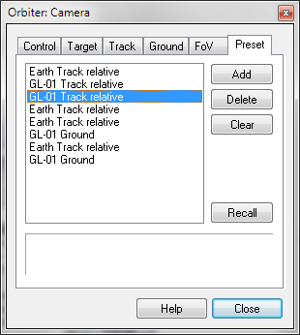
Orbiter provides an easy method to store and recall camera modes in a preset list. Click on the Preset tab in the camera dialog. Any available modes are listed here. To activate a mode, double-click it in the list, or select the mode and click Recall.
To store the current camera mode as a new preset in the list, simply click Add. This will produce a new entry with a short description. To delete a mode, click Delete, or Clear to clear the whole list.
Each entry remembers its track mode, position, target and FoV. The preset list is a good way to prepare a set of camera angles beforehand (for example to follow a launch) and then activate them quickly without having to adjust the positions manually. The preset list is stored together with the simulation state, so it can be shared via a scenario file.

Time acceleration
Spaceflight missions can take take weeks, months or even years in real time. If you plan a trip to the outer planets, running the simulation in real time is impractical, so Orbiter provides a time acceleration feature to fast-forward through coasting phases where nothing much is happening.
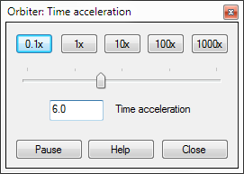
Open the Time acceleration dialog with the speed button on the main menu (keyboard shortcut: ▪). Time can be accelerated up to 1000× in discrete steps with the buttons, or continuously with the slider. It can also be slowed town to one tenth of real time. Keyboard shortcuts are t for speeding up by a factor of 10, and r for slowing down by a factor of 10. The maximum time acceleration supported with the keyboard shortcuts is 100000×, compressing a year into approximately 5 minutes.
High time accelerations can affect the accuracy and stability of the simulation, in particular close to planetary bodies or in the atmosphere, because the intervals between time frames become too large to allow precise integration of the vessel state vectors. Use high time accelerations only far from gravitational sources in interplanetary space.
Always switch back to real time before firing thrusters or other manual control actions. Things happen too fast even at moderate time accelerations to make it practical during manual manoeuvres.
The dialog also provides a button for pausing/resuming the simulation (shortcut: ▪p). This function is also directly available from the main menu.

Object info
The Object info window displays data about spacecraft, celestial bodies and spaceports. It can be opened with the info button on the main menu (keyboard shortcut ▪i).
After opening, the window shows data for the focus vessel currently controlled by the user. Different objects can be selected from the drop-down lists at the top of the window. The information presented depends on the object type. Data are grouped into categories. Categories can be expanded or collapsed individually, or collectively with the controls at the bottom of the window.
The Map button opens the Map window (see Chapter 6.5) automatically focussed on the selected target.

Vessel info
For vessel objects, the info panel shows information categories
- Designation: vessel name and class, transponder frequency
- Physical parameters: mass (total, dry, propellant), size and inertia moments
- Thruster ratings: vacuum thrust for main, retro and hover thruster groups
- Osculating elements: current 2-body orbital elements with respect to the reference body in the ecliptic frame (semi-major axis, eccentricity, inclination, longitude of ascending node, longitude of periapsis, mean longitude at epoch)
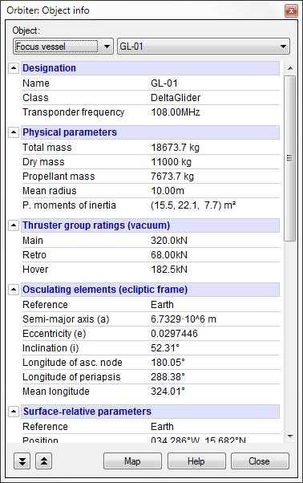
- Surface-relative parameters: position, velocity and orientation relative to the closest planetary body (longitude/latitude, altitude, ground speed, vertical speed, heading, pitch and bank angles)
- Atmospheric parameters: ambient temperature, density and static pressure at current vessel position
- Aerodynamic parameters: the vessel’s current dynamic pressure, true airspeed, Mach number, lift, drag and weight forces, lift/drag ratio, and angle of attack
- Docking ports: status (free/docked vessel designation), IDS frequency (if applicable) for each of the vessel’s docking ports
- State propagation: update mode (active/idle). For active vessels, shows current state vector propagation integrator, intra-frame subsamples and the gravity sources currently included in the computation

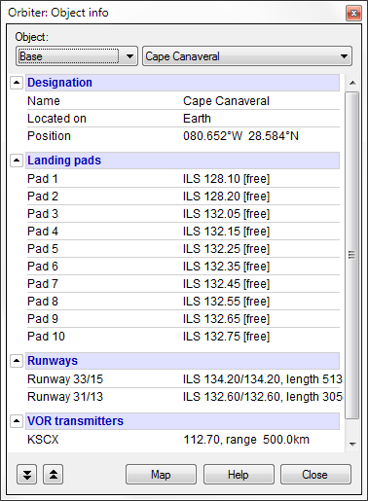
Spaceport info
For surface-based spaceports, the info panel shows categories
- Designation: base name, planet and position (longitude/latitude)
- Landing pads: Lists all VTOL pads available at the base, with status (free/landed vessel designation) and ILS frequency (if available)
- Runways: List all available runways, with 2-digit designation (including reverse direction, ILS frequencies (if available) and runway lengths
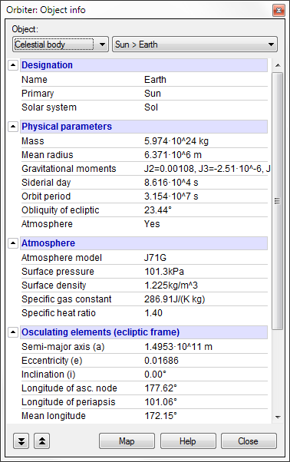
- VOR transmitters: omni-directional position beacons located directly at the base (if available)
For a more complete picture of the VOR stations located around the base, open the Map window, enable VOR stations in the options, and zoom into the target base until VOR frequencies are shown.

Celestial body info
For celestial bodies (sun, planets, moons, minor bodies), the info window shows categories
- Designation: name, primary (parent) body and solar system designation
- Physical parameters: mass, mean radius, parameters of the gravitational moments (Jx), if available, sidereal day length, orbital period, obliquity (axis tilt against ecliptic plane), atmosphere model active
- Atmosphere (if modelled): model name, surface pressure and density, specific gas constant, specific heat ratio
- Osculating elements: current 2-body orbital elements with respect to the parent body in the ecliptic frame (semi-major axis, eccentricity, inclination, longitude of ascending node, longitude of periapsis, mean longitude at epoch)
- Ecliptic position from primary: longitude, latitude in the ecliptic frame, distance from primary
- State propagation: analytic (from module): state vectors at arbitrary times available from dedicated module, or dynamic: via sequential state vector propagation

Map
The Map window shows a planetary surface represented by coastlines and contours in cylindrical projection. It contains the locations of surface bases and navigation radio transmitters, as well as the location and ground track of orbiting objects. The Map window is opened with the map button in the main menu (shortcut: ▪m).

Controls:
- Zoom: Use the buttons to zoom in and out of the map. You can also resize the map window to get a more detailed view.
- Mode: Switch between click and drag (only available if auto-center is disabled) and object selection modes.
- Body: Change the map to a different planetary body. The list is hierarchical. It lists the current body, its children and parent. To select a sibling body (e.g. go from one planet to another) you first have to pick their parent (e.g. the sun).
- Find: Select an object by type and name. Typing the first few characters opens a drop-down list to pick from.
- Auto-center selection: Keep the map centered on the currently selected object.
- Info: Open the Object info window for the currently selected object (see Chapter 6.4).
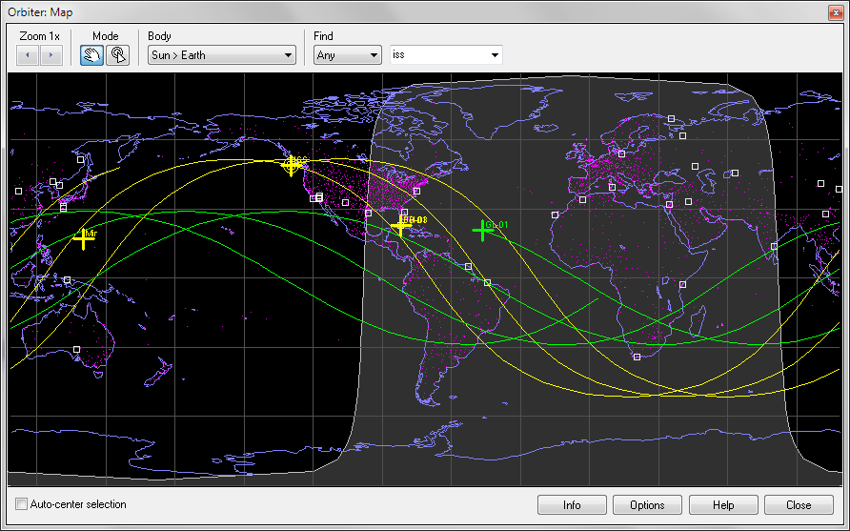
- Options: Open the map configuration dialog.

Configuration:
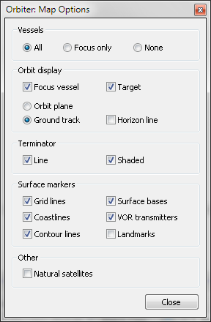
- Vessels: All (show all spacecraft currently landed on/orbiting this celestial body), Focus only (show only the user-controlled vessel, if it is landed on or orbiting the body), None (disable vessel objects)
- Orbit display: show orbit representations for the current focus vessel (the user-controlled vessel) and/or target vessel (the vessel selected in the map, if any). The map can display either the orbit plane (the intersection of the current orbital plane with the celestial body surface) for these orbits, or the predicted ground track for the next few orbits (assuming that the orbital elements don’t change). The horizon line for those vessels can also be displayed (the extent of the planet surface visible from the current vessel position and altitude).
- Surface markers: Show or hide various types of terrain data and surface objects: Grid lines (30° latitude/longitude lines), coastlines (if applicable), contour lines (if available), surface bases (the registered spaceports located on the planet), VOR transmitters (omnidirectional navigation beacons), and landmarks (currently not implemented).
- Other: Natural satellites: show or hide the location above the surface of any moons orbiting the planet.

Visual helpers
Orbiter has the ability to show a number of visual cues in the simulation window to provide additional data to the user. The Visual helpers dialog controls the display of these elements. It is opened with the display button on the main menu (shortcut: ▪).
The dialog contains tabs for planetarium mode, force vector display and object axis display.

Planetarium:
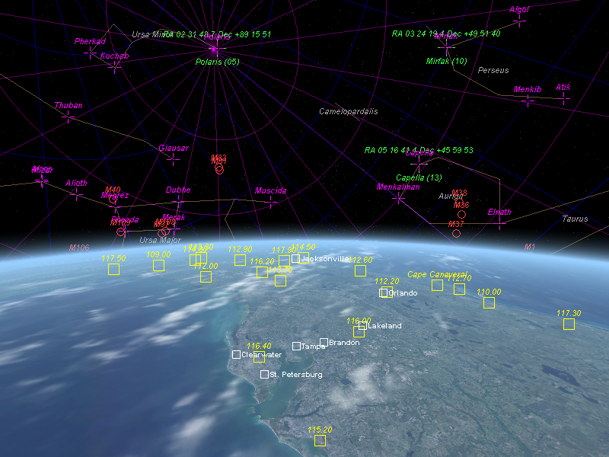
Lost in space? If you lose your bearings in the middle of an interplanetary flight, or need the location of a set of reference stars to determine your orientation, Orbiter offers guidance in the form of an in-flight “planetarium” with grids and object markers projected onto the celestial sphere and planetary surfaces. Planetarium mode can be switched on and off with the Planetarium mode box in the Planetarium tab of the visual helpers dialog (shortcut: ).
Planetarium mode with celestial grids and markers, and surface labels for cities, spaceports and VOR beacons active.
The dialog options in this tab allow to configure planetarium mode by switching on or off different elements.
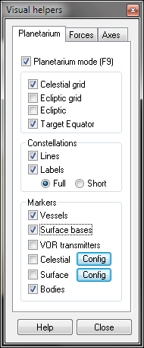
- Celestial grid: grid lines aligned with Earth’s equatorial frame projected to the celestial sphere.
- Ecliptic grid: grid lines aligned with the ecliptic frame (aligned with the Earth’s orbital plane at the J2000.0 epoch) projected to the celestial sphere.
- Ecliptic: plane of the ecliptic projected to the celestial sphere.
- Target equator: equatorial plane of the currently active reference body (not necessarily Earth) projected to the celestial sphere.
- Constellation lines: displays constellation lines on the celestial sphere.
- Constellation labels: prints the names of the constellations (in full or abbreviated) on the celestial sphere.
- Vessel markers: indicate the location of spacecraft.
- Surface bases: indicate the position of registered bases on planetary surfaces.
- VOR transmitters: indicate the position and frequency settings of omnidirectional navigation beacons.
- Celestial: display a set of configurable markers on the celestial sphere. Options include the common names of prominent stars, Messier objects, the galactic reference axis and the Apollo AGC reference stars with their celestial coordinates.
- Surface: configurable display of planetary surface landmarks (e.g. cities on Earth or geological features on other planets).
- Bodies: indicate the positions of celestial bodies.

Forces:
Orbiter can provide a graphical display of the force vectors currently acting on a spacecraft. This option is particularly useful for educational applications, to provide direct feedback of the effects of environmental parameters (gravity, atmosphere) and user input (e.g. change of lift as a function of changing angle of attack).
The display can be activated and configured in the Force tab of the visual helpers dialog.
Orbiter can show a number of separate linear force components and the resulting total force:
Weight | G (yellow) | Force due to gravitational potential
Thrust | T (blue) | Force generated by the vessel’s propulsion system
Lift | L (green) | Lift force generated by lifting airfoils in the atmosphere
Drag | D (red) | Drag force generated by friction in the atmosphere
Total | F (white) | Total force acting on the vessel
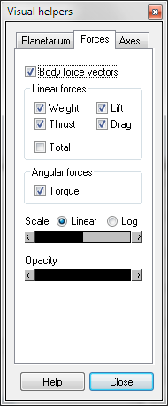
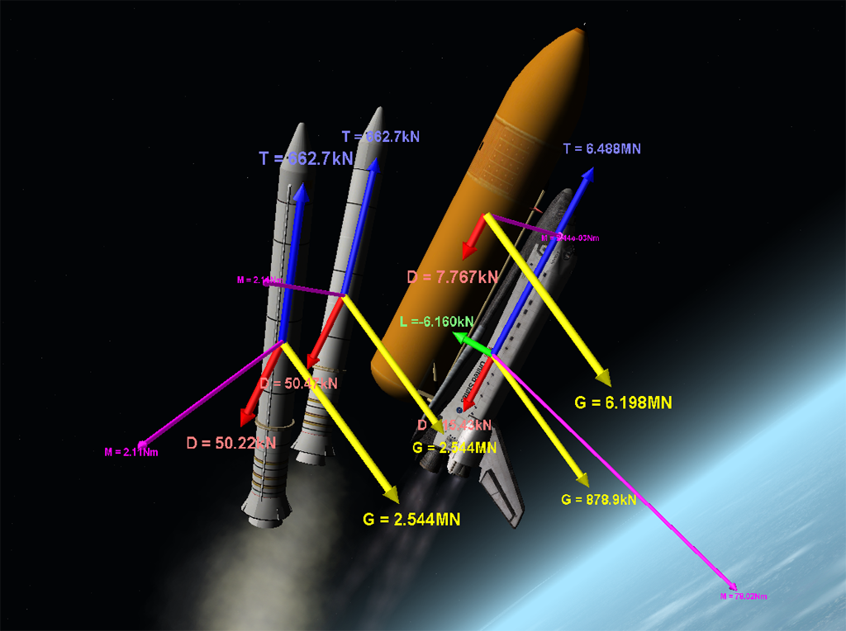
Note that the total force shown may not be equal to the sum of the four component forces, because additional forces may be acting on the vessel (e.g. custom user-defined forces).
Dynamics in action: forces and torques on the components of the Shuttle launch stack during booster separation.
Linear forces are shown graphically as vector arrows originating at the vessels centre of gravity. The vector lengths are proportional to the magnitude of the force (in linear or logarithmic scale, depending on the Scale setting). The lengths can be rescaled with the slider. In addition, the magnitudes are also shown numerically [N] with the vectors. The opacity of the vector display can be adjusted with a second slider.
In addition to the linear forces, Orbiter can also display the acting total torque

The torque vector is shown with respect to the centre of gravity of the vessel. The numerical value [Nm] is also displayed.
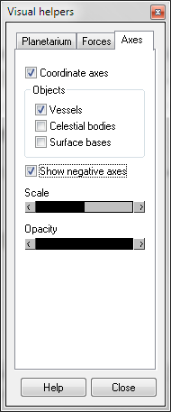
Note that for forces that are not generated at the vessel’s centre of gravity (e.g. the lift vector), the total force displayed is split into a linear component originating at the centre of gravity and a corresponding torque.

Axes
The orientation of the coordinate axes for the local frames of vessels, celestial bodies and spaceports can be displayed with the Axes tab of the visual helpers dialog. Coordinate frames can be useful for add-on designers who want to make sure that the orientation of their spacecraft design within the simulator is correct.
Unless the Show negative axes box is ticked, only the positive x, y and z axes are displayed.
The length and opacity of the axis vectors can be adjusted with the provided sliders.

Inline help
The help button on the main menu (shortcut: ) opens the inline help window accessible during a simulation session. The help window can also be called up from the Orbiter Launchpad by clicking the Help button.
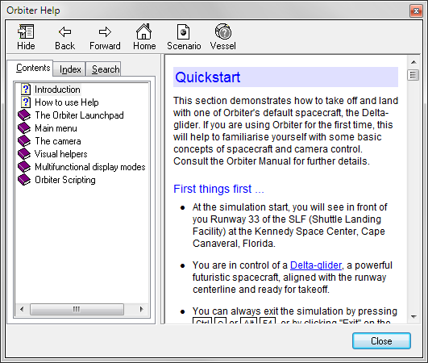
The inline help pages contain a subset of the topics covered in this manual, including
Table of contents
Scenario info
Vessel info
Help page
Elements of the inline help dialog.
- Main menu and the dialogs accessible from it.
- Camera control
- Description of the MFD modes, including controls and display elements
In addition, the inline help contains a chapter on Lua scripting and the Orbiter Lua extensions. Orbiter supports the Lua script language for a variety of tasks, including vessel control (via the Terminal MFD mode), autopilots, unsupervised vessel operation, mission design and tutorials. For a more detailed introduction to Lua scripting in Orbiter, see the Orbiter Lua Reference in Orbitersdk\doc\orbiter_lua.chm.
Various dialogs in Orbiter have a Help button which provide context-sensitive help by jumping to the appropriate page in the inline help system.
Some vessel classes, as well as specific scenarios, come with their own sections for the inline help system. You can call these up with the Scenario and Vessel buttons at the top of the help window.
Add-on developers are encouraged to provide inline help pages for their vessels and custom scenarios to help users familiarise themselves with specific controls, properties and functions.

Custom functions
Plug-in modules (either included in the basic orbiter distribution or downloadable as 3rd party contributions from the Orbiter add-on repositories) may provide a user interface using a dialog or window that can be opened inside an Orbiter session. The Custom functions dialog lists all active modules that allow opening an interface dialog box. It can be opened with the main menu function button (shortcut: ▪).
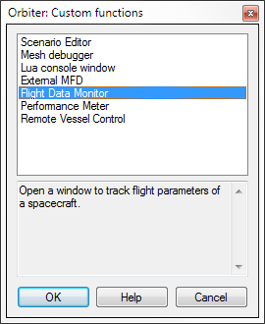
Clicking on an entry shows a short description of the plug-in below the list. Double-clicking or the OK button opens the corresponding dialog.
A module must be activated before it will be shown in the Custom functions dialog. See Chapter 4.4 on how to activate modules. Not all active modules may create an entry in the list. Some don’t require user interaction and take effect as soon as they are activated.
See Chapter 15 for a description of some of the plug-in modules included in the Orbiter installation.

User interface
This section describes the keyboard, mouse and joystick interfaces for controlling spacecraft and other functions in Orbiter.

Keyboard interface
This section describes the default Orbiter keyboard assignments. Please note that the assignments are customisable by editing the keymap.dat file in the Orbiter directory, and that therefore the keyboard controls for your Orbiter installation may be different.
The key assignments referenced in this section and the rest of the manual refer to the keyboard layout shown in the figure below. For other layouts (e.g. language-specific) the key labels may be different. The relevant criterion for key functions in Orbiter is the position of the key on the keyboard, not the label. For example, on the German keyboard the keys for the “turn orbit-normal” ( ; ) and “turn orbit-antinormal” ( ‘ ) functions will be “Ö” and “Ä”.
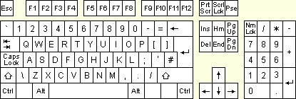
Note that certain spacecraft may define additional keyboard functions. Check individual documentation for a detailed description of spacecraft controls and functionality.
Cursor pad
Numpad
Keyboard layout reference

General
r | Time deceleration: Slow down the simulation speed by factor 10, to a minimum of 0.1× real time. See also Chapter 6.3.
t | Time acceleration: Speed up the simulation time by a factor 10, to a maximum of 100000× real time. See also Chapter 6.3.
x | Zoom camera out (increase field of view). See also Chapter 6.2.
z | Zoom camera in (decrease field of view). See also Chapter 6.2.
▪x | Zoom out (in discrete steps of 10°).
▪z | Zoom in (in discrete steps of 10°).
▪c | Start/stop recording a flight, or stop a playback. See also Chapter 13.
▪d | Undock from a vessel.
▪p | Pause/resume simulation.
▪q | Exit the simulation to the Launchpad window.
▪s | Quicksave the current simulation state to a scenario.
 | Toggle cockpit/external view of the user-controlled spacecraft.
▪ | Open the Camera dialog (see Chapter 6.2) to select camera target, view mode and field of view.
 | Open the help window (see Chapter 6.7).
 | Cycle through external tracking view modes: target-relative / absolute direction / global frame (see Chapter 6.2).
▪ | Open the Time acceleration dialog (see Chapter 6.3).
 | Open the vessel selection dialog (see Chapter 6.1).
▪ | Switch control back to the previous vessel, if any. Allows jumping backwards and forwards between the last two vessels.
 | Main menu (see Chapter 6).
▪ | Open the Custom functions dialog for access to plug-in functions and dialogs (see Chapter 6.8).
▪ | Open the Flight recorder/player dialog containing recording and playback functions (see Chapter 13).
▪i | Open the Object info dialog (see Chapter 6.4).
▪m | Open the Map window (see Chapter 6.5).
 | Toggle planetarium mode on/off (see Chapter 6.6).
▪ | Open the Visual helpers dialog for planetarium, force and axis display options (see Chapter 6.6).

Spacecraft controls
These keys allow manual manoeuvring of the user-controlled spacecraft. See also joystick controls. Note that some spacecraft may not define all thruster types.
Main/retro thruster controls:
▪+Num | Accelerate by increasing main thruster setting or by decreasing retro thruster setting.
▪-Num | Decelerate by decreasing main thruster setting or by increasing retro thruster setting.
*Num | Cut off main and retro thrusters.
+Num | Fire main thrusters at 100% while pressed (overrides permanent setting)
-Num | Fire retro thrusters at 100% while pressed (overrides permanent setting)
Hover thruster controls (where available):
0Num | Increase hover thruster setting.
.Num | Decrease hover thruster setting.
Attitude thruster controls (rotational mode):
4 / 6Num | Fire thrusters for rotation around longitudinal axis (bank).
2 / 8Num | Fire thrusters for rotation around transversal axis (pitch).
1 / 3Num | Fire thrusters for rotation around vertical axis (yaw).
5Num | Toggle kill rotation autopilot mode: stops spacecraft rotation by engaging appropriate attitude thrusters.
Attitude thruster controls (linear mode):
2 / 8Num | Fire thrusters for up/down acceleration (along vertical axis).
1 / 3Num | Fire thrusters for left/right acceleration (along transversal axis).
6 / 9Num | Fire thrusters for forward/back acceleration (along longitudinal axis).
Note: In combination with ▪, thrusters are engaged at 10% max. thrust for fine control.
Other controls:
/Num | Toggle reaction control system between rotational and linear modes.
▪/Num | Enable/disable reaction control system
/Num | Enable/disable manual user control (via keyboard or joystick) of aerodynamic control surfaces (elevator, rudder, ailerons) if available
a | Toggle hold altitude autopilot mode. Maintain current altitude above the surface by means of hover thrusters only. This will fail if hover thrusters cannot compensate for gravitational acceleration, in particular at high bank angles. Combining this mode with the H-level mode is therefore useful.
l | Toggle H-level autopilot mode. Keeps the spacecraft level with the local horizon by modulating attitude thrusters.
[ | Toggle prograde attitude mode. Turns the spacecraft into its orbital velocity vector with attitude thrusters.
] | Toggle retrograde attitude mode. Turns the spacecraft into its negative orbital velocity vector with attitude thrusters.
 | Toggle orbit-normal attitude mode. Turns the spacecraft normal to its orbital plane (into direction R × V)
 | Toggle orbit-antinormal mode. Turns the spacecraft anti-normal to its orbital plane (into direction −R × V)
 / Cur | Trim control (only for vessels with aerodynamic control surfaces)
, / . | Apply left/right wheel brake (where available)

External camera views
Tracking camera:
Cur | Move camera away from target object.
Cur | Move camera towards target object.
▪Cur | Rotate camera around target.
Ground-based camera:
▪Cur | Pan camera (free mode)
Cur | Tilt camera (free mode)
Cur | Rotate camera around target (target-locked mode)
Cur | Move camera towards/away from target (target-locked mode)
 / Cur | Raise/lower camera

Internal (cockpit) view
 | Cycle through generic (glass cockpit), 2D panel and 3D virtual cockpit views (if supported by the spacecraft)
Cur | Rotate pilot view direction.
 | Return to default (forward) pilot view direction.
▪  Cur | Lean left/right forward, return to default position (3D virtual cockpit only)
▪Cur | Switch to next observer (pilot/crew/passengers) if available (3D virtual cockpit only)
Cur | Scroll panel (2D panel view only)
▪Cur | Switch to neighbour panel if present (2D panel view only)
▪h | Toggle HUD display on/off.
h | Cycle through HUD colours.
h | Cycle through HUD modes.
▪r | HUD reference selection. (Orbit HUD: opens reference selection input box; Docking HUD: cycles through available NAV receivers)
▪r | Docking HUD only: Reference selection, bypassing XPDR and IDS transmitters

MFD control
MFD functions are generally executed with ◻–key combinations, where the left and right ◻ keys address the left and right standard MFD instruments, respectively.
◻ | Toggle MFD on/off (presses the MFD PWR button)
◻ | Cycle through all MFD mode selection pages, then jump back to current mode.
◻ | Toggle MFD menu page, listing descriptions for all function buttons.
◻<mode> | On MFD mode selection pages only: ◻ in combination with a valid mode key selects that mode (see Chapter 10).
◻<func> | In standard display mode ◻ in combination with a valid mode-specific function key executes that function (see Chapter 10).

Menu selections
Cur | Move to previous item in the list.
Cur | Move to next item in the list.
Cur | Display sub-list for the selected item if available.
Cur | Go back to the parent list from a sub-list.
★ | Select the current item and close the list.
 | Close list.

Joystick interface
A joystick can be used to operate the attitude and main thrusters, or the equivalent aerodynamic control surfaces (if available) of the user-controlled spacecraft manually.
Action | Effect
Push stick left or right | Engage ailerons or engage RCS for rotation around longitudinal axis (bank)
Push stick forward or back | Engage elevators or engage RCS for rotation around transversal axis (pitch)
Operate rudder control or push stick left or right while holding joystick button 2 | Engage rudder or engage RCS for rotation around vertical axis (yaw)
Operate throttle control | Set main thrust. Similar to ▪Num and ▪Num keyboard controls, but does not engage retro thrusters.
Direction controller (“coolie hat”) | Cockpit view: rotate pilot view direction
Direction controller (“coolie hat”) | External view: rotate camera around target
Direction controller + joystick button 2 | Cockpit view: scroll instrument panel (2D panel view only)
Direction controller + joystick button 2 | External view: tilt view diretion (free ground observer view only)

Mouse interface
Spacecraft instrument panels can be operated with the mouse. Most buttons, switches and dials are activated by clicking the left mouse button. Some elements like multi-way dials may respond to both left and right mouse clicks. In generic (glass cockpit) view, the buttons around the MFD displays can be operated with the mouse.
In external camera modes, the mouse wheel can be used to move the camera towards or away from the target.
In cockpit views, the mouse wheel changes the field of view (a good way to zoom an instrument display closer in the virtual cockpit). In addition, in 2-D panel cockpit views, ▪ + mouse wheel zooms the panel in and out if the native resolution of the panel is higher than the size of the simulation window (not supported for legacy panel implementations).
The camera direction can be rotated by pressing the right mouse button and dragging the mouse. This works both in external and cockpit views.
Action | Effect
Left mouse button | Operate instruments in cockpit views
Right mouse button + drag | Rotate camera view
Mouse wheel | Cockpit view: Change camera field of view (FoV). See x/z.
Mouse wheel | External track views: move camera toward/away from target.
▪ + mouse wheel | 2D panel view only: Zoom instrument panel in/out

Physical measures, units and magnitudes
Orbiter and the associated documentation (including this manual) use SI units (Système international), sometimes called the metric system, for all default displays and calculations, with very few exceptions, e.g. days, in particular in combination with MJD dates, or AU (astronomical units) for distances on interplanetary scales. Another exception are angles, which are mostly displayed in degrees [°] instead of radians [rad].
Some of the frequently encountered base and derived units are
Time | second [s]
Length | meter [m]
Mass | kilogram [kg]
Temperature | Kelvin [K]
Speed | [m s−1]
Acceleration | [m s−2]
Linear momentum | [kg m s−1]
Angular momentum | [kg m2 s−1]
Force | Newton [N]: 1 N = 1 kg m s−2
Energy, heat | Joule [J]: 1 J = 1 kg m2 s−2
Power | Watt [W]: 1 W = 1 kg m2 s−3
Pressure | Pascal [Pa]: 1 Pa = 1 N m−2
Frequency | Hertz [Hz]: 1 Hz = 1 s−1
In MFD displays (see Chapter 10) the units are generally omitted in numerical readouts of physical properties unless non-standard units are used.
Note that the instruments of specific spacecraft (in particular representations of historic vessels) may be calibrated in different unit systems. Always read the documentation of your vessel if in doubt.

Magnitudes
Orbiter uses either the standard scientific notation (a · 10b) or a magnitude suffix character (in particular in MFD displays when space is limited) to represent a range of magnitudes of the represented properties.
10−9 | n (nano)
10−6 | u (micro)
10−3 | m (milli)
103 | k (kilo)
106 | M (mega)
109 | G (giga)
Examples:
- A time period of 1.4k represents 1.4 · 103 s or 23 minutes 20 seconds.
- A distance of 2.83G represents 2.83 · 109 m or 2830000 km
- A mass of 4.7k represents 4.7 · 103 kg or 4.7 tons (note that the “k” in kg is part of the unit, not a magnitude suffix).
- A pressure of 2.24m represents 2.24 · 10−3 Pa.

Precision and error limits
Most displays don’t provide explicit error estimates of the shown values. However, the precision of the numerical representation should be indicative of the confidence margins. Therefore, a value displayed as 1.32 should imply an error range of the order 1.32 ± 0.01, and 4.2k should be understood as (4.2 ± 0.1)k.

Included spacecraft types
Orbiter comes with a range of diverse spacecraft types to explore different aspects of space flight. This includes fictional spacecraft such as the Delta-glider and Shuttle-A which relax a few specifications beyond current limits (in particular in terms of fuel efficiency and structural strength) to allow flights across the solar system, recreations of real vessels such as the Space Shuttle with narrow error margins that require precise flight plans, to novel concepts such as solar sails.
The spacecraft included in the basic Orbiter distribution will get you started, but many more can be downloaded as add-ons. See the Orbiter web page for a list of add-on repositories.

Delta-glider
The Delta-glider (DG) is the ideal ship for the novice pilot to get space-borne. Its futuristic design concept, high thrust and extremely low fuel consumption make it easy to achieve orbit, and it can even be used for interplanetary travel. The winged body provides aircraft-like handling in the lower atmosphere, while the vertically mounted hover thrusters allow vertical lift-offs and landings independent of atmospheric conditions and runways.
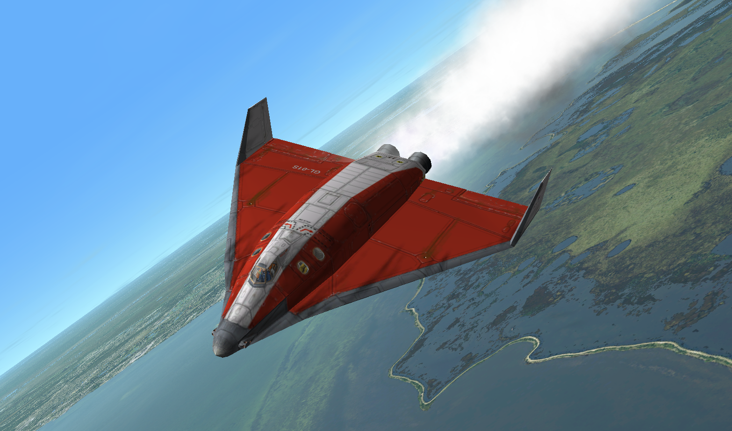
Two versions are available: The standard DG is equipped with main, retro and hover engines. The scramjet version (DG-S) has in addition two air-breathing scramjet engines fitted, which can be used during supersonic atmospheric flight. The scramjets have an operational airspeed range of Mach 3–8.
Delta-glider model and textures by Roger “Frying Tiger” Long. Instrument panels by Martin Schweiger.
The DG supports 2-D instrument panels and a virtual cockpit in addition to the standard “glass cockpit” camera mode.
The glider comes with operational landing gear, nose cone docking port, airlock door, deployable radiator and animated aerodynamic control surfaces. Details on instrumentation, controls, camera modes and technical specifications can be found in the separate document DeltaGlider Operations Manual.

Vessel-specific key controls:
Shortcut | Action
b | Extend airbrake by one step
▪b | Retract airbrake by one step
d | Deploy/retract radiators
g | Lower/raise landing gear
h | Cycle HUD modes
▪h | Deploy/retract HUD screen
k | Open/close nose cone
o | Open/close outer airlock hatch
▪o | Open/close inner airlock hatch
u | Open/close top hatch

Technical specifications:
Mass | 11.0 · 103  13.0 · 103 | kg  kg | (empty – DG)  (empty – DG-S)
 | 13.5 · 103 | kg | (fuel capacity)
 | 340 | kg | (payload)
 | 24.84 · 103  26.84 · 103 | kg  kg | (total – DG)  (total – DG-S)
Dimensions | 18.7 × 17.9 × 4.9 | m | (L × W × H)
Thrust | 2 × 160 | kN | (main)
 | 2 × 34 | kN | (retro)
 | 110 + 2 × 36.3 | kN | (hover)
Acceleration | 12.88  11.92 | m/s2  m/s2 | (main thrust at full load – DG)  (main thrust at full load – DG-S)
Isp | 4.0 · 104 | m/s | (vacuum)
Prop. flow rate | 8.0 | kg/s | (main engines in vacuum)

Shuttle-A
The Shuttle-A class vessel, designed by Roger “Frying Tiger” Long, is a medium size freighter craft, designed preliminary for low gravity/low atmospheric density environments. The current design and thrust specs allow to achieve LEO from Earth’s surface, but the ascent should be planned carefully to avoid overheating/overstressing the airframe and at the same time not running out of propellant.
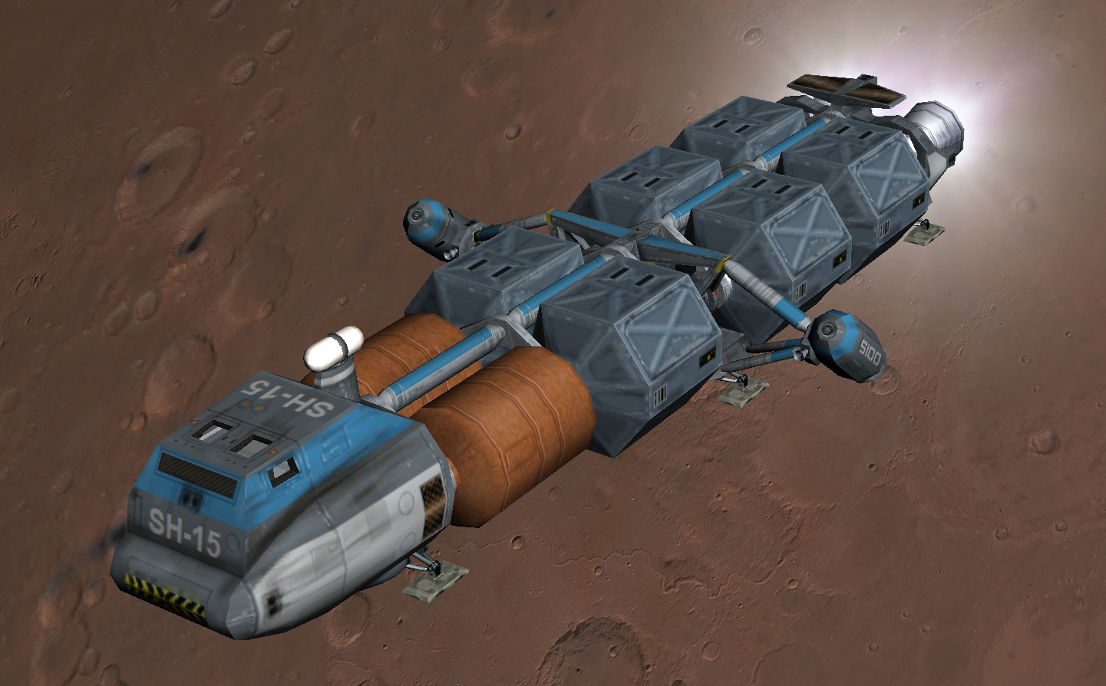
The vessel has a set of two main, and two hover thrusters which provide VTOL capability. A pair of auxiliary engine pods, which can be manually rotated 180°, can contribute additional main, hover or retro thrust. The fully loaded vessel can take off vertically from Earth surface with a combination of hover thrusters and auxiliary pods in vertical position.
Shuttle-A model design: Roger Long. Instrument panels and module code: Martin Schweiger. Virtual cockpit, payload management extensions: Radu Poenaru.
The Shuttle-A supports 2-D instrument panels and a basic virtual cockpit. An ADI (attitude director indicator) ball provides attitude and targetting information. For ADI familiarisation, check out the Tutorials\ADI training scenario. The craft has detachable cargo pods and workable landing gear, contributed by Radu Poenaru. For detailed description see the separate document Shuttle-A Operations Manual.

Vessel-specific key controls:
Shortcut | Action
k | Operate docking hatch mechanism
o | Open/close outer airlock door
G | Operate landing gear

Technical specifications:
Mass | 13.0 · 103 | kg | (empty)
 | 74.2 · 103 | kg | (fuel capacity)
 | 6 x 20.0 · 103 | kg | (payload)
 | 207.2 · 103 | kg | (total)
Dimensions | 35.0 × 15.4 × 6.9 | m | (L × W × H)
Thrust | 2 × 1064.4 | kN | (main)
 | 2 × 745.0 | kN | (hover)
 | 2 × 385.0 | kN | (auxiliary pods)
Acceleration | 14.0 | m/s2 | (main + aux. pods at full load)
 | 10.9 | m/s2 | (hover + aux. pods at full load)
Isp | 3.3 · 104 | m/s | (vacuum)
Prop. flow rate | 64.5 | kg/s | (main engines in vacuum)

Shuttle PB (PTV)
The PB is a very agile single-seat spacecraft. It has a main engine and uses hover thrusters for vertical take-off and landing. During atmospheric flight the lifting body and winglets produces lift. However, aerodynamic control surfaces are not supported in the current version. Attitude control is performed via the reaction control system (RCS).
Apart from the standard implementation of the PB vessel class, Orbiter also comes with a script version of this spacecraft type (ScriptPB). This looks and behaves identical to the original Shuttle PB, but is completely implemented as a Lua script (see chapter 14) and can therefore easily be modified. This is a good way for newcomers to get into spacecraft design. The code can be found in Config/ScriptPB.cfg.

Technical specifications:
Mass | 500 | kg | (empty)
 | 750 | kg | (fuel capacity)
 | 1250 | kg | (total)
Dimensions | 6.8 × 5.2 × 2.4 | m | (L × W × H)
Thrust | 30.0 | kN | (main)
 | 2 × 7.5 | kN | (hover)
Acceleration | 24.0 | m/s2 | (main thrust at full load)
Isp | 5.0 · 104 | m/s | (vacuum)
Prop. flow rate | 0.60 | kg/s | (main engine in vacuum)
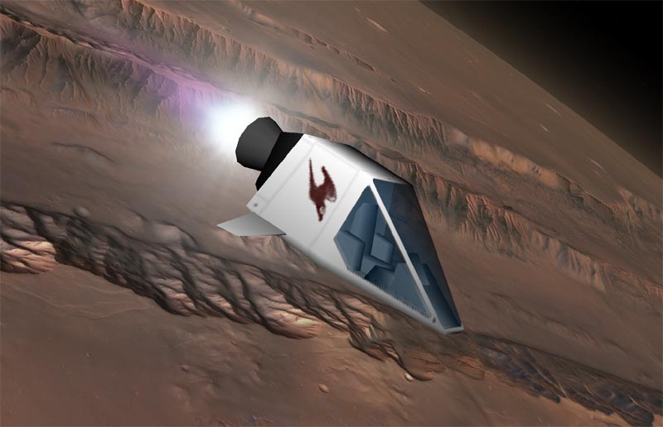
Overall design and textures: Balázs Patyi. Model improvements: Martin Schweiger

Dragonfly
The Dragonfly is a space tug designed for moving payload in orbit. It may be used to bring satellites delivered by the Space Shuttle into higher orbits, or to help in the assembly of large orbital structures.
The Dragonfly has no dedicated main engines, but a versatile and adjustable reaction control system for manoeuvring. It is not designed for atmospheric descent or surface landing.
The cockpit layout consists of a set of 2D panels that include MFD instruments, an ADI ball and radar display. The Dragonfly incorporates a detailed electrical and environmental systems simulation, contributed by Radu Poenaru. For detailed information see the Dragonfly Operations Handbook.
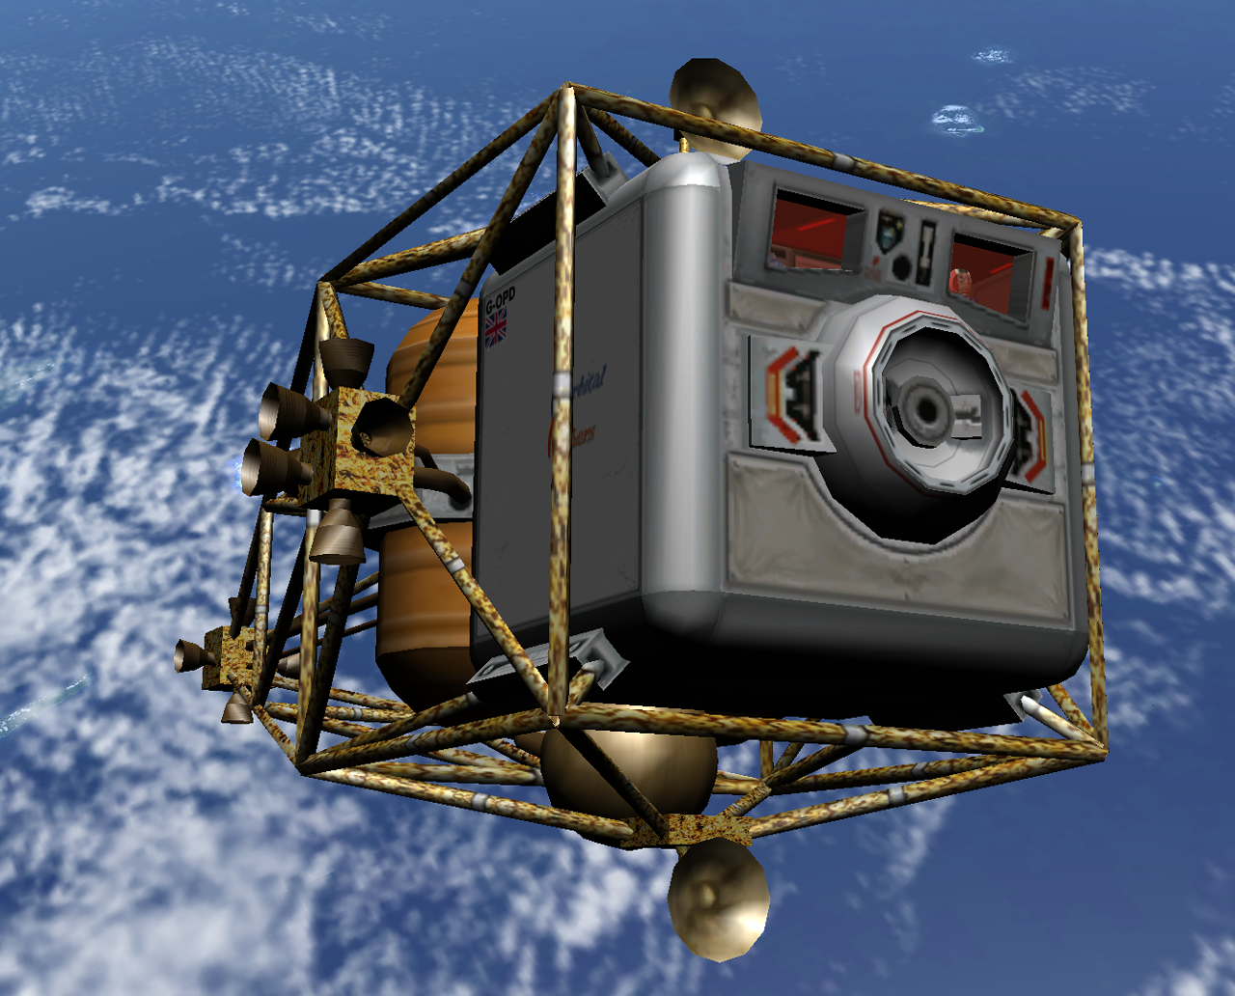
Dragonfly original design: Martin Schweiger. Model improvements and textures: Roger Long. Systems simulation and instrument panels: Radu Poenaru.

Technical specifications:
Mass | 7.0 · 103 | kg | (empty)
 | 4.0 · 103 | kg | (fuel capacity)
 | 11.0 · 103 | kg | (total)
Dimensions | 14.8 × 7.2 × 7.4 | m | (L × W × H)
Propulsion system: RCS with thrusters mounted in 3 pods (left, right, aft)
Thrust | 1.0 | kN | (per RCS engine)
Acceleration | 0.18 | m/s2 | (linear RCS engine pair thrust, at full load)
Isp | 4.0 · 103 | m/s | (vacuum)
Prop. flow rate | 0.50 | kg/s | (RCS engine pair in single axis)

Space Shuttle Atlantis
Space Shuttle Atlantis, comprising the complete launch stack of orbiter, external tank and solid rocket boosters, represents the only “real” spacecraft in the basic Orbiter distribution – but there are many more available as add-ons. Its flight characteristics and fuel management are less forgiving than fictional models like the Delta-glider, and much of it (esp. the launch phase) is automated to ease pilot workload.
Make sure to activate Limited fuel in the Parameters tab of the Launchpad dialog before flying the Space Shuttle. Without consuming fuel, Atlantis is too heavy to reach orbit.
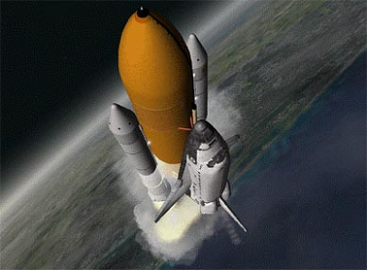
The Atlantis orbiter features a virtual cockpit with working MFD instruments and head-up display, and an operational payload bay with remote manipulator arm (“Canadarm”), so the deployment or even recapture of satellites can be simulated, as well as the shipment of resupplies to the International Space Station. Also included is MMU (manned maneuvering unit) support for extravehicular activities.
Atlantis 3D model and textures: Michael Grosberg, Don Gallagher (orbiter) and Damir Gulesich (ET+SRB). Original module code: Martin Schweiger. Original grappling, RMS and MMU extensions: Robert Conley. Module code extensions: David Hopkins and Douglas Beachy.
Operation procedures and implementation details are provided in separate documents: Space Shuttle Atlantis Operations Manual and Atlantis with MMU & Satellite Version 3.0.
Below are a few simplified checklists for launch, docking and payload operation.

Launch (autopilot):
- With the launch stack ready on the pad, enter the Atlantis cockpit and bring up the Ascent AP mode in one of the MFD instruments (◻ + ◻b).
- Adjust the launch azimuth (◻; and ◻) according to the desired orbit inclination. (The inclination resulting from the chosen azimuth is displayed in the MFD.) The further you deviate from 90° (east) the more fuel will be required for a given orbit altitude, because you make less use of the Earth’s rotation. When launching from Cape Canaveral, the allowed azimuth range is 35°–120° for safety reasons.
- Adjust the target orbit altitude (◻- and ◻=). The maximum attainable altitude depends on orbit inclination and payload mass, but is typically in the range 250–350 km. If you pick too high a value, the orbiter will not enter a stable orbit. The MFD does not provide a warning when exceeding limits.
- Enable/disable the OMS2 burn schedule (◻o). OMS2 is an orbit circularisation burn at apogee. You can turn this off to terminate the autopilot after the OMS1 burn. The final orbit insertion burn must then be executed manually.
- Launch (◻l).
- During ascent, the display shows some profile parameters (azimuth, pitch angle, apoapsis and periapsis altitudes).
- The autopilot manages the spacecraft attitude by gimballing the SRB and SME engines. The current gimbal angles can be monitored on page 2 of the Ascent AP display (◻.).
- At the end of the OMS2 burn (or after OMS1, if OMS2 was disabled), the autopilot disengages, returning control to the pilot.

Launch (manual):
Not something the real Shuttle would allow, but if you are up for a challenge, here goes:
- Fire main engines at 100% thrust.
- SRBs are ignited automatically when main engines reach 95% thrust. SRB thrust is not controlled manually. Once ignited, they cannot be shut off.
- During launch, attitude commands engage the SRB thrust vectoring system. Once clear of the tower, roll the launch stack for target heading and pitch over to achieve the required ascent profile. This is the tricky bit normally controlled by the autopilot. To reach a stable orbit before running out of fuel, you will need to fly a near-optimal profile.
- SRBs separate from the launch stack automatically at T + 2:06 min. In an emergency, the SRBs can be jettisoned manually with j.
- Ascent continues with the orbiter’s main engines. Throttle down as required for 3 g max. acceleration.
- The external tank separates at T + 8:58 min when empty, or manually with j (target altitude 110 km).
- After tank separation, the Shuttle orbiter switches to OMS (orbital maneuvering system) using internal fuel tanks for final orbit insertion. Attitude thrusters (RCS – reaction control system) are activated.

Docking:
- The orbiter carries a docking attachment in the cargo bay.
- Open cargo bay doors before docking (k).
- Docking direction is in the orbiter’s +y direction (up). The Docking MFD must be interpreted accordingly.

RMS manipulation and grappling:
- The shuttle carries a mechanical manipulator arm in the cargo bay which can be used for releasing and recapturing satellites, delivering modules to the ISS, or as an MMU platform.
- The arm can be used in orbit once the cargo bay doors have fully opened.
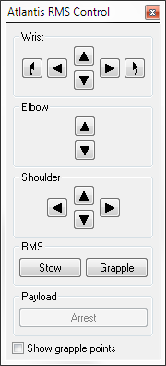
- To bring up the RMS control dialog, press ▪+Space.
- The arm has three joints: the shoulder joint can be rotated in yaw and pitch, the elbow joint can be rotated in pitch, and the wrist joint can be rotated in pitch, yaw and roll.
- To grapple a satellite currently stowed in the cargo bay, move the RMS tip onto a grappling point, and press Grapple. If grappling was successful, the button label switches to Release.
- To make it easier to identify the grappling points of satellites, you can tick the Show grapple points box. This marks all grappling points with flashing arrows.
- To release the satellite, press Release.
- You can also grapple a freely drifting satellite by steering the RMS tip to one of its grappling points.
- To return a satellite back to Earth, it must be stowed in the cargo bay. Use the RMS arm to bring the satellite into its correct position in the payload bay. When the Payload Arrest button becomes active, the satellite can be fixed in the bay by pressing the button. It is automatically released from the RMS.
- The RMS arm can be stowed in its transport position by pressing the RMS Stow button. This is only possible when no object is attached.
- Payload can be released directly from the bay by pressing the Purge button.

Vessel-specific key controls:
Shortcut | Action
j | Jettison: manually detach SRBs or external tank
K | Operate cargo bay doors. The cargo bay doors cannot be closed when the Ku-band antenna is deployed.
g | Operate landing gear (activated only after tank separation)
▪b | Operate split-rudder speed brake
▪u | Deploy/retract Ku-band antenna. The antenna can only be operated if the cargo bay doors are fully open.
▪+Space | Open RMS control dialog

International Space Station (ISS)
The International Space Station is a multinational scientific orbital platform in low Earth orbit (orbital altitude ~420 km). It is composed of multiple modules that were assembled in orbit from 1998. It has been continuously occupied since 2000 and is expected to be in operation until 2030. Many of the assembly missions (with the exception of the Russian modules) and crew operation missions were flown by the Space Shuttle until its retirement in 2011, which makes the ISS a good mission target for your Shuttle flights. Docking the Space Shuttle manually at the ISS with its Orbital Docking System installed in the payload bay is a challenge even for experienced pilots.
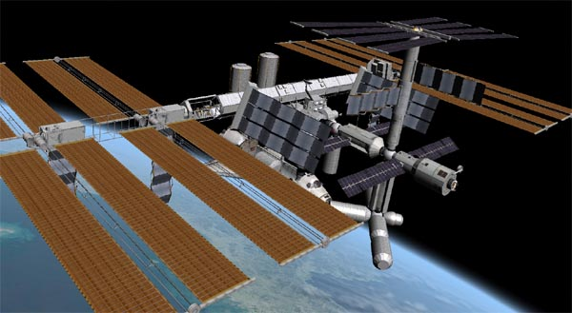
The ISS is equipped with multiple docking ports. In Orbiter, they are outfitted with IDS (Instrument Docking System) transmitters to feed the onboard docking instruments. The default IDS frequencies are listed in the table.
3D model and textures: Project Alpha by Andrew Farnaby
Port 1137.40 MHz
Port 2137.30 MHz
Port 3137.20 MHz
Port 4137.10 MHz
Port 5137.00 MHz
In addition, a transponder (XPDR) for long-range tracking at frequency 131.30 MHz is equipped.
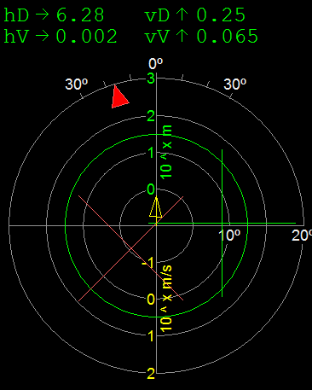
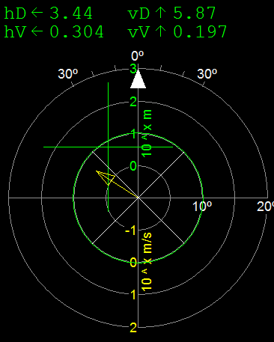
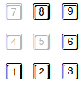
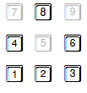
Effect of RCS command input on linear/rotational alignment cues in Docking MFD for Shuttle with docking adapter installed in cargo bay.
Linear alignment
3
Rotational alignment
Close
Separate
1
9
6
1
3
8
2
6
4

Space Station Mir
Mir was a Soviet (later Russian) modular space station in low Earth orbit (~ 360 km altitude) between 1986 and 2001. It was assembled in stages, with modules delivered to orbit mostly by Proton rockets. It was the largest manmade object in orbit before being surpassed by the ISS. It was continuously inhabited and still holds the record for longest human spaceflight. At the end of it service life it was de-orbited and burnt up in the atmosphere, with remaining fragments falling into the South Pacific Ocean.
In Orbiter, Mir is still in orbit and can be used for rendezvous and docking maneuvers. Unlike its real-life counterpart, it is orbiting in the plane of the ecliptic, which makes it a good staging platform for translunar and interplanetary missions.
Mir supports 3 docking ports, which in Orbiter are equipped with IDS with transmitting at the frequencies listed in the table. It also has a long-range transponder (XPDR) at 132.10 MHz.
Port 1135.00 MHz
Port 2135.10 MHz
Port 3135.20 MHz

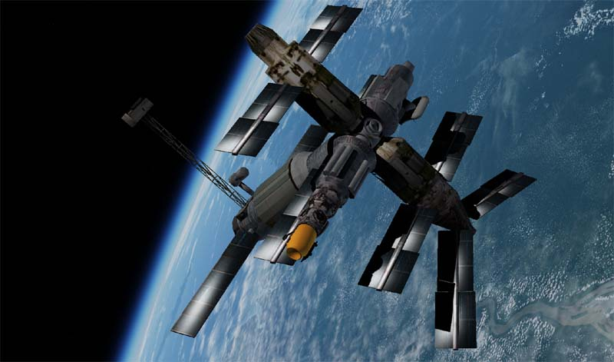
Mir model and textures by Jason Benson.

Lunar Wheel Station
This is a large fictional space station in orbit around the Moon. It consists of a wheel, attached to a central hub with two spokes. The wheel has a diameter of 500 m and is spinning at a frequency of one cycle per 36 s, providing its occupants with a centrifugal acceleration of 7.6 m/s2, or about 0.8 g, to mimic Earth’s surface gravitational force.
The main problem the station poses to an approaching spacecraft is the rotational alignment in preparation for docking. Docking with a rotating target is only possible along the rotation axis. The station has two docking ports in the central hub, with approach directions along the axis from either side. Before docking, the approaching vessel must synchronise its own rotation around its longitudinal axis with that of the station. This should happen as late as possible (within 10 m separation), because corrections in the lateral position become very difficult once the spacecraft is rotating. For docking procedures, see Chapter 12.6.
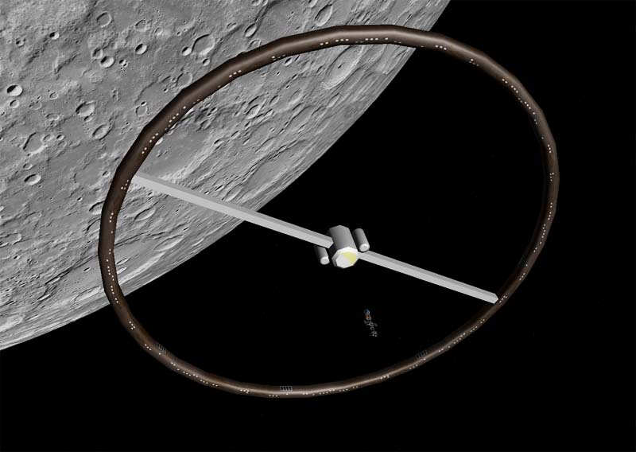
A Shuttle-A on final approach to the Lunar Wheel station.
Wheel model and textures: Martin Schweiger.
Currently, Orbiter’s docking alignment instrumentation works with rotating docking targets only if the ship’s docking port is aligned with its longitudinal axis of rotation. This is the case for Shuttle-A and Dragonfly, but not for the Delta-glider. And should you somehow get the Space Shuttle into a lunar orbit, don’t even try to dock at the Wheel.
The Wheel station emits a transponder signal at frequency 132.70 MHz.The default IDS transmitter frequencies for the two docking ports are listed in the table.
Port 1136.00 MHz
Port 2136.20 MHz

Hubble Space Telescope
The Hubble Space Telescope (HST) was launched into low Earth orbit by Space Shuttle Discovery during mission STS-31 in 1990 and is still in operation as of 2022. Several on-orbit service missions have been carried out until the retirement of the Space Shuttle program, one of which was to install corrective optics to compensate for a shape error of the primary mirror which was discovered after the telescope had been launched.
Hubble mainly operates in the visible frequency range (from near-infrared to ultraviolet). As a space-based telescope, it avoids image degradation from atmospheric effects, and during its long service life it provided images of unprecedented quality that significantly contributed to advance our understanding of the universe. Its observations range from solar system objects and events, such as the impact of comet Shoemaker-Levy on Jupiter, to deep-field images of the faintest and most distant objects yet observed in the visible band. Notable discoveries to which Hubble data contributed include the accelerated expansion of the universe, the prevalence of supermassive black holes in the centres of galaxies, detection of exosolar planets and evidence of star formation.
Orbiter provides several Space Shuttle/HST missions for both deployment and recapture operations. For Shuttle payload manipulation, see Chapter 8.5 above.

Vessel-specific key controls:
Shortcut | Action
▪1 | Deploy/retract high-gain antennae
▪2 | Open/close telescope tube hatch
▪3 | Deploy/fold solar arrays
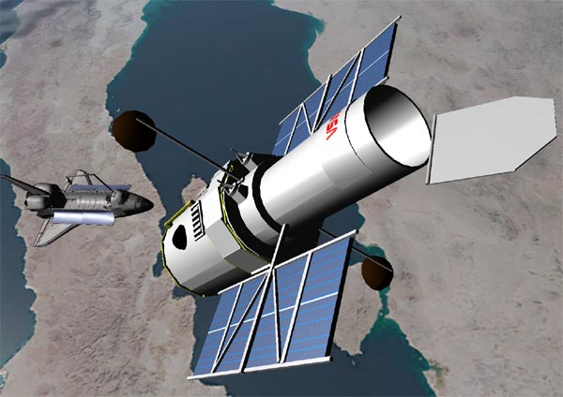
HST model and textures by David Sundstrom.

LDEF Satellite
The Long Duration Exposure Facility (LDEF) was an orbital platform designed to provide experimental data on the effect of space environment on materials, biological samples and operational procedures. It was delivered to orbit by Space Shuttle Challenger in 1984 (mission STS-41 C). It was intended to be recaptured and returned to Earth a year later, but due to delays in the aftermath of the Challenger accident, was stranded in space for six years and eventually recovered from its decaying orbit on January 11, 1990 by Columbia (STS-32), two months before it would have burnt up in the atmosphere.
The LDEF makes a good object for Shuttle deployment and retrieval missions in Orbiter. Scenario folder Satellites and Probes/LDEF contains missions for LDEF operations.
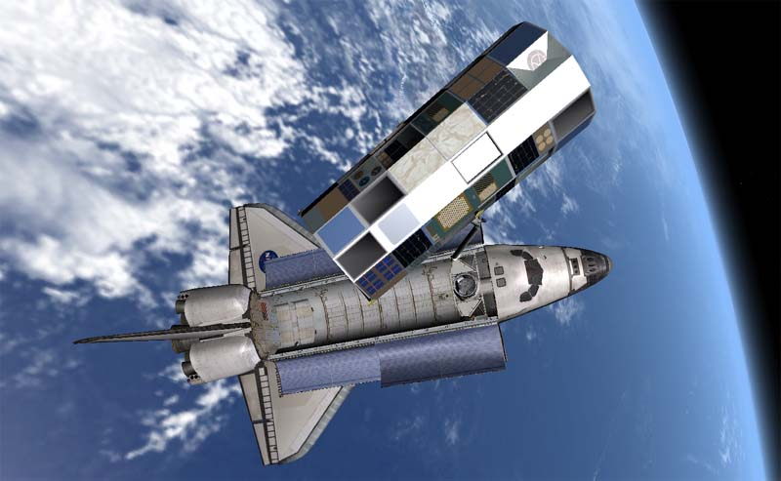
LDEF mesh by Don Gallagher.

Cockpit views
Orbiter can represent a spacecraft cockpit in different ways:
- with a generic “glass cockpit” view, consisting of two MFD displays, the HUD and a few essential controls. The glass cockpit mode is available for all spacecraft and can be useful for an unobstructed view of the surroundings.
- With one or several spacecraft-specific 2-D instrument panels.
- With a virtual 3-D representation of the cockpit.
The modes can be cycled with . Not all spacecraft may support all cockpit modes, but the glass cockpit is always available. In all three modes, instruments can be operated with the mouse.
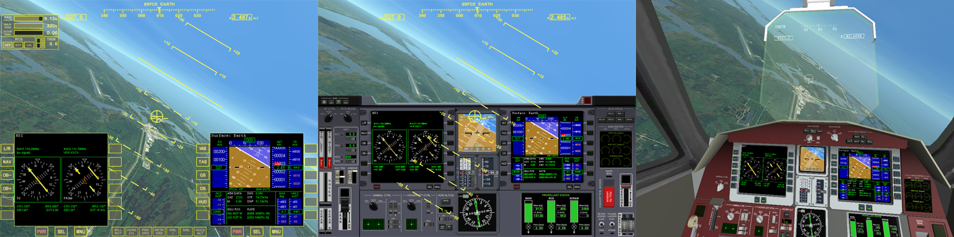
Comparison of glass cockpit, 2-D panel and virtual cockpit views for the Delta-glider.

Glass cockpit
The generic glass cockpit mode represents a head-up display (HUD) that projects various avionics data directly onto the pilot’s forward view. This mode is available for all spacecraft types and provides access to some essential avionics data, MFD instruments and basic flight controls sufficient for basic vessel control in most situations. It does not provide spacecraft-specific instruments and interfaces. For access to these, the 2-D panel or 3-D virtual cockpit view should be used.
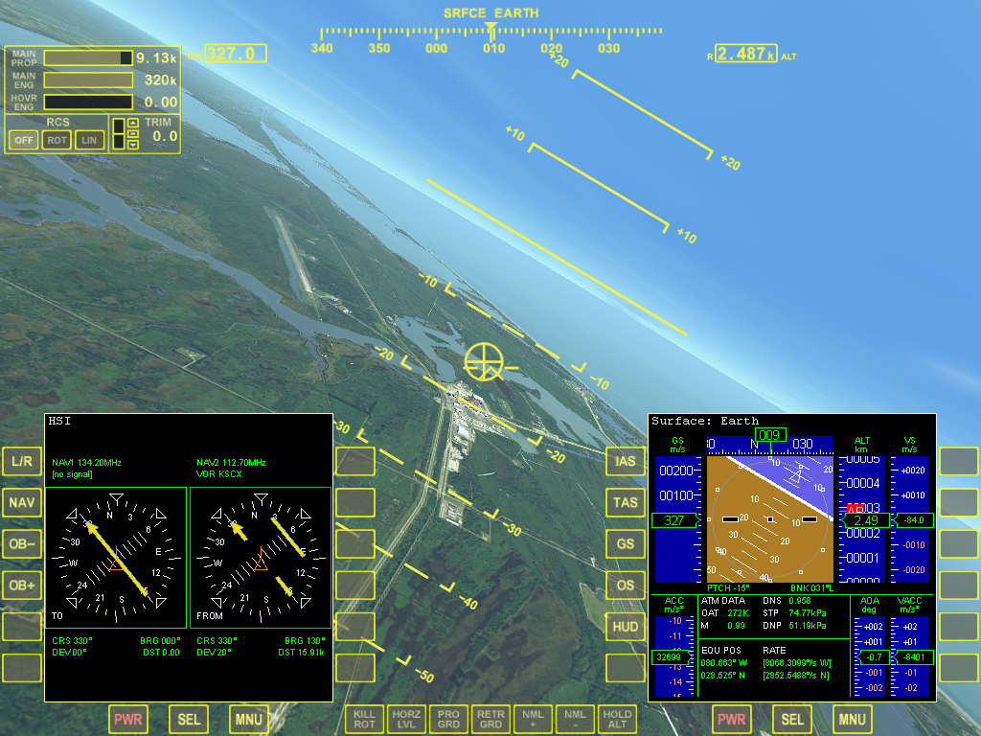
The camera direction can be changed by right-clicking and dragging the mouse. However some HUD elements like the center marker and pitch ladder are only displayed when the camera is looking straight ahead. To return to the default forward view, press Cur.
Engine and RCS display
Left MFD
Right MFD
Pitch ladder
Flight path indicator
Compass ribbon
Airspeed readout
Altitude readout
RCS attitude controls
Horizon line
Center marker

Engine and RCS display
This display block in the top left corner of the glass cockpit shows the current engine status and provides controls for RCS mode and pitch trim.
- Fuel status: Shows the propellant remaining in the main fuel tank. The numeric readout is fuel mass [kg]. Note that the vessel may have additional fuel tanks not shown in the generic glass cockpit view. Use vessel-specific 2-D or 3-D cockpit view for detailed fuel information.
- Main engine: The main engine bar shows the current main/retro engine thrust as a fraction of max. thrust. Green indicates main thrusters active, red indicates retro thrusters active (where applicable). The numerical readout is the thrust force generated [N].
- Hover engine: If the vessel is fitted with hover engines, this bar shows the current hover engine thrust as a fraction of main thrust. Hover engines generate vertical (up) thrust to assist in vertical takeoffs and landings, in particular on planetary bodies without atmospheres. The numerical readout is the thrust force generated [N].
- RCS mode indicators: Shows the current setting of the RCS (reaction control system). The RCS can be OFF, ROT (rotational mode) or LIN (linear mode). See Chapter 11.2 for details on attitude control. The indicator buttons can be clicked with the mouse to set the mode.
- Trim control: The vertical bar shows the current pitch trim settings for the vessel’s aerodynamic control surfaces, if present. The trim setting can be adjusted with the three buttons next to the bar. (top button: nose up, bottom button: nose down, centre button: trim neutral).

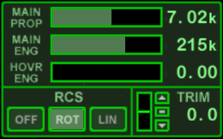
RCS attitude controls
Engine block
RCS mode indicator
Fuel mass [kg] (main tank)
Main/retro engine thrust [N]
Hover engine thrust [N]
Pitch trim controls
Glass cockpit engine and RCS display block
The seven buttons along the bottom centre of the glass cockpit screen provide an interface to some basic attitude control modes. Clicking a button activates or deactivates the corresponding mode. The active mode is indicated by a highlighted button. Activating a mode will deactivate any conflicting modes (except HOLDALT which is independent of other modes). An active mode engages the RCS thrusters to rotate and hold the vessel in a specific surface or orbit-relative attitude (with the exception of the Hold altitude mode which addresses the hover thrusters if available).
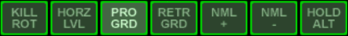
Kill rotation
Level horizon
Pro-grade
Retro-grade
Orbit-normal
Orbit-antinormal
Hold altitude
Mode | Shortcut | Action
KILLROT | Num | Cancel any vessel rotation (auto-terminates)
HORZLVL | L | Keep vessel level with local horizon
PROGRD | [ | Prograde (turn vessel to orbital velocity vector)
RETRGRD | ] | Retrograde (turn vessel to negative orbital velocity vector)
NML+ | ; | Orbit-normal (turn vessel normal to orbital plane)
NML− |  | Orbit-antinormal (turn vessel to negative normal of orbit plane)
HOLDALT | A | Hold altitude (hover function)
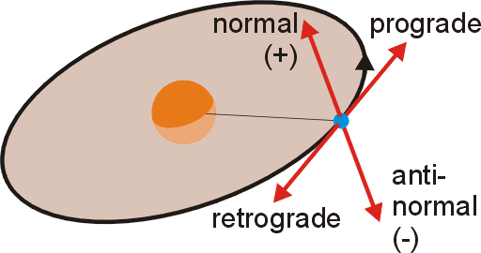
The PROGRD and RETRGRD modes turn the vessel to align with the orbital velocity vector or in the opposite direction. These modes are important for in-plane manoeuvres (e.g. increasing/decreasing the orbit radius). The NML+ and NML− modes turn and hold the vessel perpendicular to the orbital plane. These modes are important for plane change manoeuvres. The HORZLVL mode rotates the vessel to be level with the local horizon. KILLROT engages the RCS system to cancel out any rotation and automatically switches off once the vessel’s angular velocity is zero.
The HOLDALT mode engages the vessel’s hover thrusters (if available) to maintain the current altitude. This mode works best with a level flight attitude and is therefore often combined with HORZLVL.

Pitch ladder, compass ribbon, flight path indicator
These are part of the standard HUD display in Surface mode. Standard HUD elements are available in all cockpit views. The available HUD modes are described in Chapter 9.4.

2-D panel view
In 2-D panel view the spacecraft cockpit is represented by a set of vessel-specific instrument panels. The main panel usually contains the principal avionics displays, such as MFDs, ADI ball or artificial horizon, as well as basic controls (engine throttles, attitude controls, gear and docking controls, etc. Additional panels, if present, could contain electric and thermal controls, life support system and secondary instrumentation.
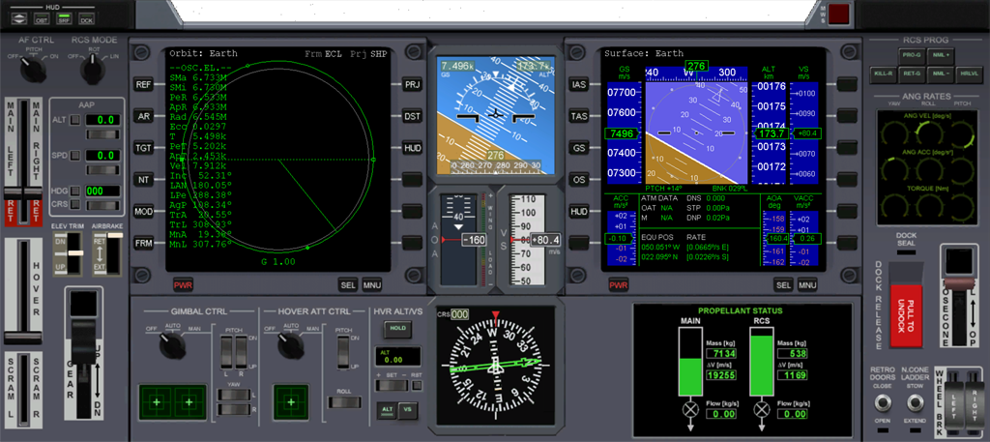
On opening panel view by cycling the cockpit modes with , you are placed in front of the main panel. Neighbour panels, if present, can be accessed with ▪Cur. For example, the Delta-glider has an overhead panel that can be called up with ▪Cur. To return to the main panel, press ▪Cur.
Delta-glider main panel
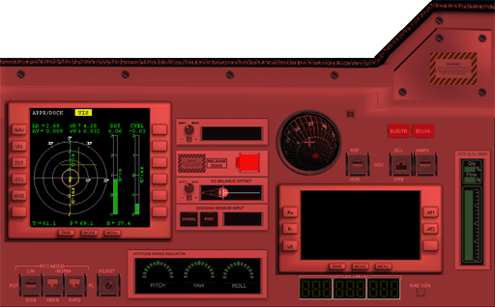
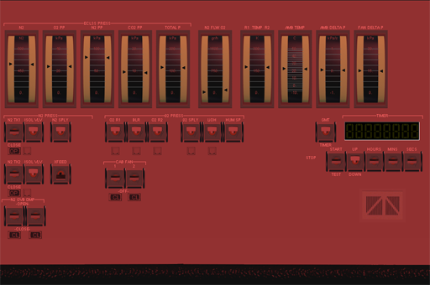
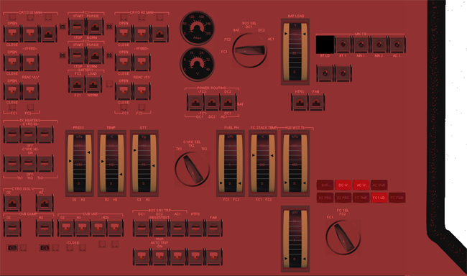
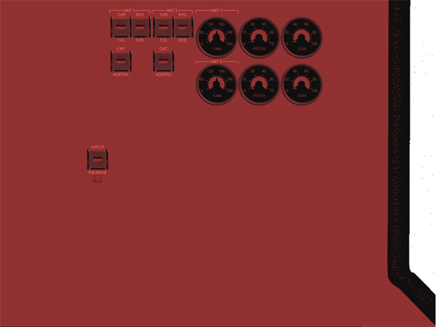
Panel connections for the Dragonfly spacecraft.
▪
▪
▪
▪
▪
▪
Most panels can be scrolled out of the way to get a better view of the surroundings. For example, press Cur to scroll the Delta-glider’s main panel down. The overhead panel can be scrolled up with Cur. The scroll speed can be adjusted with the Panel scroll speed option in the Parameters tab of the Orbiter launchpad (see Chapter 4.2).
For most vessel types, panels are automatically scaled to fit the simulation window size. If a panel’s natural size is larger than the simulation window size and resolution, the panel will be shrunk to fit. In that case, you can zoom into a panel section under the mouse with ▪ + mouse wheel.
Note that not all vessel implementations may support this feature. Older add-ons use a legacy panel interface which doesn’t automatically scale to fit. For such vessels, you can use the Panel scale option in the Parameters tab of the Orbiter launchpad to rescale panels globally (see Chapter 4.2).
Panel controls can be operated with the mouse. For details on the panel components of a spacecraft and how to use them, consult the separate documents that come with that vessel.
A standard HUD display is superimposed on the panel view. It works the same way as in glass cockpit view. The available HUD modes are described in Chapter 9.4.
The camera view of the outside world can be rotated by right-clicking and dragging the mouse. The field of view can be changed with the mouse wheel. This has no effect on the panel display. The HUD is only visible when looking straight ahead. To return to forward view, press Cur.

3D virtual cockpit
The virtual cockpit view places you directly into a 3-D model of the spacecraft cockpit. You can rotate the camera to look around you and access different control panels or get a better view of the outside world (right-click and drag the mouse for rotating the view, or use the coolie hat on your joystick). The mouse wheel zooms the camera in and out and it useful to get a closer look at instruments. Instruments can be operated with the mouse.
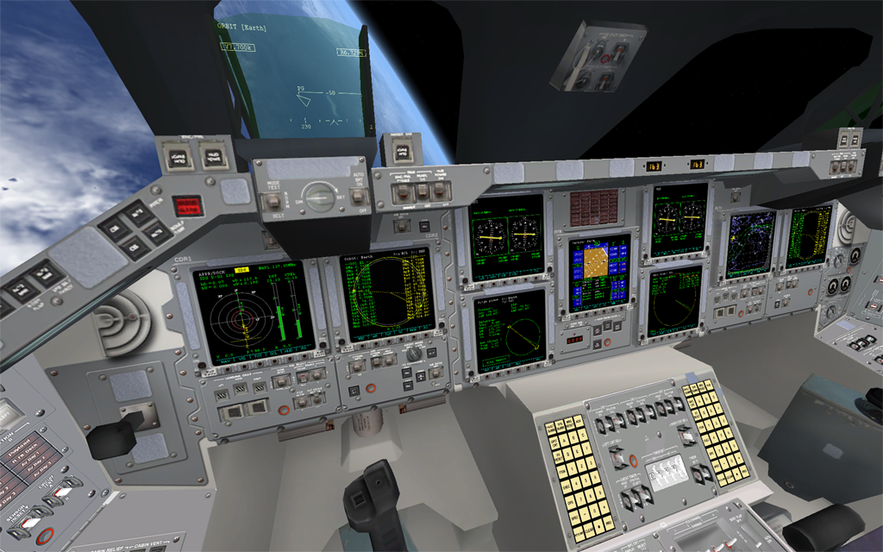
The virtual cockpit may place a HUD pane in front of the pilot’s head. This will then show similar information to the other cockpit views.
Space Shuttle virtual cockpit
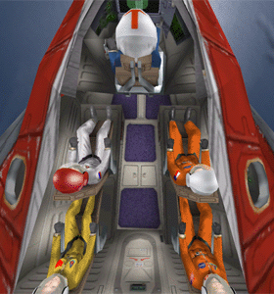
The pilot position can “lean” in different directions to get a better look out of front or side windows, with ▪Cur. To return to the default position, press ▪Cur.
▪
▪
▪
▪
▪
▪
▪
▪
▪
▪
▪
The virtual cockpit mode may define multiple operator positions. For example, the Delta-glider allows to switch views from the pilot to the different passenger positions. The Space Shuttle lets you jump from the commander to pilot and payload operator positions. To move between neighbouring positions, press ▪Cur.

HUD modes
The head-up-display projects flight data into the pilot’s line of view without the need to look down at the instruments. In Orbiter, the pilot can set the HUD into different display modes to adjust the projected data to the current flight phase: surface (during low-level flight), orbit (for orbital manoeuvres) and docking (for docking approaches). The HUD mode can be cycled by pressing h. The HUD can be turned on and off with ▪h.
The projection colour can be cycled with h to improve display contrast against different backgrounds.
All modes display a center line marker to represent the spacecraft’s longitudinal axis (forward direction).

Surface mode
In Surface mode, the HUD provides attitude information relative to the local horizon. At the top, the compass ribbon shows the current heading with regard to true north. If a surface base has been targeted in the Map MFD (see Chapter 10.3), its bearing is indicated with a marker in the compass ribbon. The pitch ladder shows the current pitch and bank angles. The readout left of the compass ribbon shows true airspeed (TAS) [m/s] if atmospheric density is sufficiently high to measure it, or ground-speed (GS) otherwise. The readout right of the ribbon shows altitude [m] above the mean planet radius (at high altitude) or radar altitude above the surface (at low altitude), indicated by R.
The flight path indicator (⊕) represents the current flight direction (the velocity vector in the local horizon frame). A flight path marker located below the center marker indicates a positive AOA (angle of attack).

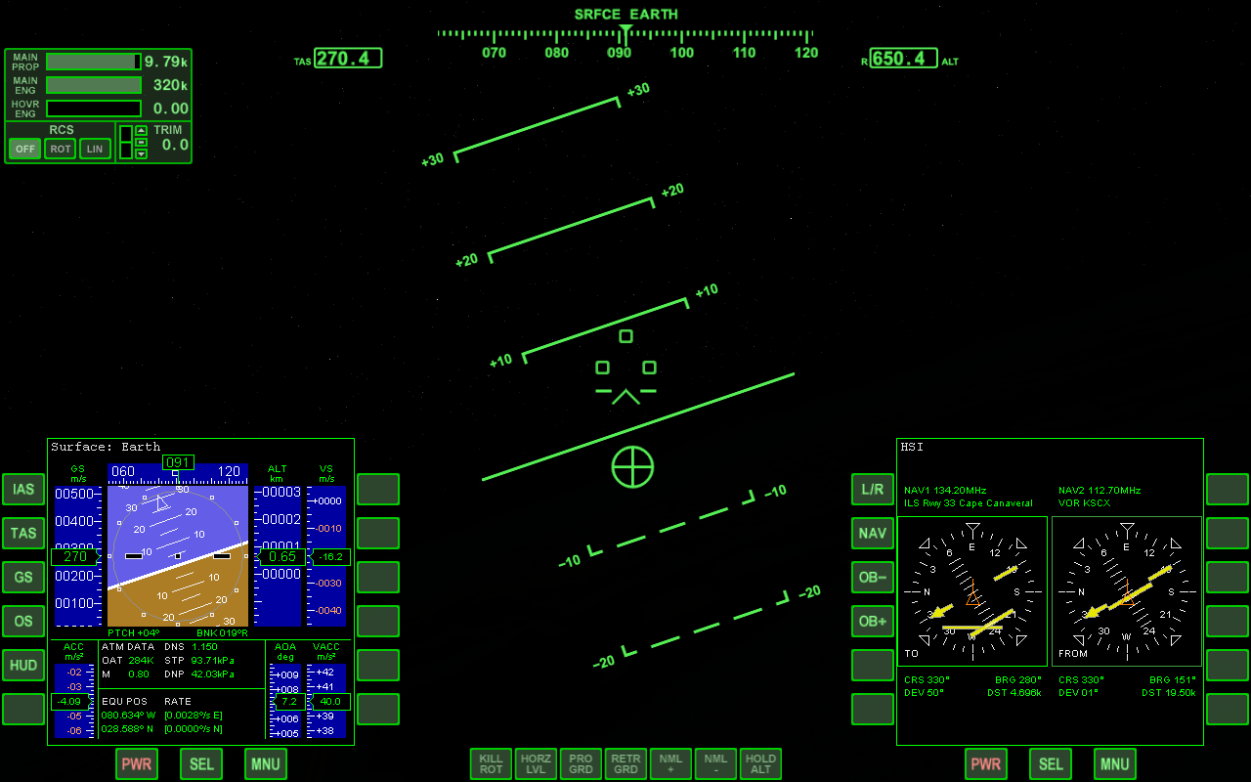
Orbit mode
Surface HUD elements and relevant MFD modes
pitch ladder
gear indicator
horizon line
flight path marker
horizontal situation MFD
surface MFD
center marker
reference body
altitude [m]
airspeed [m/s]
compass ribbon
target marker
Orbit mode is indicated by Orbit Ref at the top of the screen, where Ref is the name of the reference body being orbited. Orbiter by default selects the main gravitational source as the reference body. This can be manually adjusted with ▪, or by selecting a reference body in the Orbit MFD (see Chapter 10.6), and pressing the HUD button to copy the choice to the HUD display.
The HUD displays a pitch ladder displaying the bank and pitch angles of the spacecraft relative to the orbital plane, where the 0° line represents the orbital plane. A direction ribbon across the centre of the HUD indicates the vessel’s yaw deviation from the orbital prograde direction, where 0° and 180° are the prograde and retrograde directions, respectively.
The flight path marker (⊕) in Orbit mode represents the orbital velocity vector in the the non-rotating reference body frame, i.e. the prograde direction. The retrograde direction is indicated with another marker (⊙). If neither the prograde or retrograde direction are within view of the HUD area, the direction of the ⊕ marker is indicated with a pointer labelled PG (prograde).

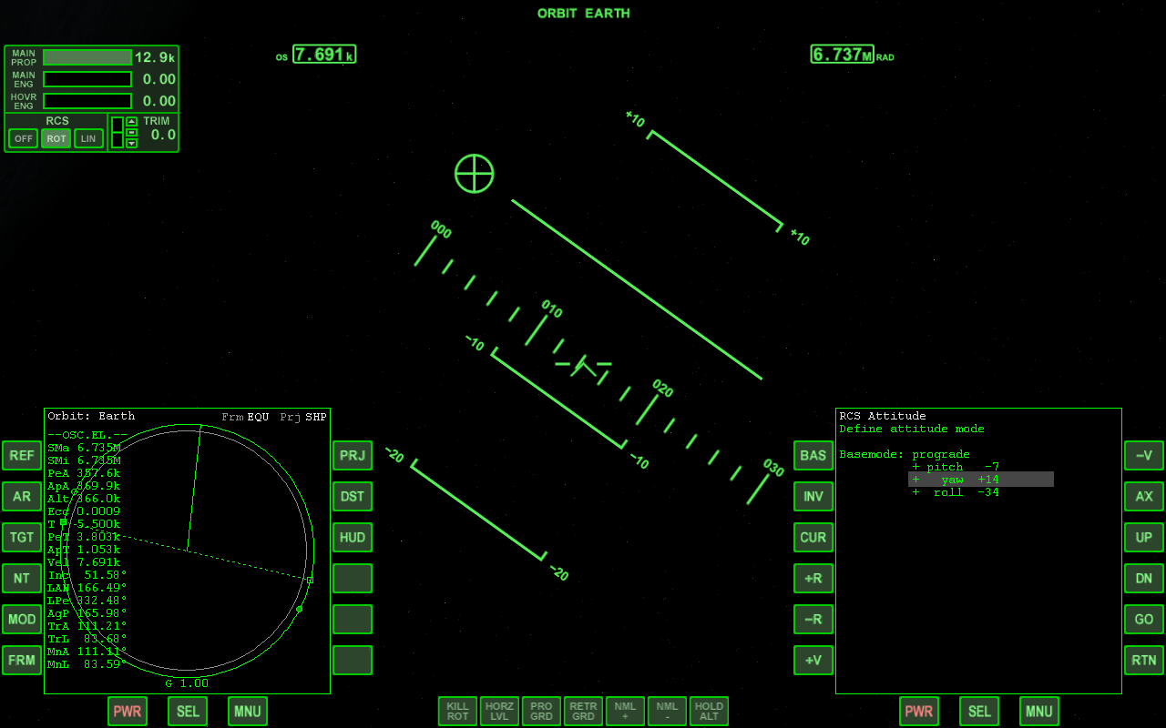
Docking mode
orbit reference body
orbit radius [m]
orbital velocity [m/s]
prograde marker
pitch ladder (to orbital plane)
prograde yaw deviation ribbon
orbit MFD
attitude MFD
orbital plane line
center marker
Orbit HUD elements and relevant MFD modes
The Docking HUD mode assists in approaching and docking with an orbital target, such as a space station. To allow it to display its visual cues it requires target position and velocity data. These are obtained by tuning one of the vessel’s NAV radio receivers to either a long-range transponder signal (XPDR) or short-range instrument docking system (IDS) frequencies of one of the target’s docking ports. See Chapter 6.4 on how to find target transmitter frequencies. See Chapter 10.1 on tuning NAV frequencies. Once the NAV receiver has been tuned and is within range of the transmitter, the Docking HUD can make use of the target data. Use ▪ to cycle through the NAV receiver stack. Alternatively, you can pick a receiver in the Docking MFD mode and copy it to the HUD by pressing the HUD button. NAV and target signal designations are shown in the top of the HUD area.
Alternatively, you can bypass the NAV receiver data acquisition and target an object or docking port directly by pressing ▪. If you are close to a docking port, you can also press the VIS button on the Docking MFD for visual docking approach acquisition, followed by HUD to copy the data to the HUD display.
The position of the target object is marked with a square box, labelled with the object name and distance [m]. If the target object is not visible in the area covered by the HUD, its direction is indicated with a pointer.
The vessel’s velocity vector relative to the target object is indicated with the flight path indicator (⊕). It is labelled with the magnitude of the relative velocity [m/s]. The opposite direction (or the velocity vector of the target relative to your ship) is indicated with ⊙ and a negative velocity label. If neither velocity marker is visible in the HUD, the direction of the ⊕ marker is indicated with a pointer.
If the HUD display is bound to a receiver tuned to an IDS signal, the approach path to the dock is symbolised with a series of virtual approach gates. These are rectangles spread along the approach path. The “up” direction (for bank alignment) is indicated with a double line.
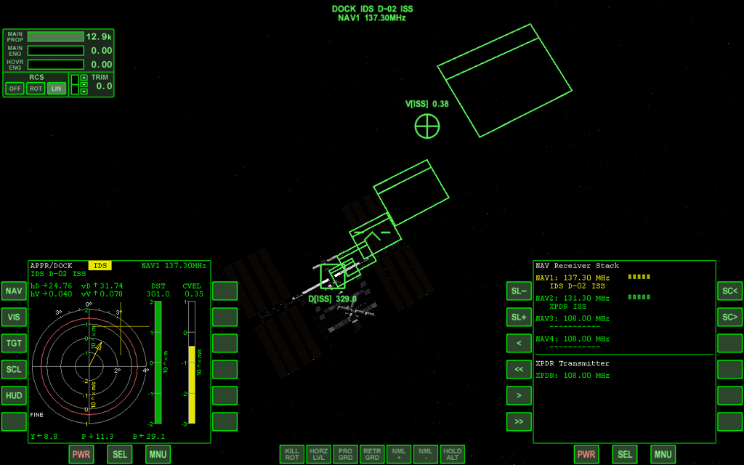
Docking HUD elements and relevant MFD modes
approach gates
target designation and NAV ID/frequency
rel. velocity indicator and speed
target box and distance
docking MFD
comms MFD

Multi-functional display modes
Multifunctional displays (or MFDs) are used in the cockpits of most military aircraft and modern airliners. The combine the function of a variety of traditional instruments in a compact format, and in combination with computerised avionics data processing they present the pilot with situation-dependent relevant data.
In spaceflight, providing the pilot with information appropriate to the current flight regime is even more critical, so for example the Space Shuttle made extensive use of MFD displays. Orbiter uses the MFD paradigm in a general and extendable way to provide flight data independent of vessel type (although vessel-specific MFD modes can be implemented by add-on developers).
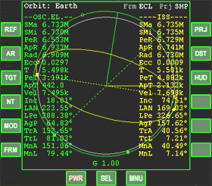
The user interface of an MFD is essentially a computer display (e.g. an LED screen) and a set of input controls (usually push buttons arranged around the screen, or a separate keyboard). In Orbiter, all spacecraft MFDs work the same way, even if the specific layout varies. The picture shows the MFD representation for the generic cockpit view, which supports two MFD positions. 2D panel and virtual cockpit views may use a different number of MFD instruments.
In the centre of the MFD is the data display. The 12 buttons along the left and right edge are mode-dependent function buttons. Their labels may change according to the current operation modus of the instrument. The three buttons along the bottom edge are static and perform mode-independent system functions.
The MFDs can be operated either by left-clicking the buttons with the mouse, or via the keyboard. All MFD keyboard functions are ◻-key combinations, where the left and right ◻ keys operate the left and right MFD, respectively. For instrument panels with more than two MFD displays, only two can be operated with the keyboard; the others are limited to mouse control.

Turning the MFD on and off
The PWR button activates and deactivates the MFD display (keyboard shortcut: ◻). In glass cockpit mode, turning off the MFD also hides the buttons (except the power button, so it can be turned on again).

Mode selection
The SEL button activates the mode selection screen (keyboard shortcut: ◻). Each MFD mode provides information for a different navigation or avionics situation (orbital parameters, surface parameters, docking and landing aids, etc.) The default modes are described below in this chapter. Many additional modes are available via 3rd party add-ons.
The mode selection screen shows the available modes in the display area, one mode next to each function button. To select a mode, simply click the corresponding button. For selection with the keyboard, press the ◻ key together with the mode selection key displayed in grey with each of the listed modes (for example, ◻o for Orbit mode).
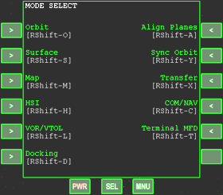
If there are more modes than can be displayed in a single page, pressing SEL (or ◻) repeatedly cycles through all mode pages. Pressing SEL on the last mode page returns to the previously selected MFD mode. Note that mode selection with keyboard shortcuts works from any of the mode selection pages, even if the requested mode is not displayed on the current page.

Function buttons
The function of the buttons to the left and right of the display depends on the current MFD mode, and their labels change accordingly. Functions and user interface for the standard MFD modes are described below. For modes provided by 3rd party add-ons, consult the accompanying documentation. In some cases the buttons may act as switches, where each press executes a discrete operation. In other cases it may be necessary to press down a button continuously to adjust a parameter.
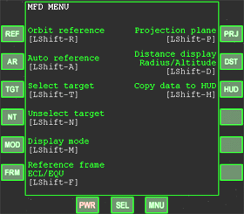
Function buttons for the two main MFD instruments can also be activated with ◻-key combinations. On pressing the MNU button below the bottom edge of the screen (keyboard shortcut: ◻) a short description of all function buttons for this mode is displayed, together with the keyboard shortcuts to activate them. Pressing MNU again, or pressing a function button, restores the display.
In glass cockpit view, and in most instrument panels in Orbiter, each MFD has 12 function buttons, but individual spacecraft can adopt a different layout in their panels. If an MFD mode assigns more function buttons than are physically present, pressing MNU repeatedly cycles through the available function pages.

Colour customisation
The default colour schemes for MFD displays can be modified by editing the Config\MFD\default.cfg text file. Note that some add-on MFD Modes may define their own colour scheme which cannot be customised.

NAV receiver/transmitter setup
The COM/NAV setup MFD mode provides an interface to the ship’s navigation radio receivers which feed data into the navigation instruments. It also allows to select the frequency of the ship’s long-range transponder which sends a signal identifying the vessel and its position. The mode is activated via the COM/NAV entry from the MFD mode selection page (shortcut: ◻ + ◻c).

Key options:
Button | Shortcut | Action
SL− | ◻, | Move selection up
SL+ | ◻. | Move selection down
<< | ◻- | Step frequency down 1 MHz
>> | ◻= | Step frequency up 1 MHz
< | ◻[ | Step frequency down 0.05 MHz
> | ◻] | Step frequency up 0.05 MHz
SC< | ◻z | Scan frequency downward
SC> | ◻x | Scan frequency upward

MFD control layout:

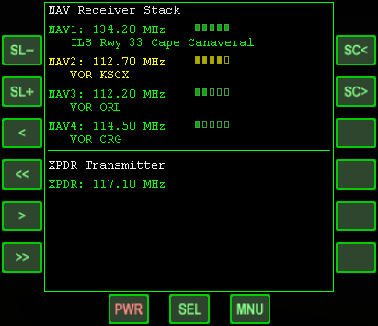
MFD display components:
Move selection up
◻,
Move selection down
◻,
Step down 0.05MHz
◻[
Step down 1MHz
◻-
Step up 0.05MHz
◻]
Step up 1MHz
◻=
Scan downward
◻z
Scan upward
◻x
The top part of the MFD display shows the NAV radio receiver stack. For each available receiver, the current frequency setting is shown, together with an identification of the received signal (if any) and a field strength indicator. The lower part of the display shows the transponder (XPDR) frequency.
The currently selected entry is highlighted in yellow. The selection can be moved up and down with the SL− (or ◻,) and SL+ (or ◻.) buttons.
The frequency of the selected receiver or transmitter can be tuned in steps of 1 MHz with ◻- and ◻=, and in steps of 0.05 MHz with ◻[ and ◻], in the range from 108.00–140.00 MHz. You can sweep the frequency range down or up with ◻z and ◻x until a signal is detected. If a compatible NAV transmitter is within range, the instrument displays information about the signal source and strength.
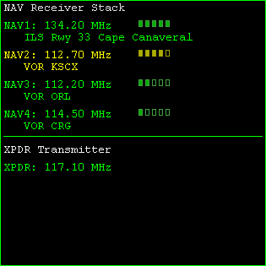
In Orbiter, NAV transmitter types include VOR (VHF omnidirectional range), ILS (instrument landing system) for runway approaches and VTOL (vertical take-off and landing) pads, XPDR (vessel transponders) and IDS (instrument docking system). Each transmitter type provides information which can be fed to other MFD modes or avionics instrumentation to provide situational awareness to the pilot.
frequency
signal strength
signal source type and ID
NAV receiver status
transponder status
The Object info (▪i, see Chapter 6.4) and Map (▪m, see Chapter 6.5) windows are useful tools to obtain surface or vessel-based transmitter frequencies.
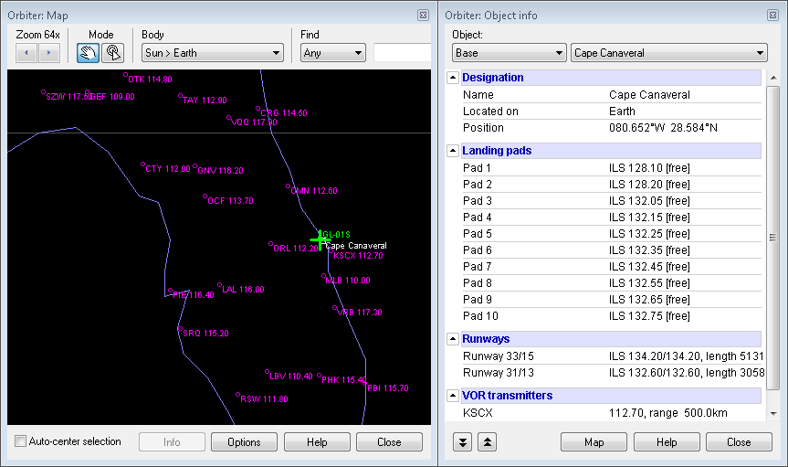
The positions and frequencies of VOR stations in your vicinity can also be displayed directly in the simulation window via the VOR Markers option in the Visual helpers dialog box (▪).
Map window (left) and object info dialog (right) with NAV transmitter information

Surface
The Surface MFD mode provides avionics data useful in flight situations close to planetary surfaces. It contains an attitude indicator (artificial horizon) displaying the vessel’s attitude relative to the local horizon plane, various tapes for altitude, speed and acceleration readouts, as well as position, pressure and temperature data.

Key options:
Button | Shortcut | Action
IAS | ◻i | Switch speed readout to indicated airspeed
TAS | ◻t | Switch speed readout to true airspeed
GS | ◻G | Switch speed readout to ground-relative speed
OS | ◻o | Switch speed readout to orbital speed
HUD | ◻h | Set HUD to Surface mode

MFD control layout:

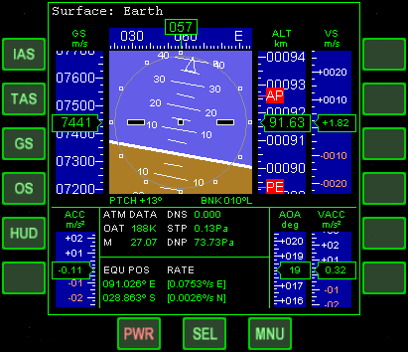
MFD display components:
Indicated airspeed
◻i
True airspeed
◻t
Ground-relative speed
◻g
Orbital speed
◻o
Copy data to HUD
◻h
The display contains an attitude indicator (AI) with horizon line and pitch ladder indicating pitch and bank attitude (including numerical readouts). Above is a compass ribbon with a heading readout. To the left of the AI is the speed readout which can be set to different modes with the MFD buttons:
- TAS (true airspeed): The speed of the spacecraft relative to the surrounding atmosphere. Airspeed is usually measured with a pitot tube in the airstream recording the difference between free-stream and stagnation point pressure. The TAS mode is only available if the free-stream pressure p1 > 10−3 Pa (on Earth, this corresponds to approx. 140 km altitude). If TAS cannot be measured, the speed tape is reset to 0 and the readout shows “−−−−”.
- IAS (indicated airspeed): Commonly used in conventional aircraft. IAS is calibrated to atmospheric density and speed of sound at sea level. IAS and TAS are similar at low altitude, but start to diverge at higher altitudes, with IAS < TAS. The limit p1 > 10−3 Pa also applies to IAS availability.
- GS (ground-relative speed): The magnitude of the vessel’s velocity vector in the rotating planet reference frame. This is similar to TAS at lower altitudes, but diverges at higher altitudes. Usually, TAS is no longer available where the differences would become significant. Note: for an object in geostationary orbit, GS would be zero since it is stationary relative to the rotating planet frame.
- OS (orbital speed): The magnitude of the vessel’s velocity relative to the planet’s centre in a non-rotating frame. This is identical to the Vel readout in the Orbit MFD. Note: OS is usually non-zero for a vessel at rest on the planet surface, because the planet itself is rotating.
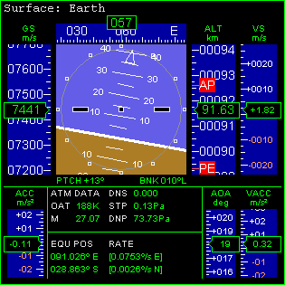
To the right of the IA is the altitude tape showing the vessel altitude [km] above the surface (ALT-R) at altitudes < 10 km, or altitude above mean planet radius (ALT) otherwise. To the right of the altitude tape is the vertical speed tape (VS) [m/s].
VSI (vertical speed indicator tape) [m/s]
Apoapsis marker
Periapsis marker
Speed tape [m/s] (IAS/TAS/GS/OS)
Reference body
Altitude tape [km]
Heading tape [deg]
Bank indicator
Pitch ladder
Horizon line
Center marker
Angle of attack tape [deg]
Vertical acceleration tape [m/s2]
Pitch/bank readout
Equatorial position and rate
Atmospheric data
Acceleration data [m/s2]
Attitude indicator
In the lower part of the display are the acceleration tape (ACC) [m/s2] (left), and the AOA (angle of attack) and vertical acceleration (VACC) [m/s2] tapes (right).
Below the AI are atmospheric data readouts: atmospheric density (DNS), static pressure (STP), dynamic pressure (DNP), outside air temperature (OAT) and Mach number (M). In the block below are vessel’s equatorial position (longitude, latitude) [deg] and their rates [deg/s].

Map
The Map MFD mode shows the surface of a celestial body in a cylindrical projection, including coastlines and contour lines. It can display surface markers for bases and VOR beacons, as well as ground tracks or orbital plane intersections for objects orbiting the body. The display elements are similar to the Map dialog (see Chapter 6.5).

Key options (map view):
Button | Shortcut | Action
Map view:
REF | ◻r | Select a celestial body for map display
TGT | ◻t | Select a target object
ZM- | ◻x | Zoom out by factor 2 down to 1× (global view)
ZM+ | ◻z | Zoom in by factor 2 up to 128× (2.8° × 2.8° cover)
TRK | ◻k | Toggle automatic vessel track mode on/off
DSP | ◻D | Display parameter configuration page
UP | ◻- | Scroll map display up (disabled in track mode)
DN | ◻= | Scroll map display down (disabled in track mode)
< | ◻[ | Scroll map display left (disabled in track mode)
> | ◻] | Scroll map display right (disabled in track mode)
Parameter selection view:
UP | ◻- | Move selection marker up
DN | ◻= | Move selection marker down
MOD | ◻m | Modify the currently selected option
OK | ◻o | Return to map view

MFD control layout:
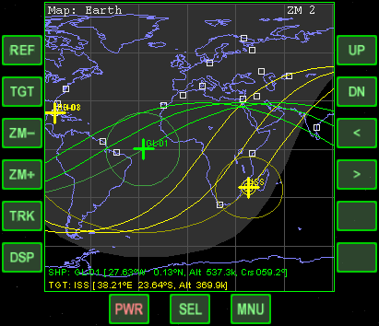
Select celestial body
◻r
Select target
◻t
Zoom out
◻x
Zoom in
◻z
Track mode on/off
◻k
Open config page
◻d
Scroll up
◻-
Scroll down
◻=
Scroll left
◻[
Scroll right
◻]

MFD display components:
The map display elements include:
- Current position (green +) projected onto the planet surface.
- Positions of any other spacecraft currently located on the planet surface or orbiting the planet (yellow +)
- Orbit ground track (past and predicted for a few orbits), or alternatively orbit plane (the great circle defined by the intersection of the orbital plane with the planet surface)
- Horizon line: indicates the limit of visibility of the planet surface as seen from the current vessel position (or equivalently, the area of the planet surface from which the spacecraft would appear above the horizon for a ground-based observer).
- Terminator line: indicates the lit hemisphere of the planet with a boundary line and/or a shaded area.
- Coastlines and contour lines (e.g. topographical levels) where supported.
- Location of surface bases, VOR transmitters with frequencies and other surface features (cities or geological features)
- The current position (longitude, latitude, altitude) and course of the vessel, and the position data of an optional target object or surface base are shown at the bottom of the screen. If the target is a base, distance and bearing from the current vessel position are also displayed.
The map can be zoomed and scrolled. It is also possible track the current position (which disables manual scrolling). At high zoom levels, labels for marked surface featues are shown.
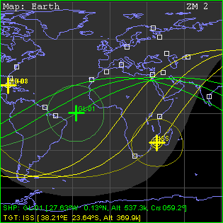
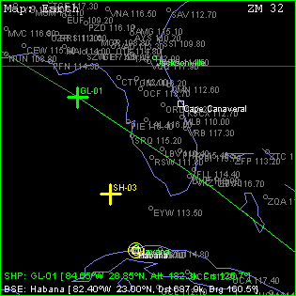
Display options can be selected from the configuration page (DSP, ◻d). Select an item with the UP (◻-) and DN (◻=) buttons, then cycle its settings with MOD (◻m). Return to the map screen with OK (◻o).
Zoom level
Surface base marker
Terminator line
Reference body
Current position
Target object
Ground track (past)
Ground track (predicted)
Horizon line
Spacecraft and target locations
Target ground track
Vessel marker
Zoom level
City
Reference body
Vessel marker
Ground track
Target base
Spacecraft and target base locations
VOR transmitter and frequency
Current position
Base
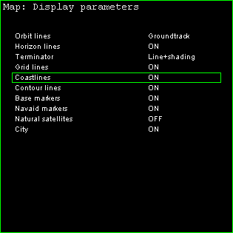
Selected item
Display elements
Display status
- Only objects (ships, stations or moons) orbiting the displayed celestial body will be accepted as orbit targets. Likewise, only surface bases located on the body will be accepted as target bases.
- Your ship’s orbital plane will only be plotted if you are orbiting the displayed body.

VOR/VTOL
The VOR/VTOL MFD mode is a navigational aid that provides position information with respect to a signal transmitter (VOR) or a landing pad for vertical take-off and landing. (see also Chapter 10.5 on HSI mode). The circular display on the left shows a top-down view of the transmitter location and bearing relative to the current vessel position in the centre of the display. The two bars to the right show vessel altitude and vertical speed.
This MFD mode can be linked to one of the ship’s NAV receivers. The current receiver and frequency are shown in the upper right corner of the display. If a signal is received, the transmitter ID is displayed in the second line. If the ship is equipped with more than a single NAV receiver, the receiver stack can be cycled with ◻n. To set the receiver frequencies, use the COM/NAV MFD mode (see Chapter 10.1).

Key options:
Button | Shortcut | Action
NAV | ◻N | Select navigation (NAV) receiver for VOR or VTOL information input.

MFD control layout:
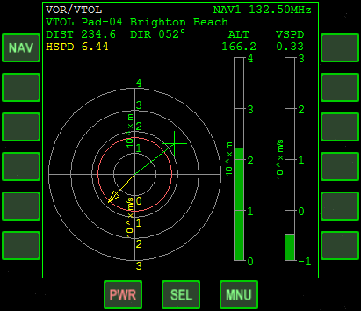
Cycle NAV receivers
◻N

MFD display components:
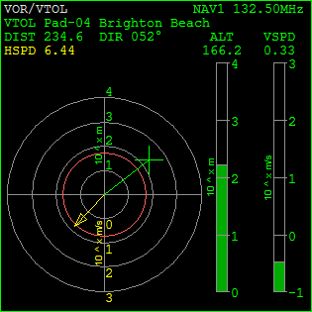
- DIST: distance to NAV transmitter [m]
NAV receiver frequency
Vertical speed [m/s]
Altitude [m]
NAV type and ID
Horizontal airspeed [m/s]
Altitude bar (log scale)
Vertical speed bar (log scale)
Target position indicator
Horizontal speed vector
NAV distance and direction
VTOL cone
Horizontal situation reticle
- DIR: NAV transmitter direction (ship-relative)
- HSPD: horizontal airspeed [m/s]
- ALT: altitude [m]. The altitude bar has a range from 1 to 104 m (logarithmic scale)
- VSPD: vertical airspeed [m/s]. The vertical speed bar has a range from ±0.1 to ±103 m/s (logarithmic scale). Positive vertical speed is indicated by a green bar, negative vertical speed by a yellow or red bar. Red is a surface impact warning.
- Horizontal reticle: Top-down view with the vessel in the centre pointing towards the 12 o’clock position.
- Target indicator: Shows the horizontal location of the transmitter source (green cross) relative to the vessel. The radial scale is logarithmic with a range from 1 to 104 m.
- Hspeed vector: Yellow arrow shows the horizontal component of the speed vector (vessel-relative). The radial scale is logarithmic with a range from 0.1 to 103 m/s.
- VTOL cone: This circle indicates the admissible horizontal displacement from the landing pad centre during descent for vertical landing. The circle becomes smaller with decreasing altitude. The target position marker should be kept inside the cone during descent. A red circle signals too large a displacement. The VTOL cone is displayed only if the MFD is linked to a VTOL transmitter signal.

Horizontal Situation Indicator
The Horizontal Situation Indicator (HSI) consists of two independent displays. Each display can be linked to a NAV receiver and show directional and relative bearing information from surface-based transmitters such as VOR (very high frequency omnidirectional range) and ILS (instrument landing system). The operation of the displays is similar to instrument navigation systems found in aircraft.
Each display represents a gyro-compass indicating the current heading at the 12 o’clock position. The yellow arrow in the centre of the display is the course arrow or Omni Bearing Selector (OBS). When the linked NAV receiver is tuned to a VOR transmitter, the OBS can be adjusted with the OB− (◻[) and OB+ (◻]) keys. For ILS transmitters, the OBS is automatically fixed to the approach direction.
The middle section of the course arrow is the Course Deviation Indicator (CDI). It can deflect to the left and right to show the deviation of the OBS setting from the current bearing to the NAV transmitter. If the CDI is deflected to the left, then the selected radial is to the left of the current position.
In the lower left corner of the display is the TO/FROM indicator. “TO” means that you are working with a bearing from you to the ground station. “FROM” indicates a radial from the ground station to you.
When tuned to an ILS (instrument landing system) transmitter, the display shows an additional horizontal glide-slope bar for vertical guidance to the runway. If the bar is centered in the instrument, you are on the correct glide-slope. If it is above the centerline, the glide-slope is above you, i.e. you are too low. If it is below the centerline, the glide-slope is below you and you are approaching too high. For instrument-guided landing approaches see also chapter 12.8.
The refresh rate for the HSI MFD mode is 4 Hz or the user selection in the Launchpad dialog, whichever is higher.

Key options:
Button | Shortcut | Action
L/R | ◻F | Switch focus between left/right HSI display
NAV | ◻N | Cycle through NAV receiver stack
OB- | ◻[ | Rotate OBS left
OB+ | ◻] | Rotate OBS right

MFD control layout:
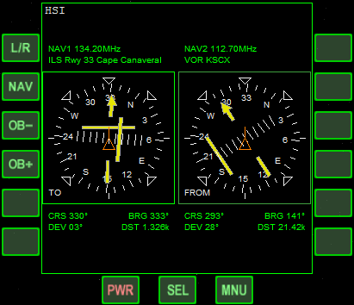
Select left/right display
◻f
Cycle NAV receiver
◻N
Rotate OBS left
◻[
Rotate OBS right
◻]

MFD display components:

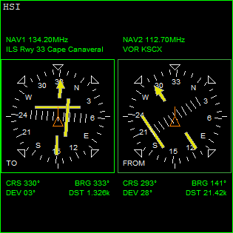
To use the HSI for surface navigation:
OBS
CDI
Deviation scale (2º/tick)
NAV receiver frequency and ID
Gyro-compass
Left HSI display
Right HSI display
Localiser
Glide-slope
Bearing
Distance [m]
Course
Deviation
To/From indicator
- Determine the frequency of the VOR station you want to use (e.g. from the Map ▪m or spaceport info dialog ▪i) and tune one of your NAV receivers to that frequency, using the COM/NAV MFD mode (see Chapter 10.1).
- Link one of the HSI displays to that receiver with ◻n.
- To fly directly towards the transmitter, turn the OBS indicator until the CDI aligns with the OBS arrow, and the TO/FROM indicator shows “TO”.
- Turn the spacecraft until the OBS indicator points to the 12 o’clock position.
- If the CDI wanders off to the left or right, turn the spacecraft to that direction until the arrow is aligned again.
- To fly away from the station, use the same procedure, but make sure that the TO/FROM indicator shows “FROM”.

To use the HSI for instrument landing:
- Make sure the runway is equipped with ILS (use he spaceport info dialog, ▪i), and tune one of your NAV receivers to the appropriate frequency.
- As soon as the ILS transmitter is in range, the OBS indicator turns to the approach direction and can be used as a localiser indicator for longitudinal alignment with the runway centerline.
- At the same time, the glideslope indicator will become active. When both indicators are centered to form a crosshair, you are on course and on glideslope to the runway.

Orbit
The Orbit MFD mode displays a list of elements and parameters which characterise the ship’s orbit around a central body, as well as a graphical representation. In addition, a target object (ship, orbital station or moon) orbiting the same central body can be selected, whose orbital track and parameters will then be displayed as well. The mode is selected via the Orbit entry from the MFD mode selection page (shortcut: ◻+◻o).
The display shows the osculating orbits at the current epoch, that is, the unperturbed 2-body orbit corresponding to the vessel’s current state vectors with respect to the reference celestial body. The orbital parameters may change with time due to the influence of perturbing effects (additional gravity sources, distortions of the gravitational field due to non-spherical planet shape, atmospheric drag, thruster action, etc.)
The celestial body to which the data in the MFD are referenced is shown in the title line. This is automatically set to the dominant gravitational source at the current spacecraft location. The reference body can be changed manually with REF (◻r) and reset to the default with AR (◻a).
The orbital elements can be displayed with respect to one of two frames of reference: ecliptic or equatorial. The plane of the ecliptic is defined by the Earth’s mean orbital plane at a reference date (in Orbiter this is J2000.0), and is useful for interplanetary flights, because most planets orbit close to the ecliptic. The equatorial plane is defined by the equator of the current reference body, and is useful for low orbital and surface-to-orbit operations. Use FRM (◻f) to switch between the two frames of reference. The current frame is displayed in the top line of the display (Frm).
The plane into which the graphical display of the orbit is projected can be selected with PRJ (◻p). The current projection plane is indicated in the top right corner of the display (Prj). In addition to projecting into the principal plane of the selected reference frame (ECL or EQU, depending on the frame setting), you can project into the current orbital plane of your spacecraft (SHP) or of the target (TGT), if defined.
Target objects can be specified with TGT (◻). Only targets orbiting the current reference body will be accepted. The target can be deselected with NT (◻).
Pressing HUD (◻) switches the vessel’s head-up-display to Orbit mode and copies the reference body from the MFD to the HUD. This is often more convenient than selecting the HUD reference directly with ▪.

Key options:
Button | Shortcut | Action
AR | ◻a | Auto-select the reference body
DST | ◻d | Toggle radius, apoapsis and periapsis data between planetocentric distance and altitude above mean planet radius
FRM | ◻f | Toggle frame of reference (ecliptic, equator of reference body)
HUD | ◻H | Set HUD to Orbit mode and copy current reference body
MOD | ◻m | Cycle display mode (list only, graphics only and both)
NT | ◻n | Disable target orbit display
PRJ | ◻p | Cycle orbit projection mode (reference plane, ship’s or target’s orbital plane)
REF | ◻r | Select new reference celestial body for element calculation
TGT | ◻t | Select orbit target

MFD control layout:

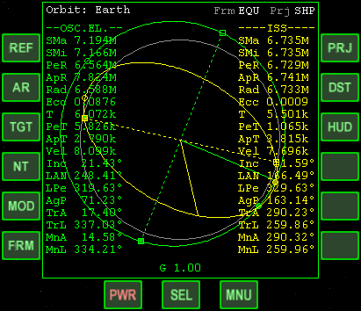
MFD display components:
Select reference body
◻r
Auto-select reference
◻a
Select target
◻t
Unselect target
◻n
Cycle display mode
◻m
Frame of reference
◻f
Cycle projection
◻p
Rad/alt readout
◻d
Copy data to HUD
◻h
a) Graphic display mode
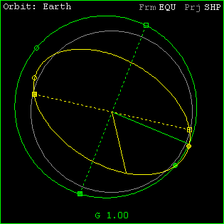
In graphical mode, the Orbit MFD shows the ship’s orbit (green) and optionally the orbit of a target object (yellow) around the reference body (surface represented by a grey circle). The display also shows the ship’s and target’s current positions (radius vectors), the periapses (lowest orbit points) and apoapses (highest points), and the ascending and descending nodes with respect to the reference plane.
Projection plane
Frame of reference
Descending node
Orbit reference
Spacecraft orbit
G-field contribution
Line of nodes
Periapsis
Radius vector
Planet surface
Ascending node
Apoapsis
Target orbit
The user can select the plane into which the orbit representations are projected.

b) Orbital element list mode
In list mode, the ship’s orbital elements and other orbital parameters are listed in a column down the left side of the display (green). If a target is selected, its elements are listed on the right (yellow). The elements refer to the selected frame of reference, so they will change when switching between ecliptic (ECL) and equatorial (EQU) frame.

Notation:
- Semi-major axis: the longest semi-diameter of the orbit ellipse
- Semi-minor axis: the shortest semi-diameter of the orbit ellipse
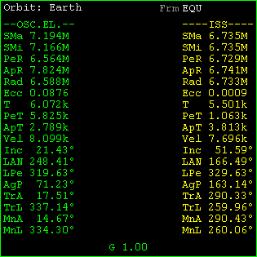
- Periapsis: the lowest point of the orbit (For Earth orbits, this is also called perigee. For solar orbits, this is also called perihelion.)
Semi-major axis
Semi-minor axis
Periapsis distance
Apoapsis distance
Radial distance
Eccentricity
Orbit period
Time to periapsis
Time to apoapsis
Velocity
Inclination
Longitude of asc. node
Longitude of periapsis
Argument of periapsis
True anomaly
True longitude
Mean anomaly
Mean longitude
Frame of reference
G-field contribution
Target elements
Orbit reference
Ship elements
- Apoapsis: the highest point of the orbit (For Earth orbits, this is also called apogee. For solar orbits, this is also called aphelion.)
- Line of nodes: the intersection line of the orbital plane with the reference plane
- Ascending node: the point at which the orbit passes through the reference plane from below
- Descending node: the point at which the orbit passes through the reference plane from above
- Radius vector: the line from the orbit’s focus to the current position of the orbiting body
For further explanation of orbital elements see Chapter xxx.
For hyperbolic (non-periodic) orbits, the following parameters are interpreted specially:
- SMa: real semi-axis a: distance from coordinate origin (defined by the intersection of the asymptotes of the hyperbola) to periapsis. The semi-major axis is displayed negative in this case.
- SMi: imaginary semi-axis
- ApD: apoapsis distance: not applicable
- T: orbit period: not applicable
- PeT: time to periapsis: negative after periapsis passages
- ApT: time to apoapsis: not applicable
- MnA: mean anomaly, defined as M = e sinh E – E, with E hyperbolic eccentric anomaly

G-field contribution
The G value at the bottom of the display shows the relative contribution of the current reference body to the total gravity field at the ship’s position. This can be used to estimate the reliability of the Keplerian (2-body) orbit data displayed in the MFD. For values close to 1, a 2-body approximation is accurate. For low values the true orbit will deviate from the analytic calculation, resulting in a change of the osculating elements over time.
As a warning indicator, the G display will turn yellow for contributions < 0.8, and red if the selected reference body is not the dominant contributor to the gravity field. In that case, AR (◻) will select the dominant body.

Align Orbital Plane
This MFD mode aids in rotating the orbital plane in space so that it matches a target plane, e.g. the orbital plane of another object. The instrument displays the relevant orbital elements (inclination and longitude of the ascending node) of the current and target objects. It also shows the relative inclination (the angle between the two planes), the angles between the current target vector and the ascending and descending nodes, the time to intercept the next node, and the predicted required thruster burn time. See section 12.4 on an introduction to plane change and how to use this MFD mode effectively.
The target plane can either be defined in terms of the orbital elements of another orbiting object, or by explicitly entering the required elements (inclination and longitude of the ascending node with respect to the ecliptic frame of reference).

Key options:
Button | Shortcut | Action
REF | ◻r | Select reference body
AR | ◻a | Auto-reference
TGT | ◻t | Input a new target orbit or target orbital parameters
ELS | ◻e | Input target plane as ecliptic inclination and longitude of ascending node
MOD | ◻M | Cycle display modes auto → orbit → ballistic → surface

MFD control layout:

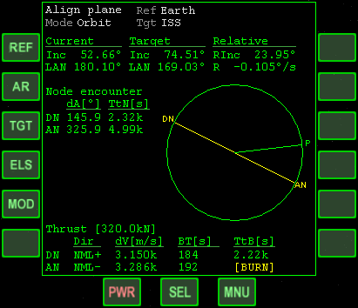
MFD display components:
Select reference body
◻r
Auto-reference
◻a
Select target object
◻t
Input plane Inc/LAN
◻e
Cycle display modes
◻m
The Align-plane MFD mode can be used in two distinct situations
- while in orbit, to rotate the orbital plane to a target orientation
- while on the ground, to find the optimal launch window for matching a target plane
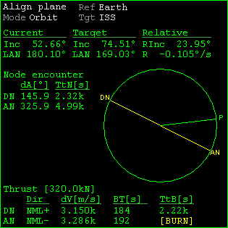
The two modes make different assumptions about the vessel trajectory. In orbit mode, the vessel is assumed to follow its current osculating elements. The current and target planes always intersect, and the reference body’s centre of mass always lies on the line of nodes.
Reference body
Target object
Rel. inclination between planes
Display mode
Current plane orientation
Rel. inclination rate of change
Target plane orientation
Angle to ascending/
descending node
Time to ascending/
descending node
Graph: ascending/
descending node, current position
Main engine thrust requirements
Thrust direction
Plane change ΔV
Burn time
Time to burn
Burn indicator
In surface mode, the vessel is expected to spin with the reference body at its current surface-relative position. Its trajectory is therefore on a plane parallel to the reference body’s equator. It only intersects the target plane if the current latitude is lower than the target plane’s inclination against the equator.
In addition, a ballistic mode is supported. This is useful in transition from the surface to orbit, while the periapsis of the orbit constructed from the vessel’s state vectors is still below the surface. In this mode, the orbit prediction is modified by altering the semi-major axis and eccentricity values such that the periapsis is on the planet surface, and the entire orbit is above ground. This mode provides more realistic burn times than orbit mode, which uses the osculating elements directly. Once the periapsis is above ground, orbit and ballistic mode are identical.
The user can select auto-mode to leave the mode selection to the software. In this case, surface mode is selected while the vessel is in contact with the surface, ballistic mode while the predicted periapsis is below surface, and orbit mode otherwise.
a) Orbit mode
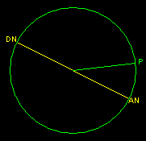
The current vessel and target plane orientations are shown in terms of two rotation angles in the ecliptic frame: Inc (inclination against the reference plane) and LAN (longitude of the ascending node – rotation of the ascending node against the vernal equinox).
P
AN
DN
RInc
Current plane
Target plane
Ref
NML-
NML+
The relative inclination between the planes and rate of change are also shown.
The Node encounter data show the angles from the current position to the ascending and descending nodes (dA) and the times to the nodes (TtN).
The Thrust data show the required main engine burn parameters required for the plane change: thrust direction (Dir) – either normal (NML+) or anti-normal (NML−) to the current plane orientation, required velocity change (dV), required burn time (BT) and time to burn (TtB). The data are shown for plane change at the next ascending node (AN) or descending node (DN) passage.
b) Ballistic mode
After launch, while the vessel’s tangential velocity is low compared to circular orbital velocity, most of the orbit predicted from state vectors will be below surface, including the line of nodes, leading to inaccurate burn time predictions. In ballistic mode, the shape of the predicted orbit is altered by modifying the a (semi-major axis) and e (eccentricity) parameters such that the entire orbit is above the surface, with periapsis on the surface. The orientation of the orbital plane remains unchanged. This mode provides more realistic burn time predictions for a vessel in low altitude suborbital flight.
P
AN
DN
Ref
AN’
DN’
c) Surface mode
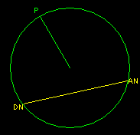
In surface mode, the vessel is assumed to remain at a fixed position at the planet surface. Its trajectory and velocity are defined by the planet radius and spin, and the latitude of the vessel position. These data are used to calculate the intersection (if any) with the target plane, the nodes, time to nodes and burn times.
P
AN
DN
RInc
Target plane
Ref
The line of nodes in Surface mode is not displayed to go through the centre of the display, because the vessel trajectory will intersect the target plane only with a small arc (left image below), or not at all (right image below), depending on the latitude of the vessel position and the target plane inclination. If there is no intersection, the data in the MFD instead refer to the point of closest encounter (CE), the point of the vessel trajectory closest to the intersection of the two planes.
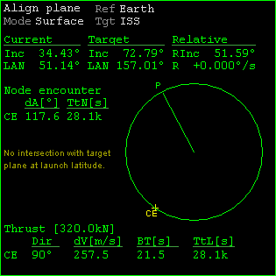
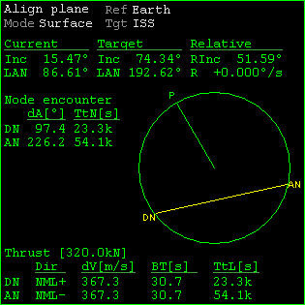
If the MFD is used in Orbit mode while the vessel is located on the surface, some of the readouts will show incorrect data because they refer to an unrealistic orbit constructed from the vessel’s current state vectors which has the vessel at the apoapsis of a highly eccentric orbit with the periapsis close to the planet centre.
Closest encounter
Latitude warning

Synchronise orbit
The Synchronise Orbit MFD mode assists in catching up with an orbiting body once the orbital planes have been aligned (see Chapter 10.7).
The display shows the ship’s and target body’s orbits, together with a reference axis. It lists the times it will take both objects to reach this axis for a series of orbits.
For this mode to work properly, the orbital planes of both objects’ orbits should be closely matched. The relative inclination between the two planes is shown in the lower left corner (RInc). If this becomes too large (e.g. > 1°), re-align the planes with the Align Orbital Planes mode. Plane alignment and orbit synchronisation manoeuvres tend to take place at different positions of the orbit (plane alignment at the nodes, synchronisation at apoapsis/periapsis, so they can usually be queued without interfering with each other. Plane alignment burns are out-of-plane, while synchronisation burns are in-plane.

Key options:
Button | Shortcut | Action
TGT | ◻t | Select target object. Only objects orbiting the same body will be accepted.
MOD | ◻M | Select reference axis mode. Intersection 1 and 2 are only available if the orbits intersect.
LEN | ◻N | Select number of lines in the orbit timing list
R- | ◻, | Rotate the reference axis counter-clockwise (manual mode only)
R+ | ◻. | Rotate the reference axis clockwise (manual mode only)

MFD control layout:

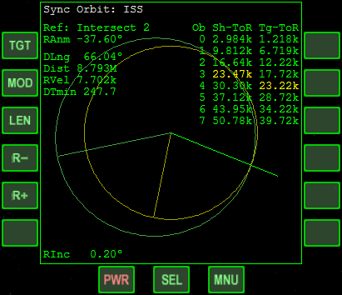
MFD display components:
Select target object
◻T
Cycle intersection mode
◻,
Adjust list length
◻N
Rotate intersection
◻,
Rotate intersection
◻.
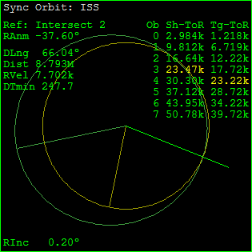
Orbit counter
Ship time to ref. axis [s]
Target time to ref. axis [s]
Reference axis
True anomaly of ref. axis
Target object
Longitude difference
Distance to target [m]
Rel. velocity [m/s]
Min. time of arrival difference [s]
Rel. orbit inclination
Ship position
Ship orbit
Reference axis
Target orbit
Target position
Closest match
Timing table
- Target object: The synchronisation target is displayed in the title line. It can be selected with ◻t.
- Reference axis: A selectable axis for which the rendezvous timings are computed. Can be selected with ◻M from one of the following: orbit intersection 1 and 2 (if applicable), ship and target apoapsis and periapsis, and manual. The manual axis can be rotated with ◻, and ◻..
- True anomaly of ref. Axis (RAnm): The angle between the reference axis and the ship’s periapsis direction.
- Longitude difference (DLng): The angle between ship and target measured from the central body.
- Distance (Dist): Linear distance between ship and target [m].
- Rel. velocity (RVel): Relative velocity between ship and target [m/s].
- Time-of-arrival difference (DTmin): The minimum time difference [s] between the ship’s and target’s arrival at the reference axis for any of the listed orbits (see below).
- Rel. orbit inclination (RInc): Angle between ship’s and target’s orbital planes.
- Time-to-reference lists (Sh-ToR and Tg-ToR): A list of time intervals for the ship and target to reach the reference axis for the next n orbits. (n can be selected with ◻n). The closest matched pair of timings is indicated in yellow. The DTmin value refers to this pair.
See also Chapter 12.5 on some basic concepts for orbit synchronisation.

Docking
The Docking MFD mode assists during final approach to dock with another vessel or orbital station. It provides indicators for translational and rotational alignment with the approach path, as well as distance and closing speed readouts.
This instrument relies on docking approach data received by your spacecraft from the target vessel. Approach data can be acquired in three different modes:
- IDS mode: Data are acquired from a radio signal sent by the docking target. The IDS (Instrument Docking System) signal is obtained by tuning a NAV receiver to the appropriate frequency and linking the Docking MFD to that receiver. The typical range for IDS is ~20 km. To select a NAV receiver, press ◻n. The selected frequency is displayed in the upper right corner of the MFD.
- Visual mode: Docking parameters are required from onboard visual systems (typically video cameras mounted in the docking port). The visual system aids in docking with targets that do not provide IDS. The typical range for visual mode is ~100 m. To switch to visual mode, press ◻v.
- Direct target selection: If you want to avoid the need to tune into a navigation transmitter signal, you can select a target directly () by entering the target name and optional docking port index ≥ 1. (This shortcut method may be dropped in a future version.)
Apart from their different operational range, the three modes provide identical data output on the MFD display.
While out of range of an IDS transmitter, the MFD can also be linked to the target vessel’s long range transponder (XPDR) signal. This typically has a range of 1000 km, but only provides distance data, no alignment information.

Key options:
Button | Shortcut | Action
DCK | ◻D | Select local docking port. Only available if the vessel has more than one docking port.
NAV | ◻n | Select NAV receiver for data input
VIS | ◻v | Switch to visual docking data acquisition mode
TGT | ◻t | Direct target and docking port selection
SCL | ◻s | Toggle display resolution (coarse/fine) in the aiming reticle and radial scales.
HUD | ◻h | Set HUD to Docking mode and copy data from MFD to HUD

MFD control layout:

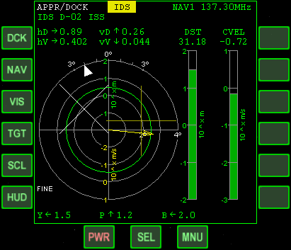
MFD display components:
Select docking port
◻d
Select NAV receiver
◻n
Visual acquisition
◻v
Direct target input
◻t
Toggle display scale
◻s
Copy data to HUD
◻h
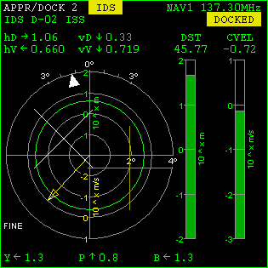
The top two lines of the display contain information about the selected local docking port (dock ID, only applicable if the vessel has more than one port) and signal status of the targeted docking port on the remote vessel (the linked NAV receiver ID and its frequency setting, the type and identifying string of the received signal, if any). Also shown is the docking indicator (DOCKED) once the docking connection has been established.
Docking indicator
Target distance [m]
Closing velocity [m/s]
Transmitter ID
Dock ID
Transmitter type
Longitudinal offset and rate scales
Distance bar (log scale)
Closing speed bar (log scale)
Approach path indicator
Attitude offsets (yaw, pitch, bank) [°]
Horizontal approach offset [m] and rate [m/s]
Vertical approach offset [m] and rate [m/s]
Bank indicator
Attitude alignment indicator
Approach cone
Transversal velocity vector
High-res scale indicator
Transversal aiming reticle
NAV receiver and frequency
- Dock ID: Identifies the docking port for which the instrument is computing approach parameters. Only applicable if the vessel has more than one docking port.
- Transmitter type/transmitter ID: Identifies the source of the currently received transmitter signal, if any. This can either be a long-range transponder (XPDR) or an instrument docking (IDS) sender on the target vessel.
The left part of the display shows a circular aiming reticle which contains a visual representation of both the lateral displacement from the approach path and the rotational alignment with the target docking port.
- Approach path indicator: The upright cross () indicates the position of the approach path relative to the ship (at the centre of the reticle). When the indicator is centered in the display, the ship is located on the approach path. The radial scale is logarithmic in the range 0.1–1000 m (coarse) or 0.01–100 m (fine). Tangential alignment is performed with attitude thrusters in linear mode (see Chapter 11.2).
- Transversal velocity vector: The yellow arrow indicates the relative tangential velocity of your vessel with respect to the target. The radial scale is logarithmic in the range 0.01–100 m/s (coarse) or 0.001–10 m/s (fine). If the relative velocity is below the lower range limits, the arrow is not shown. To move the vessel onto the approach path, engage RCS thrusters in linear configuration so that the arrow points towards the approach path indicator.
- Attitude alignment indicator: The white or red × symbol indicates the alignment of the ship’s docking port orientation with the approach path direction. When centered, the docking ports on the local and remote vessels are aligned in yaw and pitch. The symbol turns red if the misalignment is > 2.5°. The radial scale is linear in the range 0–20° (coarse) or 0–4° (fine). Rotational alignment is performed with RCS in rotational configuration (see Chapter 11.2).
- Bank rotation indicator: This arrow moves along the circumference of the reticle to indicate the ship’s longitudinal (bank) alignment with the docking port. To align, the indicator must be moved into the 12 o’clock position (0°) by rotating the ship around its longitudinal axis, engaging bank attitude thrusters in rotational configuration (see Chapter 11.2).When alignment is achieved, the indicator turns white (misalignment < 2.5°). Note that this indicator is only displayed when directional alignment (see above) is within 5°. The tick marks at the top of the aiming reticle represent 10° (coarse) or 1° (fine) misalignments.
- Approach cone: The concentric green or red circle indicates the size of the approach cone at the current distance to the target dock. The ship should approach the dock so that the approach path indicator is always inside the approach cone (green). The approach cone cross section becomes smaller as the ship approaches the dock.
The readouts above the reticle show the numerical values of the linear offsets and rates.
- hD/vD: Transversal (horizontal/vertical) displacements from the approach path [m]. These are the distances (projected into the plane normal to the approach path) of the current vessel position from the approach path. The arrows indicate the direction of the approach path from the vessel position. In the aiming reticle the offset from the approach path is graphically represented by the approach path indicator ().
- hV/vV: Transversal (horizontal/vertical) velocities relative to the approach path [m/s]. These are the velocity components relative to the target, projected into the plane normal to the approach path. The arrows indicate the velocity directions. If the velocity direction indicators match the offset direction indicators, the vessel is moving towards the approach path. In the aiming reticle the relative transversal velocity is represented by the transversal velocity vector.
The readouts below the reticle show the rotational misalignment values.
- Y/P/B: Vessel attitude rotation from the required docking attitude (yaw/pitch/bank) [degrees]. The arrows indicate the directions in which the vessel must be rotated to align with the docking port orientation. This alignment is done in rotational RCS configuration. In the aiming reticle the attitude misalignments are represented by the attitude alignment indicator (yaw, pitch) and the bank rotation indicator.
The scales in the right half of the display show the longitudinal distance and rate along the approach path direction.
- DST: dock-to-dock distance [m]. The bar shows the distance on a logarithmic scale in the range 0.1–1000 m (coarse) or 0.01–100 m (fine).
- CVEL: Closing speed [m/s]. The bar shows the closing speed on a logarithmic scale in the range 0.01–100 m/s (coarse) or 0.001–10 m/s (fine). Yellow indicates positive closing speed.
Closing speed should be reduced as the ship approaches the dock (using RCS in linear configuration). The relative velocity at contact should be < 0.1 m/s.

Notes:
- To dock successfully you must approach the dock to within 0.3 m. Additional restrictions may be implemented in the future (speed, alignment, etc.)
- No collision checks are currently performed. If you fail to dock and keep closing in, you may fly your ship through the target vessel.

RCS Attitude
The Attitude MFD mode provides advanced functions for orbital attitude control beyond the built-in attitude modes (pro-/retrograde, normal/anti-normal). This MFD mode is an example for a script-driven MFD definition. To make it available, the ScriptMFD module must be activated in the Launchpad Modules tab.
The attitude MFD mode operates by taking control of the vessel’s RCS thrusters to orient it in the commanded attitude. This only works for vessels with a full RCS that allows alignment in all three vessel axes.
A new attitude mode is defined by first selecting a Base mode and then adding additional rotations to it. Press SET to open the mode definition page. If an attitude mode is currently active, the definition page initially displays the parameters of this mode. Otherwise, a default prograde mode is shown. You can use the BAS button to cycle through the available base modes: prograde, normal, perpendicular and radial. Each mode can be inverted by pressing the INV button, e.g. prograde → retrograde, or normal → anti-normal, etc. The following table shows the orientation of each base mode from two principal vessel axes (forward, z, and up, y), relative to the orbital velocity vector (v), radius vector (r) and orbital plane normal (n = r × v).

Mode | Vessel orientation
prograde | z → v, y → n
retrograde | z → −v, y → −n
normal | z → n, y → −v
antinormal | z → −n, y → −v
perpendicular (in) | z → −v × n, y → v
perpendicular (out) | z → v × n, y → −v
radial (down) | z → −r, y → v
radial (up) | z → r, y → −v
After defining the base mode, additional rotations can be added to modify the vessel orientation. Press the +R button to add a rotation. You can select a rotation axis (pitch, yaw, roll) by pressing the AX button. Set a rotation angle with the +V and −V buttons. You can add multiple rotations, but note that the order is significant. Rotations do not commute. You can select a rotation with the UP and DN buttons. Rotations can be deleted with the −R button.
When the mode definition is complete, press the GO button to activate it. You can continue editing the mode, and activate the modifications by pressing GO again. To return to the main page, press RTN.

Key options:
Button | Shortcut | Action
Main page:
SET | ◻s | Set/adjust attitude mode
DCK | ◻d | Switch to docking alignment mode
SUS | ◻p | Suspend/activate attitude mode
END | ◻x | Cancel active attitude mode
CFG | ◻c | Define offset angles for default attitude modes
Attitude definition page:
BAS | ◻b | Cycle through attitude base modes
INV | ◻I | Invert current base mode
CUR | ◻k | Bind target mode to current attitude
+R | ◻a | Add a rotation to the base mode
−R | ◻x | Delete the currently selected rotation
+V | ◻. | Increase the angle of the currently selected rotation
−V | ◻, | Decrease the angle of the currently selected rotation
AX | ◻c | Cycle through rotation axes for currently selected rotation
UP | ◻u | Switch to the previous rotation
DN | ◻d | Switch to the next rotation
GO | ◻g | Activate the attitude mode
RTN | ◻r | Return to main page
Docking alignment page:
NAV | ◻n | Cycle through NAV receiver stack
ACT | ◻a | Activate dock alignment mode
CNC | ◻x | Cancel docking alignment mode
RTN | ◻r | Return to main page
Offset configuration page:
+R | ◻a | Add a new rotation offset
−R | ◻x | Delete the currently selected rotation offset
AX | ◻c | Cycle through rotation axes for currently selected rotation
+V | ◻. | Increase angle for currently selected rotation
−V | ◻, | Decrease angle for currently selected rotation
UP | ◻u | Switch to previous rotation
DN | ◻D | Switch to next rotation
GO | ◻g | Activate offset configuration
RTN | ◻r | Return to main page

MFD control layout (main page):

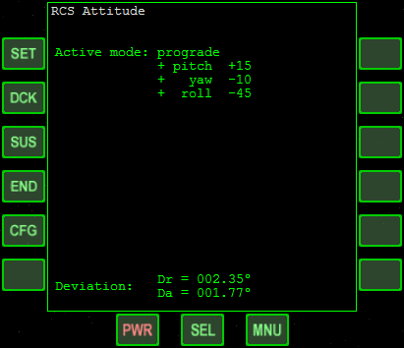
MFD display components (main page):
Set attitude mode
◻s
Dock sync mode
◻d
Suspend/activate
◻p
Cancel active mode
◻x
Configure vessel
◻c

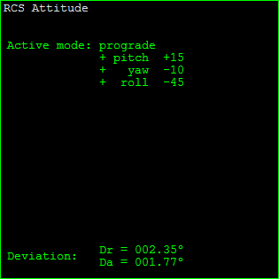
Rotational docking alignment
Active base mode
Additional rotations
Deviation from target direction
Attitude mode definition
Deviations
Deviation from target rotation
The Attitude MFD can also align the vessel with the target docking port orientation. From the main page, press the DCK button. This opens the Dock alignment page. Docking alignment is performed with data from an IDS (instrument docking system) transmitter. Make sure that one of your NAV radios is tuned to the IDS of the target dock. Use the NAV button to select the appropriate receiver from the stack. Docking alignment can only be activated once an IDS signal is received. Press ACT to activate the alignment mode. You can then return to the main page with RTN.
Docking alignment mode is cancelled if the IDS transmitter goes out of range, or if the NAV receiver is re-tuned.
Docking alignment also works for docking ports not oriented in the vessel’s forward (+z) axis.

Pre-multiplying an angular offset
Sometimes it is useful to apply an angular offset to all attitude modes. For example, the Space Shuttle’s OMS engines are tilted by 15° against the longitudinal axis. The resulting thrust vector therefore points to −15° pitch. For a prograde OMS burn, the Shuttle needs to pitch up by 15° against the orbital velocity vector. This constant offset due to engine arrangement can be taken into account with the Attitude MFD.
Open the Configuration page by pressing CFG from the main page. You can now add angular offsets by pressing the ADD button. You can then set the rotation axis and angle similar to the attitude mode setup. For example for the Shuttle, add a pitch rotation of +15°. When done, press RTN to return to the main page. The additional offset will be added to all attitude modes, except for the docking alignment mode.

Transfer
The Transfer MFD mode is used for calculating transfer orbits between planets or moons (or more generally, between any objects with significantly different orbits, for which the Sync orbit MFD mode is not sufficient).
Note that Orbiter now contains Duncan Sharpe’s TransX MFD mode as a plugin module, which supersedes and extends most of the Transfer MFD functionality. TransX is described in a separate document (Doc\TransX\TransXmanualv3.pdf).

Key options:
Button | Shortcut | Action
REF | ◻r | Select the reference celestial body
SRC | ◻S | Select the source object
TGT | ◻T | Select target
NT | ◻N | Unselect target
HTO | ◻X | Toggle HTO (hypothetical transfer orbit) display on/off
NUM | ◻M | Toggle numerical multi-body trajectory calculation
UPD | ◻U | Refresh numerical trajectory if displayed
STP | ◻Z | Set up time step length
EJ− | ◻, | Rotate transfer orbit ejection point counter-clockwise
EJ+ | ◻. | Rotate transfer orbit ejection point clockwise
DV− | ◻- | Decrease ejection velocity difference
DV+ | ◻= | Increase ejection velocity difference

MFD control layout:

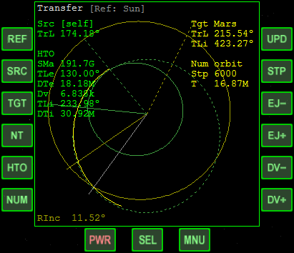
MFD display components:
Select reference body
◻r
Select source orbit
◻s
Select target
◻t
Unselect target
◻n
Hypothetical transfer
◻x
Numerical trajectory
◻M
Update trajectory
◻u
Time steps
◻z
Rotate ejection point
◻,
Rotate ejection point
◻.
Decrease ΔV
◻-
Increase ΔV
◻-
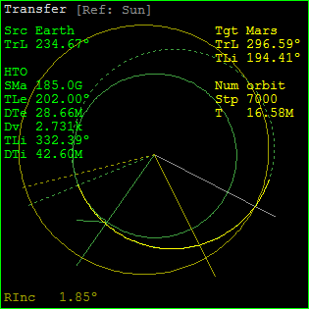
The Transfer MFD looks similar to the Orbit MFD: it displays a source and target orbit, relative to an orbit reference body. The source orbit is usually your ship’s current orbit, although sometimes a different source is more appropriate (see below). The Transfer MFD mode only works correctly for in-plane operation (i.e. assumes matching source and target orbital planes), although this condition usually can not be precisely satisfied for interplanetary transfers.
Target object
Target longitude
Transfer orbit
Source longitude
Current source orbit
HTO params:
Semi-major axis
Eject longitude
Time to eject burn
Velocity difference
Intercept longitude
Time to intercept
Rel. inclination
Num. orbit params
Transfer reference
Source object
Target at intersect
Eject indicator
Target longitude at intercept
Numerical orbit
Current source pos
Intersect indicator
Target orbit
Current target pos

Source orbit selection
The source orbit is the orbit from which to eject into the transfer orbit. Usually the source orbit will be the ship’s current orbit. In certain situations however it is better to use a different source. Consider for example an interplanetary transfer from Earth to Mars, using the Sun as reference. Since the ship’s primary gravitational source will be Earth rather than the Sun, its orbit with respect to the Sun will be strongly distorted by the Earth’s gravity. In this case it is better to directly use Earth as the source object.
Whenever the source is a body other than the ship, a small direction indicator is displayed at the current source position which shows the ship’s position relative to the source. This helps with timing the ejection burn. For example, to make use of the ship’s orbital velocity around the source body, the ejection burn should take place when the direction indicator points away from the sun (assuming a prograde orbit).

Hypothetical transfer orbit
To plan the transfer, a hypothetical transfer orbit (HTO) can be plotted given an ejection time and velocity difference (∆v), which allows to set up “what if” scenarios, before changing the actual orbit. The HTO display is toggled on/off with ◻x. It is calculated assuming that somewhere along the current source orbit a prograde or retrograde orbit ejection burn occurs. The HTO has two parameters: the longitude at which the ejection burn takes place (adjusted with ◻,/.), and the velocity change during the burn (adjusted with ◻-/=). The HTO is displayed as a dashed green curve. The position of the ejection burn is indicated by a dashed green radius vector.
A number of parameters is shown when the HTO is active:
- SMa: semi-major axis of the transfer orbit
- TLe: True longitude of the orbit ejection point
- Dv: Velocity difference from ejection burn
- TLi: True longitude of intercept point with target orbit (if applicable)
- DTi: Time to intercept with target orbit [s] (if applicable)

Intercept indicator
If the source orbit (or, if shown, the HTO) intersects the target orbit, the intersect point is marked by a grey line, and the intersect longitude is displayed (TLi). The position of the target at the time when the ship reaches the intersect point is marked by a dashed yellow line. To plan an encounter with the target body, the objective is to adjust the HTO so that the grey and dashed yellow lines coincide (ship and target arrive at the intersect point simultaneously) by adjusting the ejection time and ∆v.

Hohmann transfer orbit
A transfer orbit which just touches the target orbit, and where ejection and intersect longitudes are 180° apart, is called a Hohmann minimum energy transfer orbit, because it minimises the amount of fuel used during the orbit ejection and insertion burns. Transfer orbits with larger major axis require more fuel, but are faster than Hohmann orbits.

Ejection burn
Once the HTO has been set up, the ejection burn takes place when the ejection longitude is reached (when the solid and dashed green lines coincide). The ejection burn is prograde (or retrograde) given the orbit w.r.t. the current orbit reference. As the burn takes place, the current orbit (solid green line) will approach the HTO. The burn is terminated when the orbit coincides with the HTO and Dv has reached zero. After ejection the HTO should be turned off so that the intercept parameters are displayed for the actual transfer orbit.

Numerical multi-body trajectory calculation
The source, target and transfer orbits discussed above are analytic 2-body solutions. The Transfer MFD however also supports a numerical trajectory calculation to account for the effect of multiple gravitational sources. The display of the numerical trajectory is toggled with ◻m. The trajectory is displayed as a solid bright yellow line. The calculation is performed in discrete time steps, starting from the current source position, or (if active) from the HTO ejection point. Since the calculation of the trajectory can be time-consuming, it is not automatically updated, but can be refreshed with ◻u. The interval between time steps is automatically adjusted to provide consistent accuracy. The number of time steps, and the total time interval covered by the trajectory segment, can be selected with ◻z. The number of time steps and the total time interval, are displayed under Num orbit in the MFD.

Interplanetary transfers
Using the Transfer MFD for Earth to Moon orbits should be straightforward. For interplanetary transfers, e.g. Earth to Mars, a few caveats apply:
- For interplanetary transfers, the reference should be the Sun, and the source body should be the planet currently being orbited. This is because the ship’s orbit relative to the Sun is significantly distorted by the planet.
- The ship should be in an orbit with zero inclination against the ecliptic before ejection. The relative inclination between source and target orbits cannot be adjusted – it is simply given by the relative inclinations between the planets’ orbits.
- The ejection burn should take place with the Sun in opposition (on the planet’s ‘dark’ side) so that the ship’s orbital velocity is added to the planetary velocity. This is the case when the source → ship direction indicator is pointing away from the Sun.
- Immediately before the ejection burn, switch the source orbit to your ship, so that Dv can be estimated.

Spacecraft controls
This chapter contains guidelines on how to control your spacecraft in free space (outside the influence of aerodynamic forces induced by a planetary atmosphere). We are considering a “generic” vessel with a standard engine layout. The handling of individual spacecraft types may vary considerably. Always read the operating instructions of your vessel, if available.

Main, retro and hover engines
Main thrusters accelerate the ship forward, retro thrusters (if installed) accelerate it backward. Main and retro thrusters can be adjusted with ▪+Num (to increase main thrust of decrease retro thrust) and ▪-Num (to decrease main thrust or increase retro thrust). Main and retro thrusters can be killed with ▪*Num. The permanent setting can be temporarily overridden with +Num (set main thrusters to 100%) and -Num (set retro thrusters to 100%). To set permanent full main thrust directly, press and hold +Num, followed by ▪ to lock the setting. If available, a joystick throttle control can be used to set the main thrusters.
Main | Retro | Hover
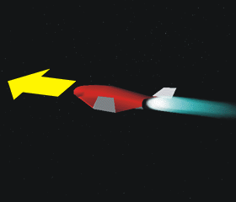 | 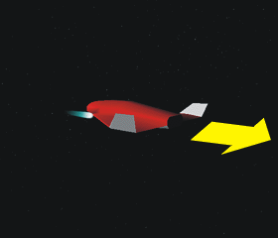 | 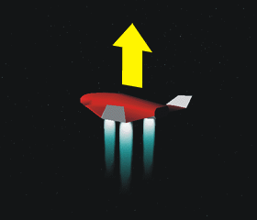
- ▪+Num (permanent)  - +Num (temp. 100%)  - Joystick throttle control | - ▪-Num (permanent)  - -Num (temp. 100%) | - 0Num (increase)  - .Num (decrease)

Background: Rocket propulsion
The ship’s acceleration a resulting from engaging main or retro thrusters depends on the force F produced by the engines, and the ship’s mass m:

Note that both a and F are vectors, that is, they have a direction as well as a magnitude. In the absence of additional forces (such as gravity or atmospheric drag) the spacecraft moves with constant velocity v as long as no engines are engaged. When the engines are firing, the resulting acceleration a changes the velocity according to

For a fixed thruster setting F the acceleration will slowly increase as fuel is consumed, resulting in a reduction of the ship’s mass m. This situation is described by the rocket equation:

where thrust F = −c dm/dt is given by the product of exhaust velocity c and mass flow rate dm/dt. This can be integrated over a time interval to compute the change in velocity Δv as a function of initial mass m0 and final mass m1:

Hover engines, if available, are mounted underneath the ship’s fuselage to provide upward thrust. Hover engines are typically used for spaceplane designs to provide vertical take-off and landing (VTOL) capabilities without the need to tilt the ship upward to obtain a vertical acceleration component from the main thrusters. Standard rocket layouts (“tailsitters”) don’t have dedicated hover thrusters, because the main engines are used to produce the takeoff (and sometimes landing) thrust. Hover thrust is increased with 0Num and decreased with .Num.
The current main/retro thruster setting and corresponding thrust [N] are shown in the engine control block in the top left corner of the generic glass cockpit view (MAIN ENG, see Chapter 9.1). The indicator bar is green for positive (main) thrust, and yellow for negative (retro) thrust. If applicable, the hover thrust setting (HOVR ENG) is also shown. Spacecraft which support customised instrument panel and virtual cockpit views usually have their own indicators for engine status displays.
The maximum vacuum thrust ratings for main, retro and hover thrusters, as well as the current spacecraft mass, are displayed in the vessel’s info sheet (▪i). Values are in Newton (1 N = 1 kg m s−2). Note that the actual generated thrust may be lower in the presence of ambient atmospheric pressure. At extremely high atmospheric pressures, e.g. on the surface of Venus, the spacecraft engines may not produce any thrust at all.

Attitude thrusters
Attitude thrusters are small engines which are engaged in pairs to change the angular velocity of the spacecraft around a specific axis by generating an angular momentum. A complete set of attitude thrusters that allows to control the vessel’s orientation in all three of its principal axes is often referred to as reaction control system (RCS). The same set of thrusters, fired in different configurations, may also be used to generate linear thrust for acceleration along its principal axes without changing the vessel’s orientation.
In Orbiter, the RCS mode is set to either rotational (ROT) or linear (LIN) with /Num. The RCS can also be disabled (OFF) with ▪/Num, for example during launch, where attitude is more commonly controlled by gimbaling the main engines, or during reentry, where body shape or aerodynamic surfaces control flight attitude. The current mode is shown in the engine display block in the top left of the glass cockpit view.
Attitude thrusters are controlled with the keyboard or joystick. In rotational mode:
Rotate: yaw | Rotate: pitch | Rotate: roll
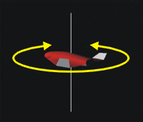 | 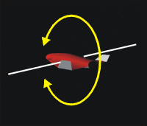 | 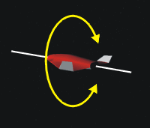
- 1Num / 3Num  - Joystick rudder control  - Joystick left/right+Button 2 | - 2Num / 8Num  - Joystick forward/back | - 4Num / 6Num  - Joystick left/right
and in linear (translational) mode:
Translate: forward/back | Translate: left/right | Translate: up/down
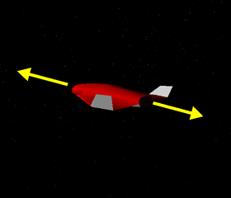 | 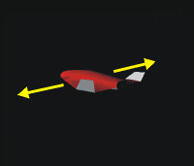 | 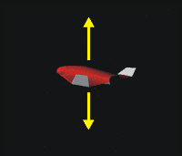
- 6Num / 9Num | - 1Num / 3Num  - Joystick rudder control  - Joystick left/right+Button 2 | - 2Num / 8Num  - Joystick forward/back
For fine control of attitude thrusters with the keyboard use ▪-Numpad key combinations. This engages the engines at 10% thrust.
An important control function is the automatic Kill rotation mode (5Num). This function fires appropriate attitude thrusters to stop the vessel’s rotation. This mode remains active until the vessel’s angular velocity is cancelled or until manually disengaged with another 5Num.

Basic flight manoeuvres
This chapter discusses a few general approaches for manoeuvres during different phases of a flight. Some of the details may differ depending on the spacecraft used, most significantly during launch and landing.

Surface flight
Surface flight paths, as opposed to orbits, include continuously powered trajectories that counter gravitational forces with thrust or aerodynamic lift, as well as suborbital ballistic trajectories with a short initial powered acceleration phase and an unpowered ballistic phase that ends on the surface of the same body. Surface-to-surface transfers (from one surface base to another) typically involve surface flight.
Depending on the celestial body, surface flight may take place within an atmosphere. In that case, atmospheric friction will have an influence on the flight parameters, causing atmospheric drag, possibly supersonic effects, surface heating, etc. Some of the vessels in Orbiter are particularly adapted for atmospheric flight, such as the Delta-glider, which has an aerodynamic body and surfaces which generate lift when moving through a planetary surface. The Space Shuttle orbiter makes use of the atmosphere during its reentry and unpowered landing approach to extend its range compared to a capsule, and allow it to land on a runway.
In the absence of an atmospheric layer, engine thrust must be substituted for lift to counter gravitational forces. This can be done with dedicated hover thrusters (Delta-glider, Shuttle-A), or with main thrusters, by adjusting the vessel’s attitude to provide appropriate horizontal and vertical thrust components. Without an atmosphere to slow the vessel down, orbits can be realised at arbitrarily low altitudes, as long as surface obstacles are cleared. When the horizontal velocity component approaches orbital speed, less vertical thrust is required to maintain altitude.
The most useful MFD modes for surface flight are
- Surface (altitude, speed, acceleration, attitude, atmospheric parameters)
- HSI (navigation in the presence of VOR beacons, instrument landing)
- Map (navigation, ground track prediction)
- VTOL (vertical take-off and landing support)

Launching into orbit
Launching from a planetary surface into a low orbit is one of the most basic problems in spaceflight. A suitable launch profile minimises fuel consumption, while keeping relevant parameters (acceleration, aerodynamic loads, heat generation, etc.) within predefined limits. The chosen profile will depend on the type of launch vehicle – the Space Shuttle has to follow a precisely defined launch trajectory with little deviation to reach orbit with limited propellant resources and without subjecting its crew to excessive forces at any phase of the ascent, while the futuristic Delta-glider can achieve orbit effortlessly and nearly hands-off. Some general rules can however be formulated:
- The initial part of the ascent is vertical to leave the denser part of the atmosphere before the increasing airspeed leads to excessive drag and heating.
- Later the vessel pitches over to start building up the horizontal velocity component required for attaining orbit.
- The engines may be cut once the highest point of the projected trajectory (apoapsis) coincides with the target orbit altitude.
- Once that point is reached, the engines are engaged again in a prograde vessel orientation (aligned with the trajectory direction) for orbital insertion (lifting the lowest part of the orbit above the planet surface and sufficiently high above the atmosphere layer to enter a stable orbit).
- For efficiency reasons, launch direction should be prograde (in the direction of the planetary rotation, i.e. eastward on Earth) to get the surface velocity component for free. For the same reason, a launch site closer to the equator will be more efficient. (On Earth, a prograde equatorial launch saves Δv = 930 m/s compared to a retrograde launch).
- If a specific target orbit must be achieved (e.g. for rendezvous with an orbital station), this will determine a launch window (time) and launch azimuth (heading). The launch should take place when the launch site passes through the target orbital plane, and the azimuth is given by the inclination of the target plane at the launch latitude. This will minimise the requirement for later expensive orbital pane changes. The Map and Align orbital plane MFD modes help with picking launch window and azimuth.

Background: Launch azimuth calculation
Given latitude ϕ of the launch site and target inclination i, the launch azimuth β can be calculated with

This is a simplified formula doesn’t take into account the effect of planet rotation. For a discussion of the required correction, see for example the OrbiterWiki.

Changing the orbit
To change the shape of the orbit without changing the orbital plane, any thrust must be applied in the orbital plane (in-plane manoeuvres). An important consideration in orbit changes is the fact that the point in the orbit at which the engines are fired for the orbit change manoeuvre is also part of the new orbit (assuming a short, impulse-like burn). In other words, to modify a particular section of the orbit, the corresponding engine burn should occur on the opposite side of the orbit.

Task: modifying apoapsis/periapsis distances
A common task is the raising or lowering of apoapsis (highest point of the orbit) or periapsis (lowest point of the orbit), for example for circularising an orbit after initial orbit insertion, or to initialise a change in orbital radius. In keeping with the above principle, the apoapsis distance is modified by an engine burn at periapsis, and vice versa:
- Increase apoapsis distance: Wait until the ship reaches periapsis. Apply thrust prograde (in the direction of the orbital velocity vector)
- Decrease apoapsis distance: Wait until the ship reaches periapsis. Apply thrust retrograde (opposite the direction of the orbital velocity vector)
- Increase periapsis distance: Wait until the ship reaches apoapsis. Apply thrust prograde.
- Decrease periapsis distance: Wait until the ship reaches apoapsis. Apply thrust retrograde.
The Orbit MFD mode (Chapter 10.6) can be used to monitor the time to apoapsis and periapsis. Prograde and retrograde orbit directions can be visualised on the HUD in Orbit mode (Chapter 9.4). The vessel can be automatically oriented in prograde or retrograde attitude in preparation for the orbit change burn by using the corresponding RCS attitude modes (Chapter 9.1).

Task: Increasing/decreasing the radius of a circular orbit
The manoeuvres in the previous task can be combined to change the radius of a circular orbit. This is achieved by two separate engine burns: the first enters an intermediate elliptic orbit whose apoapsis (or periapsis) distance coincides with the desired orbit radius. The second burn re-circularises the orbit.
To raise the radius of the orbit:
- Turn the ship prograde.
- Fire main thrusters until apoapsis (at the opposite side of the orbit) reaches the desired orbit radius. Kill thrusters.
- Wait for half an orbit, until the new apoapsis is reached.
- Turn prograde again, fire main thrusters until periapsis distance also reaches the desired orbit radius and orbit eccentricity is back to 0.
To lower the radius of the orbit:
- As above, but perform both engine burns retrograde instead of prograde.

Task: Rotate the argument of periapsis of an elliptic orbit
Moving into a higher orbit involves prograde acceleration at P and A (periapsis and apoapsis of the transfer orbit). Conversely, moving from a higher to a lower orbit requires retrograde acceleration at A and P.
Transfer orbits
Δv_{P}
Target orbit
Initial orbit
P
A
Δv_{A}
r_{T}
r_{S}
Target orbit
P
Initial orbit
A
-Δv_{P}
-Δv_{A}
r_{T}
r_{S}
The task here is to rotate an elliptic orbit in-plane, by moving the apoapsis and periapsis locations without changing the shape of the orbit. One way to accomplish this is by first performing a prograde burn at apoapsis to enter an intermediate circular orbit, then performing a retrograde burn at the desired new apoapsis position to restore the initial elliptic orbit shape. (Alternatively, a retrograde burn at periapsis could be performed, but the required Δv budget for these two approaches could be different. Which is cheaper?)
Note that the described approach is simple to perform, but may neither be fastest nor cheapest (in terms of fuel consumption). A more direct approach would be to perform the burn at one of the intersections of the old and new orbit, but the computation of burn time and direction is less trivial then.

Rotation of argument of periapsis by Δω using a direct burn Δv_{a} or Δv_{b} at one of the intersection points of initial and target orbits. The burn takes place at true anomaly ν = Δω/2 or Δω/2 + π in a radial direction.
v_{b}
v’_{b}
v_{a}
v’_{a}
Δω
Initial orbit
Target orbit
Δv_{b}
Δv_{a}
Δω
2

Rotating the orbital plane
When trying to rendezvous with another object in orbit, the required orbit changes can be split into two separate phases: a plane change that rotates the plane of the current orbit into that of the target, and further in-plane operations that only require the application of thrust in the plane of the orbit (see previous chapter). Once the orbit planes have been aligned, the remaining operations become essentially two-dimensional, which makes them significantly easier to plan and execute (but possibly less efficient in time and fuel requirements).
In terms of the orbital elements, aligning the plane of the orbit with the target plane means to match the two elements which define the orientation of the orbit in space: inclination (i) and longitude of the ascending node (Ω).
It should be noted that substantial plane changes can require large Δv budgets. It is therefore important to minimise the need for plane changes where possible, for example by carefully planning launch and ascent (launch window and azimuth, see Chapter 12.2).
The rotation of the orbital plane requires the application of out-of-plane thrust, in a direction normal to the current plane. The engine burn takes place in one of the nodes (the points where the orbit crosses the intersection of the current and target planes). This rotates the orbital plane around an axis defined by the current radius vector (which at this point coincides with the line of nodes).
The amount of normal Δv required to rotate by a given angle ir is proportional to the orbital velocity v. It is therefore more fuel-efficient to perform the plane change where v is small, i.e. at the node closest to apoapsis. Sometimes it may even be more fuel-efficient to first raise apoapsis by a separate in-plane manoeuvre, because the fuel savings of the more efficient plane change more than makes up for the additional in-plane burn.
v_{S}
Initial plane
Target plane
Node
Δv
i_{r}
v_{T}

Notes:
- If the angle between the initial and target plane is large it may be necessary to adjust the orientation of the spacecraft during the burn to keep it normal to the plane. Alternatively (and slightly more efficient), the spacecraft may be kept at a constant orientation given by the mean of the normals of the initial and target planes.
- Substantial plane changes require long burns. It may not be possible to align the plane in a single node crossing. If the inclination difference does not decrease further during the burn, cut the engines and wait for the next node crossing.
- Since the manoeuvre will take a finite amount of time ΔT, thrusters should be engaged approximately ΔT/2 before the node encounter.
The direction of the burn depends on the node at which it takes place. If we define the normal vector ns as

for radius vector rs and velocity vector vs, then the thrust should be applied in direction +ns (“normal”) at the descending node (DN) and in direction -ns (“anti-normal”) at the ascending node (AN).

In practice:
Alignment of the orbital plane requires an out-of-plane burn at one of the nodes. rS: radius vector, vS: orbital velocity vector, AN: ascending node, DN: descending node, nS: normal of the current plane, nT: normal of the target plane.
v_{S}
r_{S}
Current orbit
Target plane
n_{T}
n_{S}
AN
DN
Δv_{A}
Δv_{D}
i_{r}
- The Align orbital plane MFD mode (see Chapter 10.7) is designed to aid in plane alignment. Make sure the display is in Orbit mode (◻M) and select the target object (◻t).
- The HUD should be in Orbit mode. As the ship approaches a node (intersection with the target plane), use the appropriate RCS attitude mode to rotate to a normal (;) at DN or anti-normal () orientation to the orbital plane at AN. Use the HUD Orbit inclination ladder to monitor progress.
- As soon as the time-to-burn (TtB) counter reaches 0 for the targeted node and the burn indicator ([BURN]) is shown, engage full main engines. This will happen when the time to node (TtN) counter reaches half the estimated burn time (BT).
- Make sure that the relative inclination (RInc) decreases, i.e. that the rate (R) is negative, otherwise you may be pointing in the wrong direction.
- Adjust the ship’s orientation as required to keep normal to the orbital plane (the automated RCS mode will do this for you).
- Cut engines when:
  - relative inclination (RInc) reaches 0, or
  - rate (R) turns positive, or
  - burn time (BT) counts down to 0, or
  - burn indicator ([BURN]) disappears.
- If the relative inclination was not sufficiently reduced, repeat the procedure at the next node passage.
- During the manoeuvre make sure that your orbit does not become unstable. Watch in particular for the eccentricity and periapsis altitude (use the Orbit MFD mode to monitor this).

Synchronising orbits
The next step in a rendezvous manoeuvre after aligning the orbital planes (see previous chapter) is to modify the orbit in-plane such that it intercepts the target’s orbit and both ship and target arrive simultaneously at the interception point. Use the Synchronise Orbit MFD mode to calculate the appropriate orbit changes.
For simplicity we first assume that the ship and target are in a circular orbit with the same orbital radius (for modifying orbital radii see Chapter 12.3), i.e. both objects have the same orbital elements except for the mean anomaly. The method for intercepting the target is then as follows:
- Switch the reference mode of the Synchronise Orbit MFD to Manual and rotate the axis to your current position.
- Turn your ship prograde (using Orbit HUD mode and RCS attitude functions) and fire main thrusters.
- The orbit will become elliptic, with an increasing apoapsis distance. Your current position becomes periapsis of the new orbit. Simultaneously the orbit period and the times to reference axis are increasing.
- Kill engines as soon as one of the ship-time-to-reference (Sh-ToR) times coincides with one of the target-time-to-reference (Tg-ToR) times.
- Wait until the target is intercepted (the corresponding Sh-ToR and Tg-ToR times have counted down).
- Fire thrusters retrograde to get back to the circular orbit and match velocity with the target.

Notes:
A transition orbit to intercept the target at the next periapsis passage. TT: target orbit period, TS: transition orbit period, ΔtT: remaining time for target to reach periapsis from its current position.
Δt_{T}
Sync orbit
Target orbit
ship
target
T_{S}
T_{T}
Sh-ToR(0) = T_{S}
Tg-ToR(0) = Δt_{T}
Tg-ToR(1) = T_{T} + Δt_{T}

Synchronisation:
T_{S} = T_{T} + Δt_{T}
- Instead of increasing the apoapsis distance one could fire retrograde and reduce the periapsis distance in this manoeuvre. This may be more efficient if the target is ahead of the ship. However the maximum orbit change in this case is limited by keeping periapsis at a safe altitude.
- There is usually a trade-off between the time to encounter and the required orbit change (Δv budget). An encounter in an earlier orbit may require longer engine burns to enter and exit the transition orbit. Matching the intercept times in a later orbit requires shorter burns.
- It is not essential that the orbits are identical or circular at the start of the manoeuvre. It is sufficient for them to intersect. In that case it is best to use Intersection 1 or 2 reference mode in Synchronise MFD mode.
- You don’t necessarily need to wait until you reach the reference point before firing thrusters, but it simplifies matters because otherwise the intersection point itself will move, making the alignment of orbit timings more difficult.

Docking
Docking to an orbital station is the final step in a rendezvous manoeuvre. Assuming that the target station has been intercepted following the operations discussed in the preceding chapters (i.e. ship and target are in close proximity in similar orbits), the last task is to actually dock at one of the station’s available docking ports. This requires
- positioning the ship on the approach path to the selected port
- orienting the ship so that its docking port is aligned with the target
- approaching the docking port along the approach path with suitable relative velocity, correcting for lateral and rotational drift along the way
Here is a checklist of the steps involved in the docking operation:
- Select Docking mode for one of the MFD instruments (◻, ◻d).
- Tune one of your NAV receivers to the station’s long-range transponder (XPDR) frequency, using the COM/NAV MFD mode (◻, ◻c). Tune a second receiver to the IDS (instrument docking system) frequency of the intended docking port. The transponder and IDS frequencies for all vessels are listed in the object info dialog (▪i).
- Link the Docking MFD display to the XPDR signal by selecting the corresponding NAV receiver (◻n).
- Copy the docking parameters to the HUD by pressing the HUD button of the Docking MFD (◻h).
- If not done already, null out relative velocity with the target by rotating the ship to align it with the negative relative velocity marker (⊙) and fire main thrusters until the indicated velocity value (V) approaches zero.

- Rotate the ship to face the station (D▻ marker).
- Approach the station to about 10 km and hold at that relative position. Switch the Docking MFD display over to the IDS receiver (◻n) and copy to the HUD (◻h). This will activate alignment indicators in the MFD display, and a visual representation of the approach path (rectangles) in the HUD.
- Move towards the approach path rectangle furthest from the station, and hold.
- Align the ship’s orientation with the flight path direction using the ‘×’ indicator in the MFD. Use RCS thrusters in rotational (ROT) mode for this.
- Align the ship’s rotation along its longitudinal axis (bank angle) using the arrow indicator in the MFD display.
- Align the ship’s position on the approach path using the ‘’ indicator in the MFD. Switch RCS to linear (LIN) mode for this.
- Approach the station by using the longitudinal RCS thrusters in linear mode (6/9Num). During approach correct your lateral deviation from approach path continuously with linear RCS. Correct rotational drift with rotational RCS.
- Slow down approach speed to less than 0.1 m/s before contact with the station’s docking port.
- Wait until positive docking confirmation is reported.
- To disengage from the docking port, press ▪d.
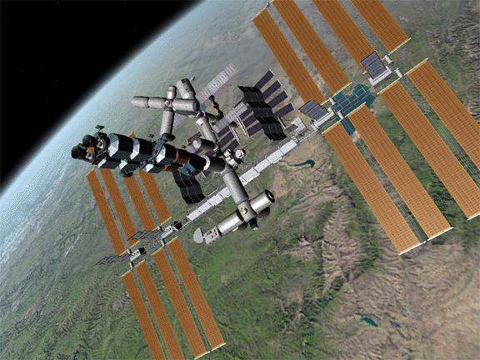
A Shuttle-A class cargo ship after successfully completed docking approach to the ISS.

Notes:
- For precise attitude control with the keyboard, use the RCS thrusters in low power mode (Ctrl + Numpad key).
- Rotational alignment is not currently enforced, but may be in future versions.
- Currently no collision tests are performed, so you might fly straight through the station if you miss the docking approach.

Docking adapter location:
If the ship’s docking adapter is not mounted along its longitudinal axis, you will need to approach the station with your ship rotated accordingly. An example is the Space Shuttle, which had its docking adapter (if present) installed in the payload bay. In this case, the pilot may not have a direct view of the station, but the Docking MFD alignment cues will still work correctly. Care must be taken to use the correct RCS thrusters for alignment corrections.

Docking at rotating stations:
Stations like Orbiter’s fictional Luna-OB1 rotate to use centrifugal forces for emulating gravity – which is nice for its inhabitants but makes docking a lot more complicated. Docking is only possible along the rotation axis, so at most 2 docking ports can be provided. The docking procedure is similar to the standard one, but once aligned with the approach path, the rotation around the ship’s longitudinal axis must be synced with that of the station. Some points to note:
- Initiate your ship’s longitudinal rotation only immediately before docking (when past the last approach rectangle). Once you are rotating, linear adjustments become very difficult.
- Once the rotation is matched with the station, don’t hit Kill Rot (5Num) by accident, or you will have to start the rotation alignment again.

Lunar and interplanetary transfers
A spaceflight from Earth to the Moon or a planet is generally performed in several phases:
- Launch from Earth’s surface into a low Earth orbit
- Ejection burn from orbit into a cislunar or interplanetary transfer orbit
- If required, one or several mid-course correction burns
- Orbit injection burn from transfer orbit into an orbit around the target object
- If part of the mission, a deorbit burn and descent to the surface by a landing module
The Moon and the planets orbit in planes close to the ecliptic (the plane of Earth’s orbit). It therefore simplifies mission planning if the spacecraft’s initial Earth orbit is also aligned with the plane of the ecliptic. This avoids the need for out-of-plane maneuvers.

Hohmann transfer
A common type of interplanetary transfer is the Hohmann orbit, an elliptic orbit with periapsis at the initial (circular) Earth orbit, and apoapsis at the target planet’s distance from Earth. This requires a prograde orbit ejection burn at the appropriate time, similar to the orbit change maneuver described in Chapter 12.3. The launch window is restricted by the requirement that the spacecraft and target body arrive at the transfer orbit’s apoapsis location at the same time. Within that window, the transfer orbit ejection burn takes place at the spacecraft’s appropriate position in its Earth orbit, to make use of its orbital velocity. In Orbiter, the Transfer MFD mode (see Chapter 10.11) assists with simple transfer planning. For more complex missions, 3rd party addon instruments can be downloaded.
Hohmann transfer
Δv_{E}
Moon’s orbit
Initial Earth orbit
E
I
Δv_{I}
A Hohmann transfer from Earth orbit to a Moon encounter. E: ejection burn for transition to transfer orbit. I: Lunar encounter, orbit injection burn.

Gravity assist
Interplanetary transfers often make use of gravity-assist maneuvers (“slingshots”) around other planets to increase velocity and shorten flight times. Slingshots, in particular if they involve multiple planetary encounters, require careful planning.

Free return trajectories
On arriving at the target body, an orbit injection burn is required to enter an orbit around the body from the transfer orbit. It is however sometimes possible to design the transfer orbit such that the spacecraft returns to Earth after swinging around the target body if the injection burn is not executed. This approach was used by the early Apollo lunar missions in case the lunar orbit injection burn failed. Free return trajectories are also possible for Mars missions.

Landing (runway approach)
Some of Orbiter’s spacecraft support powered or unpowered runway approaches, similar to normal aircraft. Examples are the Delta-glider and the Space Shuttle. The Shuttle Landing Facility (SLF) at Kennedy Space Center provides a good opportunity for exercising landing approaches.

Visual approach indicators
The visual approach aids at SLF are designed for Shuttle landings. They include a Precision Approach Path Indicator (PAPI) for long-range glide slope alignment, and a Visual Approach Slope Indicator (VASI) for short-range alignment. The PAPI is set up for a glide slope of 20° (about 6 times as steep as standard aircraft approach slopes!). The VASI is set up for a 1.5° slope during the final flare up prior to touchdown.
Precision Approach Path Indicator: The PAPI consists of an array of 4 lights, which appear white or red to the pilot depending on the approaching vessel’s position above or below the glide slope. At the correct slope there will be 2 white and 2 red lights (see figure). In Orbiter there are 2 PAPI units per approach direction at the SLF, located about 2000 m in front of the runway threshold.
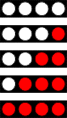 | Above glide slope
 | Slightly above glide slope
 | On glide slope
 | Slightly below glide slope
 | Below glide slope
PAPI indicator signals
Visual Approach Slope Indicator: The VASI consists of a red bar of lights and a set of white lights in front of it. At the correct slope, the white lights are aligned with the red bard (see figure). At the SLF, the VASI is located 670 m behind the runway threshold.
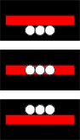 | Above glide slope  On glide slope  Below glide slope
VASI indicator signals
SLF Shuttle approach path

Instrument landing system (ILS)
Runways equipped with ILS transmit a radio signal that provides alignment data to an approaching spacecraft. This information can be presented to the pilot in the HSI MFD mode (see Chapter 10.5) or in dedicated instruments such as the Delta-glider’s VOR indicator instrument. To get ILS data, tune one of the NAV receivers to the desired ILS frequency and switch the HSI feed to that receiver. ILS frequencies can be found in the surface base info pages (▪i).
In ILS mode, the course select needle is fixed to the runway approach direction. The central section of the needle acts as a course deviation bar (CDI). Horizontal alignment is achieved when the course needle points to the 12 o’clock direction and the CDI is centred.
Glideslope
Flight path
Localizer plane
Runway threshold
Vertical alignment is indicated with the glideslope needle. This horizontal bar symbolises the position of the target approach plane relative to the spacecraft at the current distance to the runway threshold. The spacecraft is on glideslope when the needle is centred in the instrument display. A low approach is represented with the needle above the centre line, a high approach with the needle below centre.
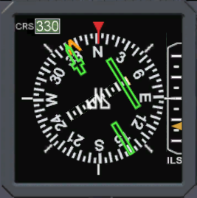
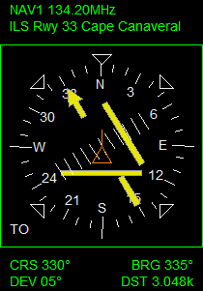
Course indicator
(approach direction)
Deviation indicator
Glideslope indicator
HSI MFD mode
Delta-glider VOR indicator
HSI instruments in ILS mode. Left: DG VOR indicator, right: HSI MFD mode.

Fight recorder
You can record and play back your Orbiter simulation sessions with the built-in flight recorder feature. To open the recorder during a simulation, click record in the main menu (shortcut: ▪). Click the REC button to start the recording. Click STOP to turn the recorder off. A keyboard shortcut for starting and stopping the recording without opening the dialog is ▪c. Recording sessions are stored as new scenarios in the Playback scenario folder. By default, they have the same name as the original scenario, but a different name can be specified in the dialog before starting the recorder. After a recording has been stopped, restarting the recorder will overwrite the earlier segment, unless a different name is chosen.
A running recording session is indicated by a blinking REC light in the top right corner.
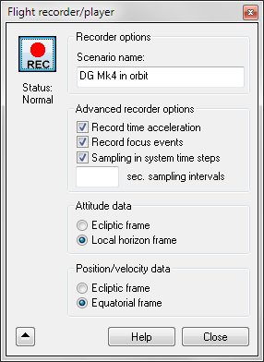
Some additional options can be accessed by pressing the ▼ button in the dialog. These include
- Record time acceleration: Any changes in time acceleration during the session are recorded in the playback stream. During replay, the user has the option to set time compression automatically from the recorded data.
- Record focus events: Switching the focus to a different spacecraft during the recording is recorded in the stream. The same switches will then occur in the playback.
- Sampling in system time steps: If ticked, the intervals between recorded data samples are determined in system time, otherwise in simulation time. In system time, sampling is less dense during time compression. This allows to reduce the size of the data files when recording over long periods of time that are fast-forwarded during recording, but it can lead to noticeable position errors if the same time compression is not used during playback.
- Sampling intervals: Not currently used.
- Attitude data: The vessel attitude can be recorded either with respect to the global ecliptic frame of reference, or with respect to the local horizon of the current reference celestial body. This has no effect on the playback, but may be of interest if the data are used externally, e.g. for trajectory analysis.
- Position/velocity data: Vessel position and velocity samples can be stored with respect to the ecliptic frame or the equatorial frame of the reference object. This has no effect on the playback, but may be of interest if the data are used externally, e.g. for trajectory analysis.
To play back a previously recorded session, launch the scenario under the Playback scenario folder. During playback, all vessels will follow their pre-recorded trajectories and will not respond to manual user control. At the end of the playback the simulation will automatically switch back to manual mode, and the user can take over control. You can terminate the playback before the end of the data stream is reached by pressing ▪c. A running replay is indicated by a green playback symbol in the top right corder of the screen.
A playback is more powerful than just a video clip: the user still has various options to interact with the simulation. For example, it is possible to move the camera, change between cockpit and external views, and even manipulate the MFD instruments to access more fight data. You can however not manipulate the engines: all vessels follow their recorded trajectories.
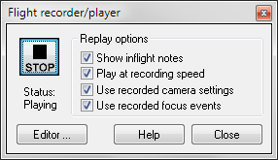
Pressing ▪ during a playback will open the Player dialog which can be used to stop playback and to set some playback options:
- Show inflight notes: Show/hide on-screen text embedded in the recording. Inflight notes can be added to recordings during post-processing, and are useful for creating demos and tutorials.
- Play at recording speed: Use/ignore any time acceleration data stored in the recording. If this option is selected, time acceleration is applied from the recording stream, and manual time acceleration settings are disabled.
- Use recorded camera settings: Recorded camera movements and cuts are applied in the playback. Turning off this option allows to operate the camera manually during playback.
- Use recorded focus events: Any switches to different vessels are replicated in the playback. Turning off this option leaves the focus on the initial vessel.

Trajectory and event data
The data for recorded simulation sessions are stored under the Flights subdirectory. Orbiter creates a new subfolder for each recording, using the same name as the recorded scenario. Each vessel in the scenario writes three data streams to this folder, consisting of:
- position and velocity (*.pos). Contains a sequence of state vector samples, recorded relative to a reference planet, either in a non-rotating reference system (ecliptic and equinox of J2000.0), or a rotating equatorial reference system. As a result, trajectories are recorded in an absolute time frame. Samples are written in regular intervals (2 s) or if the velocity vector rotates by more than 5°.
- attitude (*.att). Attitude data are saved as Euler angles of the spacecraft with respect to the ecliptic frame or local horizon frame. Samples are written whenever one of the angles has changed by more than a predefined threshold limit.
- Articulation events (*.atc). This stream records changes in thrust levels of the spacecraft engines, and other event types (e.g. change of RCS mode, activation of autopilot functions, animations, etc.). It can also be used by custom vessel modules to store non-standard events. During playback, the vessel can retrieve these data to replicate the events.
The recording folder also contains a system.dat file that holds global (non-vessel specific) events such as camera settings, time acceleration events and on-screen annotations and their timings. This system file can be modified and extended in post-processing with the Playback event editor (see Chapter 13.2).
A complete recording session consists of the playback scenario in the Scenarios\playback folder, and the corresponding flight data folder under the Flights directory. To share a playback with other Orbiter users, these files must be copied. Note that the scenario file can be moved to a different Scenario folder, but no two playback scenarios can have the same name.
Be aware that long simulation sessions (in particular during time acceleration) may lead to very large data files, if Sampling in system time steps is disabled.
Not all 3rd party spacecraft addons may fully support the recorder/playback tool, if they implement non-standard features but do not support parsing these to/from the articulation stream.
Implementation details and flight recorder file format specifications can be found in separate Orbiter Technical Note Flight Recorder and Playback Technical Reference.

Playback event editor
After recording a flight you have the option to enhance the playback with the use of the Playback editor. You can
- add annotations which appear on the simulation window at particular times during the replay,
- change camera positions,
- modify the time compression settings applied during the playback.
However, you cannot modify the recorded simulation itself (such as changing vessel trajectories, engine burn times, animations, etc.) To access the playback editor, start a previously recorded scenario, open the Player dialog box with ▪, and click the Editor button. This will open the playback editor dialog.

Event list
The top part of the dialog box contains the event list for the scenario. Initially, this may be empty, or contain some event tags that were inserted during the original recording.
Each line in the list represents an event. Each event contains
- a time stamp (simulation time from the start of the recording in seconds),
- an event tag defining the event type,
- any event type-specific parameters.
The current position in the playback is indicated by a blinking line (<<<<). As the replay progresses, this marker is moving through the event list. Sometimes it may be useful to pause the playback (▪ in the simulation window) to have more time to examine and edit the event list.

Adding a new event
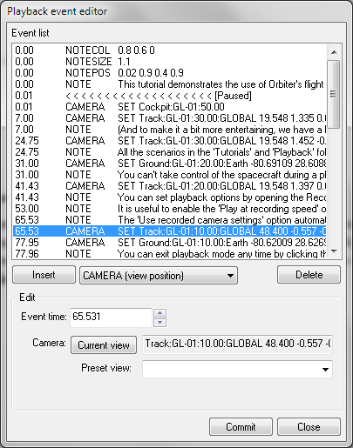
Events are always added at the current playback time (at the position of the <<<<< time marker). You can however later edit the time stamps of events to move them to a different position in the stream.
First, select an event type from the drop-down list below the event list. The most important event types have entries in the list. For less frequently used items, pick the <Other> option and enter the event tag manually. After selecting a type, press the Insert button.
A new event line will appear in the list, and the Edit area in the lower part of the dialog box will allow to set any required parameters for the event.

Editing an existing event
If you want to modify the parameters of an event already in the list, simply highlight it by clicking on a line in the list. The event parameters will appear in the Edit area, and you can modify them.

Deleting events
To delete an event, highlight it by clicking on a line in the list. Then press the Delete button.

Committing changes
To commit the changes you have made to the event list, press the Commit button at the bottom of the dialog box. This will save the modified event list in the playback file. Orbiter will immediately re-scan the file up to the current playback time so that any changes can be examined immediately.

Script interface
The Orbiter application contains an embedded script interpreter that allows users and developers to control a variety of simulation tasks with the help of scripts and commands. Scripts can be used to implement autopilot and MFD functions, interactive tutorials and flight instructors, mission control, and many others.
The script engine is based on the Lua scripting language (www.lua.org). A large number of functions and methods have been added to the default Lua command set to provide an interface to the Orbiter simulation environment. To a large extent the Lua-Orbiter interface replicates the Orbiter C++ API interface.
For script examples and a list of available functions, see the Orbiter Scripting User Manual section of the Orbiter inline help pages, available from the Help button in the Orbiter Launchpad or with h during a running simulation session. From a terminal (console window or Terminal MFD) the scripting documentation can be opened by typing help(api).
There are several methods available for accessing the script engine.

Console window
The console window can be opened during a running simulation to enter command or launch scripts controlling various aspects of spacecraft behaviour (see chapter 15.6). Make sure that the LuaConsole module is activated in the Modules tab of the Orbiter Launchpad. Open the console with the Lua console window option from the function list (▪).
The console is a simple text terminal. User input is shown in black, program responses are shown in green. The window can be resized. The font size can be adjusted under the Console configuration option in the Extras tab of the Orbiter Launchpad. The console allows simple command line editing and scrolling through the command history with the  key.

Terminal MFD
If the LuaMFD module has been activated in the Modules tab of the Orbiter Launchpad, an additional Terminal MFD mode is available in every spacecraft.
Commands can be entered by pressing the INP (input) button (◻i), typing the command, and pressing .
The MFD allows to open multiple command interpreters simultaneously. To open a new terminal page, press NEW (◻N). To switch between pages, press PG> (◻.) or <PG (◻,). To close a terminal page, press DEL (◻d).

Run a script on scenario launch
To run a script automatically when a scenario starts, the scenario file must contain the following line inside the ENVIRONMENT block:
SCRIPT <path>
where <path> is the path to the script file, relative to the Script subdirectory. Script files are text files. The file name should have the extension .lua, but the extension should not be added to the path specification. For example, if the script is located in file tutorial1.lua in directory Script\MyScripts under the Orbiter main directory, the entry in the scenario file would be
SCRIPT MyScripts/tutorials

Execute a command or script programmatically
For developers who want to access the script engine from within the C++ code of their plug-in module, an interpreter instance must be created with the oapiCreateInterpreter function. This returns a handle which can subsequently be used to issue commands with the oapiExecScriptCmd function. It is possible to execute individual commands or entire scripts via the run command.

Extra functionality
The standard Orbiter installation comes with a set of optional plug-in modules which can be used to enhance the core functionality of the simulator. To enable these additional functions, the appropriate modules must be loaded in the Modules tab of the Orbiter Launchpad dialog (see Chapter 4.4 on how to activate plug-in modules).
Many more plug-ins are available from 3rd party add-on developers. Check out the Orbiter repositories on the web to find more.
You should only activate modules you want to use during your simulation session, because many plug-ins may consume CPU cycles even if they are running in the background. Too many active modules can degrade the simulation performance.
When activated, some plug-ins, such as custom MFD modes, take effect automatically whenever the simulation is started. Others are accessible via the Custom functions dialog (see Chapter 6.8).

Scenario editor
Orbiter comes with an editor that allows creation, configuration and deletion of vessels from within a running simulation session, as well as adjustment of simulation time. The editor is provided as a plug-in module. To use it, make sure that the ScnEditor module is activated in the Modules tab of the Orbiter Launchpad dialog.
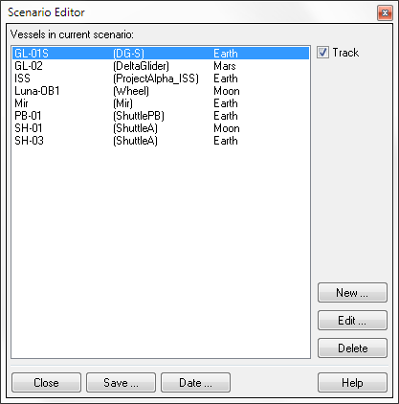
During the simulation the editor can be accessed by opening the Custom functions dialog with ▪ and double-clicking the Scenario Editor entry in the list. This brings up the editor’s main page. From here, you can either configure or delete any vessels currently present in the simulation, or create a new vessel.
The operation of the scenario editor is described in detail in a separate document: ScenarioEditor. This also contains a section for vessel add-on developers who want to add customised scenario editor support to their vessel code.

External MFDs
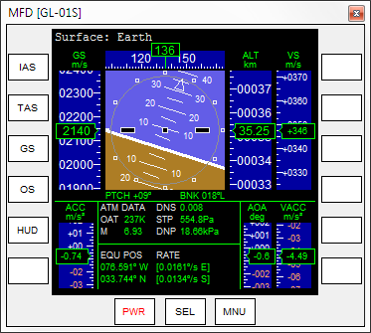
If the multifunctional displays (MFD) integrated in the vessel instrument panels do not provide enough information, you can open additional MFD displays in external windows. This is particularly useful in multi-monitor settings where you can display the Orbiter simulation window on one monitor, and a set of MFDs on the other.
To open external MFDs, the ExtMFD module must be activated in the Orbiter Launchpad dialog. You can then open any number of MFD windows by clicking External MFD from the Custom functions dialog (▪).
External MFDs behave in the same way as built-in MFDs. They can be controlled by pressing the buttons around the left, right and bottom edges. See Chapter 10 for a description of the available MFD modes and controls.
Unlike built-in MFD displays, the window MFDs can be resized. They are available in external view as well as cockpit view, and they can be configured to either automatically follow the focus vessel, or remain attached to a specific vessel, even if the focus is switched to a different vessel.

Performance meter
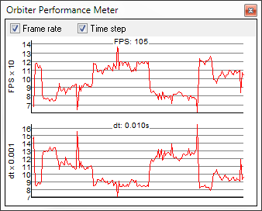
This is a dialog box to keep track of Orbiter’s frame rate performance and simulation time step intervals. It shows the frames per second (FPS) and/or the step length interval (in seconds) between consecutive frames in a graphical display over the last 200 seconds. This is a useful tool to estimate the impact of complex scenery and visual effects on the simulation performance. The time step graph also incorporates the effect of time acceleration, and thus reflects the fidelity of the physical model (accuracy of trajectory calculation, etc.)
This function is available if the Framerate module is active and is accessible via the Frame Rate entry in the Custom functions list (▪).

Remote vessel control
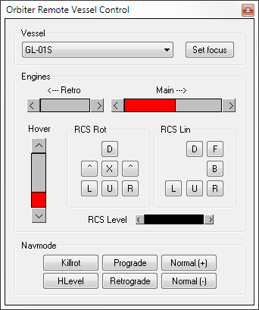
The Remote Vessel Control plug-in allows remote control of the engines of any spacecraft in the simulation.
The dialog allows selection of a vessel from a drop-down list. It contains gauges for main, retro and hover engines, controls for RCS thrusters in rotational and linear mode, and provides access to the standard attitude control functions. RCS thrust can be controlled with a slider. This interface can also be useful if simultaneous access to linear and rotational RCS modes is required.
This tool is available if the Rcontrol module is active and can be accessed via the Remote Vessel Control entry in the Custom functions list (▪).

Flight data monitor
The Flight data monitor graphically displays a number of flight parameters as a function of time. This tool is available if the FlightData module is active. The dialog box is accessible via the Custom functions list (▪).
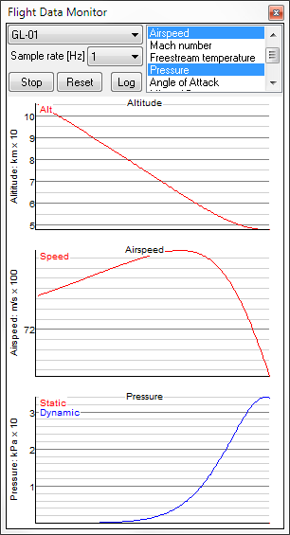
The control area of the dialog box allows selection of the vessel for which data are displayed, sampling rate, and the set of data to show.
The following parameter displays are supported:
- Altitude
- Airspeed
- Mach number
- Free stream temperature
- Static and dynamic pressure
- Angle of attack
- Lift and drag force
- Lift over drag ratio (L/D)
- Vessel mass
For each parameter category selected in the list, a graph display is opened below the control area to track that parameter as a function of time.
- The Start/Stop button starts or stops the update of the data graphs.
- The Reset button clears the data graphs.
- The Log button starts or stops the output of flight data to a log file. When the Log button is ticked, Orbiter writes out data into text file FlightData.log in the main Orbiter directory. This file can later be used to analyse or visualise the data with external tools. FlightData.log is overwritten whenever Orbiter is restarted.

Lua Console
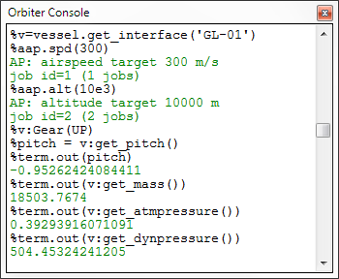
The Lua Console window is available from the Custom functions list (▪) if the LuaConsole module has been activated. The console provides an interactive script interface which allows script execution (tutorials, autopilots, etc.) and reading/writing of simulation and spacecraft parameters and states. The script interface and Orbiter Lua extensions are described in more detail in Chapter 14.

Flight checklists and challenges
This section contains point-by-point checklists for some complete flights. The scenarios for the checklist flights can be found under the Checklists folder in the Orbiter Launchpad dialog. While performing these missions, you may want to save regularly (▪S), so you can pick up from a previous state if necessary.
The checklists for these flights can also be accessed during the simulation by calling up help () and clicking the Scenario button in the help window. Other scenarios may also provide inline help.
The flight challenges (under the Challenges folder) consist of a set of missions that demand some skills in planning and navigation. You get a score depending on how well you completed the mission within the specified parameters.

Checklist mission 1: Delta-glider to ISS
In this mission we launch the Delta-glider spaceplane into orbit from runway 33 of the Shuttle Landing Facility (SLF) at Kennedy Space Center, and perform a rendezvous and docking maneuver with the International Space Station.
- Start Orbiter with the Checklists/DG to ISS scenario. Your glider is on the runway, ready for take-off.
- You may need to scroll the instrument panel down a bit (Cur) to see the runway in front of you. Make sure you can still see the top half of the panel with the MFD screens.
- Your launch is scheduled for MJD = 51983.6308 (the Modified Julian Date, or MJD, is Orbiter’s universal time reference, and is shown in the top right corner of the screen). This leaves plenty of time to get used to the instrumentation. If you are not yet familiar with the DG’s panel layout, check Chapter 8.1. For details on MFD modes see Chapter 10.
- The left MFD instrument is in Surface mode and shows velocity and altitude data during flight.
- The right MFD is in Map mode and shows your current location at KSC as a green cross, labelled GL-01. The orbital plane of the ISS is shown as a yellow curve. As time progresses and Earth rotates under the space station’s orbit plane, the curve will shift across the map.
- To fast-forward to your launch window, press t. (Each time you press t, time speeds up by a factor of 10.) As you approach launch time, switch back to real-time by pressing r until the ▸▸ indicator in the top right corner of the screen disappears.
- Launch when the space station’s orbital plane crosses your landing site (to zoom into the MFD map display, press the ZM+ button (◻z).
- Engage main engines at 100% thrust: Press and hold +Num, then ▪ to lock thrust setting. You may also use the sliders in the instrument panel or the throttle control on your joystick to operate the main engines.
- At ground speed 150 m/s (Surface MFD or HUD readout), pull the stick (or press 2Num) to rotate.
- Climb at 10° and retract the landing gear (g).
- Turn right towards a heading of 140°.
- Pitch up steeply to 70°. We want to climb quickly out of the dense lower part of the atmosphere to avoid friction losses and excessive hull heating as we build up speed.
- At about 30 km altitude the glider will start to drop its nose due to decreasing atmospheric pressure, even while pulling back on the stick. Activate the RCS (Reaction Control System) by clicking the right part of the RCS Mode selector dial (on the right side of the instrument panel) or by pressing ▪/Num. You are now controlling your craft with attitude thrusters.
- Pitch down to about 20°. At this point we need to start gaining tangential velocity to achieve orbit. Your flight path indicator (the ⊕ symbol in the HUD) should stay above 0°.
- Switch the right MFD to Orbit mode (◻+◻o). Select the ship’s orbit as reference plane (◻p) and select the ISS as target (◻t, , ‘ISS’, ).
- Continue at 100% main thrust and maintain your heading. Adjust pitch angle so that the flight path vector remains slightly above 0°. As the horizontal component of your velocity vector increases, the orbit trajectory (green curve in the Orbit MFD) starts growing.
- Cut engines when the apogee radius (highest point of the orbit) reaches 6.731M (the ApR entry in the left column of the Orbit MFD). This corresponds to an altitude of 360 km.
- Switch to Orbit HUD mode (h+h, or press the HUD button in the Orbit MFD).
- At the moment we are on a ballistic flight path that would eventually bring us back to the surface. To enter orbit we need to perform a further burn (orbit insertion burn) at the apex of the trajectory. Wait until you reach apogee (the remaining time is shown as ApT in the Orbit MFD). This could take a while, so you may want to time-accelerate.
- At apogee, press the PRO-G button (shortcut: [) to activate the prograde attitude mode. One the velocity marker (⊕) is centered in the HUD, engage main thrusters until orbit eccentricity (Ecc value in Orbit MFD) reaches a minimum, and perigee radius (PeR) approximately equals ApR. This will require only a short burn!
- Switch the left MFD to Plane Alignment mode (◻+◻A). Select ISS as target (◻t, , ‘ISS’, ).
- Your orbital plane should already roughly match that of the ISS (RInc ≤ 5°), thanks to the chosen launch time and azimuth. We now need to fine-adjust the plane.
- As your ship (P) approaches the intersection point (node) with the target plane (AN or DN): Rotate the ship perpendicular to your current orbital plane (90° on the Orbit HUD inclination ladder). If you are approaching the ascending node (AN), turn orbit-antinormal (the NML− attitude mode button, shortcut ). If you are approaching the descending node (DN), turn orbit-normal (the NML+ attitude mode button, shortcut ;).
- As soon at the time-to-burn (TtB) counter for the node has reached zero and the [BURN] indicator appears, fire the main engines at 100% for the indicated burn time (BT). The relative inclination (RInc) between the current and target planes should now decrease.
- Cut engines when the BT counter reaches zero and the [BURN] indicator is turned off. If the planes were not sufficiently aligned in this maneuver (RInc within ~0.5°), repeat the process at the next node crossing.
- Once the planes are aligned, the next step is intersecting the ISS. Switch to Sync Orbit MFD mode (◻+◻y). Select ISS as target (◻t, , ‘ISS’, ), and switch the reference point to Intersect 1 or Intersect 2 (◻m). If the orbits don’t intersect, select Sh periapsis instead.
- The two columns on the right of the MFD display show the times it will take you (Sh-ToR) and your target (Tg-ToR) to pass the reference position during your current orbit (Ob 0) and the 4 subsequent orbits (Ob 1-4).
- Turn the ship prograde (PRO-G button, [), so that orbital velocity indicator (⊕) is centered in the HUD.
- Fire main engines until Sh-ToR(0) matches Tg-ToR(1). You will now intercept the ISS at your next passage of the reference point. You may want to engage time acceleration until the time-to-reference counters are close to zero, indicating that you are approaching the encounter point.
- On approach, tune your NAV receivers to the station’s navigation radio transmitters: Select NAV/COM MFD mode (◻+◻c), and tune NAV1 to 131.30 MHz (ISS XPDR frequency) and NAV2 to 137.40 MHz (Dock 1 IDS frequency).
- Switch to Docking MFD mode (◻+◻d). Make sure that the display is fed from the NAV1 receiver. (Use ◻n to cycle through the receiver inputs until NAV1 is selected.)
- Copy docking information to the HUD (◻h).
- In Docking mode, the ⊕ HUD symbol indicates your velocity vector relative to the target, and ⊙ indicates the opposite direction. Rotate the ship to center the ⊙ marker in the HUD and fire main engines until the relative velocity (−V[ISS]) is close to zero.
- Rotate the ship to point towards the ISS ( target designator box) and move to within 5 km of the station. You may want to use attitude thrusters in linear (translational) mode for this. Switch between linear and rotational mode with the /Num key.
- Switch the Docking MFD feed to NAV2 (◻n) and route the data to the HUD (◻h). Once you are within range of the IDS (Instrument Docking System) transmitter (~10 km), you will receive docking approach data for docking port 1, providing alignment information on the MFD display and a visual representation (a series of rectangles) mapping a virtual approach path on the HUD.
- Maneuver your ship to the rectangle furthest away from the station, using RCS, and hold relative position.
- Align your ship’s longitudinal axis with the approach path direction: In the MFD display, center the “×” indicator in the aiming reticle, using RCS thrusters in rotational mode.
- Align your ship’s bank angle with the docking port by rotating around its longitudinal axis: In the aiming reticle of the MFD display, make sure that the bank indicator (“^”) is pointing to the 12 o’clock position.
- Center the ship on the approach path: Using RCS in linear mode, center the “” indicator in the aiming reticle.
- Expose the docking mechanism under the nose cone by pressing k.
- Start moving towards the dock with a short burst of the main engines. Closing speed (CVel) should be gradually reduced as you approach the dock. Final speed should be < 0.1 m/s. Re-align the ship on the approach path with linear RCS as required.
- The docking mechanism will engage automatically on contact. A DOCK indicator appears in the MFD when a secure docking connection has been established.
- Mission completed!
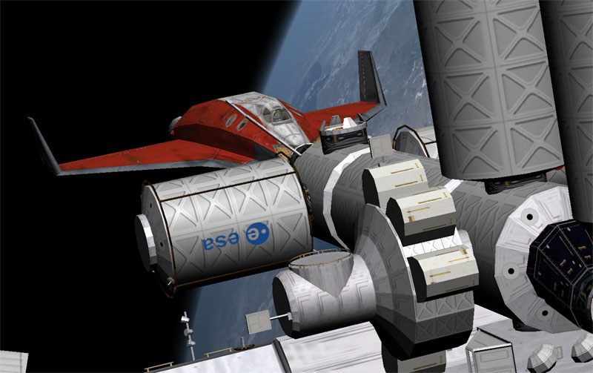
Checklist mission 1 completed successfully.

Checklist mission 2: ISS to Mir transfer
This mission consists of an orbital transfer from the International Space Station to the Russian Mir station (which in Orbiter’s virtual reality is still happily orbiting Earth). Note that in Orbiter, Mir is placed in an ecliptic orbit to make it a platform for interplanetary missions. This means that ISS and Mir have a very high relative inclination which makes the transfer expensive in terms of fuel expenditure.
- Launch Orbiter with the Checklists/ISS to Mir scenario. The mission starts with your glider docked at the ISS.
- Press  to jump into the glider’s cockpit.
- Select target Mir in the Orbit MFD: Press Right-◻t, , “mir”.
- To prepare for the high inclination orbit change, select the Align plane mode in the left MFD: Left-◻+◻a, followed by ◻t+, “mir”.
- Undock from the ISS (▪d). Once clear of the dock, close the nose cone (k).
- Switch to Orbit HUD mode (h).
- The first burn will take place at the DN (descending node) point. Use time compression to fast-forward there, but switch back to real-time when the “time-to-node” (TtN) value in the Align planes MFD is down to 500.
- Rotate the ship to the correct attitude for the burn: Click the Orbit-normal (NML+) button. Wait until the glider has oriented itself perpendicular to the orbital plane (90° on the orbit inclination ladder).
- When the time-to-burn (TtB) counter for DN in the MFD display has counted down to 0, the [BURN] indicator will appear. Engage full main engines. The relative orbit inclination (RInc) should start to drop. Kill engines when the relative inclination reaches a minimum and the burn indicator disappears.
- This is a very long burn (about 900 s), so you may want to fast-forward, but do not miss the end of the burn!
- You probably won’t be able to sufficiently reduce the relative inclination (to less than ~0.5°) in a single burn. Repeat the process at the next node passage (at AN, ascending node). Remember that the glider must be oriented in the opposite direction for this burn, by activating the orbit-antinormal (NML−) attitude function.
- Once the orbital planes are sufficiently aligned, you need to plot a rendezvous trajectory using the Sync Orbit MFD mode. The procedure is the same as in the previous mission.
- Tune your NAV1 receiver to Mir’s transponder frequency of 132.10 MHz, and NAV2 to the IDS frequency of docking port 1 at 135.00 MHz.
- When the sync maneuver is complete, switch one of the MFD instruments to Docking mode (◻+◻d) and make sure that NAV1 is selected for data input. Copy the setting to the HUD (◻h).
- Proceed with the docking maneuver to Mir in the same way as the ISS approach in the previous mission. Do not forget to open the nose cone before making contact.
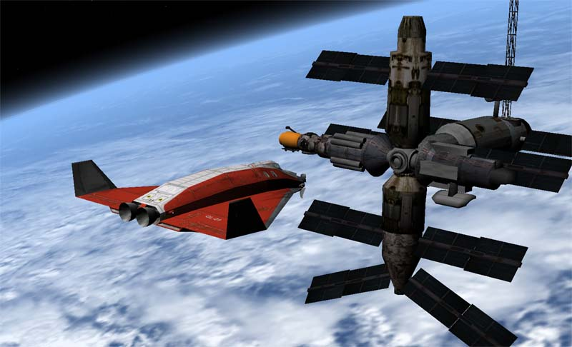
Advanced version: The long burn required for the plane change in this mission used up a lot of fuel. Try to find a more efficient way to perform this maneuver. Hint: The rotation of the orbital plane requires less Delta-V if the orbital velocity is lower. Can you perform an in-plane orbit change that will bring down the velocity to set up the plane rotation (and still requires less Delta-V in total than the direct rotation)?
Docking approach to Mir space station.

Checklist mission 3: De-orbit from Mir
This mission completes your orbital roundtrip with a re-entry to return to Kennedy Space Center.
- Launch Orbiter with the Checklists/Deorbit scenario. This picks up where the previous mission ended, with the glider docked to the Mir station. You are currently over the Pacific ocean, already in the correct location for the de-orbit burn.
- Undock (▪d) and wait for sufficient clearance from the station. You can use your retro engines (-_{Num}) to increase separation velocity after reaching a safe distance.
- Close the nose cone (k).
- Turn retrograde (]).
- When the glider’s attitude has stabilised and the retrograde direction is no longer obstructed by the station, engage main engines at 100% thrust.
- Cut engines when the perigee radius (PeR in Orbit MFD) has decreased to 5.600M.
- Turn prograde ([).
- When attitude has stabilised, roll the glider level with the horizon (l).
- Switch to Surface HUD mode (h).
- Switch the left MFD instrument to Surface mode (◻+◻D).
- You should reach 100 km altitude about 4000 km from the target (Dst: 4000M in the bottom line of the Map MFD). At this stage, aerodynamic forces will become noticeable.
- At 50 km altitude, turn off attitude stabilisation (l), disable the RCS (▪/Num) and make sure that attitude commands are routed to airfoils (AF CTRL dial is set to ON).
- Lift forces now cause the glider to pitch up. To bleed off kinetic energy, perform left and right banks and pull the stick to put the glider into a high-AOA attitude. Due to the relatively high lift/drag ratio of the glider you need very steep bank angles (90°) to avoid reducing your descent rate in these maneuvers.
- The bank meneuvers can also be used to increase the cross-range of your flight path. Your initial trajectory passes south of the KSC, so use left bank to correct the approach path (check Map MFD).
- The bank angle determines your rate of descent and airspeed. If you come up short of the target, reduce the bank angle to slow your descent and reduce atmospheric deceleration. If you come in too fast or too high, increase the bank angles to increase the descent slope and atmospheric friction.
- Timing of the reentry path is not quite as critical as for the Space Shuttle, because the glider can use its engines for a powered approach.
- When the distance to target drops below 500 km, tune your NAV1 receiver to frequency 112.70 (KSCX VOR) and NAV2 to frequency 134.20 (Rwy 33 ILS) using the NAV/COM MFD mode (◻+◻c).
- Switch an MFD to Horizontal Situation Indicator (HSI) mode (◻+◻h). Leave the left HSI dial feed on NAV1, and flip the right dial to NAV2 (◻f+◻n).
- Use the left dial for initial approach to KSC. Once in range of the ILS transmitter, use the course deviation and glide slope indicators on the right dial to line up your approach path to SLF runway 33. The HSI dials work like standard aircraft instruments.
- Deploy airbrakes as required (b to deploy by ½ step, ▪b to retract by ½ step). Lower landing gear at airspeed < 300 m/s. Touchdown speed is 200 m/s.
- After touchdown, deploy airbrakes fully (b+b). Use wheelbrakes at ground speed < 100 m/s (. and , simultaneously), until you come to a halt.
- Welcome back to Earth, commander!
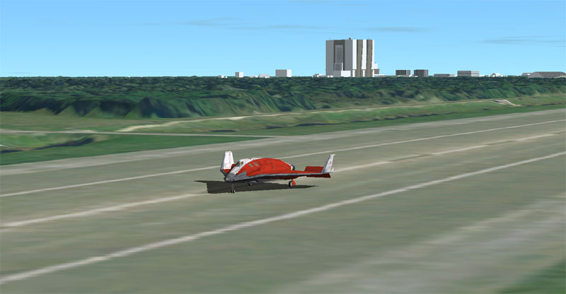
DG wheelstop at KSC SLF runway 33 after a successful return from orbit.

Challenge missions
The flight scenarios under the Challenges folder put your flight skills to the test with missions that need to be completed with limited resources or by minimising fuel consumption. After completion of each mission, you get a score on how well the mission criteria were fulfilled. The available challenges are
- Challenge 1: Launch and docking. Launch the Delta-glider into orbit from the runway at Kennedy Space Center and dock with the ISS. Minimise fuel consumption (consider your launch window, launch azimuth, ascent profile, in-orbit maneuvers). The score after completing the mission will reflect fuel expenditure.
- Challenge 2: Lunar transfer. From low Earth orbit, perform a trans-lunar injection maneuver in your Delta-glider. On arriving at the Moon, enter a lunar orbit, and rendezvous and dock with the rotating wheel station. Again, the task is to minimise fuel consumption, so plan your engine burns carefully.
- Challenge 3: Advanced lunar transfer. This is similar to the previous challenge, but this time you start out-of-plane of the Moon’s orbit, so you will have to consider an initial plane alignment, or an out-of-plane lunar transfer. The latter is trickier to plan, but may save on Delta-V, resulting in a higher score.
- Challenge 4: Entry and landing. This scenario starts in a high Earth orbit. The objective is to deorbit and land at Kennedy Space Center. The problem: your main and RCS fuel levels are very low, and you are not allowed to refuel during the mission. Plan your deorbit burn and descent profile carefully! If the landing succeeds, the score rewards any fuel left over.

The solar system neighbourhood
Orbiter’s playground is our solar system. The basic installation includes its major bodies (the Sun and planets) and a subset of minor bodies (moons and asteroids), providing a variety of mission targets. Planning and executing a trip that is efficient both in duration and fuel consumption offers different challenge levels. Additional objects may be downloaded as add-ons.
Sun
Mercury
Venus
Earth
Mars
Jupiter
Saturn
Uranus
Neptune
Asteroid
belt
Terrestrial planets
Gas giants
Ice giants
Kuiper belt

Solar system bodies

The Sun
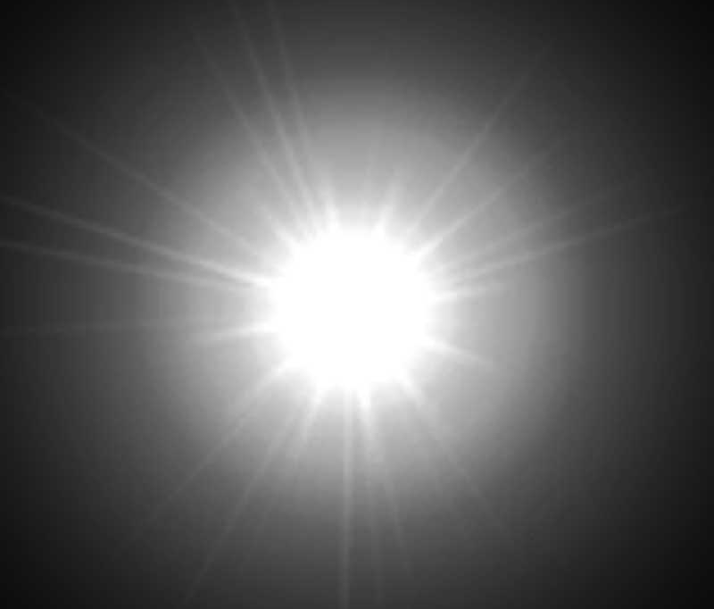 | The Sun is a type G2 main sequence star at the centre of our solar system, formed approximately 4.6 billion years ago from a gravitationally collapsing interstellar gas cloud. It comprises nearly the entire mass of the solar system and emits a large amount of electromagnetic energy generated by nuclear fusion in its core. In another 5 billion years the hydrogen fuel will be exhausted and the Sun will expand into a red giant, losing a significant amount of its mass, before the remaining core, a white dwarf, will slowly cool down over trillions of years.

Mercury
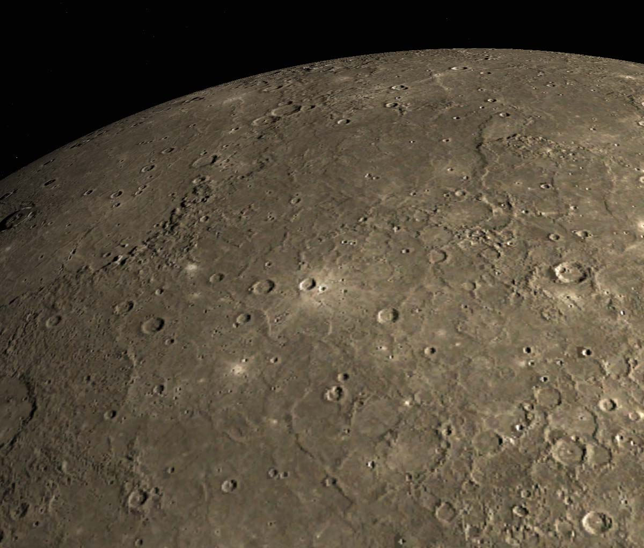 | Mercury is one of the four terrestrial (rocky) inner planets of the solar system. Its orbit is the closest to the Sun and the most eccentric of all planets.  Mercury has no significant atmosphere, and its slow rotation (it is tidally locked with the Sun in in a 3:2 spin-orbit resonance) results in a large variation between day and night surface temperatures. The surface is heavily cratered and similar in appearance to Earth’s Moon.  Mercury’s visual representation in Orbiter is based on images from the Messenger mission.

Venus
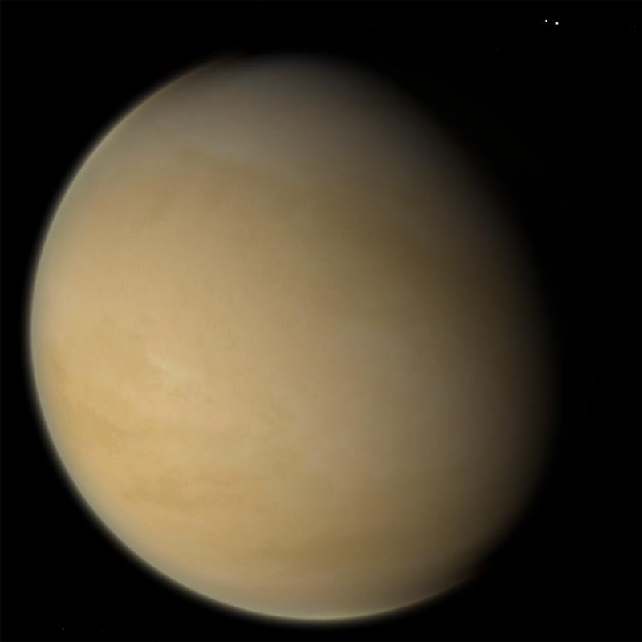 | Venus is the second planet from the Sun, and similar in mass and size to Earth. It has a very dense atmosphere of mainly carbon dioxide that completely obscures the surface at visible wavelengths and results in a high albedo. The extreme surface pressure and temperatures pose severe challenges for surface-bound missions.  In Orbiter, the surface representation of Venus is based on the synthetic aperture radar data from the Magellan mission, while the cloud layer is derived from a map by Björn Jónsson.

Earth
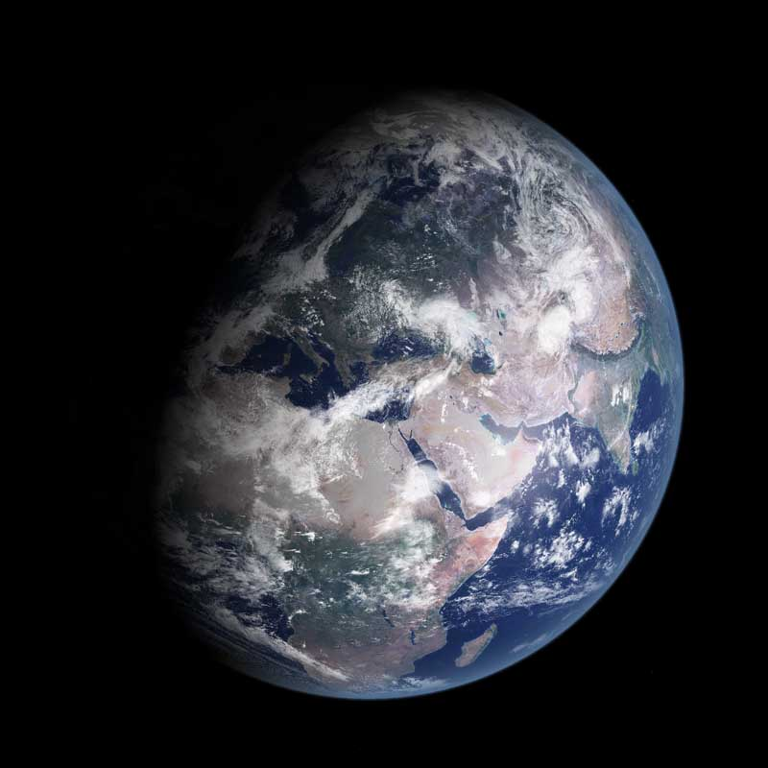 | The home planet. Earth is the only place we know to date for life to have evolved. Its distance from the sun, atmospheric conditions and internal heating allow for liquid water to exist in large quantities, forming its oceans. Its atmospheric layer, as well as its magnetic field, protect the surface from harmful radiation. The biosphere (the sections of surface, lower atmosphere and oceans containing life) is a self-regulating system whose balance may be threatened by human activity (pollution, release of greenhouse gases).  The Moon is Earth’s natural satellite. It has no significant atmosphere, and its surface is characterised by impact craters. The Earth-Moon system is unusual in the solar system for the relatively large size of the Moon compared to the planet it orbits, and may have an influence on stabilising Earth’s spin axis.  In Orbiter, Earth’s surface textures have been custom processed from Landsat-7 ETM orthorectified scenes, augmented by aerial imagery for selected areas. Elevations are from NASA SRTM 90m Digital elevation data. Moon surface textures were generated from LRO LRO-WAC Global Mosaic 100m, elevations from LOLA-GDR/Cylindrical
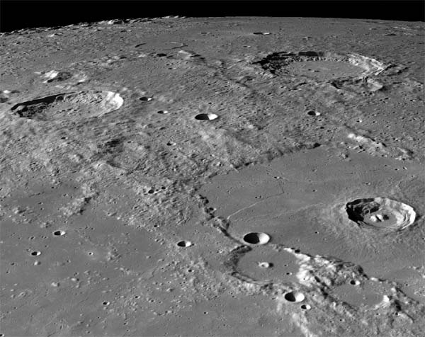
Moon
Moon

Mars
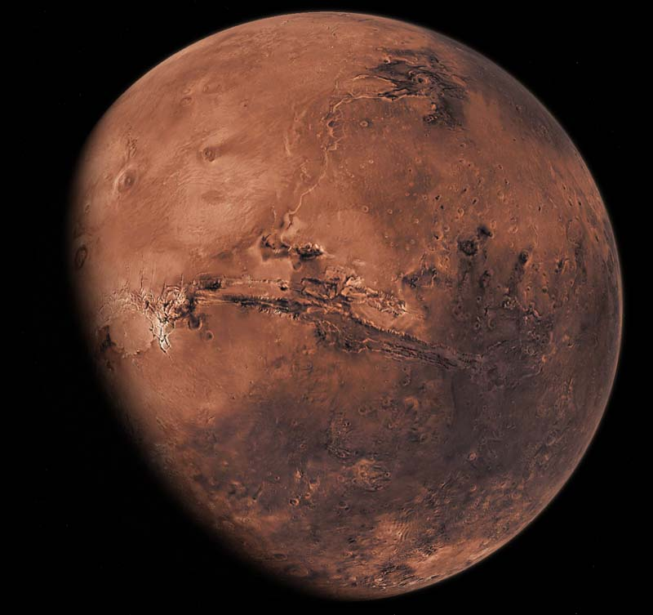 | Mars is smaller than Earth (about 1/10 of its mass) with a very thin atmosphere predominantly consisting of carbon dioxide, which nevertheless can produce extensive dust storms that sometimes cover the entire surface. Geological features include Valles Marineris, a 3000 km long network of canyons, and Olympus Mons, the largest shield volcano in the solar system. The polar caps are mainly composed of solid carbon dioxide with small quantities of water ice. Mars has two small irregularly shaped moons, Phobos and Deimos. There have been numerous unmanned missions to Mars, including several rovers to explore the surface.  The Mars surface textures and elevation data in Orbiter are composed from ESA Mars Express High Resolution Stereo Camera (HRSC) imagery, with missing areas filled from NASA MOC (surface) and MOLA (elevation) data.
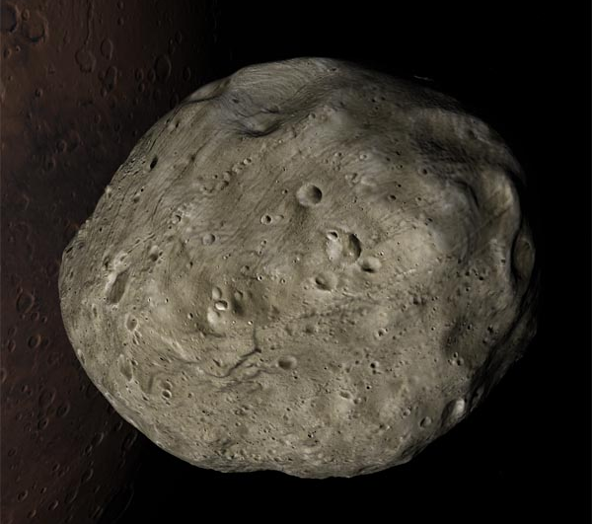
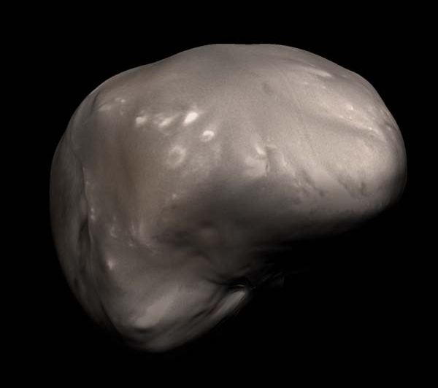
Phobos
Deimos

Vesta (asteroid belt object)
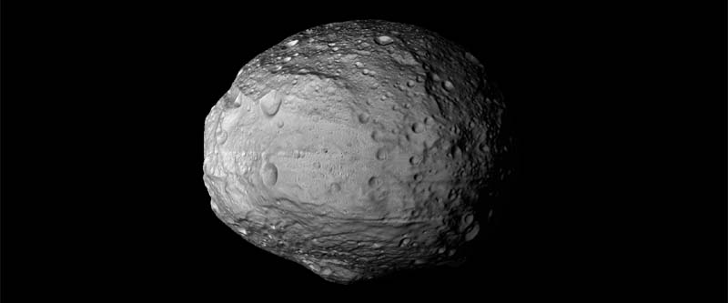 | Vesta is the second-largest asteroid belt object after Ceres. It was visited by the NASA Dawn spacecraft in 2011.  Surface and elevation data for Orbiter are derived from Dawn HAMO mosaics.

Jupiter
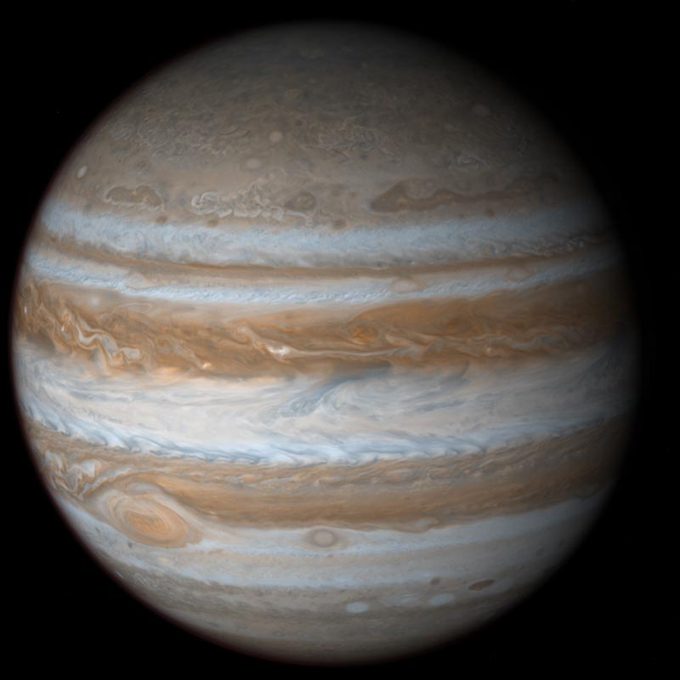 | Jupiter is the 5th planet from the Sun, and the innermost of the gas giants. It is the most massive of the planets in the solar system. Its mass allowed it to retain the lighter elements; it is mainly composed of hydrogen and helium, but probably has a core of heavier elements. Jupiter’s atmosphere has a characteristic band structure. Its most prominent feature is the Great Red Spot, an anticyclonic storm that has persisted for centuries.  Jupiter has a faint ring system and is orbited by at least 80 moons, four of which (the Galilean moons, so called because they were discovered by Galieo Galilei in 1610) are modelled in Orbiter.  Jupiter and its moons have been visited by several robotic missions, starting with Pioneer 10 and including the Voyager probes, Cassini (en-route to Saturn) and New Horizons.  In Orbiter, Jupiter visuals are based on Cassini image data (NASA/JPL/Space Science Institute), with cloud maps by Rolf Keibel based on CICLOPS maps.  The Galilean moon maps are based on Galileo/SSI/Voyager mosaics (Astrogeology Science Center, USGS), with Io elevations based on O. L. White et al., J. Geophys. Res.: Planets 119(6), 1276-1301 (2014)
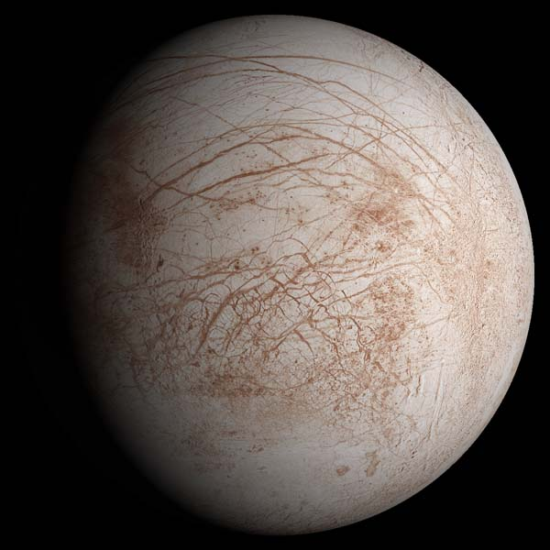
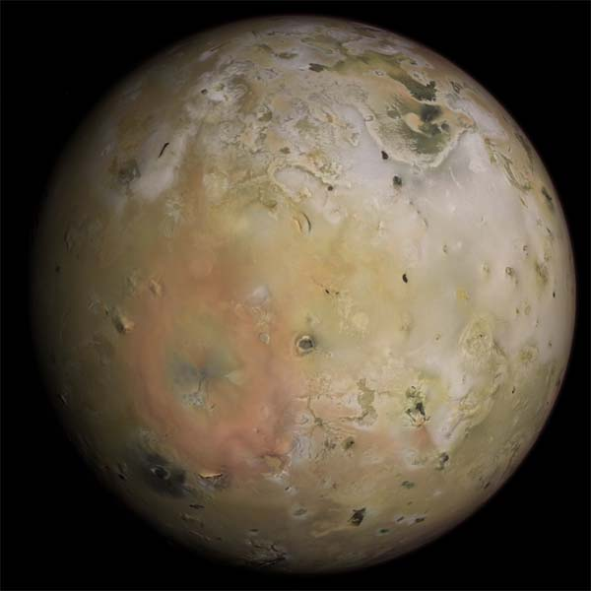
Io
Europa
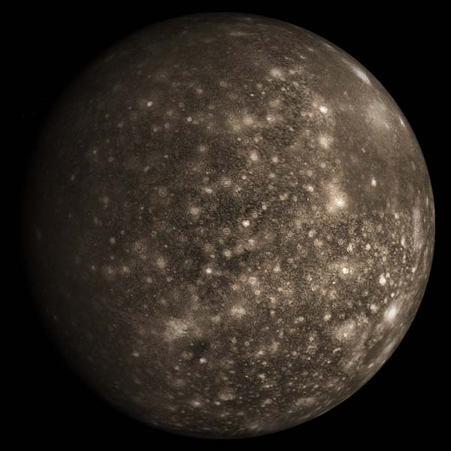
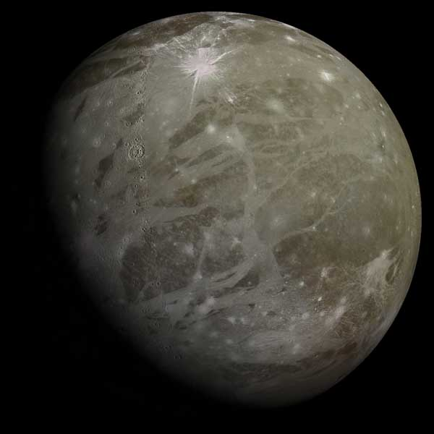
Ganymede
Callisto

Saturn
Io
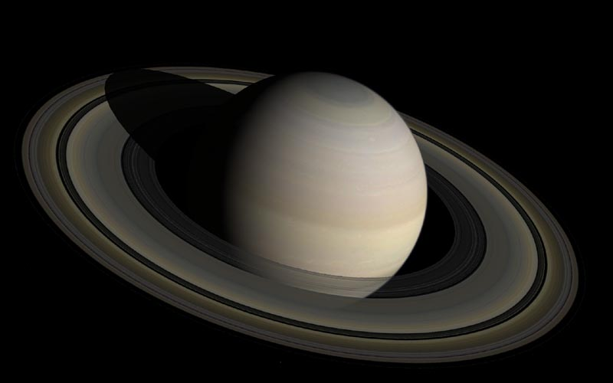 | Saturn is one of the gas giants and the second-largest planet in the solar system. Like Jupiter, it is composed predominantly of hydrogen and helium. Saturn’s most striking feature is the ring system in the equatorial plane, composed mostly of water ice particles and stretching out from about 1.1 to 3 planet radii, with a thickness of about 20 km.  Saturn has 83 known moons, not counting a large number of moonlets in the rings. Titan is of comparable size to Mercury and the only moon in the solar system with a substantial atmosphere. There is complex gravitational interaction between the moons and rings, with shepherd moons clearing gaps and keeping rings contained, as well as causing ripples in the ring structure.  Saturn’s surface and rings in Orbiter are based on maps by Björn Jónsson, adapted by Rolf Keibel. The moon surfaces based on NASA/JPL-Caltech/SSI/Lunar and Planetary Institute, Cassini Central Laboratory for Operations. Titan elevation data P. Corlies et al, Geophysical Research Letters 44(23), 11754-11761 (2017)
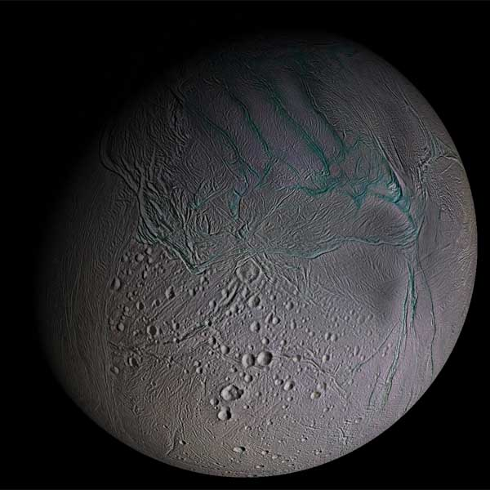
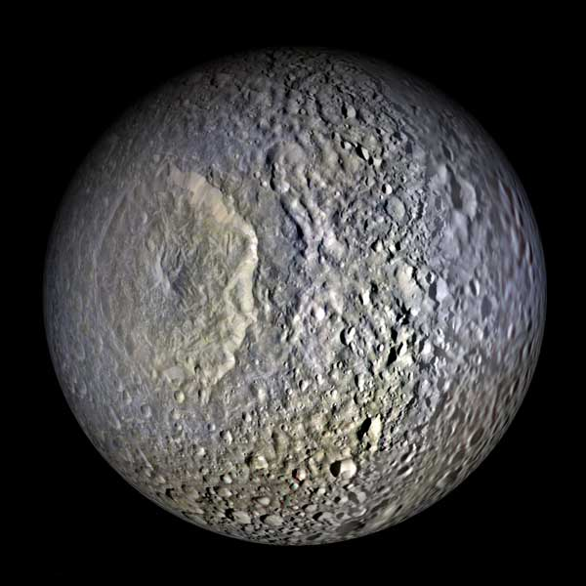
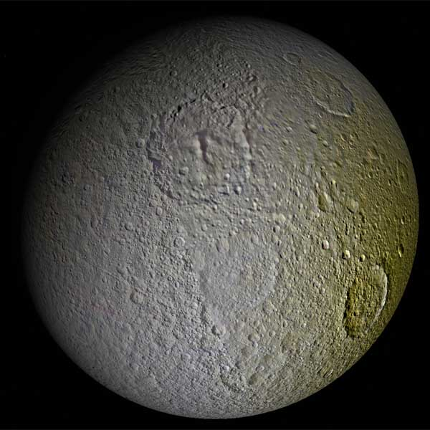
Mimas
Enceladus
Tethys
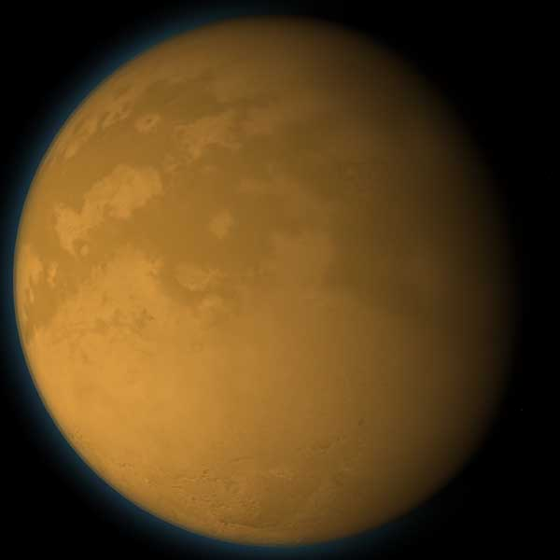
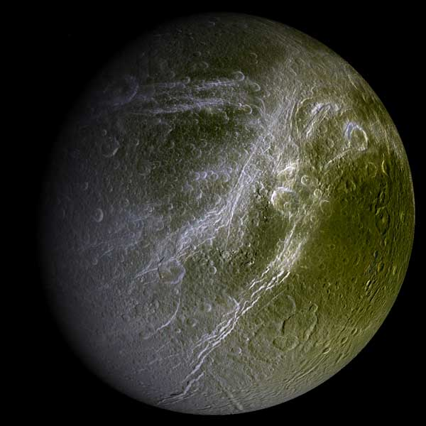
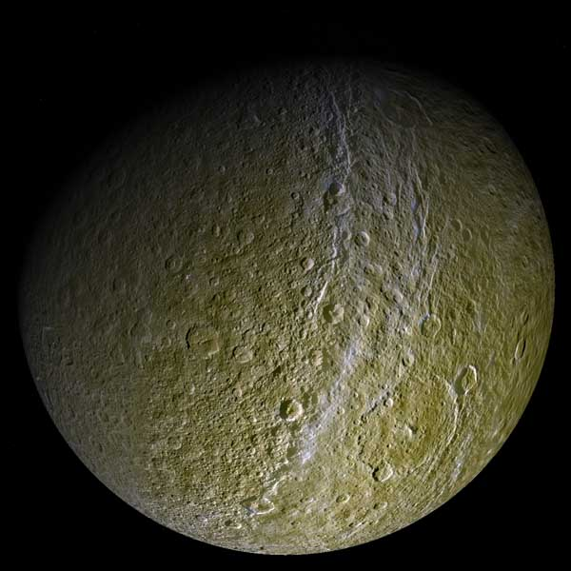
Dione
Rhea
Titan
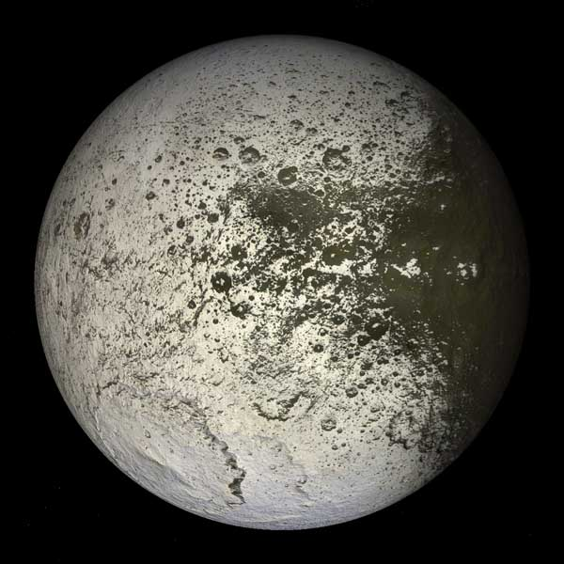
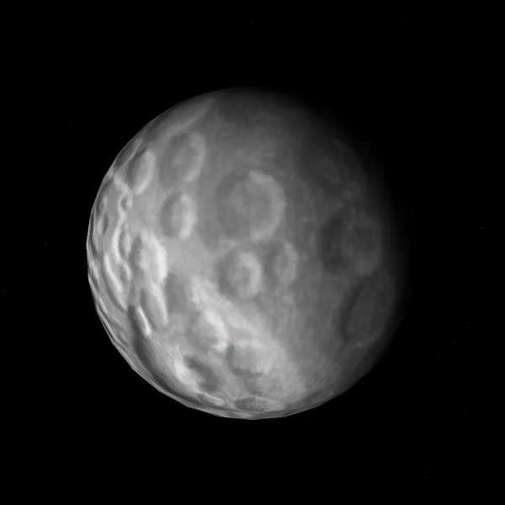
Hyperion
Iapetus

Uranus
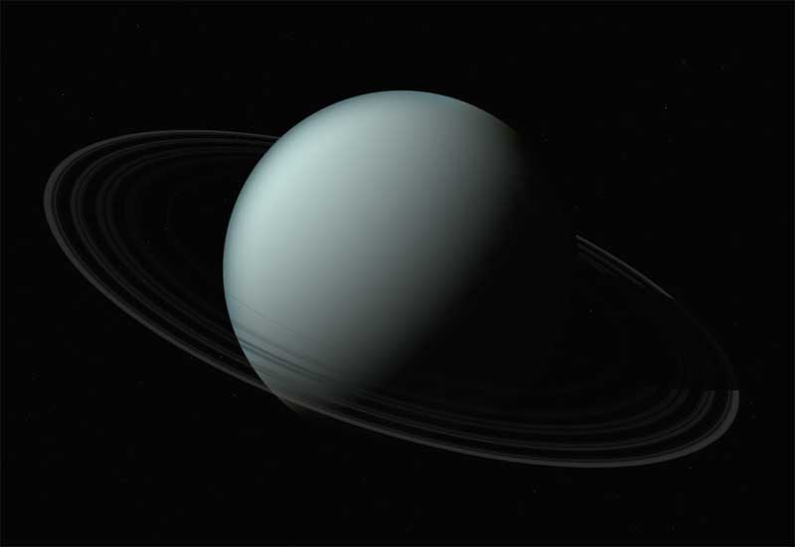 | Uranus is the seventh planet from the Sun, third-largest by radius and fourth by mass. Its chemical composition is similar to Neptune, containing a solid core of silicate and iron-nickel, a mantle of water/ammonia/methane ice and a hydrogen/helium atmosphere.  The planet produces little internal heat and emits virtually no excess energy, making it the coldest planet in the solar system.  Uranus has a ring system consisting of very dark particles and is orbited by at least 27 moons, the main 5 of which are modelled in Orbiter.  Uranus textures are based on maps by James Hastings-Trew, adapted for Orbiter by Rolf Keibel. The moon textures are based on maps by Robert Stettner and Voyager images adapted by Rolf Keibel.
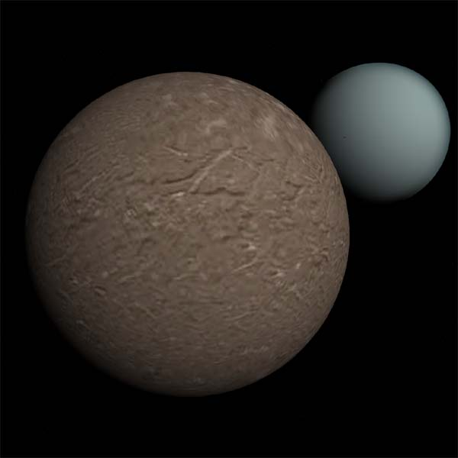
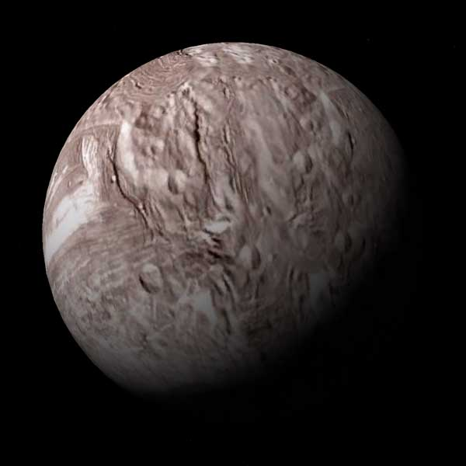
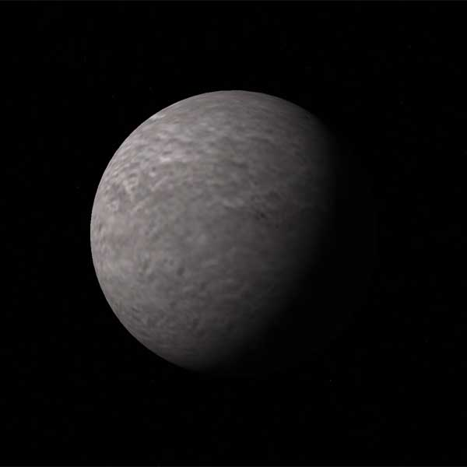
Miranda
Ariel
Umbriel
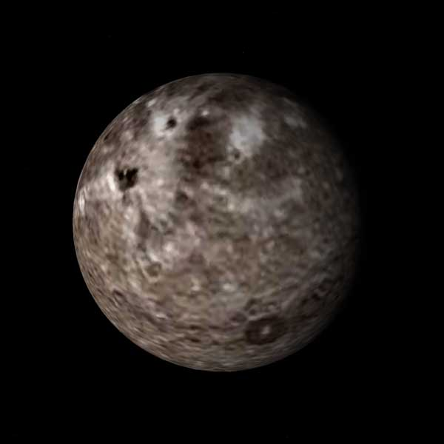
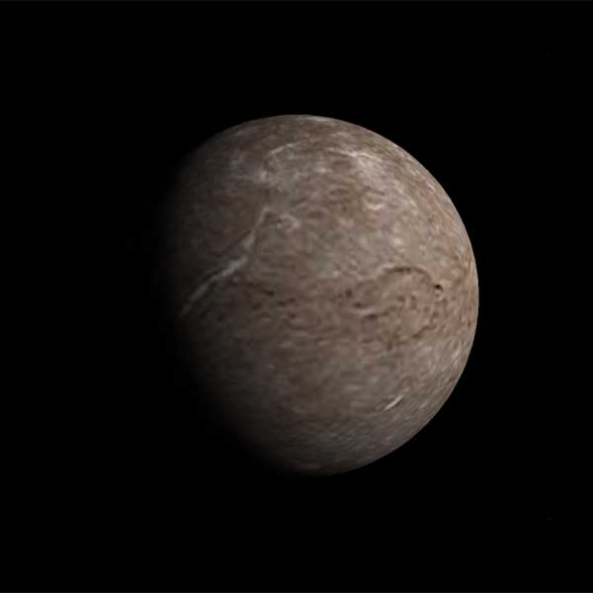
Titania
Oberon

Neptune
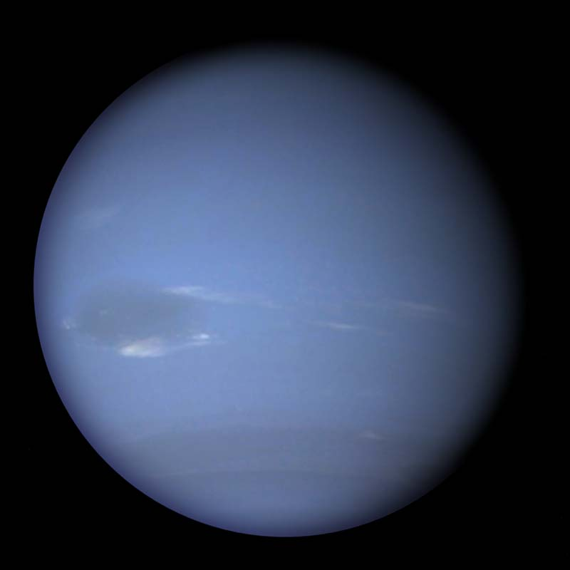 | Neptune is the farthest planet from the Sun. It is one of the ice giants, and similar in size and composition to Uranus, with a solid rocky core, a mantle of water, ammonia and methane ice, and an atmosphere of hydrogen, helium and methane. The atmosphere frequently features storm systems, visible as dark spots, which can persist for several months and are often accompanied by bright clouds higher up in the atmosphere.  Neptune has 14 known moons. It also exerts a gravitational influence on the Kuiper belt objects in the region beyond its orbit, including Pluto which orbits in a 2:3 resonance with Neptune.  Orbiter’s Neptune textures based on a map by James Hastings-Trew, moons by Robert Stettner, from Planetary Mean Orbital Parameters and Moon Maps.
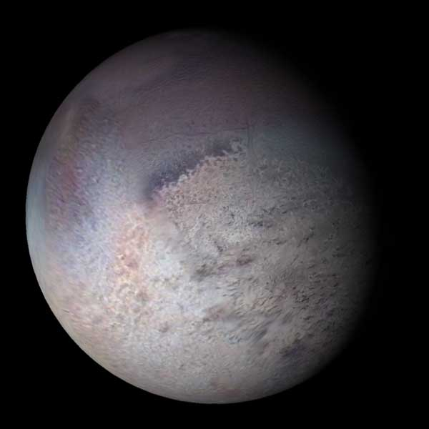
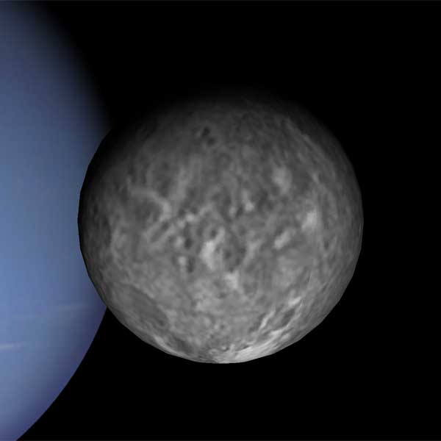
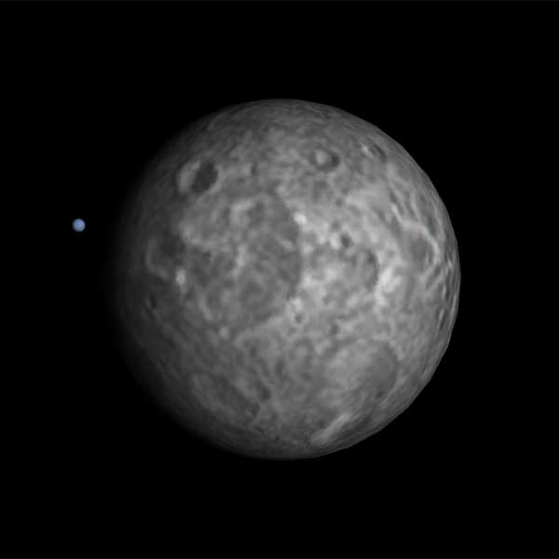
Triton
Proteus
Nereid

Orbital mechanics primer
Knowing the underlying physics may not be required to fly a spacecraft (after all, you can drive a car without in-depth knowledge of internal combustion – or electromagnetic induction, depending on when you are reading this), but understanding the laws governing the movement of your craft should provide some additional intellectual satisfaction, or (if that doesn’t appeal), may even one day help you get out of an unexpected emergency situation.

Kepler’s laws of planetary motion
Johannes Kepler published his three laws of planetary motion in his books Astronomica Nova (1609), and Harmonica Mundi (1619), refining the Kopernican heliocentric model by dropping the assumption of circular orbits, thereby reconciling the theory with observational data.
Kepler’s first law: A planet orbits the Sun in an ellipse, with the Sun at one of the foci.
Kepler’s second law: A straight line from the Sun to the planet sweeps out equal areas in equal time intervals.
Kepler’s third law: The ratio of the square of a planet’s orbital period with the cube of its semi-major axis is the same for all planets orbiting the Sun.

Elliptic orbits
An ellipse is a special case of a conic section (the intersection of the surface of a cone with a plane). The equation of a conic section with the origin in one focus (F) is given in polar coordinates (r, ν) by
F
A
B
C
a
b
p
S
ν
r

with parameters e (eccentricity) and p (semi-latus rectum). An ellipse is characterised by eccentricity 0 ≤ e < 1 (where a circle, e = 0, is taken as the bounding case for an ellipse). The shape of the ellipse is commonly defined by the two parameters e and a (semi-major axis, the longest semi-diameter), given by

Secondary shape parameters can be derived, including the semi-minor axis (shortest semi-diameter) b

periapsis distance FA (where periapsis A is the point on the ellipse closest to the focus)

and apoapsis distance FB (where apoapsis B is the point on the ellipse farthest from the focus)

Kepler’s laws successfully described the motion of celestial bodies in accordance with the observations, but they didn’t provide a reason (the underlying forces) for this motion. This was provided a few decades later by Isaac Newton.

Newton’s laws of motion
Newtonian mechanics provides the general framework for describing the motion not only of celestial bodies, but all objects according to their mass (including falling apples). More than three centuries later, Newtonian dynamics is still an appropriate tool for describing the dynamics of a system of bodies for most practical situations (such as those encountered in Orbiter), where the difference to predictions from general relativity (today’s accepted best theory at large scales) are negligible.
Newton’s first law (law of inertia): An object on which no external force is acting remains at rest or continues moving at a constant velocity.
Newton’s second law: An object experiences an acceleration that is proportional (and in the same direction) as the sum of all forces acting on it, and inversely proportional to its mass.

Newton’s third law: For every action (force of an object 1 on another object 2) there is an equal and opposite reaction from 2 on 1:

Newton’s law of gravitation
Newton introduced the notion of a universal attractive force that works between any two objects. The magnitude of this force is proportional to the object masses m1 and m2, and inversely proportional to the square of their distance r12:

where proportionality factor G is the universal gravitational constant. The direction of the forces is along the straight line from one object to the other:

where is the unit vector pointing from object 1 to 2.
It is possible to derive Kepler’s laws from Newton’s laws of motion and gravity. This derivation can be found in most textbooks on astrophysics. It requires some calculus (which was developed by Newton for exactly this purpose, in parallel with the work of Gottfried Leibnitz). Expressing Kepler’s laws in terms of Newtonian dynamics leads to some useful orbital parameters:
The orbital period of an object orbiting a body with mass M is given by

with standard gravitational parameter .
The orbital speed v as a function of radius r is

Maximum and minimum speed occur at periapsis and apoapsis, respectively:

and the mean orbital speed is

with mean angular motion .
The specific orbital energy (or vis-viva energy) E is the sum of potential energy Ep and kinetic energy Ek of an orbiting body. E is constant along the orbit.

where h is the specific angular momentum of the orbiting body. For specific types of orbit, E is given by

Orbital elements
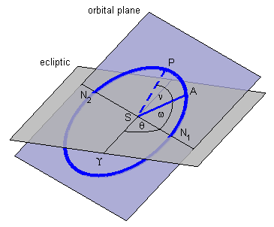
The orbit of an object around a central body is completely defined by a set of 6 scalar parameters. In addition to the two parameters a and e discussed above that describe the shape of the ellipse, a further parameter ω (argument of periapsis) defines the rotation angle of the ellipse in the orbital plane. Two parameters i (inclination) and θ (longitude of the ascending node) define the orientation of the orbital plane in space relative to a reference coordinate system, and a final parameter ν(t) (true anomaly) at epoch defines the angular position of the orbiting object along the orbit at a specific time t. These are the Keplerian or 2-body elements of an unperturbed orbit. Equivalently, the orbit can also be defined by the state vectors of the orbiting object at a given time: position r(t) and velocity v(t). It is possible to calculate the orbital elements from the state vectors and vice versa.
From Newtonian dynamics we know that Kepler’s laws strictly apply only to two-body problems. In the solar system containing multiple bodies which all exert a gravitational force on each other, all orbits are perturbed to some extent from the elliptical shape. In some cases these perturbations are small, but often they cannot be neglected. For example, the Earth’s orbit around the Sun is significantly affected by the gravitational influence of its relatively large moon. In this case, it is more appropriate to describe the trajectory the barycentre (the centre of mass) of the Earth-Moon system around the Sun as a two-body problem, and the orbits of Earth and Moon around each other as a separate two-body problem on top of it. If even more precision is required, e.g. to factor in the gravitational influence of other planets, an n-body treatment is required, which can generally only be solved numerically.
In perturbed orbits, the orbital elements change over time. Computing the 2-body elements from the state vectors at a specific time t0 results in the expression of an orbit that the orbiting object would follow in the absence of perturbing influences (osculating orbit). The elements are the osculating elements at t0.

Kepler’s equation
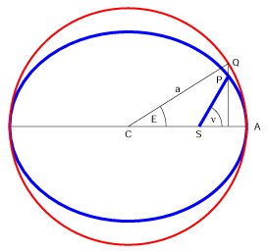
Computing the true anomaly ν is not trivial for eccentric orbits, because the orbital velocity is changing along the orbit according to Kepler’s second law. It is sometimes useful to substitute ν with the mean anomaly M, a parameter that is changing linearly with time:

where t0 is the time of periapsis passage. M is the angular position of a body in a circular orbit with the same semi-major axis a (and thus the same orbital period T) and the same periapsis passage time t0.
To compute true anomaly from mean anomaly, we first introduce the eccentric anomaly E: Define a circle with radius a whose centre coincides with the centre of the elliptic orbit. Project the object position P perpendicular to the semi-major axis onto the circle (Q). Then E is defined as the angle ACQ between periapsis A and Q, measured at the centre C of the circle.
The relationship between orbit radius r and E is given by

ν can be computed from E by

and E is related to M via Kepler’s equation

which cannot be solved in closed form, but generally requires an iterative solution.

Sphere of influence and patched conic approximation
Planning the trajectory of an interplanetary space probe requires the solution of a multi-body problem that takes into account the gravitational influence of Earth, the Sun and the target planet(s) and possibly their moons. This usually involves a numerical simulation that propagates the flight path in time, given a set of intital conditions and potential mid-flight manouvres. Such a solution can be computationally expensive, in particular if many trajectory simulations are required, for example to find suitable launch parameters for a trip that involves multiple planet encounters and gravity assist manouvres.
An alternative to the full multi-body solution is the patched conic approximation. Given two gravitational sources with masses M and m, the less massive body m is assigned a sphere of influence, in the simplest form defined as a sphere with radius
M
m
SOI(m)
Patched conic trajectory
Transition with continuity condition

where a is the semi-major axis of the orbit of m around M. The region of influence of M is all space outside the smaller body’s SOI.
The spacecraft on a point along its trajectory is assumed to be under the gravitational influence of only the single body whose SOI is currently traversed. As soon as the SOI boundery of another body is crossed, that body’s gravitational field is exclusively used for the computation of the next part of the trajectory, subject to the boundary condition that the state vectors (position r and velocity v) are continuous across the SOI boundary.
In the solar system, SOI can be assigned for each planet or other body orbiting the Sun. On a second level, a planet’s moons may be assigned their own SOI that are embedded in the planet’s SOI.
The patched conic method is not exact - in particular at the SOI boundaries, where the gravitational influences of the two bodies are approximately equal, neglecting one of them may lead to errors in the trajectory prediction. However, it can be a reasonable initial estimate for designing a mission, and can be refined by a precise numerical multi-body simulation if required.

Selected constants and parameters
These data may be useful when planning missions across the solar system.

Astrodynamic constants
Constant | Symbol | Value
Julian day | d | 86400 s
Julian year | yr | 365.25 d
Julian century | Cy | 36525 d
Speed of light | c | 299792458 m/s
Gaussian gravitational constant | k | 0.01720209895 (AU3/d2)1/2
Defining constants
Constant | Symbol | Value
Mean sidereal day |  | 86164.09054 s = 23:56:04.09054
Sidereal year (quasar ref. frame) |  | 365.25636 d
Light time for 1 AU | τA | 499.004783806 (± 0.00000001) s
Gravitational constant | G | 6.67259 (± 0.00030) × 10−11 kg−1 m3 s−2
General precession in longitude |  | 5028.83 (± 0.04) arcsec/Cy
Obliquity of ecliptic (J2000.0) | ε | 84381.412 (± 0.005) arcsec
Mass: Sun / Mercury |  | 6023600. (± 250.)
Mass: Sun / Venus |  | 408523.71 (± 0.06)
Mass: Sun / (Earth + Moon) |  | 328900.56 (± 0.02)
Mass: Sun / (Mars system) |  | 3098708. (± 9.)
Mass: Sun / (Jupiter system) |  | 1047.3486 (± 0.0008)
Mass: Sun / (Saturn system) |  | 3497.898 (± 0.018)
Mass: Sun / (Uranus system) |  | 22902.98 (± 0.03)
Mass: Sun / (Neptune system) |  | 19412.24 (± 0.04)
Mass: Sun / (Pluto system) |  | 1.35 (± 0.07) × 108
Mass: Moon / Earth |  | 0.012300034 (± 3 × 10−9)
Primary constants
Constant | Symbol | Value
Astronomical unit distance | c × τA = AU | 1.49597870691 × 1011 (± 3) m
Heliocentric gravitational constant | k2 AU3 d−2 = GMsun | 1.32712440018 × 1020 (± 8 × 109) m3 s−2
Mass: Earth / Moon |  | 81.30059 (± 0.00001)
Derived constants
Notes:
Data are from the 1994 IAU file of current best estimates. Planetary ranging determines the Earth/Moon mass ratio. The value for 1 AU is taken from JPL’s current planetary ephemeris DE-405.
Reference:
Standish, E. M. (1995) Report of the IAU WGAS Sub-Group on Numerical Standards, in Highlights of Astronomy (I. Appenzeller, ed.), Table 1, Kluwer Academic Publishers, Dordrecht.

Planetary mean orbital elements and centennial rates
Planet | a [AU] | e | i [deg] | Ω [deg] | ϖ [deg] | L [deg]
Mercury | 0.38709893 | 0.20563069 | 7.00487 | 48.33167 | 77.45645 | 252.25084
Venus | 0.72333199 | 0.00677323 | 3.39471 | 76.68069 | 131.53298 | 181.97973
Earth | 1.00000011 | 0.01671022 | 0.00005 | −11.26064 | 102.94719 | 100.46435
Mars | 1.52366231 | 0.09341233 | 1.85061 | 49.57854 | 336.04084 | 355.45332
Jupiter | 5.20336301 | 0.04839266 | 1.30530 | 100.55615 | 14.75385 | 34.40438
Saturn | 9.53707032 | 0.05415060 | 2.48446 | 113.71504 | 92.43194 | 49.94432
Uranus | 19.19126393 | 0.04716771 | 0.76986 | 74.22988 | 170.96424 | 313.23218
Neptune | 30.06896348 | 0.00858587 | 1.76917 | 131.72169 | 44.97135 | 304.88003
Pluto | 39.48168677 | 0.24880766 | 17.14175 | 110.30347 | 224.06676 | 238.92881

Planet | da/dt [AU/Cy] | de/dt [/Cy] | di/dt [“/Cy] | dΩ/dt [“/Cy] | dϖ/dt [“/Cy] | dL/dt [“/Cy]
Mercury | 0.00000066 | 0.00002527 | −23.51 | −446.30 | 573.57 | 538101628.29
Venus | 0.00000092 | −0.00004938 | −2.86 | −996.89 | −108.80 | 210664136.06
Earth | −0.00000005 | −0.00003804 | −46.94 | −18228.25 | 1198.28 | 129597740.63
Mars | −0.00007221 | 0.00011902 | −25.47 | −1020.19 | 1560.78 | 68905103.78
Jupiter | 0.00060737 | −0.00012880 | −4.15 | 1217.17 | 839.93 | 10925078.35
Saturn | −0.00301530 | −0.00036762 | 6.11 | −1591.05 | −1948.89 | 4401052.95
Uranus | 0.00152025 | −0.00019150 | −2.09 | −1681.40 | 1312.56 | 1542547.79
Neptune | −0.00125196 | 0.0000251 | −3.64 | −151.25 | −844.43 | 786449.21
Pluto | −0.00076912 | 0.00006465 | 11.07 | −37.33 | −132.25 | 522747.90
a: semi-major axis, e: eccentricity, i: inclination, Ω: longitude of the ascending node, ϖ: longitude of perihelion, L: mean longitude, Cy: Julian century, “: arcsec
Epoch = J2000 = 2000 January 1.5
Notes:
The tables contain mean orbit solutions from a 250 yr. least squares fit of the DE 200 planetary ephemeris to a Keplerian orbit where each element is allowed to vary linearly with time. This solution fits the terrestrial planet orbits to ~25” or better, but achieves only ~600” for Saturn. Elements are referenced to mean ecliptic and equinox of J2000 at the J2000 epoch (2451545.0 JD).
Reference:
Explanatory Supplement to the Astronomical Almanac (1992), K. P. Seidelmann (ed.), p. 316 (Table 5.8.1), University Science Books, Mill Valley, California.

Selected physical parameters
Planet | mean radius [km] | mass [1023 km] | density [g/cm3] | sidereal rotation period [h] | sidereal orbit period [yr]
Mercury | 2440. ± 1. | 3.301880 | 5.427 | 1407.509 | 0.2408445
Venus | 6051.84 ± 0.01 | 48.6855374 | 5.204 | −5832.444 | 0.6151826
Earth | 6371.01 ± 0.02 | 59.73698968 | 5.515 | 23.93419** | 0.9999786
Mars | 3389.92 ± 0.04 | 6.418542 | 3.9335 ± 0.0004 | 24.622962 | 1.88071105
Jupiter | 69911. ± 6. | 18986.111 | 1.326 | 9.92425 | 11.856523
Saturn | 58232. ± 6. | 5684.6272 | 0.6873 | 10.65622 | 29.423519
Uranus | 25362. ± 12. | 868.32054 | 1.318 | 17.24 ± 0.01 | 83.747407
Neptune | 24624. ± 21. | 1024.569 | 1.638 | 16.11 ± 0.01 | 163.72321
Pluto* | 1151 | 0.15 | 1.1 | 153.28 | 248.0208

Planet | V(1,0) [mag.] | Geometric albedo | Equatorial gravity [m/s2] | Escape velocity [km/s]
Mercury | −0.42 | 0.106 | 3.701 | 4.435
Venus | −4.4 | 0.65 | 8.87 | 10.361
Earth | −3.86 | 0.367 | 9.780327 | 11.186
Mars | −1.52 | 0.15 | 3.69 | 5.027
Jupiter | −9.4 | 0.52 | 23.12 ± 0.01 | 59.5
Saturn | −8.88 | 0.47 | 8.96 ± 0.01 | 35.5
Uranus | −7.19 | 0.51 | 8.69 ± 0.01 | 21.3
Neptune | −6.87 | 0.41 | 11.00 ± 0.05 | 23.5
Pluto* | −1.0* | 0.3* | 0.655 | 1.3
All values from [1] except Pluto data from [2]. Mercury to Neptune masses derived from standard gravitational parameter (GM) data in [1].
** Orbiter uses 23.93447 h (=23 h 56 m 4.09 s) which gives better long-term stability.
References:
[1] Yoder, C. F. (1995) Astrometric and Geodetic Properties of Earth and the Solar System, in Global Earth Physics, A Handbook of Physical Constants, AGU Reference Shelf 1, American Geophysical Union.
[2] Explanatory Supplement to the Astronomical Almanac (1992), K. P. Seidelmann (ed.), p. 706, Table 15.8, University Science Books, Mill Valley, California.

Demo mode
Orbiter can be run in “demo” or “kiosk” mode to facilitate its use in public environments such as exhibitions and museums.
Demo mode can be configured by manually editing the Orbiter.cfg configuration file in the main Orbiter directory. The following options are available:
Flag | Type | Description
DemoMode | bool | Set to TRUE to enable demo mode. (default: FALSE)
BackgroundImage | bool | Set to TRUE to cover the desktop with a static image. (default: FALSE)
BlockExit | bool | Set to TRUE to disable the Exit function in Orbiter’s Launchpad dialog. If this option is enabled, Orbiter can only be terminated via the task manager. (default: FALSE)
MaxDemoTime | float | Maximum runtime for a simulation session [s]. Orbiter automatically returns to the Launchpad when the time has expired.
MaxLaunchpadIdleTime | float | Maximum time spent in the Launchpad without user input before Orbiter auto-launches a demo scenario [s].
In Demo mode, only the Scenario tab is accessible in the Launchpad dialog, to prevent users from modifying simulation configuration features such as screen resolution or plug-in modules. Orbiter should be configured as required before launching into demo mode.
To use the auto-launch feature in demo mode, a folder Demo must be created in the main scenario folder. Orbiter randomly picks a scenario from this folder to launch.
Note: When using Orbiter in Demo mode, it is recommended that the simulation is run in a window, or in a fullscreen mode that matches the native screen resolution, to avoid excessive switching between video display modes.

Command line interface
When starting Orbiter (orbiter.exe) or the Orbiter graphics server (orbiter_ng.exe) from the command line, optional parameters can be provided to modify the behaviour of the simulation.
orbiter.exe [options]
Below is a list of the supported options. Options are separated with space. Most options can be specified with a long notation (with prefix --) or short notation (with prefix -). If the option requires an argument, it must be separated from the option key with = (for the long version) or with a space (for the short version). If an argument contains spaces, it should be enclosed in double quotes (“).
Long | Short | Effect
--help | -h | Display usage and list of options, then exit.
--fastexit | -x | Terminate Orbiter at the end of the session. Don’t return to the Launchpad dialog.
--scenario=<scn> | -S <scn> | Directly launch scenario <scn>. Bypass the Launchpad dialog. <scn> should contain the path to the scenario file relative to .\Scenarios. The file extension (.scn) should be omitted.
--scenariox=<scn> | -s <scn> | Shortcut for -x -S <scn>. Launch scenario directly and terminate on session end.
--openvideotab | -v | Open Launchpad dialog on video tab instead of scenarios.
--keeplog | -l | Append log output to Orbiter.log instead of overwriting the previous log data.
--fixedstep=<s> | -f <s> | Set a fixed simulation time step of <s> seconds for each frame, independent of how long the frame takes to render in real time.
--maxsystime=<t> | -T <t> | Terminate the simulation session after <t> seconds.
--maxsimtime=<t> | -t <t> | Terminate the simulation session at simulation time <t>.
--maxframes=<f> |  | Terminate the simulation session after <f> time frames.
--plugin=<pg> | -p <pg> | Enforce loading of plugin <pg>. Any path provided must be relative to .\Modules\Plugin. The extension (.dll) should be omitted. Multiple –plugin options can be provided. Any plugins requested on the command line cannot be unloaded interactively.

Glossary
A list of technical terms and abbreviations frequently used in this manual and elsewhere in Orbiter.
Albedo | Fraction of incident radiation reflected back diffusely by a body.
Apoapsis | The point of an elliptic orbit farthest from the focus (from the orbited body). Body-specific names are sometimes used, e.g. apogee (for Earth orbits) or aphelion (for solar orbits). Orbital velocity is lowest at apoapsis. See also periapsis.
Argument of periapsis | The angle from ascending node to periapsis of an orbit, measured in the direction of motion (ω). One of the 6 primary 2-body orbital elements (defines the orientation of the orbit in the orbital plane).
Ascending node | One of the points (nodes) of an orbit intersecting an inclined reference plane (e.g. the equator). At the ascending node, the orbiting object crosses the reference plane from south to north. See also descending node.
Astronomical unit | One astronomical unit (1 AU) is the mean radius of Earth’s orbit around the sun (approximately 150 · 106 km). It is commonly used as a distance measure on interplanetary scales within the solar system.
Axial precession | A change in the orientation of the rotation axis of a rotating body (e.g. a planet). For example, Earth’s axis is precessing around the ecliptic pole at an angle of 23.5° over a period of 26000 years.
Descending node | One of the points (nodes) of an orbit intersecting an inclined reference plane (e.g. the equator). At the descending node, the orbiting object crosses the reference plane from north to south. See also ascending node.
Eccentricity | Shape parameter for conic sections, e.g. 2-body orbits (e). Circular: e = 0, elliptic: 0 < e < 1, parabolic: e = 1, hyperbolic: e > 1. One of the 6 primary 2-body orbital elements.
Ecliptic | The ecliptic is the Earth’s mean orbital plane. The orbital planes of most planetary bodies are close to the ecliptic, which makes it an important reference plane for interplanetary missions. The ecliptic undergoes slight variations over time due to gravitational perturbations, so a reference date (epoch), e.g. J2000.0 must be added to define a fixed plane.
Geostationary orbit | A circular equatorial orbit with an orbit period equal to the orbited body’s sidereal rotation period. As a result, the orbiting object maintains its position above a point on the equator, at zero ground speed. For Earth, geostationary orbits are at an altitude of ~36000 km. Geostationary orbits are often used by communication or weather satellites.
HUD | Head-up display. Avionics display used in modern aircraft and spacecraft that projects data and visual cues onto a transparent screen directly in the pilot’s line of sight.
IDS | Instrument docking system. A fictional universal docking system that provides linear and rotational alignment cues for docking approaches, similar to ILS.
ILS | Instrument Landing System. A combination of radio transmitters installed at a runway, and onboard receivers and avionics displays to provide an aircraft pilot with deviation cues from a target approach path. In Orbiter, this is also used by horizontally landing spacecraft, including a (fictional) ILS at the Kennedy SLF.
Inclination | The angle between the orbital plane and a reference plane (i). One of the 6 primary orbital elements to describe a 2-body orbit (defines the orientation of the orbital plane in space together with the longitude of the ascending node).
Inertia tensor | A 3x3 matrix that defines a rigid body’s resistance to a change of its angular velocity around its axes, analogous to the role of mass in linear kinematics:  L = Iω (L: angular momentum, I: inertia tensor, ω: angular velocity)
Isp | Specific impulse (I_{sp}). Equivalent to effective exhaust velocity v_{e} [m/s]. Specifies the amount of thrust [N] produced by burning propellant at a rate of 1 kg/s. An often used alternative definition for I_{sp} is v_{e} · g₀ [s] with standard gravity g₀ = 9.81 m/s².
LEO | Low Earth orbit. An orbit with an an apogee altitude of less than ~2000 km and an orbital period of less than ~128 minutes. Objects in LEO can experience orbit degradation due to atmospheric friction, limiting their lifetime unless periodically boosted to compensate, such as the ISS.
Line of nodes | The intersection of the orbital plane with an inclined reference plane. Contains the ascending and descending nodes.
Longitude of the ascending node | The angle in the reference plane between reference direction (e.g. vernal point) and the orbit’s ascending node (Ω). One of the primary 2-body orbital elements (defines the orientation of the orbital plane in space together with inclination).
Mean anomaly | Fraction of orbital period passed since apoapsis passage, expressed as an angle (M). Equivalent to true anomaly of a fictitious circular orbit with the same orbital period as the actual orbit. Unlike true anomaly in a non-circular orbit, mean anomaly varies linearly with time.
Mean longitude | The sum of longitude of the ascending node, argument of periapsis and mean anomaly: l = Ω + ω + M. See also true longitude.
MET | Mission elapsed time. A time scale for mission events referenced to launch time.
MFD | Multifunctional display. An avionics instrument consisting of a digital display and input device. Can display a variety of data and combines multiple traditional aircraft/spacecraft instruments.
Normal | The direction perpendicular to a plane. In orbital operations, attitudes normal to the orbital plane are often used for out-of-plane maneuvers, such as plane rotations. Orbiter differentiates between normal (in the direction of the momentum vector r x v) and anti-normal (in the opposite direction). See also specific relative angular momentum.
Orbital elements | 6 scalar values defining the Keplerian (2-body) orbital motion of an object in the unperturbed field of a gravitational point source. Shape and size of the orbit are defined by semi-major axis (a) and eccentricity (e); orientation of the orbital plane is defined by inclination (i) and longitude of the ascending node (Ω); orientation of the orbit in the plane is defined by argument of periapsis (ω); position of the orbiting object along the orbit is given by true anomaly (ν) at a given time. See also state vectors.
Osculating elements | The momentary orbital elements of a body corresponding to its current state vectors. In the presence of gravitational forces in addition to the primary, the orbit is perturbed and the osculating elements change over time.
Periapsis | The point of an elliptic orbit closest to the focus (the orbited body). Body-specific names are sometimes used, e.g. perigee (for Earth orbits) or perihelion (for solar orbits). Orbital velocity is highest at periapsis. See also apoapsis.
PMI | Principal moments of inertia: the diagonal elements of the inertia tensor expressed in the principal body frame where the inertia tensor is diagonal. See Technotes/composite.pdf for more details.
Prograde | The prograde direction of an orbiting body is that of the current orbital velocity vector. In a prograde orbit the orbiting body is moving in the direction of the rotation of the orbited body. See also retrograde.
RCS | Reaction Control System. A set of thrusters on a spacecraft that provides attitude control. Usually engaged in pairs to create angular moments (in angular mode) or linear moments (in linear mode) in the 3 main spacecraft axes.
Retrograde | The retrograde direction of an orbiting body is the direction opposite to the current orbital velocity vector. In a retrograde orbit the orbiting body is moving in the opposite direction to the rotation of the orbited body. See also prograde.
Semi-major axis | Longest half-axis of an ellipse (a). One of the 6 primary 2-body orbital elements (defines the shape of the orbit together with the eccentricity).
Semi-minor axis | Shortest half-axis of an ellipse.
Sidereal day | Time for one full (360°) rotation of a celestial body. Used in astronomy, where a star will appear at the same position in the sky at the same sidereal time. Shorter than a synodic day, which also has to take into account the apparent motion of the sun in front of the celestial background, caused by the planet’s orbital motion.
Specific relative angular momentum | The vector product of an orbiting object’s position and velocity vectors: h = r x v. h is normal (perpendicular) to the orbital plane.
SRB | Solid rocket booster. Solid propellant rocket used to provide additional thrust during first stage ascent of a launch vehicle, in particular the Space Shuttle.
State vectors | Cartesian position (r) and velocity (v) vectors of an orbiting body at a given time. Uniquely defines an unperturbed (Keplerian) orbit. From the state vectors, the 6 orbital elements of the corresponding 2-body orbit can be calculated, and vice versa.
Synodic day | Mean period between two meridian passages of the sun, averaged over a year. For a planet rotating prograde, this requires a rotation > 360° to account for the orbital movement of the planet around its sun, and is therefore longer than a sidereal day. The length of a synodic day varies annually on a planet with an elliptic orbit.
True anomaly | Angular distance of an orbital position from periapsis, as measured from the focus (ν).
True longitude | The sum of longitude of the ascending node, argument of periapsis and true anomaly: L = Ω + ω + ν). See also mean longitude.
VTOL | Vertical take-off and landing. Spacecraft can use downward directed engines to compensate for gravitational acceleration and enable vertical takeoff and soft touchdown, either using main engines (“tailsitters”) or dedicated hover engines. Spacecraft with lifting bodies or airfoils may more efficiently use horizontal runway takeoffs and/or landings on planets with sufficient atmospheric density.

License notice
Orbiter Space Flight Simulator
MIT License
Copyright (c) 2000-2021 Martin Schweiger
Permission is hereby granted, free of charge, to any person obtaining a copy of this software and associated documentation files (the "Software"), to deal in the Software without restriction, including without limitation the rights to use, copy, modify, merge, publish, distribute, sublicense, and/or sell copies of the Software, and to permit persons to whom the Software is furnished to do so, subject to the following conditions:
The above copyright notice and this permission notice shall be included in all copies or substantial portions of the Software.
THE SOFTWARE IS PROVIDED "AS IS", WITHOUT WARRANTY OF ANY KIND, EXPRESS OR IMPLIED, INCLUDING BUT NOT LIMITED TO THE WARRANTIES OF MERCHANTABILITY, FITNESS FOR A PARTICULAR PURPOSE AND NONINFRINGEMENT. IN NO EVENT SHALL THE AUTHORS OR COPYRIGHT HOLDERS BE LIABLE FOR ANY CLAIM, DAMAGES OR OTHER LIABILITY, WHETHER IN AN ACTION OF CONTRACT, TORT OR OTHERWISE, ARISING FROM, OUT OF OR IN CONNECTION WITH THE SOFTWARE OR THE USE OR OTHER DEALINGS IN THE SOFTWARE.

