Heatwave Heat Map Life: An AI-Driven Heatwave Prediction
and Public Warning System for Thailand
Chonradsadornumrung School
Course Number: Course Name

Author Note
Include any grant/funding information and a complete correspondence address.

Abstract
Heatwaves are becoming increasingly frequent and severe as a consequence of global climate change, posing significant risks to human health, infrastructure, and ecosystems. Early detection and effective communication of heatwave risk are essential for improving public preparedness and reducing potential impacts. This project presents Heatwave Heat Map Life, an AI-driven heatwave prediction and public alert system designed to provide accessible and understandable heatwave risk information for the general public in Thailand.
The system integrates a machine learning model with a user-friendly application interface. To address the challenge that heatwaves are considered rare climatic events, the study employs the Balanced Random Forest algorithm to improve predictive performance under imbalanced datasets. Historical climate data from 2000 to 2025 were used for model training, including atmospheric variables from the ERA5 reanalysis dataset and vegetation indicators derived from Normalized Difference Vegetation Index (NDVI) data.
The AI model predicts the probability of heatwave occurrence for specific geographic areas and converts the results into intuitive visual representations within the application. The platform provides a heat risk heatmap, percentage-based risk indicators, and a survival checklist designed to help users understand preventive actions during extreme heat conditions. Additionally, the system integrates a cooling location navigation feature, guiding users to nearby publicly accessible air-conditioned spaces such as hospitals, shopping malls, and convenience stores.
By combining AI-based prediction with accessible visualization and public guidance features, this project aims to enhance climate risk awareness and improve community preparedness for extreme heat events in tropical regions such as Thailand.
Keywords: Add keywords here.

Introduction
In recent decades, global climate change has intensified the frequency and severity of extreme weather events. Among these events, heatwaves have become one of the most critical climate-related hazards affecting both developed and developing countries. Prolonged exposure to extreme heat can lead to severe health consequences, including heat exhaustion, heatstroke, and increased mortality rates, particularly among vulnerable populations such as the elderly, children, and outdoor workers.
Tropical regions, including Thailand, are especially vulnerable to rising temperatures due to their already warm and humid climate conditions. In such environments, even moderate increases in temperature can significantly elevate heat stress levels. As a result, the ability to predict and communicate potential heatwave risks becomes an important component of climate adaptation and disaster preparedness.
Traditional weather monitoring systems typically provide temperature forecasts but may not effectively communicate the probability of heatwave events or the level of associated risk to the general public. Furthermore, many existing prediction approaches focus primarily on meteorological variables while overlooking environmental indicators such as vegetation conditions, which can influence local temperature patterns and heat accumulation.
To address these limitations, this study proposes Heatwave Heat Map Life, an integrated system that combines artificial intelligence-based heatwave prediction with a public-oriented mobile application. The system utilizes historical climate data spanning 2000–2025, incorporating atmospheric variables from the ERA5 reanalysis dataset alongside vegetation indicators derived from Normalized Difference Vegetation Index (NDVI) data.
Because heatwaves are considered rare climatic events, the dataset used for training exhibits significant class imbalance. To overcome this challenge, the system employs the Balanced Random Forest algorithm, a machine learning method designed to improve predictive performance when dealing with imbalanced data distributions.
The prediction model estimates the probability of heatwave occurrence for specific geographic regions. These predictions are then translated into intuitive visual information within the application, including heat risk heatmaps and percentage-based risk indicators. In addition to prediction capabilities, the application provides practical support features such as a heat survival checklist and navigation to nearby cooling locations, including public buildings with air-conditioning.
By integrating climate data analysis, machine learning prediction, and user-centered visualization, this project aims to develop an accessible heatwave early warning and public awareness platform for Thailand. The system seeks to enhance the public’s ability to recognize heatwave risks, respond effectively to extreme heat conditions, and ultimately reduce the potential impacts of climate-related heat hazards.

Footnotes
¹For APA reports, add footnotes manually on their own page following references. Do not use the Insert Footnotes method on the References tab as they will not be formatted correctly. For APA formatting requirements, it’s easier to type your own footnote references and notes. To format a footnote reference, select the number and then, on the Home tab, in the Styles gallery, click Footnote Reference. The body of a footnote, such as this example, uses the Normal text style. If you delete this sample footnote, don’t forget to delete its in-text reference at the end of the sample Heading 2 paragraph on the first page of body content in this template.

Tables
Table 1
Table Title
Column Head | Column Head | Column Head | Column Head | Column Head
Row Head | 123 | 123 | 123 | 123
Row Head | 456 | 456 | 456 | 456
Row Head | 789 | 789 | 789 | 789
Row Head | 123 | 123 | 123 | 123
Row Head | 456 | 456 | 456 | 456
Row Head | 789 | 789 | 789 | 789

Note: Place all tables for your paper in a tables section, following references and footnotes. Start a new page for each table, include a table number and table title for each, as shown. All explanatory text appears in a table note that follows the table, like this one. Use the Table/Figure style, available on the Home tab, in the Styles gallery, to get the spacing between table and note. Tables in APA format can use single or 1.5 line spacing. Include a heading for every row and column, even if the content seems obvious. A default table style has been set up for this template that fits APA guidelines. To insert a table, on the Insert tab, click Table.

Figures Title
Figure 1.
Include all figures in their own section, following references, footnotes, and tables. Include a numbered caption for each figure. Use the Table/Figure style for easy spacing between figure and caption.

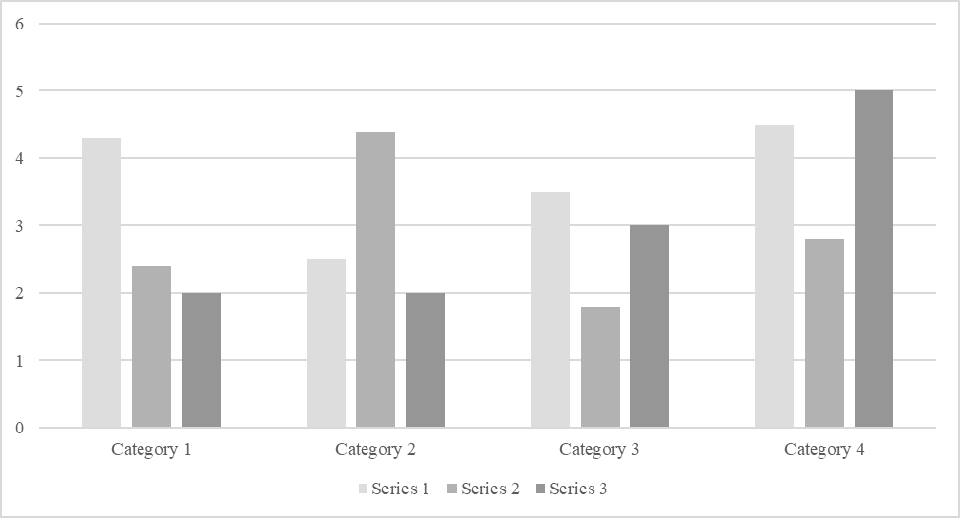

For additional information on APA Style formatting, please consult the APA Style Manual, 7th Edition.

