LIGHTWAVE 2009
Expression of Interest Submission

Calling all techno-artists, playful scientists, renegade engineers, architects, sculptors, lighting designers, fashion designers, guerrilla projectionists and inventors …

LIGHTWAVE returns to the Science Gallery at Trinity College Dublin following the unprecedented success and international acclaim received in its phenomenal inaugural show. Bigger, better and raising the bar, LIGHTWAVE 2009 promises to mesmerize audiences not only within the Science Gallery, but to captivate on-lookers city wide as interactive experiences, roving installations and participatory workshops flood the creative, cultural quarters of Dublin.

The launch of LIGHTWAVE 2009 will open with a 9-day festival running from January 24th to the February 1st 2009, with exhibitions continuing to February 21st. LIGHTWAVE 2008 highlights can be viewed on the Science Gallery website at http://www.sciencegallery.com/programme/Lightwave

Interested applicants are encouraged to send new, in-progress or interdisciplinary project proposals (installations, events, workshops) highlighting interactivity, connectivity, participation and public engagement both confined by, and freed from the gallery walls. We are looking for proposals of the highest standard that incorporate art, science and new technology in exciting and engaging projects focusing on light. Examples of project themes already proposed are the development of sustainable light sources in Africa, light pollution, effects of light on the body and the creative control of light through technology. Fresh and innovative projects that investigate a variety of themes are very welcome.

While creativity has no bounds, funding does and is limited in supply and capped at €10,000 per project which will cover all costs, including shipping, travel, lodging, meals, etc. Projects that have lower financial requirements, or that bring their own funding, will be favourably received. Additional funding may be available for exceptional projects. Clear budget outline and timeline are essential to your successful submission. There is no entry fee.

Entry submissions and documentation, images and videos can be sent by email only to:
Beth Gormley, Production Assistant at beth.gormley@sciencegallery.com

As we are accepting email submissions no larger than 10Mb we strongly encourage you to create a website with entry materials in an easily viewable format, or include URL’s to video or blog sites.

Entries must be submitted no later than Friday, 5 September 2008, 5pm GMT.

The Science Gallery is open to the public and can be viewed by virtual tour at http://www.sciencegallery.com/hire_host_your_event A confirmation receipt will be sent to all applicants via email. Questions can be directed to Beth Gormley by email only at beth.gormley@sciencegallery.com.
Expression of Interest Submission

Applicant’s Details (250 words maximum)
Name | SWARM
Address | 3435 24th St #9, San Francisco, CA 94110
Telephone | 01-415-577-8424(Niladri Bora), 01-415-306-2151(Lee Sonko)
Email | niladri.bora@gmail.com  info@orbswarm.com
Name and contact details of any co-applicants
Applicants Bio
This is a combined project featuring members of the Flaming Lotus Girls, the Sunflower Robots Project and members of the robotics and kinetic art communities in the San Francisco Bay area.

Description of relevant work; URL’s
In past years, crew members have made major contributions to the following Burning Man artworks:
o Sunflower Robots (2006) (http://www.sunflowerrobots.com/)
o The Flaming Lotus Girls' Serpent Mother (2006)(http://serpentmother.com/), Angel of the Apocalypse (2005)(http://www.flaminglotus.com/angel/index.htm), Seven Sisters (2004)(http://www.flaminglotus.com/sisters/index.htm), Hand of God (2003)
o The Mad Scientist's L3K (2006) and STS (2004)(http://www.mad-scientists.com/)
o Al Honig's Hope/Fear Gauge (2006)
o Dana Albany's Bone Tree (1999)

In addition, we have years of experience with robotics and kinetic artworks presented in such challenging venues as The Burning Man festival, Coachella music festival, Robogames, Combots, the Power Tool Drag Races, and Robodock (in the Netherlands).

Project Description (500 words maximum)
What kind of project? (installation, event, workshop)
Mobile installation
Is the project proposed for Science Gallery or citywide location?
(If citywide, specify proposed project site.)
We would like to exibhit both inside the Science gallery and outside. To really show off SWARM in all its autonomous glory we need at least 40ftx40ft of open, flat space.
Vision for the project
SWARM is a kinetic art work of semi-autonomous spherical robots ("Orbs"). Each robot has a shell 30 inches in diameter, with batteries, motors, audio system and color LED illumination inside. The SWARM is under the command of an on-board computer with wireless connectivity to other orbs and a central computer.

SWARM is built to explore the aesthetic possibilities in the emergent behavior of artificial systems. As a first step, Orbs are remote-controlled by human operators, but each Orb's sounds and color illumination is algorithmically generated in response to location and motion. Each Orb has sophisticated navigational sensors including GPS, accelerometers, and rate gyros. We are progressing towards sophisticated navigational algorithms that allow each orb to determine its location with high accuracy. From this, we can explore emergent and cooperative behavior like flocking as well as new possibilities in machine choreography. SWARM is not a simulation. SWARM is a platform for art of the 21st century.

Project relevance to Science Gallery or Lightwave aims and objectives
SWARM is an interactive project that encourages audience participation. SWARM operates in two modes – remote controlled(RC) and autonoumous mode. In RC mode the user can control the light and sound for each orb using a joystick. In autonomous mode audience members can program their own light and sound timelines and choreograph a performance.

SWARM is also interactive in the sense that it's a completely open platform. We invite other artists to enhance and modify the SWARM platform to do whatever they choose. We strongly believe in repurposing technology to create art.
Describe stage of project development (planning, in progress or completed work)
The project is near completion and demonstrable. The following features have been completed -
- RC control
- Autonomous motion control
The following features are in development -
- User interface for light and sound choreography

Proposed duration of project
(Will the installation run for the two week period? How long will the event last?)
1 week

Please feel free to attach any visual documentation of relevance to the project proposed via email or include URL to website or other links.
Technical Details and Requirements
Installation proposals to include:
Physical dimensions of the proposed work
Each orb is 30 in in diameter and we propose to bring four of them.
Any special power, networking/IT needs
Energy requirements – One 15 amp line for recharging the orbs. The orbs use Zigbee radios to communicate. Although Zigbee operates in the same frequency band as wi-fi(2.4 GHz) we haven’t seen any problems with interference yet. If other projects in the gallery are using Zigbee we would like to co-ordinate with them so that we each use different chanels and PAN Ids and play nicely with each other.
Access to any resources other than electrical power that you need the Science Gallery to provide (sound system, video projector, running water, etc)
For automous performances we would like a fence to keep the audience out of the performance space. We would also like a charging space and space for secured storage for the orbs when not in operation.
Requirements with regards display (maintenance, ability to run reliably over installation period, etc)
Multiple 20 minute performances with four orbs will occur throughout the event. Performances are mobile but orbs may require charging in-between performances.
Does your work require specific light/sound conditions, extreme quiet or darkness?
SWARM was designed to perform in the evening / at dusk and truly shines after dark. The sound effects are best appreciated in a moderately quiet environment.
Event/Workshop proposals to include:
Physical space requirements
The minimum space for orb mobile performance is 40ft x 40 ft, optimal space is 60ft x 60ft. For operation in autonomous mode the orbs need a GPS signal. For this reason autonomous performances are best done in large spaces with view of the open sky (a soccer field is ideal), however a large room with a lot of windows may work. Non-autonomous RC control mode does not require GPS and can be set up indoors.
Technical requirements (AV, web, power needs, lighting requirements) with regards to events or workshops both inside the Science Gallery and citywide
One 15 amp line for recharging the orbs.
Approximate audience numbers
100

All successful projects will be required to liaise with the Lightwave technical team to ensure the feasibility and safety of all projects.
Summary Budget
Costs of fees, creation, delivery and installation
Shipping, customs broker for 4 orbs – 4216.00 euros
Airfare and lodging for a 4 person crew for 7 days – 4140.00 euros
Repair and maintenance – 1500.00 euros
Total – 9856.00 euros
Any sources of funding available or secured
None.

Production Schedule
Timeline indicating ability to deliver project
All features are expected to be ready Dec 1st.
Clear outline of set up times and associated man power/technical contraints
We need 1 day to setup and ½ day for teardown. We would also like access to a forklift during setup and teardown.

Health and Safety
Elements of your work that are potentially dangerous or may cause problems with indoor health and safety guidelines
The orbs are heavy and have a wide turning radius. Persons running into the path of an orb may possibly sustain injuries/scrapes to legs if they get hit by it. In RC mode the operators will make every effort to avoid such contact if people are present. Small children should be restrained and kept out of the path of the orbs.
Any site specific health and safety issues regarding outdoor installations, events and workshops
Please see above.

Please note all successful projects will be required to adhere to Science Gallery’s Health and Safety Guidelines.

Other
Any other information we should know about your project proposal
Our main web page is - www.orbswarm.com
Our wiki page is - http://wiki.orbswarm.com/index.php?title=Main_Page
Our blog is - http://wiki.orbswarm.com/index.php?title=Blog
Our media page(for pictures of our work) is- http://wiki.orbswarm.com/index.php?title=In_The_Media

We regret that incomplete submissions will not be considered.
Appendices

- Science Gallery Mission Statement

To ignite creativity and discovery where science and art collide

- LIGHTWAVE Objectives

- Develop a festival which juxtaposes disciplines of design, art, science and technology to create refreshing installations and programmes
- Build relationships with artists, scientists, innovators and designers who will contribute to the LIGHTWAVE programme
- Develop exhibits and workshops which allow participants to gain an insight into the principles of light and the technologies to control it
- Develop programmes both within the Science Gallery space and online that encourage active participation of both students and educators in LIGHTWAVE
- Involve university researchers in festival development
- Involve indigenous and international technology industries in festival development

3.0 Draft Timeline

- Deadline for submission of Expression of Interest forms: 5 Sept 2008
- Notification of successful applicants: 19 Sept 2008
- Production timeframe: 22 Sept 2008 – 10 Jan 2009
- Installation timeframe: 11 Jan – 22 Jan 2009
- Opening night: 23 January 2009
- Festival dates: 24 Jan – 31 Jan 2009
- Exhibition dates: 24 Jan – 21 Feb 2009
- Takedown: 22 Feb – 24 Feb 2009

4.0 Criteria for Selection

The following are the criteria for selection by the Curatorial Team:

- Balance/spread across disciplines (science, design, art, technology, etc)
- Relevance to the aims and objectives of Lightwave
- Innovation
- Quality: nature of installation/event, depth of engagement
- Budget
- Realisation: ability to deliver on time and in budget
5.0 Science Gallery Floor Plans

- Pdf floor plans of Science Gallery space below – A4.1 and A4.2

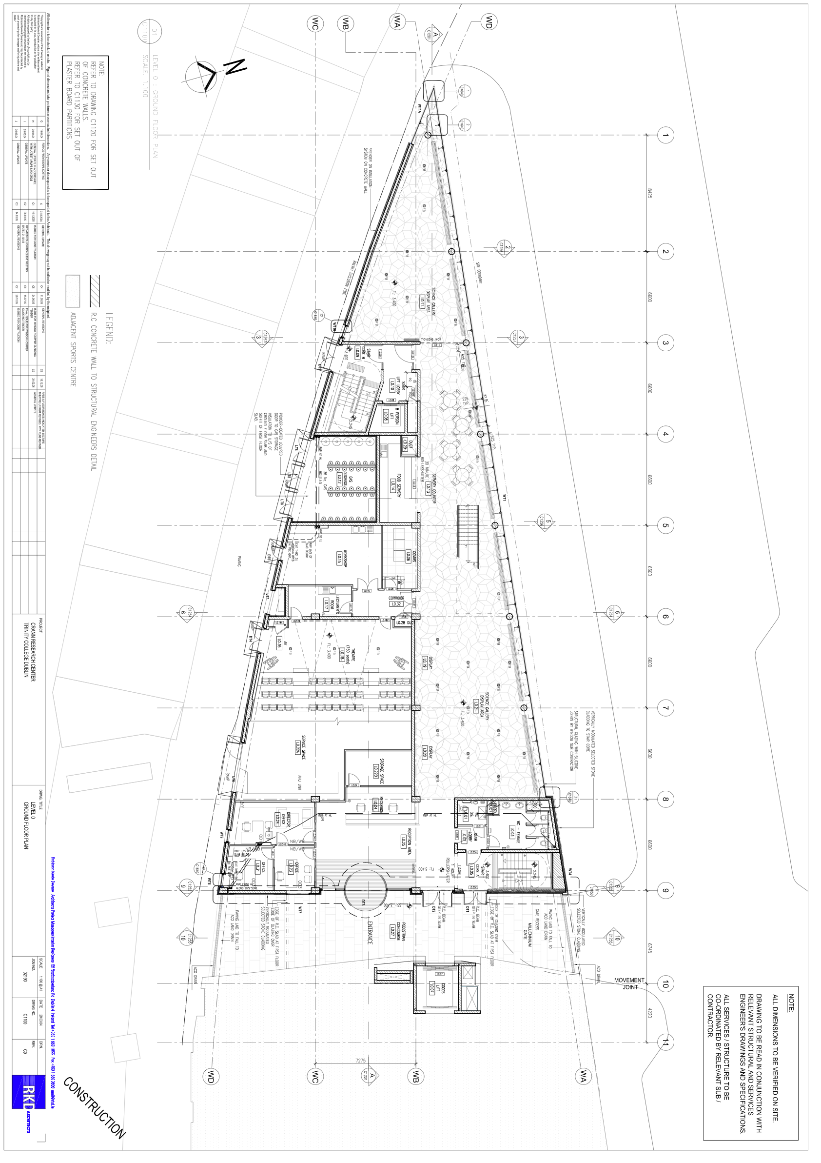
A4.1 – Ground Floor
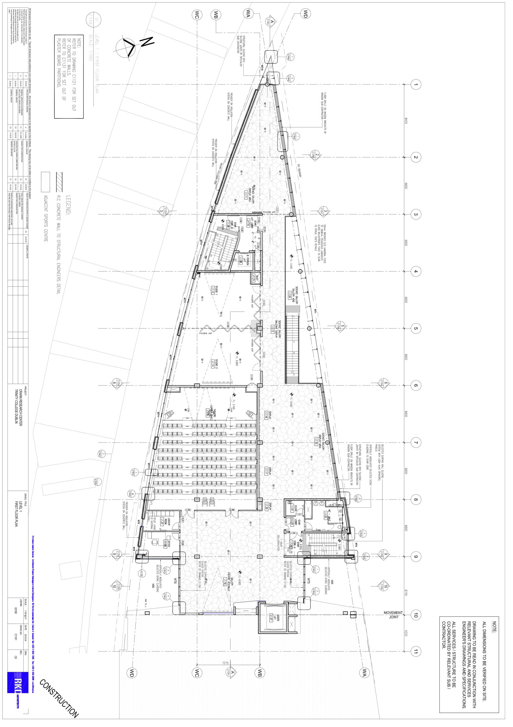
A4.2 – First Floor

