LIBRARY AUTOMATION SYSTEM

System-Wide Requirements Specification

# Introduction

This document contains the software system requirements of the library automation system. This document includes the use cases, activity diagrams, entity relations and the design of the software windows in this document.

# System-Wide Functional Requirements

**Use Case:**



Diagram 1: Use Case Diagram

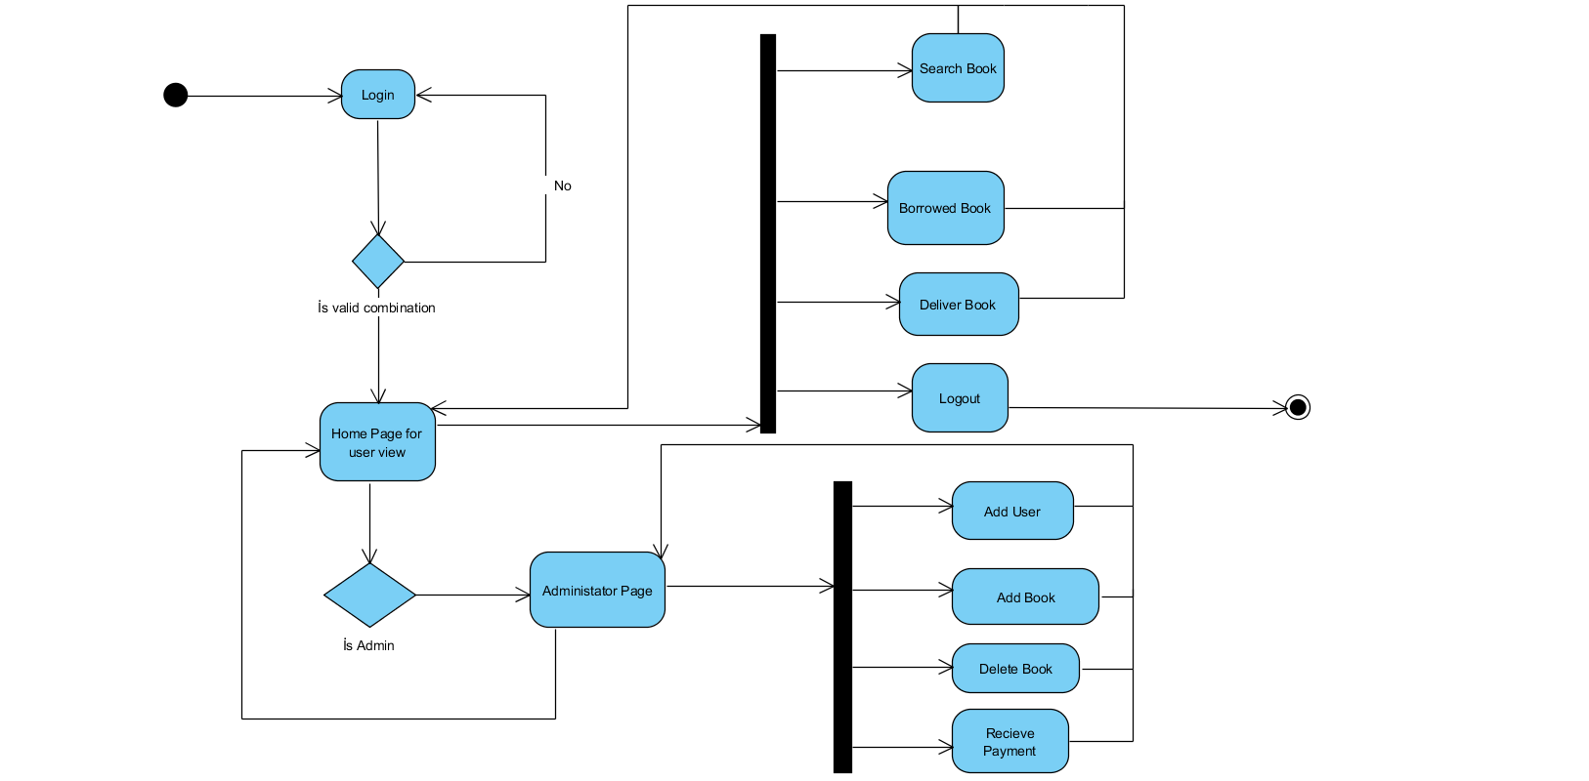

Diagram 2: Activity Diagram

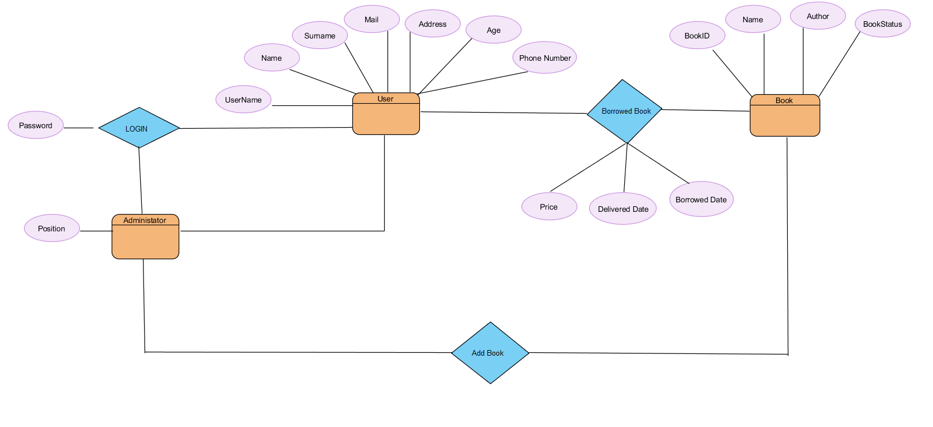

Diagram 3: Entity Relation Diagram

# System Qualities

## Usability

The use of the software does not have any difficulties for the users. The use of the software is such that many users can easily use it. For use, users will first become a member of the site. When they enter the site after this phase, the user's own interface will come to window. In this interface, do the desired operations and logout.

## Reliability

Information of the user will only be displayed by the admin except their password. The passwords of the users will be recorded with a key. Other information belonging to the user will be kept securely within the system.

## Performance

The library system has an acceptable response time. A large number of users can log in and process the system. In the event of any crashed, the system is restarted with the end procceses preserved.

## Supportability

Feedback is provided for problems encountered in the system. As a result of these feedbacks, the system is improved. restructured system will be repaired in cases that require extensive modifications

# System Interfaces

The system will be a desktop application and the interface is planned to be done as described below.

## User Interfaces

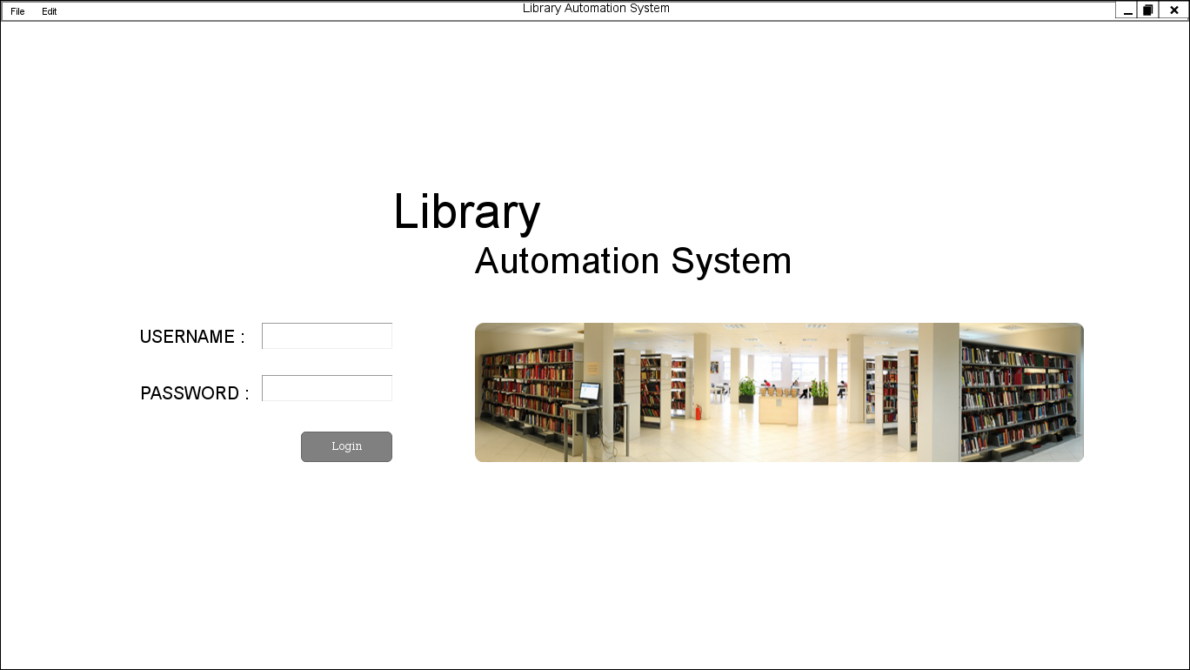Figure 1 shows the login screen.They were able to login to the system with the username and password of this interface user.

**Figure-1 Login Screen**

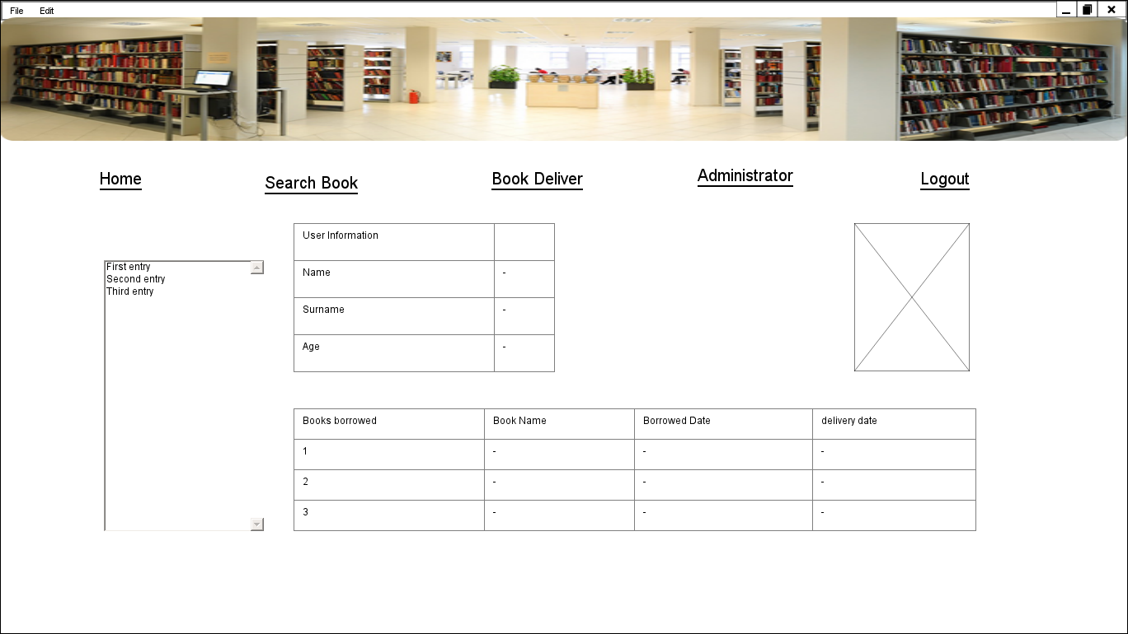Figure 2 shows the home page. This page also contains information about the user, which books you have, and books available at the library.

**Figure-2 Home Page**

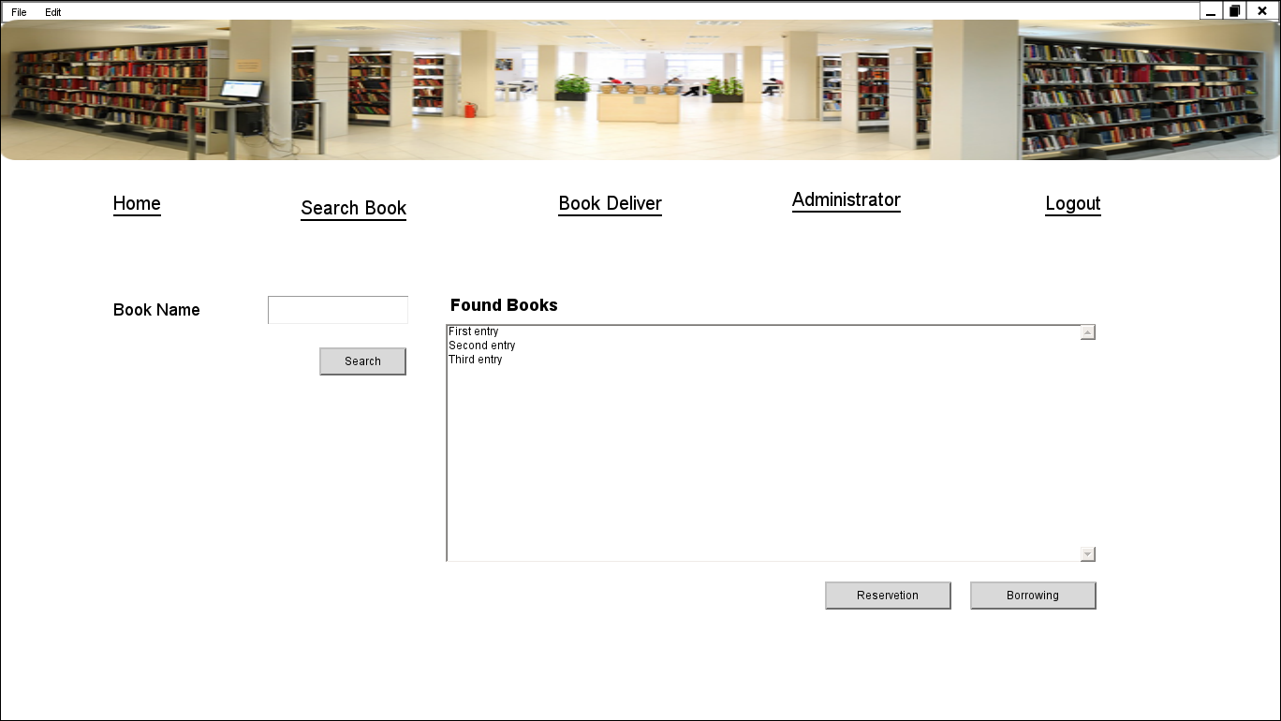Figure 3 shows the book search screen. Here you can search by the name of the book you want. If the book is available, you can borrow the book from here.

**Figure-3 Search Books Page**

Figure 4 shows the book delivery screen. If the book does not have a penalty, the book can be returned.

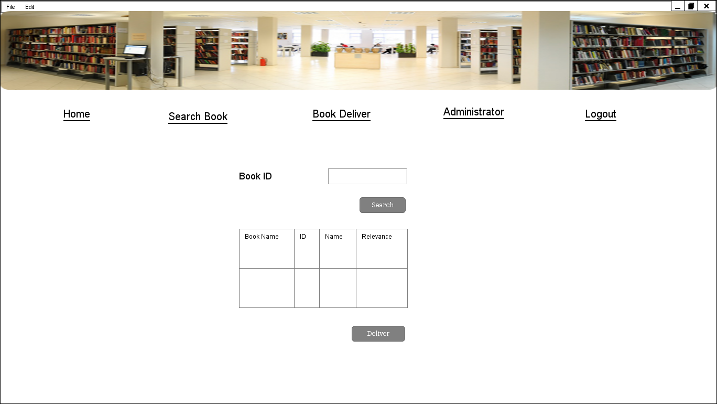

**Figure-4 Book Deliver**

Figure 5 is the admin page. Only users with administrator ID can login here. Administrators can add users. You can add books. The book can ignore the fines.

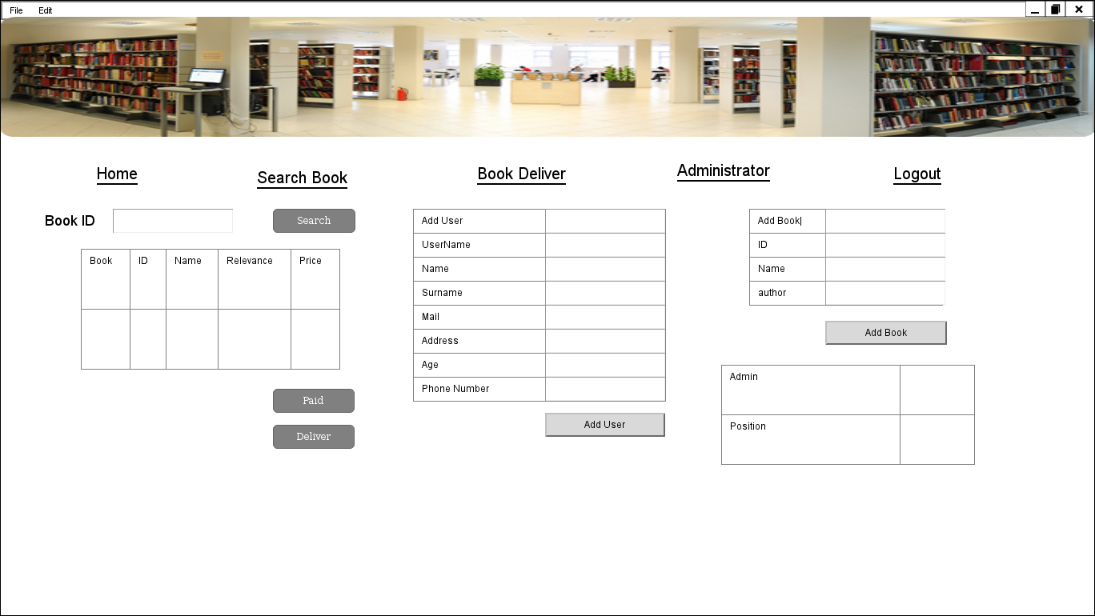

**Figure-5 Administrator**

All interfaces can be switched and Log Out button can be used to exit the system.

### Look & Feel

The user interface will be a simple design. No background color is planned in the design. It is a simple color that people like to use.

### Layout and Navigation Requirements

The user has to login in order to use the system. When a user logs in to a manager, he or she can go to the administrator's account and perform actions.

### Consistency

In this system, books can be borrowed, received books can be returned and books can be reserved.

### User Personalization & Customization Requirements

A common interface is designed in the system. The administrator page will not be able to login except for the administrators.

## Interfaces to External Systems or Devices

It is a desktop application. It is a single application connected to computers that can connect to each other.

### Software Interfaces

It is planned to use java in the coding phase of the system.

### Hardware Interfaces

### Communications Interfaces

A system connected to the main system and loaded with the application is required.

# Business Rules

## < Borrowing books>

### < Money Penalty >

A user can borrow a book for a maximum of 15 days.15 Anyone who holds more than one day will be fined for the penalty. He can not borrow or return books from the system without paying the penalty.

### <Maximum of Book Count>

Users can not borrow more than 3 books at the same time.

## < User Account>

### < Creating Account >

Only one account is opened from a mail. Account opening is done by an administrator.

### < Delete Account >

Administrators are responsible for user deletion. Do not delete a user's own account.

# System Constraints

The desktop application will be able to be used on interconnected computers in the system that will be. Devices that are not connected to the system can not reach the system and do not operate.

# System Compliance

## Licensing Requirements

In the software phase, java will be used. Since Java is open source, no license is required.

## Applicable Standards

In the project, software architects will be tried to be tracked and production costs will be reduced. For unexpected situations in the project, architectural changes can be made during the construction phase, and architecture can change according to the endings received.

# System Documentation

To inform the users, a usage document will be prepared for the purpose. This document will explain how each interface is used and provide information on important points.