**Register Account**

<http://landrick.react.themesbrand.com/auth-signup>

Password they create should have 8-character length,

One capital letter, 1 numeric, 1 symbol minimum  
we don’t need social media signup , please remove those

In mobile version remove the image

Once user click register,

user need to verify their email

SELECT * FROM `users` this is where these info need to be saved

confirmed_email = 0 <= email not verified

SELECT * FROM `users_log` log the IP address of login

log_type=1 when user login to the account

The password should be encrypted most secured way

**Verify Email**  
<http://landrick.react.themesbrand.com/email-confirmation>

Once user verify their account, take them to account page

verification link should work for 2 hour

After verification done,

confirmed_email = 1

On next page, customer need to enter their phone and address to complete the registration. Use google place API integration to autofill the address when user enter street address.

**Login Page**

<http://landrick.react.themesbrand.com/auth-login>

SELECT * FROM `users` WHERE approved=1

users those are approved=1 can login to the account,  
otherwise, “Contact support before you login”

confirmed_email = 0 can also login to their account but, they will see   
<http://landrick.react.themesbrand.com/email-confirmation>  
email not verified page.

If the user attempt login and failed 3 times, user should solve google captcha

SELECT * FROM `users_log`

log_type=2 <= this means, failed attempt

In mobile version remove the image showing in the left

every user logs should be logged with their IP, user_agent in a table.

every failed attempt should be logged with their IP, user_agent in a table

**Forget password/Recover Account**

<http://landrick.react.themesbrand.com/auth-re-password>

In mobile version remove the image

Once the user enter the email address to reset account, it should show up a message  
“If this email registered in our account, we’ll send the reset password link.”

user need to solve captcha to sent the reset link

forget password need to be logged in a table

Reset password link need to expire after 15 minute.

the reset code should contain mix of numbers and letters to avoid bruteforce attacks. (10 characters in total)  
and the reset link should contains md5 hash (encrypted form of reset code).  
SELECT * FROM `users_log`

log_type=3 <= reset password requested

**Reset link**

When user click on the link they receive, this page need to show up

<http://landrick.react.themesbrand.com/email-password-reset>

SELECT * FROM `users_log`

log_type=4 <= password resetted.

**Account**

<http://landrick.react.themesbrand.com/page-profile>

**All Navigations list:**

**Profile =** details of account

**Subscription =** list of subscribed packages

**Device =** list of user devices

**Wishlist =** list of products that user added to wishlist from the shop

**Payment =** user can edit the card payment details here

**Bills** = list of all the purchased list

**Support =** support tickets

**Settings =** account settings, user can edit

In mobile version, these navigation buttons are not showing. we need this

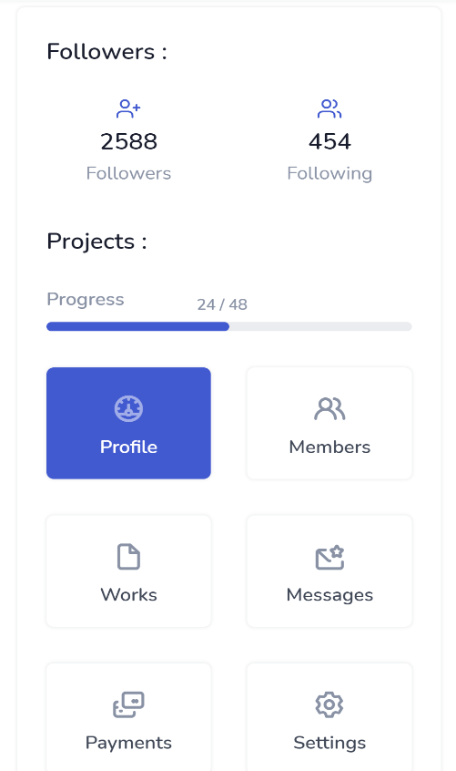

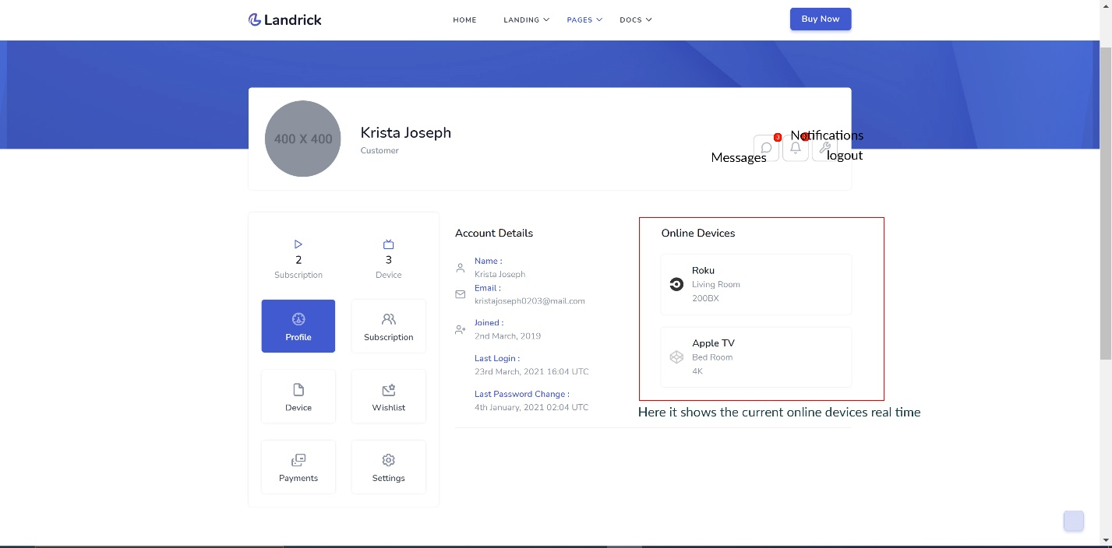

devices that are online is

SELECT * FROM `user_login` WHERE `user_id` = '16' AND token_expire >= [current timestamp]  
  
it means device is online.

**Subscription**

you can use this “product card” widget from <http://landrick.react.themesbrand.com/widget>

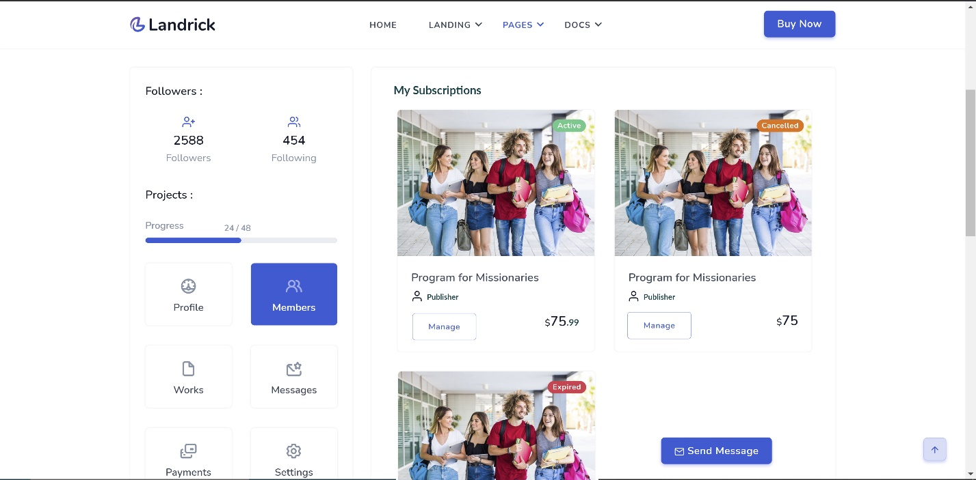

SELECT * FROM `users_subscription`

When user click on **manage** button this shows up

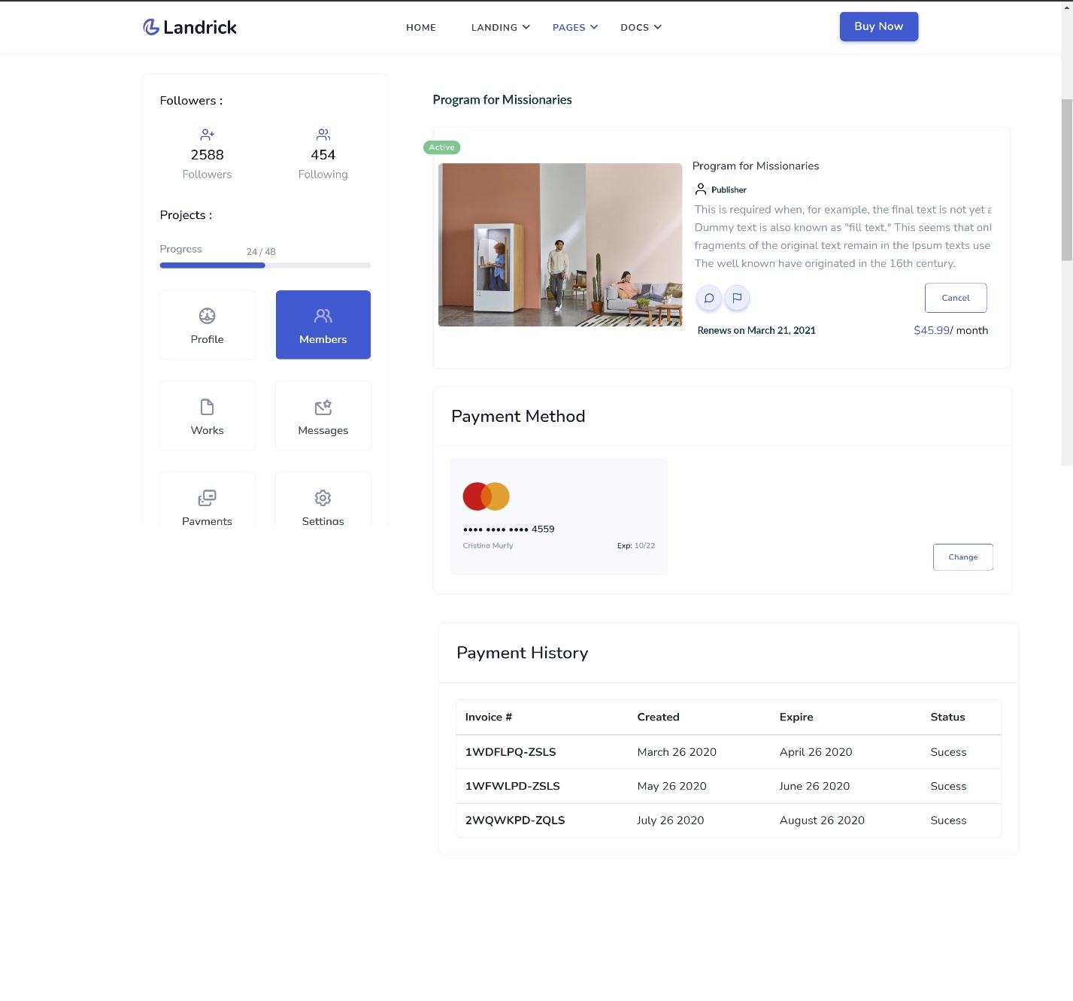

if its paypal purchase, change button shouldn’t be there because we can’t change paypal account.

When user click on Invoice <http://landrick.react.themesbrand.com/page-invoice>

About circle buttons “message” and “flag”

**“message”:** this allows the user to communicate directly with the **publisher, when** user click on the message button, a modal pop-up shows up, user can enter select the issue and type their message and sent.

**“flag”** : this allows the user to flag down the product to the site admin. when user flag the product, it show up pop-up modal asking to enter what type of flag.   
options are,

Hateful or abusive content

Sexual content

Copyrighted contents/DMCA

Misleading contents

user can also describe the issue and when they send, it will be sent to site admin

I haven’t created any table for this case.

**Wishlist**

Same page like **subscription** but we don’t need manage button and active, expired, cancelled badges. instead put a heart broken icon

SELECT * FROM `product_wishlist`

**Payment**<http://landrick.react.themesbrand.com/page-payments>

user can add, change the card details or delete it from stripe.  
for paypal, user can’t change anything, so if it’s a paypal payment. edit, delete option should be disabled.

**Account settings**

<http://landrick.react.themesbrand.com/page-profile-edit>

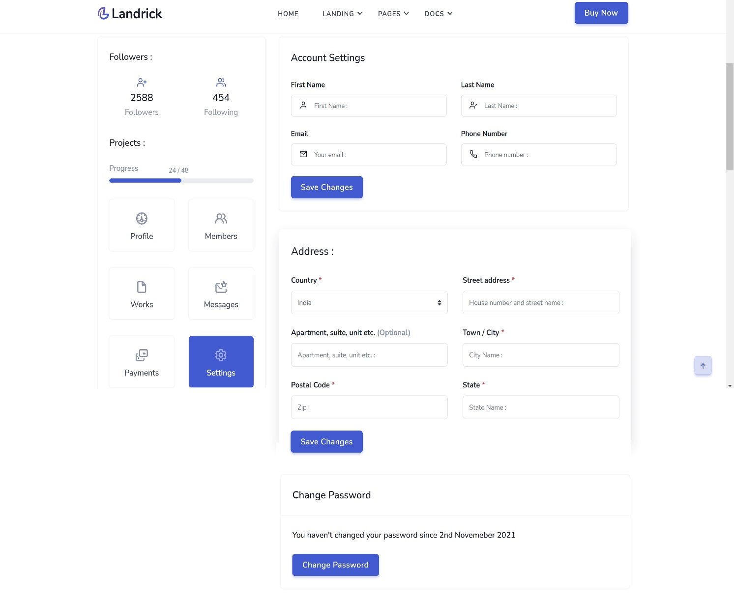

On each save changes, make sure to ask to re-enter password in modal

before inserting, save the previous information to SELECT * FROM `users_changes`

**Device**

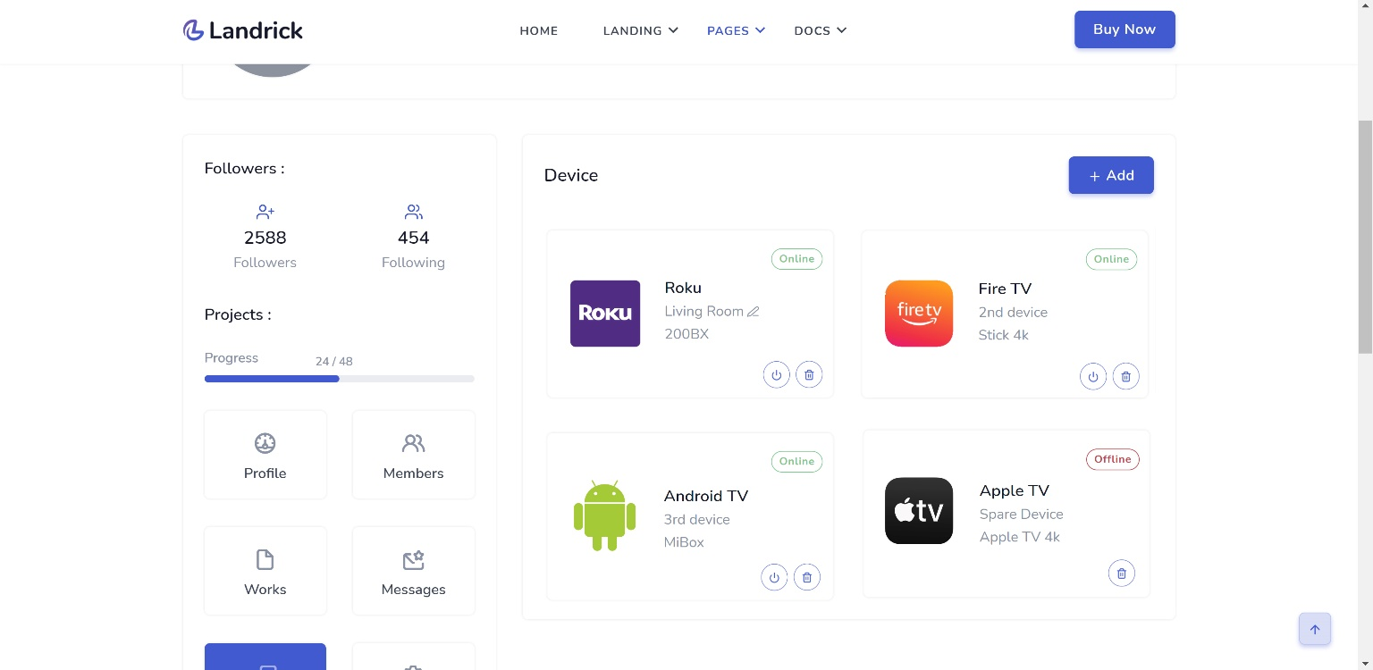

Here it will list all the device user have available. User can add a new device by clicking on the add button , it will show up modal pop-up asking to enter the name of the device. user can put Living room for example, on the next column, user input the code.  
once that’s done, device show up.  
  
user can rename the device by hover over the living room, it will show pen icon there and user can rename it to something else later.  
  
the circle button first button is logout, when user press logout, it show up, Are you sure, you want to logout the session ?  
if user press “Yes” it ask to enter password of the account.  
  
the circle button 2nd, (trash icon) is the de-link button, when user click on that, it will delete the device from the account.

notice that, offline device don’t need logout button, please make sure not to put logout button in offline device.

SELECT * FROM `user_device` WHERE `user_id` = '16' AND status = "1" AND approved= "1"

**Online/Offline Status: if the device serial showing up a result**

SELECT * FROM `user_login` WHERE `user_device_serial` = '85d266b0567ceb92' AND `user_id` = '16' limit 1

it means device is online.

if the device not found in the result, it means offline

**Logout button** : delete from user_login where user_id = 16 and user_device_serial = ac85b5d120eb3775 limit 1

**Delink button:** delete from user_device where user_id = 16 and user_device_serial = ac85b5d120eb3775 limit 1

if user delink the device, put that device info to this table user_device_changes

**Bills**

Same table we put on manage subscription page,  
instead of putting expire, we put the product name there.

**Support**

integrate a support ticket system. we can discuss about this

**Shop**

http://landrick.react.themesbrand.com/shop-grids

for product card, we can use the same we used on subscription page  
<http://landrick.react.themesbrand.com/widget>

remove rating, 30 students, 5 lesson.  
In there we put add to wish list or checkout icon  
we don’t need cart functionality   
clicking on the product directly take them to checkout page

You can get the categories from here:

SELECT * FROM `product`

Identify the category and show it using product id:

SELECT * FROM `publisher_package` WHERE `product_id` = '2'

If the column package_hidden = 1 Don’t show the product on store

If the column package_enable = 0 Don’t show the product on store

If the column super_package = 1 Don’t show the product on store

**Checkout**

<http://landrick.react.themesbrand.com/shop-checkouts>

it autofill the user account name, address, phone already.  
user can change if their billing address is different.

after purchasing an email need to be sent with <http://landrick.react.themesbrand.com/email-invoice>

this link