Notes on training our first Convolutional Autoencoder:

First Model:
Model: "model"
_________________________________________________________________
Layer (type) Output Shape Param #
=================================================================
input_1 (InputLayer) [(None, 64, 64, 1)] 0
_________________________________________________________________
conv2d (Conv2D) (None, 32, 32, 64) 576
_________________________________________________________________
batch_normalization (BatchNo (None, 32, 32, 64) 256
_________________________________________________________________
re_lu (ReLU) (None, 32, 32, 64) 0
_________________________________________________________________
conv2d_1 (Conv2D) (None, 16, 16, 32) 18432
_________________________________________________________________
batch_normalization_1 (Batch (None, 16, 16, 32) 128
_________________________________________________________________
re_lu_1 (ReLU) (None, 16, 16, 32) 0
_________________________________________________________________
conv2d_2 (Conv2D) (None, 8, 8, 32) 9216
_________________________________________________________________
batch_normalization_2 (Batch (None, 8, 8, 32) 128
_________________________________________________________________
re_lu_2 (ReLU) (None, 8, 8, 32) 0
_________________________________________________________________
conv2d_transpose (Conv2DTran (None, 16, 16, 32) 9216
_________________________________________________________________
batch_normalization_3 (Batch (None, 16, 16, 32) 128
_________________________________________________________________
re_lu_3 (ReLU) (None, 16, 16, 32) 0
_________________________________________________________________
conv2d_transpose_1 (Conv2DTr (None, 32, 32, 32) 9216
_________________________________________________________________
batch_normalization_4 (Batch (None, 32, 32, 32) 128
_________________________________________________________________
re_lu_4 (ReLU) (None, 32, 32, 32) 0
_________________________________________________________________
conv2d_transpose_2 (Conv2DTr (None, 64, 64, 1) 288
_________________________________________________________________
batch_normalization_5 (Batch (None, 64, 64, 1) 4
_________________________________________________________________
re_lu_5 (ReLU) (None, 64, 64, 1) 0
=================================================================
Total params: 47,716
Trainable params: 47,330
Non-trainable params: 386
_________________________________________________________________
None
spec shape is (64, 64)

Detailed model definition:

def encoderCNN(inputs, layers):
""" Construct the Encoder
inputs : the input vector
layers : number of filters per layer """
x = inputs
# Feature pooling by 1/2H x 1/2W
for n_filters in layers:
x = Conv2D(n_filters, (3, 3), strides=(2, 2), padding='same', use_bias=False, kernel_initializer='he_normal')(x)
x = BatchNormalization()(x)
x = ReLU()(x)
return x
def decoderCNN(x, layers):
""" Construct the Decoder
x : input to decoder
layers : the number of filters per layer (in encoder)
"""
# Feature unpooling by 2H x 2W
for _ in range(len(layers) - 1, 0, -1):
n_filters = layers[_]
x = Conv2DTranspose(n_filters, (3, 3), strides=(2, 2), padding='same', use_bias=False,
kernel_initializer='he_normal')(x)
x = BatchNormalization()(x)
x = ReLU()(x)
# Last unpooling, restore number of channels
x = Conv2DTranspose(1, (3, 3), strides=(2, 2), padding='same', use_bias=False, kernel_initializer='he_normal')(x)
x = BatchNormalization()(x)
x = ReLU()(x)
return x

############
# The encoder
x = encoderCNN(inputs, layers)
# The decoder
outputs = decoderCNN(x, layers)

# the model
aeCNN = Model(inputs, outputs)

Inputs are numpy spectrograms 64 x 64

Note: The design of this model requires that the input dimensions each be a power of two!
This is because the convolutions have strides of (2,2) so that each successive convolution operates on an array that is half the dimensions of its input.

The current run (10/10/21) has as input some 23,500 spectrograms apportioned as:
# about 10 % of these 23,500 are reserved for testing the autoencoder after it is trained
x_train has length 21171
x_test has length 2404

The Python script orca-autoencoder-cnn.py reads in these spectrograms, sets up the model and then fits the output arrays to the input arrays in the x_train group of spectrograms.

After 1000 epochs, the Loss with respect to the x_test spectrograms is 0.535 and the Accuracy is 0.00093 .

(I have to figure out exactly what Tensorflow’s keras is reporting as Loss and Accuracy.)

This global evaluation of applying the trained model to the test spectrograms seems terrible.

But, take a look at the reconstructed spectrograms. Here are a bunch: These are in vertical triplets with the input above and the reconstruction below and the difference below that. The sum of the averaged pixel differences is noted and for comparison this is done for the input and the reconstruction and also for the following reconstuction.

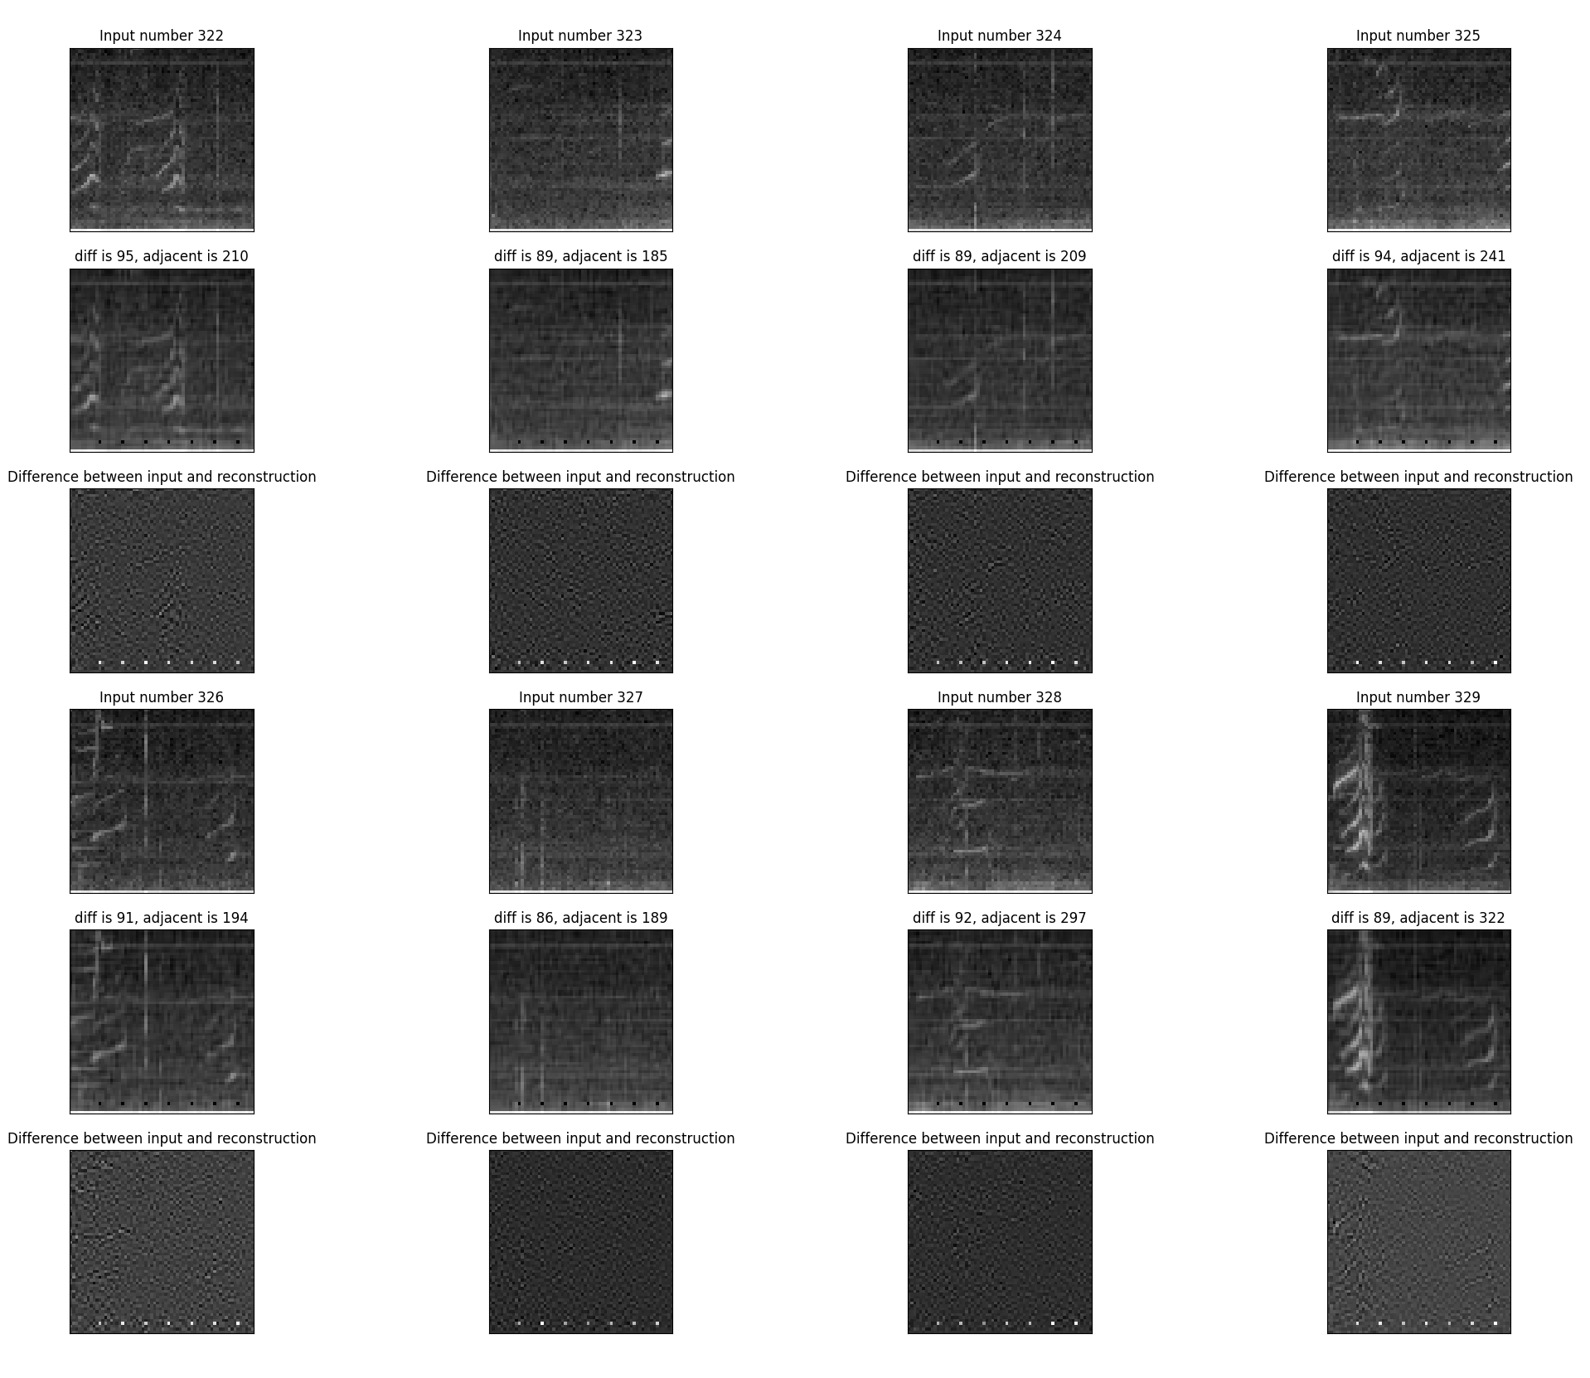
One can notice that the reconstructed images are a bit smeared compared to the somewhat pixelated input spectrograms.

I wonder what causes the low frequency ‘artifacts’ seen in the difference images.

