Website Development Document
by Yikun Xian

1. Technology Overview
This website consists of static web pages without backend web server and database supported. Main front-end technologies are listed below.
Language: | HTML, CSS, JavaScript
UI Framework: | Bootstrap v3.3.5
MVC Framework: | AngularJS v1.4.8
Data Format: | JSON

2. How to change page content
Contents on pages can be updated in two ways: either directly editing HTML file located in “pages/” directory, or modifying JSON-format file located in “data/” directory. One simple example of JSON-format file looks like following:
[
{
“key_1”: “value_1”,
“key_2”: “value_2”,
…
“key_n”: “value_n”
},
{
“key_1”: “value_1”,
“key_2”: “value_2”,
…
“key_n”: “value_n”,
},
…
{
“key_1”: “value_1”,
“key_2”: “value_2”,
…
“key_n”: “value_n”,
}
]
where square bracket “[]” defines a list, curly bracket “{}” defines key-value pairs, and double quotes “” defines a string. Notice that each item inside “[]” or “{}” must be separated by a comma “,”, except that the last item must not end with a comma “,”.

2.1 Home page
All contents on this page can be found in “pages/home.html”. Just open this file with your favorite text editor and modify the content.

2.2 Publication page
Each record of journal papers, magazine articles and conference papers are respectively stored in “data/journal.json”, “data/magzine.json” and “data/conference.json”.
To append one more record in journal list, open “data/journal.json”, go to the last line before “]”, append a comma to “}” of the last item, which should now look like “},”, and add following lines between this “},” and “]” by changing corresponding values. (DO NOT CHANGE KEYS: “author”, “title”, “link”, “source”)
{
“author”: “author names”,
“title”: “paper title”,
“link”: “PDF file name”,
“source”: “journal name”
}
Finally, place your PDF paper file under “files/” directory.
Perform the same actions to magazines and conferences to add more records.

2.3 Research page
For Sponsors/Collaborators part, edit “pages/research.html”.
For Projects part, edit “data/project.json”, where each record contains four keys:
{
“title”: “project name”,
“content”: “project description”,
“figure”: “project figure name”,
“link”: “project link (can be empty)”
}
where project figure should be placed under “img/” directory.

2.4 Teaching page
Edit “data/course.json”, where each record contains three keys:
{
“title”: “course name”,
“content”: “course description”,
“figure”: “course figure name”
}
where course figure should be placed under “img/” directory.

2.5 Students page
For Group Members part, edit “data/member.json”, where each record contains five keys:
{
“name”: “member name”,
“intro”: “member introduction”,
“avatar”: “member figure name”,
“publication”: [],
“honor”: []
}
where member avatar image should be placed under “img/” directory. Values for publication and honor are also lists. Each item in publication list is the same as the previous publication item. Each item in honor list is just a string. Both publication list and honor list can be empty.
For Event part, edit “data/event.json”, where each record contains three keys:
{
“title”: “event name”,
“content”: “event description”,
“figure:”: “event figure name”,
}
where event figure must be placed under “img/” directory if the figure name specified. The figure name can also be empty.
For Graduate Assistantship Opportunity part, please directly edit “pages/student.html”.

2.6 Useful materials page
Edit “pages/material.html”. The attachment is placed under “files/” directory.

3. How to use RCI
Since RCI server is running Linux, it is recommended to connect to it via SSH. For detail, please refer to https://oit-nb.rutgers.edu/documentation/remote-access-ssh-and-sftp.
After the website has been updated on your local computer, the source code needs to be uploaded to RCI server. The following is one example to update codes for EDEN server, which is similar to RCI server:
a) Suppose our local source code is already packed into “webpage.zip”, using “scp” command to copy it to “public_html” directory of eden server:
scp webpage.zip yx150@eden.rutgers.edu:~/public_html/
where “yx150” shall be changed to your netid and “eden” to “rci”. Then, the eden system will ask for password for your netid account. So just type your password. (character will not show!)
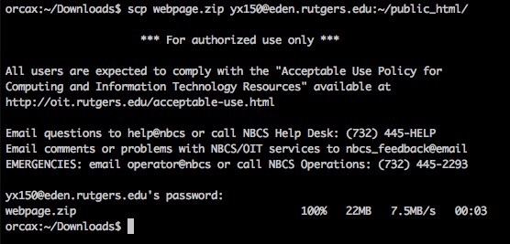

b) Now connect to eden via SSH command:
ssh yx150@eden.rutgers.edu
You will be asked for password again. Some prompt messages will be like this:
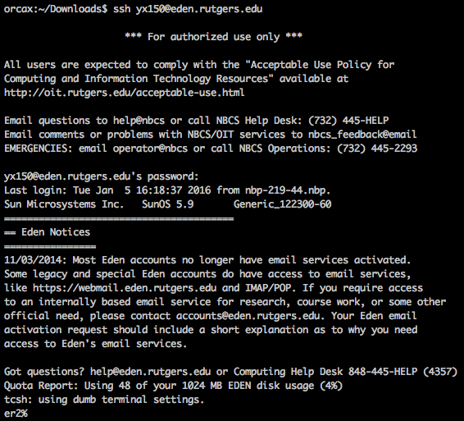

3) Use command “ls” to list files and folders under current directory and “cd” to change to specified directory, and “unzip” command to extract source code to that folder:
cd public_html
unzip webpage.zip
If you are asked to replace original file, type “A” to override them all.
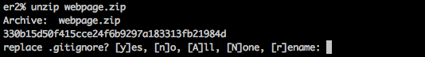

4) Type following commands “public_html” directory to change source code file/folder accessibility.
chmod 755 *
chmod 644 index.html css/* data/* files/* fonts/* img/* js/* pages/*
chmod 755 js/lib
chmod 644 js/lib/*

5) Type command “exit” to log out of eden. Refresh page in your browser and view your updated website!

