<https://www.specbee.com/blogs/introduction-php-standard-recommendation-psr#:~:text=PSR%2D4%20(Autoloading%20Standard)&text=The%20fully%20qualified%20class%20name%20MUST%20have%20a%20terminating%20class,combination%20of%20lowercase%20and%20uppercase>.

For PSR0, <https://www.sitepoint.com/battle-autoloaders-psr-0-vs-psr-4/#:~:text=PSR%2D0%20looks%20at%20the,%2FZend%2FMail%2FMessage>.

PSR-0 looks at the namespace of a class and discerns its location on the hard drive from that bit of information. For example, the class \Zend\Mail\Message would lead to /path/to/project/lib/vendor/Zend/Mail/Message.php.

PSR-0 also supports underscores in the class names as an alternative, to make transitioning from 5.2 and earlier easier. Zend_Mail_Message would also lead to /path/to/project/lib/vendor/Zend/Mail/Message.php.

touch composer.json

{

"autoload": {

"psr-4": {

"CodeCourse\\" : "src/"

}

}

}

Create directories and files like this:

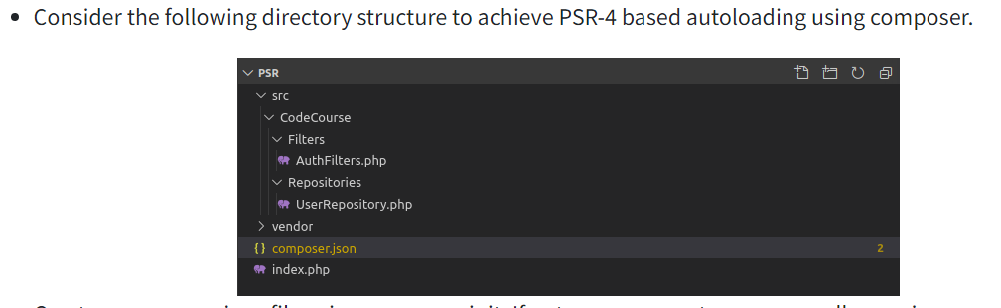

The above one is wrong because src/CodeCoure should be removed

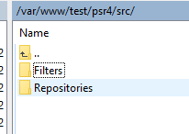

src/Filters/AuthFilters.php

<?php

namespace CodeCourse\Filters;

class AuthFilters

{

public function __construct()

{

echo "AuthFilters";

}

}

src/Repositories/ UserRepository.php

<?php

namespace CodeCourse\Repositories;

class UserRepository

{

public function __construct()

{

echo "Hello";

}

}

install autoloading files

composer dump-autoload -o

this will generate the directory and files like this:

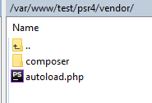 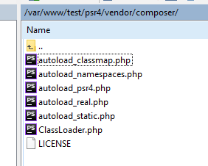

Create index.php

<?php

use CodeCourse\Repositories\UserRepository as UserRepository;

use CodeCourse\Filters\AuthFilters as AuthFilters;

require_once __DIR__ . '/vendor/autoload.php';

$user = new UserRepository();

$filter = new AuthFilters();

//This echoes "Hello AuthFilters"

Php index.php