[select](http://184.168.125.174/phpmyadmin/url.php?url=https://dev.mysql.com/doc/refman/5.5/en/select.html) * from sales_order_item where order_id=6859

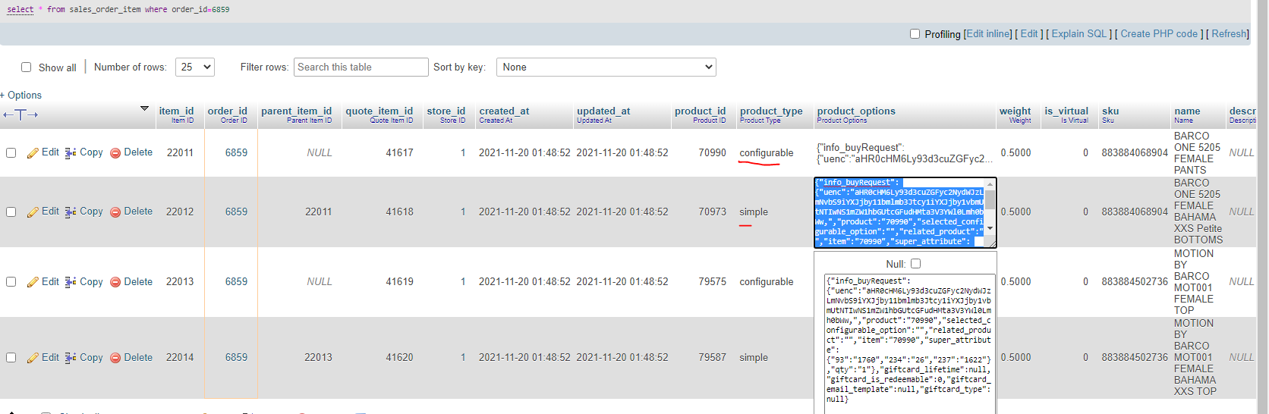

The following is product_options for simple product

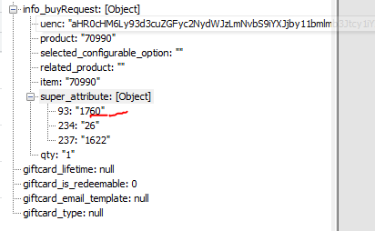

The following is product_options for configurable product

