Find key characters from Amazon Sales Dataset:
Title Page
- Dataset Name: Amazon Sales Dataset
- Team Members: Orchlon Chinbat, Magnus Hayden, Michael Whitefoot
Introduction
- Dataset description:
The dataset contains 1,465 Amazon products with 16 attributes including product details (ID, name, category), pricing information (discounted price, actual price, discount percentage), customer feedback (ratings, rating count, reviews), and user information (user ID, username). The data is nearly complete with only 2 missing values in the rating_count field. Key features include both numerical data (prices, ratings) and categorical data (product categories, review text) suitable for classification and clustering analysis.
Results
Part1: KNN and K mean - Orchlon
Question 1: What is the optimal K value for predicting product rating categories based on price and customer engagement using K-Nearest Neighbors?
Result Figure:
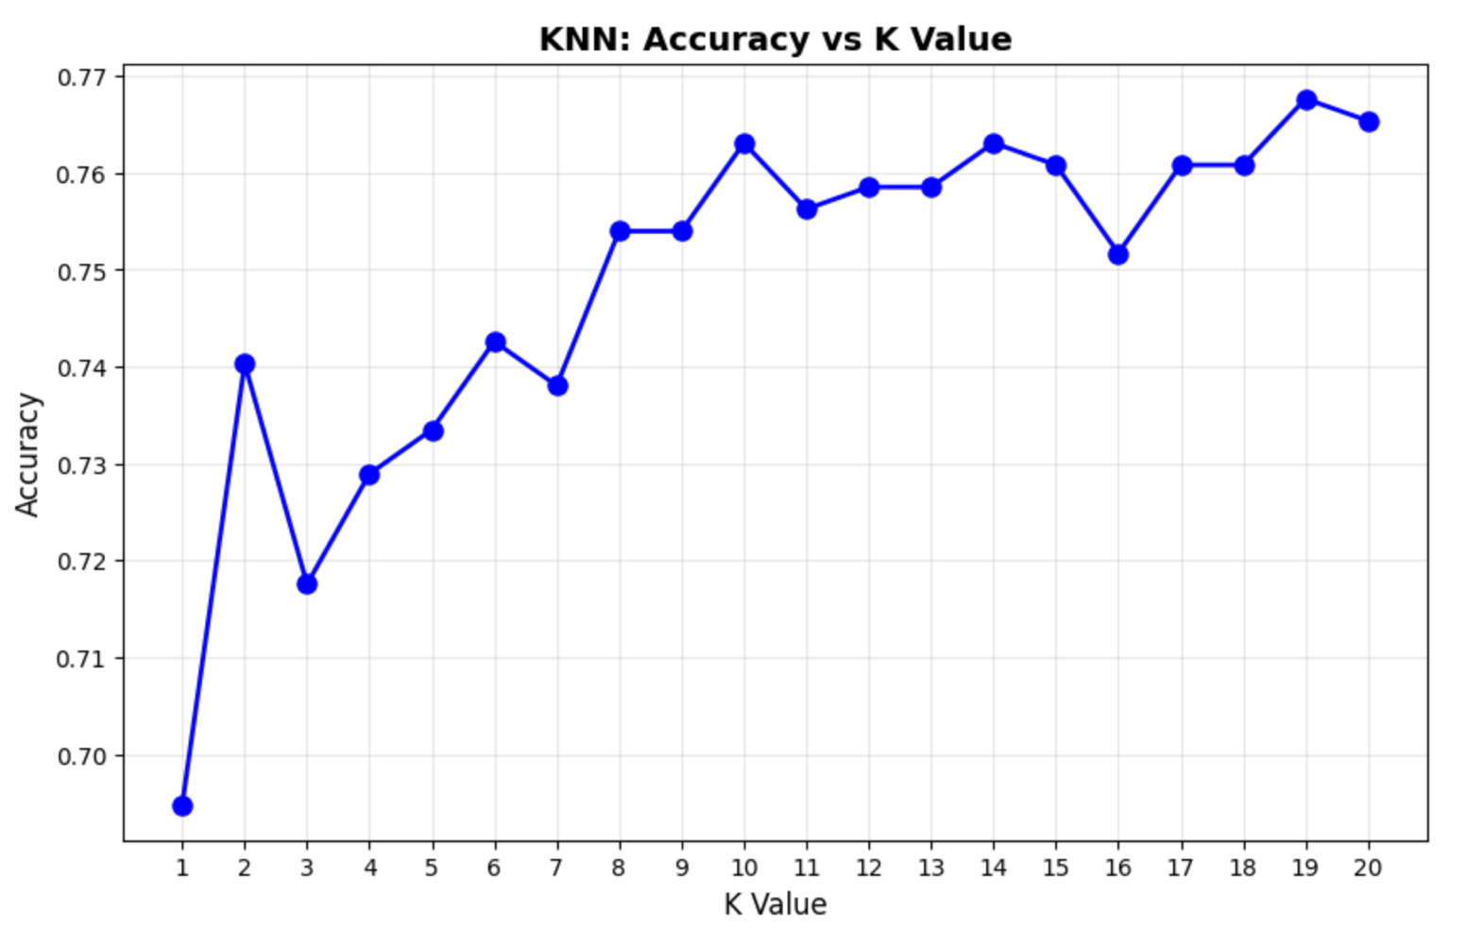

Explanation:

1. Purpose
To find the optimal K value for the KNN classifier that best predicts product rating categories.

2. Methodology
- Test K values from 1 to 20
- Train a KNN model for each K value
- Calculate accuracy on test data for each model
- Identify the K with highest accuracy

3. Graph Explanation
- X-axis: K value (number of neighbors, 1 to 20)
- Y-axis: Classification accuracy (0 to 1 or 0% to 100%)
- Line plot: Shows how accuracy changes as K increases

4. Key Highlights
- Best K value: 19 neighbors
- Best accuracy: 76.77%
- Accuracy generally improves and stabilizes as K increases
- Helps avoid overfitting (low K) or underfitting (very high K)

Question 2: What is the classification performance of KNN in predicting product rating categories?
Result figure:
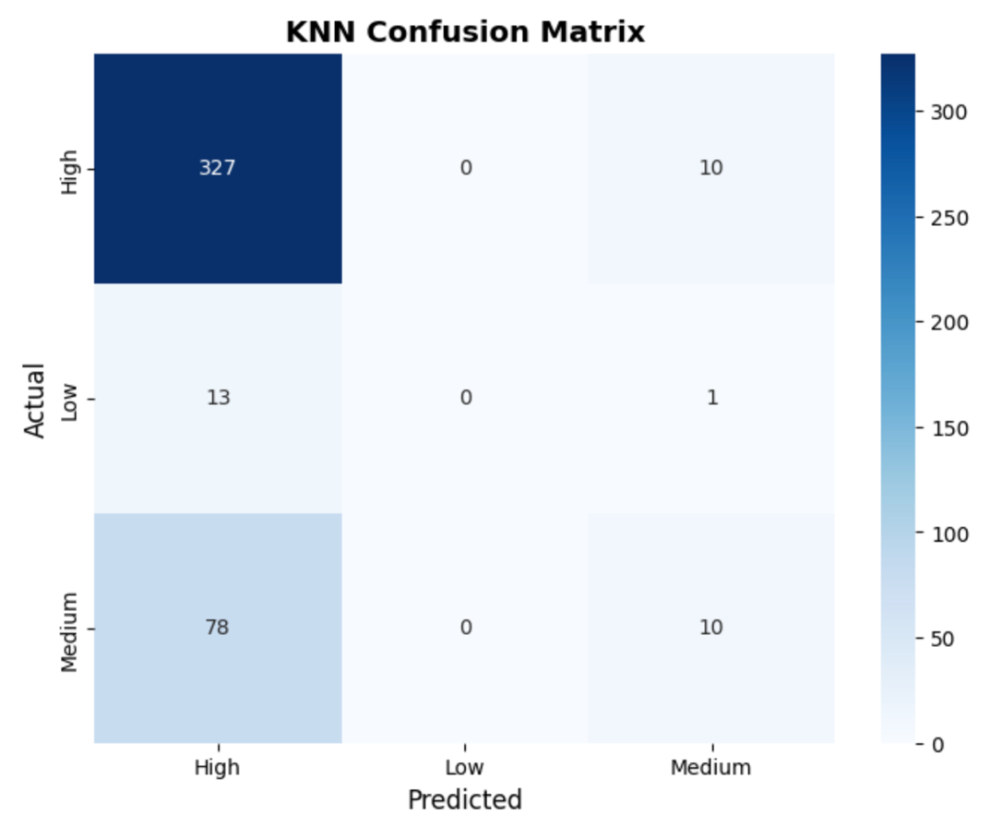
Explanation:

1. Purpose
To evaluate the final KNN model's performance and identify which rating categories are correctly or incorrectly classified.

2. Methodology
- Train KNN model with optimal K (19 neighbors)
- Make predictions on test data
- Generate classification report (precision, recall, F1-score)
- Create confusion matrix visualization

3. Graph Explanation
- Confusion Matrix Heatmap
- Rows (Y-axis): Actual rating categories
- Columns (X-axis): Predicted rating categories
- Cell values: Number of products in each actual/predicted combination
- Diagonal cells: Correct predictions
- Off-diagonal cells: Misclassifications

4. Key Highlights
- Overall accuracy: 76.77%
- High ratings: 97% correctly identified (337 products)
- Medium ratings: Only 11% correctly identified (poor performance)
- Low ratings: 0% correctly identified (complete failure)
- Model performs well for "High" category but struggles with minority classes
Question 3: What is the optimal number of clusters to group Amazon products based on their pricing and rating characteristics using K-Means clustering?
Result figure:
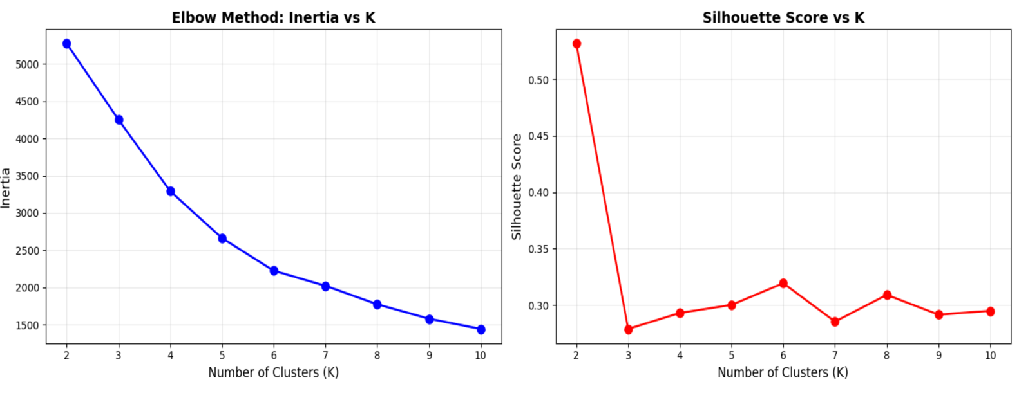

Explanation:

1. Purpose
To determine the optimal number of clusters (K) for grouping Amazon products based on pricing and rating features.

2. Methodology
- Test K values from 2 to 10 clusters
- Apply K-Means clustering for each K value
- Calculate two metrics: Inertia and Silhouette Score
- Use Elbow Method and Silhouette analysis to find optimal K

3. Graph Explanation
Two side-by-side plots: Left Plot (Inertia):
- X-axis: Number of clusters (K = 2 to 10)
- Y-axis: Inertia (within-cluster sum of squares)
- Lower inertia = tighter clusters
Right Plot (Silhouette Score):
- X-axis: Number of clusters (K = 2 to 10)
- Y-axis: Silhouette Score (0 to 1)
- Higher score = better-defined clusters

4. Key Highlights
- Best K value: 2 clusters
- Best silhouette score: 0.5319 (moderate cluster quality)
- Inertia decreases as K increases (expected pattern)
- Two distinct product segments identified in the dataset
- Simple segmentation suggests clear market division

Part 2: Statistical question:
Question: Which product categories have the highest rating counts?
Result figure: 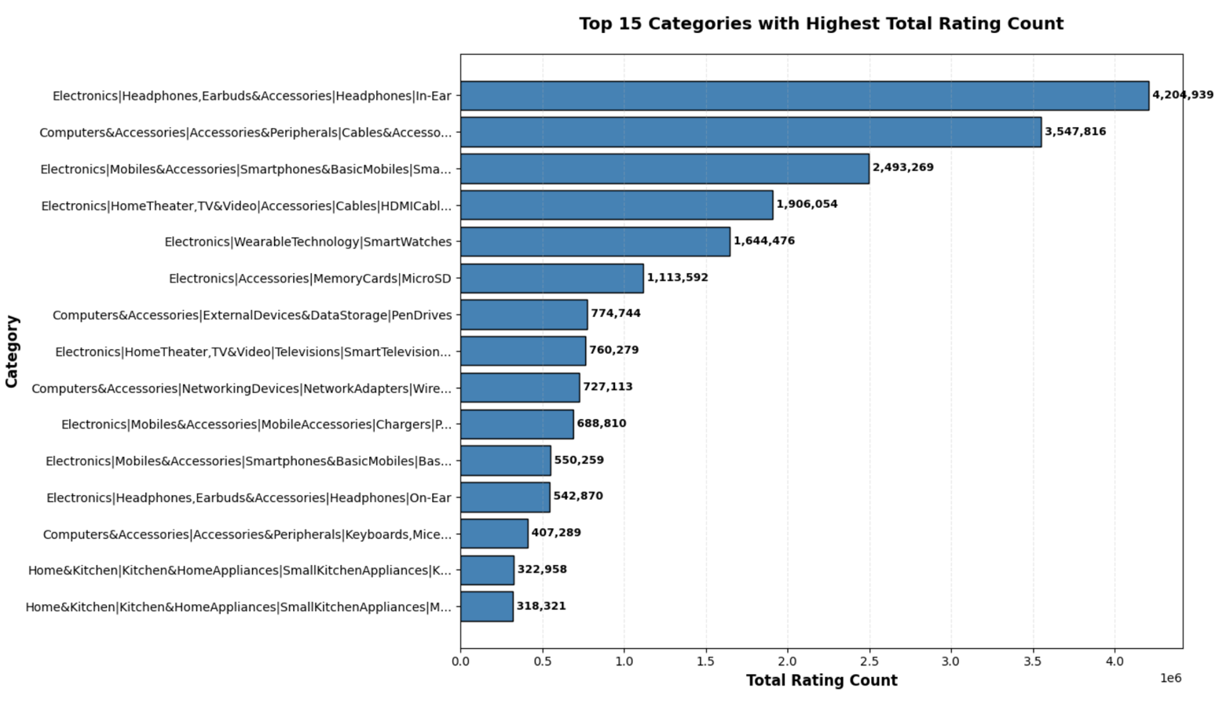
Explanation:

1. Purpose
To visualize and compare which product categories have the highest total customer engagement (rating counts).

2. Methodology
- Select top 15 categories with highest total rating counts
- Create horizontal bar chart
- Add value labels on each bar for exact counts
- Shorten long category names for readability

3. Graph Explanation
- Horizontal Bar Chart
- X-axis: Total Rating Count (customer engagement volume)
- Y-axis: Product categories (top 15)
- Bars: Length represents total rating count for each category
- Labels: Exact count values displayed on each bar

4. Key Highlights
- Top category: In-Ear Headphones (~4.2M ratings)
- USB Cables ranked 2nd (~3.5M ratings)
- Smartphones ranked 3rd (~2.5M ratings)
- Electronics and accessories dominate top positions
- Clear visual hierarchy showing engagement concentration in specific categories

[Part2: xxx] for Student B
[Question4]: [Define your data mining question]
[Your Figure]

[Your explanation: 1. Purpose, 2. Methodology, 3. Explain the graph (e.g. what is x axis, what is y axis), 4. Harvest Highlights.]

[Question5]: [Define your data mining question]
[Your Figure]

[Your explanation: 1. Purpose, 2. Methodology, 3. Explain the graph (e.g. what is x axis, what is y axis), 4. Harvest Highlights.]

[Question6]: [Define your data mining question]
[Your Figure]

[Your explanation: 1. Purpose, 2. Methodology, 3. Explain the graph (e.g. what is x axis, what is y axis), 4. Harvest Highlights.]

[Part3: XXX] for Student C
[Question7]: [Define your data mining question]
[Your Figure]

[Your explanation: 1. Purpose, 2. Methodology, 3. Explain the graph (e.g. what is x axis, what is y axis), 4. Harvest Highlights.]

[Question8]: [Define your data mining question]
[Your Figure]

[Your explanation: 1. Purpose, 2. Methodology, 3. Explain the graph (e.g. what is x axis, what is y axis), 4. Harvest Highlights.]

[Question9]: [Define your data mining question]
[Your Figure]

[Your explanation: 1. Purpose, 2. Methodology, 3. Explain the graph (e.g. what is x axis, what is y axis), 4. Harvest Highlights.]

Overview
[Summarize at least three findings that you feel are most worth reporting.]
Contributions
[Student A, describe your responsibility in this project with details, mention what the methodology you use, what the big challenge you meet.]

[Student B, describe your responsibility in this project with details, mention what the methodology you use, what the big challenge you meet.]

[Student C, describe your responsibility in this project with details, mention what the methodology you use, what the big challenge you meet.]

