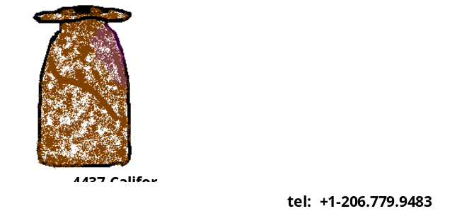

I have been making pots for many years and successfully built my reputation as an artist through yearly shows and gallery openings in Northern California until 1989. The patrons who collect my work have brought it to Japan, New Zealand, Australia and many other areas of the United States. After a 12-year hiatus, and relocating to Seattle, I began my work newly in 2000.

My work, particularly the surface decoration, is inspired by the colors and textures found in nature (with my love of Japanese and Italian ceramics as a contributing factor) . I am passionate about, challenged and delighted by, and fulfilled in my work. Each piece is unique – one of a kind. They are fired to Cone 6 (approximately 2200 degrees), and are safe for food and beverages. They can safely be washed by hand with soap and water, or in the dishwasher.

My studio is located at Earthworks, The Pottery School of West Seattle, 4733 California Avenue S.W., Seattle, WA
98116. (206) 779-9483.

