Chris Orcutt
Computer Science
University of California, Los Angeles
March 18, 2016

Pervasive Connectivity
Classifying Supporters & Opponents of Governmental Surveillance Programs

CS170A: Mathematical Modeling and Methods for Computer Science
Professor Stott Parker
Abstract
In this paper, I investigate public sentiment of governmental surveillance programs using the Pervasive Connectivity dataset provided by the Pew Research Center. The dataset was obtained via phone interview from August 7, 2013 to September 16, 2013 and consists of a sample of 1,801 adults residing in the United States. The dataset was analyzed using Principal Component Analysis using Numpy, a scientific computing library written in the Python programming language. Principal component analysis did not yield data separation; therefore, I was unable to reach any significant conclusion about public sentiment of governmental surveillance.

1 Dataset

The Pervasive Connectivity dataset is authentic and provided by a reputable source. The dataset was collected by Princeton Survey Research Associates International via phone interview from August 7, 2013 to September 16, 2013. The phone interviews were conducted in both Spanish and English on adults (age 18 or older) currently residing in the United States. The dataset consists of 1,801 samples, 901 from landline and 900 from cellphone. The dataset was provided in .cvs format by the Pew Research Center and can be found at the following link: http://www.pewinternet.org/datasets/aug-7-sep-16-2013-pervasive-connectivity.

The Pervasive Connectivity dataset contains questions on people's opinions of governmental surveillance programs, their willingness to discuss such programs, and their Internet usage, with a focus on social media platforms. The phone survey consisted of 132 questions, some of which were optional dependent upon a respondent's answers to previous questions, leading to an incomplete dataset. Although the dataset did not explicitly categorize questions, I placed each question into one of the following categories: demographic, phone information, perceived control of life, Internet usage, social associations, governmental surveillance, fear of exclusion, miscellaneous. (The miscellaneous category contained insignificant questions and was not included in the analysis.)

1.1 Demographic

The demographic category consisted of questions regarding one's identity: sex, marital status, age, race, employment status, income, education, etc. The demographic category contained 13 questions.

1.2 Phone Information

The phone information category (containing 14 questions) consisted of questions concerning one's phone type (landline, cellphone, smartphone) and personal phone usage. For example:

Some cell phones are called “smartphones” because of certain features they have. Is your cell phone a smartphone such as an iPhone, Android, Blackberry or Windows phone, or are you not sure?

Some people attach photos to text messages. On an average day, about how many photos do you send and receive by text with other people using your cell phone?

1.3 Perceived Control of Life

The perceived control of life category (containing 10 questions) consisted of questions concerning how much someone felt in control over their life in the past 30 days. For example:

- In the last 30 days, how often have you been able to control irritations in your life – frequently, sometimes, hardly ever, or never?
- In the last 30 days, how often have you felt nervous and “stressed” – frequently, sometimes, hardly ever, or never?
1.4 Internet Usage

The Internet usage category (containing 43 questions) consisted of questions regarding how one accesses the Internet and how certain social media platforms (Twitter, Instagram, Pinterest, LinkedIn, Facebook) are used. For example:

- Do you ever use the Internet to use Twitter?
- Has anyone ever asked you to remove someone from your Facebook network, or has this not happened?

1.5 Social Association

The social association category (containing 12 questions) consisted of questions regarding whether one knew people who have gone through various events in the last 12 months. For example:

- Do you know someone who has been hospitalized or experienced a serious accident or injury?
- Do you know someone who has been fired or laid off?

1.6 Government

The government category (containing 22 questions) consisted of questions regarding one's view on governmental surveillance programs and their willingness to discuss such programs in various contexts. For example:

- Overall, how knowledgeable would you say you are about the debate surrounding these government programs aimed at collecting information about people’s calls, emails and other online communications?
- If the topic of the government’s surveillance programs came up at work, would you be very will coing, somewhat willing, somewhat unwilling, or very unwilling to join in the conversation?

1.7 Fear of Exclusion

The fear of exclusion category (containing 5 questions) consisted of questions regarding one's desire to fit into a group or fear of being excluded from a group. For example:

Does this describe you very well, somewhat, not much, or not at all?
- It is scary to think about not being invited to social gatherings by people I know.
- It is important to me to fit into the group I am with.

2 Analysis

Using principal component analysis, I tried finding a pattern in the dataset such that I could classify people by their support or opposition to governmental surveillance programs. I decided to split the data into categories (as mentioned in Dataset) in order to isolate the potential causes for support or opposition. As each category contained various questions and the dataset was not organized according to my categories, I first built a system to extract individual features from the overall dataset. This system allowed me to specify the features under observation and would then construct a subset of the dataset using the given features. Because the dataset was imperfect (containing blank fields and entries signifying "Don't Know" and "Refused"), I created a system to mask invalid entries. I then found the correlation matrix of the masked data subset. The correlation matrix was used as the scale for each feature was not consistent. Using the correlation matrix, I then computed the eigenvectors of the data subset using singular value decomposition. I extracted the first two principle components from the eigenvectors and then projected the masked data subset onto the principal components using the dot product. I then plotted the projected data, labeling each point based on the degree to which the respondent supported or opposed governmental surveillance programs, which was determined using the following question:

Thinking about the debate over the U.S. government's surveillance programs. Do you highly favor, favor, oppose, or highly oppose a government program to collect nearly all communications in the U.S. as part of anti-terrorism efforts?

3 Results

After running principal component analysis on each of the categories mentioned in Dataset, it became clear that classification of support or opposition of government surveillance programs on this specific dataset using principal component analysis would be impossible. Although each data subset was projected onto its principal components, the data did not separate in any distinguishable way.

For each category (demographic, phone information, perceived control of life, Internet usage, social associations, governmental surveillance, fear of exclusion), I graphed five projections. The first four graphs (the group of small graphs) plot the individual projections of each class (highly in favor, in favor, opposed, highly opposed). It was necessary to plot each class individually because the data did not separate. This lack of separation led to all points stacking on top of each other, as illustrated by the fifth graph, which shows the projection of the entire data subset. Notice that the “Highly Opposed” class visually dominates the fifth graph, this is because the “Highly Opposed” class was drawn last and therefore has the highest z-order. Additionally, the first and second principal components are shown to right of the , the highest values have been bolded.

In order to prove that my system and algorithms were functioning correctly, I did principal component analysis on a well known dataset (Fisher's Iris Dataset) using the same system and algorithms used for the Pervasive Connectivity Dataset, the dataset under observation for this paper. My system and algorithms produced the expected results when using Fisher's Iris Dataset (3.8), which leads me to believe that my system and algorithms are correct and that the Pervasive Connectivity dataset is ill suited for principal component analysis.
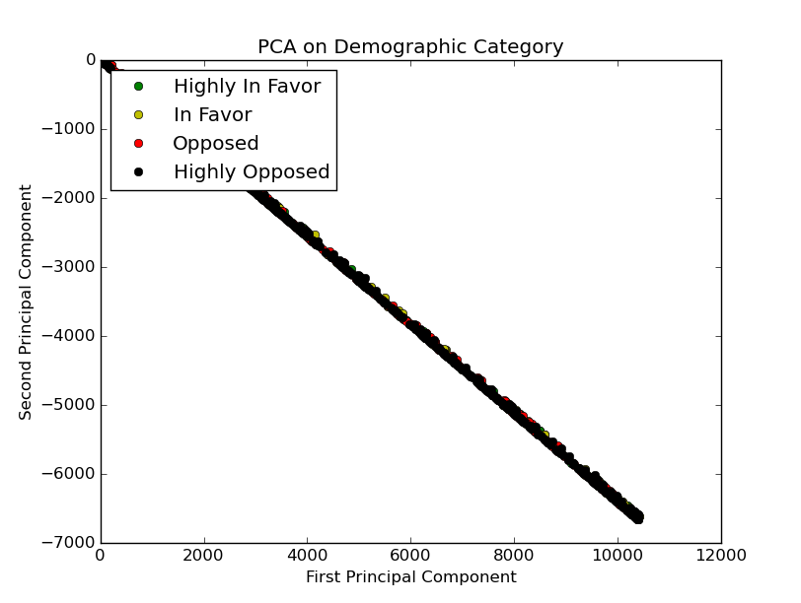
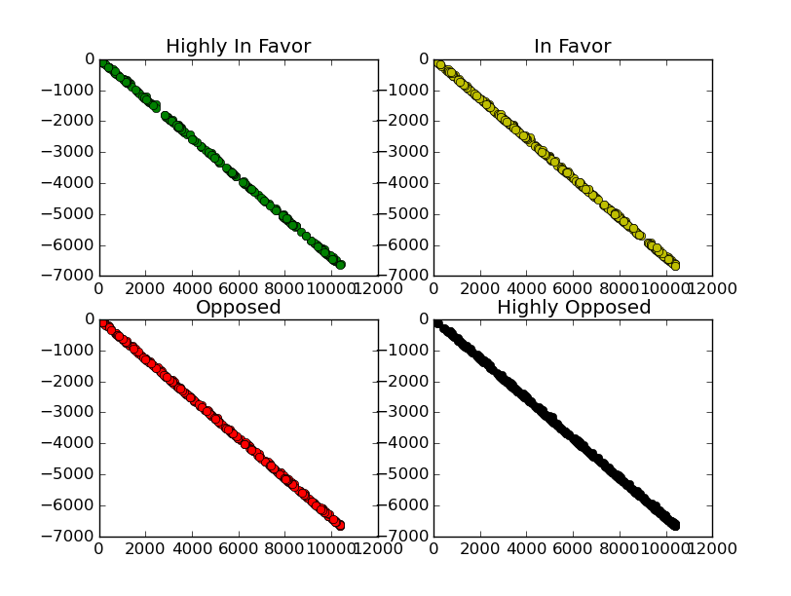
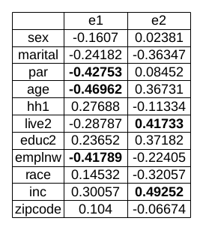
3.1 Demographic
3.2 Phone Information
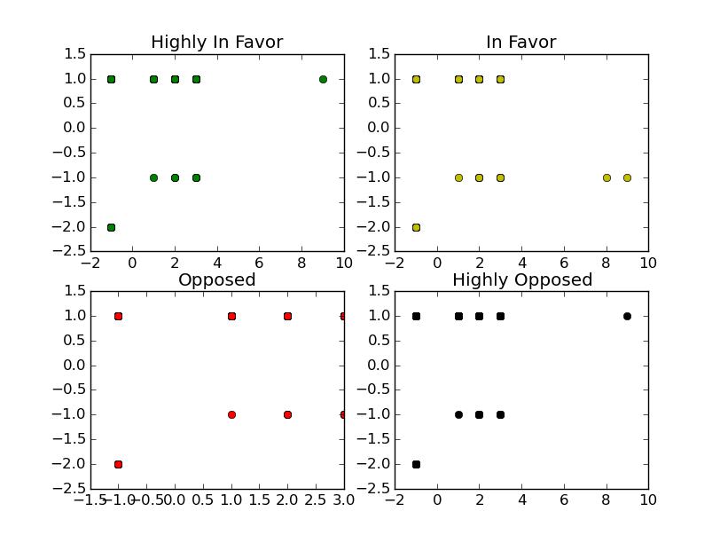
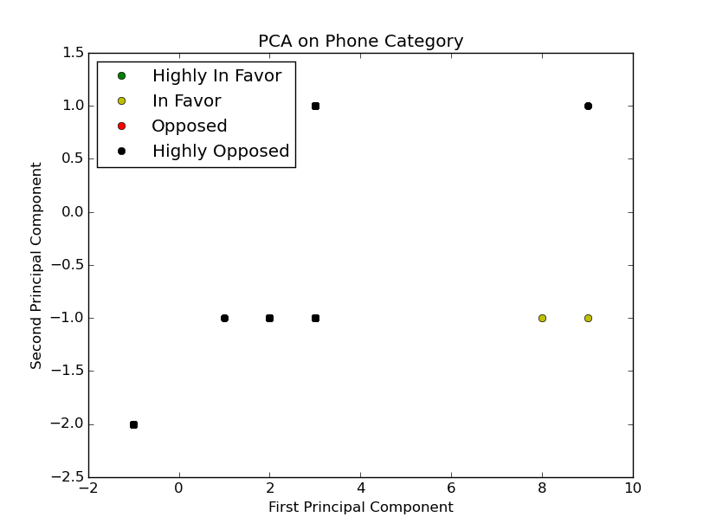
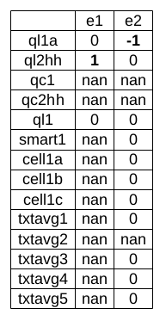
3.3 Perceived Control of Life
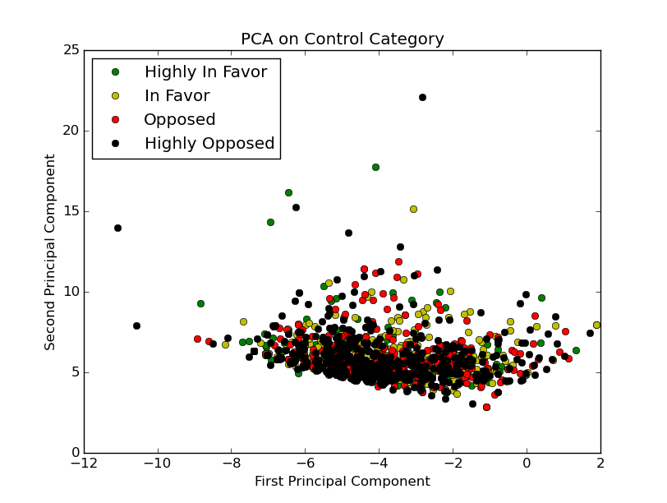
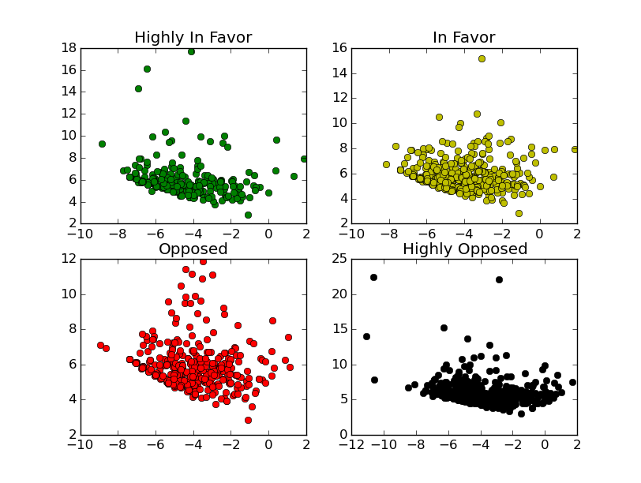
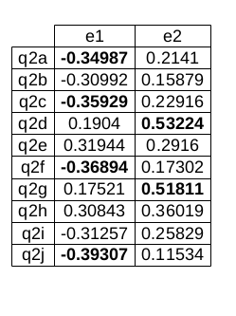
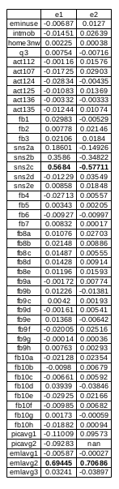
3.4 Internet Usage
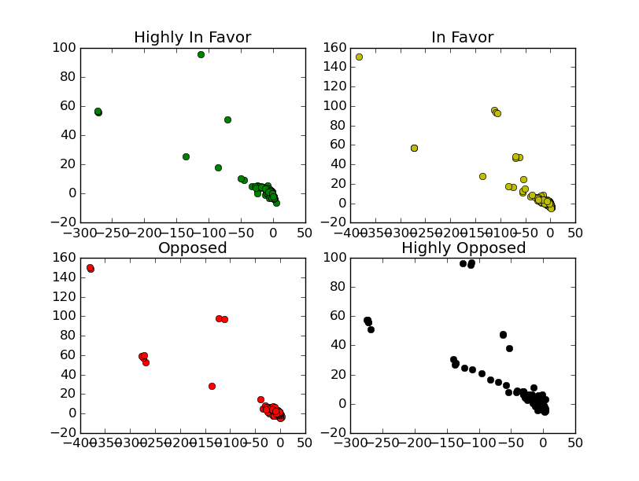
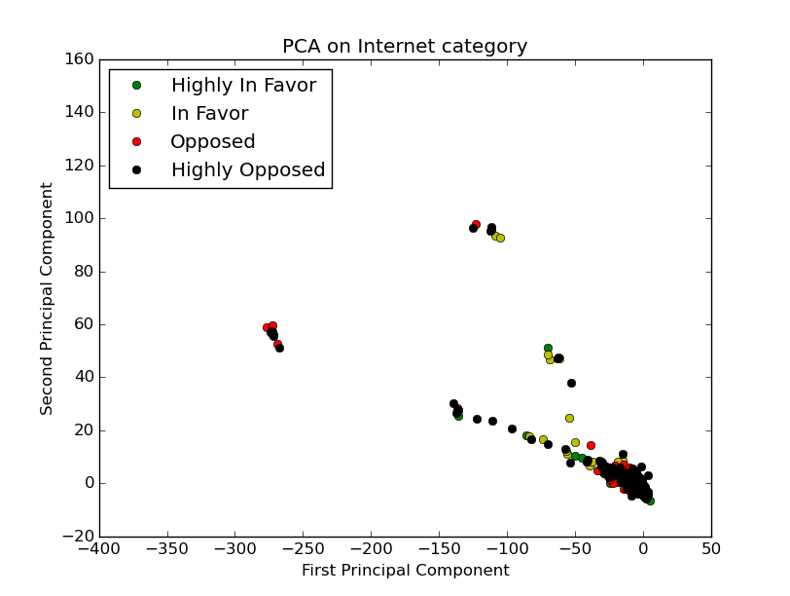
3.5 Social Association
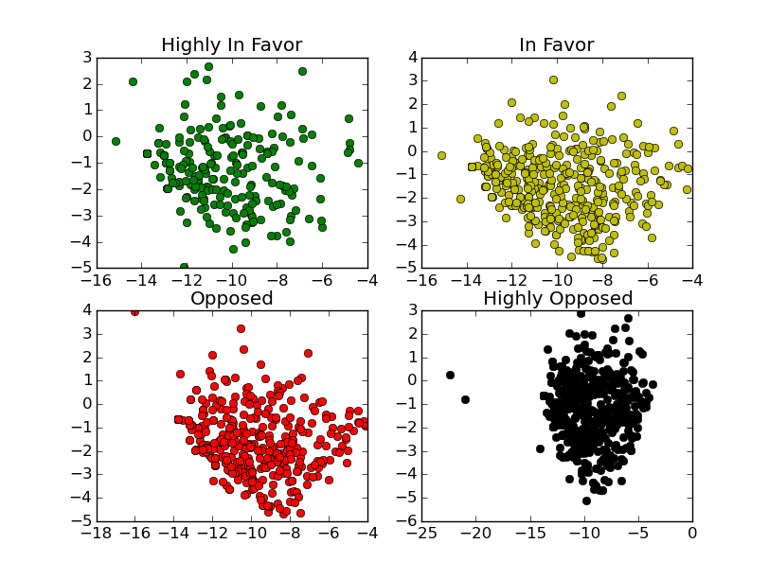
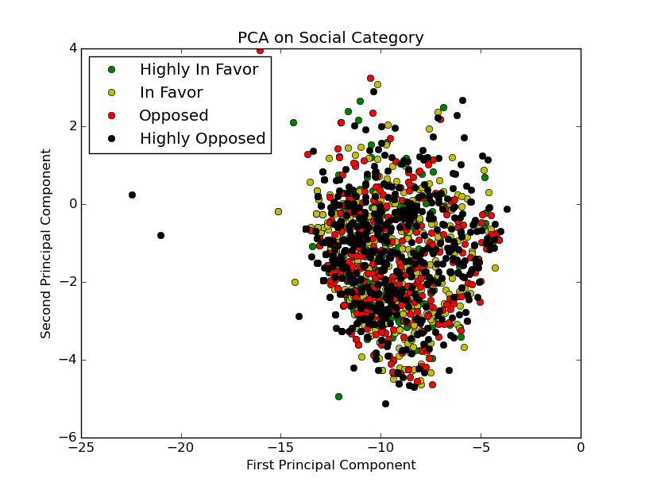
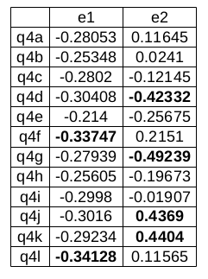
3.6 Government
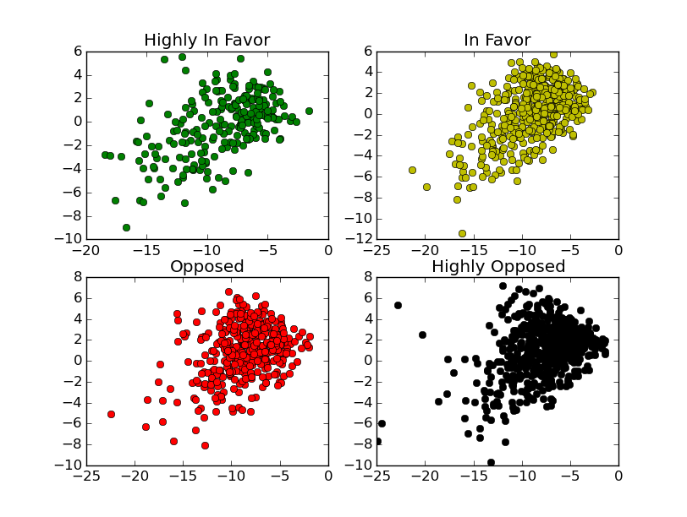
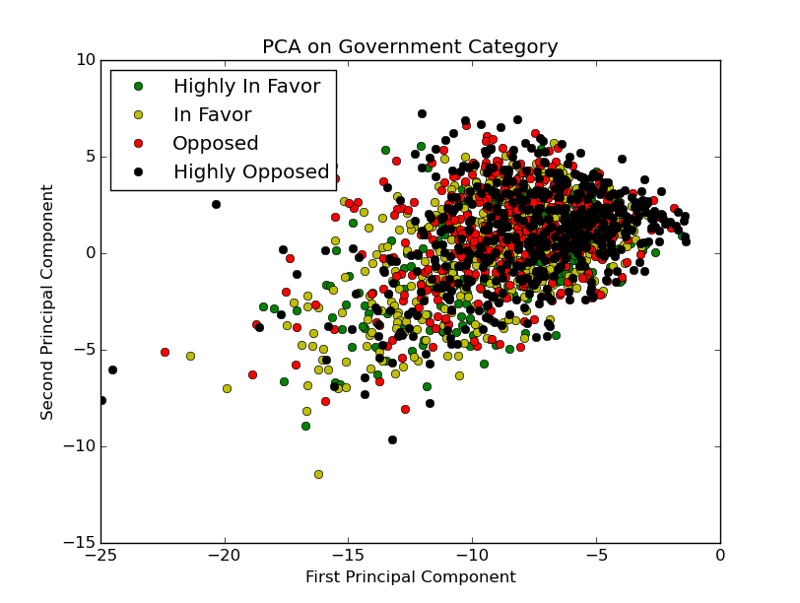
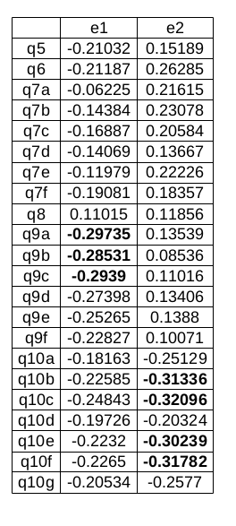
3.7 Fear of Exclusion
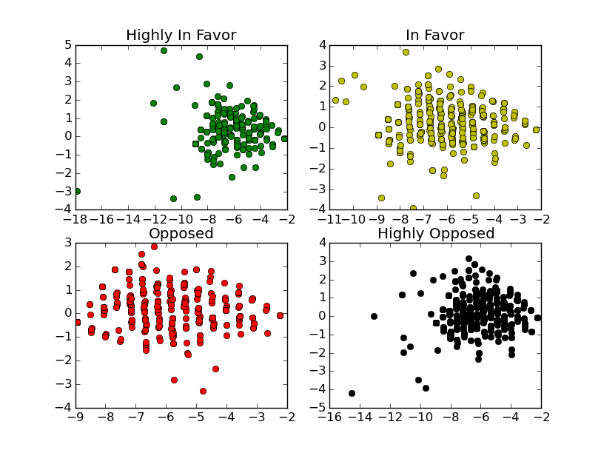
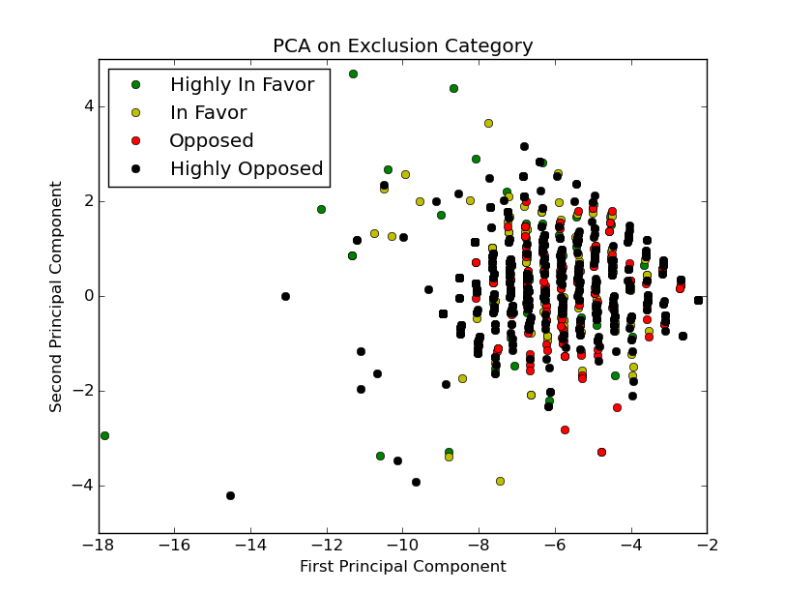
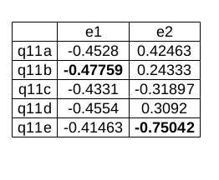
3.8 Fisher's Iris Dataset
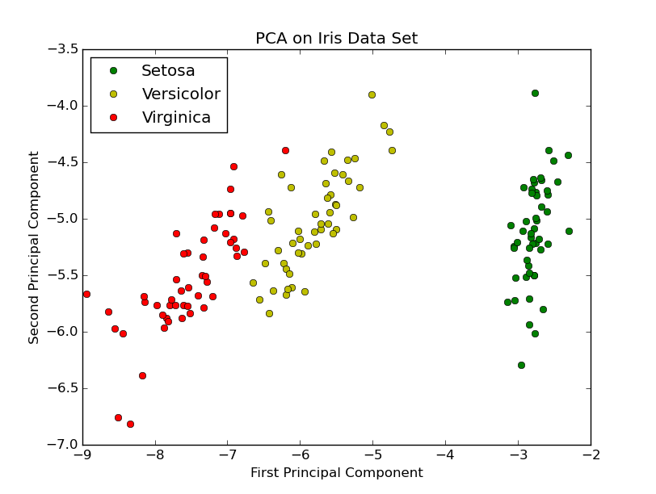
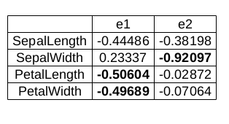

4 Discussion of Results
4.1 Demographics
The first principle component primary consists of whether someone is married, has children, and is currently employed. The second principle component primarily consists of how long someone has been living at their current residence and their income. Their is clearly a linear relationship between the two principle components; however, as all the classes overlay one another, I am unable to classify based on the demographics category.

4.2 Phone Information
Many of the questions in the phone information category were dependent on answers to previous questions and was therefore very sparse. As is illustrated by the principle components, computation of the eigenvectors was unsuccessful as many features resolved to "nan". Phone information does not provide good information for analysis, as the data was too sparse, and should not be considered further.

4.3 Perceived Control of Life
The first principle component primarily consists of how upset someone has been, how nervous and stressed someone has been, how someone has found that they could not cope with all the things they had to do, and how they found difficulties were piling up so high that they could not overcome them. The second principle component primarily consists of how someone felt confident about their ability to handle any personal problem, and been able to control irritations in their life. Intuitively, these principle components seem orthogonal: The first is a measure of how negative someone feels and the second is a measure of how positive someone feels. However, the data in the perceived control of life category does not separate and I am unable to classify in any meaningful way.

4.4 Internet Usage
The first and second principle components both primarily consist of how often someone uses Pinterest and how many emails are sent or received on an average day. It seems odd that both the first and second principle components are primarily comprised of the same feature, as the two principle components should be orthogonal. Despite this curiosity, the data does not diverge in any meaningful way and cannot be used for classification.

4.5 Social Association
The first principle component primarily consists of whether the respondent knows someone who has just started a new job and whether they know someone who has just moved or changed homes. The second principle component consists of whether the respondent knows someone who has just been fired or layed off, whether they know someone who experienced a demotion or pay cut at work, whether they know someone who became engaged or married, and whether they know someone who has given birth, became pregnant, or adopted a child. There is not a clear orthogonal interpretation of the principle components and, as the data did not separate, the social association category cannot be used for classification.

4.6 Governmental
The first principle component primarily consists of whether someone would be willing to discuss government surveillance programs at a community meeting, at work, or at a restaurant with friends. The second principle component primarily consists of whether someone's family members, close friends, neighbors, and Facebook friends agree with them about their views on government surveillance programs. The principal components seem orthogonal as the first component could represent disagreement of views while the second could represent agreement of views. However, because the data did not separate, the government category cannot be used for classification.

4.7 Fear of Exclusion
The first principle component primarily consists of whether someone feels that one of the worst things that can happen to them is to be excluded by people they know. They second principle component primarily consists of whether someone feels it is important for them to fit into the group they are with. There is no clear orthogonal relationship between the principle components and, because the data did not separate, the fear of exclusion category cannot be used for classification.

5 Conclusion
Principle component analysis did not yield any meaningful results for this dataset. I believe this is because the dataset was sparse and consisted of discrete responses, meaning that the numerical values in the dataset did not actually have a numerical interpretation. For example, consider the following question:

Well, on an average day, would you say you send and receive by text...
1 No photos using your cell phone
2 1 to 10 photos
3 11 to 20
4 21 to 50
5 51 to 100
6 101 to 200 (OR)
7 More than 200 photos a day
8 Don’t know
9 Refused

The responses are recorded using a numerical encoding, but do not have any meaningful numerical interpretation. The above convention was used in the entire dataset. When using principal component analysis in the future, I think it wise to use a dataset that has numerical meaning. Additionally, this project taught me the difficulties of working with an imperfect dataset, a majority of my time was spent cleaning the data.

6 Effort Analysis
6.1 Interest in Data (Why is it that are you knowledgeable about/interested in this data?)
I am very interested in the interaction between being connected (via technology) and personal privacy. As humanity becomes more dependent on technology, the threat of abuse of technology rises (as showcased by the Snowden leaks) and I would like to help ensure that a mutually acceptable (for the public and governments) steady state is reached. In studying this dataset, I was hoping to classify people such that I could further investigate why (or why not) certain people value privacy.

6.2 Data Construction (How much effort is required to construct the data?)
The data was provided by the Pew Research Center, so obtaining the data was trivially easy; however, because the dataset was imperfect (it contained blank entries and invalid data), I had to develop a system for masking the invalid entries in the dataset.

6.3 Data Novelty (In what ways is looking at this kind of data new or innovative?)
As a society, we are consistently moving towards a state of greater connectivity (via electronics). It seems that many people value increased connectivity; however, it also seems that many people fail to realize the duality of being connected and personal privacy.
To my knowledge, no one has tried to use principal component analysis to try to classify people by their support or opposition to governmental surveillance programs. In this regard,

6.4 Data Analysis (How much work is needed to analyze the data?)
6.5 Method Novelty (Which methods are most unusual, novel or worthwhile?)
6.6 Challenges (In what ways is the project most challenging?)
6.7 Relationship to Matrix Methods & Modeling (How does the project relate to matrix methods and modeling?)
6.8 Creativity (Which aspects of the project are most unusual or creativ\
e?)
6.9 Effort (Which aspects of the report require the most effort?)

