Trial trials:

1. The person will light the fireplace
2. The postman will ride the bike

Critical trials:

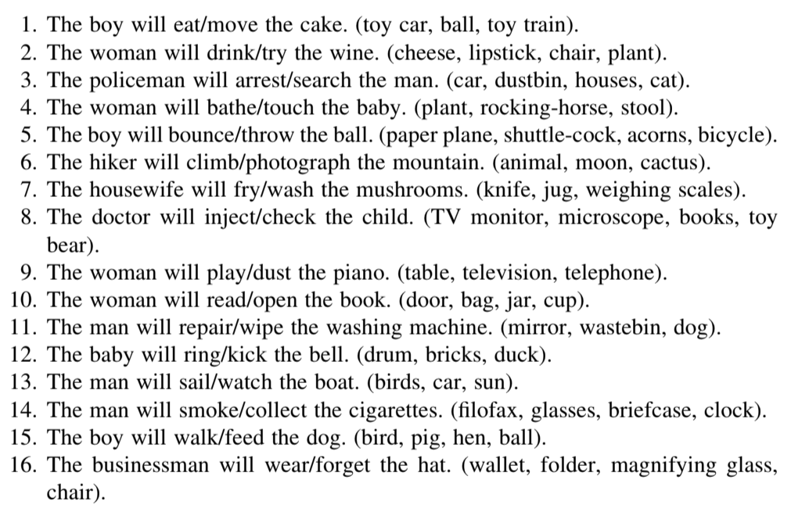

*for filofax, put books

Filler trials

1. The grandfather will pet the cat (L) - 2
2. The shopper will bake the cake (L) - 0
3. The student will break the vase (L) - 1
4. The teacher will open the door (L) - 0
5. The vet will shave the dog (L) - 3
6. The girl will eat the cake (N) 0
7. The woman will smell the fruits (N) 1
8. The child will ride the carousel (N) 2
9. The baby will pick up the pacifier (N) 2
10. The farmer will feed the hen (N) 3
11. **The man will paint the room (boat, sun, starfish, shark) (A) 1**
12. The boy will eat the potato (watering can, wheel barrow, carrot, tomato) (A) 2
13. The teacher will wrap the present (desk, apple, books, whiteboard) (A) 0
14. The girl will train the dog (fish, bird, cat, television, teddy bear) (A) 3
15. **The seamstress will sew the skirt (mannequin, dress, shirt, sewing machine, pants) (A) 3**
16. The baker will bake the cupcakes (bread, pan, oven, rolling pin, oven mit) (A) 1