Front Matter - Abstract, Keywords, Highlights
Manuscript: From One Channel to Four: A Jointly-Trained Time-Use Occupancy Model for Mixed-Use Building Energy Simulation (Canada, 2005-2030) Authors: O. Iseri and C. Hachem-Vermette · Concordia University

Abstract
Context. Tall buildings increasingly stack residential, office, retail and hospitality uses inside one structure, yet the occupancy schedules driving their energy models remain single-channel, borrowed from one use and held at code default everywhere else. Gap. No published occupancy generator produces multiple independent, jointly-trained presence channels for one mixed-use building, and the energy-use-intensity references used to judge such channels were built for single-use stock, not stacked towers. Aim. This study jointly trains one model to generate four independent time-use presence channels and injects them into a mixed-use tower. Methodology. A three-head conditional Transformer, trained on four Canadian General Social Survey time-use cycles, generates residential, office and retail presence; a SARIMA side-track driven by provincial tourism statistics generates hotel presence; a per-space Tag-2 dispatch injects all four into PNNL Tall and SuperTall prototypes across two Canadian cities, forecast 2005-2030 (56 cells: four channels, two prototypes, two cities). Key quantified results. The four populations do not behave as one occupant: they peak at four different hours, hotel at 18.91 h against a midday cluster near 12 h for the other three, and the resulting whole-building coincidence factor stays below 1 in all four building-city cells (median 0.941), so use-type diversity attenuates the aggregate peak inside a single building. Three of four channel EUI gates fail: the uninjected office control alone scores 85.45 kWh/m2/yr against a floor of 100; the hotel gate splits into two prototype clusters 84.64 kWh/m2/yr apart, 70.5% of the band width, with the 300 ceiling inside that gap; the retail median sits 5.47% below its floor. Impact. These failures are findings about reference-band applicability to mixed-use towers, not model error, reported at full strength with no band widened to pass them.

Keywords
Multi-channel occupancy; Mixed-use tall building; Time-use survey; Joint multi-task transformer; Building energy simulation; Energy use intensity band

Highlights
- Four occupant populations in one tower peak at four different hours.
- Coincidence factor below 1 in all four cells: use diversity flattens the peak.
- One Transformer jointly generates four independent occupancy channels.
- Uninjected office control fails its own band, 85.45 kWh/m2/yr vs a floor of 100.
- Hotel gate splits into two clusters 84.64 kWh/m2/yr apart, deciding the verdict.

Author Information
Orcun Koral Iseri · Caroline Hachem-Vermette
1 Gina Cody School of Engineering and Computer Science, Concordia University, 1455 De Maisonneuve Blvd. W., Montréal, Québec, H3G 1M8, Canada
* Corresponding author: orcunkoral.oseri@concordia.ca
ORCID: Orcun Koral Iseri - https://orcid.org/0000-0001-7735-3363

Declarations
Funding. This postdoctoral research was financially supported by the Natural Sciences and Engineering Research Council of Canada (NSERC) and the Voltage-Age Seed fund. The authors gratefully acknowledge this support.
Data availability. The General Social Survey Time-Use microdata and the provincial tourism-statistics series (ISQ for Quebec, CBRE/Travel Alberta for Alberta) analysed in this study are publicly available under the catalogue numbers listed in §2. The derived four-channel occupancy schedules, the injected IDFs, and the analysis code are available from the corresponding author on reasonable request.
Declaration of competing interest. The authors declare that they have no known competing financial interests or personal relationships that could have appeared to influence the work reported in this paper.
CRediT authorship contribution statement. Orcun Koral Iseri: Conceptualization, Methodology, Software, Formal analysis, Investigation, Data curation, Validation, Visualization, Writing - original draft. Caroline Hachem-Vermette: Conceptualization, Supervision, Funding acquisition, Resources, Writing - review and editing. Both authors read and approved the final manuscript.
Ethical approval. This study does not contain any studies with human or animal subjects performed by any of the authors. The analysis uses anonymized public-use microdata files released by Statistics Canada, together with published provincial tourism-occupancy statistics.
Graphical abstract.
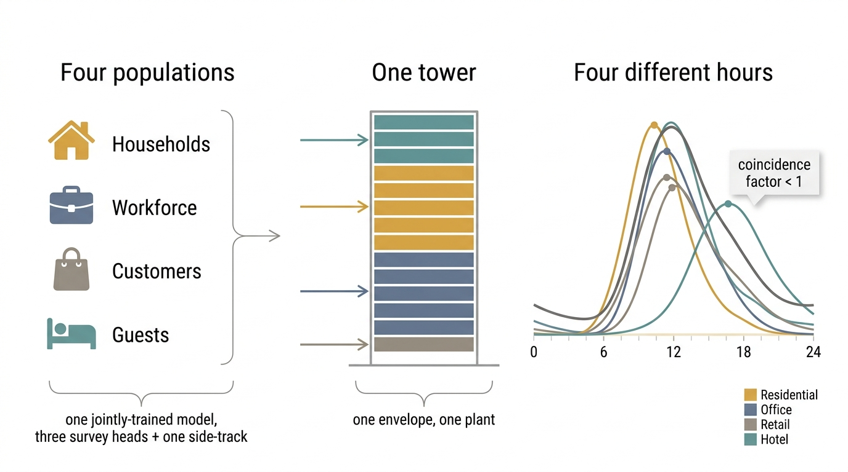
Graphical abstract

1 Introduction
This introduction proceeds as a funnel: from the multi-use gap that motivates the study (§1.1), through the two literatures that address occupancy separately and now need a mixed-use axis added between them (§1.2), to the observation that occupant behaviour is non-stationary per use, and that the uses drift apart rather than together (§1.3); it then states the authors’ prior line as the explicit departure point (§1.4) and closes with the contributions and aim of the present study (§1.5).

1.1 The Multi-Use Gap: Single-Channel Occupancy Applied to Stacked Buildings
Occupant behaviour is now widely recognised as a dominant, unexplained driver of the gap between predicted and measured building energy use, and the response of the field has been to build increasingly capable single-use occupancy generators: Markov-chain, survival-model and time-use-survey-based tools that reproduce the presence and activity of one population inside one building type. That response does not transfer cleanly to a tall building that stacks several uses at once. A mixed-use tower carries households on some floors, an office workforce on others, retail customers at grade, and hotel guests in a separate tower, all sharing one envelope, one central plant, and often one energy meter, yet the occupancy signal driving such a model is still, in current practice, a single channel: one schedule is chosen (most often residential or office), applied uniformly, and the remaining uses are left on their code-default densities. The populations behind these four uses are not interchangeable. Households, a workforce, customers and overnight guests keep different hours, respond to different drivers (commuting patterns, retail footfall, tourism demand), and are observed, if at all, by different data sources. A single-channel occupancy model applied to a stacked building therefore either represents one use correctly and holds the rest at a static default, or blends several populations into one signal that represents none of them precisely. This is the gap the present study addresses: not “does time-series occupancy improve a building energy model,” which the authors’ own prior line has already answered for a single use, but “what happens when that model has to carry four functionally distinct populations inside one structure, on four largely independent temporal signals.”

1.2 Two Literatures That Rarely Meet, Now With the Mixed-Use Axis
Two literatures bear on this problem, and between them sits a cell that Table 1 shows to be unoccupied. The first develops calibrated, time-use-survey-driven occupancy models with genuine behavioural grounding, but stays single-channel and residential: Buttitta and Finn (2020) use the Irish time-use survey to generate high-resolution residential heating-load occupancy, and Widén and Wäckelgård (2010) do the same from a single-wave Swedish time-use survey; neither extends the method to a second use, and neither forecasts to a future year. The second develops genuinely multi-channel, mixed-use occupancy, but not from a time-use survey and not inside one stacked building: Doma and Ouf (2023, 2024) model office, retail and residential occupancy together from mobile-positioning snapshots, at a district scale, with each use represented as a separate building rather than as stacked floors sharing one plant, and without a forecast horizon. Read across Table 1’s eight positioning axes, none of the three named studies combines a time-use-survey-driven behavioural model, more than one occupancy channel, a forecast to a future year, and a single mixed-use building in one design. Those four axes are what the claim rests on, and they are the four on which the three named studies are unanimous in the sources consulted; the remaining four axes, including the sense in which a behavioural model is called calibrated, are defined under Table 1 and are scored there for completeness rather than because the claim turns on them. That is the cell this paper’s Leg-3 row occupies, and it is the cell the present pipeline was built to fill: four occupancy channels driving four uses inside one building, forecast forward from a behavioural time-series whose parameters are estimated from national time-use microdata.
Table 1. - Eight-column competitor positioning matrix scoring Doma and Ouf (2023/2024), Buttitta and Finn (2020) and Widén and Wäckelgård (2010) against time-series occupancy, time-use-survey-driven, multi-channel (more than one use), calibrated behavioural model, forecast to a future year, mixed-use single building, activity/end-use resolution and stock-scale, with this study’s Leg-3 and 2J rows bolded to show the increment; the four axes on which the novelty claim rests and the sense given to calibrated are defined beneath the matrix.
Study | Time-series occupancy | Time-use-survey-driven | Multi-channel (>1 use) | Calibrated behavioural model | Forecast to a future year | Mixed-use single building | Activity/end-use resolved | Stock-scale
Doma & Ouf (2023/2024) | ✓ | ✗ | ✓ | ✗ | ✗ | ✗ | ✓ | ✗
Buttitta & Finn (2020) | ✓ | ✓ | ✗ | ✓ | ✗ | ✗ | ✗ | ✓
Widen & Wackelgard (2010) | ✓ | ✓ | ✗ | ✓ | ✗ | ✗ | ✓ | ✗
This study (Leg-3) | ✓ | ✓ | ✓ | ✓ | ✓ | ✓ | ✓ | ✗
This study (2J) | ✓ | ✓ | ✗ | ✓ | ✓ | ✗ | ✓ | ✓
What the axes mean. Two of the seven are read in more than one way in this literature, so both are defined here and every cell in the column is scored against the definition given, this study’s row included.
- Calibrated behavioural model - presence is produced by a behavioural model whose parameters are estimated from observed microdata on the population being modelled, rather than assumed from a standard schedule or read off a sensor or positioning trace of one particular building. The axis is about where the model’s parameters come from, not about how accurately its output reproduces a measured energy series; the latter is what §5’s energy-use-intensity gates test, and three of those gates are reported failing.
- Stock-scale - the study’s result is intended to represent a building population rather than a named set of buildings. A district of individually modelled buildings is not scored as stock-scale; a small set of archetypes weighted to stand for a national dwelling stock is.
Reading of the matrix. The three named competitors each hold one axis Leg-3 combines: Doma & Ouf put multiple uses (office, retail, residential) in one modelling framework but from mobile-positioning snapshots, not a time-use survey, and at district scale, not inside one building. Buttitta & Finn and Widen & Wackelgard both drive occupancy from a time-use survey but stay single-channel, residential only, single-wave, with no forecast. The cell none of the three occupies is a time-use-survey-driven, multi-channel, forecast-to-a-future-year model inside a single mixed-use building - that is the Leg-3 cell that review’s positioning verdict names as “genuinely unclaimed in the literature.” The 2J row is carried alongside Leg-3 to show the increment is additive: 2J already cleared time-series, calibration, forecast, activity-resolution and stock-scale on the residential-only, single-channel problem; Leg-3 trades stock-scale representativeness (2 tower prototypes, not a housing stock) for multi-channel and mixed-use-single-building resolution, which 2J did not attempt.
The five cells that this table previously left unscored. An earlier version of this matrix carried five cells the primary positioning review does not state, marked as unscored rather than inferred. All five have since been read out of the competitors’ full texts, and each is recorded with the fact it rests on: Doma & Ouf resolve occupancy at one hour (time-series ✓), read presence from a mobile-positioning trace with no behavioural model estimated from it (calibrated ✗), and model a district of 221 individually represented buildings, which under the definition above is not a stock (stock-scale ✗); Buttitta & Finn estimate their presence model from a national time-use survey (calibrated ✓), report presence-state counts rather than activity categories (activity/end-use ✗), and apply four archetypes standing for a dwelling stock (stock-scale ✓).
Two disagreements between sources, recorded rather than resolved, because neither changes a verdict. The competitor axes were cross-checked against a second, independent reading of the same nine studies, and it differs from the sources used here in two places. It gives Doma & Ouf’s positioning data as a different vendor than the one this table’s primary source names, and it records Buttitta & Finn’s survey as a different country’s than the one §1.2 names. Both are attribute disagreements inside a cell whose verdict is the same under either reading (mobile positioning either way; a national time-use survey either way), so both are noted here and neither has been adopted on a single unverified report.
A third disagreement, on this study’s own row, and why the tick stands. That same independent reading marks this study No on calibrated behavioural model. It marks all ten rows of its own matrix No on that axis, including the two rows it separately certifies as time-use-survey-driven, and its parenthetical for this study is “gate-tested control” - a statement about validation, not a denial that the model’s parameters are estimated from microdata. A column with no variation across ten studies separates nothing, in either direction. Under the definition given above the tick stands for this study and for the three competitors that also estimate from survey microdata; under a stricter reading that requires agreement with a measured energy series, no row in either matrix would be ticked, this study included, and §5 reports three such gates failing rather than claiming otherwise. The axis is therefore not one of the four this paper’s novelty claim rests on, which are time-use-survey-driven, multi-channel, forecast to a future year, and mixed-use single building.

1.3 Behaviour Is Non-Stationary Per Use, and the Uses Move in Different Directions
The authors’ prior residential work established that occupant behaviour is not stationary through the COVID/work-from-home structural break, and that a schedule anchored to a pre-pandemic baseline mis-estimates both how much energy is used and when. A stacked mixed-use building sharpens that finding rather than repeating it, because the non-stationarity is not one trend line shared by every floor; it is four separate trends, each attached to a different use, and they do not move together. Office presence is pulled down by the persistence of hybrid and work-from-home arrangements. Retail presence is pulled down by a longer-running structural shift toward e-commerce: the measured weighted episode-time share of shopping locations in the General Social Survey declines by roughly 25% across the four cycles used in this pipeline (Table 7, L14), a decline this study’s own deep-research check found to be internationally normal in direction and comparable in magnitude to the United States, the United Kingdom and the European Union. Hotel presence follows neither of these slopes; it collapses sharply during the pandemic and recovers along a province-level tourism trajectory that this pipeline reconstructs directly from occupancy-rate statistics rather than from a household survey, because hotel guests are outside the General Social Survey’s sampling frame by construction (Table 7, L1). Residential presence, by contrast, is the one channel the authors’ prior line already showed moving upward through the same period. A single “occupancy” trend, scaled and reused across four uses, would therefore misrepresent at least three of the four channels in sign, timing, or both. This is the concrete argument for why the present study jointly trains four channel-specific signals rather than deriving three of them from one calibrated residential series: the uses are not stationary, and they are not non-stationary in the same direction.

1.4 The Authors’ Prior Line: Leg-1 to 2J to Leg-2, the Departure Point
The present study departs from a specific prior line of work by the authors, built in three stages. Leg-1, published as the second journal in this line (2J), established a single-channel, residential-only occupancy pipeline: General Social Survey time-use cycles harmonized and augmented by a calibrated conditional generator, linked to the Census dwelling stock, and forecast to 2030 through the COVID/work-from-home break, together with the paired stock-scale simulation design used to isolate the behavioural signal (Iseri and Hachem-Vermette, under review a; Iseri and Hachem-Vermette, under review b; Iseri and Hachem-Vermette, 2026). That line is treated here as established, not re-claimed: the premise that survey-grounded, time-series occupancy can be generated for Canadian building energy models, and that it changes both magnitude and load shape, is the foundation this paper builds on rather than a result this paper repeats. A second, intermediate construction stage, referred to in this paper as Leg-2, extended that single-channel machinery to two channels, residential and office, growing the generator from one decoder head to two and establishing the modulate-versus-replace distinction that the present pipeline reuses: residential presence replaces baseline schedules per household, while office presence modulates a code-of-record density rather than overriding it. Leg-2 is a construction step in this project, not a second headline result, and it is discussed further, on its own terms, only in the Methods chapter, where its two-channel machinery and one hard-won wiring-verification lesson are the direct ancestors of the present design. Figure 2 draws the three stages as nested rather than sequential, so that what each stage carries forward into the next is visible on a single connector; Figure S3 gives the two-channel construction stage’s own pipeline in full, for a reader who needs that stage’s internals rather than the summary given here.

1.5 Contributions and Aim of the Study
This paper makes four advances over the two-channel construction stage it is built on. They are stated behaviour first, because the occupancy signal is the object of this study and the building energy model is the instrument that tests it, not the other way round.
- Four populations, resolved separately inside one envelope. Households, a workforce, customers and overnight guests are carried as four independent presence channels through one stacked tower, and the campaign shows they do not behave as one occupant: the four channels peak at different hours of the day, hotel roughly seven hours after the midday cluster of the other three, and they move in different directions across the four survey cycles, retail reversing its own trend while residential stays close to flat. The whole-building coincidence factor stays below 1 in all four building-city cells under the central 2030 scenario, so use-type diversity inside one building attenuates the aggregate peak in the same way household diversity does inside one archetype.
- Validation stance. Three of the four channel-level energy-use-intensity gates are reported failing, at full strength, together with the evidence bearing on whether the reference band or the model is at fault, most notably an uninjected control that fails the office band on its own and two explanatory mechanisms refuted in every one of 56 cells; no band is widened, and no scoring rule is chosen because it happens to pass.
- Architecture and injection. A shared-encoder Transformer with three General Social Survey decoder heads (residential, office, retail) is jointly trained alongside a non-GSS hotel side-track driven by provincial tourism statistics, with a decode-time exclusivity projection that drives the raw impossible-state rate from at most 0.5% down to 0% without distorting the individual channel marginals; a per-space Tag-2 exact-match dispatch then routes all four channels into the same physical tower geometry, where apartment tags replace baseline schedules, office/retail/guest-room tags modulate code densities, and any missing channel falls back to the untouched code baseline, so the injection is additive by construction rather than by assertion.
- Experimental design. A 56-cell campaign (four channels, two tower prototypes, two Canadian cities) forecasts all four channels from 2005 to 2030 under one scenario lever per channel, isolating channel-specific sensitivity inside a single stacked building rather than across a housing stock.
The aim of the study follows directly. This paper asks what four functionally distinct occupant populations do to a single stacked building when each is carried on its own behavioural signal rather than blended into one, whether a single jointly-trained occupancy model can generate all four, and where the energy-use-intensity references built for single-use stock do, and do not, still apply to the result. The full pipeline that operationalises this question is summarised in Figure 1, with each stage detailed in the sections that follow: the datasets (§2), the methods spanning harmonization through the four-channel injection (§3), the paired experimental design (§4), the results from per-channel behaviour to the three failing gates (§5), the discussion of what a multi-channel model buys and why the band failures are findings about applicability rather than error (§6), the limitations (§7), and the conclusion (§8).
Figure 1. - End-to-end Steps 1-9 for the four-channel pipeline, each block annotated with its section reference; the two channels inherited from the construction stage (residential, office) are marked in one colour and the two Leg-3 additions (retail, hotel) in another, with the hotel side-track marked as bypassing the Transformer entirely.
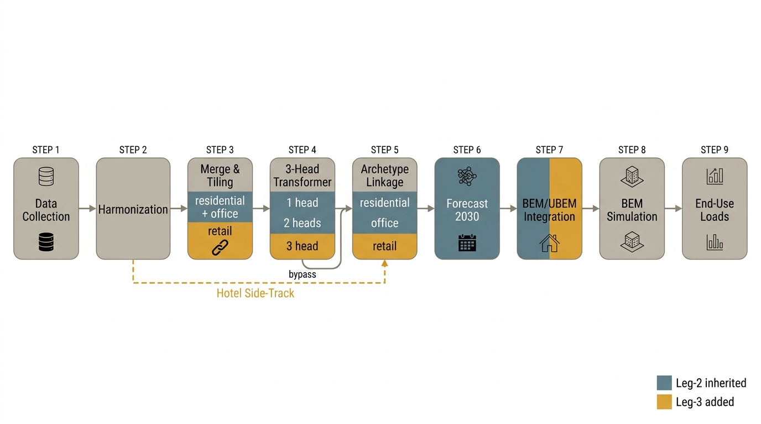
Figure 1
Figure 2. - The three-leg roadmap: the single-channel residential stage, the two-channel construction stage it grew into, and the four-channel model reported here, with each leg drawn as containing the previous one and the artefacts carried forward marked along a connector beneath all three.
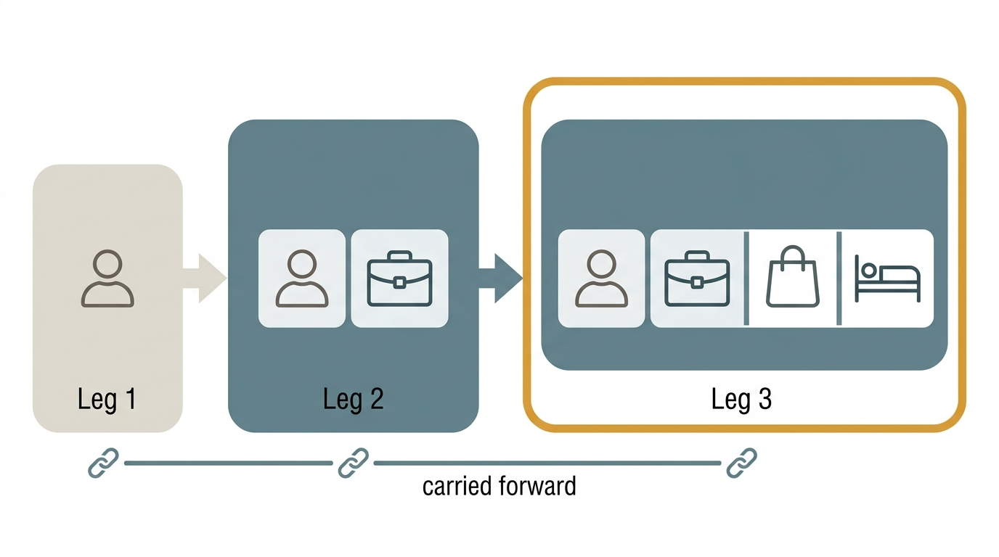
Figure 2

2 Datasets
Four occupancy channels drive four uses inside one stacked building: Residential, Office, Retail, and Hotel. Three of the four channels are survey-derived; the fourth, Hotel, is deliberately sourced outside the survey frame. This chapter inventories every input the four-channel generator and its downstream simulation campaign consume. Channel provenance is summarized in Table 2; the simulation domain built from the weather and prototype inputs described below is summarized in Table 3.

2.1 General Social Survey Time-Use Microdata (2005-2022)
The behavioural backbone for three of the four channels is the same four cross-sectional waves of the Statistics Canada General Social Survey (GSS) Time-Use program used in the authors’ prior work (Statistics Canada, 2022; Iseri and Hachem-Vermette, under review b): Cycle 19 (2005), Cycle 24 (2010), Cycle 29 (2015), and the GSS Time Use 2022 cycle (GSSP). Residential (AT_HOME) and Office (AT_WORK) presence are read from the harmonized diary exactly as in the two-channel construction stage (Leg-2; see Chapter 3). The one new GSS-derived channel added for this paper is Retail (AT_RETAIL): a customer-presence indicator constructed from the occPRE (location) and occACT (activity) columns that were already carried in every cycle, so no new GSS variable was collected. occPRE/occACT location-mapping coverage is per cycle: 2005 and 2010 use PLACE = 06+07; 2015 uses LOCATION = 306; 2022 uses LOCATION = 3306. Grocery and general-merchandise shopping are not separable in the 2015 and 2022 cycles, which record a single combined shopping-location bucket; the AT_RETAIL derivation and its frozen OR-rule are given in full in Chapter 3 (§3.1) and in Table 2’s footnote.
One population that the GSS records but that this paper’s Retail channel deliberately does not model is retail staff: workers present in a store are coded by the survey as engaged in AT_WORK, not as a retail-specific activity, so no GSS signal distinguishes a shopper from a cashier. Retail worker density therefore stays on the NECB code baseline being modulated, and the Retail channel models customer presence only (Table 2, footnote 2).

2.2 Census Public-Use Microdata for Dwelling-Stock and Workforce Linkage
The Statistics Canada Census Public-Use Microdata File (PUMF; Statistics Canada, 2021) provides the dwelling-stock and workforce variables used to situate Residential and Office diary respondents within a representative building and labour-force population. This linkage stage is unchanged from the two-channel construction stage (Chapter 3, §3.3): dwelling type, tenure, and household-size variables anchor the Residential channel, and NOC-by-NAICS occupation/industry crosswalks anchor the Office channel. Retail and Hotel do not use the Census PUMF linkage. Retail is modelled at the population level against a single PNNL “Retail Retail” archetype rather than through a per-respondent Census match, because the grocery/merchandise split needed for a finer archetype lookup is not recoverable from the 2015/2022 GSS location codes (§2.1). Hotel has no respondent-level archetype at all: guests are entirely outside the GSS sampling frame, so the channel is driven by a province-level multiplier rather than by any individual linkage record (§2.3).

2.3 Provincial Tourism Statistics as a Non-Survey Channel Source
Hotel is the one channel in this paper with no General Social Survey signal behind it at all: overnight hotel guests are, by construction, outside the GSS Time-Use sampling frame, which samples the resident population at their dwelling of record. Injecting the Hotel channel from a GSS-derived series would therefore systematically under-occupy hotel zones, since the survey simply never interviews a guest in a hotel room. This is a frame limitation, not a data-quality one, and it forces the Hotel channel to be built from an entirely separate, non-survey data family: monthly provincial tourism statistics.
No StatCan table of monthly hotel-occupancy rates exists (a data-availability check run for this study); the paper therefore draws on the two provincial data sources available for the cities in the simulation domain. For Quebec, the source is the Institut de la statistique du Québec (ISQ) monthly hotel-occupancy series (Institut de la statistique du Québec). For Alberta, the source is CBRE / Travel Alberta market reporting, with the 2005-2009 span of the Alberta series spliced from CBRE National Market Report archives (CBRE Limited and Travel Alberta). Both provincial series carry YEAR, MONTH, province (PR), occupancy rate, average daily rate (ADR), and RevPAR fields and span 2005-2022. This tourism-statistics series is converted to a monthly multiplier by a SARIMA model with an explicit COVID-19 indicator (Chapter 3, §3.4); it never passes through the three-head Transformer used for the three GSS channels, because it has no respondent-level structure to condition on (Chapter 3, §3.2).

2.4 NECB / PNNL Prototype Building Stock
The building domain is the U.S. DOE / PNNL Tall and SuperTall mixed-use tower prototypes (U.S. Department of Energy and Pacific Northwest National Laboratory), built to the NECB-2017 standard (National Research Council Canada, 2017), reused from the two-channel construction stage without modification to their geometry. Total occupiable floor area, measured directly from the model geometry rather than assumed, is reported per prototype in Table 3. Each prototype’s Space objects carry an IDF Tag 2 field that functions as the per-Space routing key for occupancy injection (Chapter 3, §3.5): apartment tags, office tags, retail tags, and guest-room tags each resolve to a distinct one of the four channels, while amenity and service/MEP tags carry no occupant-driven channel and remain on the untouched NECB default schedule.

2.5 Weather Files
The simulation domain spans two Canadian cities selected to bracket a one-zone climate contrast within the campaign: Montréal (ASHRAE climate zone 6A) and Calgary (ASHRAE climate zone 7A). One Typical Meteorological Year EnergyPlus weather file (EPW) is used per city. The two prototype IDFs (Montréal, Calgary) differ from one another by geometry-preserving, climate-tag-only edits, so that EUI differences between the two cities can be attributed to climate rather than to any building-geometry covariate (Table 3). All simulations run in EnergyPlus v24.2 (U.S. Department of Energy, 2024). The full two-prototype-by-two-city-by-fourteen- scenario, 56-cell campaign built from these weather and prototype inputs is defined in Chapter 4.
Table 2.
Four occupancy channels drive four uses inside one stacked building (not four building archetypes; see Standing rules). Residential and Office are the Leg-2 channels, reused; Retail is the one new GSS channel; Hotel is the one non-GSS, tourism-statistics side-track.
Channel | Source | Derivation | Injection mode | Scenario lever
Residential (AT_HOME) | GSS Time-Use, Leg-1 | Household matched via Census PUMF linkage; Number_of_People_Schedule = HHSIZE, drawn per residential Space | REPLACE (full substitution of the code schedule) | none
Office (AT_WORK) | GSS Time-Use, Leg-2 | AT_WORK presence from Transformer Head 2; archetype linkage NOCxNAICS (Leg-2) | MODULATE - NECB office density x AT_WORK_fraction(t) | WFH band (conservative / hybrid / fullyhybrid)
Retail (AT_RETAIL) | GSS Time-Use, Leg-3 - the one new GSS channel | AT_RETAIL derived from occPRE/occACT already carried in the survey (see footnote 1); Transformer Head 3 (new); single PNNL “Retail Retail” archetype, population-level fraction, no per-household lookup (grocery/merchandise not separable in 2015/2022) | MODULATE - People = 0.95 x peak-normalized shape_cd(t) in customer hours; staff-only slots (<= 0.10) keep the NECB baseline (see footnote 2) | In-store share, 2030 bands (0.97 default / 0.90 / 1.05) + QC-Sunday sub-axis
Hotel | non-GSS - ISQ (Quebec) monthly series + CBRE / Travel Alberta (Alberta) monthly series | ISQ/CBRE monthly occupancy rate to SARIMA(1,1,1)(1,1,1,12) per province + COVID indicator (2020-03 to 2022-06) to hotel_multiplier(t,month,PR) = s(t) x monthly rate; s(t) = unit-normalized 48-slot guest-room shape (fixed by a diurnal-shape review run for this study) | MODULATE - NECB guest-room schedule x hotel_multiplier(t,month,PR) | SARIMA 2030 bands (0.92 / 1.00 / 1.05)

Footnotes
1. AT_RETAIL rule, frozen 2026-07-02.
AT_RETAIL = (occPRE == 5) | ((occACT == 4) & occPRE in {5, 9})
Location-mapping detail by cycle: 2005/2010 PLACE = 06+07; 2015 LOCATION = 306; 2022 LOCATION = 3306. The activity arm (occACT == 4, “Purchasing Goods & Services”) is gated to occPRE in {5, 9} specifically to exclude the online-shopping wrinkle occACT == 4 & occPRE == 1 (shopping from home) from being counted as retail presence. That online-shopping leak cross-tab is still reported per cycle as a verification check, even though the rule itself is frozen and not reopened by it. Restaurant presence (occPRE == 7) is available in all cycles and is explicitly out of scope (no prototype Space to drive it).
2. Retail staff are invisible in GSS. Retail workers are logged as AT_WORK (the office channel), not as a retail-specific activity, so no GSS signal exists for staff presence. Staff-only slots therefore stay on the NECB baseline density, and the retail channel models customer presence only - worker density already lives in the NECB baseline being modulated.

3 Methods
Each pipeline stage is presented with its design rationale and its validation result. Residential and Office reuse the two-channel construction stage (Leg-2) without change to their harmonization, architecture, or linkage logic; that stage is described here only where its output is a direct input to the two new channels, or where one of its lessons became a hard gate carried into this paper. The complete gate set referenced throughout this chapter is given in Table 4, with each threshold’s provenance (ASHRAE Guideline 14, project-chosen, or heuristic) marked explicitly there rather than repeated in prose.

3.1 Harmonization and the AT_RETAIL Derivation
Residential and Office harmonization - the mapping of raw cycle-specific activity and location codes to a shared vocabulary, and the tiling of each diary onto the 48-slot, 30-minute grid - is unchanged from the two-channel construction stage and is not restated here. The one harmonization addition made for this paper is the derivation of the Retail channel, AT_RETAIL, from columns the survey already carries in every cycle: occPRE (location) and occACT (activity). No new GSS variable was collected or coded for this addition.
The derivation rule, frozen 2026-07-02 before any training run, is:
AT_RETAIL = (occPRE == 5) | ((occACT == 4) & occPRE in {5, 9})
The activity arm (occACT == 4, “Purchasing Goods & Services”) is deliberately gated to occPRE in {5, 9} to exclude a specific wrinkle: occACT == 4 & occPRE == 1 records purchasing conducted from the respondent’s own home (online shopping), which is not retail-space presence and must not be counted as such. This exclusion is not merely asserted; the online-shopping leak cross-tab is recomputed and reported for every GSS cycle as a standing verification check, even though the rule itself is not reopened by that check. The location-mapping detail differs by cycle, because the underlying PLACE/LOCATION coding scheme changed across GSS redesigns: 2005 and 2010 use PLACE = 06 + 07; 2015 uses LOCATION = 306; 2022 uses LOCATION = 3306. In both 2015 and 2022 the grocery and general-merchandise shopping locations are collapsed into a single bucket, so the two cannot be separated for those cycles (Table 2, footnote 1).
The merge step that appends AT_RETAIL to the diary record is the one place the GSS build pipeline itself changes for this paper: the tiler that produces the 30-minute channel columns was already list-driven in the two-channel construction stage, so adding Retail is one additional list entry rather than a new tiling procedure. Retail is written to its own CSV file rather than into the existing residential/office output, specifically so the addition cannot overwrite or reshape the two reused channels’ columns.
Restaurant presence (occPRE == 7) is available in every cycle and was considered as a candidate fifth channel; it is explicitly out of scope for this paper because no prototype Space in the Tall/SuperTall towers corresponds to a restaurant use.

3.2 The Three-Head Transformer
The conditional generator used to synthesize unobserved day-types for the three GSS-derived channels is grown directly from the two-channel construction stage’s architecture, not designed from scratch. The shared encoder is unchanged; the decoder side gains one head. The decoder therefore carries three heads in total: Head 1 (Residential presence), Head 2 (AT_WORK / Office), and Head 3 (AT_RETAIL / Retail, the one addition for this paper). Hotel has no head and never passes through this model at all; it is produced by an entirely separate side-track described in §3.4. Figure 3 draws the resulting topology, with the hotel side-track placed beside the encoder and connected to nothing inside it, because the distinction between three GSS heads plus one non-GSS side-track and a four-head model is the one reading of this architecture that must not be got wrong.
The three heads are trained under fixed-weight scalarization with loss weights 1.0 : 0.5 : 0.3 (Residential : Office : Retail) combined with PCGrad pairwise gradient-conflict correction. This combination was selected over dynamic loss-balancing schemes (SLAW, uncertainty weighting) because those schemes proved unstable on the approximately 2%-positive Retail task; fixed weights tuned before training matched or beat the dynamic alternatives at this task count. Retail’s rarity is addressed with a binary cross-entropy loss at pos_weight = 49, corrected at inference by subtracting the corresponding -ln 49 logit shift so that the class-imbalance correction does not distort the decoded probability scale. Training proceeds as a 5-epoch head-only warmup followed by 15 epochs of joint fine-tuning with PCGrad active throughout the joint phase. Decoding uses temperature T = 0.7 with a minimum-dwell constraint of two consecutive slots, and per-head decision thresholds of 0.50 (Residential), 0.40 (Office), and 0.15 (Retail) - the lower Retail threshold reflecting its lower base rate.
CYCLE_YEAR is encoded as a continuous conditioning value rather than a categorical one, so that the model remains usable for the 2030 forecast year without retraining on a held-out category (§3.4).
Because independent binary heads can jointly predict a respondent as present in more than one channel at the same slot, the raw decoder output is passed through a decode-time, threshold-normalized argmax projection that enforces mutual exclusivity across the three channels before the output is used downstream. Table 4 reports this as the Impossible-State Rate (ISR) gate: raw ISR must fall at or below 0.5%, and the projected ISR must reach exactly 0%. A categorical softmax alternative was considered and rejected, because it would crush the roughly 2%-positive Retail class and would also break bit-compatible continuity with the two-channel construction stage’s own Head-1/Head-2 outputs; the chosen projection-after-independent-heads design preserves per-head calibration while still guaranteeing one-channel-at-a-time occupancy. Figure 4 traces one slot through that projection, from the three independent sigmoid outputs that may conflict to the mutually exclusive decode, with the impossible-state rate reported on both sides of it.
The complete hyperparameter set behind the paragraphs above, including the encoder fields carried unchanged from the two-channel construction stage and the one line that could not be confirmed against either the design document or the code, is reported as a model card in Table A1 rather than scattered through this section.
Residential and Office are not left to drift freely as the third head is added: a regression gate (Table 4) bounds how far the two reused heads’ output may move relative to the two-channel construction stage’s own validation baseline, expressed as a Jensen-Shannon divergence tolerance rather than as a bit-identity requirement.
Checkpoint selection, and a disclosed deviation between the specification and the shipped artefact. The specified selection rule is gate-first then lexicographic: discard every checkpoint that fails any hard gate, then maximize Retail F1 among the survivors, with no composite score at any stage. The prohibition on composites is not stylistic. It is a finding carried forward from the first leg of this project, where a composite score selected a model that passed only two of four gates, and it is recorded as a standing principle in the two-channel stage’s own pipeline document. The shipped weights were nevertheless not selected by that rule. The training driver checkpoints on val_score = mean_js + 0.5 x (home_gap + work_gap + retail_gap) / 3, a composite that contains neither PR-AUC nor F1. The two rules select different epochs in four of five seeds. The shipped seed ranks first of five on the composite and fourth of five on the metric the specification names, and it sits 0.0218 Retail F1 below the specified rule’s winner, which is 5.6 % in relative terms and 0.16 standard deviations of the cross-seed spread.
Three things are stated rather than smoothed over. First, the specification is not amended to describe what the code does, because rewriting the rule at the moment it becomes inconvenient would delete the principle that motivates it. Second, the reason for not re-selecting is evidential rather than economic: both rules rank epochs on teacher-forced validation columns, and a separate person-level probe established that those columns are blind to person-level Retail skill, so re-selecting would buy 0.0218 of a statistic already shown not to measure the quantity of interest. Third, the specified rule was never implementable as written on this data. Two of its five hard-gate families are pool-level quantities, computable only after inference and raking, and absent from every column of the training log; and on the observed range the gate clause is inert in any case, since the worst epoch of the run clears PR-AUC 0.518 against a bar of 0.15, F1 0.282 against 0.25, and raw ISR 0.014 % against 0.5 %, so gate-first then argmax reduces to global argmax F1. A reader who wishes to re-implement the specified rule must first make its first clause affordable or drop it explicitly.
Figure 3. - Shared encoder with three GSS decoder heads (residential, AT_WORK, AT_RETAIL) and, drawn separately and connected to nothing in the encoder, the non-GSS hotel side-track. The architecture is three GSS heads plus one non-GSS side-track, not four heads.
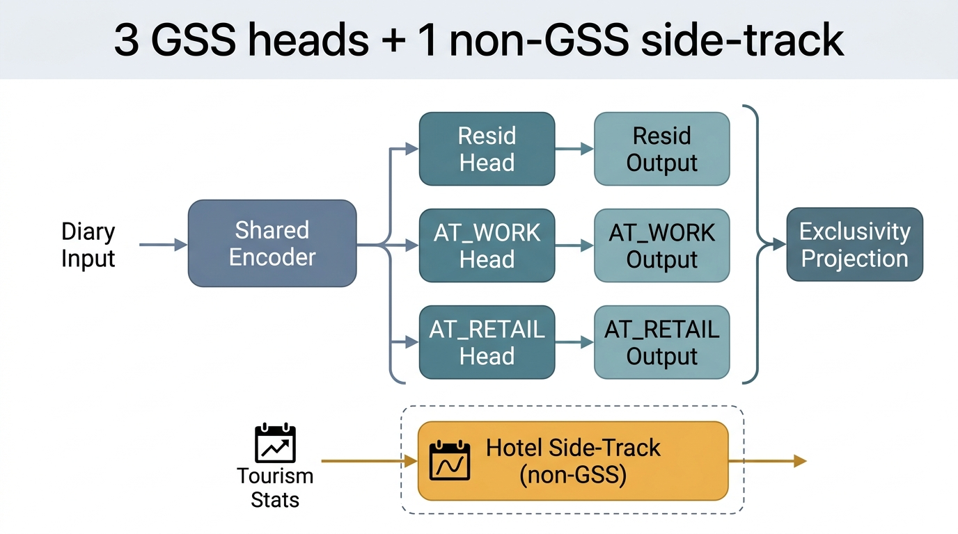
Figure 3
Figure 4. - The exclusivity projection: three independent sigmoid outputs, which may conflict, passed through a threshold-normalised argmax to a mutually exclusive decode, with the impossible-state rate before and after.
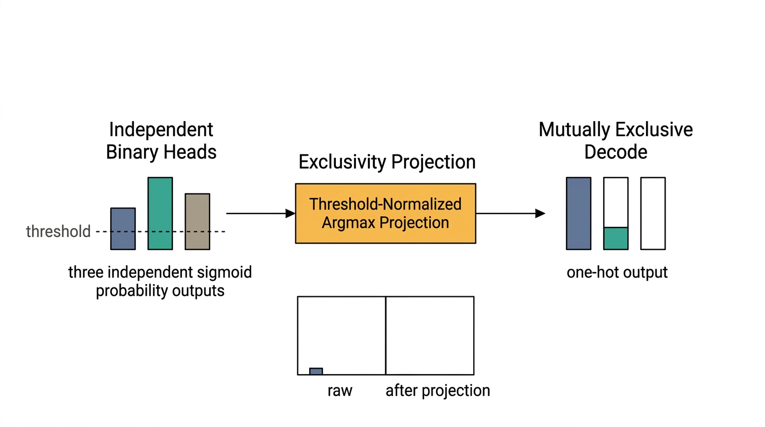
Figure 4

3.3 Linkage and the Population-Level Retail/Hotel Fallbacks
Residential linkage (household matching via the Census PUMF) and Office linkage (workforce matching via NOC-by-NAICS crosswalks) are unchanged from the two-channel construction stage; the mechanics of both are not restated here.
Retail and Hotel do not receive a respondent-level linkage at all, for two different reasons that both resolve to the same population-level fallback design. Retail cannot be linked to a specific archetype at finer resolution than a single population fraction, because the grocery/merchandise location split needed to place a respondent against a particular retail sub-type is not recoverable from the 2015/2022 GSS coding (§3.1); the channel is therefore driven by a single PNNL “Retail Retail” archetype applied as a population-level fraction rather than as a per-household lookup. Hotel cannot be linked to any respondent at all, because hotel guests are outside the GSS sampling frame by construction (Chapter 2, §2.3); the channel is therefore driven by a province-level multiplier (Quebec or Alberta) rather than by any individual archetype record. Both fallbacks are additive-safe in the same sense used elsewhere in this pipeline: a channel with no per-respondent linkage available falls back to a population- or province-level signal rather than to a missing value.

3.4 Forecasting and the Hotel SARIMA Side-Track
Residential and Office are forecast to 2030 by the same reused mechanism as the two-channel construction stage: progressive fine-tuning across the GSS cycle chain (2005 to 2010 to 2015 to 2022) with weight inheritance, plus the same demographic drift-matrix accounting. Retail reuses this same GSS chain for its generative-model output, and layers a separate scenario lever on top: three named 2030 in-store-share bands (0.97 plateau/resilient-central default, 0.90 continued-shift, 1.05 in-store-renaissance), applied before the peak-normalization step described in §3.5, plus a QC-Sunday sub-axis reflecting Quebec’s distinct regulated Sunday retail hours.
Hotel is forecast by a side-track that bypasses the three-head Transformer entirely, because it has no respondent-level structure for that model to condition on. The monthly ISQ (Quebec) and CBRE (Alberta) occupancy-rate series (Chapter 2, §2.3) are each fit with a SARIMA(1,1,1)(1,1,1,12) model per province, with an explicit COVID-19 indicator covering March 2020 through June 2022 so that the pandemic-era occupancy collapse does not bias the fitted seasonal structure. The fitted model produces a monthly occupancy-rate forecast that is converted into a half-hourly multiplier by:
hotel_multiplier(t, month, PR) = s(t) x monthly_rate(month, PR)
where s(t) is a unit-normalized, 48-slot guest-room diurnal shape common to both provinces: an overnight plateau at 1.00 from 22:00 to 06:00, and a day trough of 0.200 on weekdays versus 0.308 on weekends. The side-track’s own backcast validation gate (Table 4) requires QC and AB monthly reconstructions for 2015-2019 to reach a mean absolute error below 0.05, and requires the 2020-04 COVID-dip reconstruction to recover without overshoot. The 2030 forecast is expressed as three named bands (0.92, 1.00, 1.05) around the central SARIMA projection, mirroring the scenario-lever pattern used for the Office WFH band and the Retail in-store-share band (§3.5, §4). Figure 5 follows the side-track end to end, from the provincial monthly series through the SARIMA fit and its COVID indicator to the half-hourly multiplier that reaches the guest-room schedules.
Figure 5. - The hotel side-track end to end: provincial monthly tourism statistics, the SARIMA forecast with its COVID indicator, the diurnal shape function, and the resulting multiplier applied to guest-room schedules. The channel never touches the Transformer.
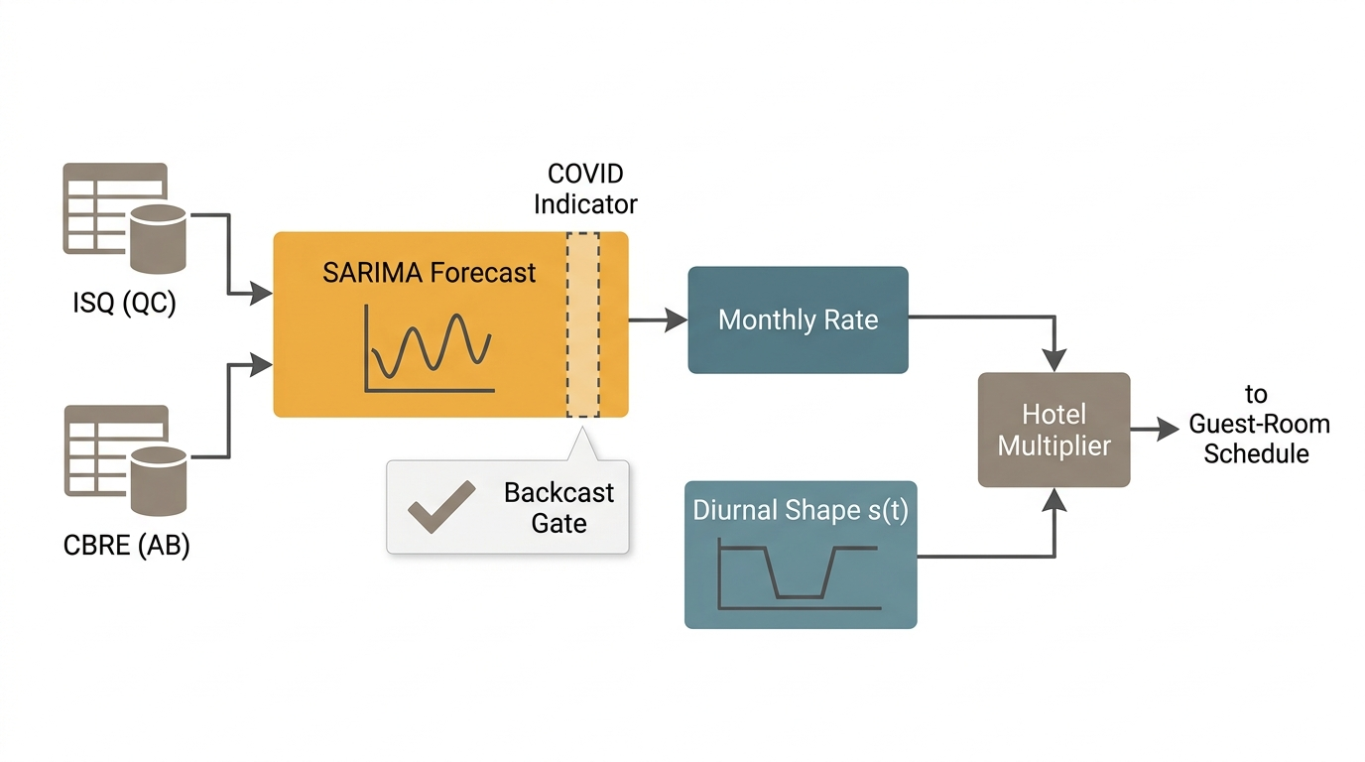
Figure 5

3.5 Tag-2 Dispatch and Modulate-vs-Replace
Injection into the building energy model is dispatched per Space using the IDF Tag 2 field as an exact-match routing key, because the PNNL Tall/SuperTall prototypes leave the standard EnergyPlus Space Type field blank. Figure 6 shows the dispatch for every Space in the tower, including the branch that matters most for the additivity claim in §6.1: an unrecognised tag falls back to the untouched code baseline rather than to an undefined state. Four dispatch outcomes follow from the tag match, and they are not interchangeable:
- Apartment tags -> Residential, REPLACE. The code default People schedule is fully substituted by the modelled schedule (Number_of_People driven by household size). Replacement is appropriate here because residential occupancy is per-household, not a code-density baseline to be adjusted.
- Office tags -> Office, MODULATE. The NECB office occupant density is multiplied by the modelled AT_WORK fraction over time, preserving the code-of-record peak density while injecting the temporal signal.
- Retail tags -> Retail, MODULATE. Customer presence is injected as People = 0.95 x peak-normalized shape_cd(t) during customer hours; slots identified as staff-only (baseline occupancy at or below 0.10) are left on the NECB baseline rather than modulated, consistent with Retail modelling customer presence only (§2.1, Table 2 footnote 2). The occupant density used for this Space type is the NECB office value (24.97 m2/person) rather than NECB’s own Retail-Sales value (29.97 m2/person); this is documented as a limitation, not corrected in this paper, because it is a code-density input, not an occupancy-schedule question, and correcting it is outside this paper’s scope.
- Guest-room tags -> Hotel, MODULATE. The NECB guest-room schedule is multiplied by hotel_multiplier(t, month, PR) from §3.4.
- Amenity and service/MEP tags -> untouched NECB baseline. No occupant-driven channel is defined for these Space types, so the code default is left in place.
- Missing channel -> NECB fallback. Any Space whose tag does not resolve to one of the four channels falls back to the untouched NECB default, the same additive-safe behaviour used for the Retail/Hotel linkage fallbacks in §3.3.
A hard wiring gate is asserted after every injection, and its origin is a defect found in the two-channel construction stage, not in this paper’s own new code. In that construction stage, a modulated People schedule was referenced by the field Schedule_Name rather than the field the People object actually consumes at simulation time, Number_of_People_Schedule_Name. Because the misreferenced field still existed and still held a syntactically valid schedule, every input-side check available at the time - schedule presence, schedule syntax, field non-emptiness - passed cleanly; the defect flattened the Office channel’s temporal signal and was caught only when Office simulation output failed to differ from an unmodulated baseline, an output-side observation. The post-injection gate that now asserts the correct field on 100% of modulated Spaces (Table 4, Wiring row) closes that specific input-side blind spot. But an input-side assertion, however strict, is still an input-side check, and the defect that motivated it was caught only on the output side; this is why the campaign design in Chapter 4 additionally makes two output-side probes mandatory before any Leg-3 campaign cell is accepted, rather than leaving output-side verification to good practice. The wiring defect and the gates it motivated are a methods contribution carried forward from the two-channel construction stage into this paper’s validation design; the construction stage itself does not receive a results narrative here.
Figure 6. - Tag-2 exact-match dispatch for every Space in the tower: apartment tags are replaced, office, retail and guest-room tags are modulated, amenity and service/MEP tags are left at the untouched code baseline, and an unrecognised tag falls back to that baseline rather than to an undefined state. The hard wiring gate applies to the modulated branch.
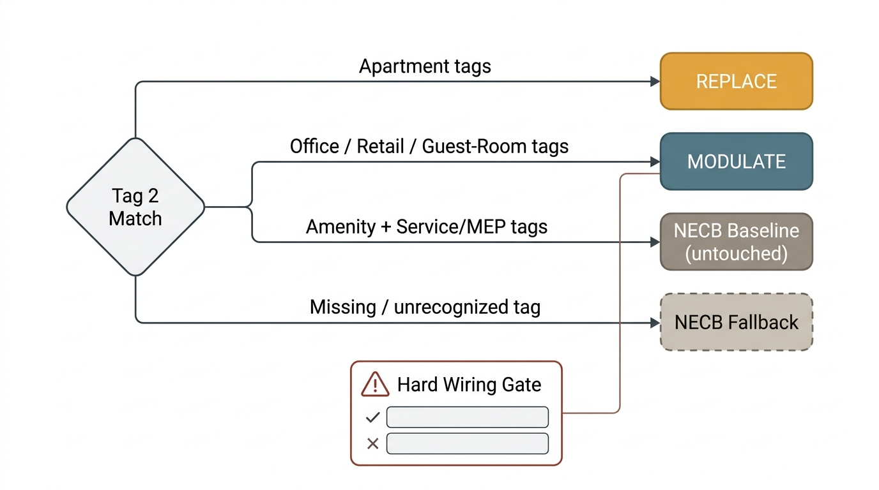
Figure 6

3.6 End-Use Loads
Activity-driven equipment and lighting loads follow channel-specific rules rather than one shared rule across all four uses, because the four uses do not share an occupancy semantics. For Retail, lighting and HVAC-relevant schedules follow the Space’s opening hours rather than the customer-presence signal itself, plug load follows the staff schedule (and therefore stays on the NECB baseline, consistent with §3.5), and customer presence modulates only the People-driven internal gain; minimum lighting and baseline plug floors (Lmin, Pbase) are enforced so that an empty-of-customers slot during opening hours is not modelled as a fully unlit, unpowered space. For Hotel, guest-room loads are modulated by the same s(t) diurnal shape and monthly amplitude used for occupancy (§3.4), while amenity-zone loads remain on the NECB baseline, matching the amenity-zone occupancy treatment in §3.5.
The activity-driven end-use layer is calibrated against the NRCan Survey of Commercial and Institutional Energy Use (SCIEU; Natural Resources Canada), the commercial analogue of the residential SHEU anchoring (Natural Resources Canada, 2019) used in the two-channel construction stage and in the authors’ residential-only prior work (Iseri and Hachem-Vermette, under review b).
Table 6.
This table carries the paper’s additive claim, and it carries the limits of that claim in the same place. A Bit-identical? = Yes cell is entered only where file-level evidence was located, meaning a shared file path or a hash computed directly on the files themselves, and never from a design document’s own prose. Where no such evidence exists, the verdict cell reads not reported and the basis cell says plainly what was not compared. An unexamined step is reported as unexamined, which is a result about the strength of the claim rather than a gap to be filled with an assumption.
Pipeline step | Two-channel stage artefact | Four-channel change | Bit-identical? | Basis for the verdict
Step 1 - Data collection | Survey column selection for the residential and office channels | A new, non-survey hotel ingest of the provincial monthly occupancy series, alongside the survey reader; no new survey variable is added for retail, which derives from location and activity columns the survey already carries | not reported | Nothing was compared. The two stages’ collection scripts differ in name and the four-channel side adds a reader the two-channel side never had, but no byte-level or column-level comparison of the survey-column output was run, so no verdict is entered
Step 2 - Data harmonization | Crosswalk and OR-rule for the residential and office channels | A new hotel harmonization step, plus the retail OR-rule frozen 2026-07-02 (Table 2, footnote 1) | not reported | Nothing was compared. As at Step 1, the scripts differ in name and no byte-level or column-level comparison of their output was run
Step 3 - Merge and tiling | List-driven tiler producing residential and office 30-minute output | One additional list entry for retail, whose output is written to a separate file specifically so it cannot overwrite or reshape the residential and office columns | not reported | The design intends the two reused paths to be untouched, and the separate-file arrangement is what would make that true. That intent is documented, but it was never tested against the tiler’s own output, and a design statement about a program is not evidence about what the program wrote
Step 4 - Three-head Transformer | Two-head Transformer, residential and office presence | A third head for retail; the backbone is kept with targeted upgrades (warmup, gradient-conflict correction, logit-adjusted loss, raking) rather than frozen and copied | No | The gate that governs the two reused heads is a tolerance, bounding their drift at 0.002 bits of Jensen-Shannon divergence against the two-channel stage’s own validation baseline. A bounded-drift guarantee is not bit-identity, and the two reused heads are expected to move within it, so the verdict is No on the evidence that exists. The measured drift value itself was not located and is left unreported rather than estimated
Step 5 - Archetype linkage | Residential dwelling-stock linkage and office workforce linkage | Retail is driven by a single retail archetype applied as a population-level fraction, hotel by a province-level multiplier; neither receives a respondent-level linkage | not reported | The two reused linkages are documented as carried over unchanged, but no file-level or column-level comparison of their output across the two stages was run, so no verdict is entered
Step 6 - Forecast to 2030 and the hotel side-track | Survey-cycle raking chain with a demographic drift matrix, plus the office work-from-home bands | The same raking chain is reused for the survey-derived channels; a retail scenario lever is added, and the hotel SARIMA side-track is added, bypassing the Transformer entirely | No | The code is reused but the level has moved, so this is a verdict on measured output rather than on an untested step. Post-calibration 2030 work presence sits 10.51 percentage points below observed 2022 (Cohen’s d -0.649), an open, recorded bias that is four to five times the roughly 2.4 percentage-point work-from-home signal the campaign exists to detect. The bias is close to common-mode across the three work-from-home bands, so contrasts between bands are less affected than the level itself, but a reading of “the reused channels’ Step-6 output is unchanged” is directly contradicted
Step 7 - Building-model integration | Two-channel tag-based injection into the tower prototypes | Four-channel exact-match dispatch, with a missing channel falling back to the untouched code baseline | Yes, for the base prototype geometry only | The strongest evidence in this table, and also the narrowest. Both campaigns read the same four physical prototype model files from one directory, with no copy taken, and all four were confirmed byte-identical by hash at review. That establishes the geometry and nothing wider: the injector code is not a shared frozen asset, since three copies of the related residential injector were hashed and do not match one another. The tower the two stages simulate is the same building; the code that writes schedules into it is not the same code
Step 8 - Building simulation | 72-run residential re-simulation plus the office campaign | The 56-cell campaign, two prototypes by two cities by fourteen scenarios, with all four channels injected per cell | not reported | Channel isolation was demonstrated inside this study’s own campaign, where any channel not varied between a pair of cells moves by exactly zero, confirmed by simulation rather than inferred. That is a within-study result about interference between channels. The two stages’ simulation outputs were never compared with one another, so no cross-stage verdict is entered
Step 9 - Activity-driven end-use loads | Two-channel end-use validation against national survey and prototype references | Four-channel validation over thirty gates, three of which are left failing on purpose (Table 5) | No | The two stages are scored on different gate sets, and, more seriously, may not share a basis at all. Whether the two-channel stage’s office figure counts electricity only while this study’s counts all fuels is an open question in that stage’s own record, and the shared tower burns natural gas in every run. Until that is settled the two figures cannot be differenced, and a claim of reproduction cannot be entered

4 Experimental Design
The simulation campaign is organised as a fully-specified factorial experiment whose domain is summarised in Table 3: two tower prototypes, two cities, and fourteen scenarios, for 56 cells in total. Four occupancy channels drive four uses inside one stacked building at every cell; the campaign design exists to isolate, as far as a single-building study can, which of those four uses’ temporal signal is responsible for a given change in simulated output.

4.1 The Two Towers
The building domain is two PNNL mixed-use tower prototypes, Tall and SuperTall, reused without modification to their geometry from the two-channel construction stage. Their measured total occupiable floor areas are 72,623.1 m2 (Tall) and 135,857.6 m2 (SuperTall) - parsed directly from the model geometry as the sum of Space FloorArea x Multiplier over IsPartOfTotalArea = 1 zones, reproducing EnergyPlus’s own Total Building Area exactly (Table 3). Both towers stack the same four occupiable uses - residential, office, retail, hotel - inside one building envelope, plus amenity and service/MEP space that carries no occupant-driven channel. This is the concrete meaning of “four channels driving four uses inside one building”: the campaign does not compare four separate archetype buildings, it compares two buildings that each already contain all four uses. Figure S1 gives the measured occupiable-area share carried by each channel in each prototype, with the service and mechanical share shown separately because it is a share of gross floor area rather than of occupiable area; the two prototypes do not divide their floor area between the four uses in the same proportions, which is what makes the prototype axis a genuine experimental factor rather than a size rescaling.
Figure S1. - Measured occupiable-area share per channel for both tower prototypes, with the service and mechanical share shown separately because it is a share of gross floor area rather than of occupiable area.
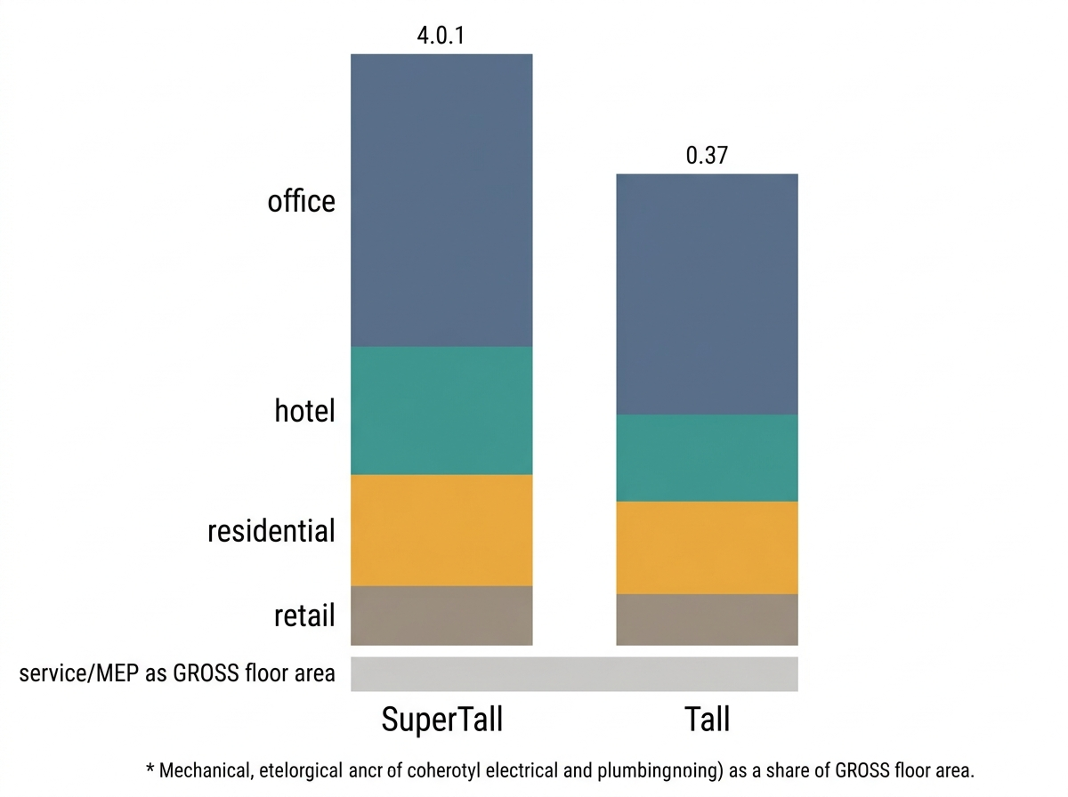
Figure S1

4.2 The Two Cities
Two cities anchor the climate axis: Montréal (ASHRAE climate zone 6A) and Calgary (ASHRAE climate zone 7A). Each city is assigned its own TMY EnergyPlus weather file. The Montréal and Calgary IDF for a given tower differ from one another by a climate-tag edit only, so that any EUI delta observed between the two cities is attributable to climate rather than to a co-varying geometry difference (Table 3, and its footnote on the Calgary EPW’s on-disk _6B filename versus its campaign-assigned Z7A climate-zone label).

4.3 The 56-Cell Campaign and Its Scenario Levers
The full campaign crosses 2 towers x 2 cities x 14 scenarios = 56 cells, all 56 simulated (Table 3 footer). The fourteen scenarios are, by design, not an arbitrary list: one scenario is the uninjected NECB baseline; four are the historical GSS cycle years; three are the 2030 forecast bundled at a conservative, central, and optimistic band; and six are single-axis sensitivity variants built on top of the central 2030 bundle, two per scenario-lever channel.
- Default (NECB). No occupancy injection at all - every Space runs its untouched NECB default schedule. This is the uninjected control behind the office band-applicability finding in the Limitations chapter (not reported for its full quoted EUI value, which belongs to Table 5 / Chapter 5, not to this chapter).
- 2022. All four channels injected at their observed-2022 GSS/tourism-statistics product.
- 2005, 2010, 2015. The three earlier historical GSS cycle years, with office, retail, and residential injected; Hotel is deliberately absent from all three historical years, because the provincial tourism-statistics series behind the Hotel channel does not extend to a matching pre-2019 Quebec coverage for these years (§4.4, and Chapter 7’s limitation on the pre-2019 hotel gap).
- B-cons, B-central, B-opt (2030). The three named 2030 bundles, one per conservative / central / optimistic combination of the per-channel scenario levers below, with B-central as the reference point the six sensitivity scenarios are built against.
- sens_office_cons, sens_office_opt. B-central with the Office WFH band swapped to conservative or fullyhybrid. Residential is swapped together with Office in both of these scenarios, not independently: Residential’s 2030 product is produced by the same function, keyed off the same office-band parameter, as Office’s own 2030 product, so the two channels share one lever rather than each carrying its own. This is the concrete sense in which “Residential has no lever” (Table 2): Residential does not have a null 2030 axis, it has no axis independent of Office’s.
- sens_retail_cons, sens_retail_opt. B-central with only the Retail in-store-share csv swapped to its conservative or optimistic 2030 value; Office and Residential stay at their central-band draw.
- sens_hotel_cons, sens_hotel_opt. B-central with only the Hotel SARIMA-band csv swapped to its conservative or optimistic 2030 value; Office and Residential stay at their central-band draw.
Each of the three GSS-linked channels therefore carries exactly one 2030 scenario lever - Office’s WFH band (conservative / hybrid / fullyhybrid), Retail’s in-store share (0.90 / 0.97 default / 1.05), and Hotel’s SARIMA band (0.92 / 1.00 / 1.05) - and each lever is exercised both jointly, in the three B- bundles, and in isolation, in the corresponding pair of sens_ scenarios (Table 2). Residential carries no independent lever of its own; its 2030 product moves only as a consequence of the Office WFH band, a design choice made explicit in the campaign’s own scenario-construction code rather than left implicit. Figure S2 lays the four channels’ levers side by side, so that Residential’s deliberate absence of an independent axis is legible as a design decision rather than as an omission.
Figure S2. - One scenario lever per channel: office, retail and hotel each carry a single three-position lever that can be re-run independently, and residential deliberately carries none.
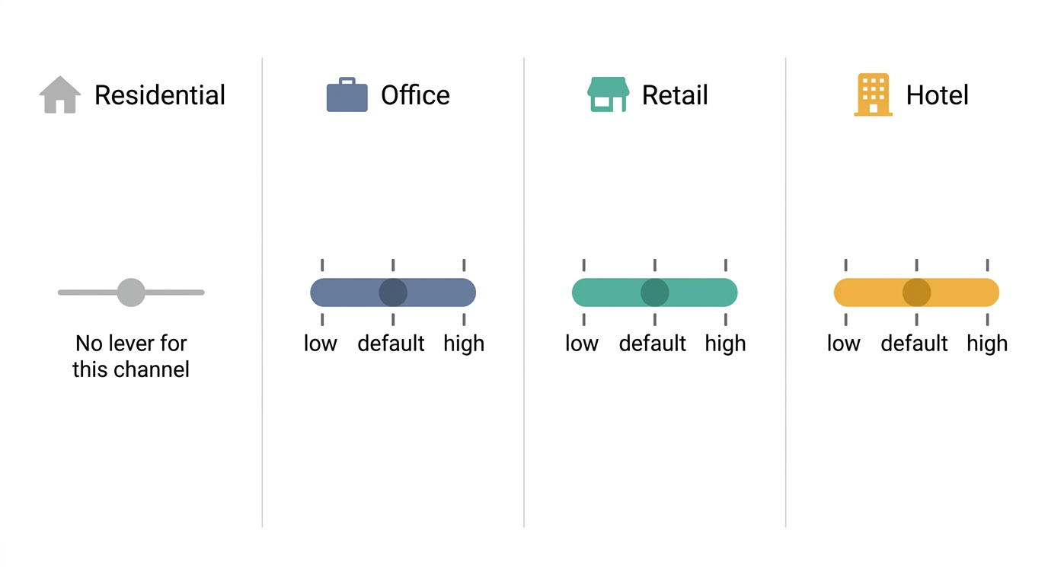
Figure S2

4.4 Two Mandatory Probes
Two output-side probes are run before any Leg-3 campaign cell is accepted, and both exist because of a specific defect found in the two-channel construction stage: a modulated schedule referenced by the wrong IDF field passed every input-side check available at the time and was caught only when its simulated output failed to differ from an unmodulated run (Chapter 3, §3.5). An input-side field assertion closes that particular blind spot, but does not, by itself, guarantee that a campaign’s outputs actually carry the scenario signal they are supposed to carry. The two probes below are the output-side complement to that input-side assertion.
Probe 1 - scenario-differentiation. Two distinct scenarios - for example B-central versus sens_retail_opt - must produce EnergyPlus outputs that differ from one another. A pair of scenarios that are supposed to differ in occupant schedule but return byte-identical simulation output is treated as an automatic fail, on the same logic as the construction-stage defect: a schedule that looks correct on disk but never reaches the simulated result is indistinguishable, at the output, from no injection at all.
Probe 2 - stale-output guard. A wiring fix to the injector - or, more generally, any change to the Step-7 schedule products the injector consumes - invalidates previously completed (“skip_done”) cell outputs that were produced before the fix. A campaign resume mechanism that silently treats an already-populated output directory as done, without checking whether the code or the input products that produced it have since changed, can allow two incompatible result sets to occupy the same output path with no trace of which one is current. The guard that was first implemented fingerprinted only the injector script itself; a subsequent correction extended it to also cover the Step-7 product files, because a scenario’s schedule content, not only the injector code, determines what gets injected, and a changed product file with an unchanged injector script would otherwise leave a stale result undetected at the same output path.
The scenario-differentiation probe is listed in Table 4 alongside the wiring field-reference assertion, under the wiring-and-differentiation gate group made mandatory by the two-channel construction stage’s own lesson. The stale-output guard is a campaign-orchestration control rather than a per-cell validation metric, and for that reason is not itself a Table 4 row; it is documented in the Step-8 campaign implementation record cited below.
Table 3.
The 56-cell Step-8 campaign: two tower prototypes x two cities x 14 scenarios. Surfaces below are the corrected, parsed values (an implementation correction recorded 2026-07-31) - Sigma(FloorArea x Multiplier) on IsPartOfTotalArea = 1 zones, reproducing EnergyPlus’s own Total Building Area exactly. The two IDFs per prototype (Montreal / Calgary) differ by 36 bytes only - geometry is identical, the climate tag is the sole difference, so EUI deltas isolate climate.
Prototype | Total area (m2) | Cities | ASHRAE CZ | EPW | Standard | Cells
SuperTall | 135,857.6 | CAN_MTL, CAN_CLG | 6A (Montreal), 7A (Calgary) | CAN_QC_Montreal.Center-Jean.Brebeuf-McGill.Univ-McTavish.716120_TMYx_6A.epw (MTL); CAN_AB_Calgary-Canadian.Olympic.Park.Upper.712350_TMYx_6B.epw (CLG) | NECB-2017 | 28 (2 cities x 14 scenarios)
Tall | 72,623.1 | CAN_MTL, CAN_CLG | 6A (Montreal), 7A (Calgary) | CAN_QC_Montreal.Center-Jean.Brebeuf-McGill.Univ-McTavish.716120_TMYx_6A.epw (MTL); CAN_AB_Calgary-Canadian.Olympic.Park.Upper.712350_TMYx_6B.epw (CLG) | NECB-2017 | 28 (2 cities x 14 scenarios)
Footer: 56/56 cells simulated, geometry-identical IDFs across cities. agg_meta.csv records total_building_area_m2 = 135,857.594… (SuperTall) and 72,623.070… (Tall) on every one of the 56 rows, unchanged across scenario and city - confirming area is a building-geometry property, not a per-run artefact.

Footnote - the EPW filename carries a “6B” tag; the campaign’s own climate-zone label is 7A
The Calgary EPW file is named with a _6B suffix on disk (CAN_AB_Calgary-...712350_TMYx_6B.epw), but the campaign driver assigns it climate zone Z7A (cz: "Z7A" in CITIES, confirmed in every Calgary row of agg_meta.csv). This is not a transcription error: the driver’s own docstring names it explicitly (“EPW tagged _6B on disk … NOT renamed per instruction”) and elects to keep the file’s original name rather than rename it to match the zone label used in the NECB-2017 analysis. The same EPW file (_6B in its filename) is also used by the 2J manuscript, where it is reported against ASHRAE zone 6B (2J_docs_occ_nTemp/writing/tables/Table_03_sim_domain.md) - i.e. the same physical weather file is legitimately labelled differently by climate-zone standard/vintage across the two manuscripts. Montreal’s EPW, by contrast, is filed as _6A and reported as CZ 6A in both.
Table 4.
Gates applied across Steps 4-9 of the Leg-3 (4-split) pipeline. The Provenance column classifies every threshold as exactly one of three kinds. This distinction is load-bearing for the paper’s honesty: a project-chosen threshold is not literature, and must never be cited as if it were.

(a) Tiered gates - Tier 1 distributional / Tier 2 structural / Tier 3 ASHRAE G14
Applied per day-type, to AT_RETAIL exactly as to AT_WORK in Leg-2.
Tier | Metric | Threshold | Provenance
1 Distributional | KL divergence (arrival / departure) | < 0.05 | project-chosen (set before tuning)
1 Distributional | 1-Wasserstein / EMD on hourly presence CDF | < 0.05 | project-chosen (set before tuning)
1 Distributional | Presence-rate RMS error | ≤ 5 pp per day-type | project-chosen (set before tuning)
2 Structural | Transition-matrix Frobenius / MAE | < 0.05 | project-chosen (set before tuning)
2 Structural | Dwell-time KS test | p > 0.05 (fail to reject H₀) | project-chosen (set before tuning)
2 Structural | Autocorrelation MAE, lags 1-24 h | < 0.05 | project-chosen (set before tuning)
3 Downstream | NMBE | monthly ±5 %, hourly ±10 % | ASHRAE Guideline 14
3 Downstream | CV(RMSE) | monthly 15 %, hourly 30 % | ASHRAE Guideline 14
3 Downstream | Peak demand magnitude + timing | magnitude ±15 %; timing ≤ 1 h | project-chosen (set before tuning)

(b) Channel-specific gates
Layer | Check | Target | Provenance
LOCATION mapping | AT_RETAIL rate, weekday 12:00-14:00, per cycle | 0.06-0.10 (confirmed by a retail presence-rate review, central ≈ 0.079) | project-chosen (set before tuning)
LOCATION mapping | Saturday peak rate, 13:00-16:00 | 0.09-0.12 | project-chosen (set before tuning)
LOCATION mapping | Sunday peak rate, per city | Calgary 0.06-0.10 / Montreal 0.04-0.07 | project-chosen (set before tuning)
LOCATION mapping | Night slots 00:00-05:00, all day-types | 0.000-0.003 | project-chosen (set before tuning)
OR-rule leak | occACT==4 & occPRE==1 (online-shopping) share per cycle, excluded from AT_RETAIL | rule FROZEN 2026-07-02; cross-tab still reported as verification | project-chosen (set before tuning)
Transformer (JS) | JS(AT_WORK), JS(AT_RETAIL) per stratum | < 0.02 each (JS alone is toothless for AT_RETAIL; paired with PR-AUC / F1 below) | project-chosen (set before tuning)
Transformer (Resolution) | PR-AUC and F1 on positive slots, AT_RETAIL | PR-AUC ≥ 0.15, F1 ≥ 0.25 (catches all-zeros failure) | heuristic
Transformer (Dynamics) | Midday (11-14 h) rate error + transitions/day, AT_RETAIL | Midday error ≤ 3.0 pp, transitions ≥ 0.05/day | project-chosen (set before tuning)
Transformer (Regression) | Old-head (Head 1, Head 2) JS drift | ΔJS ≤ 0.002 bits vs Leg-2 validation baseline | project-chosen (set before tuning)
Transformer (Exclusivity) | Impossible-State Rate: slots with > 1 of {AT_HOME, AT_WORK, AT_RETAIL} active | ISR ≤ 0.5 % raw; = 0 % after decode-time projection | project-chosen (set before tuning)
Hotel backcast | QC + AB monthly 2015-2019 vs reconstruction | MAE < 0.05 | project-chosen (set before tuning)
Hotel COVID dip | 2020-04 reconstruction | recovered without overshoot | project-chosen (set before tuning)
BEM end-to-end | Default vs 2022, Montreal SuperTall | EUI delta positive; Office + Hotel dominant | project-chosen (set before tuning)
Floor-area sanity | Per-channel EUI share vs parsed occupiable share | ± 2 pp | project-chosen (set before tuning)

(c) Wiring + differentiation gates (the Leg-2 lesson gates)
Made mandatory because the Leg-2 People-field wiring bug (Number_of_People_Schedule_Name, not Schedule_Name) passed every input-side check and was caught only output-side.
Layer | Check | Target | Provenance
Wiring | Post-injection field-reference assertion | 100 % of modulated Spaces pass | project-chosen (set before tuning)
Simulation | Scenario-differentiation probe | Outputs differ per channel across ≥ 2 scenarios (byte-identical results = automatic FAIL) | project-chosen (set before tuning)

Threshold provenance
- ASHRAE Guideline 14 - NMBE (±5 % monthly / ±10 % hourly) and CV(RMSE) (15 % monthly / 30 % hourly) only. Cite the standard.
- project-chosen (set before tuning) - every < 0.05 gate (KL, EMD, transition-matrix Frobenius/MAE, autocorrelation MAE), the presence-rate RMS ≤ 5 pp, the dwell-time KS p > 0.05, the peak ±15 % / ≤ 1 h gate, the 0.06-0.10 retail rate family (weekday/Saturday/Sunday/night), the OR-rule freeze, the JS < 0.02 pairing, the midday-dynamics and JS-drift gates, the ISR ≤ 0.5 % bar, the hotel MAE < 0.05 and COVID-recovery checks, the decode thresholds (0.50 / 0.40 / 0.15), the wiring and scenario-differentiation gates, and the ± 2 pp EUI-share gate. All were set before tuning and are project acceptance bars, not literature values.
- heuristic - PR-AUC ≥ 0.15 and F1 ≥ 0.25, adopted to catch an all-zeros failure mode, flagged by this project’s own architecture and training reviews as heuristic rather than literature-derived.
not reported - the decode-time thresholds (0.50 / 0.40 / 0.15) named in the pipeline overview’s provenance blockquote are not broken out as individual gate rows in the VALIDATION GATES / VALIDATION PLAN tables of either source document; they are recorded here only inside the provenance key, per the source text itself.

5 Results
The four subsections below move from the raw behavioural driver behind each channel (Section 5.1), to its annual energy consequence measured against reference bands, including where that consequence fails the bands (Section 5.2), to its reshaping of the load curve inside a single stacked building (Section 5.3), and finally to how each channel responds when its own 2030 scenario lever, and only its own lever, is moved (Section 5.4). Every measured value in this chapter is read from the frozen Leg3_4-split/Step9_docs/outputs_step9_deliverable/ directory; the sibling outputs_step9/ directory is superseded and is not used here. No band value is moved and no gate verdict changes anywhere in this chapter.

5.1 Four channels move differently over 2005 to 2030
step9_longitudinal.csv carries the four historical GSS Time-Use cycles - 2005, 2010, 2015, 2022 - simulated across all four building-city cells (SuperTall and Tall, Montreal and Calgary). Read as the median EUI (CFA basis) across those four cells, three of the four channels genuinely vary by cycle, and they do not move together or in the same direction.
Office is not monotonic. Median EUI falls from 70.63 kWh/m2/yr in 2005 to 69.78 in 2010 (-1.21 %), climbs to 71.29 by 2015 (+0.94 % against 2005), then falls again to 70.20 by 2022 (-0.67 %) - a dip-rise-dip pattern rather than a trend, with the individual four-cell range never exceeding -1.48 % to +1.18 % in any cycle. Retail moves the furthest and reverses direction outright: it declines through 2010 (median 76.36, -1.42 % vs 2005) and 2015 (median 75.84, -2.03 %), then jumps past its own 2005 baseline by 2022 (median 79.19, +2.36 %, four-cell range +0.13 % to +4.69 %). Residential is close to flat across all four cycles, drifting from a 2005 median of 118.73 kWh/m2/yr to 118.68 in 2022 (median change -0.07 %, four-cell range -0.49 % to +0.09 %).
Hotel’s apparent flatness across the same four cycles is a feature of the campaign design, not a measured behavioural finding, and must be read as such. Per the scenario list (Chapter 4, §4.3), Hotel is deliberately left uninjected - on the untouched NECB default schedule - in the 2005, 2010 and 2015 scenarios, because the ISQ/CBRE provincial tourism-statistics series behind it does not reach a matching pre-2019 Quebec coverage (Chapter 7). The near-zero change recorded for hotel across those three cycles in step9_longitudinal.csv (median change from the 2005 baseline: -0.003 % in 2010, +0.031 % in 2015) therefore reflects whole-building thermal coupling with the three genuinely-varying channels, not a hotel occupancy signal. The first cycle at which Hotel is actually injected is 2022, at its observed-2022 tourism-statistics product; even there the median change against the uninjected-2005 baseline is small, +0.09 % (four-cell range -0.39 % to +0.73 %). Hotel’s real year-to-year movement is carried by the SARIMA 2030 band rather than by the historical GSS-cycle axis, and is examined directly in Section 5.4. Figure 7 plots all four trajectories on the same cycle axis, with Hotel’s 2005 to 2015 segment marked as the uninjected NECB baseline so that its flatness is not read off the figure as a measured hotel signal.
The four channels also carry very different weight inside the same building envelope. Aggregated across all four cycles and all four building-city cells (step9_longitudinal.csv, energy_share_pct and area_share_pct columns), Hotel’s median share of building energy (44.47 %) runs 24.22 percentage points above its median share of building floor area (20.25 %), while Office’s median energy share (21.42 %) runs 13.72 points below its area share (35.14 %); Residential (energy 18.27 % vs area 17.73 %) and Retail (2.56 % vs 3.92 %) sit close to proportional. This asymmetry between one high-intensity, low-footprint channel and one low-intensity, high-footprint channel is the structural backdrop for the per-channel band verdicts in Section 5.2 (Figure 8).
Figure 7. - four-channel EUI trajectory across the 2005, 2010, 2015
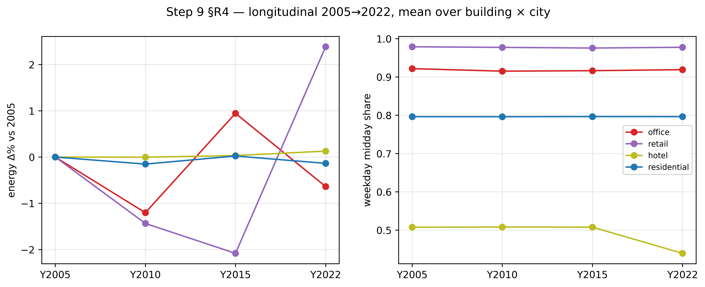
Figure 7
and 2022 GSS Time-Use cycles, one panel or series per channel, Hotel’s 2005-2015 segment marked as the uninjected NECB baseline rather than a measured hotel signal.

5.2 Per-channel EUI and the band verdicts, including the three failures
Table 5 reports per-channel EUI on a dual basis - conditioned floor area (CFA, the primary thermodynamic metric) and gross-floor-area occupiable-share (GFA-share, a secondary stock-comparability check) - never averaged together - against an as-modelled band (PASS criterion) and a wider empirical band (INFO criterion only, not scored). Residential carries no as-modelled band and is reported INFO-only, 55 of 56 cells outside the empirical band (1 of 56 IN). Of the three channels that do carry a PASS/FAIL band, all three fail, and all three are reported here at full strength, with the deciding number in the same sentence that states the failure.
Office fails hardest: all 56 injected campaign cells sit below the 100 kWh/m2/yr floor, median 71.02 kWh/m2/yr (CFA range 61.72-90.21), and the uninjected Default_NECB control - the code’s own reference implementation, carrying no occupancy signal at all - scores 85.45 kWh/m2/yr against that same 100 floor, so the untreated control fails too. A gate that no untreated control can pass is measuring the band, not the model. Two candidate mechanisms for the gap were tested and both were refuted in 56 of 56 cells: modelled heating share sits at 17 % against the band’s own 35-45 %, and rebasing on service/MEP area moves every cell further down, not up. The band’s own source document additionally gives three different floors for itself (Table 7.1 = 100.0; line 21 = 80-140; Table 2.1 = 85.0-115.0), so the floor is recorded as contested and unsourced, not merely missed.
Hotel fails on the opposite side of its band: 28 of 56 cells FAIL, every one above the 300 kWh/m2/yr ceiling and every one on the Tall prototype (SuperTall clears the ceiling in all 28 of its own cells), over a measured range of 203.33 to 318.42 kWh/m2/yr (median 260.54). The band ceiling rests on the first-party DOE/PNNL Large Hotel, ASHRAE 90.1-2019 (ASHRAE, 2019) prototype value (284.44 kWh/m2/yr at CZ 6A, 299.28 at CZ 7), which is 1.0 % from the ceiling’s original 90.1-2004-lineage anchor of 302.21, so a vintage-mismatch objection does not hold; what remains is that the reference archetype’s own city set (Rochester / International Falls) does not match this study’s NECB-2017 Montreal / Calgary towers.
Retail fails under the gate rule actually in force, median-in-band rather than all-cells (decided in advance of the numbers): the measured median is 75.63 kWh/m2/yr, which is 5.47 % below the 80 kWh/m2/yr floor. Under an all-cells count, 12 of 56 cells sit inside the band and 44 of 56 sit below the floor (0 above the ceiling); that per-cell tally is reported for transparency but is not the rule that scores the gate. This 5.47 % median-to-floor gap must not be confused with a different, smaller quantity: the retired all-cells rule was itself replaced because it was turning on a margin of only 0.15 % of its floor (a -0.05 % shift in the median, from a separate improvement round, flipped one cell’s individual verdict) - that 0.15 % is the decision margin that justified changing the rule, not the distance between the median and the floor, which is the 5.47 % reported above.
No band value was moved and no gate verdict was changed to produce these results; all three failures are reported as findings about band applicability, not resolved by widening a band or by selecting whichever rule happens to pass (Table 5). Figure 8 plots all 56 cells per channel against their own band, which is where the three failures’ different geometries are visible at once: office below its floor across the whole cell set, hotel split into two prototype clusters on either side of its ceiling, and retail straddling its floor with the median on the failing side.
Figure 8. - per-channel EUI across all 56 cells, CFA basis, as-modelled bands
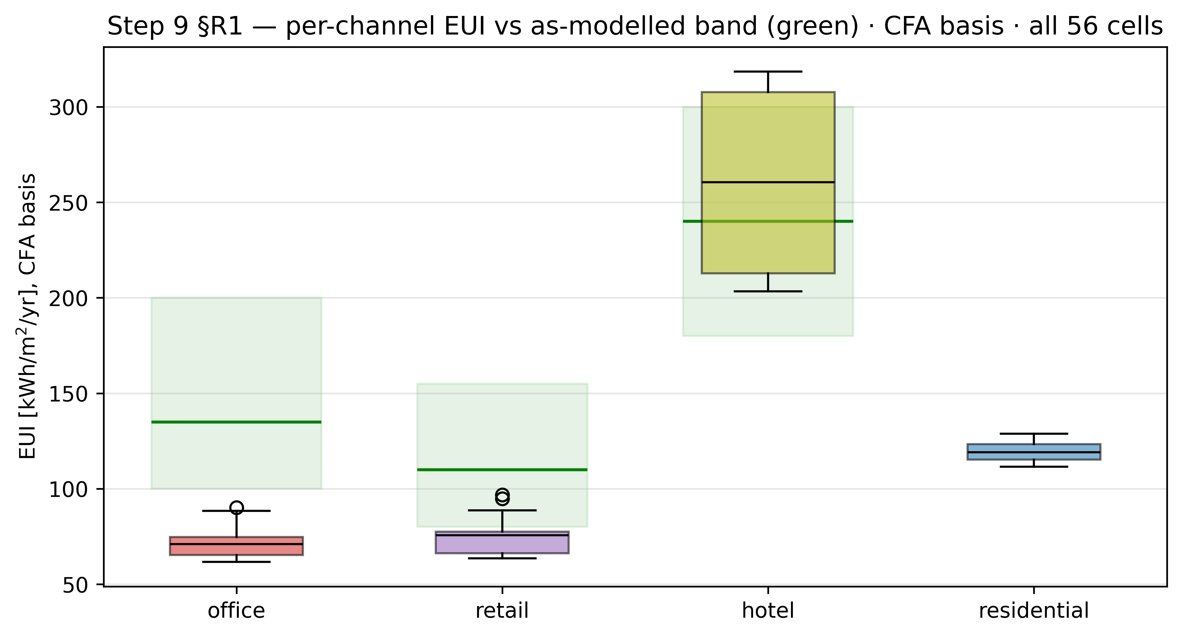
Figure 8
marked, the three failing channels’ cells shown against their respective floor/ceiling.

5.3 Load shape and peak-hour behaviour in a stacked building
step9_loadshape_peaks.csv reports a full-day and weekday/weekend load shape per channel and per whole-building total, for the same cell grid used in Table 5. Under the central 2030 scenario (B_central), the four channels do not share a peak hour. By the circular-mean weekday peak-hour metric (median across the four building-city cells), Office peaks at 11.90 h (range 11.82-11.93 h), Residential at 12.04 h (range 12.01-12.10 h), and Retail at 12.37 h (range 12.11-12.62 h) - all clustered around midday - while Hotel peaks at 18.91 h (range 18.84-18.94 h), roughly seven hours later, in the early evening. The whole-building peak (_BUILDING channel, peak_hour_circular) lands at a median of 14.95 h (range 14.11-15.70 h across the four cells): between the midday cluster of Office/Residential/Retail and Hotel’s evening peak, and coincident with none of the four channels’ own peaks exactly. Figure 10 places the four channel peaks and the whole-building peak on one clock face for all four building-city cells, and Figure 9 gives the underlying weekday and weekend load-shape curves the peaks are read from.
The weekday midday-to-night contrast (wd_midday_kW against wd_night_kW) also differs sharply by channel, and one channel inverts it. Retail shows the sharpest daytime concentration: median weekday midday demand of 72.03 kW against 2.11 kW at night, a ratio near 34 to 1. Office follows at roughly 11.8 to 1 (569.33 kW midday, 48.10 kW night). Residential is far flatter, near 3.9 to 1 (347.82 kW midday, 89.53 kW night) - a floor set by continuously-operating residential end uses rather than by occupant presence alone. Hotel is the only channel where the ratio inverts: median weekday night demand of 434.47 kW exceeds median midday demand of 335.93 kW, consistent with a guest-room channel occupied overnight rather than during the day.
Because the four channels peak at different hours and carry different day/night profiles, the whole-building coincidence factor - the ratio of the simultaneous building peak to the sum of the four channels’ own individual peaks - stays below 1 in every one of the four cells under B_central: median 0.941, low of 0.851 (Tall, Calgary). Occupant and use-type diversity inside one stacked building therefore flattens the aggregate peak relative to what a simple sum of the four channels’ individual peaks would imply, the same attenuation effect reported for household diversity within a single archetype in the Leg-2 construction stage, here operating across four different uses sharing one envelope instead of across households sharing one archetype.
Figure 9. - weekday and weekend diurnal load shape, one curve per channel
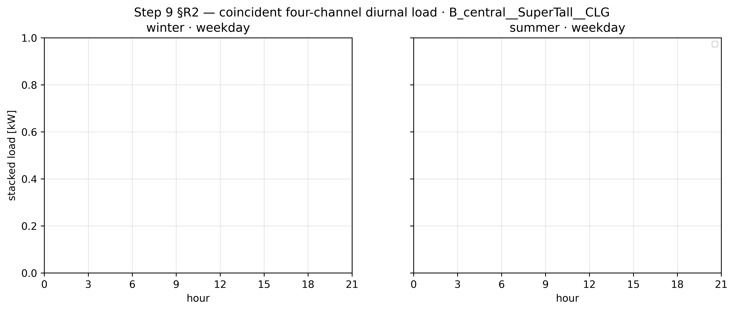
Figure 9
plus the whole-building total, B_central scenario, midday and night reference bands marked.
Figure 10. - per-channel and whole-building peak hour (circular-mean),
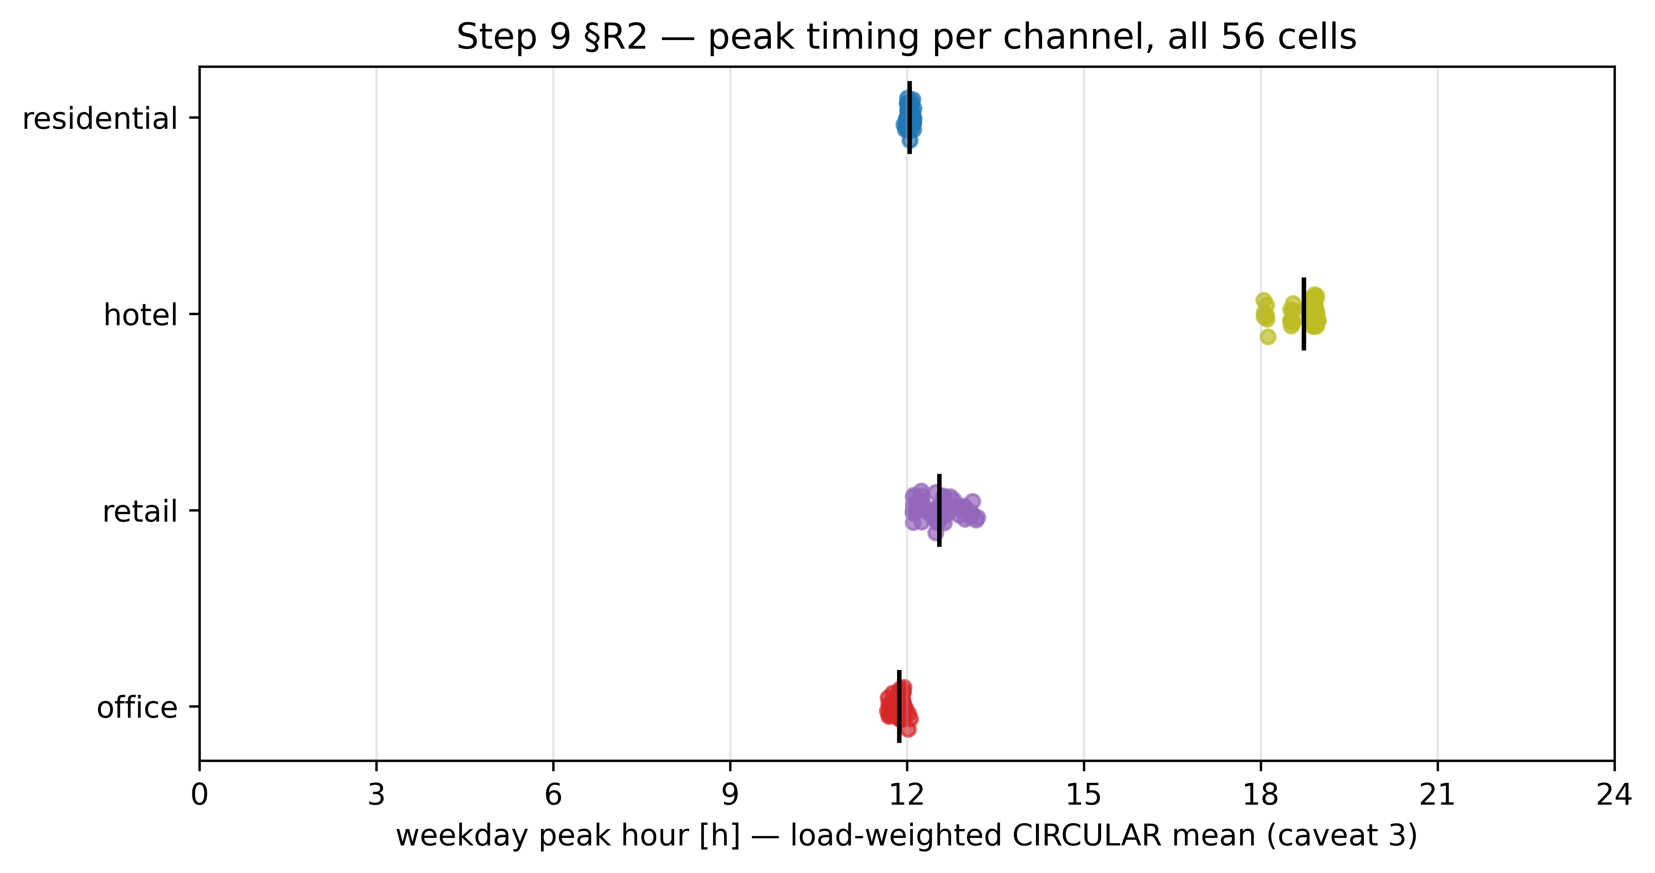
Figure 10
B_central scenario, all four building-city cells, coincidence factor annotated.

5.4 Scenario sensitivity, one lever per channel
step9_scenario_response.csv isolates each of Table 2’s three scenario levers - Office’s WFH band, Retail’s in-store share, Hotel’s SARIMA band - one at a time against the 2030 central scenario (B_central), holding the other two levers at their central draw (sens_office_*, sens_retail_*, sens_hotel_*). Each lever moves its own channel by a margin specific to that channel and leaves the other channels close to unmoved.
Office’s own energy moves by +1.67 % to +2.45 % under the conservative WFH draw (sens_office_cons, less work-from-home, more office presence) and by -2.19 % to -1.46 % under the optimistic draw (sens_office_opt), both read against B_central. Retail’s own energy moves by -2.42 % to -1.76 % under its conservative in-store-share draw (sens_retail_cons) and by +1.88 % to +2.50 % under its optimistic draw (sens_retail_opt). Hotel’s own energy moves by the smallest margin of the three, -0.76 % to -0.40 % under its conservative SARIMA draw (sens_hotel_cons) and +0.26 % to +0.48 % under its optimistic draw (sens_hotel_opt) - consistent with a channel whose 2030 product is a province-level monthly multiplier applied to a fixed guest-room shape, rather than a per-household behavioural draw.
The three levers leave the channels they were not built to move close to unchanged. Under sens_office_cons, Retail’s own energy shifts by only -0.08 % to +0.02 % and Hotel’s by +0.004 % to +0.03 %. Under sens_retail_cons, Office shifts by -0.02 % to -0.01 % and Hotel by -0.01 % to 0.00 %. Under sens_hotel_cons, Office shifts by -0.27 % to -0.18 % and Retail by -0.23 % to -0.16 %. Residential is the one channel that structurally has no scenario lever of its own (Table 2): its 2030 product is produced by the same function, keyed off the same WFH-band parameter, as Office’s own product, rather than carrying an independent draw (Chapter 4, §4.3). Measured against B_central, Residential’s own energy moves by +0.06 % to +0.29 % under the coupled sens_office_* scenarios and by under 0.10 % under sens_retail_* and sens_hotel_*, in every case the smallest movement of any channel under any lever. The three jointly-varying 2030 bundles (B_cons, B_opt) reproduce this same per-channel ordering when all three levers move together - Office -2.05 % to +2.20 %, Retail -2.42 % to +2.66 %, Hotel -0.73 % to +0.45 % against B_central - close to the sum of the isolated single-lever effects above, which is the cross-check this section relies on: each lever’s effect is close to additive rather than interacting with the other two. Figure 11 shows the three isolated levers and the two jointly-varying bundles on one panel per channel, which is where that near-additivity is read directly rather than inferred from the percentages above.
Figure 11. - per-channel energy response to each of the three isolated
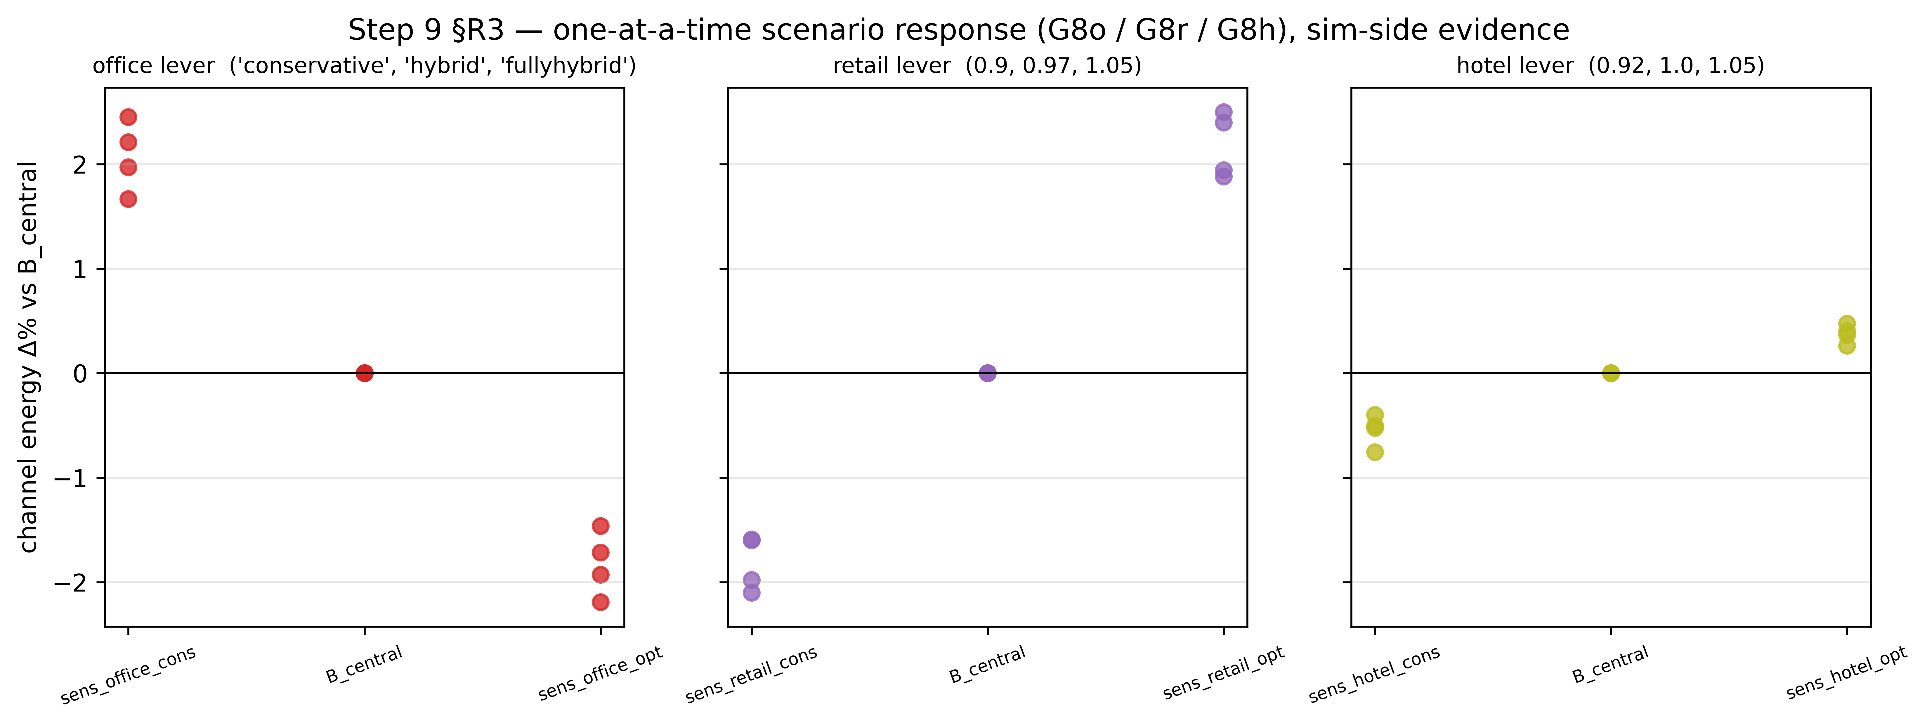
Figure 11
2030 scenario levers, against B_central, one panel per channel, the jointly-varying B_cons/B_opt bundles overlaid for the additivity cross-check.
Table 5.
Dual-basis EUI reporting, as recommended by this project’s own positioning review: CFA (Conditioned Floor Area of the zones assigned to that use) is the primary thermodynamic metric; GFA-share (whole-building Gross Floor Area times the parsed occupiable-area fraction for that channel) is reported for stock/SCIEU comparability. The two bases are never averaged.
Channel | As-modelled band, low/central/high (PASS criterion) | Empirical band, low/central/high (INFO criterion) | Measured range, CFA basis (median) | Measured range, GFA-share basis (median) | Cells passing (as-modelled) | Verdict
Office | 100 / 135 / 200 kWh/m2/yr | 170 / not reported / 360 kWh/m2/yr | 61.72-90.21 (median 71.02) | 63.27-85.51 (median 71.53) | 0/56 | FAIL, all 56 cells below the 100 floor
Retail | 80 / 110 / 155 kWh/m2/yr | 150 / 280 / 380 kWh/m2/yr | 63.63-96.84 (median 75.63) | 62.88-91.95 (median 73.27) | 12/56 individually in-band; gate scored on the median (75.63, below the 80 floor) | FAIL under the median-in-band rule in force (all-cells count: 12 PASS / 44 FAIL)
Hotel | 180 / 240 / 300 kWh/m2/yr | 220 / 350 / 480 kWh/m2/yr | 203.33-318.42 (median 260.54) | 171.07-261.18 (median 215.96) | 28/56 | FAIL, 28/56 above the 300 ceiling, 0/56 below the 180 floor, all failures on Tall
Residential | no as-modelled band defined | 113.9 / not reported / 147.2 kWh/m2/yr (SHEU HighRise context) | 111.57-128.77 (median 119.10) | 101.54-115.05 (median 107.24) | n/a (INFO only) | INFO, 55/56 outside the empirical band (1/56 IN)

The three failing gates, at full strength
- Office. The as-modelled band floor is 100 kWh/m2/yr. All 56 injected campaign cells fail it (median 71.02, range 61.72-90.21 on the CFA basis). Separately, and more importantly for the band-applicability argument: the uninjected Default_NECB control (the code’s own reference implementation, no occupancy signal applied at all) scores 85.45 kWh/m2/yr against the same 100 floor – it fails the band by 15 % before this work touches it. A gate that no untreated control can pass is measuring the band, not the model. Two candidate mechanisms were tested to explain the gap and both were refuted in 56/56 cells: modelled heating share is 17 % against the band’s 35-45 %, and rebasing on service/MEP area moves all 56 cells further down, not up. The band’s own source document additionally gives three different floors for itself (Table 7.1 = 100.0; line 21 = 80-140; Table 2.1 = 85.0-115.0), so the floor is recorded as contested and unsourced.
- Hotel. S9-EUI-hotel FAILs 28 of 56 cells, measured range 203.33-318.42 kWh/m2/yr, median 260.54. Every failure is above the 300 kWh/m2/yr ceiling (0 cells below the 180 floor), and every failure is on the Tall prototype (SuperTall clears the ceiling in 28/28 of its cells). This is the count and direction read directly from step9_gates.json (S9-EUI-hotel detail string) and step9_eui_by_channel.csv, both in the frozen deliverable. The band ceiling itself rests on the first-party DOE/PNNL Large Hotel, ASHRAE 90.1-2019 prototype value (284.44 kWh/m2/yr, CZ 6A Rochester; 299.28, CZ 7 International Falls), which is 1.0 % from the ceiling’s original 90.1-2004-lineage anchor of 302.21, so the vintage-mismatch objection does not hold; the remaining limitation is that the reference archetype (90.1-2019 Rochester/International Falls) and city set do not match this study’s NECB-2017 Montreal/Calgary tower.
- Retail. The gate rule in force is median-in-band, not all-cells (decided in advance of the numbers). The retail band spans 80-155 kWh/m2/yr; the measured median is 75.63, which is 5.47 % below the 80 floor (re-derived from the 56 CFA values in the deliverable CSV). Under the median rule the gate is FAIL. Under an all-cells count, 12/56 cells sit inside the band and 44/56 sit below the floor (0 above the ceiling); this per-cell tally is reported for transparency but is not the rule that scores the gate. The rule change itself was justified by a different quantity, and the two must not be conflated: The decision record states that the all-cells gate was turning on 0.15 % of its floor, meaning the per-cell verdict count was decided by a margin that narrow, so that a -0.05 % median shift in a separate improvement round’s arm flipped one cell (55/56 to 54/56). That 0.15 % is the decision margin of the retired all-cells rule; it is not the distance between the median and the floor, which is 5.47 %.

Scope of verification
Confirmed directly against step9_eui_by_channel.csv (56 rows per channel, 224 rows total) and cross-checked against step9_gates.json’s S9-EUI-* gate detail strings: - Office: CFA range 61.72-90.21, median 71.02; GFA-share range 63.27-85.51, median 71.53; band 100/135/200; empirical/INFO band 170/not reported/360 (info_central is not a column in the CSV; only info_lo/info_hi are present); 0/56 PASS; all FAIL. - Retail: CFA range 63.63-96.84, median 75.63; GFA-share range 62.88-91.95, median 73.27; band 80/110/155; empirical/INFO band 150/380 (both info_verdict = OUT, 56/56); per-cell tally 12 PASS / 44 FAIL; gate-level verdict FAIL under the median rule. - Hotel: CFA range 203.33-318.42, median 260.54; GFA-share range 171.07-261.18, median 215.96; band 180/240/300; empirical/INFO band 220/480 (info_verdict 28 IN / 28 OUT); 28/56 PASS, 28/56 FAIL, all failures above the ceiling, all on Tall (verdict_asmodelled cross-tabulated by building column in the CSV). - Residential: CFA range 111.57-128.77, median 119.10; GFA-share range 101.54-115.05, median 107.24; no as-modelled band (band_lo/central/hi empty, gate is INFO-only); empirical/INFO band 113.9/not reported/147.2, 55/56 info_verdict = OUT, 1/56 IN.
Confirmed against _PROVENANCE.md in the deliverable directory (not the CSV/JSON): the hotel median 260.5411 kWh/m2/yr and the “28 above the 300 ceiling, 0 below the 180 floor” summary, matching the CSV/JSON independently.
Taken from the brief and the pipeline docs, not independently re-derived from a per-cell CSV row (no such standalone row exists in the deliverable’s tabular outputs): - The uninjected Default_NECB control value of 85.45 kWh/m2/yr. This number does not appear as a row in step9_eui_by_channel.csv (that file’s 56 office rows are all injected cells). It does appear verbatim inside step9_gates.json’s S9-EUI-office gate detail string and inside step9_report.html, both in the frozen deliverable, so it is deliverable-sourced, just not CSV-tabulated. Its underlying simulation artefact (the finding9_verify/ uninjected-control IDF) is held in the sibling outputs_step9/ directory, which _PROVENANCE.md states is retained specifically because it is not reproducible elsewhere. - The as-modelled band values themselves (retail 80/110/155; hotel 180/240/300; office 100/135/200) and the empirical/INFO bounds are sourced to this project’s own retail and hotel reference-band reviews, and, for office, to the office reference document inherited from the two-channel construction stage, Table 7.1, cited via the band_src field in the results file itself.
No band value was moved and no gate verdict was changed to produce this table.

6 Discussion
The findings of §5 are interpreted here against the gap they were designed to close. The discussion moves from what a jointly-trained, multi-channel model buys and what it does not yet prove (§6.1), through the central argument of this paper, that the office gate’s failure is a finding about reference-band applicability rather than a model defect (§6.2), to a second, independent illustration of the same point in the hotel gate’s own geometry (§6.3), and closes with the lesson that spans all three failing gates and what it implies for how mixed-use reference bands should be built next (§6.4).

6.1 What a Multi-Channel Model Buys, and What It Does Not Yet Prove
The first thing the campaign establishes is behavioural rather than architectural: inside one envelope, on one plant, the four populations do not behave as one occupant, and the ways they differ are large enough to matter to the building rather than only to the occupancy model. They peak at different hours, with hotel at 18.91 h against a midday cluster of 11.90 to 12.37 h for office, residential and retail, and the whole-building peak at 14.95 h coincides with none of the four. They differ in day-to-night structure by an order of magnitude and in one case by sign, from retail’s weekday midday-to-night ratio near 34 to 1 down to residential’s 3.9 to 1 and hotel’s outright inversion. They move in different directions across the four survey cycles, retail declining and then reversing past its own 2005 baseline while residential stays close to flat (§5.1, §5.3). The consequence for the building is measurable and not merely descriptive: because the four peaks fall at different hours, the whole-building coincidence factor stays below 1 in every one of the four cells, median 0.941, so use-type diversity inside one stacked building attenuates the aggregate peak in the same way household diversity attenuates it inside a single archetype. A single-channel schedule applied uniformly across every floor cannot represent any of this, because the quantity it would have to represent is a difference between populations, not a level.
The architecture is what makes that observation available. Jointly training one model to output four independent, per-use presence channels, then dispatching them through a per-space, exact-match routing key, lets a single stacked tower carry four functionally distinct populations, households, a workforce, customers and overnight guests, each on its own signal, instead of one blended “occupant” trend applied uniformly across every floor. That design choice is not incidental: a single composite channel would smear the four populations’ genuinely different temporal behaviour into one curve that represents none of them (§1.3), and the decode-time exclusivity projection exists precisely so that four independently generated channels do not collide inside the same tower before they reach the building model.
This design is additive on the two-channel construction stage it grew from, and it is additive in a specific, demonstrable sense: a missing channel falls back to the untouched code baseline rather than to an undefined state, retail presence is written to its own file rather than into the residential or office columns, and the campaign reads the same four prototype geometry files the two-channel stage used, confirmed byte for byte at the point they enter the campaign. What the design does not demonstrate, and what this paper does not claim, is bit-identity of the residential and office outputs across the two construction stages. Five of the nine pipeline steps carry no cross-stage byte or column comparison at all, and the injector code itself exists in three non-matching copies across the live repository and the two stages’ own frozen snapshots; only the base tower geometry, not the code that writes schedules into it, is confirmed unchanged. Table 6 records this step by step, stating for each of the nine steps what was compared, what was found, and, on the five steps where nothing was compared, saying so in place of a verdict. The paper is therefore precise about what “additive” means here: additive by construction, evidenced at the one step where geometry reuse was checked, and not yet an empirically demonstrated claim that no residential or office figure from the construction stage would move if the comparison were run.

6.2 Why the Office Band Failure Is a Finding About Band Applicability, Not a Model Error
The office channel fails its energy-use-intensity gate in every one of the 56 campaign cells, and the natural first reading of that result is that the model under-predicts office demand. The evidence does not support that reading, and the strongest piece of it is a control the model never touches. The uninjected Default_NECB reference implementation, the code’s own baseline with no occupancy signal applied to it at all, scores 85.45 kWh/m2/yr against the same 100 kWh/m2/yr floor the injected cells are judged against, and fails by 15% before this study’s occupancy model contributes a single schedule. A gate that no untreated control can pass is not measuring whether the occupancy injection is correct; it is measuring the floor itself against a code-default tower that has nothing to do with the occupancy question this paper asks.
Two candidate mechanisms were tested to see whether the model, rather than the band, could still be at fault, and both were refuted, not left unresolved. The first candidate was that the band’s floor implicitly assumes a heating share the injected tower does not carry: measured heating share across the campaign is approximately 17%, against the band’s own implied 35 to 45%, in the wrong direction to close the gap. The second candidate was that the office EUI should be re-based on a different denominator, service and mechanical/electrical/plumbing area rather than office-conditioned floor area: rebasing on service/MEP area moves every one of the 56 cells further down, away from the floor, not toward it. Both failed in all 56 cells, not in a majority or a subset. The record does not describe either mechanism as pre-registered, and this paper does not claim they were: they were candidate explanations proposed and then tested, and what carries weight is that both were refuted across the full cell set rather than left open. The band’s own source document additionally states three different floors for itself across its own tables (100.0, 80-140, and 85.0-115.0), which is independent evidence that the number being failed against is contested even on its own terms. The gate values and bands quoted in this section are those of Table 5 and Section 5.2; the sixteen limitations they feed are itemised in Table 7.
None of this is used to move the band or to change the verdict. The floor stays at 100, the gate stays FAIL for all 56 cells (median 71.02 kWh/m2/yr, range 61.72 to 90.21 on the CFA basis), and the finding this paper reports is not “the office channel passes once the right comparison is made.” It is that an untreated control already fails the same gate, by a margin larger than any plausible occupancy effect could close, which relocates the question from “is the injected model wrong” to “does this reference band apply to this building at all.”

6.3 The Hotel Gate’s Lack of Resolving Power
The hotel channel fails a different way, and the failure geometry is itself informative. Across the 56 campaign cells the measured energy-use intensity does not form one continuous distribution; it separates cleanly into two disjoint clusters that track the tower prototype and nothing else. The SuperTall prototype’s 28 cells sit at 203.33 to 218.22 kWh/m2/yr, comfortably inside the as-modelled band; the Tall prototype’s 28 cells sit at 302.86 to 318.42 kWh/m2/yr, entirely above the band’s 300 kWh/m2/yr ceiling. The largest gap between any two consecutive measured values in the whole 56-cell set falls exactly between these two clusters, at 84.64 kWh/m2/yr, which is 70.5% of the band’s own 120 kWh/m2/yr width (180 to 300); the cluster bounds and the band are those reported in Table 5. The 300 ceiling sits inside that gap, not near either cluster’s edge.
The consequence is that the pass/fail verdict for any given cell is decided almost entirely by which prototype it belongs to, before the occupancy channel contributes anything cell-specific. A ceiling placed anywhere inside an 84.64 kWh/m2/yr gap between two tight, well-separated prototype clusters will always split the 56 cells the same way the current one does, because there is essentially no continuous variation across that gap for the occupancy signal to move a cell through. This is not a claim that the Tall prototype’s hotel demand is wrong; it is a claim that this particular gate, as constructed, has very little power to distinguish “hotel occupancy is being modelled correctly on Tall” from “the Tall prototype’s hotel zones simply run hotter than the SuperTall prototype’s, for reasons the ceiling was never designed to separate from an occupancy effect.” The gate’s own reference archetype, the DOE/PNNL Large Hotel prototype at ASHRAE 90.1-2019, is itself Rochester/International Falls climate-normalized and city-mismatched against this study’s NECB-2017 Montreal/Calgary tower, which is a second, independent reason the same 28-cell split does not automatically indict the occupancy model.
As with the office channel, none of this moves the ceiling. S9-EUI-hotel remains FAIL on all 28 Tall cells, at their full measured values, and the finding is that the gate’s resolving power is limited by geometry it did not design for, not that the failing cells should be read as passing under a different rule.

6.4 A Common Lesson Across Three Failing Gates, and What It Implies Going Forward
The office, hotel and retail energy-use-intensity gates fail for three different reasons, an uncontested but suspect floor with a failing untreated control behind it, a ceiling that sits inside a prototype-driven gap rather than a continuum, and a median that falls narrowly short of a floor under a rule chosen in advance of the numbers (§5). What the three share is discipline rather than outcome: in every case the reference value was left exactly where it was, no scoring rule was changed after the fact because a different rule happened to pass, and each failure is reported here with the specific evidence that bears on whether the model or the reference is responsible. That evidence points the same direction in the two cases examined closely in this chapter. It does not point toward “these gates are wrong and should be discarded”; it points toward reference bands built for single-use building stock not yet having the resolving power, or in the office case the sourcing discipline, to judge a channel that lives inside a stacked mixed-use tower rather than inside a building of its own. Building that resolving power, an as-modelled band with a floor an untreated control can pass, and a hotel reference stratified by the same prototype geometry the tower campaign varies, is future work this paper’s failing gates motivate rather than something this paper’s writing phase is positioned to deliver.

7 Limitations
Sixteen limitations bound the interpretation of the results, transcribed here from the same consolidated source as Table 7 rather than re-derived or re-worded, in the same five groups and the same order: Frame (§7.A, L1-L3), Reference bands (§7.B, L4-L8), Internal gains (§7.C, L9-L11), Method conventions (§7.D, L12-L14), and Physical model (§7.E, L15-L16). Fifteen of the sixteen carry a bounding measurement; the sixteenth, L15, carries none and is marked accordingly rather than given an invented figure. A sixteenth topic, a reproducibility point about a defect found in a related codebase and this pipeline’s structural immunity to it, closes the chapter (§7.F) without being folded into the sixteen or given an L-number of its own.

7.A Frame: What the Source Data Can and Cannot See (L1-L3)
L1. Hotel guests are outside the General Social Survey frame by construction; the hotel channel is driven by a non-GSS provincial tourism series (Step 6, the SARIMA side-track), not by time-use data. GSS observes 0% of hotel occupancy. The consequence for this paper’s own framing is direct: the “one longitudinal time-use source to four channels” contribution is, precisely, three of four channels time-use-survey-driven and one of four series-driven.
L2. Retail sees customers only; staff are excluded by construction, because GSS logs retail workers as AT_WORK, not as shopping. 0% of retail staff presence enters the occupancy signal, and 0% of retail plug load is modulated by it, since plug load follows staff and staff stay on the untouched code baseline.
L3. Residential intra-household presence diversity is partial, not complete; an earlier, stronger internal claim that it was exactly zero is falsified by direct measurement. 3,499 of 16,367 multi-person households, 21.38%, carry at least one slot value outside {0, 0.5, 1}. A surviving defect behind this number is that one pipeline stage computes a household maximum that a later stage never reads, while the aggregation actually applied downstream is the mean.

7.B Reference Bands: What “Plausible” Is Being Measured Against (L4-L8)
L4. The office band’s floor is contested and unsourced; the gate is a band-applicability finding, not a model defect. The uninjected Default_NECB control scores 85.45 kWh/m2/yr against a floor of 100, failing by 15% before this study’s occupancy model touches it. Two candidate mechanisms were tested and refuted: modelled heating share is approximately 17% against the band’s implied 35-45%, and rebasing the metric on service/MEP area moves all 56 of 56 cells further down, not up. The band’s own source document gives three different floors for itself across its own tables (100.0; 80-140; 85.0-115.0). The value is not moved to make the gate pass (§6.2 develops this argument in full).
L5. The hotel band is archetype- and city-mismatched, and that mismatch is stated rather than absorbed into a tolerance; this study’s tower is NECB-2017 Montreal/Calgary, while the reference is the DOE/PNNL Large Hotel prototype at ASHRAE 90.1-2019. The first-party reference value is 284.44 kWh/m2/yr (Rochester, Minnesota, climate zone 6A) and 299.28 (International Falls, Minnesota, climate zone 7). The gate fails on 28 of 56 cells, all on the Tall prototype, every one over the 300 ceiling; the deliverable-sourced measured range is 203.33-318.42 kWh/m2/yr. A vintage-matched alternative value (the 90.1-2004 lineage, 302.21) is only 1.0% away from the current ceiling, so the archetype/city mismatch, not a vintage mismatch, is the limitation that remains (§6.3 develops the resolving-power argument this failure motivates).
L6. The “stacked channel” explanation once offered for the hotel channel’s low measured values, that a mid-tower channel carries little roof, ground or facade load and should therefore read low, was tested and refuted; it is not cited as an explanation anywhere in this paper. It is wrong in sign and order in all 56 of 56 cells: hotel is the least thermally exposed of the three banded channels and sits closest to its floor, not furthest from it. A second bound on the same claim is that geometry varies only between the Tall and SuperTall prototypes, so the exposure ratio this explanation would need takes only two distinct values across the whole campaign, not 56 independent ones; the corresponding gate is reported as informational only, never as a pass or fail criterion.
L7. The retail channel is validated on shape, not on level; no population-denominated in-store presence reference exists at time-of-day resolution in the American, harmonized European or United Kingdom time-use surveys this project checked. The energy-use-intensity gate rule in force is median-in-band, not a 56-of-56 count, because the measured spread is smaller than the quantity’s own re-run uncertainty: a single re-derivation moved the median by 0.05% and flipped one cell’s individual verdict. The retail median is 75.63 kWh/m2/yr against a floor of 80, 5.47% below, with 44 of 56 cells under the floor. The corresponding presence-rate gate was separately demoted to informational status, because the one time-of-day reference available (BLS ATUS table A-3B) reports retail activity running roughly 44% high while an earlier reference band said 24.5% low; the two references disagree in direction, not only in magnitude.
L8. The residential channel carries no as-modelled band at all; the SHEU-2019 HighRise figure is carried as context only and is never used as a pass criterion, because a residential channel inside a mixed-use tower is not the housing stock SHEU sampled. The SHEU-2019 HighRise reference is 130.6 kWh/m2/yr (113.9-147.2), context only.

7.C Internal Gains That Were Never Parameterised (L9-L11)
L9. Retail zones run the code’s office occupant density, not the code’s own retail figure. The model uses 24.97 m2/person (the NECB whole-building office value), while NECB’s own Retail - sales space type gives 29.97 m2/person; retail is therefore modelled roughly 20% over-crowded relative to the code’s own retail reference.
L10. Equipment power density is a single blanket value applied to every space type in both tower prototypes (7.5028 W/m2), while lighting is differentiated per space type. Occupant density and equipment power density are the two internal-gain fields never parameterised by use in this pipeline.
L11. The retail occupancy peak of 0.95 has no independent source, and the code’s own retail schedule (type C) was never loaded into the injected model. NECB’s retail type-C schedule peaks at 0.80 on weekdays at 16:00 with no midday dip, 0.90 on Saturday and 0.40 on Sunday; the tower instead carries the code’s office schedule (type A) byte for byte, which peaks at 0.90 with a 0.50 lunch-hour dip, and the injector applies a further 0.95 multiplier on top of that curve. Retail therefore runs approximately 18.75% hot at peak, and on the wrong-shaped curve; no NECB type-C schedule string is present anywhere in the injected model.

7.D Method Conventions That Are Judgement, Not Derivation (L12-L14)
L12. The minimum adjustment-cell pool size (15 respondents) is an analyst judgement call, presented here as one; no numeric convention for this kind of minimum cell size was located in the literature this project checked. The anchor previously cited for it in fact gives a value of 5 as that source’s own study design, not as a general recommendation, and the corresponding validation gate is measured to be non-monotonic in the pool size (failing at 10, passing at 11-20, failing again at 30), which rules it out as a principled selection criterion.
L13. Household aggregation is the mean, and this is a decision, not an inheritance, because the three construction stages behind this project do not agree with one another: the earlier residential-only converter, the two-channel construction stage’s converter, and this pipeline each aggregate household presence differently. This pipeline’s own choice of the mean was verified against its own code, not against another stage’s documentation.
L14. The retail episode-time share declines across survey cycles; an earlier internal claim that it was stable across cycles was a documentation defect, not a measurement. The measured share is 2.00%, 2.14%, 1.66% and 1.50% across the four cycles used, an approximately 25% decline overall, a direction and rough magnitude that comparable American, European and United Kingdom time-use series independently confirm as internationally normal rather than a coding artefact specific to this project.

7.E Physical Model (L15-L16)
L15. The building’s weather file is applied at ground level on a supertall tower; this is the one limitation in this list with no bounding measurement. Not quantified. No altitudinal temperature or wind-speed gradient is represented over a tower of this height; establishing one would require either a vertical weather profile or an instrumented tall building, and this study has neither. It is listed here with an explicit “not quantified” rather than a plausible-sounding invented bound.
L16. The hotel domestic-hot-water plant is capacity-pinned on a single object, and a global correction does not correct it. The LAUNDRY heater’s delivered-energy slope against draw volume is -0.98 in both tested arms, meaning delivered energy is almost completely insensitive to how much water is actually drawn. Raising a single global sizing factor to 6 drove every other heater’s slope to exactly 0.000 and moved LAUNDRY’s own share of hotel domestic-hot-water demand from 26.7% to 65.4%, a share-reweighting effect that alone reproduces the resulting 0.334 elasticity measured against this correction. The instrument that actually addresses the defect is a per-object resize, LAUNDRY alone raised to a sizing factor near 7 against an internal reference heater, with the other fifteen heaters left at a sizing factor of 1, not a single building-wide multiplier.

7.F Reproducibility: A Shared Extraction Defect, and Why This Pipeline Is Structurally Immune to It
One further point belongs in this chapter, not as a seventeenth item in the numbered list above but as a reproducibility caveat about the codebase this project descends from. The residential energy-use-intensity table published in the authors’ prior single-channel study (2J; Iseri and Hachem-Vermette, under review b) was found, during this project’s own review process, to have been computed by a shared extraction function carrying two compounding defects: a demand-summary table double-counted into an annual energy total as though it were an energy quantity rather than a power quantity, and a water-heating guard that correctly zeroes water energy on SI-unit runs but fails to recognise imperial units, so that on imperial-unit runs a water volume is summed directly into the reported energy-use intensity as if it were electricity. Every run in that prior study’s campaign carried exactly one of the two defects, decided by which unit system the run happened to use, and correcting both moved three of the four reported SHEU band verdicts in that prior study.
This pipeline is verified immune to that specific defect, and the reason is structural rather than incidental: the present study’s energy-use-intensity values, reported in Table 5 and discussed throughout §5 and §6, are read from hourly EnergyPlus meter streams, never from the tabular demand-summary extraction function the prior study’s defect lived inside. The two pipelines share a lineage and, at points, shared code, but they do not share this particular extraction path, and that structural difference, not a targeted fix, is what protects this study’s own reported values. This is recorded here as a reproducibility point about the family of pipelines this project belongs to, not as a limitation of the results reported in this paper.
Table 7.
Transcribed, not rewritten, from Leg3_4-split/3rdJ_00_4split_Occupancy_Pipeline.md § “LIMITATIONS - CONSOLIDATED” (written 2026-08-05). Sixteen items, fifteen carry a number; L15 carries none and is marked accordingly rather than given an invented figure. Wording is trimmed to fit a table cell; no number or verdict is paraphrased.
ID | Group | Statement | Bounding measurement
L1 | A Frame | Hotel guests are outside the GSS frame by construction; the channel is driven by a non-GSS tourism series (Step 6C), not by time-use data. | GSS observes 0 % of hotel occupancy. Consequence: the “one longitudinal TUS source to four channels” contribution is really 3 of 4 channels TUS-driven, 1 of 4 series-driven.
L2 | A Frame | Retail sees customers only; staff are excluded by construction (GSS logs retail workers as AT_WORK, not shopping). | 0 % of retail staff presence enters the occupancy signal; 0 % of retail plug load is modulated by it (plug follows staff, staff stay on the NECB baseline).
L3 | A Frame | Residential intra-household presence diversity is partial, not complete; the stronger claim once made internally, that it is exactly zero, is falsified by this measurement. | 3,499 of 16,367 multi-person households (21.38 %) carry at least one slot value outside {0, 0.5, 1}. Surviving defect: Step 5 computes a household maximum that Step 7 never reads; aggregation is the mean (V2-B5).
L4 | B Reference bands | The office band’s floor is contested and unsourced; the gate is a band-applicability finding, not a model defect. | Uninjected Default_NECB control scores 85.45 against a floor of 100 - fails by 15 % before this work touches it. Two candidate mechanisms refuted: modelled heating share 17 % vs band’s 35-45 %; rebasing on service/MEP moves 56 of 56 cells down. Source document gives three different floors for itself (Table 7.1 = 100.0; line 21 = 80-140; Table 2.1 = 85.0-115.0). Value not moved to make the gate pass.
L5 | B Reference bands | The hotel band is archetype- and city-mismatched, and that is stated rather than absorbed; our tower is NECB-2017 Montreal/Calgary, the reference is DOE/PNNL Large Hotel at ASHRAE 90.1-2019. | Reference: 284.44 kWh/m2*yr (Rochester MN, CZ 6A) / 299.28 (International Falls MN, CZ 7), read first-party from the prototype’s own packaged table. Gate FAILs on 28 of 56 cells, all Tall, every one OVER the 300 ceiling; deliverable range 203.33-318.42 (corrected 2026-08-06, V4-A4, read from outputs_step9_deliverable/, not the superseded outputs_step9/ which inverted the direction). Vintage-matched value (90.1-2004 lineage, 302.21) is only 1.0 % away; the archetype/city gap remains and is recorded, not converted to a tolerance.
L6 | B Reference bands | The “stacked channel” explanation for low EUIs (a mid-tower channel has little roof/ground/facade load, so a low EUI is expected) was tested and REFUTED; do not cite it. | Wrong in sign and order in 56 of 56 cells: hotel is the least-exposed of the three banded channels and sits closest to its floor, not furthest. Second bound: geometry varies only Tall/SuperTall, so exposure_ratio takes 2 distinct values per channel, not 56 independent ones. Gate S9-EUI-EXPOSURE is INFO, never PASS/FAIL.
L7 | B Reference bands | The retail channel is validated on SHAPE, not on LEVEL; no population-denominated in-store presence reference exists at time-of-day resolution in ATUS, HETUS or the UK TUS. | EUI gate rule is median-in-band, not 56-of-56, because the spread is smaller than the quantity’s own uncertainty: a single re-run moved the median by -0.05 % and flipped a cell. Retail median is 75.63 against a floor of 80, i.e. 5.47 % below, with 44 of 56 cells under. Rate gate demoted to INFO: BLS ATUS A-3B says retail runs ~44 % high, the previous band said 24.5 % low - references disagree in direction.
L8 | B Reference bands | The residential channel has no as-modelled band at all; SHEU-2019 HighRise is carried as context only and is never a PASS criterion, because a channel inside a mixed-use tower is not the stock basis SHEU sampled. | SHEU-2019 HighRise: 130.6 [113.9-147.2] kWh/m2*yr, context only, lo=None in BENCH["residential"].
L9 | C Internal gains | Retail runs on NECB’s OFFICE occupant density, not NECB’s own retail figure. | Model uses 24.97 m2/person (3.72 occ/1000 ft2, NECB WholeBuilding Office); NECB Retail - sales is 3.10 occ/1000 ft2 = 29.97 m2/person - retail modelled roughly 20 % over-crowded. (An earlier alleged 6.8x density error was retired 2026-08-05: 25.0 / 3.7 = 6.76 is the unit-conversion factor between m2/person and occ/1000 ft2, the same number written two ways, not two numbers.)
L10 | C Internal gains | Equipment power density is a single blanket value, while lighting is differentiated per space type. | 7.5028 W/m2 on every space type in both towers. Occupancy and plug load are the two internal-gain fields never parameterised.
L11 | C Internal gains | The retail occupancy peak of 0.95 has no source, and NECB’s real retail schedule (type C) was never loaded. | NECB retail (type C): weekday peak 0.80 at 16:00, no midday dip, Saturday 0.90, Sunday 0.40. Our tower carries NECB office (type A) byte for byte (peaks 0.90 with a 0.50 lunch dip). Injector applies 0.95 - retail runs 18.75 % hot at peak on the wrong-shaped curve; grep -c "NECB-C-" injected.idf returns 0.
L12 | D Method conventions | MIN_POOL = 15 is an analyst judgement call and is presented as one; no numeric convention for a minimum adjustment-cell size was located in the literature. | Anchor previously cited for it gives n = 5, that paper’s own study design, not a recommendation. Gate W1 is non-monotonic: FAIL at 10, PASS at 11-20, FAIL at 30 - not a selection criterion.
L13 | D Method conventions | Household aggregation is the MEAN, and the three legs of this project do not agree; the 2J converter, the Leg-2 converter and the Leg-3 pipeline each aggregate household presence differently. | 3 legs, 3 different implementations. Leg 3 uses the mean, decided and recorded rather than inherited; verified against each leg’s own code, never against another leg’s prose.
L14 | D Method conventions | The retail episode-time share DECLINES across cycles; the earlier “stable” claim was a documentation defect. | Measured 2.00 % -> 2.14 % -> 1.66 % -> 1.50 % across the four cycles, a -25 % decline, which ATUS, UK TUS and HETUS all confirm is internationally normal. Superseded text read “~2.1-2.3 %, stable across cycles”.
L15 | E Physical model | Ground-level EPW on a supertall; this is the one item here with NO bounding measurement. | Not quantified. No altitudinal temperature or wind-speed gradient is represented over a tower of this height; it would take either a vertical weather profile or an instrumented tall building, and this work has neither. Listed with an explicit “not quantified” rather than a plausible-sounding guess.
L16 | E Physical model | The hotel DHW plant is capacity-pinned on a single object, and a global fix does not fix it. | LAUNDRY slope -0.98 in both arms (E ∝ V^0.02) - delivered energy almost completely insensitive to draw volume. Raising a global K to 6 made every other heater’s slope exactly 0.000 and moved LAUNDRY’s share of hotel DHW from 26.7 % to 65.4 %; share-reweighting alone reproduces the resulting 0.334 elasticity. Correct instrument: per-object resize (LAUNDRY alone at K ~ 7 against internal BOOSTER reference of 71.34 K, other fifteen heaters at K = 1).

8 Conclusion
This paper asked what four functionally distinct occupant populations do to a single stacked building when each is carried on its own behavioural signal rather than blended into one, whether one jointly-trained occupancy model can generate all four, and where the energy-use-intensity references built for single-use building stock do, and do not, still apply to the result. Answering the first two parts of that question required building a shared-encoder Transformer with three time-use-survey decoder heads and a separate, non-survey side-track for the one use the source survey cannot see, then dispatching all four resulting channels into the same tower geometry through a per-space, exact-match routing key so that a missing channel falls back safely to the untouched code baseline rather than to an undefined state. Answering the third required taking the resulting failing gates seriously rather than resolving them, which is where this paper’s central contribution sits.
The evidence supports a clear set of answers. First, the four populations do not behave as one occupant inside one envelope, and the difference reaches the building rather than stopping at the occupancy model: the four channels peak at four different hours, with the hotel channel roughly seven hours after the midday cluster formed by the other three and the whole-building peak coincident with none of them; their weekday day-to-night structure differs by an order of magnitude across channels and inverts outright for hotel; and they move in different directions across the four survey cycles rather than along one shared trend. Because those peaks do not coincide, the whole-building coincidence factor stays below 1 in all four building-city cells tested, so use-type diversity inside one stacked building attenuates the aggregate peak in the same way household diversity does inside a single archetype. Second, four independent, per-use occupancy channels can be jointly trained and injected into one mixed-use tower without collapsing into one blended signal, and doing so is additive on the two-channel construction stage this project grew from in the specific, evidenced sense that a missing channel is handled safely and the underlying tower geometry is confirmed unchanged, without claiming a bit-identity between construction stages that was not tested. Third, three of the four channel-level energy-use-intensity gates fail, and in each case the failure is a finding about whether a reference band built for single-use stock applies to a stacked mixed-use tower, not a defect in the occupancy model that produced the injected schedules. The office gate fails alongside its own uninjected, occupancy-free control, which fails the same floor on its own. The hotel gate’s 56 cells separate into two prototype-driven clusters with a gap wide enough, relative to the band’s own width, to decide most of the verdict before any occupancy signal is injected. The retail gate fails a median-in-band rule chosen in advance of the numbers, on a channel this study’s own review found has no population-level, time-of-day presence reference to validate against at all. In every one of the three cases, the reference value was left exactly where it started, and no scoring rule was swapped once it was known which rule would pass.
Taken together, these results establish that jointly-trained, per-use occupancy injection into a stacked mixed-use building is feasible with the architecture and dispatch mechanism this paper describes, and that the more immediate barrier to a clean validation story is not the occupancy model but the reference bands available to judge it, none of which were built with a stacked mixed-use tower in mind. The limitations set out in §7, an occupancy frame that cannot see hotel guests or retail staff, internal-gain parameters carried over unchanged from a single office reference, and a domestic-hot-water plant whose capacity pinning defeats a global correction, bound how far the present results generalise, and several of them point directly at what a following study would need to build: reference bands constructed for, and validated against, buildings that stack more than one use, rather than borrowed from single-use stock and applied to a tower they were never designed to score.

References
- ASHRAE (2019) ANSI/ASHRAE/IES Standard 90.1-2019: Energy Standard for Buildings Except Low-Rise Residential Buildings. Atlanta, GA: American Society of Heating, Refrigerating and Air-Conditioning Engineers.
- ASHRAE, ASHRAE Guideline 14: Measurement of Energy, Demand and Water Savings. Atlanta, GA: American Society of Heating, Refrigerating and Air-Conditioning Engineers. Edition not reported.
- Buttitta, G. and Finn, D.P. (2020) A high-temporal resolution residential building occupancy model to generate high-temporal resolution heating load profiles of occupancy-integrated archetypes. Energy and Buildings, 206, 109577. https://doi.org/10.1016/j.enbuild.2019.109577
- CBRE Limited and Travel Alberta, Alberta hotel-occupancy and average-daily-rate series, including CBRE National Market Report archives for the 2005-2009 span. not reported (exact report/catalogue identifier).
- Doma, A. and Ouf, M. (2023) Leveraging mobile positioning data to model building occupant behaviour in a mixed-use district. Proceedings of Building Simulation 2023: 18th Conference of IBPSA, pp. 1671-1678. https://publications.ibpsa.org/proceedings/bs/2023/papers/bs2023_1671.pdf
- Doma, A., Padsala, R., Ouf, M.M. and Eicker, U. (2024) Bottom-up framework for modelling occupancy-based demand-side management strategies in a mixed-use district. Applied Energy, 375, 124081. https://doi.org/10.1016/j.apenergy.2024.124081
- Institut de la statistique du Québec, monthly hotel-occupancy statistics for Quebec. not reported (exact table/catalogue identifier).
- Iseri, O. and Hachem-Vermette, C. (2026) Longitudinal Analysis of Occupancy-Driven Energy Demand in Canadian Residentials (companion conference paper). eSim 2026, IBPSA-Canada.
- Iseri, O. and Hachem-Vermette, C. (under review a) Longitudinal Analysis of Occupancy-Driven Energy Demand in Canadian Residentials. Journal of Building Performance Simulation.
- Iseri, O. and Hachem-Vermette, C. (under review b) From “How Much” to “When”: Forecasting the Residential Energy Load Shape from a Calibrated Behavioural Occupancy Time-Series (Canada, 2005-2030). Building Simulation.
- Kurin, V., De Witt, C.S. and Whiteson, S. (2022) In defense of the unitary scalarization for deep multi-task learning. Advances in Neural Information Processing Systems 35 (NeurIPS 2022).
- Menon, A.K., Jayasumana, S., Rawat, A.S., Liang, H., Veit, A. and Kumar, S. (2020) Long-tail learning via logit adjustment. International Conference on Learning Representations (ICLR 2021). https://arxiv.org/abs/2007.10738
- National Research Council Canada (2017) National Energy Code of Canada for Buildings 2017, Fourth Edition. Ottawa: Canadian Commission on Building and Fire Codes (Cat. NR24-24/2017E-PDF; ISBN 0-660-24321-4). https://doi.org/10.4224/40002011
- Natural Resources Canada (2019) Survey of Household Energy Use (SHEU), 2019 - Data Tables. Office of Energy Efficiency, Natural Resources Canada (comparative energy-intensity series: CODR table 25-10-0061-01). https://oee.nrcan.gc.ca/corporate/statistics/neud/dpa/menus/sheu/2019/tables.cfm
- Natural Resources Canada, Survey of Commercial and Institutional Energy Use (SCIEU). Office of Energy Efficiency, Natural Resources Canada. not reported (survey year and table identifier).
- Statistics Canada (2021) Census of Population, 2021: Public Use Microdata Files (Series Catalogue no. 98M0001X). Individuals File: 98M0001X2021001; Hierarchical File: 98M0001X2021002. https://www150.statcan.gc.ca/n1/en/catalogue/98M0001X
- Statistics Canada (2022) General Social Survey - Time Use: Public Use Microdata Files (Series Catalogue no. 45-25-0001; series DOI https://doi.org/10.25318/45250001-eng). Individual cycles: 12M0019X (Cycle 19, 2005), 12M0024X (Cycle 24, 2010), 89M0034X (Cycle 29, 2015), and 45-25-0001 issue 2025001 (Time Use, 2022). https://www150.statcan.gc.ca/n1/pub/45-25-0001/index-eng.htm
- U.S. Department of Energy (2024) EnergyPlus (Version 24.2.0). National Renewable Energy Laboratory (NREL). https://energyplus.net/
- U.S. Department of Energy and Pacific Northwest National Laboratory, Commercial Prototype Building Models: Tall and SuperTall mixed-use prototypes. not reported (exact release and version).
- Widén, J. and Wäckelgård, E. (2010) A Swedish time-use survey and its utility for building energy modeling. Energy and Buildings, 42(5), pp. 706-714. https://doi.org/10.1016/j.enbuild.2009.11.010

Supplementary material
Table A1.
About the Source in the project repository column. The right-hand column of the three tables below gives, for each hyperparameter, the file and line in the authors’ own project repository from which that value was read. These are internal paths and internal document identifiers; they are not expected to resolve for a reader, and nothing in this model card depends on opening them. They are printed so that every number in the card is attributable to a specific place in the build rather than restated from a summary, and so that a value which was read from code can be told apart from one that was read from a design document. Where the two disagreed, the disagreement is disclosed in the notes beneath the table rather than reconciled silently.

A1.1 - Architecture
Component | Specification | Source in the project repository
Backbone | Shared multi-head Transformer encoder-decoder, “J3 lineage”; AUGMENT verdict (keep incumbent, graft targeted upgrades) - no 2023-2026 challenger (discrete diffusion MDLM/SEDD, decoder-only AR, SSM/Mamba, discrete flow matching, non-AR iterative) passed the project’s gates at this scale | dr_L3-11_architecture_pressure_test_REPORT.md Table 5; 3rdJ_04_augmentationGSS_4split.md:61
Encoder | 6-layer Transformer, d_model=256, n_heads=8, d_ff per layer config, ~29M parameters | 3rdJ_04B_model_4split.py:86-92 (PROD_CONFIG: d_model=256, n_heads=8, N_enc=6, N_dec=6, d_act=32, d_cycle=32); dr_L3-13_training_regimen_REPORT.md:4 (“~29M parameters”)
AR activity arm | Autoregressive decoder, 14-category activity classes, 48 half-hour slots/day | 3rdJ_04_augmentationGSS_4split.md CONTRACT (act_logits (B,48,14))
Head 1 | AT_HOME binary presence (shipped, Leg-1/Leg-2, unchanged) | 3rdJ_04B_model_4split.py - home_head
Head 2 | AT_WORK binary presence (shipped, Leg-2, unchanged) | 3rdJ_04B_model_4split.py - work_head
Head 3 (new, Leg-3) | AT_RETAIL binary presence - retail_head = Linear(d_model,d_model) → Tanh → Linear(d_model,1), off Arm-2’s fused representation, mirrors work_head; AR-arm detach() barrier untouched | 3rdJ_04_augmentationGSS_4split.md Delta B
Co-presence head | 9-channel co-presence (Alone/Spouse/Children/parents/otherInFAMs/otherHHs/friends/others/colleagues), unmodified by the retail delta | 3rdJ_04_augmentationGSS_4split.md CONTRACT (cop_logits (B,48,9))
aux_seq width | (n,48,11) → (n,48,12) = [AT_HOME \| AT_WORK \| AT_RETAIL \| 9×cop]; retail_avail (n,48) bool mirrors work_avail | 3rdJ_04_augmentationGSS_4split.md Delta A; CONTRACT

A1.2 - Conditioning vector (d_cond = 120)
Covariate group | Encoding | Notes
Demographics | nn.Embedding per categorical field, concatenated/projected | AGEGRP, SEX, MARSTH, HHSIZE, PR, CMA, KOL, LFTAG, HRSWRK, NOCS, COW, ATTSCH, POWST, TOTINC + NAICS/TELEWORK/WORK_SCHEDULE office set; unchanged from Leg-2 in structure
Day-type stratum | DDAY_STRATA, nn.Embedding(3, d_model) | drives diurnal shape (Wasserstein gate)
Cycle year | Continuous projection, (year-2005)/25 → nn.Linear(1, d_model) - never categorical | must extrapolate to unseen 2030; dr_L3-13 Table 2 + Fix-vs-Ablate item 2
Collection mode | COLLECT_MODE, low-capacity nn.Embedding(2, 16) | confound control, deliberately too small to leak physical signal
No retail-specific conditioning is added | - | “retail presence is population-behavioural, not occupation-gated”
Note. d_cond drift, disclosed in the build log, not part of the retail delta. Leg-2’s d_cond=119 grew to Leg-3’s 120 because MARSTH gained a missing-value (-1) category - an independent Leg-3 data-pipeline fix, not something the retail head introduced. This contradicts the runbook’s own “no retail-specific conditioning is added / conditioning unchanged from Leg-2” framing at the field-count level (structure unchanged, width changed by one unrelated field). ### A1.3 - Training regimen
Item | Value | Source in the project repository
Loss weights (α_resid : α_work : α_retail) | 1.0 : 0.5 : 0.3 | 3rdJ_04_augmentationGSS_4split.md Delta D; dr_L3-13 §“Fix-vs-Ablate” item 1
Scalarization | Unitary/fixed-weight scalarization (Kurin et al. 2022) - dynamic weighters (SLAW/UW/GradNorm/DWA/CAGrad) explicitly rejected; they destabilize on a ~2%-positive task | 3rdJ_04_augmentationGSS_4split.md Delta D: “WEIGHT_MODE=fixed… Never SLAW / UW / GradNorm / DWA / CAGrad”; code confirmation at 3rdJ_04_augmentationGSS_4split.md:302 (“No UW/SLAW/equal/GradNorm/DWA/CAGrad code path exists anywhere in the new file”)
Gradient surgery | PCGrad, pairwise across the 3-task set, applied only in --phase joint | 3rdJ_04_augmentationGSS_4split.md Delta D; :302
Class imbalance (retail, ~2% positive) | BCEWithLogitsLoss(pos_weight = 49) | 3rdJ_04_augmentationGSS_4split.md Delta C
Inference logit shift | logit_calibrated = logit_raw − ln(49) ≈ −3.89, applied in 04E only, never during training | 3rdJ_04_augmentationGSS_4split.md Delta C; dr_L3-13 §“Fix-vs-Ablate” item 3 (Menon et al. 2020)
Warmup phase | 5 epochs, Head 3 only trainable (encoder + Heads 1-2 + cop frozen), lr 1e-3 AdamW | 3rdJ_04_augmentationGSS_4split.md Delta E table
Joint phase | 15 epochs, all parameters trainable, lr 1e-4 AdamW, PCGrad ON, fixed α, early stopping on the gate set (patience 10), never on training loss | 3rdJ_04_augmentationGSS_4split.md Delta E table
Dropout | 0.1, attention/residual only - never on output projections | 3rdJ_04_augmentationGSS_4split.md Delta E
Weight decay | 1e-4, AdamW | 3rdJ_04_augmentationGSS_4split.md Delta E
Label smoothing | 0 (disabled) | 3rdJ_04_augmentationGSS_4split.md Delta E; dr_L3-13 Table 4 (label smoothing rejected - distorts calibration)
Diary augmentation | None (no slot jitter / cyclic shift) | 3rdJ_04_augmentationGSS_4split.md Delta E; dr_L3-13 Table 4
Scheduled sampling | Dropped (ranked by dr_L3-11, rejected by dr_L3-13 at 48-slot length) | 3rdJ_04_augmentationGSS_4split.md Delta E
Batch composition | Stratified 50% weekday / 25% Sat / 25% Sun + inverse-cycle-frequency weighting (2022 has fewest diaries) | 3rdJ_04_augmentationGSS_4split.md Delta E
Survey weights | WGHT_PER inside the loss, clipped at the 99th percentile | 3rdJ_04_augmentationGSS_4split.md Delta E
Ablation budget | Hard cap 4 runs (shared / LoRA-adapter r=8 / semi-shared / reserve) | 3rdJ_04_augmentationGSS_4split.md Delta I
Note. Measured vs. frozen pos_weight. The frozen design value is 49 (an a-priori estimate at ~2% positive, from dr_L3-08/dr_L3-11). The actual Step-4 training-split positive rate implies a measured value of 50.1056 (retail_pos_weight recorded in step4_feature_config.json). The shipped code trains on the frozen 49, not the recomputed value; both numbers are close but not identical, and the doc records this as expected, not as a defect. ### A1.4 - Decoding
Item | Value | Source in the project repository
AR sampling | Temperature T = 0.7 + nucleus p = 0.9 | 3rdJ_04_augmentationGSS_4split.md Delta F item 1
Min-dwell constraint | ≥ 2 slots (60 min) for work and retail events, applied AFTER the exclusivity projection and the activity override (so it can only flip 1→0) | 3rdJ_04_augmentationGSS_4split.md Delta F item 2; :309
Decision thresholds | θ_home = 0.50, θ_work = 0.40, θ_retail = 0.15 (F1-derived on validation) | 3rdJ_04_augmentationGSS_4split.md Delta G
Exclusivity enforcement | Threshold-normalized argmax projection: a slot with >1 channel over threshold keeps only c* = argmax_c p_c(t)/θ_c | 3rdJ_04_augmentationGSS_4split.md Delta G; dr_L3-12 §2
ISR (Impossible-State Rate) | Raw model output: hard gate ≤ 0.5%. Final injected schedules: 0% by construction | 3rdJ_04_augmentationGSS_4split.md Delta G
Rejected alternative | Categorical/softmax location head - rejected (softmax competition crushes the ~2% retail class, couples calibration, breaks Head-1 bit-compatibility) | dr_L3-12_output_representation_REPORT.md Table 5
Note. Leg-2 decode temperature note. The Leg-2 sweep had locked T = 0.8 with no nucleus sampling. Leg-3’s T = 0.7 + nucleus p = 0.9 is a frozen but distinct choice from dr_L3-13; the build doc flags that if Heads-1/2 regression gates trip on the decode change alone, this is the mechanism to inspect first (not yet triggered as of the last recorded validator run). ### A1.5 - Checkpoint selection rule and the gate record
Documented rule (gate-first → lexicographic). Keep only checkpoints passing every hard gate - ΔJS ≤ 0.002 bits on Heads 1-2 vs. the Leg-2 baseline, ISR_raw ≤ 0.5%, PR-AUC ≥ 0.15 AND F1 ≥ 0.25 on retail, midday (11:00-14:00) rate error ≤ 3.0 pp, mean transitions ≥ 0.05/day - then maximize retail F1 among survivors. Report mean ± sd over 5 seeds. Shipped Step-4 validator scorecard (seed 3 pool, seed_3_g3fix_raked3_mindwell_actv): 147 PASS / 18 WARN / 1 FAIL. The sole FAIL is OW5 (day-type ordering), pre-existing in the Leg-2 baseline and non-blocking; REG-4 PASS confirms no NEW fail was introduced. 🔴 Disclosed deviation: the shipped checkpoint was not selected by the rule above. 3rdJ_04D_train_4split.py:881 saves best_model.pt on a composite val_score = mean_js + 0.5·(home_gap+work_gap+retail_gap)/3 (:499) that contains neither pr_auc nor f1. The documented rule and the code’s actual selection rule pick different epochs in 4 of 5 seeds; seed 3 ships as the argmin of the composite (1st of 5 on val_score, 4th of 5 on the documented rule’s metric). The gap to the documented rule’s global winner is +0.0218 retail F1 (5.6% relative, 0.16 sd of the cross-seed spread). This was reviewed and left as-is on 2026-08-06 (V3-H1, option C): the documented rule is not amended (it remains the specification, consistent with the Leg-1/Leg-2 “never a single composite score” lesson), the shipped deviation is recorded with its reason, and three explicit reopen triggers are on file (a person-level gate disagreeing with val_score’s ranking; the F1 gap exceeding 1 sd of the cross-seed spread; Steps 5-9 reopening for any other reason).
GSS cycle | Raw variable | Codes mapped to unified occPRE == 5 (“Shopping”) | Status
2005 (C19) | PLACE | 06 (Grocery) + 07 (Other store / Mall) | ✅ confirmed
2010 (C24) | PLACE | 06 + 07 | ✅ confirmed
2015 (C29) | LOCATION | 306 | ✅ confirmed
2022 (GSSP) | LOCATION | 3306 | ✅ confirmed
Granularity note. 2005/2010’s PLACE = 06 + 07 combines two source codes (grocery, other store/mall) into one unified value; 2015/2022’s single LOCATION code (306/3306) is already a merged grocery/general-merchandise bucket at the source. Grocery vs. general merchandise is therefore not separable in 2015 or 2022 - the harmonization keeps all four cycles on one unified “Shopping” category for cross-cycle consistency, but a grocery-vs-merchandise retail-archetype split is impossible from GSS. This is recorded as the reason the Leg-3 retail channel uses a single retail archetype (drives the Step-5 single-retail-archetype decision).
The AT_RETAIL rule itself (frozen 2026-07-02, OD-1, executed at the Step-3 tiler, not at Step 2):
AT_RETAIL = (occPRE == 5) | ((occACT == 4) & occPRE.isin({5, 9}))
The activity arm (occACT == 4, “Purchasing Goods & Services”) is gated to plausible retail locations {5 Shopping, 9 Other/unspecified-out}, which excludes the online-shopping leak (occACT == 4 & occPRE == 1, shopping from home) from the retail channel. Consequences: (a) AT_HOME ∧ AT_RETAIL is not a legitimate overlap, so the exclusivity projection (Table A1.4) applies to the full {AT_HOME, AT_WORK, AT_RETAIL} set; (b) the per-cycle occACT==4 × occPRE cross-tab is produced as a standing verification output, not skipped by the freeze.
Excluded channel, recorded as a decision not an oversight. occPRE == 7 (Restaurant/bar/club) is available in all four cycles (PLACE=04 in 2005/2010; LOCATION=309/3309 in 2015/2022) but is explicitly out of scope for Leg-3 - the PNNL prototypes route Dining to the Office channel and LargeHotel Cafe to the hotel-amenity NECB baseline, so there is no Space in the tower geometry for a restaurant channel to drive (OD-9).
Episode-time share (validation target, not a training input). Note. The value in the Step-2 doc itself (:43, “~2.1-2.3%, stable across cycles”) is superseded. The corrected, measured figure is 1.50-2.14%, an approximately 25% decline across cycles. The decline is not a coding artefact: it is corroborated independently across four national time-use series over comparable spans - Canada GSS 2005-2022 -25.0%, US ATUS 2003-2022 -20.8%, UK TUS/CTUR 2000-2022 -34.4%, Eurostat HETUS 2000-2020 -21.4% - and the measured level sits inside the 1.5-2.2% range every one of those series occupies.
Figure S3.
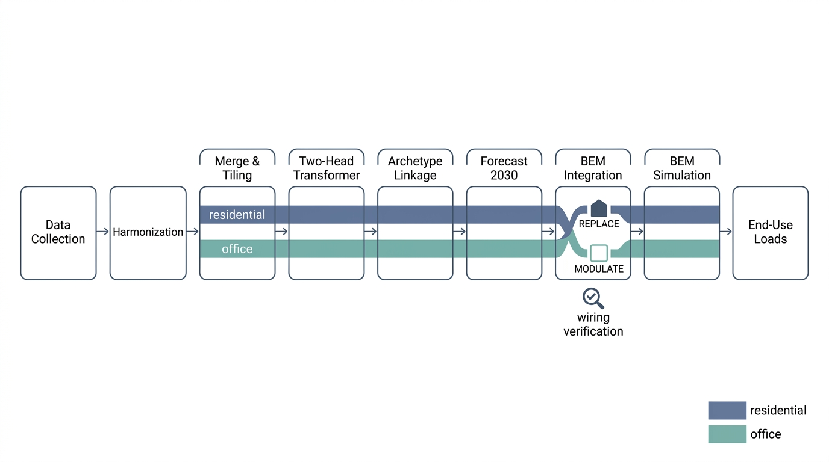
Figure S3

