Longitudinal Analysis of Occupancy-Driven Energy Demand in Canadian Residential Buildings (2005–2025)

XX¹, XX²
¹Institution 1, City 1, Country 1
²Institution 2, City 2, Country 2

Abstract
Building Performance Modeling often relies on static schedules that ignore how long term societal transformations alter residential energy demand. This paper presents a longitudinal analysis from 2005 to 2025, tracking shifts in Canadian residential energy demand due to evolving occupancy patterns. Using General Social Survey (GSS) data and machine learning, we developed a data driven framework to generate historically grounded dynamic occupancy profiles. Integrating these profiles into energy simulations reveals significant shifts in energy use directly attributable to behavioral dynamics. This methodology provides critical insights for engineers and policymakers to develop adaptive building codes and effective energy retrofit strategies.

Introduction
Building performance simulation (BPS) serves as a vital tool for examining energy metrics throughout the building life cycle, yet a significant performance gap remains between predicted and actual outcomes (Turley et al., 2020). This discrepancy is largely attributed to the inadequate representation of occupant behavior, as traditional modeling often relies on deterministic schedules that fail to capture the stochastic nature of real world usage (Hong et al., 2017; Mahdavi et al., 2021). Residential buildings are particularly sensitive to these errors, accounting for nearly 30 percent of global energy consumption while exhibiting highly diverse behavioral patterns driven by individual lifestyles and household dynamics (Pérez-Lombard, Ortiz and Pout, 2008). Capturing these dynamics requires models that go beyond static assumptions to account for both temporal routines and specific demographic characteristics, such as age and employment status, which fundamentally alter internal heat gain profiles (Wilke, Haldi and Robinson, 2011; Lu et al., 2021).
Time Use Surveys (TUS) provide the foundational empirical data required for activity based modeling, allowing researchers to link specific behaviors to demographic attributes (Richardson, Thomson and Infield, 2008; Mitra, Chu and Cetin, 2020). However, existing methodologies ranging from stochastic Markov chains to complex agent based models often struggle with longitudinal consistency or overlook the intra household social interactions that drive energy use (Duan, He and Yu, 2015). While TUS data is instrumental for bottom up modeling, many current frameworks rely on single day snapshots that fail to account for decadal societal transformations, such as the rise of remote work or demographic aging (Fischer, Härtl and Wille-Haussmann, 2015; Iseri, Dino and Kalkan, 2026).
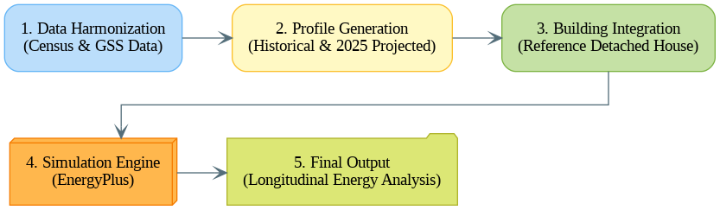
Figure 1. GSS Classification and Occupancy Impact
This study develops and validates a data-driven framework that synthesizes Canadian Census and General Social Survey (GSS) time-use data to generate statistically grounded occupancy profiles. These profiles capture both the non-temporal and temporal characteristics of residential building occupants across successive historical periods. The framework then quantifies how occupancy-driven variability influences heating, cooling, lighting, and equipment demand in Building Energy Models (BEM), addressing the critical gap between default schedules and actual behavior.
To achieve these objectives (Figure 1), the study first constructs a generative machine learning framework that integrates Canadian Census and GSS datasets to produce longitudinal occupancy schedules spanning historical and projected periods from 2005 to 2025. The resulting profiles are then used to quantify the magnitude of change in residential occupancy patterns and evaluate how these behavioral shifts propagate into simulated heating and cooling demand. Finally, the projected 2025 occupancy patterns are assessed against historical trends to examine their utility for near-term residential building performance forecasting.

Datasets
This study utilizes two complementary national datasets managed by Statistics Canada to construct comprehensive occupancy profiles for residential building energy modeling: the Census of Population and the General Social Statistics Program (GSS) Time Use cycle (Statistics Canada, 2012, 2022). The Census provides the demographic structure while the GSS supplies behavioral dynamics and the GSS animates this structure with behavioral and temporal dynamics. Census data from four cycles (2006, 2011, 2016, and 2021) provide the non temporal occupancy characteristics, including household size, dwelling type, occupant age distribution, and family structure (Statistics Canada, 2021). These variables establish the demographic foundation upon which temporal patterns are mapped. Complementing this, the GSS Time Use cycles from 2005, 2010, 2015, and 2022 capture the temporal patterns of occupant presence through 24 hour retrospective diaries (Statistics Canada, 2022). In these diaries, respondents report their primary activities, locations, and social context for every 10-minute interval of a reference day, offering a detailed behavioral record that evolves across successive survey cycles. Together, these datasets enable the generation of statistically grounded occupancy profiles that reflect the diversity and temporal evolution of actual Canadian households, addressing the limitations of generic, static assumptions common in conventional energy modeling.

Data Preprocessing
The integration of disparate national datasets into a longitudinal occupancy framework requires a multi stage preprocessing pipeline, as illustrated in Figure 2. This unified workflow standardizes the demographic microdata from the Census alongside the temporal event based diaries from the GSS, ensuring structural compatibility across the twenty year study period. For Census datasets, the workflow involved cleaning raw files to preserve demographic completeness, harmonizing dwelling typology classifications to enable cross cycle comparability, and engineering features to aggregate individual level records into household level observations. This process culminated in standardized datasets with consistent variable structures across all four census periods, facilitating a robust analysis of dwelling type distribution trends, such as the documented shift toward urban densification and apartment living in Canadian cities.
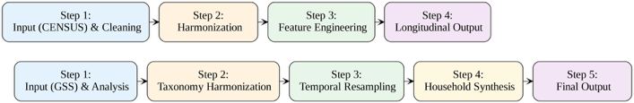
Figure 2. Dataset Preprocessing Census & GSS
The preprocessing of GSS Time Use data involved higher methodological complexity due to evolving survey instruments and activity classification systems. A master taxonomy was developed to map varied activity codes across cycles into 14 standardized categories, such as sleep, personal care, and leisure, while location and co-presence categories were standardized to binary flags indicating the presence of spouse, children, or other household members. Because building energy simulations require fixed interval states, the event based diaries were resampled into discrete 5 minute intervals, and a conditional generation methodology was implemented to synthesize internally consistent multi occupant household diaries from individual records. Finally, a statistical matching approach was used to probabilistically assign Census derived dwelling types to GSS records using shared demographic variables, ensuring that occupancy schedules are paired with physically consistent building thermal characteristics across the longitudinal analysis period.

Classification Framework
Structural integration of Census and GSS datasets required addressing fundamental incompatibilities between household-level Census records and the two-part structure of the GSS, which is composed of a main person file and a separate activity episode file. Joining process using unique respondent identifiers consolidated these structures, broadcasting static demographic attributes onto associated activity episodes. This phase concluded with systematic variable harmonization, mapping cycle specific nomenclature to unified Census conventions to ensure a consistent and compatible feature set for subsequent machine learning tasks.
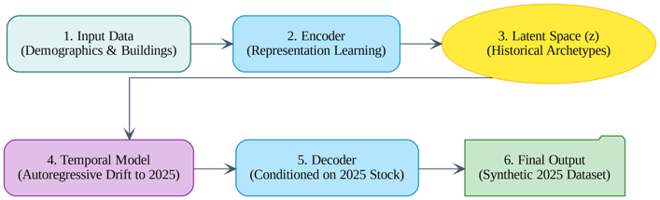
Figure 3. Multi-head Conditional Variational Autoencoder
To overcome the absence of empirical data for future years, a generative temporal framework was developed using a Multi head C-VAE (Figure 3). Traditional supervised classification assumes static demographic relationships that fail to account for decadal societal shifts and the cross sectional nature of census sampling. C-VAE instead learns low dimensional archetype representations of household demographics in a latent space conditioned on stable building features, eg, dwelling type and construction period. By applying autoregressive models to the mean latent vectors across historical cycles, the framework tracks temporal drift and extrapolates the population level evolution to 2025. This allows the trained decoder to synthesize statistically consistent 2025 household profiles, transforming static classification into dynamic population synthesis for near term residential energy demand forecasting.

Multi-Phase Generative Occupancy Pipeline
The generation of 2025 occupancy datasets follows a multi-phase pipeline that integrates representation learning, temporal forecasting, and behavioral synthesis, as illustrated in Figure 4. The process begins with the multi head C-VAE, which was trained on harmonized historical census data. This model compresses high dimensional demographic features—including income, age, and household size—into a 128 dimensional latent vector z that captures the statistical essence of Canadian households. Training convergence was successfully achieved over 100 epochs with a total loss stabilizing at 3.89, ensuring a smooth and interpolatable latent space. To project these demographic archetypes to 2025, a Cluster Based Vector Momentum was employed, using K-means clustering (K=8) to track lifecycle trajectories. A decay factor of λ = 0.95 was applied to the velocity vectors to prevent unrealistic linear growth, ensuring the forecasted population remains statistically grounded (Figure B1).
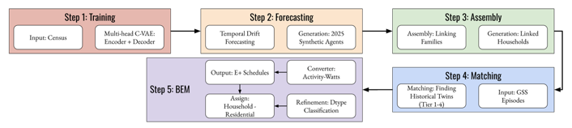
Figure 4. Machine learning multi-phase pipeline
Following the demographic projection, a multi stage assembly algorithm reconstructs coherent household units from individual synthetic agents by identifying household heads and filling units based on familial relationship indicators. These synthetic 2025 agents are then linked to empirical behavioral sequences from the GSS library through a cascading four tier search strategy (Step 4, Figure 4). This hierarchical protocol achieved high quality matches, with 84.6% of weekday profiles assigned at Tier 2 based on primary energy drivers. To ensure architectural precision, a stochastic super resolution methodology utilized Random Forest classifiers to refine coarse dwelling categories into specific building forms, such as high rise versus low rise apartments. Finally, these individual activity sequences were aggregated into household profiles and mapped to metabolic rates ranging from sleep (70W) to active leisure (245W). The resulting BEM ready schedules correctly couple occupancy fractions with metabolic heat gains (Figure B2-3).

Simulation Setup
While the 2025 dataset utilizes synthetic generation, the 2005 and 2015 comparison datasets were derived directly from empirical microdata pairing the 2006 Census with 2005 GSS and the 2016 Census with 2015 GSS. These historical pipelines (Table C1), reconcile disparate coding schemes to create feature spaces identical to the synthetic 2025 data. For the 2016 dataset, an additional machine learning based dwelling type refinement was required to expand coarse categories into the detailed eight category classification used in Building Energy Modeling (BEM). Behavioral profiles were assigned through tiered matching, achieving high quality alignment across ten demographic variables. This ensures all three temporal datasets (2005, 2015, 2025) yield structurally identical outputs for occupancy presence and metabolic heat gains, enabling valid longitudinal comparisons. The energy simulations were conducted using the DOE ASHRAE 90.1 Prototype Building for single family detached residential construction across three Canadian climate zones (U.S. Department of Energy, 2022; Building Energy Codes Program, 2025): Toronto (Zone 5A), Montreal (Zone 6A), and Winnipeg (Zone 7). The reference building represents a 223 m² two story dwelling typical of post 1980 North American housing stock. To isolate the impact of occupancy behavior, building envelope and HVAC characteristics remained constant across all scenarios, while TMYx weather files (2009 to 2023) were used to capture contemporary meteorological trends. Default schedules were standardized using the DOE MidRise Apartment archetype as a residential proxy, ensuring that all comparative energy demand shifts reflect empirically derived occupancy patterns rather than artifacts of inconsistent default schedules (Mostapha Sadeghipour Roudsari, 2025; National Renewable Energy Laboratory, 2025).
Occupancy profiles were integrated into EnergyPlus through a presence aware filtering methodology that prevents unrealistic binary switching. The Presence Filter algorithm (Figure C1), modulates default end use loads based on the following integration logic:
${Load}_{t}$= ${occupancy}_{t}$ * max (${default}_{t}, floor$) + (1 - ${occupancy}_{t}$) * baseload (1)
Occupancy profiles were integrated into EnergyPlus through a presence aware filtering methodology that prevents unrealistic binary switching. The Presence Filter algorithm, shown in Figure C1, modulates default end use loads based on household state: during occupied hours, loads follow the default schedule profile, whereas during vacancy, they decay to baseload levels representing standby power or recirculation losses. This methodology applies to lighting, electrical equipment, and domestic hot water, while metabolic heat gains are computed via time weighted averaging of activity intensities. A comparative ensemble was created by selecting the 100 households per scenario (n=100) that best matched a target working day profile through Sum of Squared Error (SSE) minimization. This controlled design ensures observed energy differences reflect behavioral evolution within a consistent household archetype rather than stochastic noise from fundamentally different occupancy types (Figure C2).

Results
Canadian residential occupancy patterns have undergone substantial transformation over the past two decades, fundamentally altering the boundary conditions for building energy performance. Population average presence schedules reveal distinct behavioral trajectories across the study periods, as illustrated in Figure 5. Weekday profiles in 2005 reflected traditional employment patterns with a midday vacancy trough of 40 percent occupancy and 15.8 total daily occupied hours. By 2015, total occupancy rose to 17.6 hours while maintaining a similar daytime presence fraction. In contrast, the 2025 synthetic population projection demonstrates a significant reduction to 11.2 weekday occupied hours with daytime presence dropping to 28 percent. These shifts contradict conventional default schedules, which assume a constant 16.4 hours for all day types and miss the observed 1.8 to 2.4 hour weekday to weekend variation. Most critically, default schedules assume 74% daytime vacancy, whereas empirical 2005/2015 data show only 40% — nearly double the actual absence rate.
Residential occupancy encompasses diverse activities that drive varying internal heat gains, distinguishing these findings from default schedule models that rely on a constant 120W rate. Daily time use patterns show that sleep declined from 9.7 to 8.7 hours per day between 2005 and 2025, while digital activities and remote work transitions surged to 6.0 hours. The resulting hourly metabolic profiles exhibit pronounced diurnal variation, consistently remaining at or below the conventional 120W assumption. This disparity reveals that constant rate assumptions overestimate nighttime internal gains by 40 to 50W during sleeping hours, which artificially masks envelope heat losses, while underestimating peak daytime generation during high intensity activities. Utilizing an activity based mapping methodology captures the thermal reality that heat generation scales significantly with specific behaviors, improving simulation fidelity.
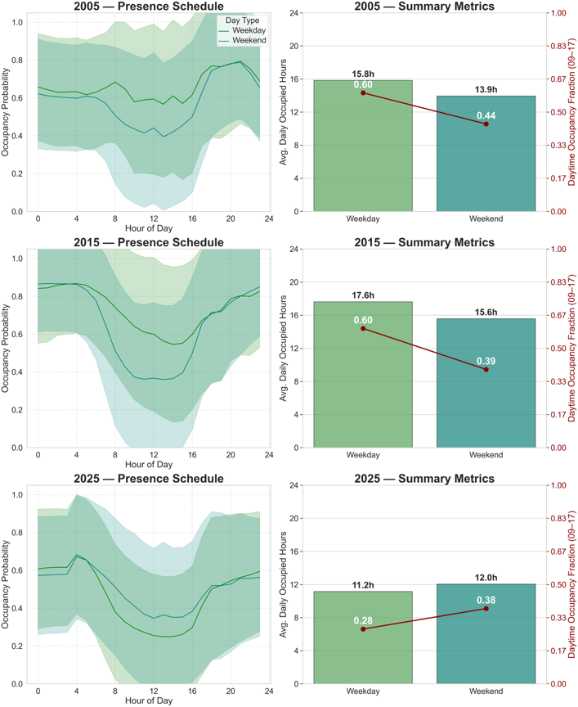
Figure 5. Residential presence schedules (top) and occupancy metrics (bottom) for 2005, 2015, and 2025.
Analysis reveals that conventional schedules systematically overestimate mean weekday occupancy (0.684 vs 0.465) and weekend occupancy (0.684 vs 0.502), leading to an inflation of internal heat gains. The mean metabolic rate exhibits a plus 23.5 percent overestimation (95W vs 72.7W), further compounding the bias. While daytime occupancy percentages (09:00 to 17:00) appear to approximate midday presence at roughly 26 to 28 percent, the underlying temporal profile shapes are fundamentally different, resulting in a 4 hour shift in peak occupancy timing.
Table 1. Schedule Discrepancies: Default vs 2025 GSS derived Patterns
Parameter | Default | 2025GSS | Diff. | % Error
Mean weekday occupancy (0–1) | 0.684 | 0.465 | +0.219 | +32.1%
Mean weekend occupancy (0–1) | 0.684 | 0.502 | +0.182 | +26.6%
Peak occupancy time (weekday) | 00:00 | 04:00 | Δ -4 h | —
Daytime occupancy (09–17) | 25.60% | 27.60% | -2.0 pp | —
Mean metabolic (W) | 95 | 72.7 | +22.3 W | +23.5%
Peak metabolic (W) | 95 | 95 | +0.0 W | 0%
Direct comparisons between conventional baseline assumptions and empirically derived Canadian patterns expose systematic discrepancies in both timing and magnitude. While default schedules assume binary transitions and a constant 25 percent daytime presence, the GSS patterns exhibit gradual probabilistic shifts where morning departures and evening returns occur over several hours. Peak occupancy timing differs by 4 hours between default schedule models and empirical data, directly affecting overnight HVAC scheduling. Quantified metrics, detailed in Table 1, show that default schedules systematically overestimate mean weekday occupancy by 32.1 percent and metabolic heat generation by 23.5 percent. These discrepancies provide evidence based metrics for building code revisions, confirming that conventional assumptions significantly bias both heating and cooling load predictions by mischaracterizing internal heat gain profiles.

Energy Impact Results
The comparative simulation results across three Canadian climate zones demonstrate that occupancy schedule choice materially affects building energy predictions. Empirically derived GSS schedules consistently increased annual heating demand by plus 3.9% to plus 12.6% while reducing cooling demand by minus 10.3% to minus 27.1% relative to Default assumptions (Figure 6). GSS schedules show 28–60% daytime presence versus Default's 25.6%, resulting in lower internal gains and higher heating requirements. With fewer occupants generating metabolic heat and operating appliances, the building requires additional heating energy to maintain setpoint temperatures. This relationship remains consistent across Toronto (5A), Montreal (6A), and Winnipeg (7), confirming that these impacts reflect fundamental building physics rather than climate specific artifacts.
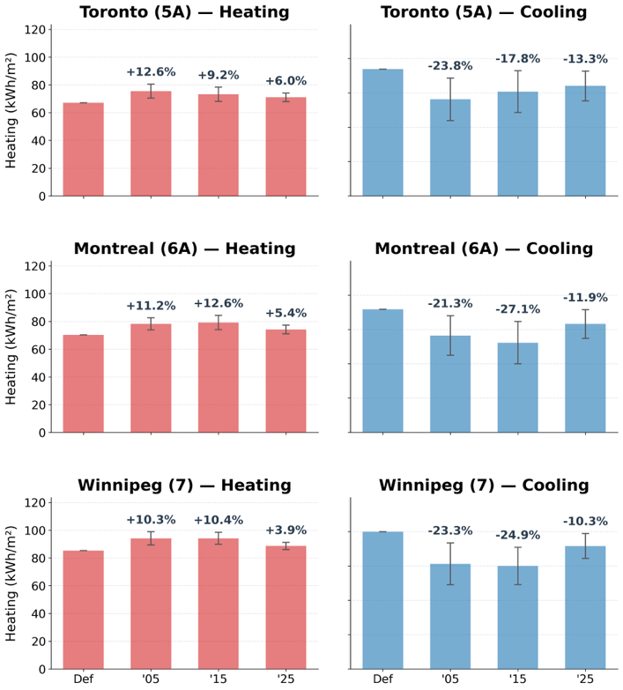

Figure 6. Annual heating and cooling demand by scenario and climate zone
Longitudinal trends, referring to the directional patterns observed across the 2005, 2015, and 2025 simulation periods, show that while heating demand exhibited divergent, climate specific patterns, cooling demand demonstrated consistent monotonic convergence toward Default assumptions by 2025. This convergence is driven by the synthetic 2025 population projection, where daytime occupancy closely mirrors default schedule assumptions more than the 2005 or 2015 empirical data. However, annual energy totals can obscure the temporal details necessary for infrastructure planning. Diurnal load profiles (Figure D1), reveal that Default models overestimate weekend cooling loads by up to 27% and mischaracterize peak windows, which directly impacts the accuracy of demand response dispatch algorithms and grid forecasting.
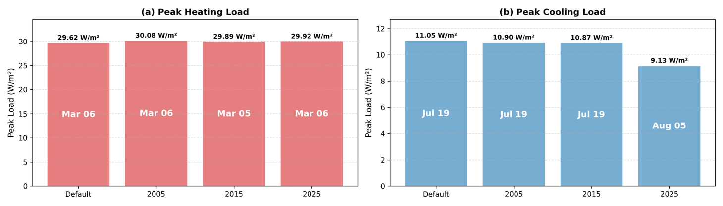
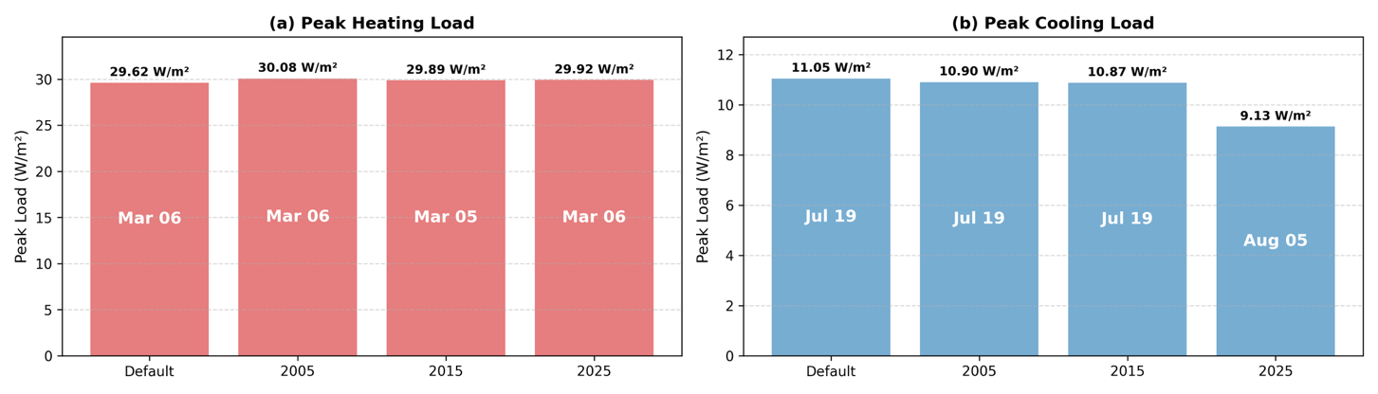
Figure 7. Peak heating (a) and cooling loads (b) by scenario
Peak load analysis (Figure 7) highlights the implications for HVAC equipment sizing. While peak heating loads remained remarkably stable across all scenarios—ranging from 29.62 to 30.08 W/m²—peak cooling loads exhibited substantial scenario dependent variation. 2025 scenario demonstrated a 17.4% reduction to 9.13 W/m² with a delayed occurrence on August 5th, compared to the July 19th peaks found in other scenarios. This shift reflects the compound effect of lower midday internal gains and activity patterns shifting toward evening hours. These findings suggest that current sizing practices are robust for heating but may overestimate cooling capacity by nearly 18% for future building stock. Such discrepancies necessitate that grid operators and engineers reassess seasonal peak forecasting assumptions that currently presume stable mid summer cooling maxima.

Discussion
Default schedules overestimate mean occupancy by 32% and metabolic heat by 24%, creating a systematic bias where heating demand is underestimated by 6 to 13% and cooling is overestimated by 10 to 27%. These errors stem from a counterintuitive thermophysical relationship: Default models assume much higher continuous presence (68.4%) than empirical Canadian patterns (46.5%), resulting in artificially high internal heat gains that mask the true heating requirements of the building envelope. This study advances the research area by proving that constant metabolic rate assumptions (95 to 120W) fundamentally mischaracterize the diurnal variation of human life, which actually ranges from 70W during sleep to 245W during active leisure. Furthermore, the findings reveal that population average schedules hide extreme heterogeneity, such as the vast difference between single person (18.2h) and five person (5.2h) occupancy probabilities. Moving beyond binary presence absence modeling to activity based frameworks is therefore essential for capturing the realistic stochasticity that governs modern residential energy performance.
The practical implications for building design and grid planning are significant. Current HVAC sizing based on default schedules likely overestimates cooling capacity by up to 18%, offering clear opportunities for equipment downsizing and capital savings, while heating sizing remains robust at only 1.5% variation. These findings suggest that correction factors on the order of +10% for heating and −20% for cooling may be warranted for single-family residential buildings in Canadian cold climates.For utilities, the observed 1 to 2 hour peak timing shift from late afternoon toward early afternoon (13:00 to 15:00) and the seasonal shift from July to August necessitate a total reassessment of demand response dispatch and grid stress forecasting. The non monotonic evolution of these patterns (79 to 80 to 75 kWh/m² in Montreal) suggests that building codes relying on static schedules accumulate compounding errors over decadal lifespans, requiring periodic recalibration synchronized with census cycles.
The analysis is currently restricted to single family detached housing built after 1980 within climate zones 5A, 6A, and 7; consequently, results may not generalize to multifamily buildings with shared envelopes or to more extreme arctic climates. While lighting and equipment loads were integrated, their specific occupancy driven impacts were not disaggregated. Future research should prioritize validating by extending models to multi family archetypes, and performing household size segmented simulations. Coupling these granular occupancy patterns with housing stock turnover models will be vital for projecting the aggregate grid level impacts of evolving societal behaviors on regional electricity demand.

Conclusion
This research established a replicable generative machine learning framework integrating Canadian Census and General Social Survey data to produce longitudinal occupancy schedules from 2005 to 2025. The study transformed episodic time use diaries into standardized household level presence and activity profiles suitable for simulation, bridging the gap between national statistics and modeling requirements. This methodology enables the representation of diverse household compositions and activities that govern modern residential energy performance. The findings confirm that behavioral evolution materially determines building energy predictions. Historical data reveal that empirical presence is significantly higher than conventional assumptions, leading to a systematic underestimation of heating and an overestimation of cooling demand. While 2025 projections show a gradual convergence toward default schedules, they also indicate a critical shift in seasonal peak timing from mid July toward August. These results prove that static occupancy assumptions fail to capture the stochasticity of daily routines and the impact of societal transformations like remote work, resulting in biased internal gain profiles and oversized cooling equipment. This research provides the first longitudinal quantification of occupancy driven energy demand in Canada, demonstrating that building performance degrades through the continuous transformation of occupant behavior rather than physical aging alone. The substantial discrepancies between default schedule assumptions and empirical data provide compelling evidence for updating residential building energy modeling practices. As evolving lifestyle patterns continue to reshape domestic energy use, these data driven representations offer a vital foundation for the development of adaptive building codes and grid planning strategies that account for the dynamic nature of human behavior.

Acknowledgement
The authors gratefully acknowledge the financial support provided for this postdoctoral research by NSERC and the Voltage-Age Seed fund.

References
Building Energy Codes Program (2025) Prototype Building Models — IECC Residential. Available at: https://www.energycodes.gov/prototype-building-models#Residential (Accessed: February 15, 2026).
Duan, J., He, J. and Yu, C.W. (2015) “A brief review of modelling methods for occupants’ behaviours in residential buildings,” Indoor and Built Environment, 0(0), p. 1420326X251396163. Available at: https://doi.org/10.1177/1420326X251396163.
Fischer, D., Härtl, A. and Wille-Haussmann, B. (2015) “Model for electric load profiles with high time resolution for German households,” Energy and Buildings, 92, pp. 170–179. Available at: https://doi.org/https://doi.org/10.1016/j.enbuild.2015.01.058.
Hong, T. et al. (2017) “Ten questions concerning occupant behavior in buildings: The big picture,” Building and Environment, 114, pp. 518–530. Available at: https://doi.org/https://doi.org/10.1016/j.buildenv.2016.12.006.
Iseri, O.K., Dino, I.G. and Kalkan, S. (2026) “Occupancy modeling using population statistics and machine learning for urban residential built environment,” Energy and Buildings, p. 117155. Available at: https://doi.org/https://doi.org/10.1016/j.enbuild.2026.117155.
Lu, X. et al. (2021) “Extracting typical occupancy schedules from social media (TOSSM) and its integration with building energy modeling,” Building Simulation, 14(1), pp. 25–41. Available at: https://doi.org/10.1007/s12273-020-0637-y.
Mahdavi, A. et al. (2021) “The Role of Occupants in Buildings’ Energy Performance Gap: Myth or Reality?,” Sustainability, 13(6). Available at: https://doi.org/10.3390/su13063146.
Mitra, D., Chu, Y. and Cetin, K. (2020) “Activity Profiles of Occupants in Residential Buildings Using the American Time Use Survey Data.” Available at: https://doi.org/10.1061/9780784482865.113.
Mostapha Sadeghipour Roudsari, C.M. (2025) Honeybee Energy Standards — Schedule Library. Available at: https://github.com/ladybug-tools/honeybee-energy-standards (Accessed: February 15, 2026).
National Renewable Energy Laboratory (2025) OpenStudio Standards Gem. Available at: https://github.com/NREL/openstudio-standards (Accessed: February 15, 2026).
Pérez-Lombard, L., Ortiz, J. and Pout, C. (2008) “A review on buildings energy consumption information,” Energy and Buildings, 40(3), pp. 394–398. Available at: https://doi.org/https://doi.org/10.1016/j.enbuild.2007.03.007.
Richardson, I., Thomson, M. and Infield, D. (2008) “A high-resolution domestic building occupancy model for energy demand simulations,” Energy and Buildings, 40(8), pp. 1560–1566. Available at: https://doi.org/https://doi.org/10.1016/j.enbuild.2008.02.006.
Statistics Canada (2012) 2011 National Household Survey. Available at: https://www12.statcan.gc.ca/nhs-enm/index-eng.cfm (Accessed: February 15, 2026).
Statistics Canada (2021) Guide to the Census of Population, 2021. Available at: https://www12.statcan.gc.ca/census-recensement/2021/ref/98-304/98-304-x2021001-eng.pdf (Accessed: February 15, 2026).
Statistics Canada (2022) General Social Survey – Time Use (GSS). Available at: https://www150.statcan.gc.ca/n1/pub/45-25-0001/index-eng.htm (Accessed: February 15, 2026).
Turley, C. et al. (2020) “Development and Evaluation of Occupancy-Aware HVAC Control for Residential Building Energy Efficiency and Occupant Comfort,” Energies, 13(20). Available at: https://doi.org/10.3390/en13205396.
U.S. Department of Energy (2022) Commercial Reference Buildings. 16 common building types. Developed to comply with ASHRAE Standard 90.1 (2004, 2010, 2013, 2016, 2019). Available at: https://www.energy.gov/eere/buildings/commercial-reference-buildings (Accessed: February 15, 2026).
Wilke, U., Haldi, F. and Robinson, D. (2011) “A model of occupant’ activities based on time use survey data,” Proceedings of Building Simulation 2011: 12th Conference of International Building Performance Simulation Association.

Appendix A
Table A1. Standardized Categories between four GSS datasets (2005/10/15/25)
# | Category Name | Description
1 | Work & Related | Paid/unpaid work, job searching, overtime, and work-related breaks or idle time (excluding travel).
2 | Household Work & Maintenance | Cooking prep, cleaning, laundry, repairs, gardening, pet/plant care, household finances, organization, etc.
3 | Caregiving & Help | Caring for children, adults, or non-household members; includes physical, emotional, or medical assistance.
4 | Purchasing Goods & Services | Shopping, errands, and use of personal, financial, government, medical, or professional services.
5 | Sleep & Naps & Resting | Night sleep, naps, or lying down to rest.
6 | Eating & Drinking | All eating and drinking activities (home or away).
7 | Personal Care | Grooming, hygiene, personal medical care, and private activities (bathroom, sex).
8 | Education | Attending classes, studying, homework, or school/training-related events.
9 | Socializing | Visiting, parties, weddings, bars, clubs, or any direct social interactions.
10 | Passive Leisure | Relaxing, resting, reading, watching TV, gaming, listening to music, meditation, or private prayer.
11 | Active Leisure | Sports, exercise, hobbies, outdoor recreation, arts, dancing, or physically engaging activities.
12 | Community & Volunteer | Civic participation, religious services, volunteering, and organized community activities.
13 | Travel | All travel between locations for any purpose (work, errands, social, education, etc.).
14 | Miscellaneous / Idle | Waiting, unspecified, or unclassifiable time.

Appendix B
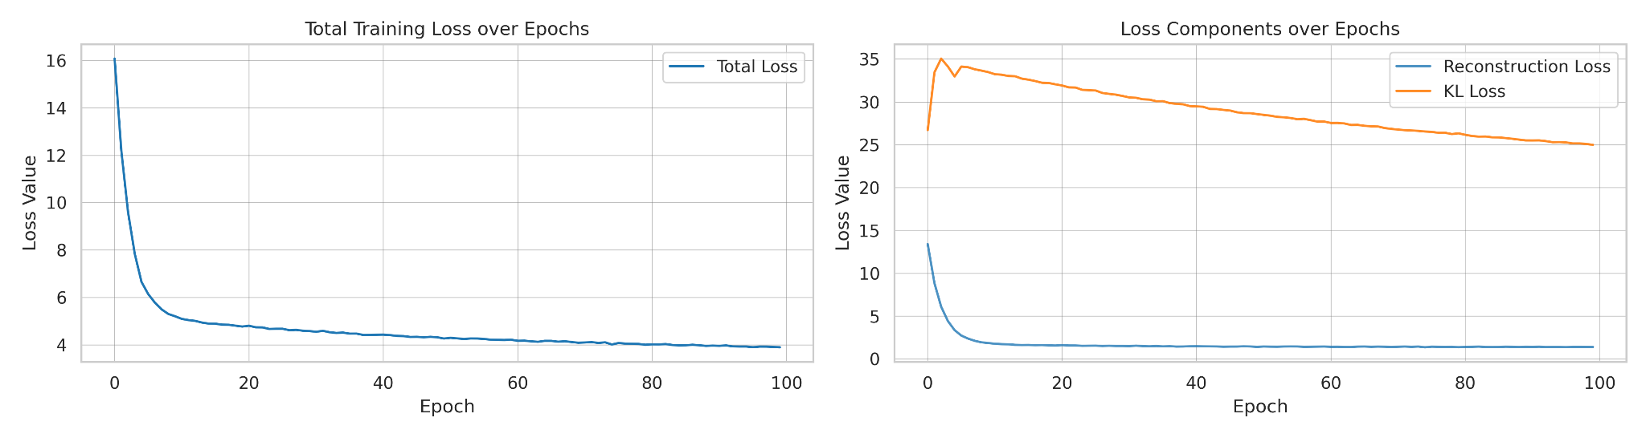
Figure B1. C-VAE training convergence plots (loss curves)
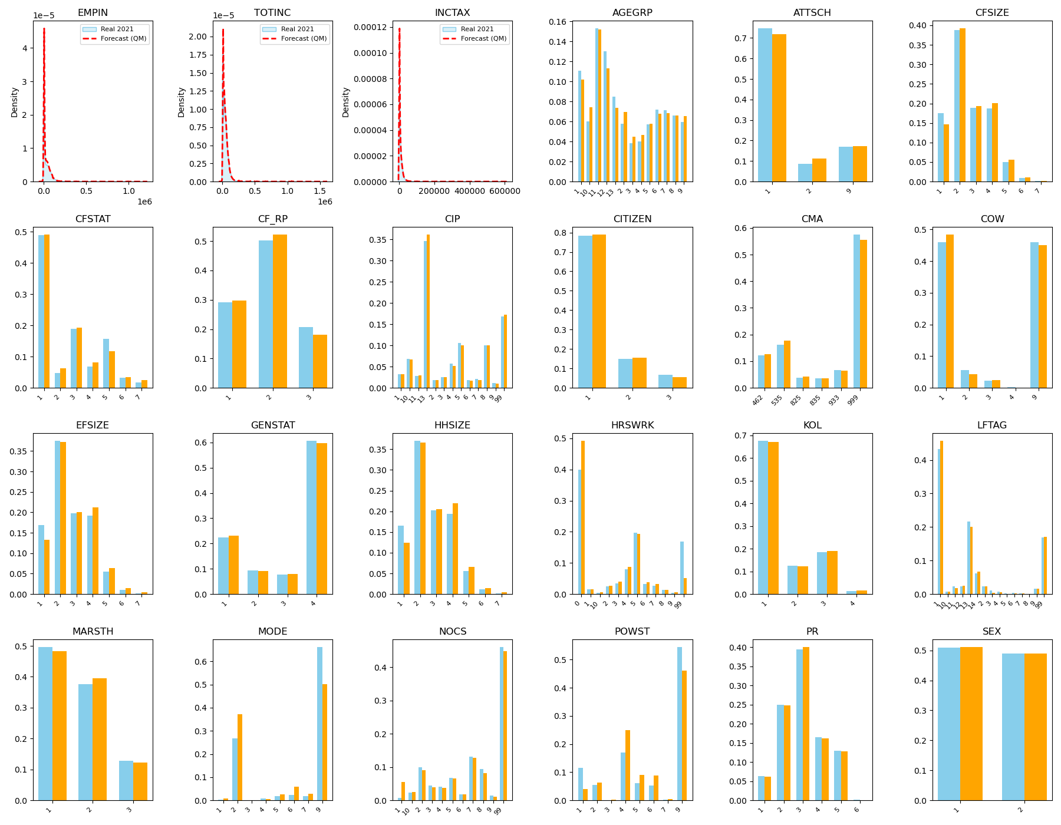
Figure B2.The large 12-panel grid showing C-VAE reconstruction accuracy per variable
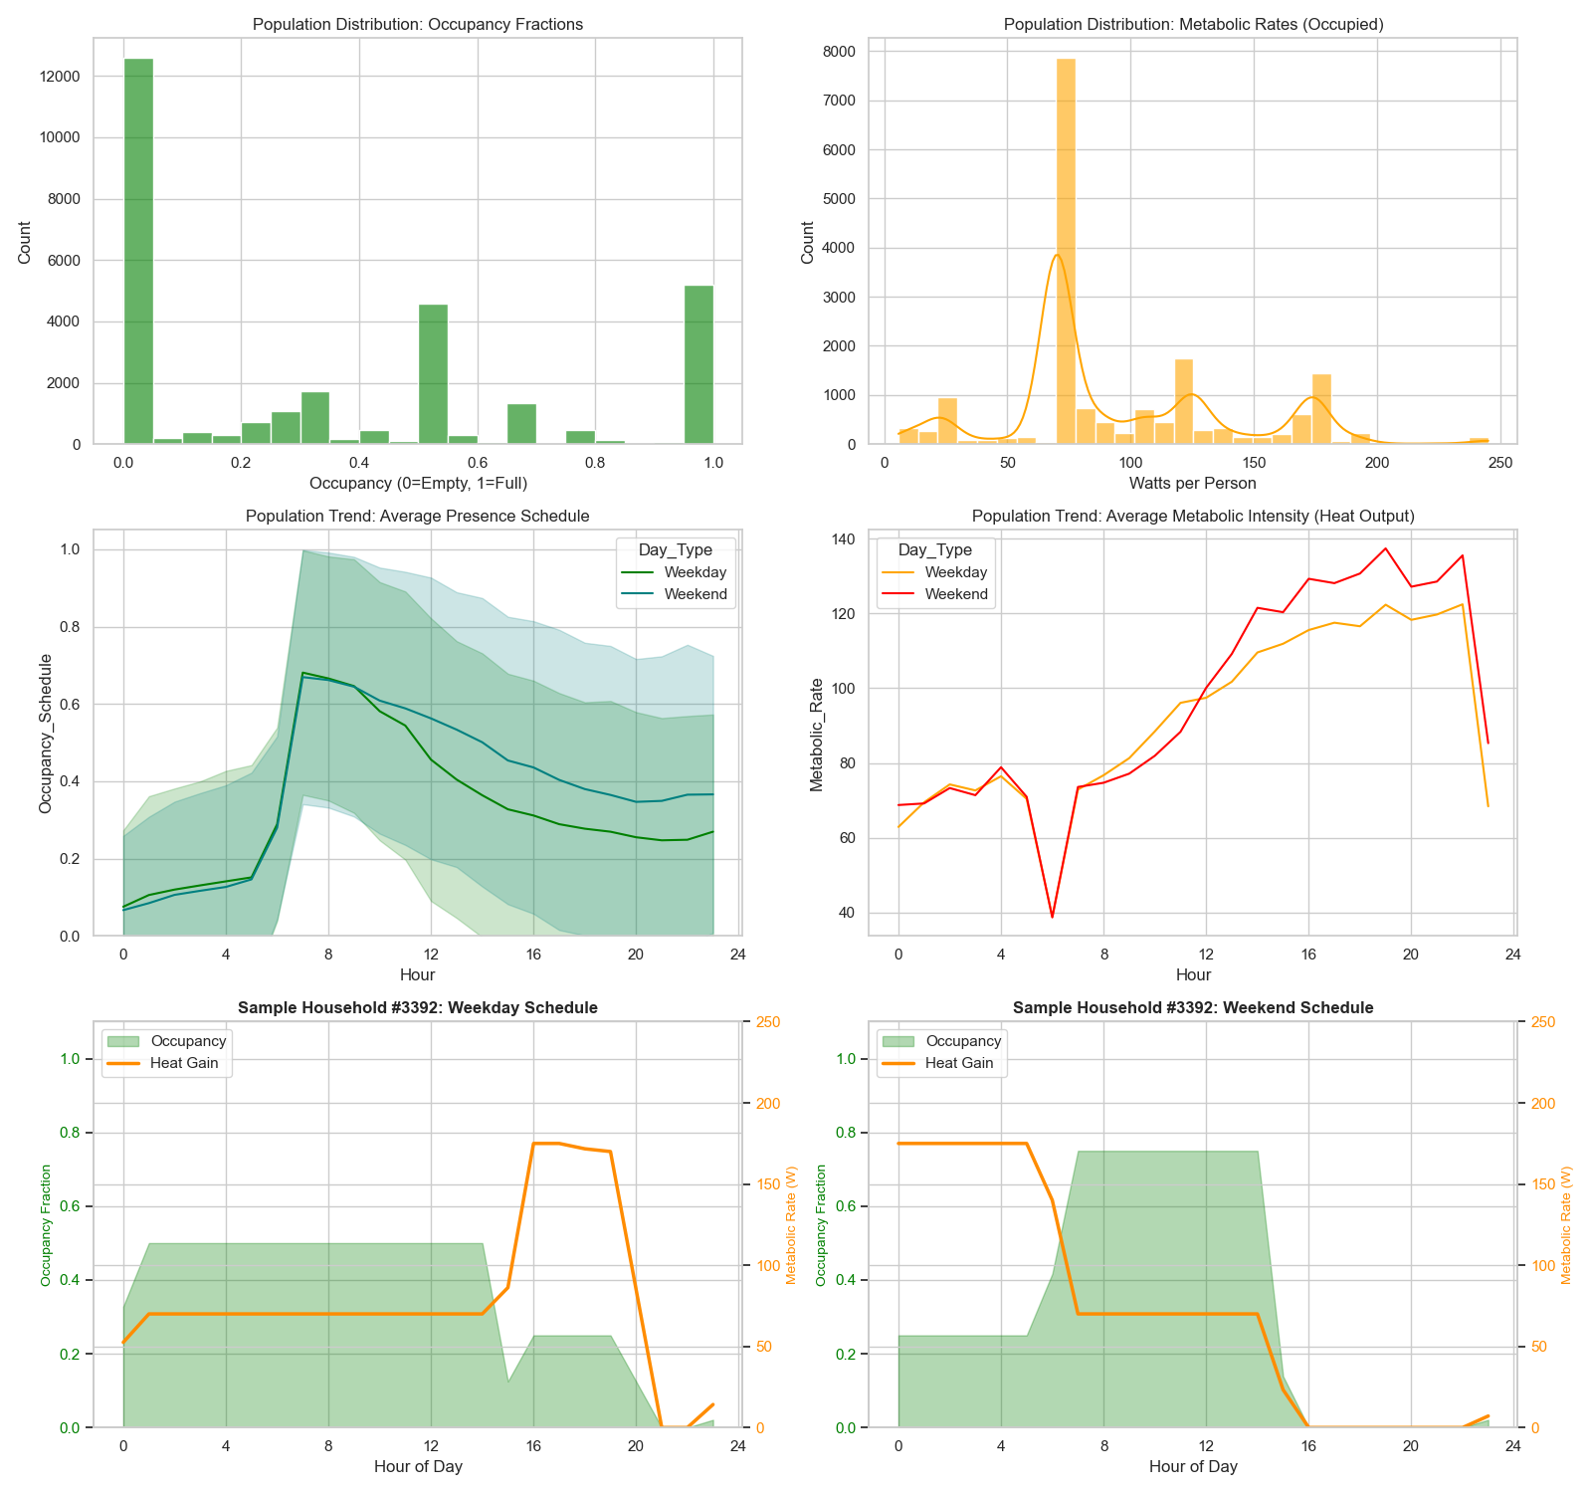
Figure B3. Population-level BEM validation: weekday/weekend average presence

Appendix C
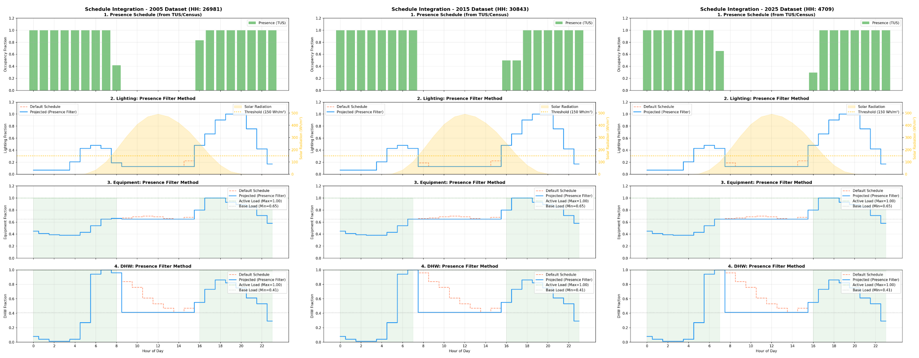
Figure C1. Representative Integrated Load Profiles

Appendix D
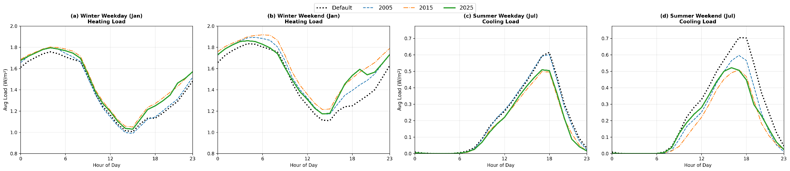




Figure D1: Diurnal load profiles for Winter and Summer seasons

