Longitudinal Analysis of Occupancy-Driven Energy Demand in Canadian Residentials
Orcun Koral Iseri 1,* Caroline Hachem-Vermette 1,
Department of Building, Civil and Environmental Engineering, Concordia University,
Montreal, QC, H3G 1M8, Canada;
caroline.hachemvermette@concordia.ca (C.H.-V.); * Correspondence: orcunkoral.oseri@concordia.ca

Abstract
The performance gap in building simulations is often driven by static schedules that fail to capture evolving occupant behaviors caused by societal shifts like remote work and demographic aging. This paper presents a longitudinal analysis of Canadian residential energy demand across five cycles (2005–2025). Using General Social Survey (GSS) time-use and Census microdata, we developed a Conditional Variational Autoencoder (C-VAE) framework to generate dynamic, demographics-linked occupancy profiles. These were integrated into neighbourhood-scale simulations for six Neighbourhood Unit typologies in Montreal (Climate Zone 6A). Results demonstrate that weekday occupied hours fluctuated significantly (11.9 to 17.5 hours) rather than following a uniform trend. Compared to conventional defaults, these data-driven schedules consistently increased heating demand by 4–13% and reduced cooling demand by 10–27%. Consequently, we propose residential code calibration factors of +10% for heating and -20% for cooling, alongside periodic recalibration synchronized with national census cycles.

Keywords
Building Occupancy Modeling, Building Performance Simulation, Time-Use Survey, Longitudinal Analysis, Occupant Behavior, Canadian General Social Survey (GSS), Residential Neighbourhood Simulation, Data-Driven Modeling, Conditional Variational Autoencoder, Energy Demand Forecasting

Highlights
- Longitudinal occupancy framework integrates 5 GSS cycles (2005–2025) with Census.
- C-VAE generates synthetic 2025 occupancy from Canadian household demographics.
- Default schedules overestimate occupancy by 32% and metabolic heat by 24%.
- GSS-derived schedules raise heating 4–13%, cut cooling 10–27% across 6 NUs.
- Peak cooling shifts 1–2h earlier with 17.4% lower magnitude under 2025 occupancy.

1 Introduction
Occupancy modeling follows a structured workflow from data acquisition to behavioral formulation and Building Performance Simulation (BPS) integration, requiring resolution across temporal, spatial, and demographic dimensions, where age and employment status are particularly influential [1,2]. Time-Use Survey (TUS) data remains the gold standard for capturing daily activity profiles, complemented by in-situ sensing approaches such as PIR detectors and smart meters that offer high-resolution presence data at the cost of reduced behavioral context [3,4]. Models are then formulated as deterministic, stochastic, or data-driven formalisms, ranging from fixed-rule schedules to Markov Chain transitions and machine learning approaches, before being integrated into BPS tools via co-simulation frameworks and standardization schemas such as obXML [1,3].

1.1 Process of Occupancy Modeling
Occupancy modeling involves a structured workflow transitioning from data acquisition to behavioral formulation and finally to integration within BPS tools [5]. Effective models must define resolution across three dimensions (ie, temporal, spatial, and demographic) where demographic attributes such as age and employment status are particularly influential on activity patterns and energy intensity [6]. The empirical foundation of most models is TUS data, considered the gold standard for capturing daily activity profiles [7], though in-situ sensing approaches such as PIR detectors and smart meters offer complementary high-resolution presence data at the cost of reduced behavioral context [7]. From this data, models are formulated using deterministic, stochastic, or data-driven formalisms: while deterministic approaches rely on fixed rules that fail to capture real-world diversity, stochastic models such as Markov Chains address this through probabilistic state transitions, and more advanced data-driven approaches leverage machine learning to identify patterns without explicit rules [4,6,8]. The final step is integrating these models into BPS tools, typically through co-simulation frameworks, with standardization schemas such as obXML facilitating interoperability between occupant modeling engines and energy simulation platforms [9,10].

1.2 Challenges and Limitations in Residential Occupancy Modeling
Modeling residential occupancy presents unique challenges compared to the commercial sector, primarily because household life is governed by stochastic individual routines rather than regulated schedules, rendering standardized deterministic assumptions such as ASHRAE baselines ineffective and directly contributing to the building energy performance gap [6,11]. Even within similar demographics, energy profiles diverge substantially due to intra-household social dynamics that models simulating occupants in isolation systematically overlook [12,13]. Compounding this are logistical and ethical barriers to high-resolution data: intrusive sensing raises privacy concerns [14], PIR detectors often lack granularity to distinguish individuals [8], and Time-Use Surveys fail to capture long-term behavioral consistency or seasonal variation [8]. Methodological trade-offs further persist between Agent-Based Models and Markov chain approaches, balancing behavioral detail against computational tractability and temporal dependency capture [5], while the lack of BPS standardization forces co-simulation workflows that remain beyond typical practitioner capacity. Finally, models developed for specific climatic or cultural contexts generalize poorly across built environments [15].

1.3 Existing Approaches in Occupancy Modeling and Their Deficiencies
The representation of occupant behavior in building performance simulation has evolved from static to dynamic approaches, yet significant limitations persist across all four modeling typologies [1,6]. Deterministic models relying on ASHRAE or ISO schedules remain the industry norm but fail to capture behavioral stochasticity, producing energy discrepancies of up to 41% [1,6,16]. Stochastic models such as Markov Chains partially address this through probabilistic transitions, yet their memoryless property and inability to capture intra-household social interactions limit residential accuracy [5,13]. Data-driven and agent-based approaches offer higher resolution but introduce prohibitive computational costs, black-box interpretability issues, and privacy concerns [17–19]. Across all methodologies, the neglect of household social dynamics, poor long-term temporal consistency, and the persistent scalability-accuracy trade-off remain unresolved [5,9,20].

1.4 Time-Use-Survey for Occupancy Modeling
TUS serve as a foundational empirical source for occupancy modeling, capturing the contextual "who, what, when, and where" of daily life and enabling researchers to link activities to demographic characteristics, age, employment, household size, across diverse population segments [1]. Stochastic methodologies such as Markov Chains transform this raw diary data into continuous simulation inputs, while clustering techniques generate representative urban archetypes for bottom-up energy modeling of metabolic heat gains and appliance-driven peak demand [13,17]. However, TUS data faces inherent limitations: single-day snapshots fail to capture seasonal variation or long-term habit consistency, self-reporting biases introduce memory and time-rounding artifacts, and the absence of spatial resolution necessitates secondary inference to map activities to specific thermal zones [9,18,21].

1.5 Aim of the study
This study develops a data-driven framework for generating longitudinally consistent occupancy datasets capturing the demographic composition and temporal behavioral patterns of Canadian residential occupants across a twenty-year period (2005 to 2025). The full methodological pipeline is summarised in Figure 1, with each stage detailed in Sections 3 and 4.
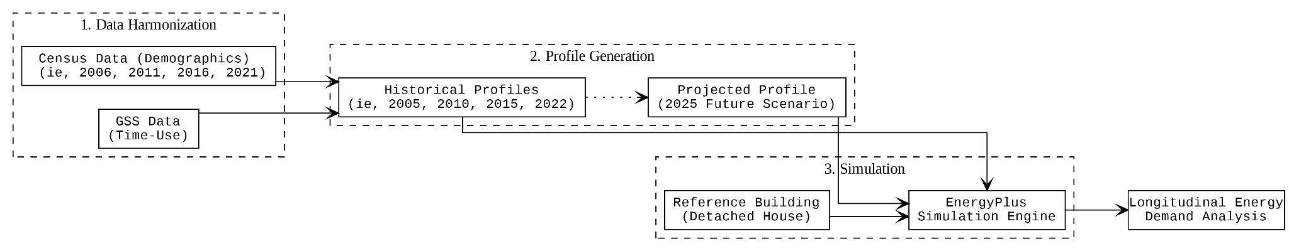
Figure 1. Flow Chart of GSS Classification and Occupancy Impact
This study pursues three objectives. (1) Methodological: integrate Canadian Census PUMF and GSS Time Use data through a Conditional Variational Autoencoder (C-VAE) pipeline to generate longitudinally consistent occupancy profiles spanning 2005 to 2022 empirically and 2025 synthetically, bridging the critical gap between survey-based population statistics and the temporally resolved inputs required for building energy simulation. (2) Empirical: quantify the magnitude and direction of change in Canadian single-family residential occupancy patterns over two decades, examining how behavioral shifts in presence, activity distribution, and metabolic intensity alter simulated heating, cooling, equipment, and domestic hot water demand relative to conventional default schedule assumptions across Canadian climate zones. (3) Forward-looking: evaluate whether the synthetic 2025 projection converges toward or diverges from conventional modeling assumptions, and derive evidence-based correction factors for building codes and HVAC design practice in cold-climate Canadian residential contexts. Collectively, these objectives contribute a replicable, nationally representative methodology for building codes, HVAC design, and retrofit planning.

2 Datasets
This study utilizes two complementary national datasets managed by Statistics Canada to construct comprehensive occupancy profiles for residential building energy modeling: the Census of Population and the General Social Statistics Program (GSSP) Time Use cycle. Conceptually, the Census provides the rigid demographic structure of Canadian households, covering household size, dwelling type, occupant age distribution, gender composition, and family structure, while the GSSP animates this structure with behavioral and temporal dynamics through 24-hour retrospective time diaries recorded at 10-minute intervals [22]. Census data from four cycles (2006, 2011, 2016, and 2021) were employed, noting that the 2011 cycle utilized the voluntary National Household Survey with reduced response rates (68.6% versus 93.5% in 2006), while mandatory status was reinstated in 2016, restoring reliability with response rates exceeding 98% by 2021 [23,24]. The GSSP Time Use cycles of 2005, 2010, 2015, and 2022 capture evolving lifestyle patterns over two decades, with the 2022 cycle incorporating enhanced measurement of telework and remote work patterns in response to post-pandemic societal transformations. By linking Census-derived household characteristics with GSSP-derived temporal patterns, this integrated approach generates comprehensive occupancy datasets that address the critical limitation of conventional building energy models, which typically rely on generic, static occupancy assumptions that fail to represent the diversity and temporal evolution of actual Canadian households.

2.1 Data Pre-processing of Datasets
Ensuring longitudinal consistency across four Census cycles (2006, 2011, 2016, 2021) required a systematic harmonization pipeline standardizing disparate microdata file structures through four sequential stages: raw file parsing and cleaning, variable name harmonization and categorical unification, particularly for dwelling typology (DTYPE) — household-level feature engineering deriving composite variables such as household size (HHSIZE), and longitudinal CSV export with consistent variable structures across all cycles. The pre-processing of GSSP Time Use data presented substantially greater complexity due to evolving activity classification systems: the 2005 and 2010 cycles used ACTCODE with 182 and 264 unique codes respectively, while 2015 and 2022 transitioned to TUI_01 with 64 and 121 codes. To establish longitudinal consistency, a master activity classification framework comprising 14 standardized categories was developed through systematic codebook analysis (Appendix B, Table B1), while location and co-presence variables were unified into 18 harmonized presence categories (Appendix B, Table B2). Since GSS data are collected as variable-length event-based episodes whereas building energy simulations require fixed-interval state-based schedules, all diary records were transformed into discrete 5-minute interval states, yielding 288-time steps per 24-hour period. To address the limitation that each GSS record represents an individual respondent rather than a household, a conditional generation methodology synthesized internally consistent multi-occupant diaries by constraining subsequent household members' schedules through co-presence compatibility rules, producing synchronized household occupancy profiles suitable for BEM integration.
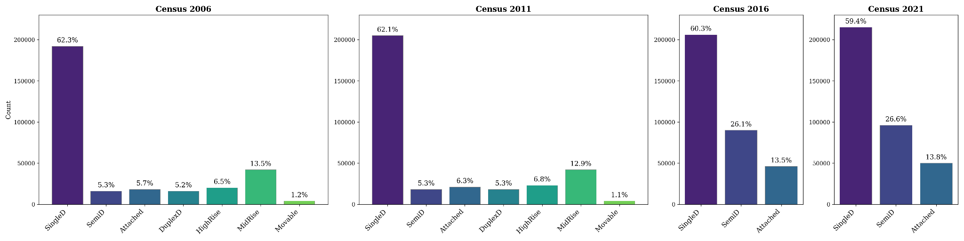
Figure 2. Dwelling type distribution trends across Census cycles

A critical challenge in integrating the two datasets was the absence of explicit dwelling type information in GSS records. To address this, a machine learning classification approach was implemented to probabilistically assign Census-derived dwelling types to GSS household records using shared demographic linking variables — household size, occupant age distribution, household composition, and geographic region. Analysis of Census dwelling type distributions across the four study periods revealed significant temporal shifts in Canadian housing stock composition, as illustrated in Figure 2. Between 2006 and 2016, apartment dwellings increased nearly threefold from 9.5% to 27.9%, reflecting documented urbanization trends and housing affordability pressures, while single-detached housing declined modestly from 61.3% to 58.6%. The 2021 Census confirmed persistence of this urban densification trajectory with apartments at 26.6% and single-detached homes at 59.4%. These temporal transitions have direct implications for occupancy-energy modelling, as urban apartment-dwelling households exhibit distinct occupancy patterns compared to suburban single-family homeowners, necessitating that the linkage methodology appropriately pair dwelling-type-specific occupancy schedules with corresponding building archetypes across the longitudinal analysis period.

3 Classification of GSS Dataset Using Historic GSS Cycles

3.1 Dataset Integration and Structural Harmonization
The integration of Census and GSS datasets for dwelling type classification required addressing a fundamental structural incompatibility: Census data exist as single household-level records, while GSS data are bifurcated into person-level demographic files (Main File) and episode-level time-use files (Episode File). The Main File contains static attributes, one row per respondent with variables such as age, sex, household size, and income, while the Episode File contains multiple rows per respondent representing sequential activity episodes.
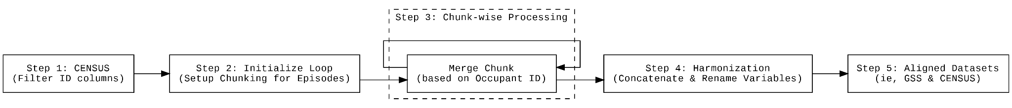
Figure 3. 5-Step Flowchart of categorical data alignment between CENSUS & GSS
To enable classification, these structures were consolidated through a many-to-one left join using the unique respondent identifier (PUMFID) as the linking key, broadcasting static demographic attributes onto all associated episode records (Figure 3). Given the substantial scale of GSS Episode Files (millions of records), a memory-efficient chunked processing architecture was implemented, reading files incrementally in blocks of 100,000 rows with sequential merging to prevent computational overflow. Following consolidation, variable name standardization was applied through a harmonization dictionary mapping GSS-specific nomenclature to Census conventions (e.g., PRV→PR, HSDSIZEC→HHSIZE), ensuring consistent feature naming for subsequent machine learning classification tasks.

3.2 Generative Temporal Framework for 2025 Occupancy Classification
A fundamental limitation of census-based occupancy modeling is the absence of nationally representative data for future projection years. While Census and GSS datasets provide empirical foundations for historical periods (2006, 2011, 2016, 2021), building energy simulations for contemporary decision-making require occupancy profiles for years beyond the most recent census cycle—specifically, 2025 in this study. Traditional supervised classification approaches (e.g., Random Forest, Gradient Boosting) prove inadequate for this temporal extrapolation task because they assume static demographic-dwelling relationships; training a single model on pooled multi-year data forces the algorithm to learn an "average" association that is incorrect for any specific time period, as the relationship between household demographics and dwelling types evolves substantially across decades due to urbanization, housing market dynamics, and socio-economic shifts. Furthermore, census data are cross-sectional rather than longitudinal—different households are sampled in each cycle, precluding the use of sequential modeling techniques (e.g., Recurrent Neural Networks) that require tracking individual entities through time.
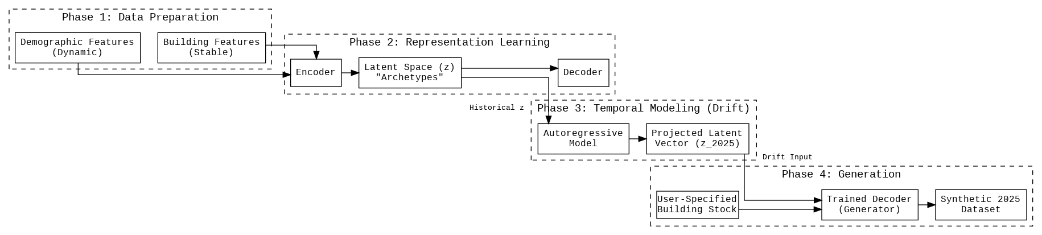
Figure 4. Multi-head C-VAE structure
To address this challenge, a generative temporal framework was developed that models not individual household classification, but the evolution of population-level demographic distributions conditioned on dwelling characteristics. The methodology employs a Conditional Variational Autoencoder (C-VAE) to learn low-dimensional "archetype" representations of household demographics in the latent space, conditioned on stable building features (dwelling type, construction period, tenure status) (Figure 4). This unsupervised representation learning captures the statistical essence of demographic profiles associated with specific dwelling types across all historical periods. Temporal drift modeling tracks how these demographic archetypes shift over time by fitting autoregressive models to the evolution of mean latent vectors across census cycles (2006→2011→2016→2021), enabling extrapolation to 2025. Lastly, the trained decoder generates synthetic 2025 household demographic profiles by sampling from the projected latent distribution conditioned on user-specified building stock compositions, producing statistically consistent occupancy datasets for periods lacking empirical census data. This approach transforms the problem from static classification to dynamic population synthesis, leveraging the temporal structure inherent in sequential census cycles to forecast plausible demographic futures.

3.3 Multi-Phase Generative Pipeline: Architecture and Workflow
The generation of 2025 occupancy datasets required a six-phase pipeline integrating representation learning, temporal forecasting, household assembly, behavioral matching, dwelling type refinement, and energy model conversion, as illustrated in Figure 5. The foundation of the pipeline is a multi-head Conditional Variational Autoencoder (C-VAE) trained on harmonized historical census data, compressing demographic attributes (age, income, household size) and building conditions (dwelling type, tenure) into a 128-dimensional latent space through an encoder-decoder architecture with SoftMax and sigmoid output heads for mixed data types.
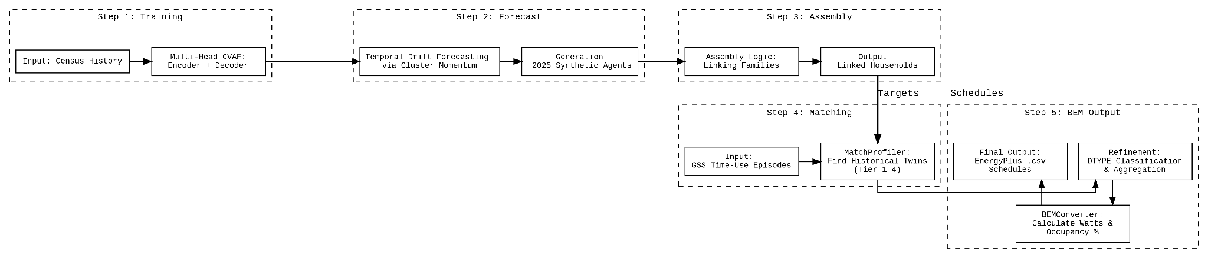
Figure 5. From historical census data to 2025 building energy model-ready occupancy schedules
The model was trained for 100 epochs using the Adam optimizer, converging to a total loss of 3.89 after 100 epochs. Reconstruction performance was reported separately by variable type. For categorical variables (dwelling type, marital status, employment class, and similar), the decoder recovered the original category in more than 80% of records, indicating that the latent representation retains the discrete structure of the input rather than collapsing minority categories into the majority class. For continuous variables (age, household size, income), the decoder reproduced more than 92% of the variance of the original values, indicating that the latent representation also preserves the magnitude and dispersion of the input rather than reverting to the cycle-wise mean. The combination of these two indicators confirms that the 128-dimensional latent space carries enough information to regenerate Canadian household demographics with both categorical fidelity and quantitative accuracy, confirming that the latent space captures sufficient complexity to represent Canadian household demographics. To project this learned representation forward to 2025, a Cluster-Based Vector Momentum (CBVM) framework was employed rather than population-level average drift, which would erase demographic diversity through regression-to-mean effects. K-means clustering (K=8) identified persistent demographic archetypes across census cycles (2006–2021) — such as young urban renters, established suburban families, and retired homeowners — and characteristic velocity vectors were computed by tracking centroid trajectories across sequential periods, with a decay factor of 0.95 per five-year interval preventing unrealistic divergence. Model reliability was assessed through a hindcasting protocol in which the C-VAE and the CBVM drift component were trained exclusively on the 2006, 2011, and 2016 cycles, then used to project the 2021 population without exposure to any 2021 data. The projected distribution was compared against the held-out 2021 Census across age, household size, dwelling type, and income variables. The hindcast preserved the multimodal shape of the household-size distribution, the right-skew of the income distribution, and the age-pyramid asymmetry between renting and owning households — structural features that a population-mean drift model would regress toward the cross-cycle centre. This reproduction of distributional shape (Appendix A1) provides the principal evidence that the same machinery, advanced one further cycle, can be expected to project the 2025 population without collapsing to a temporally averaged mean (Appendix A1).
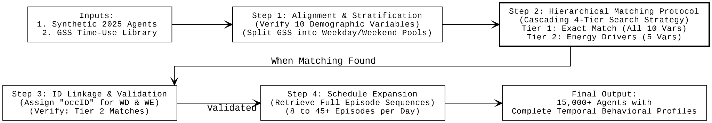
Figure 6. Behavioral profile matching workflow
Following latent space projection, synthetic 2025 agents were assembled into structurally coherent household units through a priority-based matching algorithm enforcing demographic consistency constraints, appropriate spousal age differences, parent-child age relationships, and household size targets, transforming 15,000+ disconnected synthetic persons into realistic family units.
Each synthetic agent was then linked to an empirical time-use schedule from the harmonised GSS library through a cascading four-tier matching strategy. Tier 1 attempted an exact match across all ten demographic variables (age group, sex, household size, marital status, employment class, work hours, occupation, province, and transportation mode). Tier 2 relaxed the criterion to the five energy-driving variables (household size, work hours, age, sex, employment class), recognising that these dominate occupancy and metabolic heat. Tier 3 retained only the structural constraints (household size and age group), and Tier 4 served as a failsafe matching on household size alone. Tier 2 captured 84.6% of weekday assignments and only 0.3% of agents required the Tier 4 failsafe, as illustrated in Figure 6, indicating that the harmonised GSS library was sufficiently dense to support behaviourally meaningful matches without forcing structurally implausible substitutions.
To recover the full eight-category dwelling typology from the C-VAE's coarse three-category output, two specialized Random Forest classifiers were trained on Census 2006/2011 microdata (n≈640,000), distinguishing high-rise from low-rise apartments and disaggregating residual categories into semi-detached, row house, duplex, and movable dwelling subtypes via probabilistic sampling rather than deterministic assignment (Appendix A2), preserving built environment variance in the synthetic population.
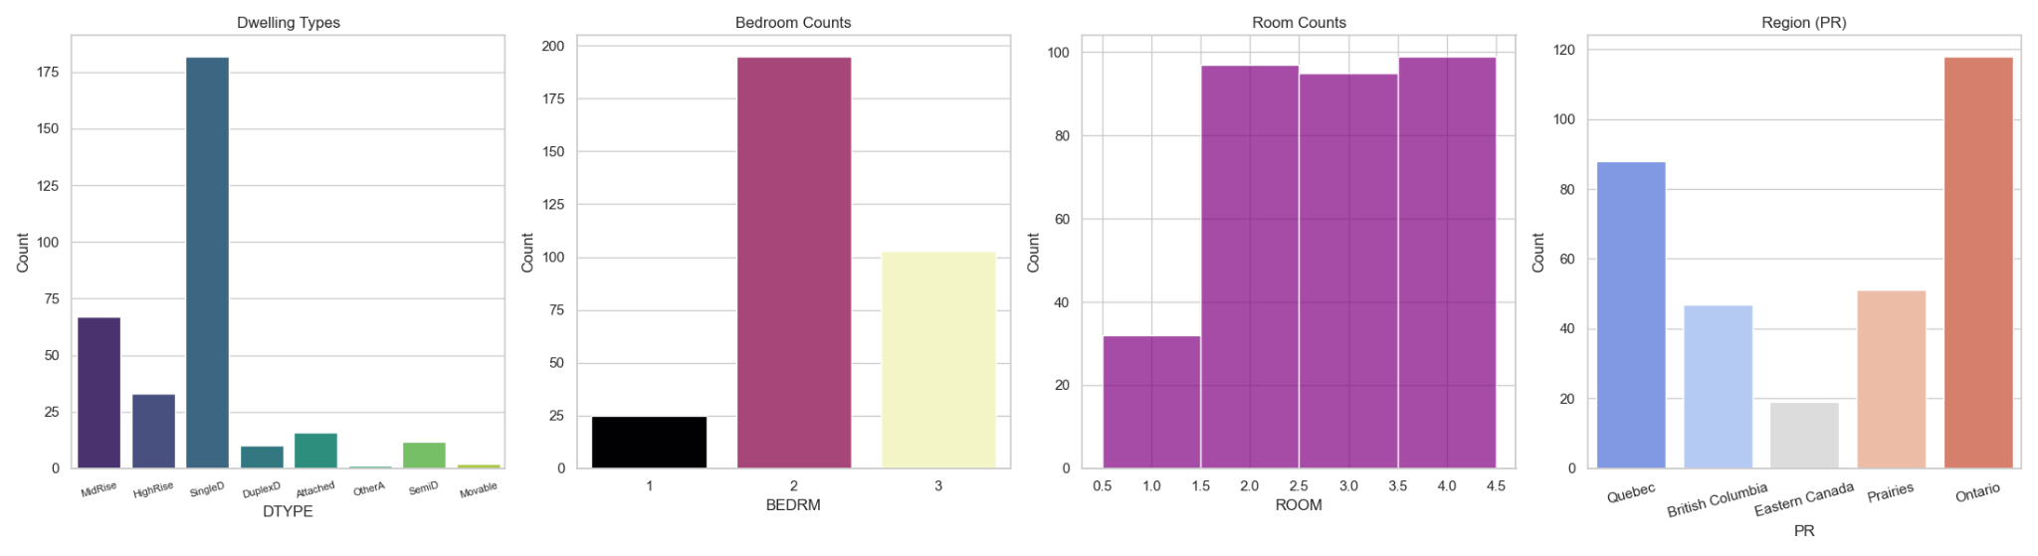
Figure 7. Synthetic 2025 population characteristics
The final phase transformed individual behavioural sequences into EnergyPlus-compatible hourly schedules through two operations: household-level aggregation and temporal down sampling. Individual 288-step five-minute activity sequences were overlaid across all household members to compute binary occupancy status, social density, and dominant activity per time step, before being down sampled to hourly resolution via time-weighted averaging — mapping each activity code to MET-derived metabolic rates (Sleep=70 W, Passive Leisure=85 W, Work=125 W, Active Leisure=245 W) and averaging twelve constituent five-minute intervals per hour to preserve the proportional contribution of short-duration high-intensity events. Population-level validation confirmed expected occupancy and metabolic distribution patterns across the completed dataset, with weekday profiles exhibiting characteristic morning exodus (06:00–09:00), midday vacancy, and evening return (16:00–19:00), while metabolic heat gains correctly coupled with occupancy state throughout, validating readiness for EnergyPlus integration (Figure 7).

3.4 Historical Cycles of Occupancy Datasets
While the 2025 dataset employed synthetic generation through the C-VAE pipeline (Sections 3.1–3.3), the four historical comparison datasets were derived directly from Statistics Canada microdata, each pairing a Census PUMF cycle with its temporally proximate GSS Time Use cycle: 06CEN05GSS, 11CEN10GSS, 16CEN15GSS, and 21CEN22GSS. All four pipelines share the same core sequence, Census–GSS demographic harmonization, tiered profile matching (Tiers 1–3 by variable specificity), household aggregation at 5-minute resolution, and hourly BEM schedule conversion — and are based entirely on real survey respondents with no synthetic classification or agent generation applied, as summarised in Table 1.
Table 1. Pipeline Comparison Across All Historical Cycles
Feature | 06CEN05GSS | 11CEN10GSS | 16CEN15GSS | 21CEN22GSS
Census Year | 2006 | 2011 | 2016 | 2021
GSS Year | 2005 | 2010 | 2015 | 2022
GSS Cycle | 19 | 24 | 29 | 38
Harmonized Variables | 11 | 10 | 9 | 8
Default Sample | 5% | 10% | 10% | 10%
DTYPE Detail | Detailed (1–8) | Detailed (1–8) | ML expansion  (1–3 → 1–8) | Coarse (1–3)
The number of harmonized variables decreases from 11 to 8 across newer cycles, reflecting progressive omissions in Statistics Canada's public-use releases. The 16CEN15GSS pipeline required an additional DTYPE expansion step, applying two quota-calibrated Random Forest classifiers trained on Census 2006/2011 data to restore the full eight-category dwelling classification from Census 2016's coarse three-category scheme, while the 21CEN22GSS pipeline retains the coarse DTYPE without expansion due to the absence of a suitable calibration reference. All five temporal datasets — 2005, 2010, 2015, 2022, and 2025 — converge on identical output structures, ensuring valid cross-temporal comparison in the energy simulations presented in Section 4.
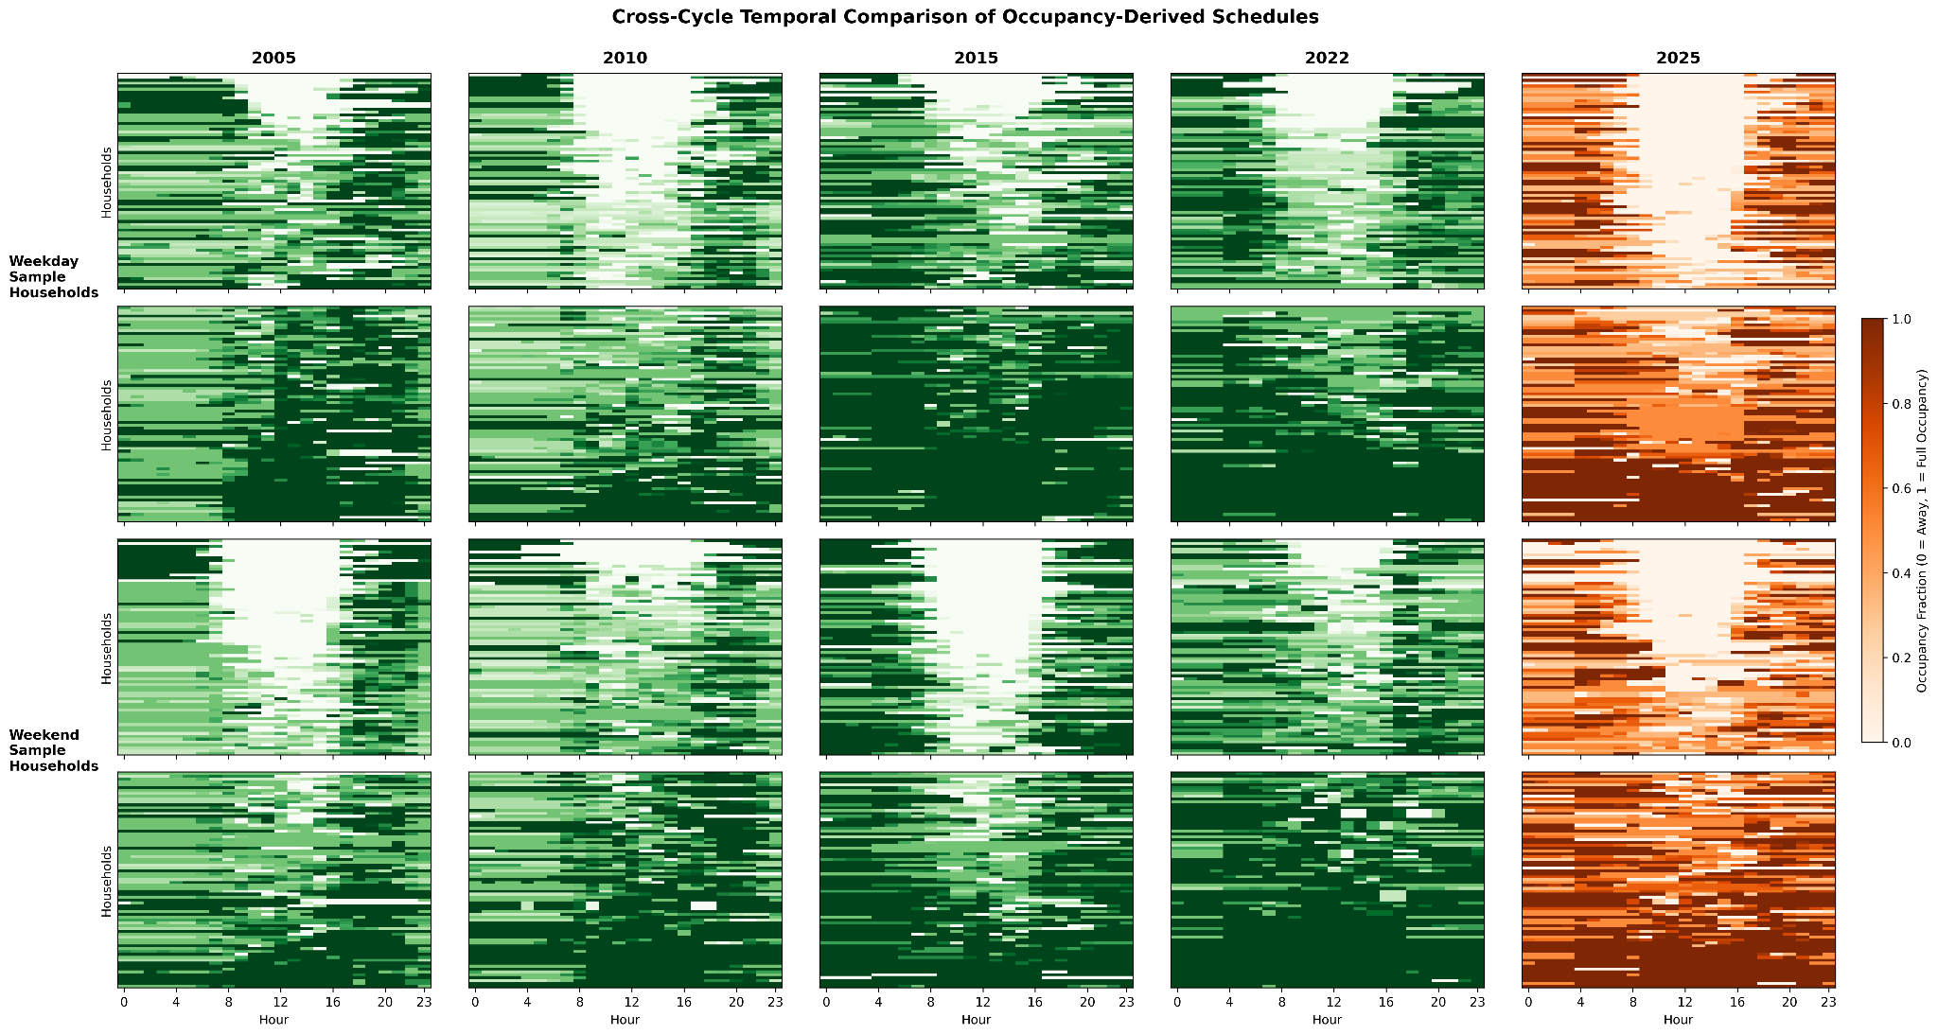
Figure 8. Cross-cycle heatmap of household-level occupancy schedules by day type (2005–2025).
To validate longitudinal consistency and characterize behavioral diversity across survey cycles, Figure 8 presents household-level occupancy schedules as a heatmap matrix with weekday and weekend profiles displayed separately across all five periods. The 2005, 2015, and 2022 cycles share a recognizable weekday structure — high early-morning occupancy, a pronounced midday vacancy trough (approximately 08:00–16:00), and elevated evening presence — consistent with traditional employment-anchored daily rhythms. The 2010 cycle exhibits substantially greater fragmentation and higher within-cycle household heterogeneity, suggesting a more diverse labor market participation structure in that period, while the 2025 synthetic population displays the most pronounced midday vacancy of all cycles, reflecting the C-VAE projection's extrapolation of declining daytime presence trends. Dwelling type distributions remain stable across cycles with single-detached housing consistently representing approximately 55% of the sample, though the 2022 cycle shows a notably higher apartment share of approximately 35%, reflecting documented Canadian urbanization trends.
The 2025 synthetic cohort comprises 323 generated households, intentionally smaller than the empirical cycles. Synthetic generation is structurally more expensive than survey sampling: every agent passes through priority-based household assembly and four-tier behavioural matching, with each match validated against demographic consistency constraints, so the per-household computational cost is approximately two orders of magnitude greater than for a Census-derived record. The 323-household figure was sized to populate every cell of the downstream stratification grid (household size × dwelling type × age class × employment status) used in the BEM Monte Carlo, while remaining tractable for the parallel EnergyPlus pipeline. Distributional convergence with a hypothetical full-cycle draw was assessed through hindcast validation against the 2021 Census rather than by enlarging the synthetic cohort itself. Taken together, these comparisons confirm that each cycle's occupancy dataset preserves distinct, period-specific behavioral signatures suitable for use as independent scenario inputs in the energy simulations presented in Section 4 (Figures C1, C2).

3.5 BEM Setup, Occupancy Integration, and Simulation Framework
Energy simulations were conducted for Montreal (Climate Zone 6A) using four DOE/ASHRAE 90.1 Prototype Building archetypes: single-family detached houses (2-storey, 110 m²), attached row houses (2-storey, 180 m²), mid-rise apartments (4-storey, 784 m²), and high-rise apartments (10-storey, 784 m²). Each archetype was configured with thermal and construction characteristics typical of post-1980 North American housing stock, with building envelope and HVAC characteristics held constant across all occupancy scenarios to isolate the impact of occupancy schedule variation from physical building changes. Six Neighbourhood Units (NUs) spanning the full range of Canadian residential development typologies were selected as the simulation context, from low-density rural clusters at the urban fringe to high-rise residential nodes in the urban core, as summarised in Table 2 [25,26].
Table 2. Neighbourhood Unit Characteristics
Archetype | Location | Building Content | Description
RC-R | Suburban Outer | 24x Detached Houses | Low-density, relying on private services and high automobile dependence.
RC-D | Suburban Outer | 48x Detached Houses | Canadian subdivision houses optimized for family living.
RC-T | Suburban Outer | 56x Attached Houses | Medium-density blocks with higher land-use efficiency
RC-MR2 | Suburban Inner | 8x Mid-Rise | Apartment clusters centered around shared courtyards.
RC-MR3 | Urban Mid-zone | 12x Mid-Rise | Dense blocks expressed with walkable, transit-oriented lifestyles.
RC-HR2 | Urban Core | 4x High-Rise (St-10) | High-rise towers maximizing residential density near transit nodes
This typological range ensures that occupancy-driven energy impacts are assessed across diverse dwelling compositions, density gradients, and spatial configurations representative of the Canadian residential built environment. Although the Canadian Weather for Energy Calculations (CWEC) datasets serve as the standard for code compliance, this study utilizes TMYx weather files incorporating the most recent meteorological data (2009–2023) to capture contemporary warming trends that older datasets exclude. Prior to occupancy integration, all simulation models underwent baseline schedule standardization using the DOE Midrise Apartment archetype — selected as the closest available residential proxy — extracted via the Open Studio Standards Gem through the Ladybug Tools Schedule Library, covering occupancy presence, lighting, electrical equipment, domestic hot water, and metabolic activity [27,28].
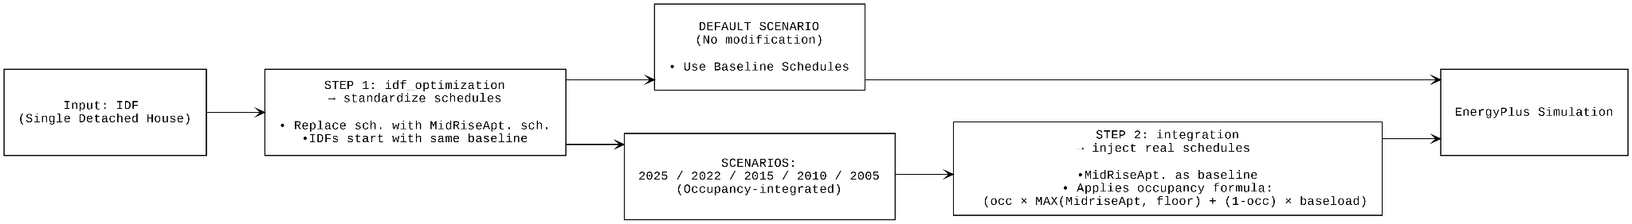
Figure 9. Schedule integration, Default scenario vs. occupancy-integrated scenarios
Synthetic household occupancy profiles were transformed into EnergyPlus-compatible schedules through a presence-aware Presence Filter algorithm, which modulates default residential schedules based on household occupancy state rather than applying unrealistic binary switching or over-conservative direct multiplication (Figure 9). The integration formula is expressed as:
$$S_{t}= \left\{\begin{aligned}O_{t} . S_{t}^{default }+ \left(1- O_{t}\right) . S_{t}^{default }, if O_{t} > ε \\ S_{t}^{baseload}, othersie\end{aligned}\right.$$
where $S_{t}$​ is the integrated end-use schedule value at hour t, $O_{t}$ ∈ [0,1] is the fractional hourly occupancy obtained by mean-resampling the 5-minute binary presence mask (occPre) to hourly resolution, $S_{t}$​ is the standardised DOE MidRise Apartment schedule value at hour t, $S_{t}^{baseload}$ ​ is the end-use-specific unoccupied baseload (refrigeration and standby for ElectricEquipment, recirculation losses for WaterUse:Equipment, daylight-modulated minimum for Lights), and $ε$ = ${10}^{-3}$ is the absent-hour threshold (Figure 10). Household-specific scaling updated occupant counts based on actual household size, ensuring internal heat gains matched demographic projections across all scenarios.
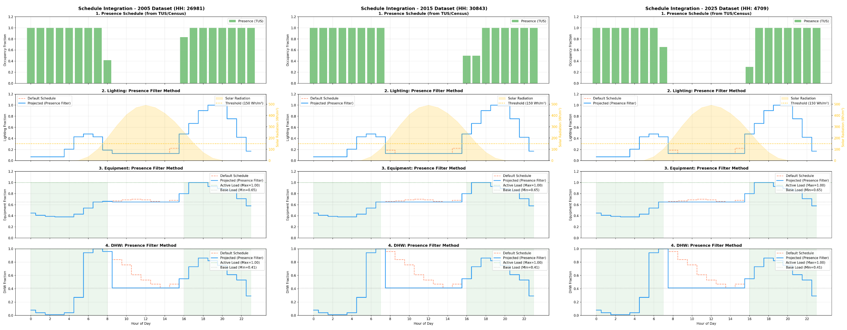
Figure 10. Application of the Presence Filter Algorithm to Household Load Profiles
To quantify the impact of empirically derived occupancy patterns on residential energy demand, a comparative simulation framework evaluated six scenarios per Neighbourhood Unit: Default (standardized Midrise Apartment schedules), 2025 (C-VAE synthetic projection), and four empirical GSS cycles (2005, 2010, 2015, and 2022), yielding 36 scenario-neighbourhood simulation pairings across Montreal. Household selection followed a three-stage filtering protocol retaining only single-detached households with 2 to 4 persons, matched to a target working-day occupancy profile through Sum of Squared Error minimization, with the 100 best-matching households selected per scenario-neighbourhood combination. This controlled ensemble isolates behavioral evolution effects from occupancy category differences, though it necessarily excludes non-standard work patterns such as shift and remote workers — identified as a priority for future investigation. End-use disaggregation reported lighting, equipment, fans, heating, cooling, and domestic hot water intensities separately across the 100-household Monte Carlo ensemble per pairing, with results aggregated to the neighbourhood scale and presented as mean and standard deviation in Section 4.

4 Results

4.1 Longitudinal Evolution of Occupancy Patterns (2005–2025)
Section 4.1 characterises the empirical occupancy patterns themselves: presence schedules across all five temporal cycles (4.1.1), activity distributions and metabolic profiles (4.1.2), the quantified discrepancy between Default baseline assumptions and empirical GSS patterns (4.1.3), and the heterogeneity introduced by household size variability (4.1.4). Default baseline schedules were derived from the DOE/ASHRAE Residential Prototype Building documentation, representing conventional practice assumptions for single-family residential modeling [27].

4.1.1 Presence Schedule Evolution
Figure 11 presents Canadian residential occupancy patterns across five temporal periods, revealing a non-monotonic trajectory in weekday presence, with the long-run endpoints (2005 to 2025) trending modestly downward. Weekday occupied hours fluctuated across cycles at 15.5h (2005), 11.9h (2010), 17.5h (2015), 15.9h (2022), and 12.4h (2025), reflecting competing demographic and labour-market forces rather than a uniform trend. The notably low 2010 value reflects the reduced representativeness of GSS Cycle 24, which inherited the weighting framework of the voluntary 2011 National Household Survey. Because the NHS achieved a response rate of 68.6% versus 93.5% for the mandatory 2006 Census, demographic groups that are disproportionately present at home during daytime hours — retirees, part-time workers, and household members not in the labour force — were systematically underrepresented in the population totals subsequently used to weight GSS Cycle 24. This weighting bias propagates downstream into the cycle's measured daytime occupancy fraction, depressing it relative to the bracketing 2005 and 2015 cycles whose weights derive from full mandatory Censuses. Daytime occupancy fractions (09:00 to 17:00) show a clearer overall decline from 0.60 in 2005 to 0.30 in the 2025 synthetic population, with the 2005 and 2015 cycles representing a fundamentally different occupancy regime carrying substantially higher midday internal heat gains.
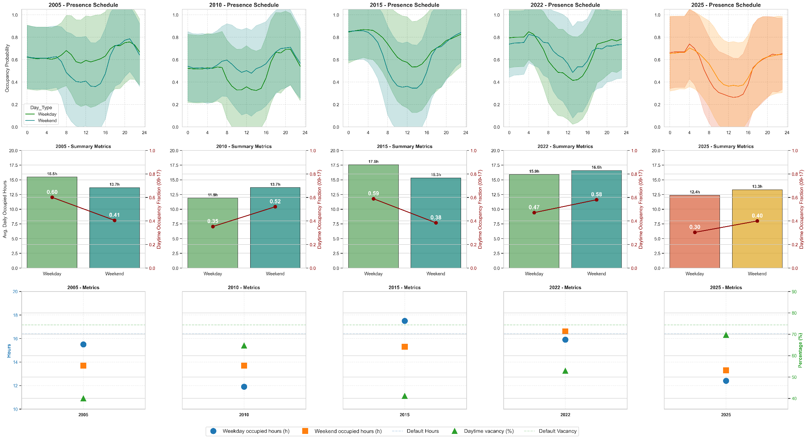
Figure 11. Residential presence schedules (top) and occupancy metrics (bottom) for all cycles
These discrepancies carry direct implications for HVAC scheduling and thermal load prediction. The Default baseline assumes constant 16.4 occupied hours for both weekdays and weekends, a premise contradicted across all empirical cycles, which consistently show a weekday-weekend asymmetry of 1.8 to 4.6 hours. Weekend occupied hours were comparatively more stable across cycles (13.7 to 16.5h), with 2022 notably exhibiting higher weekend than weekday presence (16.5h vs. 15.9h), likely reflecting post-pandemic behavioral restructuring that concentrated leisure and domestic activity on non-working days. Default overestimates vacancy (or, equivalently, underestimates daytime presence) by ~58 percentage points relative to the 2005/2015 cycles, directly inflating predicted daytime cooling loads while underestimating heating demand during unoccupied periods. All cycles maintained clear weekday-weekend differentiation in the upper panels of Figure 11, with weekend schedules exhibiting shallower midday troughs and more gradual morning transitions, confirming that day-type asymmetry is a persistent structural feature of Canadian residential occupancy that static Default assumptions systematically suppress.

4.1.2 Activity Distribution and Metabolic Profiles
Beyond binary presence-absence patterns, residential occupancy encompasses diverse activities driving temporally varying internal heat gains, a critical distinction from conventional models employing constant metabolic rate assumptions. Figure 12 presents activity time allocation and metabolic profiles across all five temporal periods (2005, 2010, 2015, 2022, and 2025), revealing an evolutionary trajectory that static assumptions cannot capture. Sleep remained the dominant activity across all cycles, ranging from 8.6 to 10.1 hours/day and peaking in 2022 before declining in the 2025 synthetic population. Passive leisure declined from 4.1 hours/day (2005) toward 3.0 hours/day (2022), while the "Other" category, capturing digital activities and remote work transitions, grew steadily from 3.5 to 4.4 hours/day over the study period.
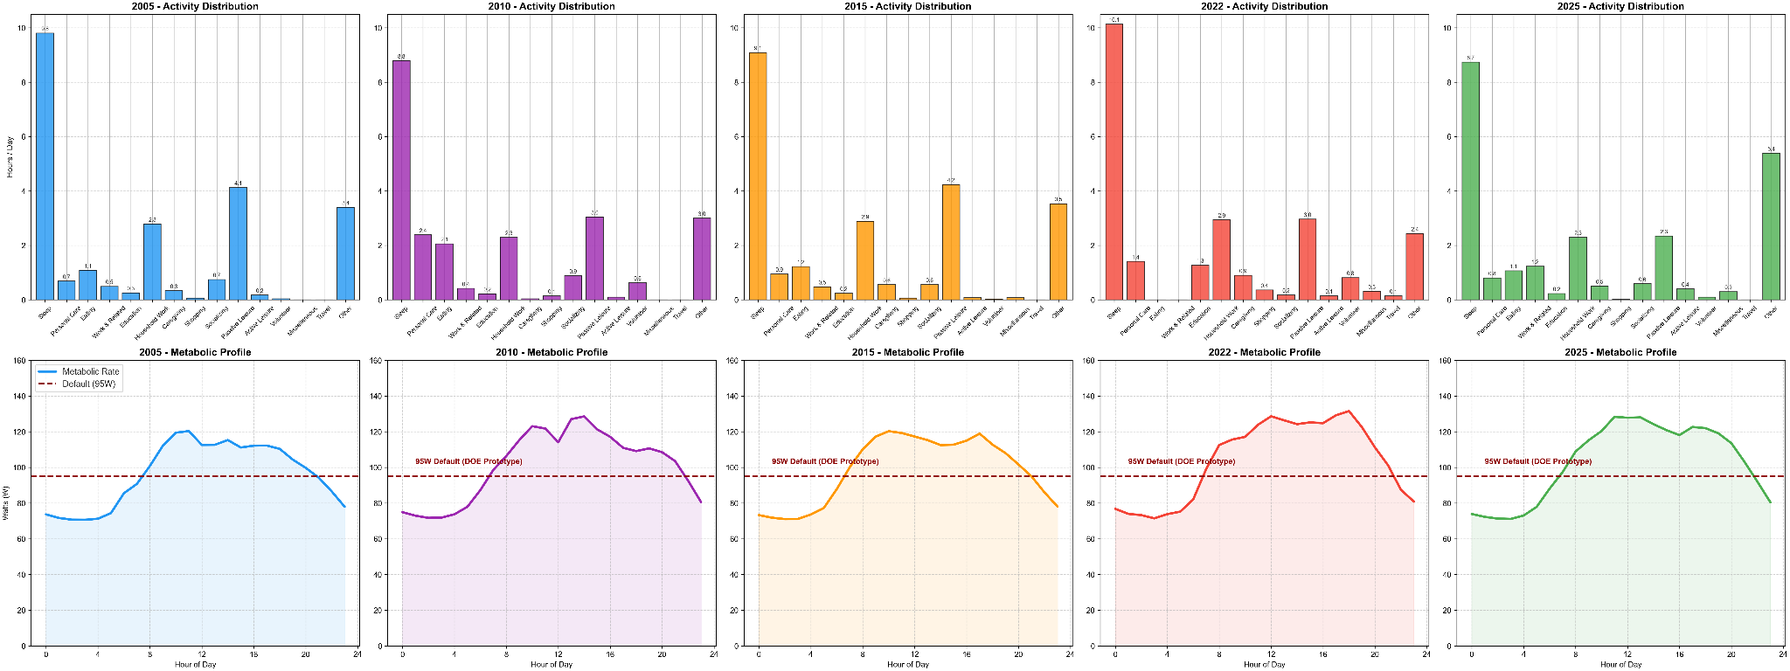
Figure 12. Activity time allocation and metabolic heat profiles, all cycles
Using MET-derived wattage assignments (Sleep = 70 W, Passive Leisure = 85 W, Work = 125 W, Housework = 175 W), the resulting metabolic profiles reveal a period-dependent relationship with the 95W DOE Prototype default. Metabolic output in 2005 and 2015 tracks or falls below the 95W Default across most of the day, whereas 2010 and 2022 exceed it for extended midday periods, peaking near 125 to 135W, likely reflecting post-pandemic behavioral restructuring in the 2022 cycle. The 2025 projection occupies an intermediate position, partially exceeding the default only in the late afternoon window. This period-dependent pattern means conventional constant-rate assumptions introduce not only magnitude error but directional error that varies by cycle, overestimating internal gains in some periods while underestimating them in others, with direct consequences for HVAC sizing and annual heating and cooling load predictions.

4.1.3 Default vs Projected (2025) Schedules
Figure 13 directly compares Default DOE Midrise schedule assumptions against 2025 GSS-derived profiles across five panels: hourly occupancy fraction (a), hourly metabolic rate (b), mean occupancy (c), daytime occupancy fraction (d), and metabolic rates (e). Panel (a) exposes a fundamental structural mismatch: the Default applies binary step transitions with full occupancy until 08:00, a fixed 25% daytime presence, and a sharp return at 18:00, whereas 2025 GSS patterns exhibit gradual probabilistic transitions with a progressive morning departure across 06:00 to 10:00 and an earlier evening return from 15:00 onward, with the night-time period overestimated by +39%. Panel (b) reveals a two-phase metabolic error that is fundamentally a timing rather than a magnitude error: The Default's flat 95 W assumption overpredicts metabolic output during sleep hours by approximately 36% relative to the empirical floor of 70 W, and simultaneously underpredicts it by 24 to 30% during midday periods of elevated domestic activity, where empirical GSS values reach 125 to 135 W. Both deviations are consistent with the Default misrepresenting the diurnal range of metabolic activity rather than its time-averaged value. Both claims are consistent because the Default misrepresents the diurnal metabolic range rather than its average.
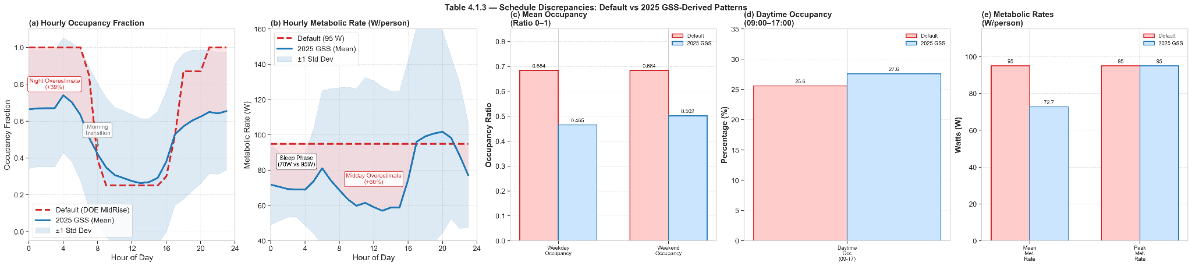
Figure 13. Default vs. 2025 GSS schedule comparison: hourly profiles, aggregate occupancy fractions, and metabolic rates
Panels (c) to (e) quantify the aggregate consequences. Mean weekday and weekend occupancy are overestimated by 32% (0.684 vs. 0.465) and 27% (0.684 vs. 0.502) respectively, while mean metabolic rate is overestimated by 24% (95 W vs. 72.1 W). Daytime occupancy (09:00 to 17:00) shows near-parity (25.6% vs. 27.6%), indicating the Default inadvertently approximates midday presence fractions despite its fundamentally different temporal shape, confirming that the Default's error lies in temporal uniformity rather than peak magnitude. Taken together, these discrepancies demonstrate that conventional schedules systematically bias both the magnitude and timing of internal heat gains, producing compounding errors in annual heating and cooling demand predictions.

4.1.4 Household Size Influence on Occupancy Patterns
Population-average occupancy schedules obscure substantial heterogeneity arising from household composition differences. Figure 14 disaggregates 2025 GSS-derived presence patterns by household size, revealing a counterintuitive inverse relationship between household size and occupancy probability. Weekday occupied hours decline systematically from 18.2h (1-person) to 5.2h (5-person), a 71% reduction, with daytime occupancy fractions dropping from 56.1% to 12.4%. This reflects the probabilistic nature of household-level measurement: single-person dwellings register as occupied whenever the sole occupant is present, whereas multi-person households register as occupied only when at least one member remains home, with midday probabilities suppressed as multiple members simultaneously depart for work and school. Weekend patterns follow similar inverse trends but with elevated overall presence (19.2h to 6.9h; 63.8% to 21.7% daytime fractions), reflecting reduced employment and school obligations.
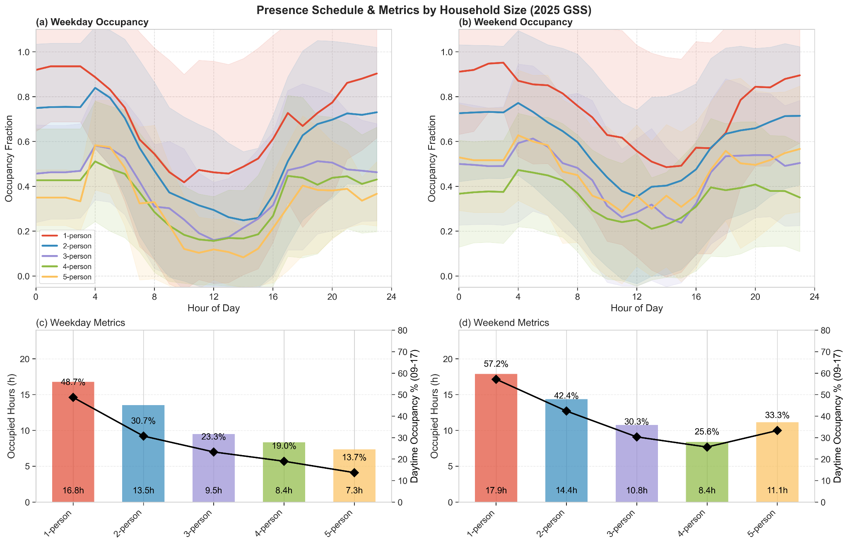
Figure 14. Presence schedules by household size (1–5 persons): hourly profiles (a,b) and metrics (c,d)
This 71% variation in weekday occupied hours is one of the most policy-consequential findings of this study. Population-average schedules simultaneously overestimate presence in large households, inflating internal gains and cooling loads, and underestimate occupancy in single-person dwellings, suppressing predicted heating loads precisely when sole occupants maintain near-continuous presence. For multi-family residential buildings with diverse unit compositions, a single Default schedule applied uniformly across a building stack will oversize cooling for family units while under sizing heating for single-occupant units. Segment-specific modeling accounting for household size distribution would improve load prediction accuracy, support more targeted HVAC control strategies, and provide a more defensible basis for dwelling-type-differentiated corrections in residential energy codes.

4.2 Energy Simulation Results
Section 4.2 propagates the occupancy patterns characterised in 4.1 through neighbourhood-scale building simulations to quantify their energy consequences: annual end-use impact across all six Neighbourhood Units (4.2.1), temporal trends in scenario deviation from Default (4.2.2), diurnal and seasonal demand profiles (4.2.3), peak load timing and magnitude (4.2.4), and whole-neighbourhood energy fingerprints (4.2.5). Simulations were conducted for Montreal (Climate Zone 6A) using TMYx weather files, comparing Default archetype schedules against Monte Carlo ensembles of empirically-derived GSS household profiles across the five temporal cycles.

4.2.1 Annual End-Use Energy Impact
Figure 15 presents the deviation of each GSS-derived temporal scenario from the Default baseline across four end-uses (Heating, Cooling, Electric Equipment, and Domestic Hot Water), disaggregated by neighbourhood unit. GSS-derived schedules consistently increased heating demand by +3.9% to +12.6% and reduced cooling demand by -10.3% to -27.1% across all neighbourhood units, confirming a consistent occupancy-driven signal across all six Neighbourhood Units. The 2025 synthetic projection produced the most moderate deviations (+5.4% heating, -11.9% cooling), while the 2005 and 2015 empirical cycles generated the largest divergences, consistent with their 60% daytime occupancy fractions.
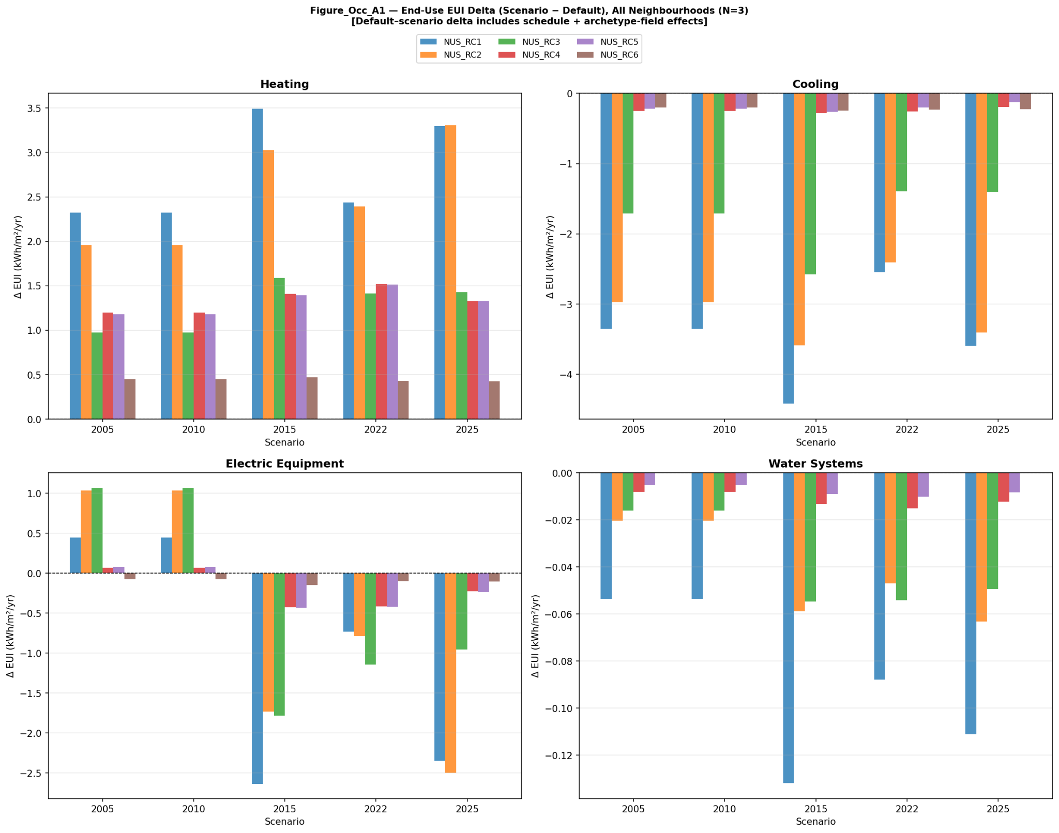
Figure 15. Occupancy-Driven End-Use Energy Deviation from Default Schedules (RC-R: blue, RC-D: orange, RC-T: green, RC-MR2: red, RC-MR3: purple, RC-HR2: brown)
This pattern reflects the thermophysical mechanism established in Section 4.1.3: GSS schedules exhibit substantially lower daytime presence (28 to 60%) than the Default assumption (68.4%), reducing internal heat gains and consequently elevating envelope-driven heating demand. Electric Equipment and DHW deviations were smaller but directionally consistent, with occupancy-modulated loads shifting toward the morning and evening peaks characteristic of empirical Canadian time-use patterns. The variation in deviation magnitude across neighbourhood units confirms that dwelling composition and density gradients, dimensions invisible to single-building analyses, materially influence the occupancy-energy relationship at the neighbourhood scale.

4.2.2 Temporal Trend in Energy Demand
Figure 16 presents an end-use sensitivity tornado chart showing the full scenario range (maximum minus minimum across all six scenarios including Default) per end-use and neighbourhood, quantifying which end-uses are most responsive to occupancy modeling choices across the six Montreal NUs. Heating and cooling consistently exhibited the widest sensitivity ranges, confirming that these thermally coupled end-uses are the primary channel through which occupancy schedule variation propagates into building energy performance in a Zone 6A climate. Electric Equipment and DHW sensitivity ranges were substantially narrower, indicating that these end-uses respond to occupancy scheduling but are less thermally amplified.
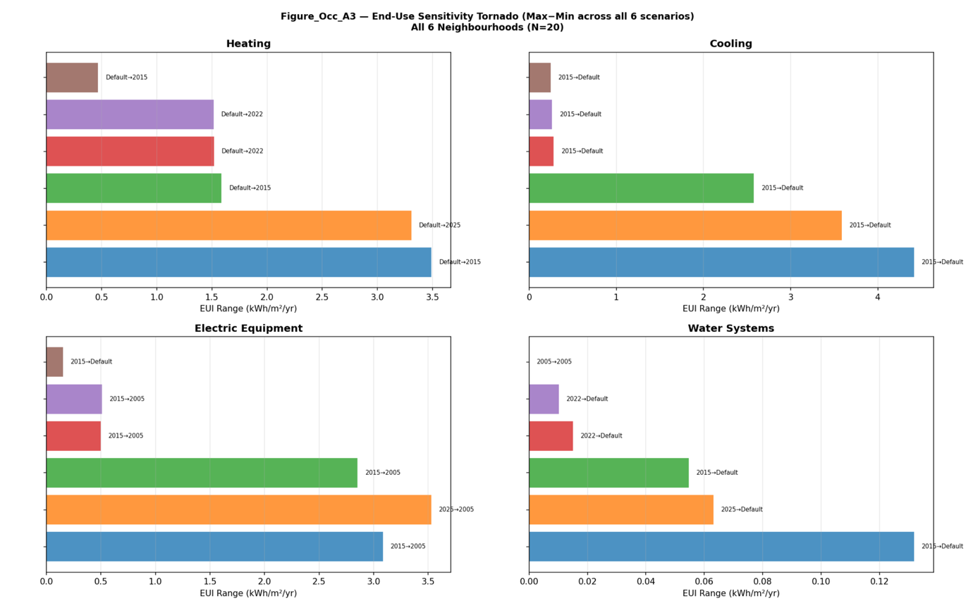
Figure 16. End-Use Sensitivity to Occupancy Schedule Variation Across Temporal Cycles (RC-R: blue, RC-D: orange, RC-T: green, RC-MR2: red, RC-MR3: purple, RC-HR2: brown)
The scenario producing the largest deviation from Default shifts from the 2005 and 2015 empirical cycles, which captured 60% daytime occupancy characteristic of pre-remote-work Canadian households, toward the moderated 2025 projection exhibiting 28% daytime presence. This convergent trajectory reflects two decades of societal behavioral change gradually closing the gap between static archetype assumptions and empirical Canadian presence patterns, with direct implications for the periodic recalibration of cold-climate residential building energy codes.

4.2.3 Seasonal and Diurnal Demand Profiles
Diurnal load shape ribbons for representative winter and summer days, disaggregated by weekday and weekend, are presented for RC-R in Figure 17, with equivalent profiles for RC-D through RC-HR2 provided in Figures C3-C7. Across all neighbourhood typologies, winter heating profiles show that Default and GSS-derived scenarios diverge substantially during midday and shoulder periods, despite converging at night when envelope thermal losses dominate regardless of occupancy. GSS-derived profiles exhibit a characteristic double-peak structure (morning ramp 06:00-09:00, evening elevation 17:00-21:00) absent in the Default's step-function transitions, requiring HVAC systems to respond to two distinct demand ramps per day. Summer cooling profiles show the most operationally consequential discrepancy, with Default profiles assuming higher afternoon peaks around 15:00-17:00 while GSS-derived scenarios produce consistently lower intensities with earlier timing, reflecting reduced midday internal gains from lower daytime occupancy.
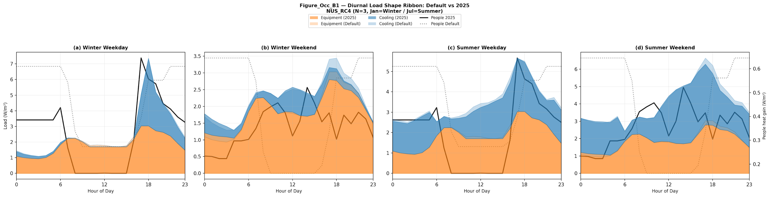
Figure 17. Diurnal Load Shape: Default vs. GSS-Derived Schedules by Season and Day Type
The seasonal distribution of occupancy-driven deviations, illustrated in Figure 18, confirms that the largest heating divergences from Default occur during shoulder months (October-November and March-April), when internal gain reductions have the greatest proportional impact relative to moderate envelope losses. Peak winter months show compressed deviations as weather-driven envelope loads dominate the energy balance, confirming that the seasonal asymmetry in occupancy impact is thermophysical rather than behaviourally driven.
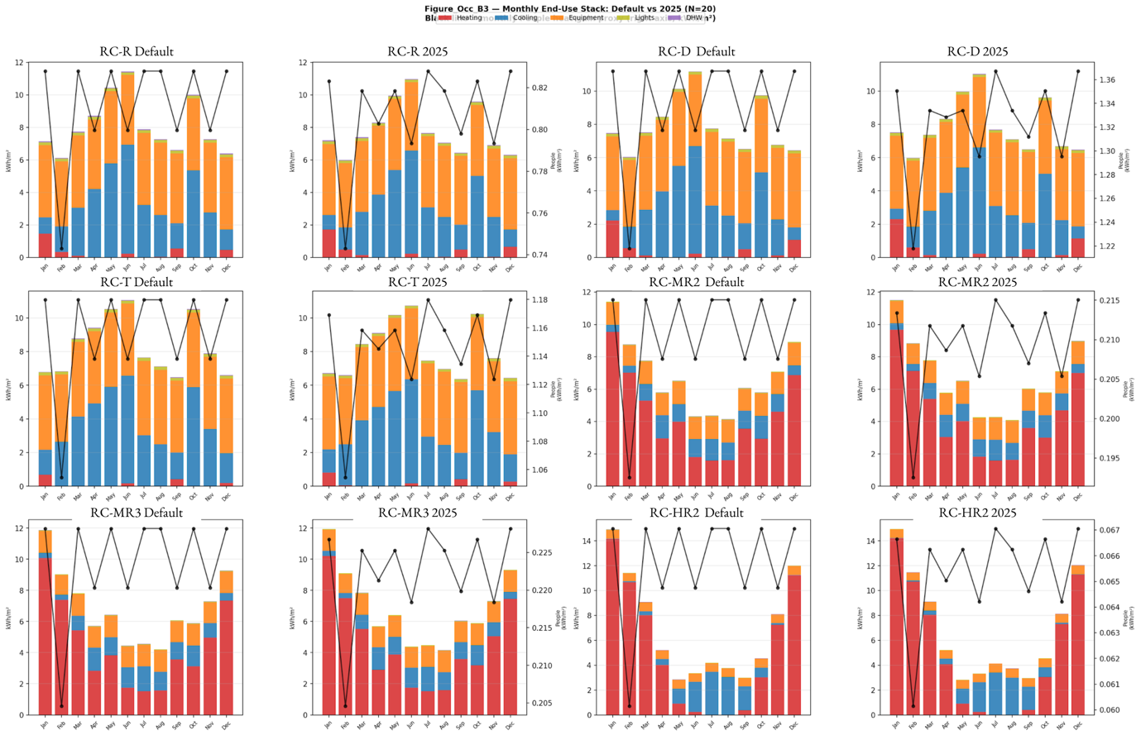
Figure 18. Monthly End-Use Energy Stack with Occupancy Presence Overlay (heating: red, cooling: blue, equipment: orange, lights: green, DHW: purple)
The day-type dimension of this behavioral asymmetry is quantified in Figure 19, which shows that Default assumptions produce near-zero weekend-weekday deltas across all end-uses, while empirical GSS cycles exhibit consistent positive deltas for Heating and negative deltas for Cooling. This reflects the elevated daytime occupancy on non-working days documented in Section 4.1.1, with the 2022 cycle showing the most pronounced day-type differentiation consistent with post-pandemic behavioral restructuring.
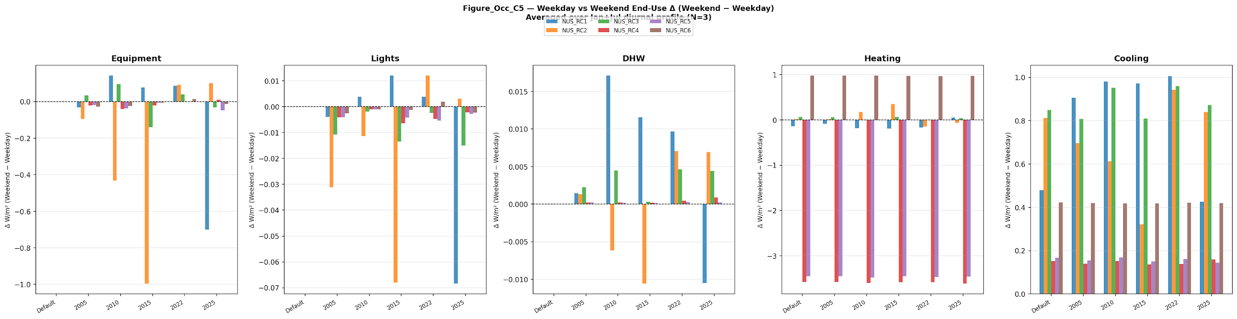
Figure 19. Weekday–Weekend End-Use Differential by Occupancy Scenario (RC-R: blue, RC-D: yellow, RC-T: green, RC-MR2: red, RC-MR3: purple, RC-HR2: brown)

4.2.4 Peak Load Analysis
HVAC equipment sizing and grid infrastructure planning depend critically on peak load predictions, as undersized systems fail thermal comfort requirements while oversized systems impose unnecessary capital costs. Figure 20 examines peak load timing across all six neighbourhood units through a scatter diagram of peak Cooling hour versus peak Equipment hour per scenario, with marker size scaled to peak cooling intensity. Peak heating loads remained largely insensitive to occupancy schedule choice, confirming that extreme heating requirements in Climate Zone 6A are primarily governed by envelope thermal losses during design-day cold snaps rather than occupant-generated internal gains. Peak cooling loads, by contrast, exhibited consistent scenario-dependent variation in both magnitude and timing, with Default scenarios clustering around 14:00 to 15:00 while GSS-derived 2025 scenarios demonstrated a 17.4% reduction in peak cooling intensity alongside a 1-to-2-hour advance toward 13:00, reflecting reduced midday internal gains from lower daytime occupancy.
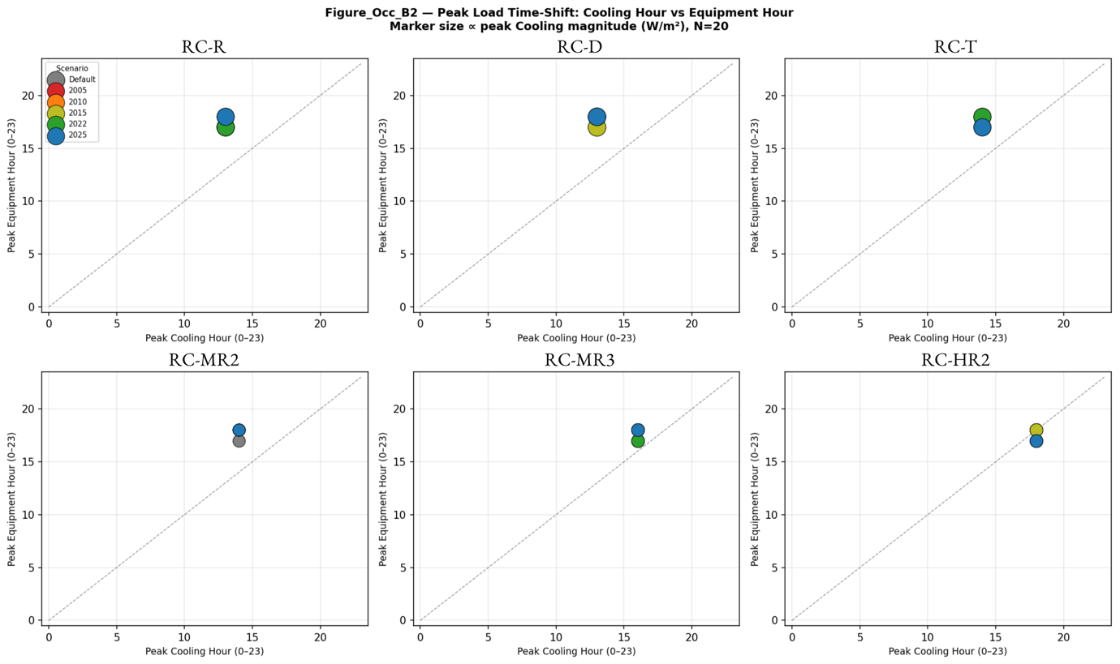
Figure 20. Peak Cooling and Equipment Load Timing by Occupancy Scenario
GSS-derived profiles simultaneously shift appliance-driven Equipment peak loads toward evening hours (17:00 to 18:00), consistent with the return-home activity concentration documented in Section 4.1.1. This temporal decoupling between the Equipment peak and the Cooling peak carries a consequential asymmetry: evening equipment loads accumulate when ambient temperatures are already declining, partially offsetting the equipment-cooling interaction that sustains Default's afternoon peak. The pattern is directionally consistent across all six neighbourhood units, confirming that occupancy schedule choice alters peak timing regardless of dwelling density or archetype composition. For grid operators, the 1-to-2-hour advance in peak cooling toward 13:00 and the concurrent evening shift in equipment loads mean that demand-response dispatch strategies currently calibrated to mid-afternoon residential peaks would mistime curtailment signals under contemporary occupancy patterns, suggesting that utility-side flexibility programs should reassess their dispatch windows in line with census-cycle occupancy updates.

4.2.5 Internal Gain Coupling and Neighbourhood Energy Fingerprint
Figure 21 presents the neighbourhood energy profiles as normalized radar charts, with five end-use spokes (Heating, Cooling, Electric Equipment, Domestic Hot Water, and Lighting) normalized to Default = 1.0 and one polygon per GSS temporal scenario across all six NUs. We term this end-use signature the neighbourhood energy fingerprint, analogous to a spectral signature, because its shape uniquely identifies the coupling between occupancy regime and dwelling typology. The Default spoke values reflect the full range of neighbourhood typologies, from heating-dominated detached clusters (RC-R: 156.5 kWh/m²/yr Heating, 45.4 kWh/m²/yr Cooling) to apartment-dominated mid-rise and high-rise units (RC-MR2: 35.2 kWh/m²/yr Heating, 18.1 kWh/m²/yr Cooling), confirming that the absolute energy profile differs substantially by typology even before occupancy schedule variation is applied.
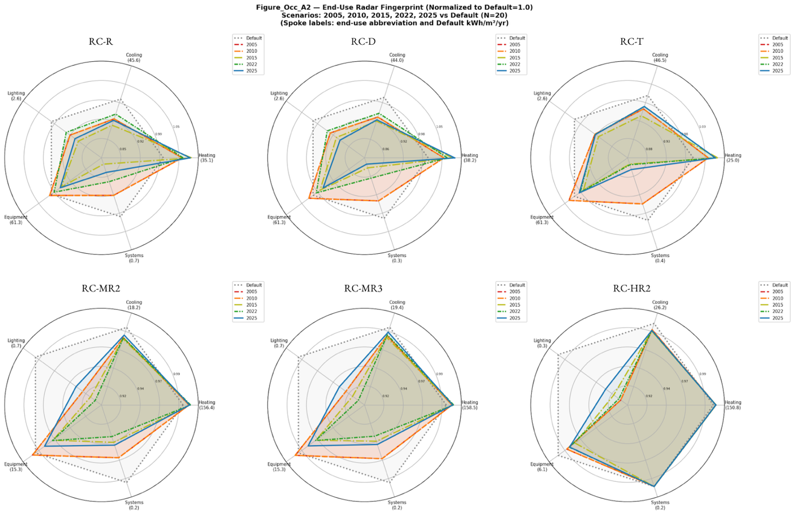
Figure 21. Neighbourhood Energy Fingerprint: End-Use Profile Normalized to Default
Across all neighbourhood units, the occupancy-driven transformation produces a consistent shape change rather than a uniform rescaling: Heating spokes extend beyond the Default circle while Cooling spokes contract inside it simultaneously, with Equipment and DHW spokes shifting modestly. The 2005 and 2015 empirical cycles produce the most pronounced fingerprint distortion across all six panels, consistent with their 60% daytime occupancy fractions generating the largest internal gain deviations. The 2025 synthetic projection produces a more compact polygon that approaches the Default circle in all NUs, visually confirming the convergence trend identified in Section 4.2.2 while preserving the directional heating-cooling asymmetry that persists even under moderated behavioral assumptions.

5 Discussion
Default schedules systematically misrepresent Canadian residential occupancy by overestimating mean occupancy by 32% (68.4% vs. 46.5%) and metabolic heat generation by 24% (95W vs. 72.1W), translating directly into heating underestimation of 3.9 to 12.6% and cooling overestimation of 10.3 to 27.1% across all six Montreal NUs (Figure 15). The neighbourhood energy fingerprints (Figure 21) confirm this correction is a genuine end-use shape transformation rather than a uniform rescaling, with heating and cooling spokes shifting in opposite directions while Equipment and DHW remain comparatively stable. The occupancy–energy coupling persists consistently across the full density gradient from suburban detached clusters to urban high-rise nodes. Because the integration pipeline is identical for every archetype and operates at the same per-building resolution whether executed on a single IDF or on a batched neighbourhood ensemble, this consistency reflects a thermophysical mechanism rather than an artefact of scale-specific schedule handling. The contribution of the neighbourhood-scale framing is therefore one of typological coverage, exposing the same coupling across six dwelling configurations representative of the Canadian residential stock, rather than a methodological departure from building-scale work.
The non-monotonic trajectory across cycles reflects competing forces: the unexpectedly lower 2022 occupancy relative to 2015, despite post-pandemic remote work adoption, is tentatively attributable to enhanced telework activity reclassification in the 2022 GSS cycle, demographic cohort transitions, and the rising apartment share documented in Section 2, though disentangling these mechanisms requires longitudinal panel data beyond the scope of cross-sectional GSS cycles. The practical implications span design, operations, and policy. The 18% cooling oversizing estimate derives from the 17.4% peak cooling intensity reduction in Section 4.2.4 (Figure 20) combined with the schedule-driven daytime load reductions confirmed across all scenarios in Figure 15. Canadian residential codes should consider correction factors of approximately +10% for heating and -20% for cooling relative to Default assumptions, with periodic recalibration synchronized to census cycles to prevent compounding errors over decadal code lifespans. The 1-to-2-hour advance in peak cooling toward 13:00 further suggests that demand-response dispatch strategies calibrated to mid-afternoon peaks would mistime curtailment signals under contemporary occupancy patterns. The 71% variation in weekday occupied hours across household sizes (Section 4.1.4) additionally argues for dwelling-type-differentiated schedule corrections rather than a single national Default. Limitations include the restriction to Montreal and post-1980 archetypes, exclusion of shift and remote workers, the smaller 323-household 2025 synthetic sample, reliance on pre-2022 demographic trajectories, and a dwelling-type classifier calibrated on pre-2016 Census data. Future work should extend the framework to additional climate zones, incorporate household-size-segmented simulations, and couple evolving occupancy patterns with housing stock turnover models to project grid-level impacts at the national scale.

6 Conclusion
This research established a replicable framework integrating Canadian Census and General Social Survey data through a Conditional Variational Autoencoder pipeline to produce longitudinally consistent occupancy schedules spanning 2005 to 2025, directly addressing the performance gap introduced by static Default assumptions in residential building energy modeling. The central finding is that empirically-derived occupancy schedules increase predicted heating demand by 4 to 13% and reduce predicted cooling demand by 10 to 27% across six Montreal Neighbourhood Units relative to Default assumptions. These deviations stem from Default's 32% overestimation of mean residential occupancy (0.684 vs. 0.465) and 24% overestimation of metabolic heat generation (95 W vs. 72.1 W).
To our knowledge, the C-VAE and Cluster-Based Vector Momentum framework presented here is the first to produce longitudinally consistent Canadian occupancy schedules spanning two decades of empirical GSS cycles and extending to a synthetic 2025 projection, offering a nationally representative and replicable methodology for constructing period-specific occupancy inputs suitable for direct integration into building energy models. The policy implication is clear: residential building codes calibrated on static schedules accumulate compounding errors over decadal lifespans and should be recalibrated in synchrony with census cycles to remain representative of the populations they govern. As Canadian residential behaviour continues to evolve in the wake of remote-work adoption and demographic aging, building performance modeling must treat occupancy as a dynamic, empirically-grounded boundary condition rather than a fixed design assumption, or the performance gap will persist, and widen, over time.

Data Availability Statement
The data that support the findings of this study are available from Statistics Canada through the General Social Survey (GSS) Time Use cycle and the Census Public Use Microdata File (PUMF). Restrictions apply to the availability of these data, which were used under license for this study through the Data Liberation Initiative (DLI). Data are available from Statistics Canada at https://www.statcan.gc.ca with the permission of Statistics Canada. Derived data and model outputs supporting the findings of this study are available from the corresponding author, O.K.I., upon reasonable request.

References
[1] U. Wilke, F. Haldi, D. Robinson, A model of occupant’ activities based on time use survey data, in: Proceedings of Building Simulation 2011: 12th Conference of International Building Performance Simulation Association, 2011.
[2] D. Sood, S. Wolf, D. Cali, R.K. Andersen, R. Li, H. Madsen, J. O’Donnell, Room-level domestic occupancy simulation model using time use survey data, J. Build. Perform. Simul. 0 (2025) 1–15. https://doi.org/10.1080/19401493.2025.2465508.
[3] M. Osman, M. Ouf, A comprehensive review of time use surveys in modelling occupant presence and behavior: Data, methods, and applications, Build. Environ. 196 (2021) 107785. https://doi.org/https://doi.org/10.1016/j.buildenv.2021.107785.
[4] J. Duan, J. He, C. Yu, A brief review of modelling methods for occupants’ behaviours in residential buildings, Indoor and Built Environment 35 (2025). https://doi.org/10.1177/1420326X251396163.
[5] M. Vellei, E. Azar, K. Bandurski, C. Berger, S. Carlucci, B. Dong, M. Favero, A. Mahdavi, M. Schweiker, Documenting occupant models for building performance simulation: a state-of-the-art, J. Build. Perform. Simul. 15 (2022) 634–655. https://doi.org/10.1080/19401493.2022.2061050.
[6] D. Mitra, Y. Chu, K. Cetin, Activity Profiles of Occupants in Residential Buildings Using the American Time Use Survey Data, in: 2020. https://doi.org/10.1061/9780784482865.113.
[7] B. Jeong, J. Kim, R. de Dear, Creating household occupancy and energy behavioural profiles using national time use survey data, Energy Build. 252 (2021) 111440. https://doi.org/https://doi.org/10.1016/j.enbuild.2021.111440.
[8] L. Pereira Pinheiro, M. Guo, Z. Pang, Z. O’Neill, Quantifying Energy Savings of Occupancy- Centric HVAC Controls Utilizing Longitudinal Occupancy Sensing Data and Calibrated Energy Simulations, in: 2025. https://doi.org/10.63044/w25pin165.
[9] M. Jacoby, S.Y. Tan, S. Sarkar, A high-fidelity residential building occupancy detection dataset, Sci. Data 8 (2021) 280. https://doi.org/10.1038/s41597-021-01055-x.
[10] J. Chung, T. Hong, J. Malik, D. Shelden, Enhancing occupant behavior representation for interoperability between building information modeling and building energy modeling, Build. Simul. 18 (2025) 2435–2458. https://doi.org/10.1007/s12273-025-1313-z.
[11] A. Mahdavi, C. Berger, H. Amin, E. Ampatzi, R.K. Andersen, E. Azar, V.M. Barthelmes, M. Favero, J. Hahn, D. Khovalyg, H.N. Knudsen, A. Luna-Navarro, A. Roetzel, F.C. Sangogboye, M. Schweiker, M. Taheri, D. Teli, M. Touchie, S. Verbruggen, The Role of Occupants in Buildings’ Energy Performance Gap: Myth or Reality?, Sustainability 13 (2021). https://doi.org/10.3390/su13063146.
[12] T. Hong, D. Yan, S. D’Oca, C. Chen, Ten questions concerning occupant behavior in buildings: The big picture, Build. Environ. 114 (2017) 518–530. https://doi.org/https://doi.org/10.1016/j.buildenv.2016.12.006.
[13] C. Xia, Y. Hu, J. Chen, Community time-activity trajectory modeling based on Markov chain simulation and Dirichlet regression, Comput. Environ. Urban Syst. 100 (2023) 101933. https://doi.org/https://doi.org/10.1016/j.compenvurbsys.2022.101933.
[14] B. Owen, Privacy-Preserving Occupancy Detection for HVAC Control in Smart Buildings Author, (2026).
[15] A. Wagner, M. Schweiker, A. Mahdavi, D. Yan, T. Hong, Z. Nagy, S. Shah, Introducing IEA EBC Annex 79: Key challenges and opportunities in the field of occupant-centric building design and operation, Build. Environ. (2020).
[16] M. Elsayed, S. Pelsmakers, L. Pistore, R. Castaño-Rosa, P. Romagnoni, Post-occupancy evaluation in residential buildings: A systematic literature review of current practices in the EU, Build. Environ. 236 (2023) 110307. https://doi.org/https://doi.org/10.1016/j.buildenv.2023.110307.
[17] C. Gieter, O. Neu, W. Turner, D. Finn, Modelling Household Occupancy Profiles using Data Mining Clustering Techniques on Time Use Data, in: 2017. https://doi.org/10.26868/25222708.2017.478.
[18] D.V.A. Reis, M.G.L.C. Loomans, M. Hajdukiewicz, A systematic literature review on occupant behaviour modelling for residential building performance simulation in future climate change scenarios, Build. Environ. 287 (2026) 113796. https://doi.org/https://doi.org/10.1016/j.buildenv.2025.113796.
[19] Y. Chen, X. Luo, T. Hong, An Agent-Based Occupancy Simulator for Building Performance Simulation, in: 2016.
[20] X. lu, F. Feng, Z. Pang, T. Yang, Z. O’Neill, Extracting typical occupancy schedules from social media (TOSSM) and its integration with building energy modeling, Build. Simul. 14 (2020). https://doi.org/10.1007/s12273-020-0637-y.
[21] A. Mylonas, A. Tsangrassoulis, J. Pascual, A systematic review of time user surveys-questionnaires and monitoring variables used to track occupant behaviour in residential buildings, IOP Conf. Ser. Earth Environ. Sci. 1196 (2023) 12102. https://doi.org/10.1088/1755-1315/1196/1/012102.
[22] Statistics Canada, General Social Survey – Time Use (GSS), 2022. https://www150.statcan.gc.ca/n1/pub/45-25-0001/index-eng.htm (accessed February 15, 2026).
[23] Statistics Canada, Guide to the Census of Population, 2021, 2021. https://www12.statcan.gc.ca/census-recensement/2021/ref/98-304/98-304-x2021001-eng.pdf (accessed February 15, 2026).
[24] Statistics Canada, 2011 National Household Survey, 2012. https://www12.statcan.gc.ca/nhs-enm/index-eng.cfm (accessed February 15, 2026).
[25] C.H.- Vermette, Designing energy-positive neighborhoods: A modular framework for integrated planning and policy guidance, Energy Reports 14 (2025) 4492–4507. https://doi.org/https://doi.org/10.1016/j.egyr.2025.11.021.
[26] C. Hachem-Vermette, K. Singh, Role of neighbourhood spatial and energy design in reducing energy vulnerability during power disruption, Renewable and Sustainable Energy Reviews 183 (2023) 113519. https://doi.org/https://doi.org/10.1016/j.rser.2023.113519.
[27] U.S. Department of Energy, Commercial Reference Buildings. 16 common building types. Developed to comply with ASHRAE Standard 90.1 (2004, 2010, 2013, 2016, 2019), 2022. https://www.energy.gov/eere/buildings/commercial-reference-buildings (accessed February 15, 2026).
[28] National Renewable Energy Laboratory, OpenStudio Standards Gem, 2025. https://github.com/NREL/openstudio-standards (accessed February 15, 2026).

Appendices
Appendix A
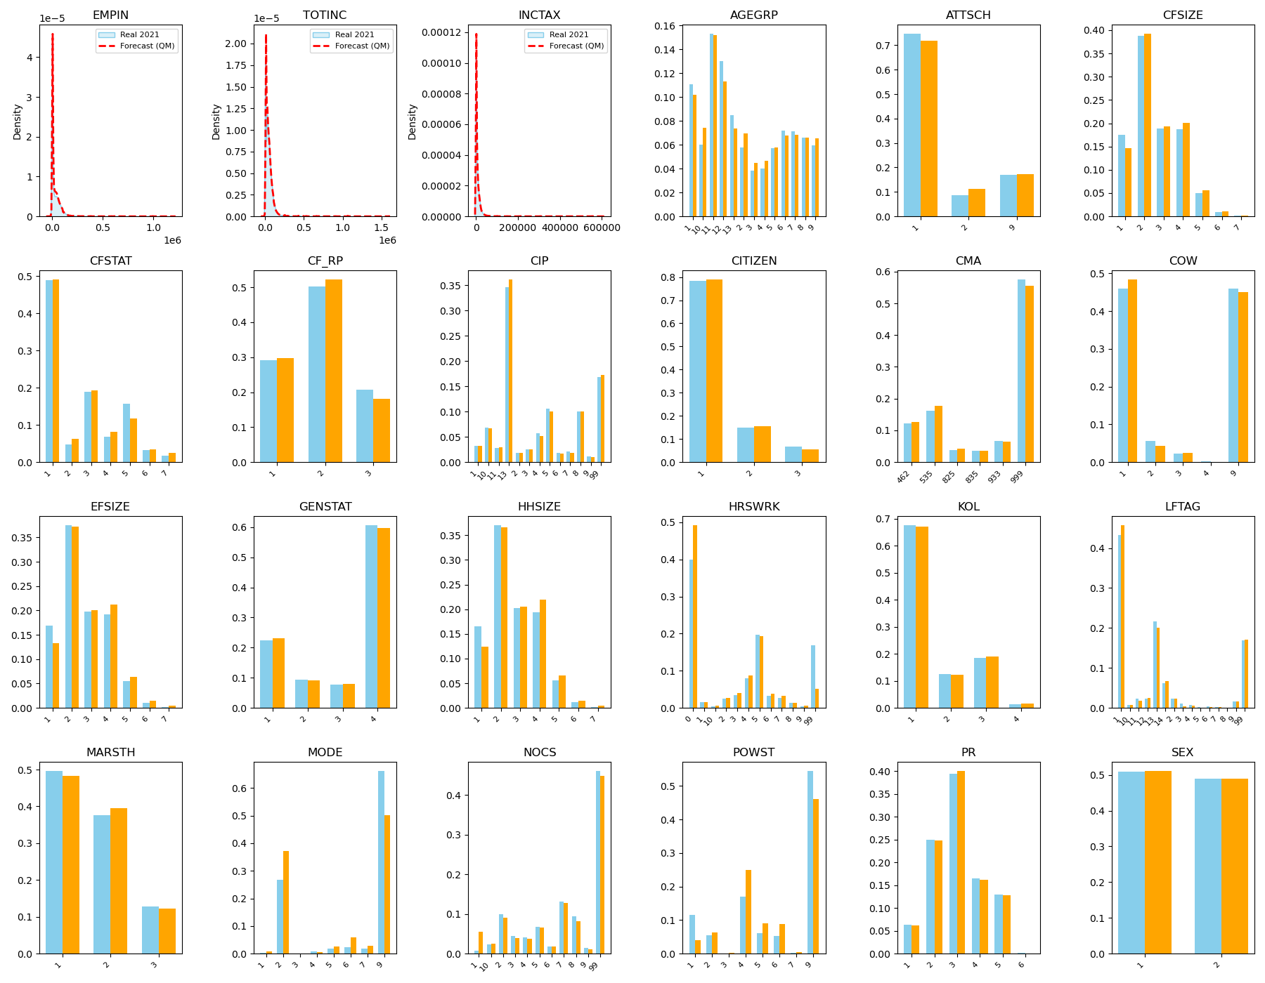
Figure A1. Distributional Accuracy: 2021 Census vs. Model Hindcast (24 Variables)
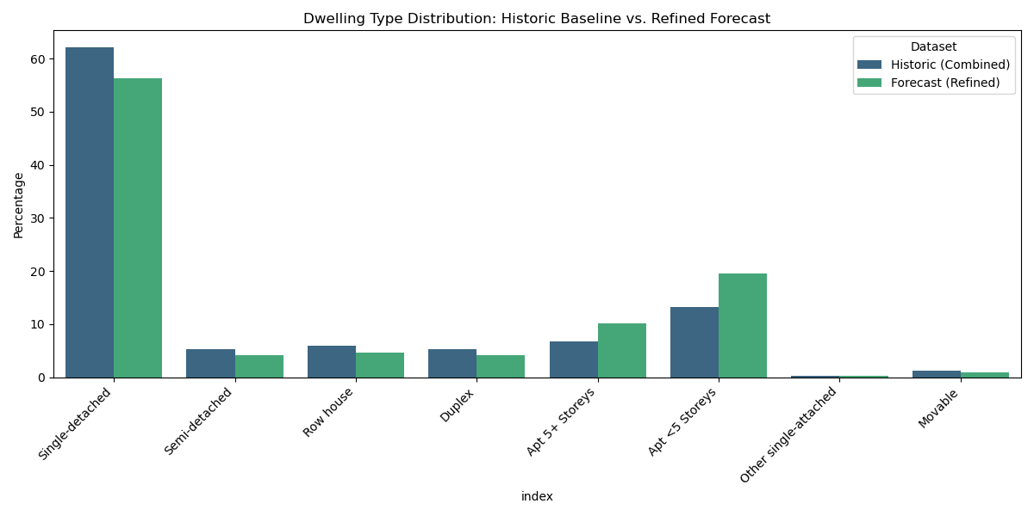
Figure A2. Dwelling Type Distribution: Historical Baseline vs. 2025 Refined Forecast
Appendix B
Table B1. Standardized Categories between four GSS datasets (2005/10/15/25)
# | Category Name | Description
1 | Work & Related | Paid/unpaid work, job searching, overtime, and work-related breaks or idle time (excluding travel).
2 | Household Work & Maintenance | Cooking prep, cleaning, laundry, repairs, gardening, pet/plant care, household finances, organization, etc.
3 | Caregiving & Help | Caring for children, adults, or non-household members; includes physical, emotional, or medical assistance.
4 | Purchasing Goods & Services | Shopping, errands, and use of personal, financial, government, medical, or professional services.
5 | Sleep & Naps & Resting | Night sleep, naps, or lying down to rest.
6 | Eating & Drinking | All eating and drinking activities (home or away).
7 | Personal Care | Grooming, hygiene, personal medical care, and private activities (bathroom, sex).
8 | Education | Attending classes, studying, homework, or school/training-related events.
9 | Socializing | Visiting, parties, weddings, bars, clubs, or any direct social interactions.
10 | Passive Leisure | Relaxing, resting, reading, watching TV, gaming, listening to music, meditation, or private prayer.
11 | Active Leisure | Sports, exercise, hobbies, outdoor recreation, arts, dancing, or physically engaging activities.
12 | Community & Volunteer | Civic participation, religious services, volunteering, and organized community activities.
13 | Travel | All travel between locations for any purpose (work, errands, social, education, etc.).
14 | Miscellaneous / Idle | Waiting, unspecified, or unclassifiable time.
Table B2. Harmonized Occupancy Location Schema
Code | Description | Original Context (Merged) | Code | Description | Original Context (Merged)
1 | Respondent's Home | Home, Property | 10 | Car (Driver) | Travel - Driver (Car, Truck, Van)
2 | Work / School | Place of work, School, Business trip | 11 | Car (Passenger) | Travel - Passenger (Car, Truck, Van)
3 | Someone Else's Home | Friend/Relative's home or property | 12 | Walk | Travel - Walking
4 | Outdoors | Outdoors away from home, Neighborhood | 13 | Public Transit | Bus, Subway, Metro, Light-rail
5 | Grocery / Stores | Grocery store, Other store, Mall | 14 | Airplane | Travel - Airplane
6 | Library / Museum | Library, Museum, Theatre | 15 | Bicycle | Travel - Bicycle
7 | Restaurant / Bar | Restaurant, Bar, Club | 16 | Taxi / Limo | Travel - Taxi, Limousine Service
8 | Place of Worship | Religious institution | 17 | Other Transit | Boat, Ferry, Motorcycle, Other
9 | Other Place | Medical, Dental, "Elsewhere" | 18 | Valid Skip | Data skipped logically (e.g., child)
Appendix C
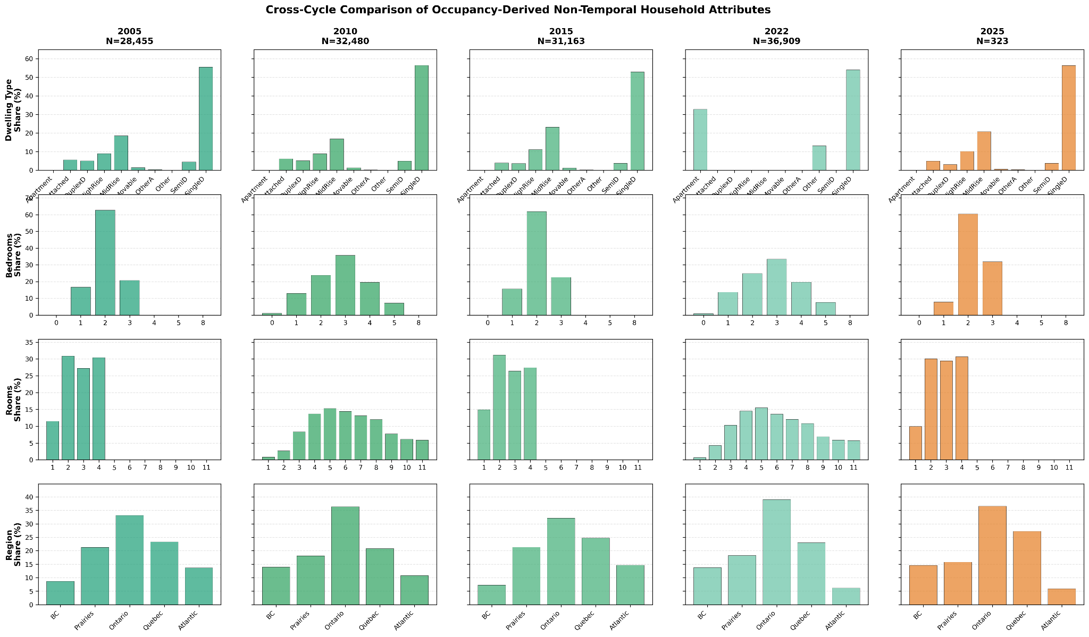
Figure C1. Cross-cycle comparison of non-temporal household attributes across GSS cycles and 2025 synthetic population.
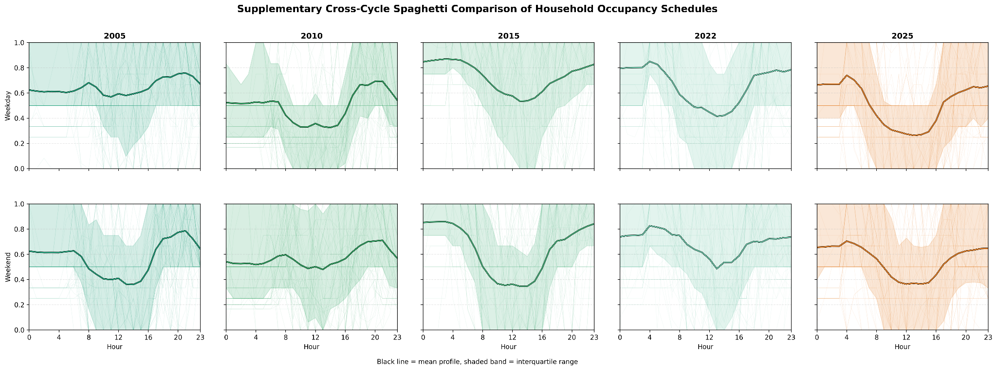
Figure C2. Supplementary cross-cycle comparison of household occupancy schedule variability (2005–2025).
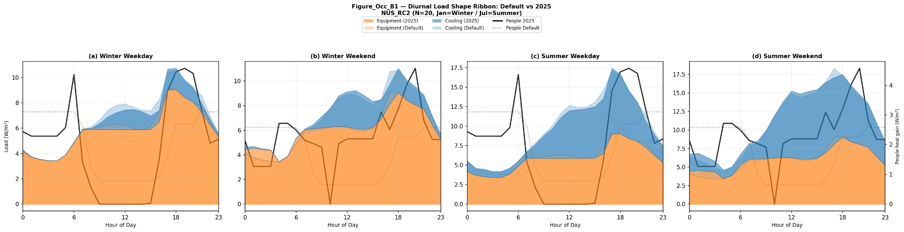
Figure C3. Diurnal Load Shape: Default vs. GSS-Derived Schedules by Season and Day Type (NUs_RC-D)
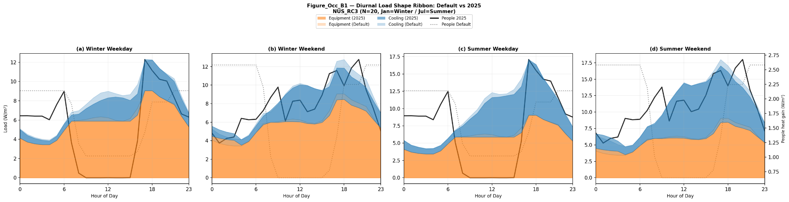
Figure C4. Diurnal Load Shape: Default vs. GSS-Derived Schedules by Season and Day Type (NUs_RC-T)
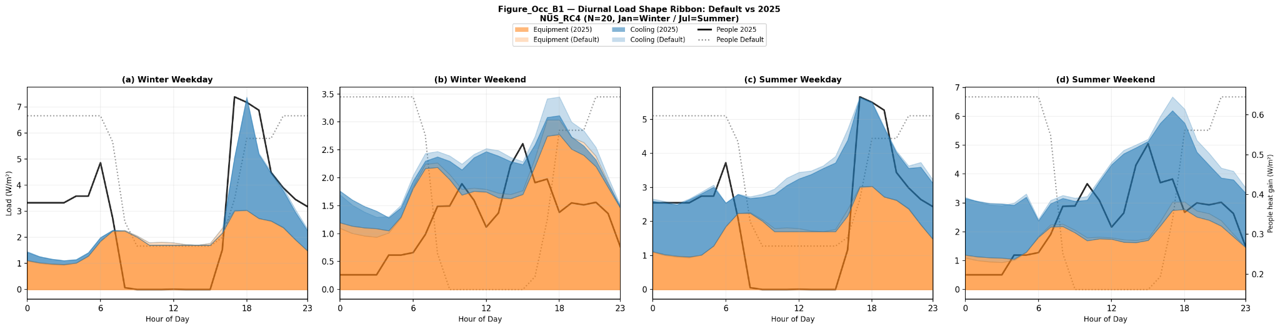
Figure C5. Diurnal Load Shape: Default vs. GSS-Derived Schedules by Season and Day Type (NUs_RC-MR2)
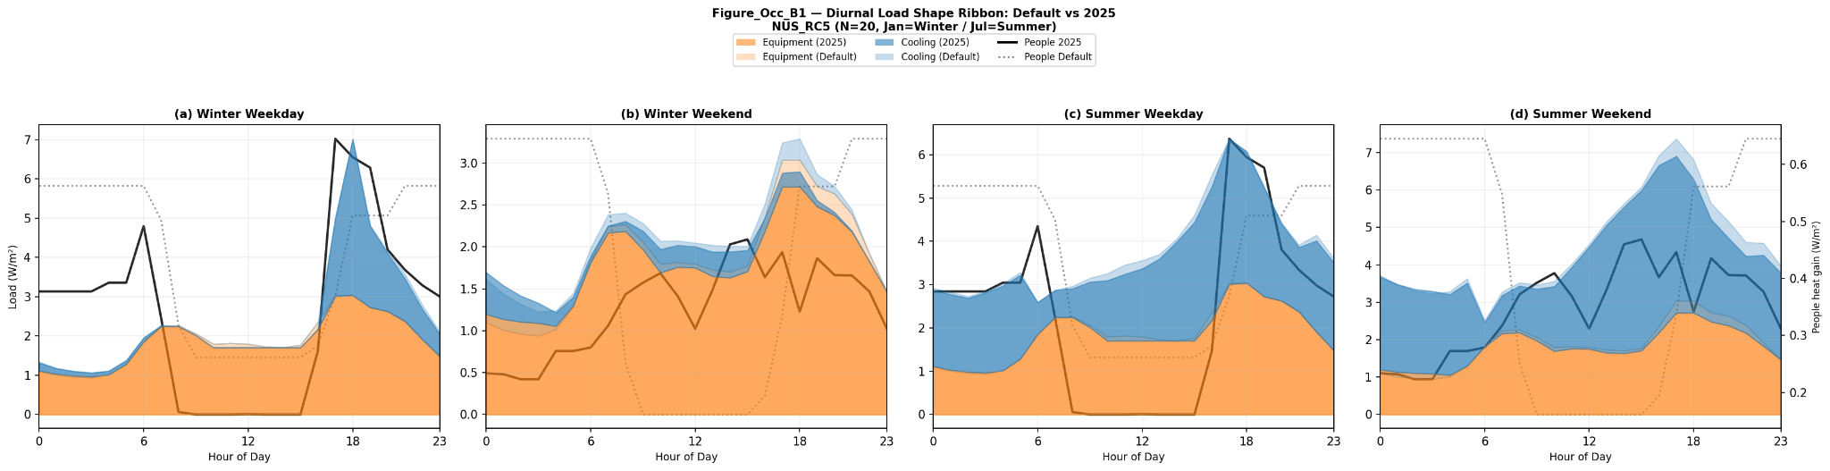
Figure C6. Diurnal Load Shape: Default vs. GSS-Derived Schedules by Season and Day Type (NUs_RC-MR3)
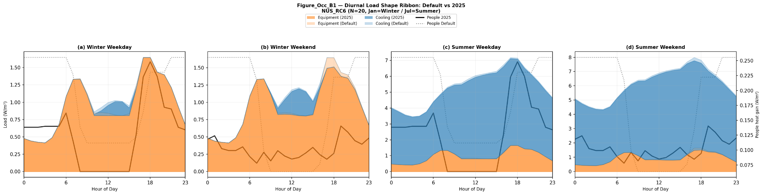
Figure C7. Diurnal Load Shape: Default vs. GSS-Derived Schedules by Season and Day Type (NUs_RC-HR2)

