**HW1 FAQs**

**Press Ctrl-C to terminate**

Q: If I press Ctrl-C to terminate after the node diagnostic.js command, does that mean that the page will no longer be hosted?

A: Ctrl-C will terminate the Node.JS server running in foreground. But if you have forever enabled previously, then you have a Node.JS server run in background.

**Cancel extraneous forever instances**

Q: I now have 5 forever instances running that I don't need. I want to cancel these instances to free up the ports, but I don't know how.

A: You could use: ./node_modules/forever/bin/forever stopall Then just re-instantiate the one that you want. If you know the pid# of the process you want to stop or kill, just use ./node_modules/forever/bin/forever stop #

Documentation: **https://www.npmjs.com/package/forever**

**Connection to server**

Q: I successfully connected to the server. What happens when my computer goes to sleep, will the server shut down? Do we need to keep flip running node after we submitted our assignment?

A: The server is always up and your node will be up by the forever process. Sometimes, if the server is under maintenance, the technician will kill all the processes that on running on the server and you need to start the forever process again. But that kind of situation is rare and if that happens, we will inform the whole class to reset the node. You need to keep the node running by forever process after you submit the assignment so that TAs can check whether it is up during grading.

**Connection timeout error**

Q: Every time I try to visit the URL, I get a connection timeout error. What is the problem?

A: Connection time-out usually implies VPN is not working. You might want to try accessing other parts of the network that require VPN to check if VPN is working fine.

**OSU-CS290-Tester as a collaborator**

Q: Where can I find OSU-CS290-Tester to add as a collaborator and how this can be accomplished?

A: From the github repo > Settings > Collaborators

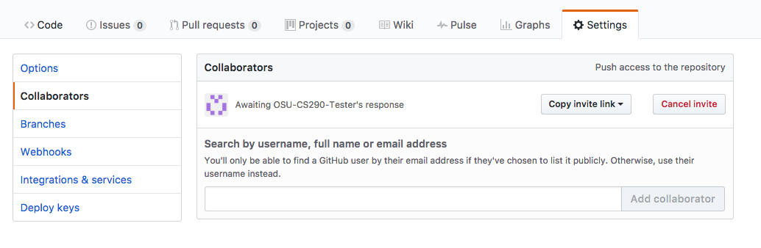

**Error 500**

Q: So I get the Error 500 - Something Has Gone Terribly Wrong. What should I do?

A: Did you try changing around your port number? And double/triple check you spelled everything right. Another note, a useful thing for troubleshooting was doing: ./node_modules/forever/bin/forever list That will print out some info on what’s running and it will include the location of a log file.   Open that file and there is also sorts of info in there. Most of it was overwhelming, but it might point you in the right direction.