**Tribhuvan University**

**Institute of Engineering**

**Pulchowk Campus**



**MINOR PROJECT**

**PASSWORD BASED DOOR LOCK SYSTEM**

**USING 8051 MICROCONTROLLER**

**Submitted by:**

**Prakash Dhakal (**074BEX423**)**

**Sunney Sharma** (074BEX449)

**Shashank Subedi (**074BEX450)

**Submitted to**:

Department of Electronics and Computer Engineering

Lalitpur, Nepal

Table of Contents

Acknowledgement 3

Abstract 4

Introduction 5

Objectives 6

Theory 7

8051 Microcontroller: 7

DC Motor: 8

LCD display: 8

Matrix Keypad: 9

Solenoid Lock. 10

Motor Driver(L293D): 10

Flow Chart 11

Components Required: 12

Working: 13

Schematic diagram 14

Output:. 15

Future Scope 17

Conclusion 18

References: 19

# Acknowledgement

First of all, we would like to thank the Department of Electronics and Computer Engineering,

IOE for giving us this great opportunity to carry out a minor project that will help us shape our Career. We would like to express our deepest gratitude to teachers for supervising this project with full dedication, support and guidance.

Without them, it would have been very difficult for us to complete the project on time.

We are sincerely grateful to our seniors and friends whose guidelines and suggestions had a major role in the completion of this project. Their scholarly advice and timely approach have helped us a great deal to accomplish this task.

We would like to acknowledge all the authors of the research papers that helped us understand the required concepts and algorithms better.

Every attempt has been made to include each and every aspects of the project in this report so that the reader can clearly understand about our project. We would be pleased to get the feedback on this project.

Sincerely,

Prakash Dhakal (074BEX423)

Sunney Sharma (074BEX449)

Shashank Subedi (074BEX450)

# 

# Abstract

The door lock industry has gone through a series of milestones to make security systems more secure and reliable. Recently, a number of advance technologies have been applied to the lock production line. They have introduced a variety of intelligent door lock that serves useful for human life. However, many consumers are still wondering whether it should use that new pro duct for their family or not.

Traditional lock systems using mechanical lock and key mechanism are being replaced by new advanced techniques of locking system. These techniques are an integration of mechanical and electronic devices and are highly intelligent. One of the prominent features of these innovative lock systems is their simplicity and high efficiency.

# Introduction

“PASSWORD BASED DOOR LOCK SYSTEM USING 8051 MICROCONTROLLER” is used in places where we need more security. It can also be used to secure lockers and others.

The system contains a microcontroller, a keypad, a 16x2 Alphanumeric LCD and a locking mechanism for door that opens and closes after correct password is entered.

The main disadvantage of traditional door lock system is that the accessing system is not unique. Key of one lock can be used to access another lock. This is a major threat to the security system.

In order to get rid of this threat the Password based door lock system is proposed. Password based door lock system is a simple lock system where the users who know the password can access the system and those who don't can't access the system. This project is a simple project designed using commonly available components and provides utmost security.

Below proposed simple circuit can be used at residential places to ensure better safety and security. It can also be used at organizations to ensure the authorized access to highly secured places instead of traditional door lock systems.

# Objectives

Major objectives of this project are as follows:

* Provide the best replacement for traditional door lock system.
* Lock the door by using password rather than key which may get lost.
* Increase the security level to prevent an unauthorized unlocking of the door.
* To give user more secure yet most cost efficient way of door unlocking system.

# Theory

## 8051 Microcontroller:

A Microcontroller is a VLSI IC that contains a CPU (Processor) along with some other peripherals like Memory (RAM and ROM), I/O Ports, Timers/Counters, Communication Interface, ADC, etc. 8051 is an 8 – bit Microcontroller i.e. the data bus of the 8051 Microcontroller (both internal and external) is 8 – bit wide. It is a CISC based Microcontroller with Harvard Architecture (separate program and data memory).

Since the basic layout of a microcontroller includes a CPU, ROM, RAM, etc. The 8051 microcontroller also has a similar layout. The following image shows a brief layout of a typical 8051 Microcontroller.

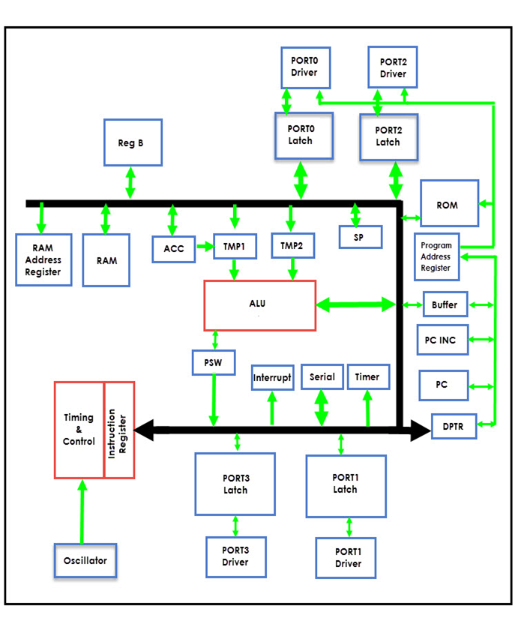

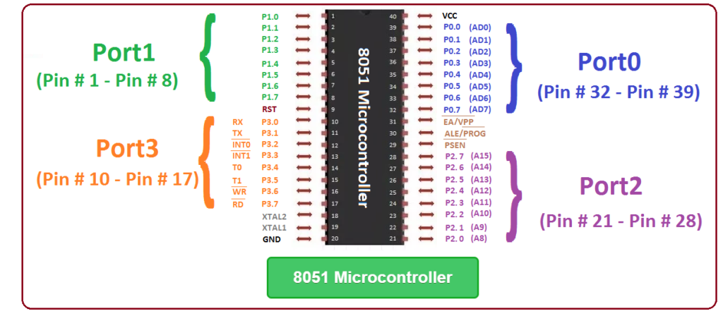

## DC Motor:

A DC motor is any of a class of rotary electrical motors that converts direct current electrical energy into mechanical energy. The most common types rely on the forces produced by magnetic fields. Nearly all types of DC motors have some internal mechanism, either electromechanical or electronic, to periodically change the direction of current in part of the motor. DC motors were the first form of motor widely used, as they could be powered from existing direct-current lighting power distribution systems. A DC motor's speed can be controlled over a wide range, using either a variable supply voltage or by changing the strength of current in its field windings. Small DC motors are used in tools, toys, and appliances. The universal motor can operate on direct current but is a lightweight brushed motor used for portable power tools and appliances. Larger DC motors are currently used in propulsion of electric vehicles, elevator and hoists, and in drives for steel rolling mills.

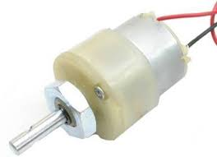

## LCD display:

A liquid-crystal display is a flat-panel display or other electronically modulated optical device that uses the light-modulating properties of liquid crystals combined with polarizers. Liquid crystals do not emit light directly, instead using a backlight or reflector to produce images in color or monochrome. LCDs are available to display arbitrary images or fixed images with low information content, which can be displayed or hidden, such as preset words, digits, and seven-segment displays, as in a digital clock. They use the same basic technology, except that arbitrary images are made from a matrix of small pixels, while other displays have larger elements. LCDs can either be normally on or off, depending on the polarizer arrangement. For example, a character positive LCD with a backlight will have black lettering on a background that is the color of the backlight, and a character negative LCD will have a black background with the letters being of the same color as the backlight.

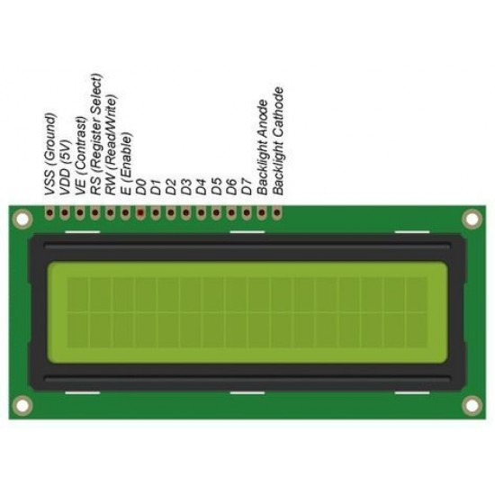

## Matrix Keypad:

A matrix keypad is the kind of keypad you see on microwave ovens, gas pumps, and calculators.  A matrix keypad you can connect to a breadboard is also great for prototypes and inventions where things like codes, times, or other values have to be entered.

The keys are connected into a matrix, so for the 3x4 matrix keypads, you only need 7 microcontroller pins (3-columns and 4-rows) to scan through the pad. On the 4x4 matrix keypads, you only need 8 microcontroller pins (4-columns and 4-rows) to scan through the pad.

[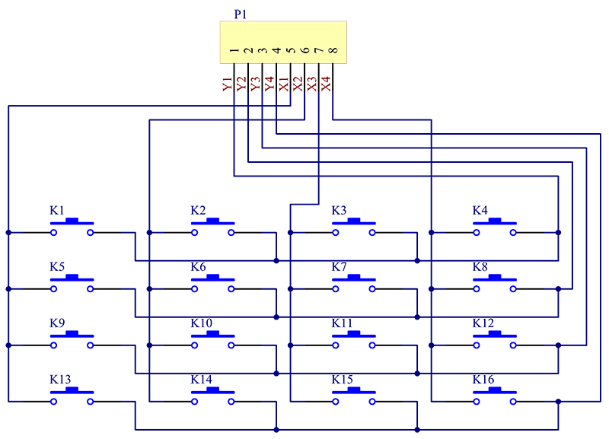](http://wiki.sunfounder.cc/index.php?title=File:Keypad_schematic.png)

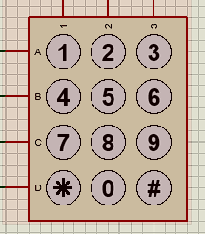

## Solenoid Lock:

The solenoid lock denotes a latch for electrical locking and unlocking. It is available in unlocking in the power-on mode type and locking and keeping in the power-on mode type, which can be used selectively for situations. The power-on unlocking type enables unlocking only while the solenoid is powered on. A door with this type is locked and not opened in case of power failure or wire disconnection, ensuring excellent safety.

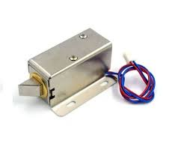

## Motor Driver(L293D):

The L293D is a popular 16-Pin **Motor Driver IC**. As the name suggests it is mainly used to drive motors. A single **L293D IC** is capable of running two [DC motors](https://components101.com/motors/toy-dc-motor) at the same time; also the direction of these two motors can be controlled independently. So if you have motors which has operating voltage less than 36V and operating current less than 600mA, which are to be controlled by digital circuits like Op-Amp, [555 timers](https://components101.com/555-timer-ic-pinout-datasheet), digital gates or even Micron rollers like Arduino, PIC, ARM etc.. this IC will be the right choice for you.

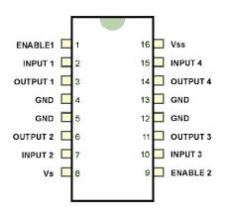

# Flow Chart

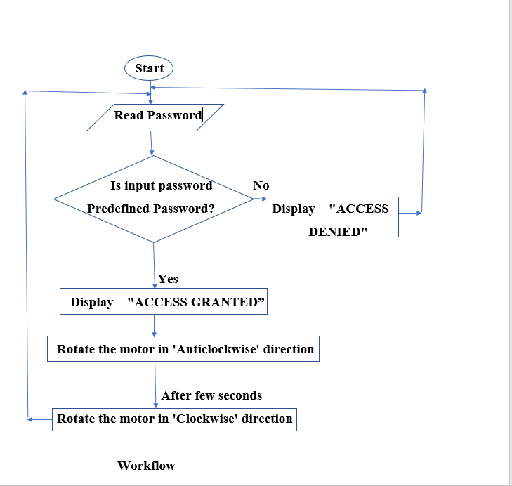

# Components Required:

* 8051 Microcontroller
* Keypad- phone
* Polarized capacitor
* Motor Driver (L293D)
* 16x2 Alphanumeric LCD
* Variable resistor/ Potentiometer
* Resistor
* Crystal
* Power source
* DC Motor
* Solenoid lock

# Working:

Once the circuit is powered ON, microcontroller sends commands to the LCD to display “ENTER PASSWORD” on LCD. Now we need to enter the password using the keypad. Once password is entered, LCD displays if the password was correct or not.

Now the controller compares the entered password with predefined password. If the password is matched, then the microcontroller makes P0.0 HIGH and P0.1 LOW, so the motor driver gets the input signals for forward motion of the motor.

As a result, the door motor rotates in forward direction to open the door. After a delay of 10 seconds, the microcontroller makes P0.0 LOW and P0.1 HIGH, so the motor driver gets the input signals for reverse motion. As a result, the door motor rotates in reverse direction to close the door.

If the password is not matched, then microcontroller maintains both P0.0 and P0.1 LOW. Hence, the door motor is stationary so that door remains closed.

Here, in the proteus simulator, we have used a dc motor, but in real life we can replace the motor with the solenoid lock which works perfectly with the circuit that we have made for the motor.

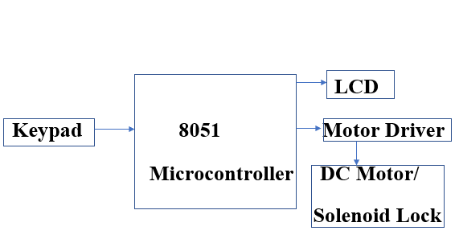

# Schematic diagram:

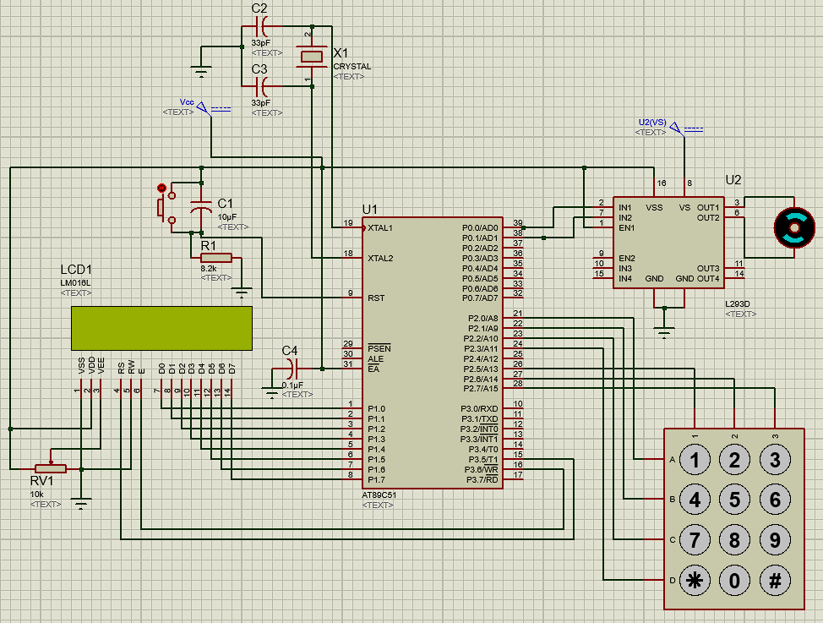

# Output:

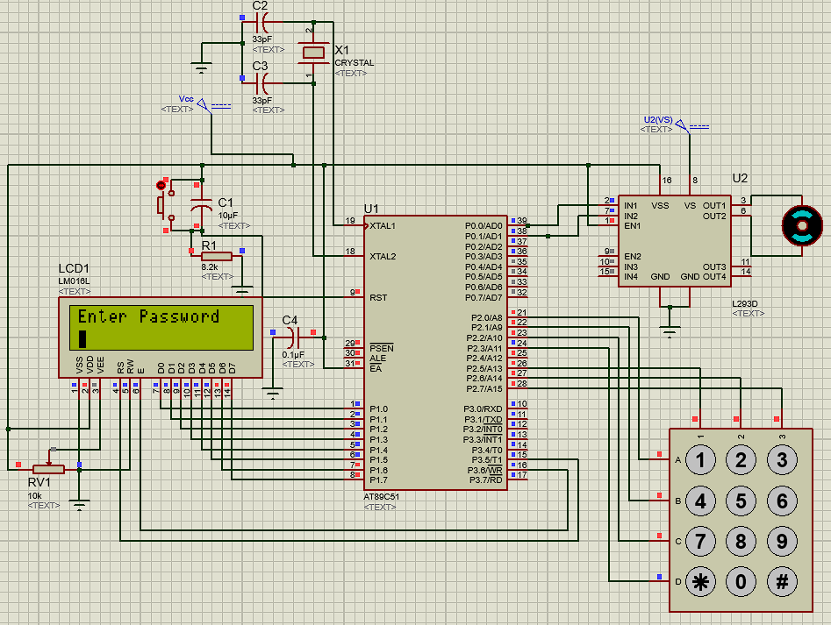

**Fig: Initially when the lock is idle**

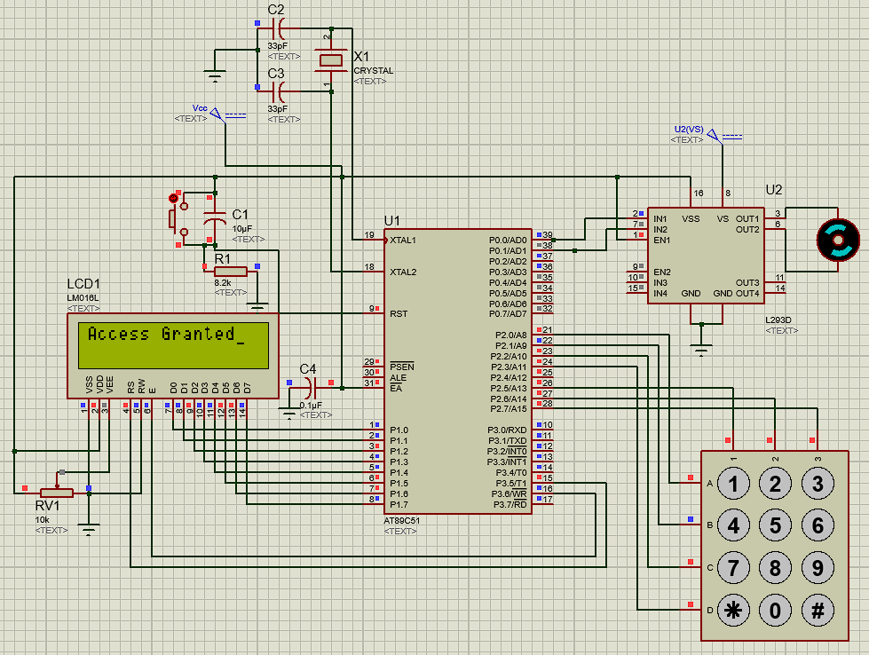

**Fig: When correct password is entered**

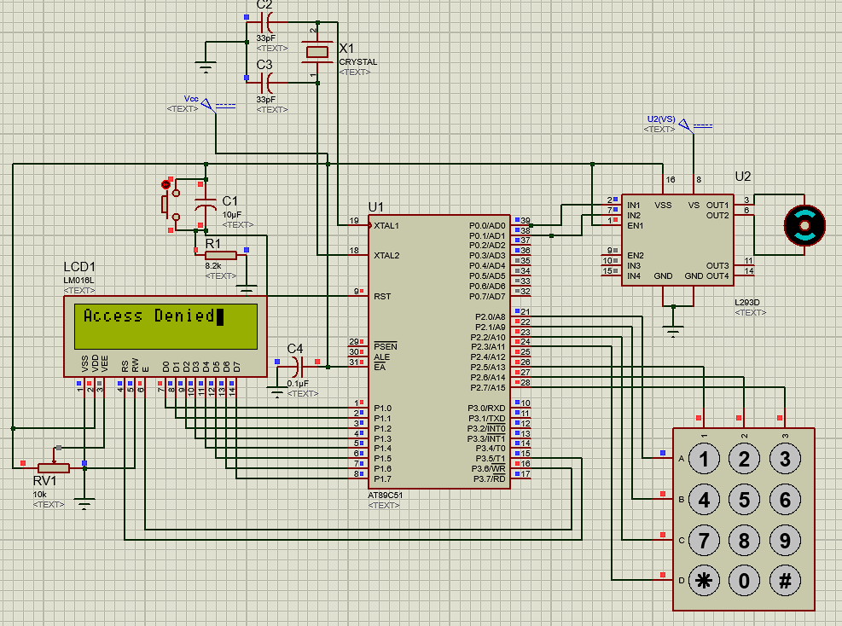

**Fig: When incorrect password is entered**

# Future Scope

From mechanical locks to smart locks the door security systems have come a long way. This password based door lock system can further be expanded to face recognition lock using Raspberry Pi. In the future version of this project the text input would be replaced by the image of a person and the controller will be replaced by PI. This model will be implemented using face recognition algorithms and various layers of neural network.

# Conclusion:

This project is meant for upgrade for our traditional security system. Using the microcontroller, the entered password is compared with our predefined password that is of 4 characters only and unlocks our lock.

We have used a dc motor in our simulated circuit, but in real life we can replace the motor with the solenoid lock which works perfectly with the circuit that we have made for the motor.

Using the customized door lock system we can have the utmost security of our business and property. The updated version of this project can be face lock door access system which is the latest trend of technology. Thus, this simple project seems a lot beneficial in many aspects. In this 21s t century of digital world, this password based door lock can be quiet effect and efficient way to protect our properties.

# References:

1. Muhammad Ali Mazidi, “8051 Microcontroller and Embedded Systems”, Prentice Hall, 2006
2. David E. Simon, “An Embedded Software Primer”, Addison‐Wesley, 2005
3. Jacob Millman and Christos C. Halkias,   “Integrated Electronics”, TATA McGRAW‐ Hill Edition 1991
4. Frank Vahid, Tony Givargis, “Embedded System Design”, John Wiley & Sons, 2008