Vantage intake and orchestration: concept paper
Stephen Costello · Credit Risk Review · 18 September 2026 · Working draft (rev 2)

Purpose and framing
One intake, two lanes, one orchestrator: files are classified by content shape at upload, documents flow through DEEP, tabular data flows through a profiling path, and a planner routes each question to the cheapest machinery that can answer it with receipts. This paper defines that design for the Vantage use case and shows how the same construction serves cases from a three-column tracking sheet to portfolio-wide scenario screening.
The central principle: Vantage does not choose an AI technique from file type alone. It first constructs a governed representation of the information, then chooses an execution method from the question. Content shape determines how structure is recovered or understood; the question determines whether the answer requires deterministic computation, structured lookup, text retrieval, or model judgment.
The design answers two live concerns. First, a developer concern: users want to drop CSV and Excel files into the tool for semantic-style questioning, which bypasses the document pipeline, and it was unclear how that would work at all. Second, a positioning concern: Vantage reads as a generic capability, not tailored enough to the variety of individual uses imagined for it. The answer to both is the same. The machinery is deliberately common; the tailoring lives in configuration (question sets, risk posture, output disposition), which is the platform's stated target operating model.
Scope: intake classification, the tabular lane, and question-time orchestration. The document lane (DEEP, retrieval, page-level provenance) is treated as defined and referenced, not re-specified.

Why tabular data breaks the document pipeline
A CSV is not a document; it is closer to a database that has not been loaded yet. In prose, meaning often lives in passages, so chunking and retrieval work naturally. In a table, meaning depends on the schema and on relationships across cells. Row embeddings can help with some retrieval tasks, but they do not preserve those relationships reliably and cannot answer important classes of tabular questions on their own.
Embedding every row of a large file produces three failures at once:
- Near-identical vectors. Serialized rows of IDs and numbers barely differ, so retrieval returns noise.
- Wrong answer class. Questions like "how many" or "what share of the portfolio" are computed across rows; the answer exists in no row, so no retrieval can find it.
- Cost and latency. Hundreds of thousands of embeddings per file, per upload, for retrieval that does not work.
The useful question is therefore not simply how to search the file, but what kind of operation the user's question requires. Three patterns recur, each with different machinery.
Question kind | Example | Right machinery
Computational | "Nominal and % of portfolio exposure with customer concentration above 20%" | Model produces a typed query plan; validated, compiled, and executed in DuckDB
Lookup / fuzzy match | "Find the entry about the watch supplier" | Hybrid search over selectively serialized rows
Semantic over free text | "Which comments mention covenant concerns?" | Lexical + vector retrieval over the text columns; structured columns become filters

For computational questions, the model shifts from reading the dataset to expressing how the system should interrogate it. Model context contains the schema and the question, not the full file. A typed query plan is validated and compiled before DuckDB executes it against the tabular data. This avoids loading every ad-hoc upload into a separate database service; performance still needs to be benchmarked against representative files and workloads.

Intake: classify by content shape, then profile once
Routing is decided by content shape, not file extension; the extension is only the prior. The classifier at upload returns one of four results per input: document, tabular, composite, or ambiguous/unsupported. A composite input (a workbook mixing narrative and data sheets, or a single sheet holding header regions, a primary table, and lookup tables) is decomposed into logical units, file to sheet to region where necessary, and each unit routes into one of the two lanes. Composite is a decomposition state, not a third lane; ambiguous inputs escalate to the analyst instead of being guessed at. CSV always routes tabular.
The lifecycle separates what must happen at intake from what is built only when needed:
- Profile time, at ingestion, unconditional. Parse and profile each tabular unit, determine grain and entity keys, infer column roles, construct the schema card, obtain the analyst's confirmation, and establish the unit's identity and security context. The card is a few hundred tokens regardless of row count and is the map the model reads; it never reads the data to decide which columns matter. Confirmation states the interpretation in plain language ("reading counterparty as Cpty_Nm, exposure as EAD_USD") once per file; corrections persist, converting the worst failure mode (a silently wrong mapping under a confident answer) into a visible ten-second checkpoint.
- Index time, under policy. Semantic units and lexical or vector indexes are built per the specification's index policy: eager, lazy, or none. Not every dataset earns an index; a use case that only ever queries deterministically gets none, which is the cheapest-machinery thesis applied to intake itself. Structured fields are never embedded on their own; they remain metadata for filtering, aggregation, and provenance.
- Question time. Planning, SQL and filtering, retrieval, classification and adjudication, aggregation, packaging.
Index time is governed by a distinct architectural object: the Semantic Unit Specification, the contract between the confirmed schema and every derived retrieval structure. It declares source fields; context fields; metadata and filter fields; provenance fields; unit granularity (row, distinct value, or grouped entity); the serialization template; embedding model and version; index policy (eager, lazy, none); retrieval policy (lexical, vector, hybrid); and the security scope inherited from the unit's entitlement context. A raw comment cell often carries too little on its own: "Counterparty: Acme | Sector: Industrials | Comment: dependent on Chinese rare-earth suppliers" is a retrievable unit where the bare comment is not. The chain is explicit: physical source, then physical profile, then confirmed semantic schema (the schema card), then Semantic Unit Specification, then derived retrieval structures.
The source remains authoritative; indexes are derived and rebuildable. A change in embedding model, serialization, or vector store should require rebuilding the retrieval layer, not reinterpreting the source. The specification also provides the per-use-case configuration point: a PICH sheet may index task text plus case ID, while a portfolio file may need a richer unit. Each specification is versioned and recorded with the index it produced. Context fields should be added only when they clarify the text; repeating metadata already available as filters can reduce retrieval precision without improving recall.
The schema card itself separates two layers. The physical profile is measured: source column name, inferred type, null rate, cardinality, min/max, sample values, language mix. The semantic profile is interpreted and confirmed: business concept, role (identifier, measure, categorical dimension, free text), unit and currency where applicable, aggregation behavior, grain and entity relationships, derivation where a concept is computed, confidence, and confirmed status. Grain and entity keys are first-class declared properties, not something inferred later from cardinality: a facility-grain file carries facility_id as its row key and counterparty_id as an entity key, many facilities to one counterparty, which is what makes COUNT versus COUNT DISTINCT and aggregation behavior safe to generate. A text column whose distinct-value count is small relative to rows is flagged as a de facto enumeration, shifting the plan from per-row reading to per-value classification.
Multilingual is a platform decision, made once. Text columns in Swiss-booked data will mix German, French, Italian, and English. Three rules:
- One multilingual embedding model for all text. Per-language model routing creates separate vector spaces that cannot see each other, so an English question silently loses the German rows. Language detection informs; it never routes.
- Classify the concept, not the string. Prompts carry intent ("the task asks the credit officer to confirm receipt of new annual financial statements"), not an English keyword, so Bilanz, bilan, and bilancio all match.
- Record the language mix on the schema card and slice evaluation by it. Recall of 97% overall and 82% on Italian is a finding to surface, not to average away.

The two lanes
The document lane is the existing platform path and is not re-specified here: DEEP parses structure-first (parse, build a tree, navigate, map, preserving hierarchy and coordinates), content lands in the document and embedding stores, retrieval filters before it searches, and every answer carries document, page, source text, and visual location. Word routes through the same lane as PDF and is the easier case: headings, lists, and tables are native objects in the file, so the parse tree comes essentially free, where PDF structure must be recovered from layout.
The tabular lane is the new path this paper defines: profile, confirm, index under policy, then answer questions through the planner described in the next sections. Its provenance artifacts are the typed query plan, the compiled query, and the returned rows rather than a highlighted page, plus the classification table where judgment was involved.
The two lanes apply the same principle to different inputs. DEEP recovers structure from document layout; the tabular lane starts with an explicit schema and determines what that schema means. Both use structure before retrieval and both return evidence that a reviewer can inspect independently of the model's summary.
 | Document lane | Tabular lane
Inputs | PDF, Word, narrative sheets | CSV, Excel sheets, table-extract PDFs
Structure | Recovered by DEEP parsing | Given; captured as a schema card
Unit of meaning | Passage in hierarchy | Schema-bound semantic unit (cell, row, distinct value, or grouped entity)
Search | Hybrid over chunks | Typed queries over columns + hybrid text retrieval over text columns
Provenance | Document, page, source text, location | Query plan, compiled query, returned rows, classification table
Expensive step | Parsing at intake | Profiling at intake; indexing under policy

The flow: intake lanes and question-time routing
Intake runs once per file (or per sheet, where a workbook mixes shapes) and populates the stores each lane needs.
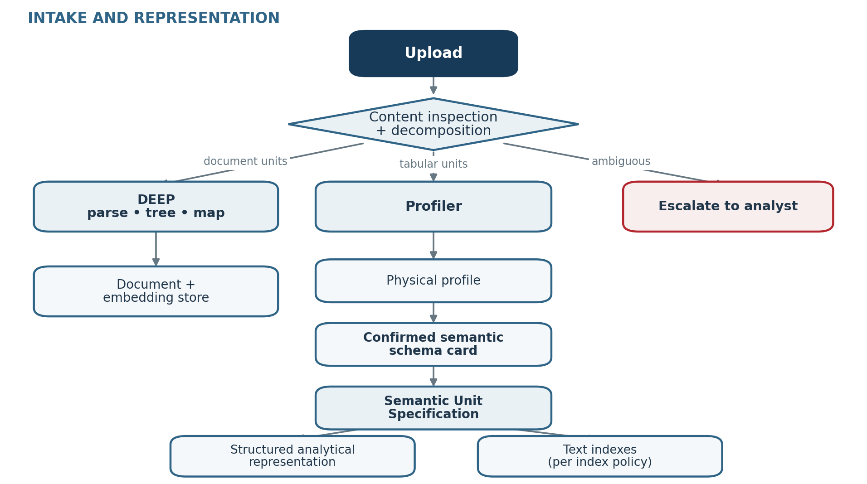
Reading: extension is only a prior. Composite inputs decompose, file to sheet to region, into logical units that route to the two lanes; ambiguous inputs escalate rather than guess. Text indexes are built per the specification's index policy, not automatically because a text column exists.
At question time the planner reads the cached schema card and dispatches only the machinery the question needs. Most questions take the cheap path.
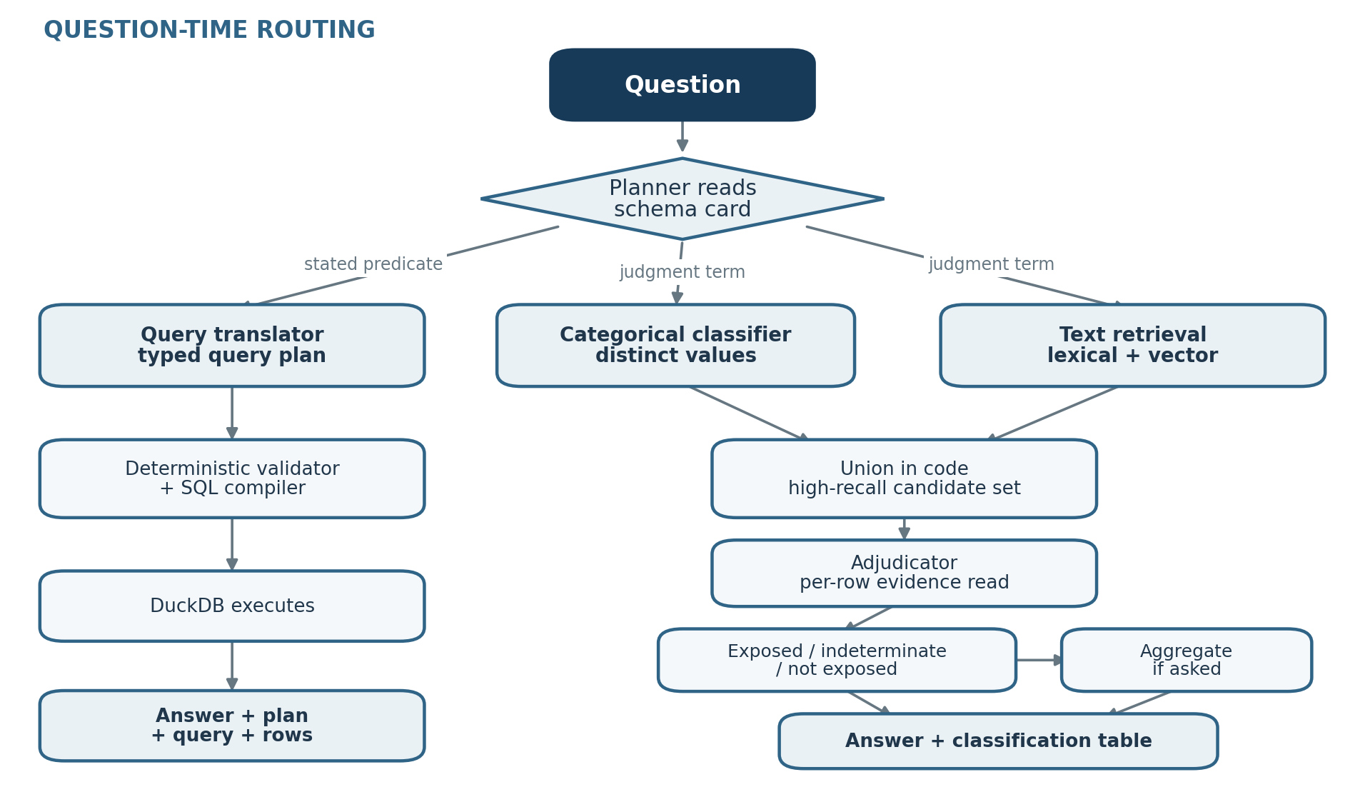
Reading: the two passes run in parallel and independently; the categorical pass prioritizes but never excludes, so the only route out of scope runs through the adjudicator with a text-grounded reason. Candidate generation is a high-recall control whose adequacy is measured against golden sets, not proof of exhaustive recall. Document questions route through the document lane's existing retrieval and are not redrawn here.
Edits to the classification table re-run only the deterministic bottom of the flow; the expensive model steps above do not repeat.

Question-time orchestration: model judgment at explicit points, code everywhere else
The orchestrator routes each question to the functions it actually needs. A stated predicate that maps to columns ("concentration above 20%", when that field exists) goes to query translation. A judgment term ("impacted by rare-earth tariffs") triggers the two screening paths. A list request may need no SQL at all. If a concept can be derived from structured fields, the planner uses a deterministic query; if it exists only in narrative fields, it uses text retrieval. One rule is fixed: filters implement conditions stated by the user, not judgments made by the model.
The current design isolates model judgment in four explicit functions, each with a visible artifact. These are logical responsibilities rather than an implementation mandate; they could be implemented as separate agents, structured model calls, shared models with different prompts, batch inference, or deterministic logic where possible.
Function | Judgment | Artifact
Planner | Which machinery the question needs | The plan, shown with the answer
Classifier | Categorical pass over distinct values, concept-level | Tiered value classification
Adjudicator | Evidence-backed call per candidate row | Reasoned call per name, editable
Query translator | Translate intent to a typed query plan | The plan, validated, compiled, and executed

Everything between them is plain code: profiling, indexing, retrieval execution, validation and compilation, the union, DuckDB execution, aggregation, packaging. Model judgment exists only at these explicit points and produces inspectable artifacts; deterministic plumbing remains code. That keeps guaranteed behaviors guaranteed and bounds the governance surface to four judgment functions connected by auditable plumbing.
Two efficiency rules do most of the scaling work:
- Classify vocabularies, not rows. A 150k-row file has perhaps 200 distinct sector values, and a templated task column behaves the same way. The classifier reads distinct values once; a deterministic join tags every row. The per-row adjudication read runs only over the union of candidates, typically thousands of rows, never the file.
- SQL is a provenance artifact, not an authoring surface and not the verification mechanism. Analysts write plain English. The model produces a constrained, typed query specification (operation, measure, aggregation, filter, entity) rather than free SQL; deterministic code validates it against the confirmed schema and compiles it. The verification the analyst sees is the interpretation restated in plain language ("sum EAD_USD for facilities where concentration is above 20%, reported across distinct counterparties"), with the compiled SQL one click away as show-your-work provenance.
The reason validation is deterministic and sits before execution: a syntactically valid query that is semantically wrong (wrong join, wrong filter) fails silently, and a human reading SQL is not a control. The validator checks the typed plan against the confirmed schema: referenced fields exist and are permitted, measure and aggregation are compatible, the declared grain drives COUNT versus COUNT DISTINCT, currencies are compatible or conversion is required, join cardinality is sound where joins exist, null handling is explicit where material, and execution is read-only. Results are validated after execution as well. The declared grain is what makes "how many counterparties" on a facility-grain file count distinct by construction rather than by luck.

Scenario screening: two independent paths, union, adjudication
Judgment questions ("which borrowers are impacted by a new tariff on rare earths?") cannot be answered by a filter, because the exposure concept exists in no column. The screening design rests on one recall principle: categoricals prioritize, they never exclude. A filter-then-refine sequence has a silent hole: an industrial bank coded "Financials", or a hedge fund specializing in data centers, is dropped by the sector filter and its free text, which states the concentration plainly, is never read. A recall failure is invisible; the answer comes back internally consistent and nobody knows what was missed.
The construction:
- Path A, categorical. The classifier reads the distinct values of the categorical dimensions against the scenario and tiers them: exposed, dependent, not exposed, and indeterminate-from-code. Every intermediary and pass-through category (banks, funds, asset managers, holding companies, "diversified") lands in the indeterminate tier by rule. A sector code on an intermediary describes its legal form, not its economic exposure; this is the look-through problem, and the classifier is prompted to know it.
- Path B, text retrieval. Lexical and vector retrieval operate together over the whole eligible text corpus, fused into one candidate set, never restricted to Path A's candidates: exact terms, identifiers, and regulatory vocabulary retrieve lexically, while embeddings carry conceptual and multilingual similarity. Path B does not trust Path A's exclusions, and the two paths run in parallel.
- Union in code, then adjudication. The candidate set is everything either path surfaced. The adjudicator reads only this union and makes an evidence-backed call per name, with a one-line reason drawn from the row's own text. Precision errors from Path B are caught here, and any that survive are visible in the output.
This independence is a recall defense, not a recall guarantee. Path A cannot exclude Path B candidates, and Path B searches the entire eligible corpus, which materially reduces the categorical false-negative hole; but retrieval has boundaries of its own (ranking depth, similarity thresholds), so recall remains an empirical property. The candidate-generation policy is configurable to corpus size and risk posture, from hybrid retrieval up to exhaustive search or batch classification where warranted, and evaluation against golden sets determines whether the configured policy meets the required recall target.
The output has three tiers; the third is essential:
- Exposed: drives the deterministic aggregate (counts, sums, share of book).
- Not exposed: excluded only through the adjudicator, with a reason; never by a code alone.
- Indeterminate, insufficient look-through information: reported with its own count and exposure total beside the answer. "247 counterparties exposed, CHF 4.2bn (6.3% of book); a further 31 financial intermediaries, CHF 1.1bn, could not be assessed from available data." The tool quantifies the file's silence instead of guessing over it, which is the tabular twin of the platform rule that an untraceable answer does not enter a deliverable. It is also the work queue: those 31 names are the list to fetch look-through data for.
The classification table is editable, and an analyst's changes re-run only the deterministic aggregate. This turns a one-off screening result into an interactive scenario view without repeating the model-heavy steps. For this use case, uncertainty is biased toward inclusion: visible false positives can be reviewed and corrected, while false negatives are harder to detect.

Worked cases: the same machinery, scaled down and up
PICH tracking sheet (scales down). A pending-items extract with three effective fields: case ID, due date, and a CO task column whose text may be German, French, Italian, or English. The question: which items ask the credit officer to verify that a new balance sheet was submitted, so that items already satisfied can be closed without manual work. The schema card is nearly trivial; the planner sees no categorical vocabulary worth a Path A pass and no aggregate, so the whole question routes through text retrieval plus adjudication, and the classification table is the deliverable. The templated task column is a de facto enumeration, so the classifier reads a few hundred distinct strings, not 80k rows. Same four judgment functions, three of them idle or trivial; nothing special-cased. Two boundaries: the actioned outcome is deletion of a control step, so the flow proposes and a human ratifies (see risk posture below), and checking the internal rating database for whether a balance sheet already exists is a lookup in another system, out of Vantage's scope until a governed connector exists.
Buried concentration (planner branching). "Nominal and % of portfolio exposure with customer concentration above 20%." If a concentration column exists, this is pure filter-and-aggregate: query translation, validation, DuckDB, done, no retrieval machinery. If concentration is derivable from customer revenue columns, the planner derives it in SQL. If it lives only in narrative fields, the planner sees that from the schema card and routes it through text retrieval. Three executions of one question, chosen from the map, never from the data.
Semiconductor supply shock (scales up). "How many counterparties would be exposed to a critical semiconductor supply shock, and what share of the portfolio?" The full construction: two parallel passes, union, adjudication, three-tier output, deterministic aggregate with distinct-counting at the right grain, and the quantified-indeterminate line beside the answer.
ERM read-across (the pattern one level up). The event-identification case ("which clients are exposed to this event?") is the same planner consulting a catalog of schema cards and document indexes instead of one file's card: what information exists already, what is in the uploaded PDFs, which candidate datasets and text fields to look over. The schema card generalizes into the platform's answer to "what do we know and where," which is also the seed of the knowledge-graph story.

Risk posture and governance
The risk asymmetry differs by use case, and the architecture absorbs it through configuration, not code. In scenario screening the dangerous error is the false negative (silent missed exposure), so doubt is pushed toward inclusion and the amber tier. In the PICH case the actioned outcome is deletion of a control step, so a false positive is the dangerous error, and the amber tier's default disposition flips to human review before any action. The machinery is common; the risk posture per use case (tier thresholds, default dispositions, whether output is a proposal or an answer) lives in use-case configuration. This is the concrete answer to "too generic": tailoring by configuration is the platform's target operating model, applied.
Provenance artifacts by path, all shown or one click away:
- Computed answers: the typed query plan, the compiled query, and the returned rows, deterministic and re-runnable.
- Judgment answers: the plan, the tiered value classification, and the per-name reasoned call, editable.
- Both: the confirmed schema mapping and the version of the semantic unit specification the retrieval index was built from.
Evaluation is part of the design. Recall and precision are measured against golden sets by language and question type, including separate DE/FR/IT/EN results. Schema-mapping confidence is measured as well. Unmapped terms, ambiguous exposure fields, and mixed-currency measures escalate to the analyst rather than being resolved silently.
Boundaries stated up front: Vantage's job in any workflow ends at the classified, evidenced candidate list or the computed answer. Lookups in other systems are exports the business joins, or governed connectors later, with the entitlement and data-access questions that implies. Arbitrary uploaded tabular data also has no ingestion identity and permissions story today the way documents do; "what data just entered the tenant" is a question the retrieval layer's model will eventually need to answer for tables, and it is flagged here so the deferral is deliberate.

Decisions and open questions
- Schema card: decided (2026-09-18). It is a first-class platform object, cached and reused; standard profiling outputs are captured once and reused, saving compute and latency. Versioning and attributed correction history remain to be specified.
- Content-shape classifier: decided (2026-09-18). A central service-layer capability; applications invoke it per use-case configuration and it is served through the UI. Runtime sequence: user uploads, the file is saved (profiling can start asynchronously here), the user enters questions or configuration, structure is captured and confirmed to the user, then the question routes down its path.
- Embedding model: confirm with the platform team rather than assume. Likely multilingual given the bank's language mix, but the extraction-heavy use cases to date barely exercise embeddings, so request the per-language retrieval evaluation (DE/FR/IT/EN) for semantic search over short free-text fields.
- Ingestion identity and permissions: uploaded tabular files follow the same permissions requirements and shape as documents (decided 2026-09-18); one intake identity model for all file types, with the entitlement gateway enforcing at query time. Open: whether these attributes, and the tabular artifacts they attach to (raw file, schema card, semantic unit specification version), are retained in the central storage layer alongside raw and parsed documents, or live only application-side. Central retention is what lets enforcement work uniformly and what extends process-once reuse to tables; the question for the platform team is whether the store's raw-plus-parsed shape accommodates a tabular unit as a first-class stored object or is document-only by design.
- PICH rating-database check: earliest acceptable integration shape (manual export and join vs. governed connector) and under whose entitlement model. Confirmed as a follow-up.
- Risk-posture configuration fields: deferred. Candidate for a 2H27 release; viability still being assessed. Not required for the initial design, which carries the concept only.

