Vantage intake and orchestration: summary
Stephen Costello · Credit Risk Review · 18 September 2026 · Companion to the concept paper
One intake, two lanes, one orchestrator. Files are classified by content shape at upload: documents flow through DEEP; tabular data (CSV, Excel) flows through a profiling path built for it. At question time a planner routes each question to the cheapest machinery that can answer it with receipts. The same construction serves a three-column tracking sheet and portfolio-wide scenario screening, and the tailoring per use case lives in configuration, not code.

Why tabular data needs its own lane
A CSV is not a document; it is closer to a database that has not been loaded yet. Meaning depends on the schema and on relationships across cells. Row embeddings can help with retrieval, but they cannot answer computed questions such as "how many" or "what share" and are a poor default for large structured files. The system therefore routes by question type: for computational questions, the model expresses how the data should be queried rather than reading the dataset itself.
Question kind | Example | Right machinery
Computational | "Nominal and % of portfolio exposure with customer concentration above 20%" | Model produces a typed query plan; validated, compiled, and executed in DuckDB
Lookup / fuzzy match | "Find the entry about the watch supplier" | Hybrid search over selectively serialized rows
Semantic over free text | "Which comments mention covenant concerns?" | Lexical + vector retrieval over the text columns; structured columns become filters

Intake: profile once, index under policy
At upload, the content-shape classifier identifies document, tabular, composite, or ambiguous inputs. Composite files are broken into logical units - file, sheet, and region where needed - and each unit routes to one of the two processing lanes. Every tabular unit is profiled into a schema card that separates measured properties (types, nulls, cardinality, language mix) from confirmed business meaning (concept, role, units, aggregation behavior, grain, and entity keys). Indexing is optional. A versioned Semantic Unit Specification defines what text and context are indexed and whether that happens eagerly, lazily, or not at all. The uploaded file remains authoritative; indexes are derived and rebuildable.
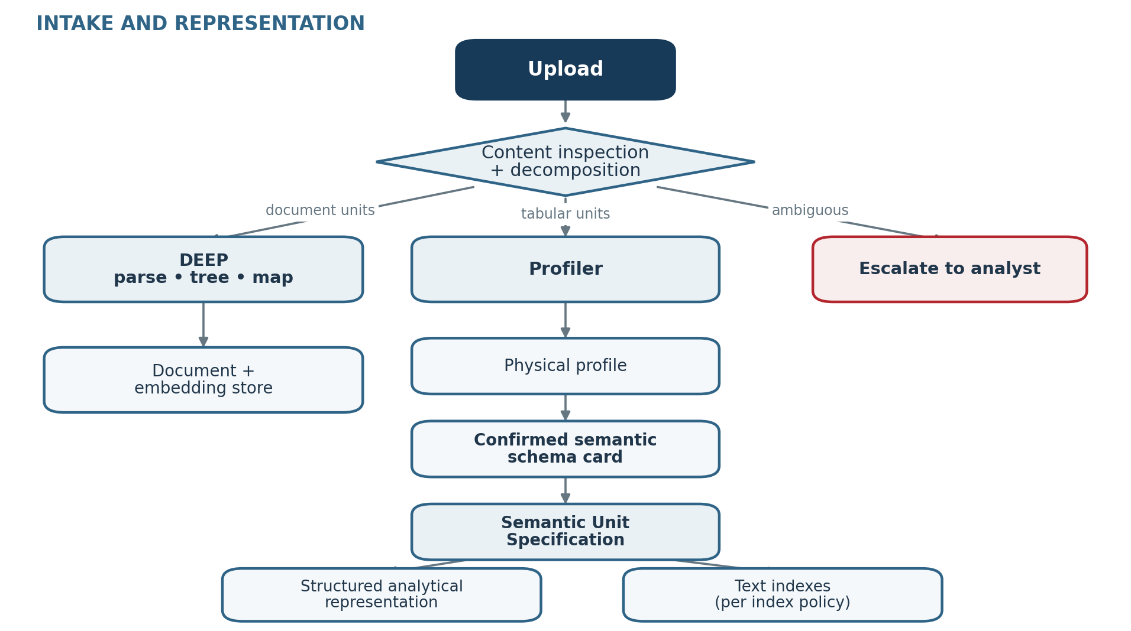
 | Document lane | Tabular lane
Inputs | PDF, Word, narrative sheets | CSV, Excel sheets, table-extract PDFs
Structure | Recovered by DEEP parsing | Given; captured as a schema card
Search | Hybrid over chunks | Typed queries over columns + hybrid text retrieval
Provenance | Document, page, source text, location | Query plan, compiled query, returned rows, classification table

Question time: a router, not a pipeline
The planner reads the cached schema card and invokes only the functions the question needs. Stated predicates become a typed query plan that is checked against the confirmed schema, compiled to SQL, and executed in DuckDB. Judgment questions use two independent candidate-generation paths: categorical classification over distinct values and hybrid lexical/vector retrieval over eligible free text. The two paths reduce different sources of false negatives, but do not guarantee recall; performance is measured against golden sets. Their union is adjudicated with row-level evidence and returned as exposed, not exposed, or indeterminate. Analyst edits to the classification table re-run only the deterministic aggregate.
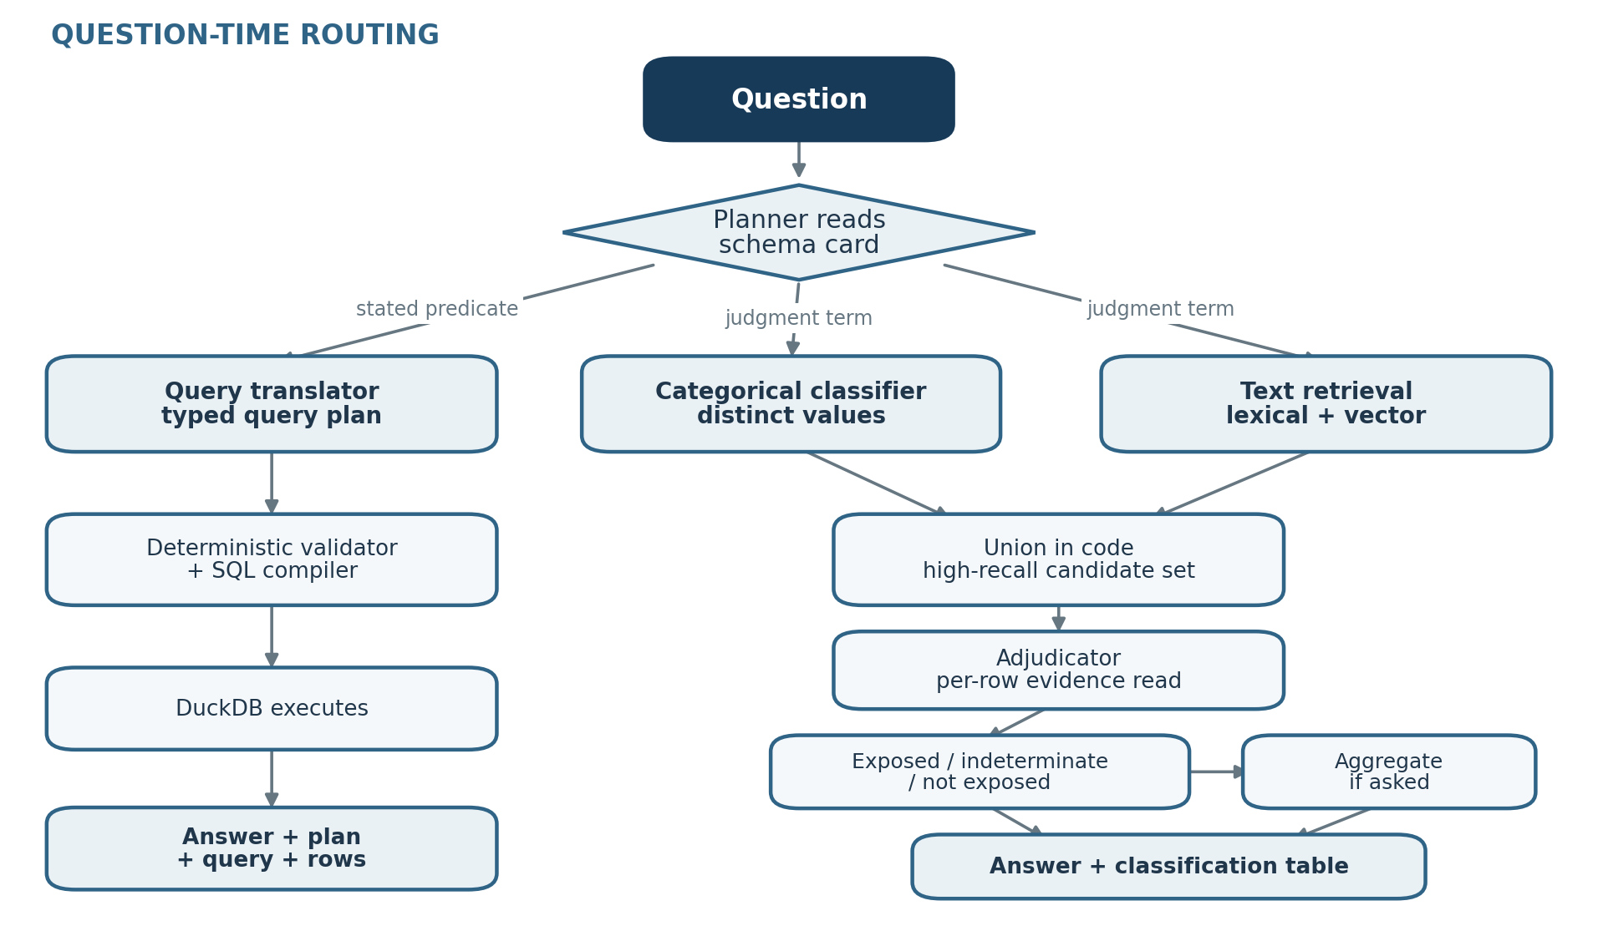
The current design isolates model judgment in four explicit functions. They are logical responsibilities, not necessarily four separate agents; the steps between them remain deterministic, auditable code.
Function | Judgment | Artifact
Planner | Which machinery the question needs | The plan, shown with the answer
Classifier | Categorical pass over distinct values, concept-level | Tiered value classification
Adjudicator | Evidence-backed call per candidate row | Reasoned call per name, editable
Query translator | Translate intent to a typed query plan | The plan, validated, compiled, and executed

Why it is safe
- Every answer ships with receipts: the typed query plan, compiled query, and returned rows for computed answers; the plan, tiered classification, and per-name reasoned calls for judgment answers; the confirmed schema mapping and specification version for both.
- Nothing is excluded by a model judgment alone; the only route out of scope runs through the adjudicator with a reason.
- The file's silence is quantified, not guessed over, matching the platform rule that an untraceable answer does not enter a deliverable.
- Evaluation is sliced per language (DE/FR/IT/EN) and per question kind; ambiguity (unmappable terms, mixed currencies) escalates to the analyst.

Status
- Decided: the schema card is a first-class platform object, cached and reused; the content-shape classifier is a central service-layer capability invoked per use-case configuration, with profiling starting asynchronously at upload.
- Decided: uploaded tabular files follow the same intake permissions shape as documents; open whether those attributes and tabular artifacts are retained in the central storage layer or only application-side.
- Open: confirm the embedding model is multilingual and request the per-language retrieval evaluation.
- Open: integration shape for the PICH rating-database check (export and join vs. governed connector).
- Deferred: risk-posture configuration fields, candidate for a 2H27 release.

