--- title: AKS Zone Resilience description: Guidance on designing a zone-resilient AKS clusters, including node-pool strategies, storage, scaling, and capacity constraints ---

Contents
Section | What it covers
Introduction | Why resilience planning matters and what these notes cover
Background | Customer scenario and reason for the engagement
Customer requirements and constraints | Regional dependencies and capacity limitations
Understanding Azure availability zones | How availability zones provide isolation within an Azure region
Zone-resilient deployment types | Difference between zonal and zone-redundant resources
How AKS uses availability zones | Control plane, node pools, pod placement, and traffic distribution
Stateless and stateful applications | Simple explanation of the two workload types
Workload and storage configuration | Storage redundancy choices and workload considerations
Managed disks with zone-spanning node pools | Using ZRS persistent volumes for cross-zone recovery
Zone spanning (Zone-redundant) AKS node pool architecture | Zone-spanning node pools and pod topology spread constraints
Zone-aligned (Zonal) AKS node-pool architecture | Zone-aligned node pools and autoscaler balancing
How a two-zone AKS deployment remains resilient | Capacity impact of a zone failure
Guaranteeing capacity with ODCR | Guaranteed capacity and commercial considerations
Extending resilience across regions | Cross-region resilience, disaster recovery, and business continuity
Choosing an AKS resilience strategy | Questions to guide the final design
Testing resilience during a zone failure | Simulate a zonal failure and verify workload resilience
Key design takeaways | Main lessons from the discussion
Troubleshooting | Common issues and investigation guidance
References | Supporting documentation and examples

Introduction
Resilience is an important part of any application architecture. With the increasing capacity constraints that many customers face, it is important to plan for failure before it occurs. That plan should explain how the application will maintain essential functionality and recover as quickly as possible.
In these notes, I focus specifically on improving regional resilience for Azure Kubernetes Service (AKS) by distributing cluster resources across availability zones. I cover the approaches for creating a zone-resilient AKS cluster, the advantages and trade-offs of each approach, and the implications of choosing a two-zone design instead of a three-zone design.
Key takeaway: Resilience is not only about preventing failure. It is about designing the application to continue operating and recover when a failure occurs.

Background
This section gives some background into why this article came about. A customer requested a confidence call about future capacity availability and architectural guidance for a two-zone Azure Kubernetes Service (AKS) deployment. I captured the key points and lessons from the engagement in these notes.
The customer originally required an AKS deployment across three availability zones in the South Central region because of dependencies on existing infrastructure. However, regional capacity constraints and other technical limitations prevented the requested deployment. This led to a broader discussion about two-zone resilience, alternative Azure regions, and the impact of moving the workload to another region.

Customer requirements and constraints
The engagement highlighted the following requirements and constraints:
- The customer's initial AKS deployment needed to span three availability zones, with a minimum of 16 cores in each zone.
- Existing infrastructure dependencies made South Central the preferred region.
- Current capacity limitations prevented the required three-zone deployment in South Central.
- After the initial deployment, the cluster could scale across only two zones. This limitation reflects the capacity currently available in many regions, including South Central.
- Moving to another region could provide different capacity options, but the effect on existing infrastructure dependencies would need to be evaluated.

Understanding Azure availability zones
An availability zone is a separate group of datacentres in a region. Key benefits include been close enough to have a fast connection to each other and low latency, but far enough to reduce the chances of all zones been affected by a local issue. Each availability zone has its own power, cooling, and networking systems and if one zone goes down, the other zones can still support regional services, capacity, and high availability. All of this to make sure your data remains accessible and in sync during unexpected events. Important to note not all the Azure regions support availability zones.
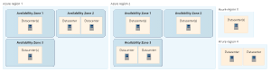Availability zones

Zone-resilient deployment types
One useful distinction I learned is that Azure resources can provide zone resilience in two ways: zonal or zone-redundant. The main difference is who manages the distribution, replication, and failover across availability zones.

Zonal deployments
A zonal resource is pinned to one specific availability zone. The customer is responsible for designing the application to remain available if that zone fails.
- The customer can deploy resources to a specific availability zone of their choice, providing the best performance and low latency
- The customer must distribute application requests across zones and manage data replication between them.
- If one availability zone has an outage, the customer must fail over the application to resources in another zone.
- Zonal resources can be deployed in regions that have only two unconstrained availability zones.
- Infrastructure as a service (IaaS) resources commonly support zonal deployments. A smaller subset of platform as a service (PaaS) resources also supports them.
- Multiple zonal deployments can be placed in different zones and combined to meet higher reliability requirements.

Zone-redundant deployments
With a zone-redundant resource, Microsoft manages the work required to spread the service across availability zones.
- Microsoft automatically distributes requests and replicates data across multiple availability zones.
- If one availability zone has an outage, Microsoft manages the failover automatically.
- Most PaaS services are designed to support zone-redundant deployments.
- With a few documented exceptions, zone-redundant services require three availability zones to maintain quorum and data consistency.
To find out more about which services support what, you can refer to Azure services that support availability zones document
Key distinction: With zonal resources, the customer designs and manages cross-zone resilience. With zone-redundant resources, Microsoft manages it as part of the service.

How AKS uses availability zones
An availability zone is a separate physical location within an Azure region. Each zone contains one or more datacentres with independent power, cooling, and networking. This separation helps protect applications and data from a failure in a single datacentre or zone.
Enabling availability zones in AKS distributes nodes across physically separate datacentres within the same region. If one zone fails, nodes in the other zones can continue running. Deploying AKS nodes across multiple zones does not add an AKS-specific charge, but the application still needs the right pod placement, storage, volume, and load-balancing configuration to benefit from that distribution.
Some workloads also have co-location requirements. This means that related resources need to run in the same availability zone. For example, an application might need its pod close to another service to reduce latency, or a pod might need to run in the same zone as the zonal disk it uses. These requirements affect if customers can spread one node pool across zones or create separate node pools aligned to specific zones.
To solve for these requirments customers can deploy the AKS cluster into a single Availability Zone, ensuring proximity and minimizing internode latency. Or PPG (Proximety placemen Groups) can be used to place nodes in the same data centre for optimal communication, minimizing latency and maintining zone redundency.

AKS cluster components
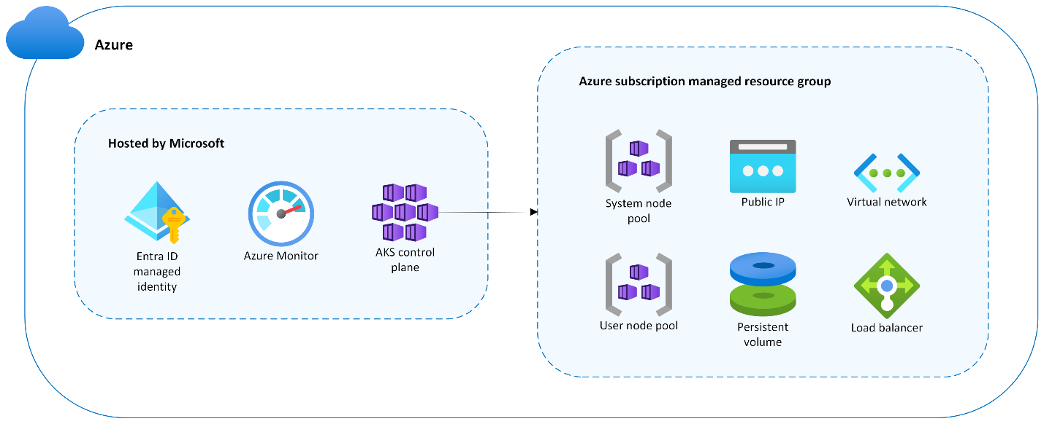AKS cluster components distributed across availability zones

Control plane
Microsoft hosts and manages the AKS control plane. This includes the Kubernetes API server, scheduler, and etcd. Microsoft replicates these control-plane components across multiple availability zones.
The other cluster resources are deployed into a managed resource group in the customer's Azure subscription. By default, its name begins with MC_, which stands for managed cluster.

Node pools
AKS node pools are implemented as Virtual Machine Scale Sets. Every AKS cluster requires at least one system node pool, which AKS creates during cluster deployment. This pool hosts critical system pods such as CoreDNS and Metrics Server. Additional user node pools can be added to host application workloads.
Customers can deploy a node pool in one of three ways:
Node-pool type | Placement | Main consideration
Zone-spanning | AKS spreads nodes across all selected zones | Provides distribution without managing a separate pool for each zone
Zone-aligned (Zonal) | Each node pool is pinned to one specific zone | Provides granular control over placement, scaling, and zone-level operations
Regional | No availability zone is selected | Azure places nodes within the region, but zone distribution is not guaranteed

Choosing a zone resilient node pool strategy
There are two main ways customers can arrange AKS worker nodes across availability zones. Both approaches provide zonally resilient worker capacity, but they offer different levels of control.
Approach | How it works | Best suited for
One zone-spanning node pool | One node pool contains nodes spread across zones 1, 2, and 3 | Simpler management and general stateless workloads
Three zone-aligned (Zonal) node pools | Each node pool is pinned to a different zone | Precise scaling, storage placement, and zone-level control
With a zone-spanning node pool, AKS manages one pool and spreads its nodes across the selected zones. If zone 1 fails, nodes in zones 2 and 3 can continue running. This option is simpler to manage, but scaling happens at the node-pool level, so customers have less control over which zone receives a new node.
With three zone-aligned (Zonal) node pools, customer can create one pool in each zone. For example, one pool is pinned to zone 1, another to zone 2, and another to zone 3. This design gives more control over scaling, pod placement, and zone-specific operations. It is useful when a workload or locally redundant disk must remain in a particular zone. The tradeoff is that you have three node pools to configure, scale, monitor, and maintain.
The node pool layout does not automatically guarantee that pods are evenly distributed. Customers still need to use topology spread constraints or affinity rules to control pod placement across zones.
Key Takeaway: A zone spanning pool is simpler to manage. Separate zone aligned pools provide more control over scaling, placement, and zonal storage.
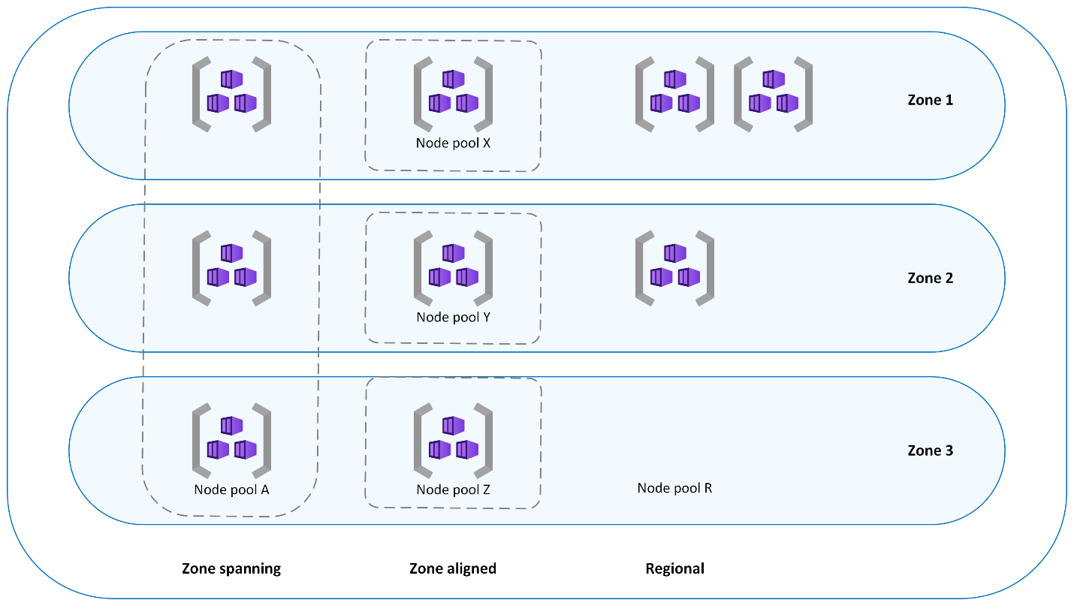AKS node-pool availability-zone options

Zone-spanning (Zone-Redundant) node pools
In a zone-spanning node pool, AKS spreads nodes across all selected zones and balances the number of nodes between them. During a zone outage, nodes in the affected zone might become unavailable, while nodes in the remaining zones continue to operate.
# AKS cluster with a zone-spanning system node pool in all three availability zones with one node in each availability zone
az aks create --resource-group example-rg --name example-cluster --node-count 3 --zones 1 2 3

# Add one new zone-spanning user node pool with two nodes in each availability zone
az aks nodepool add --resource-group example-rg --cluster-name example-cluster --name userpoola --node-count 6 --zones 1 2 3

Zone-aligned (Zonal) node pools
In a zone-aligned (Zonal) design, each node pool is pinned to a specific availability zone. I can use this approach when the workload needs lower latency between nodes in the same zone, more granular control over scaling, or deliberate cluster-autoscaler behavior for each zone.
# Add three zone-aligned (Zonal) user node pools with two nodes in each zone
az aks nodepool add --resource-group example-rg --cluster-name example-cluster --name userpoolx --node-count 2 --zones 1

az aks nodepool add --resource-group example-rg --cluster-name example-cluster --name userpooly --node-count 2 --zones 2

az aks nodepool add --resource-group example-rg --cluster-name example-cluster --name userpoolz --node-count 2 --zones 3

Regional node pools
A node pool is regional when I do not set a zone assignment in the deployment template or command. Azure creates regional instances that are not pinned to a specific zone and places them within the region. There is no guarantee that these instances will be evenly spread across zones. They might even be placed in the same zone. As a result, a full zone outage could affect some or all instances in a regional node pool.

Verify node distribution
I can use az aks show with a query to confirm which availability zones are configured for each node pool:
az aks show --name example-cluster --resource-group example-rg --query agentPoolProfiles[].availabilityZones --output tsv
I can then use kubectl get nodes to see the region and zone assigned to each node. The second command shows which node is hosting each pod:
kubectl get nodes -o custom-columns='NAME:metadata.name, REGION:metadata.labels.topology\.kubernetes\.io/region, ZONE:metadata.labels.topology\.kubernetes\.io/zone'
kubectl describe pod | grep -e "^Name:" -e "^Node:"

Distribute pods across zones
Spreading nodes across zones Zone-spanning stratergy (Zone-Redundant) does not automatically guarantee that application pods are evenly distributed. I can use Kubernetes topology spread constraints to tell the scheduler how to place pod replicas across the available zones.
This gives granular control over how pods are spread across your AKS cluster, taking into account regions, availability zones, and nodes. You can create constraints that span pod replicas across availability zones, as well as across different nodes within a single availability zone.
The topologyKey: topology.kubernetes.io/zone setting tells Kubernetes to use the node's availability-zone label as the placement boundary. The maxSkew: 1 setting controls how unevenly pods can be distributed between those zones.
For example, with three available zones, three replicas, sufficient node capacity, and an appropriate scheduling constraint, a maximum skew of 1 helps place at least one replica in each zone.
Benefits include:
- Maximize the resilience and availability of your applications in the AKS cluster.
- Optimizes resource utilization, minimizes downtime, and delivers a robust infrastructure for your workloads across multiple availability zones and nodes.

Distribute inbound traffic
AKS deploys an Azure Standard Load Balancer by default. It distributes inbound traffic to healthy backend nodes across the region. If a node becomes unavailable, the load balancer stops directing new traffic to that node and routes traffic to healthy nodes instead.
Key Takeaway Availability zones spread the infrastructure, but I still need to design node pools, pod placement, storage, and traffic routing so the application can survive a zone failure.

Stateless and stateful applications
In simple terms, the difference is whether the application needs to remember information locally between requests:
- A stateless application does not depend on information stored inside a specific application instance or pod. Each request can be handled independently by any available pod. If one pod fails, another pod can take over without needing to recover information from the failed pod.
- A stateful application needs to preserve information between requests or depends on a stable identity, ordered processing, or persistent storage. If its pod fails, the replacement might need to reconnect to its storage, recover data, or rejoin the other application replicas before it can serve traffic safely.
Characteristic | Stateless application | Stateful application
Simple analogy | A receptionist who can handle the next request without knowing the previous conversation | A personal account manager who must retain the customer's history
Common examples | Web front ends, REST APIs, and request-processing services | Databases, message brokers, and applications that store local session data
Where data is kept | In an external service, such as a database, distributed cache, or object store | In persistent storage or replicated state managed by the application
If a pod fails | Another pod can usually serve the next request immediately | A replacement might need to restore data, attach storage, or rejoin a replica group
Scaling | Usually straightforward because any replica can handle a request | Requires care to preserve data consistency, identity, and replica membership
Zone outage concern | Enough healthy pods and compute capacity must remain in the surviving zone | Data replicas, storage availability, quorum, and recovery behavior must also survive
Memory line: Stateless applications can replace a pod and continue;
stateful applications must also preserve and recover what the pod knows.
For stateless applications, a two-zone design is a supported resilient architecture when the application can absorb the capacity reduction through one or more of the following measures:
- Autoscaling
- Load shedding
- Deliberate overprovisioning
Stateful workloads need additional consideration. Workloads that require quorum might still need a three-zone design or additional multi-region protections to meet their availability and recovery requirements.

Workload and Storage Configuration
Depending on the node pool strategy chosen there are considerations around workload deployment strategy and storage configuration.
Overall for Azure Storage data is always replicated 3 times in the primary region so that your information is protected from planned and unplanned events. Redundancy ensures that your storage account meets its availability and durability targets even in case of failures.
When planning the workload & storage redundency stratergy consider the tradeoffs between lower costs and higher availability. This is normally influenced by scenarios like how your data is replicated within the primary region, or do you want your data to be replicated to a second region that is geographically distant from the primary region, to protect against regional disasters (geo-replication) or does your application requires read access to the replicated data in the secondary region if the primary region becomes unavailable for any reason (geo-replication with read access).

Options for data replication in Primary region:
- Zone-redundant storage (ZRS) disks replicate data across availability zones and provide greater flexibility during a zone failure.
- Excellent performance, low latency, and resiliency for your data.
- Replicates storage account synchronously across 3 Azure availability zones in the primary region you select.
- ZRS disks provide at least 99.9999999999% (12 9’s) of durability over a given year.
- Data is accessible for both read and write operations even if a zone becomes unavailable.
- If a zone becomes unavailable, Azure does networking updates, such as DNS repointing.
- Requires transient fault handling, implementing retry policies with exponential back-off.
- Write request happens synchronously.
- Returns successfully only after the data is written to all replicas across the three availability zones.
- If an availability zone is temporarily unavailable, the operation returns successfully after the data is written to all available zones.
- A disk can be attached by a virtual machines in a different availability zone.
ZRS is usefull if:
- Require high availability
- Want to restrict replication of data to a particular country or region to meet data governance requirements
- Using Azure files workloads
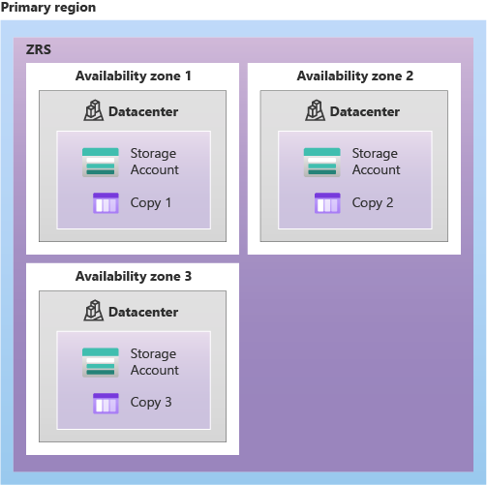zrs
Note For protection against regional disasters, Microsoft recommends using geo-zone-redundant storage (GZRS), which uses ZRS in the primary region and also geo-replicates your data to a secondary region.
- Locally redundant storage (LRS) disks remain in one zone and can attach only to nodes in that same zone.
- Lowest cost option
- Least durability
- Protects customers data against server rack and drive failures
- Write operations in LRS are synchronous
- Write operatios are successful only after the data is written to all three replicas
LRS is usefull if:
- Storing data that can be easily reconstructed if data is lost
- Using Azure unmanaged disks
- Restrictions on replicating data within a country or region due to data governance requirements (GDPR)
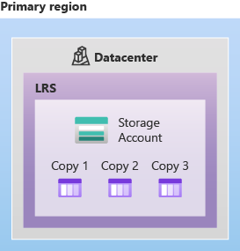LRS
Note Microsoft recommends using zone-redundant storage (ZRS), geo-redundant storage (GRS), or geo-zone-redundant storage (GZRS).
- Stateful applications also need a plan for data replication, quorum (Quorum means a majority must remain available and agree before the system can safely continue.), and recovery during a zone failure.
Key Takeaway Customers Storage and workload stratergy also needs to match the node pool strategy

Managed disks with zone-spanning node pools
When using a single zone-spanning node pool, it is recommended to use zone-redundant storage (ZRS) for persistent volumes. ZRS replicates the managed disk across availability zones, so the disk is not tied to only one zone.
The application requests storage through a Kubernetes persistent volume claim (PVC). The PVC is then bound to a persistent volume backed by the ZRS managed disk. If the pod or its availability zone becomes unavailable, Kubernetes can reschedule the pod onto a healthy node in another zone and reattach the same disk.
This provides better data availability and reliability than a locally redundant storage (LRS) disk, which can attach only to nodes in the same zone as the disk. For more information, see Persistent volumes in Kubernetes.
Key takeaway: ZRS allows a persistent disk to follow a rescheduled pod across availability zones. LRS keeps the pod and disk dependent on one zone.

Zone spanning (Zone-redundant) AKS node pool architecture
An AKS cluster with zone redundant nde pools involves deploying an AKS cluster where the nodes are distributed evenly across the availability zones within a region.
The diagram below shows an AKS cluster with a zone-redundant system-mode node pool and a zone-redundant user-mode node pool
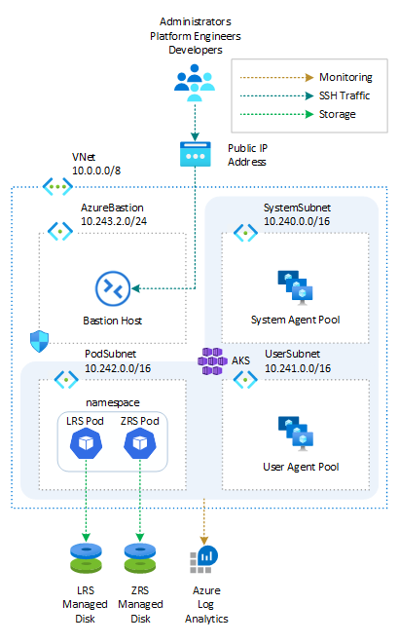AKS Cluster; Zone-redundant Node pools
Deploy the script to create the following resources.

Pod topology spread constraints
When deploying pods across multiple availability zones, it is important to distribute the replicas evenly. Spreading the cluster nodes across zones does not automatically guarantee that the application pods will also be spread across those zones.
To control this placement, customers can use the Kubernetes feature called pod topology spread constraints. These constraints tell the Kubernetes scheduler how to distribute pod replicas across failure domains such as regions, availability zones, and individual nodes.
Customers can use topology spread constraints at different levels:
- Spread replicas across availability zones so that a zone failure does not remove every instance of the application.
- Spread replicas across different nodes within the same zone to reduce the effect of a node failure or maintenance activity.
This placement strategy improves fault tolerance and helps the application remain available if a node or an entire zone becomes unavailable. It can also improve resource utilization, reduce downtime, and provide a more reliable platform for customer workloads running across multiple availability zones.
Notes: Spreading nodes creates failure domains. Pod topology spread constraints make sure application replicas use them.

Zone-aligned (Zonal ) AKS node-pool architecture
With a zonal node-pool strategy, customers deploy three user node pools and assign each pool to a different availability zone within the same Azure region. This provides direct control over the number of nodes available in each zone.
The following diagram shows this architecture with one system-mode node pool and three zonal user-mode node pools, each placed in a separate availability zone.
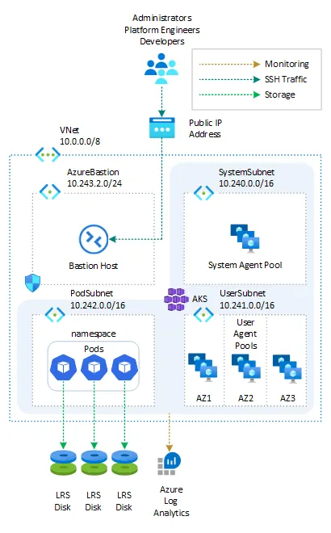Zonal node pools
Deploy the script to create the resources shown in the diagram.

Balance similar node pools during scale-up
In the script, I set the cluster autoscaler profile setting balance-similar-node-groups to true. This helps the cluster autoscaler keep similar zonal node pools balanced when it adds capacity.
The cluster autoscaler identifies node pools that use the same VM size and the same set of labels, excluding the zone label that Azure adds automatically. It then attempts to distribute new nodes across those similar pools.
This setting improves balance during scale-up, but it does not guarantee that the node pools will always contain exactly the same number of nodes. The following limitations still apply:
- Balancing occurs only during scale-up. During scale-down, the cluster autoscaler can remove underused nodes regardless of the relative sizes of the node pools.
- The autoscaler adds only the number of nodes required to schedule the pending pods. If that number cannot be divided evenly between the balanced node pools, one or more pools might contain an extra node.
- The autoscaler balances only node pools that can run the same pending pods. For example, if a pod uses a nodeSelector that restricts it to one zone, the autoscaler adds capacity only to the node pool in that zone.
- A node pool can be excluded from balancing with otherwise similar pools by assigning it a different custom label.
Key Takeaway: Separate zonal node pools provide direct control over each zone. The autoscaler can help balance similar pools during scale-up, but workload scheduling requirements still determine where capacity is added.

How a two-zone AKS deployment remains resilient
[!NOTE]
A two-zone AKS deployment remains resilient to a single-zone outage because AKS can distribute node pools across both zones and continue serving workloads from the surviving zone.
When creating AKS node pools, customers might find that the same VM family is not available in every zone for their subscription because of capacity constraints. This becomes a problem when the target architecture expects one zone-spanning node pool to use the same VM SKU across three availability zones to create a resilient, fault tolerant AKS cluster.
The capacity impact of a zone failure differs between two-zone and three-zone designs:
Design | Approximate capacity lost during one zone failure | Approximate capacity remaining
Two zones | 50% | 50%
Three zones | 33% | 67%
One workaround is to use one VM SKU in a node pool that spans the accessible zones, then create another node pool with a different SKU in the constrained zone. This still provides capacity across zones, but each node pool becomes a separate scaling domain.
The AKS cluster autoscaler feature optimizes capacity within each pool, but it does not freely move or rebalance existing capacity between pools. Multiple pools can therefore result in more nodes than required, higher compute or per-VM licensing costs, and additional upgrade and administration work.
AKS provides two features that can make capacity-constrained deployments more practical:
- Automatic zone placement improves placement and scaling across the zones that support a selected VM SKU.
- Node auto-provisioning (NAP) evaluates pending pod requirements and can provision nodes from an allowed set of VM families, SKUs, and zones.
These features provide more placement flexibility, but they do not create capacity where the underlying Azure capacity is unavailable.

Automatic zone placement in AKS
Automatic zone placement is a preview feature that dynamically selects the best availability zones for a node pool. Instead of specifying zones manually, customers can use --zones auto. AKS then uses the Azure Compute automatic zone placement policy to find zones that support the requested VM SKU applying a maximum instance percentage of 50% per zone .
The placement flow works as follows:
- AKS checks which availability zones in the target region support the requested VM SKU.
- AKS initially selects up to three supported zones and distributes nodes according to the placement policy.
- By default, no single zone can contain more than 50% of the node pool.
- During later scale-out operations, AKS checks zone availability again. If a new zone becomes available or the VM SKU becomes available in another zone, AKS can place new nodes there without requiring a node-pool configuration change.
The 50% limit controls the maximum concentration in one zone. It does not guarantee that every zone will contain exactly the same number of nodes. The actual distribution still depends on node count, SKU support, and available capacity, and an allocation can still fail if Azure cannot satisfy the request.
Automatic zone placement supports creating and updating both Virtual Machine Scale Sets-based and Virtual Machines-based node pools. It is intended for zone-spanning (Zone-Redundant) node pools. Zone-aligned pools should continue to specify their zone explicitly.

Node auto-provisioning
Node auto-provisioning keeps an AKS cluster efficient by creating nodes for pending pods and removing nodes when it is safe to do so allowing customers to create a workaround to capacity constraints. NAP evaluates pod resource requests and the requirements defined in its Kubernetes NodePool resources, then provisions nodes that satisfy the workload and policy constraints.
Unlike a traditional Virtual Machine Scale Sets node pool, which remains tied to one VM SKU, a NAP NodePool can allow multiple VM families or specific SKUs. NAP can then choose an eligible VM for each new node based on CPU, memory, GPU, zone, capacity, and other configured requirements.
NAP uses two layers of control when deciding whether a node can be removed:
- The workload layer uses Pod Disruption Budgets (PDBs). PDBs limit voluntary pod evictions by defining how many replicas must remain available or how many can be unavailable at one time.
- The infrastructure layer uses node-level disruption settings. These controls limit how quickly NAP can disrupt and replace nodes.
A NAP disruption is a voluntary action that drains and removes a node. Common examples include:
- Consolidation removes or replaces nodes with more suitable VM sizes to improve compute efficiency and reduce cost.
- Drift replaces nodes that no longer match the desired NodePool or AKSNodeClass configuration.
- Expiration replaces nodes after a configured lifetime.
Involuntary disruptions, such as Spot evictions, hardware failures, and host reboots, are not initiated by NAP and must still be included in the workload's resilience design.
When pods remain pending, NAP first checks whether they fit on existing nodes. If they do not, it evaluates their CPU, memory, GPU, affinity, topology, and other requirements. It then searches the allowed VM families and SKUs and provisions an option that meets those requirements and the configured policy. Allowing a broad but controlled set of suitable VM sizes reduces the chance of provisioning failures when one SKU has limited capacity and gives NAP more flexibility to select an alternative SKU that still meets the workload requirements and policy constraints.
The ability to use multiple SKUs depends on the AKS node pool model. VM node pools and Node Auto Provisioning both support this flexibility, but they are mutually exclusive approaches. With NAP, AKS provisions and manages standalone VMs rather than relying on traditional node pools, which enables mixed-SKU autoscaling. VM node pools, on the other hand, still use the traditional node pool model but allow mixed-SKU manual scaling.

Cluster autoscaler compared with NAP
As discussed, the cluster autoscaler scales existing node pools. Acting as the standard autoscaling method for Kubernetes and works by scaling pre-existing node pools of the same VM size. Because a traditional Virtual Machine Scale Sets pool uses one VM SKU, the autoscaler cannot switch that pool to another SKU when capacity is unavailable. To work around this customers might need multiple pools with different SKUs and zones to avoid capacity exhaustion, which adds operational overhead.In some cases, it can almost become a pattern of needing one node pool per zone for each VM SKU to scale reliably.
This is where NAP is particularly valuable. NAP works at the individual node level and can select from the VM options allowed by its NodePool requirements. This gives it more flexibility to respond to pod pressure and capacity changes and can improve both capacity resilience and cost efficiency.
The important distinction is that a NAP NodePool is a Kubernetes provisioning policy, not a traditional VMSS Uniform node pool. VMSS Uniform pools remain single-SKU by design. Their SKU can be changed through a supported update, but multiple SKUs cannot coexist in the same VMSS Uniform pool.
Key takeaway: Automatic zone placement finds suitable zones for one VM SKU. NAP can choose suitable nodes from multiple allowed VM options. Neither feature removes the need for available Azure capacity, quota, and resilient workload design.

Guaranteeing capacity with ODCR
On-demand capacity reservation (ODCR) was discussed as an alternative for guaranteeing AKS compute capacity. It is the only guaranteed method of reserving capacity in Azure and is suitable for workloads that run 24 hours a day, seven days a week.
An ODCR can be configured in the Azure portal by creating a capacity reservation group. The following commercial considerations apply:
- ODCR does not increase the per-unit price of the reserved compute capacity.
- Azure charges for the reserved capacity whether or not the workload uses it.
- Future capacity reservation options with minimum usage periods are being piloted.
Before choosing ODCR, it is important to establish the customer's actual capacity requirements. Quota approvals are region-based and must be managed carefully while supply remains constrained.

Extending resilience across regions
Another option I learned to consider is deploying the application across multiple Azure regions. A multi-region architecture can achieve many of the same goals as a multi-zone design, including high availability, resilience, and greater scalability. However, it protects against a broader failure scope because the application is not dependent on a single Azure region.
A multi-region deployment can be used in two ways:
- It can provide an alternative when the preferred region cannot support the required in-region, multi-zone architecture.
- It can complement an existing multi-zone deployment by adding another layer of protection outside the primary region.
For critical workloads, the second region can provide more options for disaster recovery and business continuity. If the primary region becomes unavailable, traffic and operations can fail over to the secondary region, provided the application, data, networking, and dependent services have been designed for cross-region recovery.
For this reason, customers should consider multi-region options for critical applications even when an in-region, multi-zone high-availability design is available. The decision should be based on the workload's recovery time, acceptable data loss, dependency, operational complexity, and cost requirements. Also considering details around latency, and synchronous/asynchronous data replication
Key Takeaway: Availability zones protect against failures within a region. A multi-region design adds protection against the loss of an entire region.

Choosing an AKS resilience strategy
The architecture discussion should consider the following questions:
- Does the workload require three zones for a technical reason, such as stateful quorum, or is the requirement based on a general resilience goal?
- Can the application continue operating after losing approximately 50% of its in-region capacity?
- Can autoscaling, load shedding, or overprovisioning provide enough capacity protection for a two-zone deployment?
- Would moving to another region introduce unacceptable effects on existing infrastructure dependencies?
- Does the workload run continuously and justify paying for guaranteed capacity through ODCR?
- Are the required regional quota and capacity approvals available?
For this customer, the key message was that a two-zone AKS architecture can provide supported single-zone-failure resilience. The final choice should be based on workload behavior, capacity-loss tolerance, stateful quorum needs, regional dependencies, and the cost of guaranteed capacity.

Testing resilience during a zone failure
After deploying the scripts, I can simulate a failure that makes all nodes in one availability zone unavailable. The aim of this demo is to verify that the application continues running on nodes in the remaining healthy zones.

Prepare the node pools
Before starting the test, I need to prevent the cluster autoscaler from changing the node count and affecting the result. The script in the test folder prepares the cluster by:
- Disabling the cluster autoscaler on each zonal node pool
- Manually setting each zonal node pool to exactly two nodes
This creates a consistent starting point and makes it easier to observe how the application responds when one zone becomes unavailable.

Expected pod and storage distribution
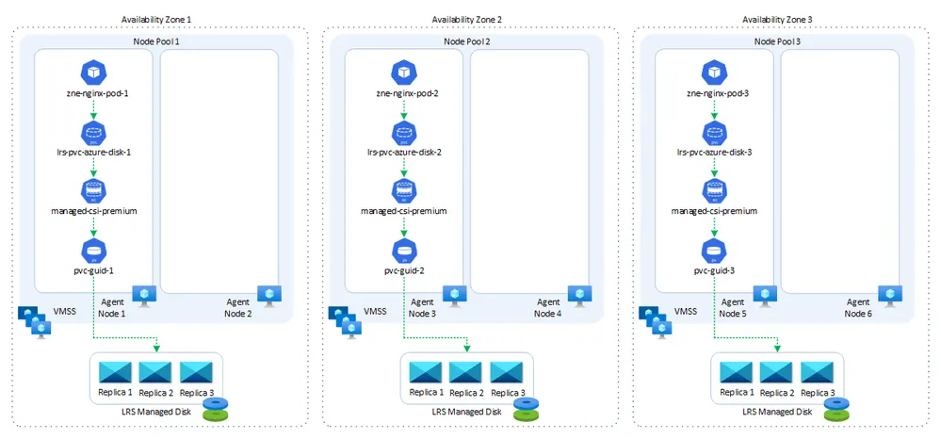Pods distributed across nodes and zonal node pools
The diagram shows the pods distributed evenly across zonal node pools, with each node pool located in a separate availability zone. This placement helps maintain application availability and fault tolerance during a zonal failure.
Each pod uses a locally redundant storage (LRS) managed disk located in the same availability zone as the pod. Keeping the pod and its disk in the same zone provides data locality and minimizes latency for disk operations.
During the test, the expected result is that workloads in the failed zone are affected, while pods and disks in the remaining zones continue operating. This distribution demonstrates how zonal node pools and zone-aligned storage can improve application resilience and performance.
Memory line: Fix the node count before the test, remove one zone, and
confirm that workloads in the healthy zones continue running.

Key design takeaways
The engagement produced several important takeaways:
- Due to global supply constraints, the industry is increasingly adopting two-zone architectures as a standard approach. Azure documentation and services are being updated to reflect this shift.
- The service-level agreement (SLA) for a two-zone deployment is effectively the same as the SLA for a three-zone deployment within a single region.
- Customers need clear guidance about the negligible SLA difference and the operational benefits of a two-zone deployment.
- A two-zone design still provides resilience against the loss of a single zone. The main architectural tradeoff is capacity: losing one zone removes roughly 50% of the cluster's in-region compute capacity, compared with roughly 33% in a three-zone design.
- Customers should size node pools so that the surviving zone can continue supporting critical workloads. Autoscaling, load shedding, and deliberate overprovisioning can help manage the loss of capacity.
- Spreading nodes across availability zones does not automatically spread application pods. Customers should use topology spread constraints or affinity rules to distribute replicas across zones and nodes.
- A resilient AKS cluster does not automatically make the application resilient. Pod placement, storage, networking, dependent services, and disruption controls must all be designed for zonal failure.
- The storage strategy must match the node-pool strategy. ZRS managed disks support cross-zone recovery, while LRS disks remain tied to nodes in the same availability zone.
- Zone-spanning node pools are simpler to manage. Separate zone-aligned node pools provide more control over scaling, workload placement, and zonal storage, but they also create additional operational overhead.
- Separate node pools are separate scaling domains. The cluster autoscaler can optimize each pool, but it does not freely rebalance existing capacity between pools.
- Automatic zone placement can find suitable zones for one VM SKU, while NAP can select nodes from multiple allowed VM options. Neither feature can create Azure capacity or quota where it is unavailable.
- On-demand capacity reservation should be considered when guaranteed baseline capacity is required, particularly for workloads that run continuously.
- Stateful workloads require additional planning for data replication, quorum, persistent storage, and recovery behavior during a zone failure.
- Availability zones protect workloads from failures within one region. Critical workloads should also consider a multi-region design for protection against a full regional outage.
- Resilience should be tested. A controlled zonal-failure exercise confirms whether workloads, storage, and traffic continue operating from the healthy zones as expected.

Troubleshooting

References
- Configure availability zones
- Zone resiliency recommendations for Azure Kubernetes Service (AKS)
- zone-redundant-aks-and-storage
- Cluster autoscaler profile settings
- Autoscaler
- Cluster Autoscaler in Azure Kubernetes Service (AKS)
- Configure node pools for node auto-provisioning (NAP) in Azure Kubernetes Service (AKS)
Navigating Capacity Challenges on AKS with Node Auto Provisioning or Virtual Machine Node Pools

