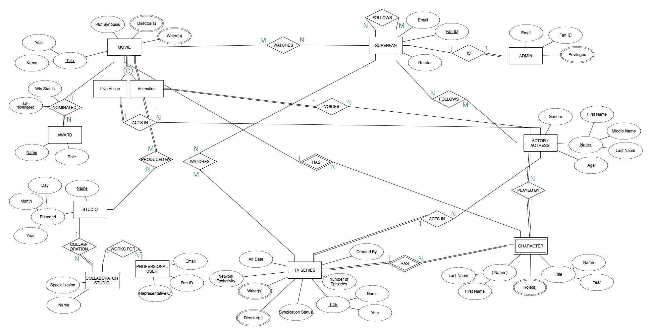Above is our ER Diagram for SUPERFAN. The following assumptions were made:

* A movie or TV show does not necessarily need to be watched by a Superfan
* Not all actor/actresses either act in or voices in a movie
* Similar for TV shows, not all actor/actresses act in a TV show
* All characters must be played by an actor/actress and an actor/actress must play a character
* A character can be played by multiple actor/actresses (for example, a character in different adaptations or a character played by different people for different ages.)
* Movie can be specialized into a live action or animation movie and the two can overlap because there are some movies that are both (for example, “Enchanted” is a live movie with animation involved.)

A few changes made to the ER diagram include changing the AWARD entity to only have the attributes: Name and Role and the relationship “NOMINATED” to have the following attribute “Win Status” because it is not guaranteed that a movie wins something. We also made the participation partial on the MOVIE side because not all movies are nominated for an award. We also added the PROFESSIONAL USER entity to consider another user of our system. In addition to the Superfan and Admin, we wanted to include a professional user who acts as a representative of a COLLABORATION STUDIO so they can use our system to host things like Q&A’s, post official quotes, etc. for a movie.